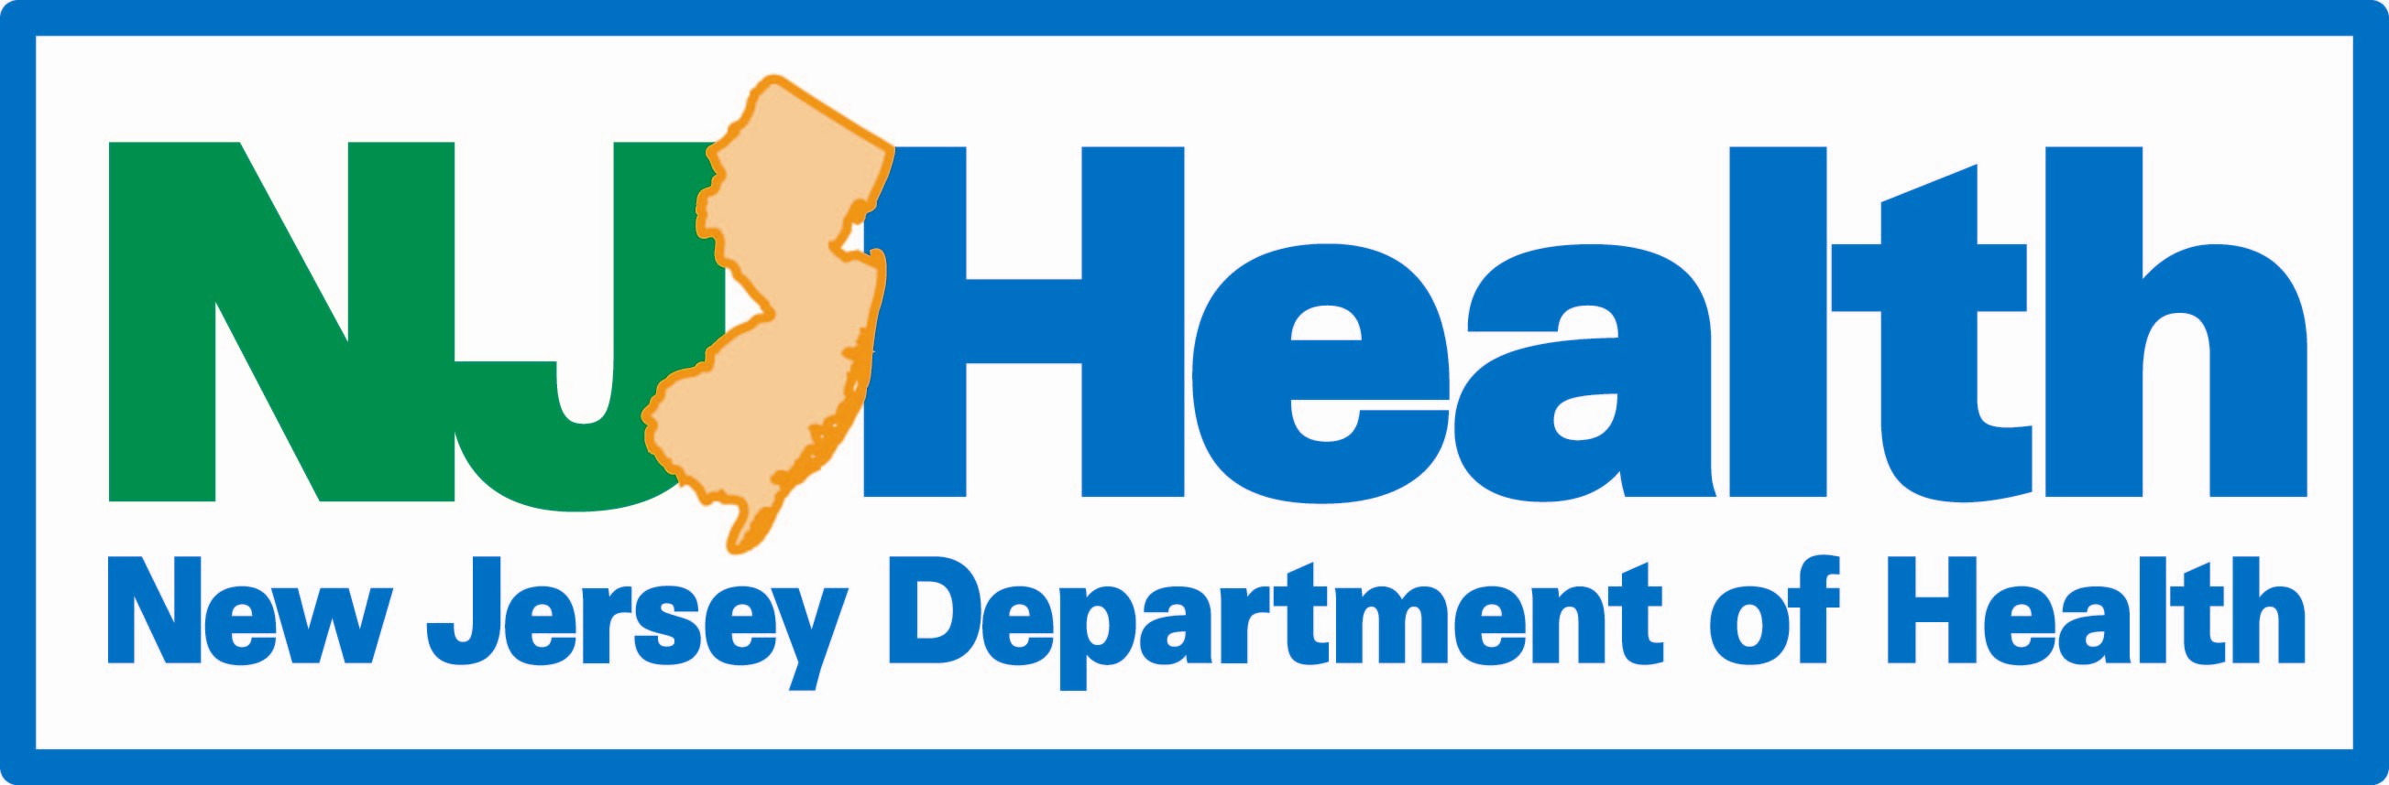 | New Jersey Department of Health  Commissioner event ATTENDANCE request
Commissioner welcomes your invitation at any time, however, we appreciate 8 weeks notice prior to an event. Once we receive your request, it will be acknowledged by a return email and processed at the appropriate time. We typically do not confirm events more than 3 - 4 weeks in advance.
If you plan on using promotional materials with the Commissioner’s name, please obtain approval by copying
Nancy Kelly-Goodstein, DOH Ethics Liaison at Nancy.Kelly-Goodstein@doh.nj.gov for Ethics Review prior to public release.
Please email the completed form to: feedback@doh.nj.gov.
Title of Event |  | Organization Sponsoring Event
 |  | Date of Event |  | Is Date Flexible?  Yes No
Type of Event  Meeting Speaking Engagement  Event Appearance Tour  Press Conference Ribbon Cutting  Fundraiser  Other (specify) : ___________________ |  | Event Location and Address
Describe the program, including timeline and speaking order or attach agenda.

Is event open to Press?
Yes No
Any associated expenses such as Registration, Travel or Meals?  Yes No |  | Can venue accommodate Powerpoint presentations?  Yes No
Requested Speaking Time/Length? |  | Are any Elected Officials invited or attending?  Yes No
Who are audience, participants and expected number of attendees? |  | Who are other invited speakers?
Contact Person | Title |  | Cell or Office Email
Additional Notes/Comments

