VELONI AWARDED THE DEPARTMENT OF THE NAVY
DISTINGUISHED CIVILIAN SERVICE AWARD

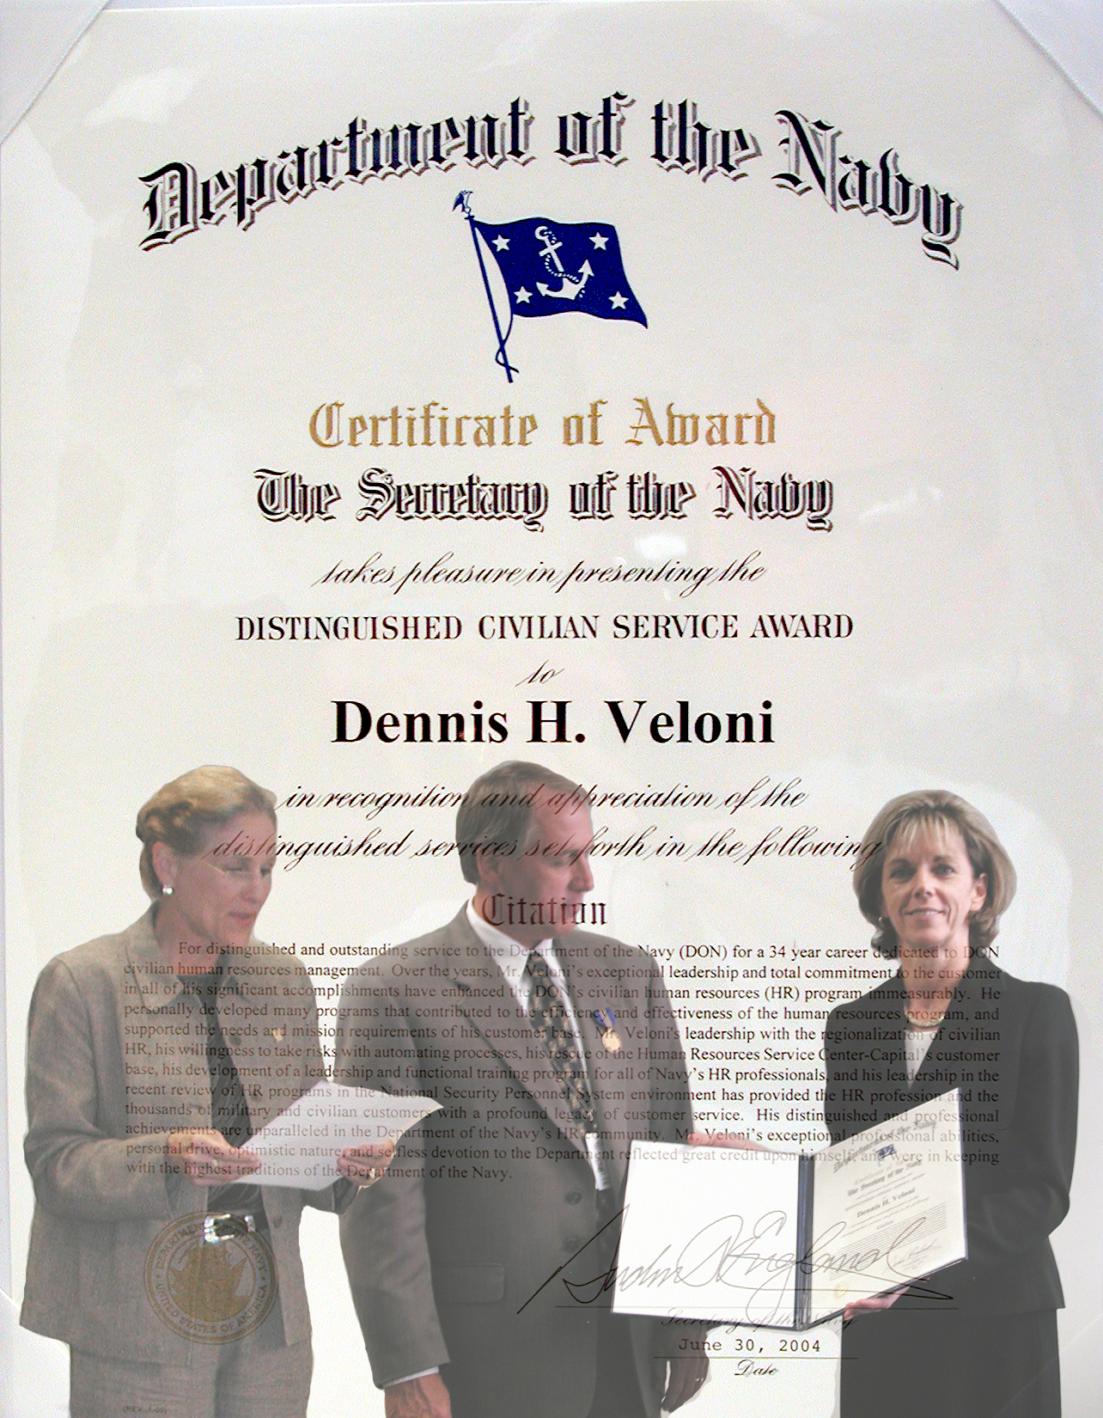
On the eve of his retirement, Mr. Dennis H. Veloni was presented with the Department of the Navy (DON) Distinguished Civilian Service Award (DCSA) in recognition of his distinguished civilian career. The award was presented on September 2, 2004, by Ms. Patricia C. Adams (Deputy Assistant Secretary of the Navy (Civilian Human Resources)) on behalf of the Secretary of the Navy. The DON DCSA, signed by The Honorable Gordon R. England cited “….Over the [34-plus] years, Mr. Veloni’s exceptional leadership and total commitment to the customer in all of his significant accomplishments have enhanced the DON’s civilian human resources program immeasurably. He personally developed many programs that contributed to the efficiency and effectiveness of the human resources program. His leadership with the regionalization of civilian HR, his willingness to take risks with automating processes, his rescue of the Human Resources Service Center-Capital’s customer base, his development of a leadership and functional training program for all of Navy’s HR professionals, and his leadership in the recent review of HR programs in the National Security Personnel System environment have provided the HR profession and the thousands of military and civilian customers with a profound legacy of customer service. Mr. Veloni’s distinguished and professional achievements are unparalleled in the Department of the Navy’s HR community…”

The ceremony was hosted by Ms. Debra Edmond, Director of the Office of Civilian Human Resources (OCHR) and was attended by many OCHR and DASN(CHR) staff members, Human Resources Service Center Directors, and several individuals representing the activities and commands that Mr. Veloni and his staff serviced.

The DON DCSA is the highest honorary award the Secretary of the Navy can confer on a DON civilian employee. The DON DCSA is granted only to those employees who have given distinguished and/or extraordinary service to the DON, in which their achievements displayed a pattern of long-term, sustained high performance, achievements recognized throughout the DON, innovative leadership of highly successful programs or projects, or accomplishments which show unusual management abilities, innovative thinking, and outstanding leadership which benefit the Department of the Navy.

