This visual guide has been established to assist Request for Personnel Action (RPA) generators who create RPAs to access the Personnel Automated Record Information System (PARIS) Position Description library for the purpose of attaching an electronic Position Description (PD) to the RPA. PDs are scanned documents and saved as *.tif files which can be viewed by whatever imaging application is on the manager’s PC associated to the *.tif file extension.

The PARIS PD library is located on the AFPC/DPC website and is best viewed using the MS Internet Explorer browser. You can start by going to the following website address ( http://www.afpc.randolph.af.mil/dpc ). From the ‘Web Applications’ drop down menu, choose ‘PD Access for RPA Generators’.

(Directorate of Civilian Personnel Operations home page)
( http://www.afpc.randolph.af.mil/dpc )

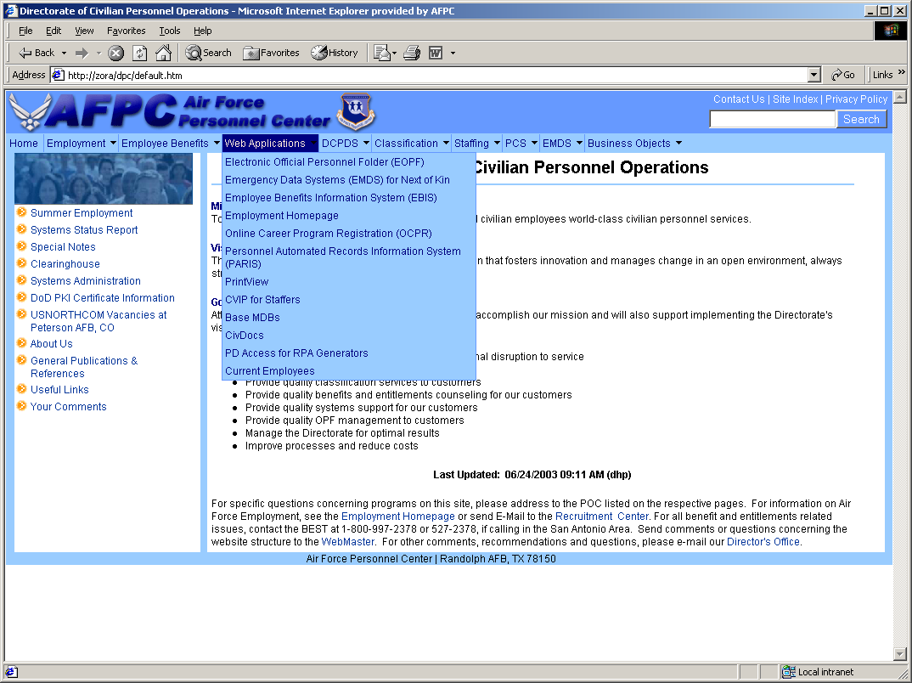

At the ‘PD Access for Managers’ page, you will have access to information pertaining to the purpose of this application, those Air Force bases authorized to access this program and links to the guides which will assist you in retrieving and linking the position description (PD) documents to the Request for Personnel Actions (RPA).

To proceed to the AFPC Secure login page, click the ‘Enter the AFPC Secure Web Site Login’ link.

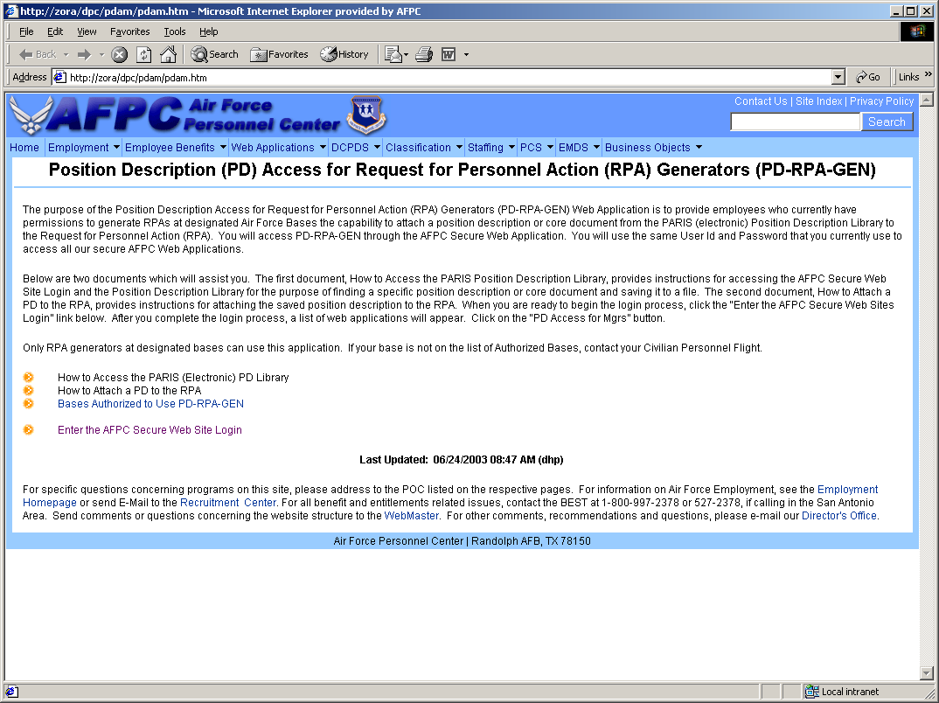

In order to get to the PARIS PD library, the manager must have an active userid/password account at the AFPC Secure login page. If you already have an active AFPC Secure account, input your userid/password in the space provided and click the ‘Secure Login’ button to proceed.

If you do not have an AFPC secure account, please read the information note to ‘First Time Air Force Users’ on the AFPC Secure Login screen and click the applicable category (Military or Civilian) where you will be authenticated as an Air Force employee based on the personal service information you provide. Samples of the military/civilian employee verification screens follow on the next two pages.

(AFPC Secure Login Page)

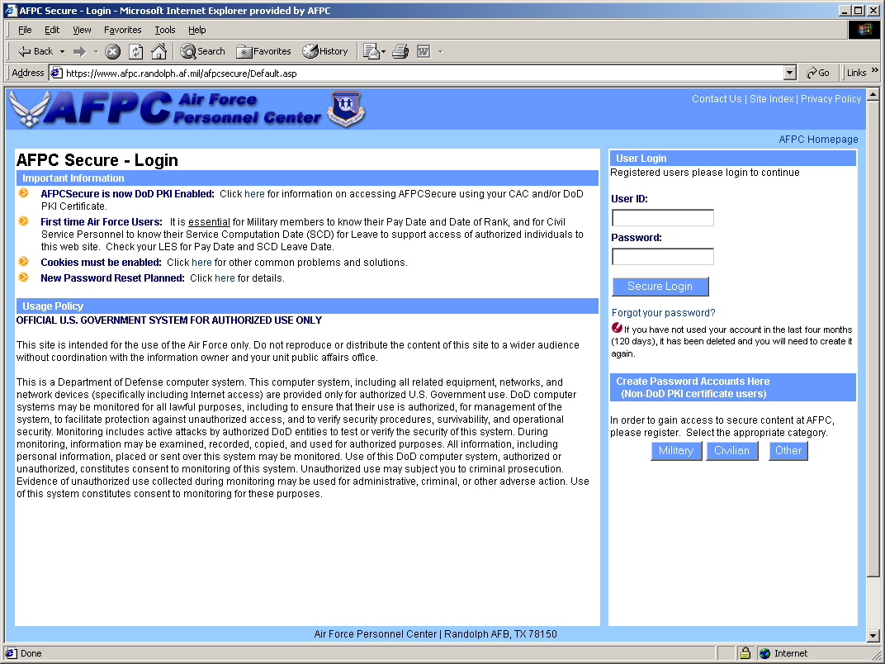

Civilian Verification screen. You will be asked to provide your SSAN, Date of Birth, SCD Leave Date, Pay Plan, Grade and Step. Should you need help with this data, all of this information can be obtained from your latest SF50 personnel action form. Once you have completed the form, click the ‘Submit’ button. The next page that will appear will guide you through the steps of creating your personal userid/password. When you have created your userid/password, you will be returned to the AFPC Secure login screen to login.

( AFPC Secure -- Civilian Verification Page )

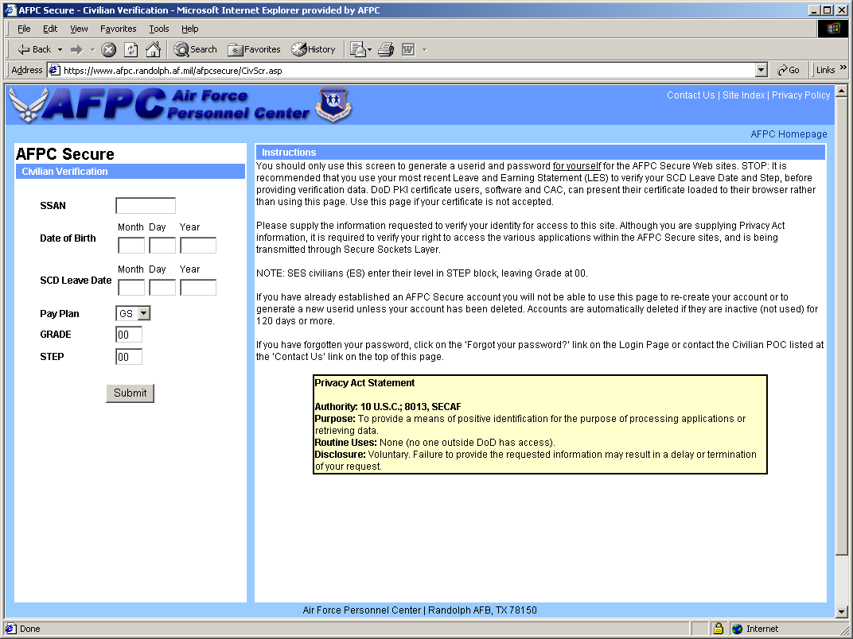

Military Verification screen. You will be asked to provide your SSAN, Major Command, Date of Birth, Pay Date, and Date of Rank. Should you need help with this data, all of this information can be obtained from your latest Leave and Earnings Statement (LES). Once you have completed the form, click the ‘Submit’ button. The next page that will appear will guide you through the steps of creating your personal userid/password. When you have created your userid/password, you will be returned to the AFPC Secure login screen to login.

( AFPC Secure -- Military Verification Page )

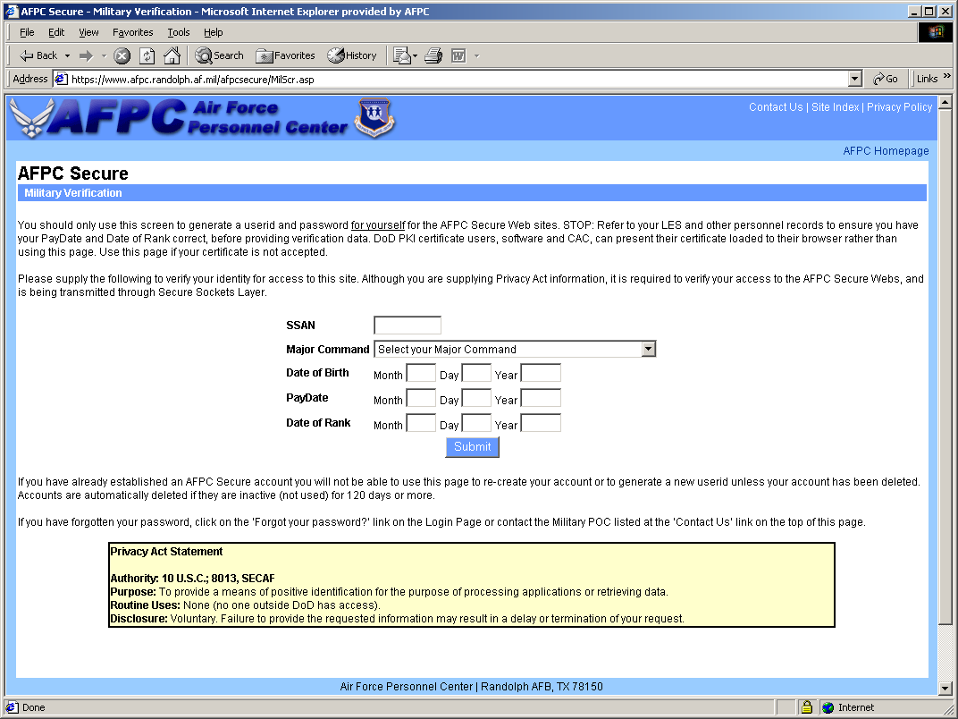
After you are returned to the AFPC Secure – Login screen, input your userid/password in the spaces provided and click the ‘Secure Login’ button to proceed.

After you have logged in to AFPC Secure, the next webpage to appear will be the AFPC Secure Main Menu. This will reflect those AFPC Secure web programs you presently have access to. To open the PARIS PD library, click the ‘PD Access for Managers’ button. This will take you directly to the PARIS position description (PD) library where you will be allowed to search for the PD(s) to attach to your RPA(s).

( AFPC Secure Main Menu page )

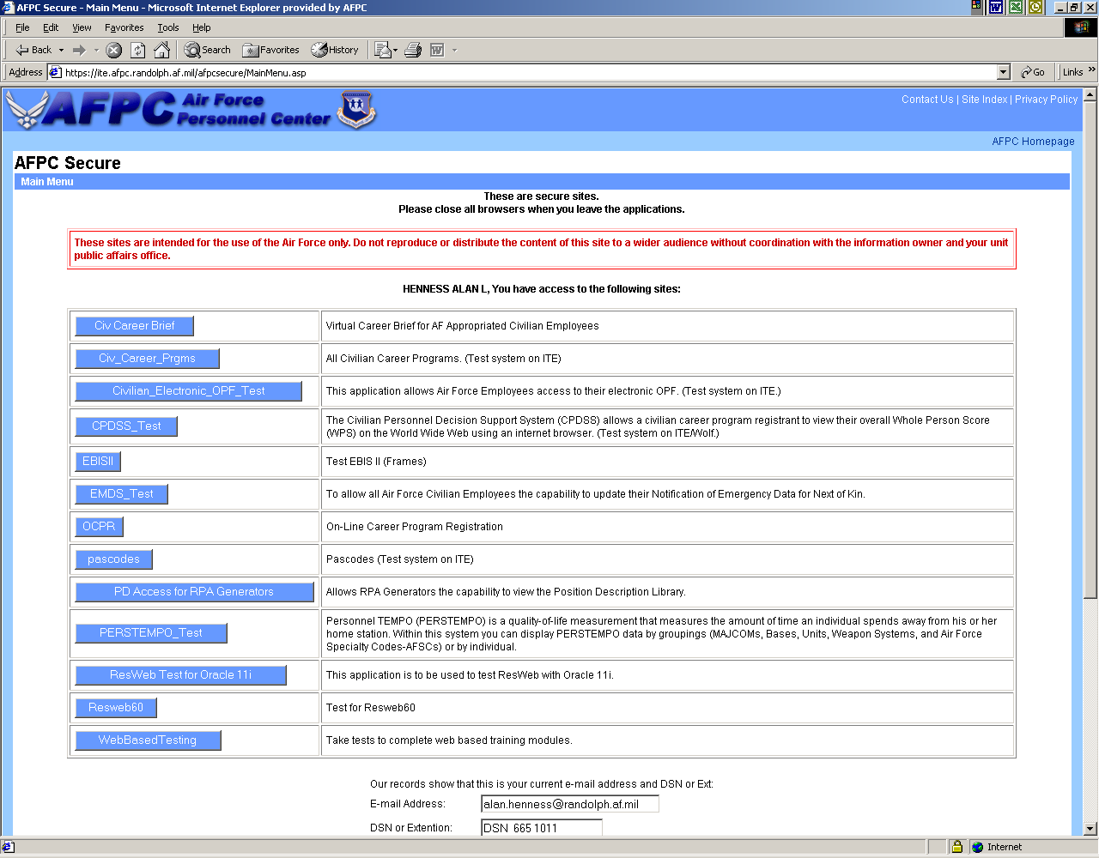

The Quick Reference page is the initial window for the PARIS PD library. To start your search for the position description of your choice, click the ‘Advanced’ link shown below. This will take you to a profile screen where you can input the select criteria for the position description.

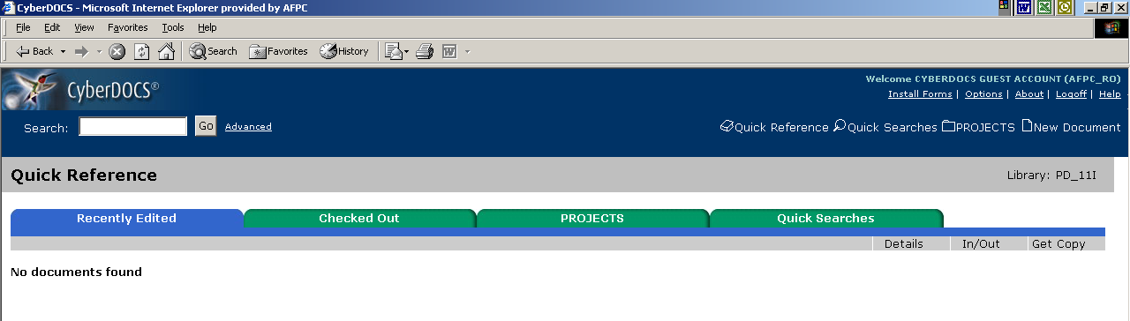

At the search profile screen, you are provided various options to select the position description of your choice. The information you provide on the search profile screen must match exactly the same information which is already profiled against the document you are trying to obtain. You do not want to be too specific in your search and, on the same token; you do not want to be too vague.

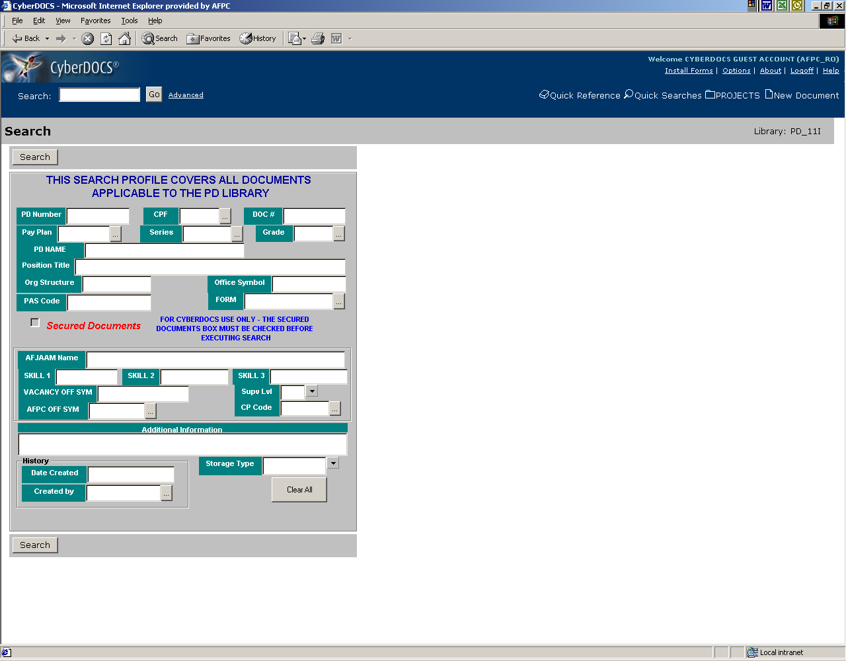
The most common search items to input are CPF, Pay Plan, Series and Grade. By each of these categories, you will see an ellipsis button (…) which is a link to a lookup table containing the applicable codes for that category. To insure accuracy of the data being input to the profile, it is best to use the values from the lookup table rather than keying in the profile information manually to avoid misspellings, etc.

CPF: The 2-digit code of the CPF (Civilian Personnel Flight) where the position is located. To access the CPF lookup, click the ellipsis button (…) for CPF.

The CPF lookup table provides a number of options to display the CPF data items. The data on this table defaults to a sort on the ‘CPF Code’ column heading. However, you can click any column heading on all lookup tables to change the sort based on that column heading. Once you are satisfied with the sort, you can use the scroll bar to find the applicable CPF Code and Description for the CPF of choice. Highlight the CPF Code you want and click the ‘Add’ button and click ‘OK’ . This will return you to the search profile page with the selected CPF code value on the profile page.

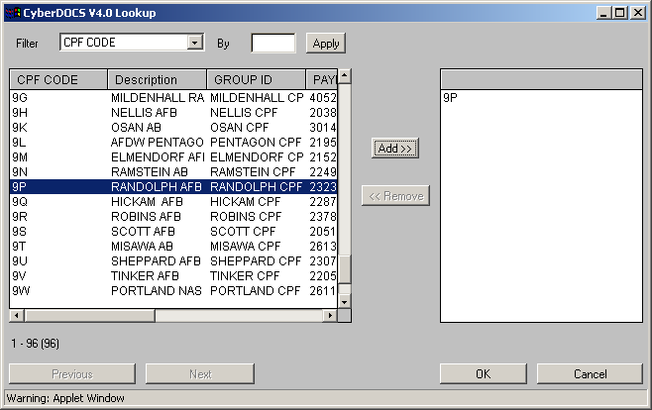

Pay Plan: This will be the pay plan of the position description you are searching for. Click the ellipsis button (…) to bring up the pay plan lookup table.

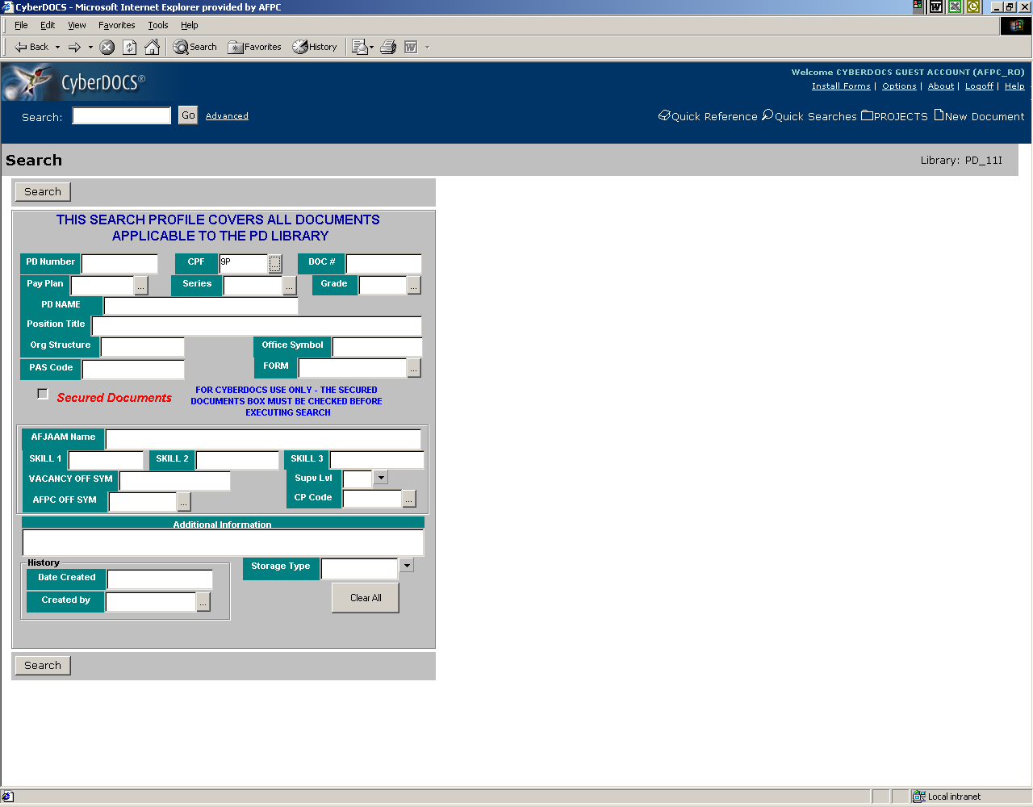

From the pay plan lookup table, scroll until you find the applicable pay plan, click to highlight the pay plan, click ‘Add’ and click ‘OK’ to add it to the search profile.

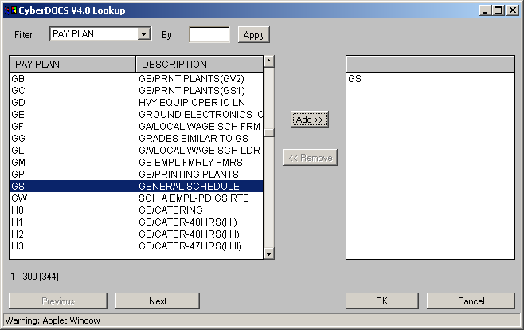
Series: The occupational series for the position description you are searching for. Click the ellipsis button (…) to bring up the occupational series lookup table.

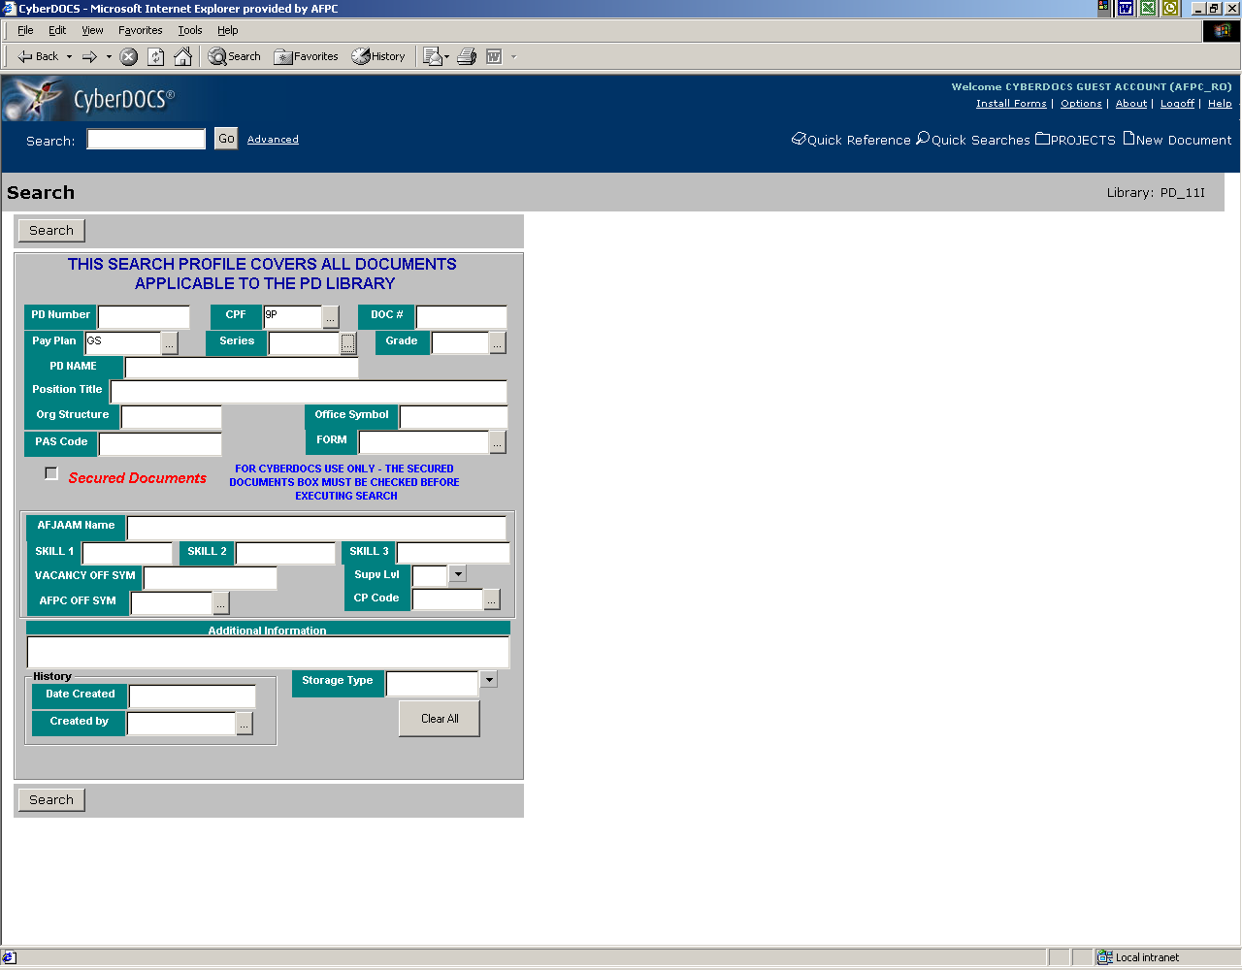

From the occupational series lookup table, scroll until you find the applicable series, click to highlight the series, click ‘Add’ and click ‘OK’ to add it to the search profile.

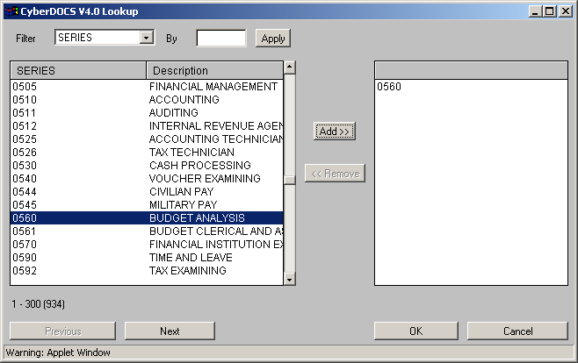

Grade: The grade for the position description you are searching for. Click the ellipsis button (…) to bring up the grade lookup table.

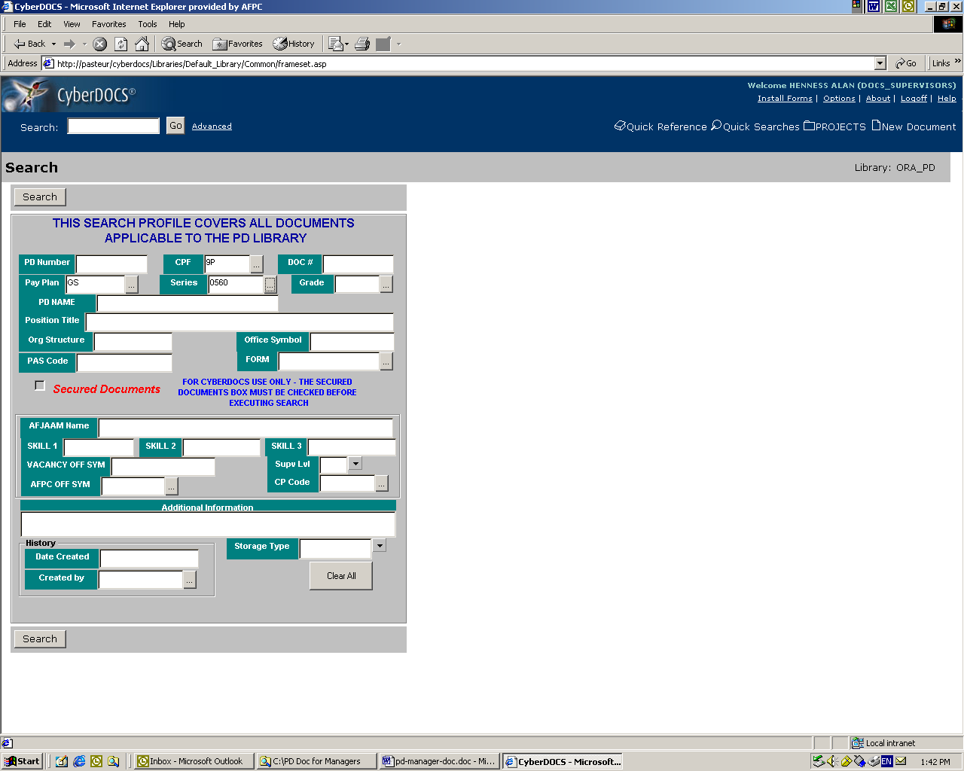

From the grade lookup table, scroll until you find the applicable grade, click to highlight the grade, click ‘Add’ and click ‘OK’ to add it to the search profile.

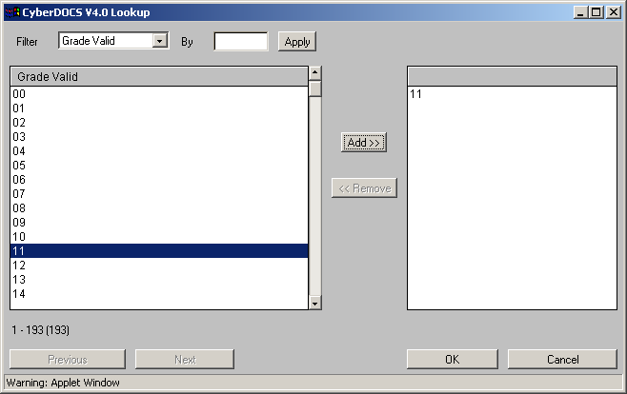

With your search profile containing a CPF code, pay plan, occupational series and grade, your search results should provide you with a number of position descriptions from which to choose the PD you are searching for.

When you are satisfied with your search profile information, click either ‘Search’ button to retrieve the position descriptions.

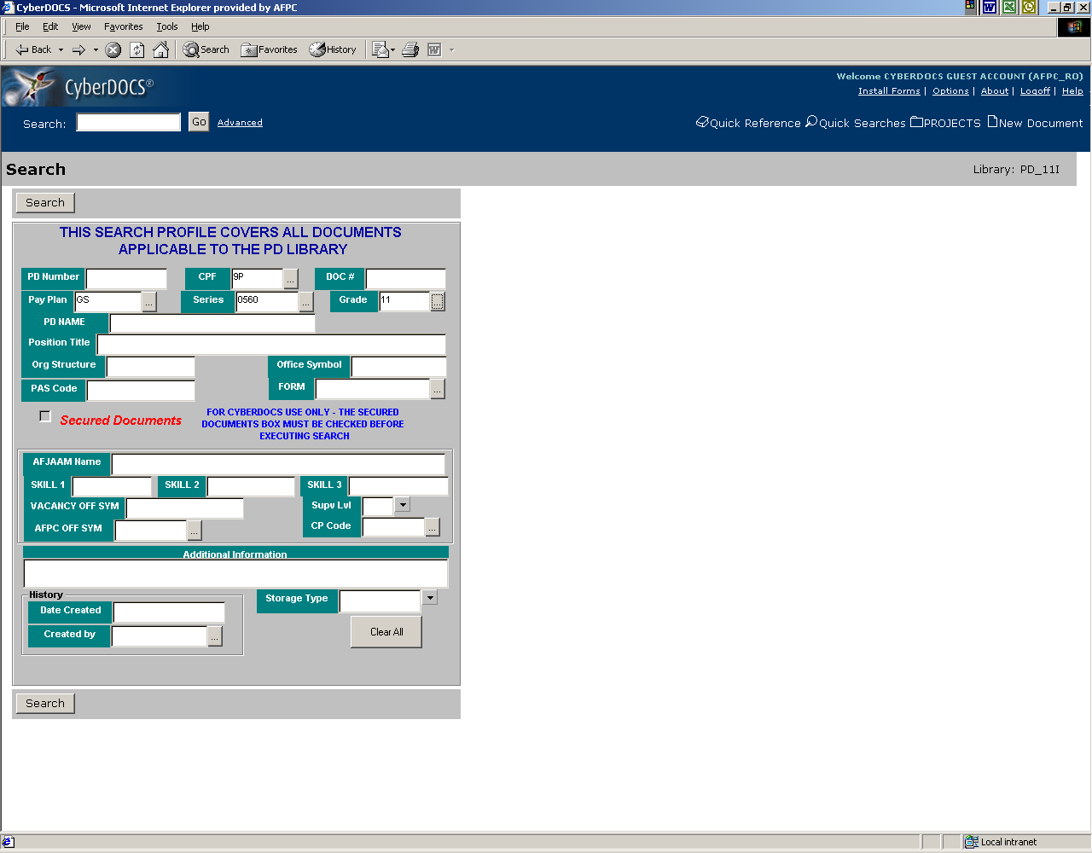

The ‘Search Results’ screen will display a list of PD documents and information that meet the search criteria defined by the user on the screen profile screen. In the event your select does not identify the position description you are looking for, click the ‘Modify Search’ button at the bottom and you will be returned to the search profile screen to search again.

The ‘Search Results’ screen will reflect a maximum of 200 position descriptions. The sort of the position descriptions displayed on this page will default to the ‘Doc #’ column heading. Again, you can change the sort of the displayed data by clicking any column heading.

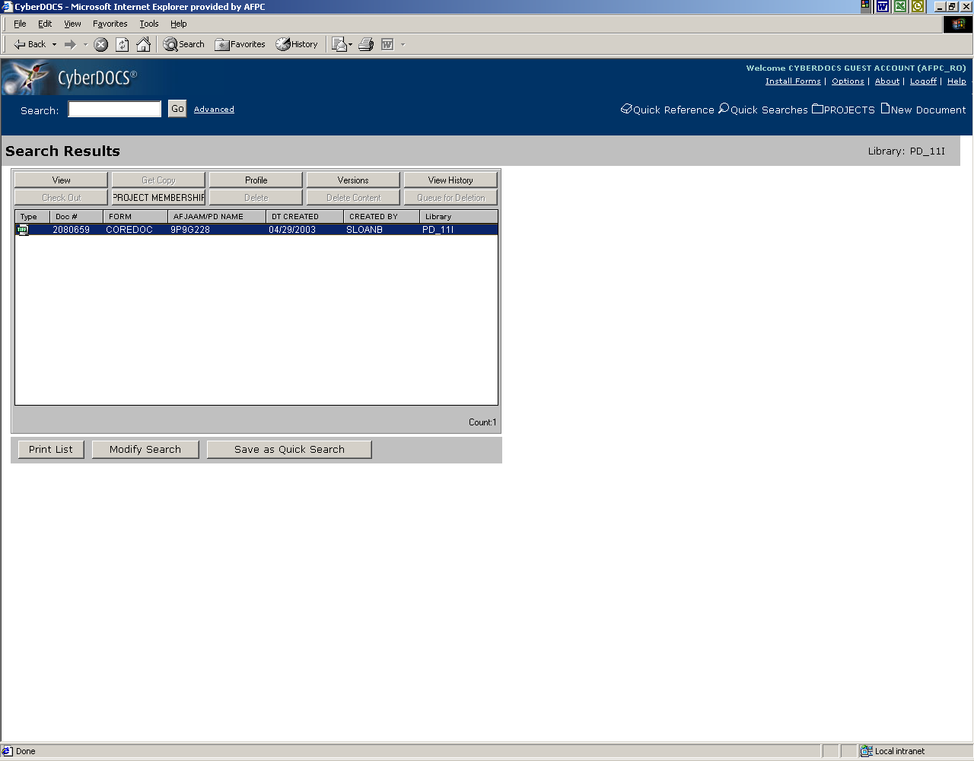

Also displayed on the ‘Search Results’ screen are a number of buttons for information purposes only and are explained on the following pages.

Profile: Accesses the ‘Document Details’ page for the document highlighted. This will display the information profiled for the position description.

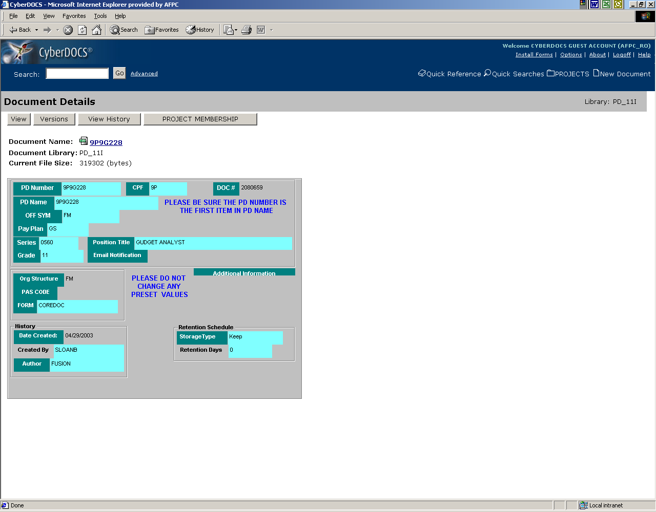

Versions: Accesses the ‘Document Versions’ page for the select document.

View History: Accesses the ‘Document History’ page to display those users who have accessed the selected document.

Modify Search: Will allow the user to return to the ‘Search’ page

View: Will allow the user to view the contents of the selected document.

Print List: Allows the user to print the entire hit list by opening the full list in a new browser window. The user then has to use the browser ‘Print’ function to print the list (do not close the browser window until the list has completely finished printing).

Save as Quick Search and Project Membership: These buttons will not apply to users outside of the Civilian Personnel Flight (CPF) venue.

To view the position description of your choice, highlight the document and click ‘View’.

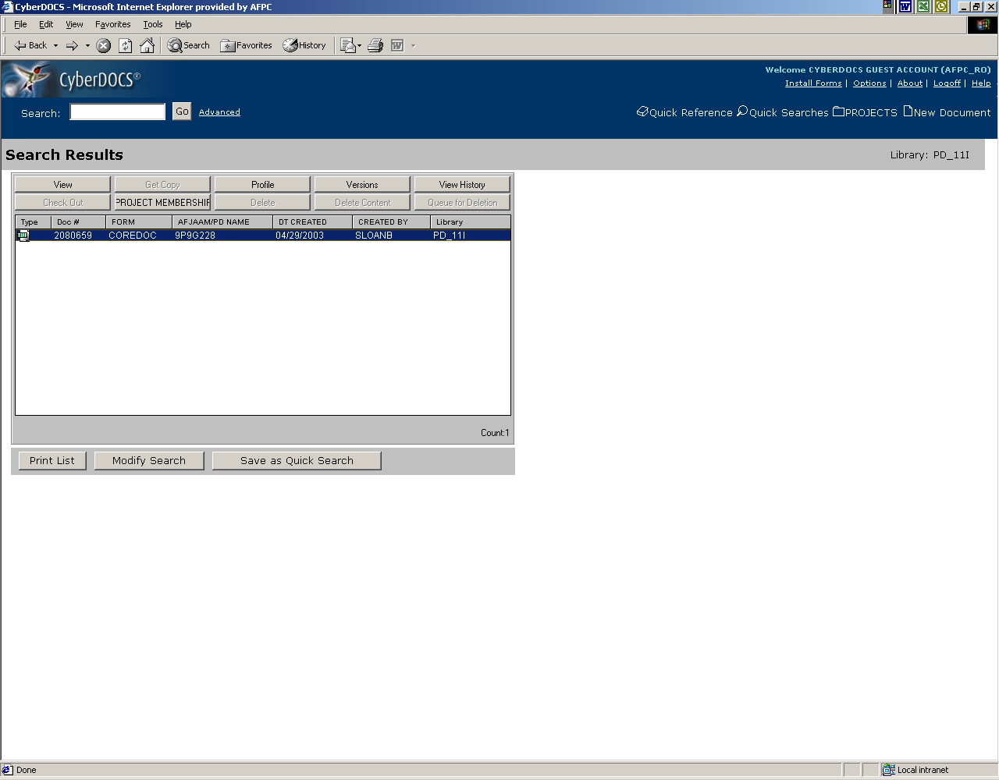

The next screen that should appear will be a ‘File Download’ screen. This will afford you the opportunity to either open the document and view it or save the document to disk. To view the document, check ‘Open this file from its current location’ and click ‘OK’.

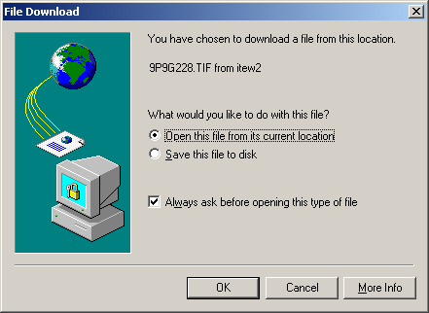
All position description documents are scanned files and should open with whatever imaging application your PC has associated to open *tif file extensions.

When you are finished viewing this document, click the ‘Back’ button of your browser to return to the ‘Search Results’ page.

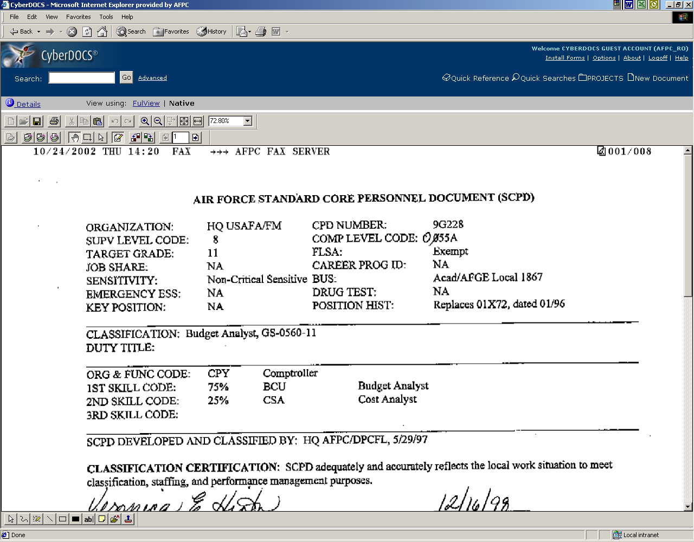

If you want to save the document to disk, check ‘Save this file to disk’ and click ‘OK’.

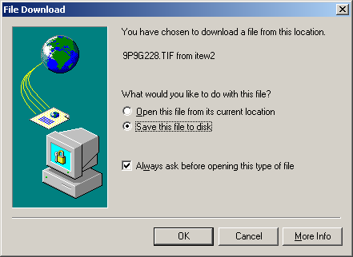

You will then receive a ‘Save As’ screen which will afford you the opportunity to save the position description to a location of your choosing.



