OBTAINING A FACILITATOR
Trained facilitators will be available for DON meetings. Their services (consistent with applicable collective bargaining obligations) can be obtained through the ADR Website or an HRSC ADR Coordinator.
HRSC ADR Locations
HRSC East Portsmouth, VA 23709 Phone: (757) 396-7856

HRSC Europe Phone: 011-44-208-385-5272

HRSC Northeast Philadelphia, PA Phone: 215-408-5215

HRSC Northwest Silverdale, WA 360-315-8090

HRSC Pacific Waipahu, HI Phone: 808-671-1643 ext 202

HRSC Southeast Gulfport, MS Phone: 228-871-2400

HRSC Southwest San Diego, CA Phone: 619-615-5560

DON ALTERNATIVE DISPUTE RESOLUTION (adr) PROGRAM
The Facilitation Program is one part of the DON's Workplace ADR program. The DON actively engages in finding methods to ensure an efficient effective workforce. This includes mediation on grievances, EEO and workplace issues. Facilitation is another method to meet this goal. Facilitated meetings can improve ways of completing our mission.

DON Facilitation PROGRAM
The DON facilitators will provide facilitation services in large and small meetings covering a wide range of topics involving Navy civilian employees. This program attracts a diverse group of participants from all areas of Navy and Marine Corps life. DON trained facilitator's experience include public speaking, active listening, managing meetings, dealing with conflict, and the ability to act in a neutral, ethical, and impartial manner.

hOW TO become a facilitator
Applicants must be current DON civilian employees, and have their supervisor’s permission to apply and participate. Application forms, instructions, and detailed information are available on the DON ADR Website, www.adr.navy.mil. and through the HRSC ADR Coordinators. . Alternative Dispute Resolution experience is beneficial but not required. Department of the Navy Certified Mediators are encouraged to apply. Check www.adr.navy.mil to see when the facilitation program is accepting applications for candidates.

TRAINING
Training in the DON model of facilitation will be arranged by most Human Resource Service Centers on a periodic basis. Upon successful completion of the training, facilitators will receive a certificate and become a member of a cadre of DON facilitators. The DON ADR Program will provide this no cost training. The applicant’s activity will fund travel, if necessary.

Why FACILITATion
Supporting the mission of the DON requires personnel to work together as part of an effective, high performance organization. Facilitation is a collaborative process used to help a group of individuals with divergent views reach a goal or complete a task to the mutual satisfaction of all. A facilitator keeps the meeting on track, makes sure people get a chance to speak, and in an orderly manner enforces any established ground rules, and stimulates discussion by asking questions. They are neutrals that focus on process, and do not make substantive contributions to the meeting. In rare instances where contentious matters may arise, before they escalate the facilitators will help meeting participants address these issues.

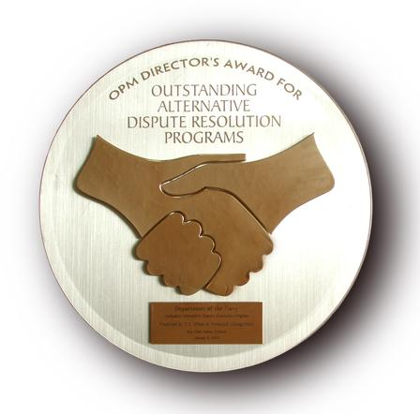
Recipient of the 2002 OPM Director's Award for Outstanding ADR Program

The DON Workplace ADR Program provides certified mediators for DON grievances, EEO and workplace mediations. See our web site for more information.
www.adr.navy.mil

Sponsored by

The DON ADR Program
720 Kennon St SE, Rom 214 Washington navy yard DC 20374 adr@mail.navy.mil and Office of Civilian Human Resources 614 Sicard Street SE, Suite 100 Washington Navy Yard, DC 20374-5072 Phone 202-685-6494 Fax 202-685-6646
Department
of the Navy
Facilitation Program

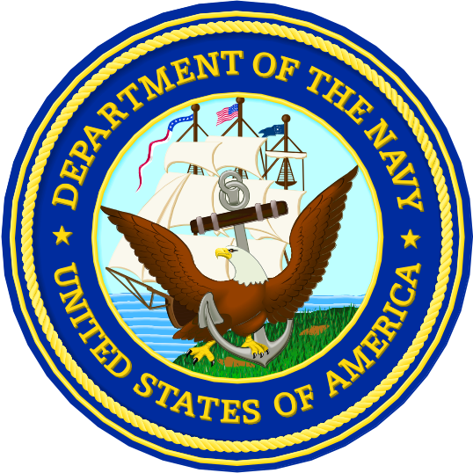
Solutions for High Performance Meetings

