


E-Government Enterprise Architecture

A Study of Web services and ebXML

Anthony Arana
Choong-Mok Kwak
Mohandas Mavilavalappil
Andrius Miksenas

Sridhar Varri
Douglas White

Faculty Advisor: Prof. Sanjay Gosain
Robert H. Smith School of Business
University of Maryland, College Park

December 2002

Table of Contents

Executive Summary 3
Background 5
Methodology 6
An Introduction to Web services 6
An Introduction of ebXML 10
Evolution and Maturity of Web services 12
Evolution and Maturity of ebXML 16
Web services Advantages and Limitations 18
ebXML Advantages and Limitations 20
Web services Adoption 22
ebXML Adoption 26
Cost and benefits Analysis 27
Case studies on other Government e-service initiatives: UK 30
Case studies on other Government e-service initiatives: Australia 35
Conclusion and Recommendations 46
Appendix I – List of Interviewees 51
Appendix II – Additional Resources 52

Executive Summary

Automating the flow of information between various entities in an enterprise has always been difficult and expensive. Better and cheaper interaction among entities can result in immediate cost savings and create potential for innovative collaboration in the long run resulting in superior value creation. Recent developments in the world of distributed computing have made possible the successful integration of diverse applications working in different environments. XML has been the single most important factor facilitating this quantum jump in technology.
The current climate for application integration offers two viable platforms that deserve close scrutiny: Web services and ebXML. There exist significant differences between the two frameworks; and there exist complementarities as well. A policy of prudent governance should take advantage of the immediate efficiencies offered by application integration and interoperability, while ensuring scalability, ubiquity of technology platform and an appropriate level of transaction security. Considering the continuing evolution of the two frameworks, it would be appropriate to adopt a sequential approach in implementing a solution.
This study carried out an objective analysis of the two frameworks and reviewed the potential
for creating the optimal enterprise architecture for GSA’s office of e-Government. The study involved a detailed review of current literature on the subject of enterprise architecture with a particular focus on Web services and ebXML; and also interviews with experts in the government and private sectors, and academic experts. The study investigates the potential enterprise architecture for government by examining the concepts behind Web services and ebXML, and the evolution and maturity of the two frameworks. The study also analyzed the benefits and limitations of each of the frameworks and profiled some of the early adopters. This report also includes a cost-benefit frame for achieving application integration and interoperability, case studies of current e-Gov initiatives in other countries and considers the challenges of interoperability across the federal, state and local spectrum of e-Gov activities.
The final section of this report lists our recommendations regarding the suitability of Web services and ebXML for e-Gov transactions. As part of our core recommendations, we counsel the government to qualify and prioritize processes that derive maximum benefit from application integration and interoperability; to tap the synergies of Web services and ebXML; to work with ebXML, WS-I, and other standards bodies towards inclusion of use cases for government transactions; and to prepare groundwork for Web service implementation. We submit these recommendations to be used as a tool in the government’s approach to achieving application interoperability to realize a more effective delivery of services.

I. BACKGROUND

The Office of Electronic Government facilitates the implementation of government-wide E-government policy. Towards fulfilling this mission, it promotes and nurtures government-wide eGOV projects. The specific roles played by the office are 1) identifying and conceptualizing eGOV opportunities, 2) encouraging the involvement and participation of the various federal agencies and 3) developing strategies for funding these projects. As such, the Office of Electronic Government plays a crucial role in encouraging and coordinating emerging eGOV projects across the federal agencies.
Creating a single federal architecture -a blueprint that defines common business practices and technologies to make government work more efficiently- is among the top management goals of the Bush administration. As governments are beginning to manage IT and web-enabled systems at the enterprise level, the U.S. government is studying the two emerging business architectures, namely ebXML and Web services in the arena of enterprise architecture. There is a need felt to better understand these architectures in order to fulfill the government’s role as a leader in electronic commerce.
Specific questions raised in this context were the following:
- What is the difference between ebXML and Web services?
- Which business architecture is better suited to government transactions?
- What is the projected maturity schedule for each of these architectures?
- What products are available today or in the near future that will allow the government to use ebXML and/or Web services?
- Our consulting team was asked to assist in finding answers to the above questions.

II. METHODOLOGY
Our approach has been to provide in-depth research and supporting materials that will help us uncover answers to the questions raised. We focused our efforts primarily on researching issues such as the stage of development of the various architectures, as well as their functionality and limitations within the context of electronic government services. Specifically our methodology included the following:
- Conduct Literature Review- Review of the existing literature on ebXML, Web services and other such frameworks currently available for the purpose of assessing the maturity level of the technologies and the time when they will come into full play.
- Interview Experts- Interview a wide range of experts in the industry that include vendors, analysts and people at the government who spearhead the eGOV initiatives. We also used the expertise of our faculty advisor Mr. Sanjay Gosain who is a leading expert in this area and is involved in ongoing research effort with the Rosetta Net consortium that is building electronic commerce standards for the IT industry.
- Benchmark- Besides exploring the current corporate usage of ebXML and Web services, an assessment of the e-government experiences of administrations of countries such as UK, Singapore and Australia was carried out.

III. An Introduction to Web services

Web services, in general, are a distributed computing architecture and are considered to be one of the most significant advances in the area of computer architecture in the past 30 years. The purpose of any distributed computing architecture such as CORBA, EDI, etc, is to enable programs in one environment to communicate and share data/content with programs in another environment. Web services, however, feature a new way to perform program-to-program communications that allow applications to communicate with each other regardless of which application language is used, and regardless of what platform and operating environment is used.
A formal definition of Web services is as follows: Web services are a new class of cross-platform program-to-program communications that enable loosely coupled applications to easily find each other, to easily and dynamically establish parameters that enable similar or disparate programs to work together cooperatively, and enable them to communicate in an automated, unattended fashion over the Internet.

Basic Web services architecture
Format | XML | A common format for presenting data and information. This data can be easily manipulated to meet the presentation needs of the requestor application
Services | UDDI  (Publish) | WSDL  (Find) | SOAP  (Bind)
 | A directory service that lists applications that can provide services | A protocol that enables applications to find a service and to agree on how data and services are to be shared and rendered | A protocol that enables applications to agree on how data and services are to be communicated
Network | The Internet
 | The Internet, using TCP/IP and other communications/networking protocols, serves as the common network for web-enabled applications.
Web services, like any other program-to-program communication architecture, pass content between applications using a common format known as XML; Web services use a registry (UDDI), a template (WSDL), and a programmatic interface (SOAP) to enable applications to find and interact with each other; and they use a common network (the Internet) to transport information and data between cooperating applications. These Web services components are further explained below.
XML: extensible Markup Language, XML, is a standard way of representing and exchanging data. Most information is shared on the Internet today using a language called HTML. XML tells cooperating application programs what the data is (a name, address etc.) and thus enables developers to control, display, share and manipulate data (rather than presenting data graphics and static information as in HTML). XML schemas need to be developed to present and share that data in a useful form between cooperating programs. There are currently about 900 XML schemas developed by various consortia such as Rosetta Net and OASIS. Most Web service-related specifications use XML for data representation, as well as XML schemas to describe data types.
UDDI: Universal Description, Discovery, and Integration is a registry standard, i.e. a place where an application program can register characteristics about itself so that it can be located by companies that need the specific application. For example, Company A might expose an invoicing Web service that the company’s suppliers use to send electronic invoices. Similarly, a Vendor V might expose a Web service for placing orders electronically. UDDI, an industry effort started by Ariba, IBM, Microsoft, and 33 other companies, currently has over 200 community members.
WSDL: The Web services Description Language is an XML-based language to define Web services and how to access them. Thus, once a source application makes a request to UDDI for a particular kind of application service, WSDL helps find the service. Once the source and the secondary applications know about each other, they need to agree on how they will communicate and exchange data. WSDL protocols help establish those parameters. Thus, in essence, WSDL protocols locate Web services applications and determine if those applications can work with the source application.
SOAP: The Simple Object Access Protocol is a simple XML based protocol that lets applications exchange information. Thus, once the source application finds the application it is looking for and the parameters of how they want to communicate have been established, SOAP helps to cement the relationship between the two applications and helps them communicate to each other so that the service is rendered.
To put it all together, the following sums up the basic Web services architecture.

Service Broker

Publish Find
(UDDI) (WSDL)
Service Service

Provider Requester
Bind (SOAP)
The Service Broker provides lists and information about Web services applications (in UDDI). The Service Requester is the one who requests a Web services application (hence, the source application) and Service Provider is the Web services application. Web services are applications that make use of registry and communications standards to work together in a dynamic manner where one application provides transactional, messaging, or computational services for another. These applications make use of an agreed-to format (XML or some other variant of XML) for presenting information and data; and they use Web services standards for finding service applications (UDDI), negotiating how to communicate information (WSDL), binding communication sessions (SOAP), and then transferring that information over the Internet (HTTP).

IV. Introduction to ebXML
Business entities communicate with each other utilizing various methods. Often the communication is performed by sending information by mail or phone. Carrying out these communications online reduces the redundancy and simplifies the process by saving considerable time and also physical and labor resources. The methodology to perform business online in such a way has been realized previously by many large companies in the industry through Electronic Data Interchange (EDI).
However, there were several problems to expand the EDI initiative. Due to the fact that EDI was developed initially for the big companies, it required vast initial investment and complicated skills that were unfeasible for small and medium size companies. To offset such shortcomings of EDI, the utilization of XML has risen as an alternative factor. XML is not just easier to use, but also has many functions rather than simply exchanging data between business partners. It is designed as a platform-neutral language so that anyone can easily create applications from anywhere. Nevertheless, XML does not address all shortcomings of EDI and identification of this gap brought about the early discussions that evolved into the ebXML initiative.
ebXML is an XML-based open framework for e-business transactions. ebXML not only defines architecture, but also views business with a new idea. It is a set of specifications to reach specific business objectives and covers Business Processes, documentation of a company's capabilities and transfer of documents among new and existing trading partners. These specifications of ebXML are briefly explained below:
Message Services:
Messages are sent using standard formats and protocols. ebXML enables the exchange of business documents among trading partners using SOAP (Simple Object Access Protocol) with Attachment, enabled by MIME (Multipurpose Internet Mail Extensions) protocol. MIME is a packaging protocol that offers a way to carry different kinds of digitized file formats. It not offers to transport not only multiple formats, but also encrypted content. The MSH (Message Service Header) controls the messages using SOAP with Attachments specification so that information about the message is included in a SOAP message, and the documents are contained in payload attachments.
Business Process & Core Components:
The Business Process standardizes diverse business transactions. Companies document their business processes and business document structures using the BPSS (Business Process Specifications Schema). Hence, the methodology of performing business utilizing a specific vocabulary in BPSS is definable. Core components standardize items of exchanging messages. Based on the core components, predefined documents such as form of purchase orders, administrative information or the goods themselves are created.
Registry/Repository:
The registry and the repository can be thought of as a database. ebXML registries contain important information on potential trading partners. They store information about items that actually reside in a repository. Items in the repository are created, updated, or deleted through requests made to the registry. Registries and repositories help companies find the information and structures they need rather than reinvent them.
Trading Partner Profiles:
Companies document capabilities by utilizing a CPP (Collaboration Protocol Profile) and make business agreements with partners using CPA (Collaboration Protocol Agreement). CPP is an outline of the capabilities of the trading partner in an XML document. Registries include information on potential trading partners in the form of a CPP. CPA matches the business processes and allows an agreement on the processes and messages. Once the companies have agreed upon the CPA, the partners are on the same page thus eliminating confusion with respect to transactions.

V. Evolution of Web services
Web services has its roots in component architecture of the 1980s. Components were originally developed in the context of Graphical User Interfaces (GUIs) and allowed the re-use of existing application code. Within this architecture, code is compiled into several independent units instead of into a single entity. As use evolved, component architecture grew from managing communication between components on the same computer to communicating with component infrastructures on other computers across a network. These newer, distributed component architectures drove the rapid development of more complex, distributed applications. This trend eventually led to the specification of CORBA (Common Object Request Broker Architecture) in 1991 and Microsoft DCOM component architecture, as well as Sun J2EE distributed architecture. Distributed component architectures have one serious limitation: generally they can only be used across a tightly managed network, such as a corporate intranet. They don’t play well in an open, fragile environment, such as the public Internet. Web services evolved to fill this void, using the Internet’s protocols to provide a component infrastructure for the development of distributed components that function on this open network. In the early1990s, HP Labs began to investigate reducing the technical and cost problems of distributed systems. The resulting design principles which led to HP's e-Speak, which emerged as probably the first Web services technology, and certainly the first commercially marketed Web services technology. The concept of using HTTP and XML technologies to develop open and license-free implementations drove results with some high levels of interoperability and low cost. At the same time, the EDI community viewed XML and Internet protocols as a vehicle for potential savings by moving their data exchanges away from the costly set up and transaction fees of Value-Added Networks (VANs). Groups such as CEN/ISSS were formed in Europe and XML/EDI in the U.S. which began working on ways to encode EDI transactions. These trends led to early forms of Web services for business-to-business transactions. These XML/EDI systems were also designed to take advantage of the established EDI mechanisms for orchestration, prioritization, security and other issues that Web services did not adequately address at the time. The effort to turn this into a formal standard became e-business XML (ebXML). ebXML is a joint project of OASIS and the United Nations Centre for Trade Facilitation and Electronic Business (UN/CEFACT). OASIS is a not-for-profit, global consortium that produces worldwide standards for security, Web services, XML conformance, business transactions, and interoperability within and between marketplaces. UN/CEFACT is a non-profit group that focuses on the worldwide facilitation of international transactions, through the simplification and harmonization of procedures and information flows. In February 2002, IBM, Microsoft, Intel and other firms formed the Web services Interoperability Organization, WS-I, a non-profit organization whose goal is to promote Web services standards. WS-I was created not only to investigate and qualify standards, but also to validate the standards from W3C and OASIS. The idea behind WS-1 was not to create new standards, but rather to assemble “profiles” of standards against which conformance tests and certifications can be established.

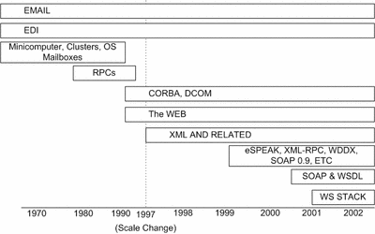
source: “The Past, Present and Future of Web services, Part 1” Uche Ogbuji,

Maturity of Web services
SOAP and WSDL are already mature with several successful applications already in use. There is another group of specs to provide more complex functionalities still evolving in
WS-Security, WS-Coordination. Public UDDI is still evolving, but it can be said that the roadmap and directions for the future of Web services already exist
. Currently, vendors are focused on selling their component tools and component frameworks that are central to building services. It is expected that vendors will want to sell their software products as Web services if a viable market develops. Potential revenue models will be studied closely by vendors in evaluating the question of whether or not to enter the market with their software products. In 2002, the majority of potential customers still view Web services with cautious curiosity. While recognizing the potential for gaining efficiencies in automating certain application functions, buyers remain somewhat wary of investment in a new, unproven technology, given the current economic situation. Indeed, those companies adopting Web services in 2002 are largely employing only those services where the impact on the bottom line is immediate and obvious. Mainstream acceptance will be attained only after the appearance of a Web Service poster child; a tested model for how to use Web services, including a pricing model as well as tools to facilitate the process. Smaller, independent software vendors are expected to lead the way in adopting Web services and we can observe today that a number of small vendors package parts of their application functionality in B2B Web services.
This trend is expected to continue through 2003, concurrent with a proliferation of private registries to support an increasing number of private, web-based exchanges. Increased government usage of the Internet for delivery of services will continue to grow and this will serve to drive the need for more Web services, especially in the G2C sector.
In the private sector, Web services will be most likely used through 2004 for integration between trusted partners and for integrating applications within an enterprise. While a recent PwC study cited that the greatest technical challenge facing most large organizations in the use of IT is application integration, it also concluded that “the realization of Web services vision will be unlikely during the three-year forecast period…because the concept assumes that companies will be willing to do business with new and unfamiliar trading partners.”
Gartner predicts that by the end of 2005, new licenses for software that use Web services will represent a $21 billion market. However, the key to Web services gaining broad acceptance will center on standards. Few vendors in 2002 agree on standards, but generally vendors concur that standards are an important governance issue and that the question of standards has to be reckoned with once the domain of Web services reaches a critical mass. Web services are very suitable for ad hoc application integration solutions, as well as more complex, automated solutions that incorporate some level of interoperability. However, as the population of users increases, new and additional scenarios develop which require laws, or standards to address the changing nature of the domain. In 2002, few laws are required as so many Web services are focused within a company’s firewall. As the domain and scope of Web services users expand outside the firewall to the set of all transaction partners and then beyond, to the global community of the Internet, it becomes more difficult to create rules on an ongoing basis. In this scenario, there is a clear requirement for standards.

VI. Evolution of ebXML
ebXML was commissioned in September 1999 and all specs were released in May, 2001.
As indicated above, the roots of this initiative go back to the EDI movement. EDI (Electronic Data Exchange) has its roots in the 1970s and represents the first generation B2B collaboration; a loosely-coupled, document-centered collaboration between business units and between business trading partners. EDI was not widely adopted in the business community as a whole due to the high investment required. EDI has a strong user base among large companies, such as automobile manufacturers and computer hardware manufacturers, yet globally just 2% of businesses use EDIs today. ebXML is designed with a larger user base in mind: it can help up to 25 million businesses worldwide to automate their inter-enterprise collaboration. Given its broad target, the success of ebXML will depend on the adoption of ebXML by a large number of companies from all points of the size spectrum. Inherent in that dependency is the notion that the ebXML initiative must be able to successfully communicate the value of ebXML to small business.
ebXML is currently in the innovator adoption phase. As of late 2002, interest in ebXML is limited mainly to the messaging component. Many of the products currently available implement the ebXML Message Service specification. Large vendors such as IBM, Microsoft, and Oracle are not zealous proponents of ebXML and that is to be expected; industry players tend to wait and see and jump on board once the platform has been established. These vendors have generally been required by the market to provide support for RosettaNet, and this requirement can be seen as an indicator that vendors will be willing to support ebXML once the demand is deemed sufficient. This can mean that procurement requirements will influence vendors when ebXML support is included in RFPs as a requirement for submission of bid or for final vendor selection. Moreover, in the current economic climate, software vendors, especially the giants, will push products to market strictly on a demand-driven basis. They are far less willing to experiment with new, unproven products in the current economy. Industry groups and possibly user groups will influence the speed at which vendors pursue open-source applications. The economic climate and the dot-com meltdown has also forced the industry to refocus on building tools and infrastructure that create value for businesses and further enable e-business activity.
ebXML messaging has generated some interest with the applications based on ebXML standards. Discovery and automated trading partner agreements have not been met with great enthusiasm, largely because businesses are generally reluctant to collaborate with unknown trading partners. The vendors may not be interested in providing applications that are less expensive and therefore undermine current revenue models. Current user groups lack the focus and the power to demand compliance of vendors. Widespread, visible support from industry groups will be required to drive adoption of ebXML, as well as government initiatives. The public sector, in pursuing the goals of reducing single-vendor dependencies and the promotion of vertical and horizontal collaboration between agencies, will continue to press for a platform based on vendor-neutral standards.

VII. Web services- Advantages and Limitations
Advantages
- Interoperability. Any Web service can interact with any other Web service. Thanks to SOAP, the new standard protocol supported by all of the major vendors (and most minor vendors), the difficulties of converting between CORBA, DCOM and other protocols should be over.
- Ubiquity. Web services communicate using HTTP and XML. Therefore, any device which supports these technologies can both host and access Web services.
- Components. Web services can break applications down to specialized components. Rather than all functions within a service residing on one server, services act as collections of components spread across the Internet. A common component, like an authentication gateway, can be shared by many applications.
- Industry Support. All of the major vendors are supporting SOAP and the surrounding Web services technology. For example, the Microsoft .NET platform is based on Web services, thereby making it very easy for components written in Visual Basic to be deployed as Web services, and consumed by Web services written using IBM VisualAge, and vice-versa.
- Direction. The foundation for Web services application design and deployment is already in place and a clear road map exists.

Limitations
Although hundreds of Web services applications have been written and UDDI, WSDL and SOAP do work as advertised, numerous improvements need to be made to UDDI registry service and related Web services protocols to make them more robust for use in message-rich, transaction-heavy, enterprise-class computing environments. Bloor-Research North America has identified mainly six shortcomings with Web services as they stand today.
- Security/Privacy. Authentication and validation of content needs to be ensured and authorization rights need to be restricted to prevent unauthorized use of the content.
- Routing/messaging, Reliability. Protocols need to be developed to track messages through multiple intermediaries. Standards must be established to ensure messaging reliability.
- Transaction handling. All prior distributed computing architectures provided ways to monitor and track transactions. Web services do not have any such transaction monitors in place, and since W3C is not in the process of developing such a standard, the task is that of the vendors.
- Manageability. An overall plan for managing Web services environments (from a system, network, and application level) does not exist.
- Interoperability. Though the formation of WS-I goes a long way toward addressing how interoperability will be achieved across multiple disparate platforms and differing application program language environments, the newness of WS-I plus its initial political positioning (leaving Sun off) make the group’s initiatives somewhat suspect.
- Performance/tuning. There is a distinct lack of performance tuning information and/or tools for optimizing Web services computing environments. Although the W3C does internal quality assurance, enough is not yet being done to assure that Web services applications can be optimized to compete from a performance perspective with tightly coupled distributed computing architectures.
Though faced with limitations at present, the W3C, the vendor community, open-source software providers and consortia are taking many initiatives to address these shortcomings.

VIII. ebXML Advantages and Limitations

Advantages
- Business Processes. Enterprise integration requires standard business processes. ebXML defines business processes for the business or organization. The business process models define how business processes are described. The specification for business process definition enables an organization to express its business processes so that they are understandable by other organizations. This enables the integration of business processes within a company, or between companies.
- Registry/Repository. The Registry and Repository of ebXML have robust and comprehensive functionality. They allow for dynamic build of schemas. ebXML registry provides space for a business or organization to store its components and authenticate trading partners. ebXML provides ways to define and register trading partners and their capabilities in concise profiles that are maintained in registries. This permits users or systems to discover registered capabilities, and facilitates the process of completing agreements among trading partners.
- Security. Government has stringent security requirements. Messaging specs of ebXML are far superior to those of SOAP for secure documents The ebXML Messaging Service specification defines the set of services and protocols that enables electronic business applications to exchange data. The specification allows any application-level protocol to be used. These can include multiple protocols such as SMTP, HTTP, and FTP. Well-established cryptographic techniques can be used to implement well-built security. For instance, secure protocols such as HTTPS can be used to guarantee secrecy. In addition, digital signatures can be applied to individual messages or a group of related messages to guarantee authenticity.

Limitations
- Payload. The success of payload (Universal Business Language) is critical for ebXML. By utilizing XML, businesses will be able to trade with anyone, any time, without the need for the expensive integration work that has been required in the earlier period. XML can be used to build electronic catalogs, purchase orders, invoices, shipping notices, and other documents needed to perform business. But XML doesn't guarantee that these documents can be understood by any business other than the one that creates them. XML is only the groundwork on which additional standards can be defined to achieve the goal of true interoperability. The Universal Business Language (UBL) initiative is the next phase in achieving this goal. The development of UBL within OASIS also helps ensure a fit with other essential ebXML specifications. ebXML may be adopted only in parts until the payload (UBL) is introduced. The first version of UBL is expected to be released sometime in 2003.
- Slow Pace of Implementation and Use: ebXML is not yet ready and its adoption curve depends on further development of other components. Many in the industry believe that ebXML is not quite ready for prime time. Some components are fully developed and ready for deployment, while others are still under construction. For example, the messaging and transport components are well developed, but the core components need more work before it can be implemented. Many businesses are using portions of the ebXML specification, but not the entire standards package.

IX. Web services adoption
Web services is still very early in the adoption cycle; the chasm to broad penetration across vertical markets will probably be crossed only over the next two years. At the same time, the adoption of Web services is deep in select verticals for some specific applications. It is now clear that the early adopters are larger enterprises in search of more cost-effective demand chain solutions, in verticals such as banking, insurance, travel, and manufacturing. Usually, early adopters are innovative market leaders who want to gain experience with a more loosely coupled architecture that has the promise of quickly delivering measurable cost reductions. These companies are in relatively data intensive industries and they need to integrate multiple partners or customers who are on heterogeneous technology platforms.
- There are four major application areas of Web services:
- Demand Chain Applications
- Supply Chain Applications
- Private Marketplaces
- Applications or Web Service Provider Integrations

Demand/Supply Chain Applications
Companies are using Web services to grow profits by distributing their applications or data to partners and/or customers. Such Web services are used by insurance, travel and financial services verticals. Fidelity is using Web services to eliminate a complex web of protocols and transformations required to give customers an integrated view of their accounts across different products. Galileo travel reservation system, connecting 42000 travel agencies, 511 airlines, 37 car rental companies, 350 tour operators and 47000 hotels, is experimenting with Web services to offer travel services and to integrate with their travel suppliers. Both supply and demand chain applications are used by companies integrate components of their demand/supply chain itself with distributors, resellers and customers. These types of Web services are used by financial services and manufacturing verticals. Smaller suppliers had resisted EDI integration because of the fear of being squeezed by their buyers, but Web services enable them to integrate without being locked into their customers’ systems.

Private Marketplaces/Collaboration Hubs
Companies are using Web services in the area of private marketplaces or collaboration hubs mostly in the insurance and manufacturing sectors. A collaboration hub brings together partners to execute business processes. For example, one insurance service provider has collaboration hub that aggregates all parties involved to execute an insurance claim. Web services are used to bring together the assessor, bank, repair shop or health care provider.

ASP/WSP Integrations
Companies try to reduce costs by transporting select data from or between application service providers (ASP) or web service providers (WSP). This information can be used to trigger events or to trigger other information feeds based on information in a specific field or fields. Putnam Lovell is an investment bank that is using Web services to integrate Salesforce (CRM) and Blue Matrix (research report distribution) with their customers. Putnam keeps customer profiles in Salesforce.com, and transports the data on the ticker symbols of companies the customer wishes to track. Using Web services, this data is delivered to Blue Matrix, which automatically sends the relevant research reports on the companies of interest directly to customer. To customer it appears that everything is done by Putnam.
Dell is one of the first companies to see a dramatic improvement in its supply chain
efficiency as a result of implementing a Web service to automate the flow of information between the firm and its suppliers. In 2000, the company began sending components specifications to its suppliers in a Web services format so that the suppliers' inventory-management systems could read the data automatically. That move helped Dell reduce the inventories of components at its many geographically distributed assembly plants by more than 80 percent. Dell also used Web services to optimize demand management across all of its assembly plants. The firm's suppliers serve many plants, and the company decided that if it could aggregate information across them, it could match production capacity to demand and manage supply shipments accordingly. However, due to the company's rapid growth and geographic expansion, each Dell assembly plant had implemented its own manufacturing applications and database-management systems, with no effort at coordination. Information was thus shared manually. Rather than replace systems to achieve uniformity across plants, Dell used Web services to do the job, vastly improving utilization and cutting logistics costs throughout the production network.
Web services products
Though there are many approaches to obtaining Web services products and services, the products available today can be classified into three categories, in general.
Category1: Most of the early, real-world competition in the Web services space has come from the providers of turnkey application server environments (turnkey systems that include software for application development, application deployment, and extensions that make it possible to easily build and deploy component applications). These Web services platform providers can further be classified into two main groups.
- Vendors that build and sell completely integrated systems software, application development environments, hardware, and services. E.g. IBM (with WebSphere), Sun (with Sun ONE) and HP (with NetAction)
- Vendors that build application development environments that can be sold on multiple different systems platforms. E.g.: Microsoft (.Net) and BEA.
Category2: Building one’s own a la carte, point product Web services applications. Examples include point product tools and utilities and open-source Appache server. Companies like google and amazon, who expose their applications as Web services could also be included in this category.
Category3: Professional services firms that can help build and maintain Web services applications, such as GE GXS, Nextlinx

X. ebXML adoption
In our research, we came up with one substantial practical implementation of ebXML. ERCOT (Electric Reliability Council of Texas) is an independent, not-for-profit organization responsible for overseeing the reliable and safe transmission of electricity over Texas' main electricity power grid.
- 1 of 10 NERC reliability regions
- Single, integrated control area
- 37,000 miles of transmission
- ~70,000 MW of generation capacity
- >57,000 MW peak demand
  - 6.25 million customers (2nd U.S.)
  - 9% of U.S. electricity demand
  - Covers 75% of land area of Texas

  - Implements full deregulation in Texas: January 2002

  - Processes over 15 million transactions per month

The system, developed by Systrends, an energy systems vendor, supports two types of activities: services and actions. The messages exchanged in the system contain largely EDI data, but use the ebXML messaging format as the transport medium.
ERCOT’s system supports upload and download services, each with request and response actions. It also supports a directory service that provides an index of folders. The stringent ebXML reliable messaging functions require persistent storage of messages in case recovery of messages is needed. The stable document identifier enables persistent storage of messages, thus making possible ebXML’s reliable messaging. ERCOT also takes advantage of ebXML’s security features. The ERCOT application includes public key and SSL certificates.
ERCOT uses ebXML “Push-Pull” with Open-PGP Encryption and HTTP with SSL. The system is used both for the transactions between retailers and ERCOT, ERCOT and customers. Currently, the above mentioned standards are used when the customer wants to switch the current electricity provider for another. It is both used for B2B and B2C transactions. ebXML was probably chosen because EDI standards were used before, and ebXML added the ability to exchange the documents safely, instead of using FTP standards.
ebXML products
Below are a few products that have ebXML messaging component:
- ebXML Connector 1.0 - btrade, Inc.
- Cyclone Activator 4.2, Cyclone Interchange 4.2 - Cyclone Commerce
- Sterling Integrator(TM) 1.2.0 - Sterling Commerce Inc.
- Web services Integrator (WSI) 2.5 - Sybase, Inc.

XI. Cost and Benefits of Web services
Total Cost of Ownership (TCO) is a concept by which all costs associated with a capital investment are accounted for. It can also be considered the cost of owning and operating an existing asset over a given period of time. As such, TCO can also be a useful means in determining the best value between several alternatives. There are broadly two different types of assets: Firstly, the development and execution environment, which is a collection of software products required to develop and execute Web services, and secondly the Web Service itself.
A TCO calculation can be applied to both asset types.

The total cost of ownership of Web services includes:
- Capital: Software license and software maintenance cost;
- Operation: Cost incurred during the lifecycle of a software product, such as installation and configuration, administration, and performance management;
- Development: Cost related to the lifecycle of a Web Service, which is developed using the software product suites development tools;
- IT staff training and consulting by vendor: Cost incurred with enabling IT staff to make optimal use of the software product.
Obviously, cost calculations begin with initial license prices and associated maintenance fees. However, this is only a small part of the picture. Any valid calculation must focus on an all-inclusive view, taking into account direct and indirect costs. While direct costs are relatively easy to obtain, it is much harder to determine indirect costs. For example, it is all but easy to track how much time developers spend getting around problems in the development environment. To get a better perspective at TCO, it is helpful to view the problem space from two different angles: the execution oriented view and the development oriented view. This perspective does justice to the very different characteristics of businesses. While some businesses will find a substantial portfolio of ready-for-use Web services, other businesses will have to carry the burden of in-house development.

Several software vendors have already launched software products that support the Web services layer. There are two camps: firstly, vendors that focus on the Web services layer and integrate their products with existing application servers from leading vendors, such as BEA and IBM; secondly, there are the application server vendors, who strive to extend their application infrastructure base by adding the Web services layer.
In the medium and long range, it is expected that full-fledged software infrastructure platforms will emerge, which, of course, include the Web services layer. In this scenario, no additional license cost is incurred for the Web services layer software. Software updates deal with the infrastructure platform as a whole, which means that system administrators need not worry about additional software update cycles. Likewise, software management encompasses the entire platform.

Web services Benefits
Medium and long term business benefits to enterprise:
- Faster time to market with new and improved services
- Expanded service deployment at lower cost
- Vastly improved business agility
- Increased process efficiencies due to business-to-business collaboration
- Reduced human error due to business process automation.
In short term, Enterprise Application Integration (EAI) projects will benefit from "wrapping" existing business services and thus extending their lifecycle. From the technical standpoint, when the Web services mature, the benefits will include:
- Lower integration costs, mainly attributable to a broad base of public standards
- Increased speed of deployment as a software services industry gains momentum
- Less coding requirements at large, owing to the ability to license more services from third party vendors
- Less internal human resources required.
McKinsey’s view on the costs of implementing Web services is as follows: the actual cost depends on the scale of the project. It costs about $30, 000 to create modest connection between 2 applications, but the cost might be as high as $800, 000 for the customized version of the software. The code rooted in a feature of an application makes for rigid connection: if the underlying application is changed, the customized connection must also be changed or even rewritten.
The impact of Web services on systems integration depends on category of systems. The largest impact in savings can be achieved by integrating systems interfacing, with 20% savings currently and up to 50% when Web services mature.
To conclude, we should consider the above discussed costs and benefits while making the decisions on implementing the Web services.
Note: Since ebXML is still under development, we are not able to make specific assessment of the costs involved in implementing it. However, some of the cost components discussed above obviously apply to ebXML as well.

XII. Case studies on other Government e-service initiatives: United Kingdom
Office of e-Envoy: e-Government Interoperability Framework
Better public services tailored to the needs of the citizen and businesses require the seamless flow of information across the government. The e-Government Interoperability Framework (e-GIF) sets out the government’s technical policies and specifications for achieving interoperability and information systems coherence across the public sector. The e-GIF defines the essential pre-requisites for joined-up and web enabled government. It is a fundamental framework policy for the e-Government strategy.
The e-GIF defines the minimum set of technical policies and specifications governing information flows across the government and the public sector. They cover interconnectivity, data integration, information access and content management. Adherence to these specifications and policies is mandatory. As these specifications set the underlying infrastructure, the public sector organizations can concentrate on serving the customer through building value added information and services. It will be for the organizations themselves to consider how the business processes can be changed to be more effective by taking advantage of the opportunities provided by increased interoperability. Gartner estimates the e-GIF targets to bear fruition by 2005.
The key policy decisions that have shaped the e-GIF are:
- Alignment with the Internet: Universal adoption of common specifications used on the Internet and World Wide Web for all public sector information systems.
- Adoption of XML as the primary standard for data integration and presentation.
- Adoption of browser as the key interface.
- Addition of metadata to government information resources.
- The development and adoption of the e-Government Metadata Standard (e-GMS) based on the international Dublin Core model.
- Adherence to e-GIF is mandated throughout the public sector.
The factors underlying the e-GIF specifications are:
- Interoperability: only specifications that are relevant to systems interconnectivity, data integration, information access and content management are specified.
- Market support: The specifications enjoy wide market support and thus reduce the cost and risk of government information systems.
- Scalability: These specifications have the capacity to be scaled to satisfy changed demands made on the system, such as changes in data volumes, number of transactions or number of users.
- Openness: The specifications are documented and available to the public at large.
Scope:
The e-GIF covers the exchange of information between government systems and the interactions between:
- UK Government and Citizens.
- UK Government and businesses. (World wide)
- UK Government organizations.
- UK Government and other Governments (UK/EC, UK/US etc).
The UK Government includes central government departments and their agencies, local government, the devolved administrations as voluntary partners, and the wider public sector. The e-GIF does not standardize the appearance of information on the human interface, which can be provided by various user channels e.g. Internet, public kiosks, Digital TV, etc. The e-GIF does standardize the interchange requirements for the delivery of data to such interfaces and tools for the management of the presentation of such data. The technical policies for interoperability across the public sector cover interconnectivity, data integration, information access and content management.
Implementation:
The OeE (office of e-Envoy) will give priority to schemas that serve the requirements of services or processes that are generic across many public sector organizations. The “Interoperability working group” will promote the development of schemas. Open submission of schemas to the GovTalk website is also welcome. This group will track international XML specifications development through links with standard organizations such as W3C and OASIS.
The OeE in consultation with local and central governments developed the e-Government Metadata Standard that defines the structure and rules governing metadata used by public sector. This standardization ensures the true interoperability of the data. The e-GMS is based on the internationally recognized Dublin Core standard, but has additional elements and refinements to meet the specialist needs of the public sector.
The UK Gov Talk website www.govtalk.gov.uk forms a fundamental part of the e-GIF implementation strategy. It will be used to provide help and guidance for XML schema developers. It is also being used for wide consultation on a number of other e-Government frameworks and documents.
Management Processes:
The Office of e-Envoy in the Cabinet Office (signifies the importance attached to the mission) is the lead authority for implementing and maintaining the e-GIF framework. The office provides central direction where required while much of the action will take place in individual public sector organizations. The Industry, which is an important partner in this endeavor, is expected to comment on the appropriateness of policies and specifications for interoperability and provide innovative solutions. The citizen is encouraged to provide comments, suggestions and innovations to help improve information access and service delivery. The approach involved creation of several working groups to tackle with various parts of the effort. Technology Advisory Group, Interoperability Working Group, Government processes Group, Government Schemas Group, and Metadata Working Group are some such groups.
Technical Policies:
The technical specifications formulated for e-GIF covers the areas of interconnectivity, data integration, content management and information access via multiple channels. The technical policies for systems data integration and transformation are:
- XML and XML schemas for data integration
- UML, RDF and XML for data modeling and description language
- XSL for data transformation
XML products will be written so as to comply with the recommendations of the World Wide Web Consortium (W3C). The attempt is to stick to open standardization within the W3C framework.
The UK initiative is actively considering the specifications being generated by various standards bodies, business communities and other groups working on XML based and other specifications for the exchange of specific content related information. Ad-hoc working groups are being set up to study maturing business specific specifications with the view to making recommendations as to their applicability and inclusion into future versions of the e-GIF. For e.g. the e-procurement Interoperability Working Group is examining the ebXML standards for e-commerce purchasing logistics.
The UK initiative is a comprehensive and robust attempt at achieving genuine electronic governance. The Government looks at it as a long-term initiative supported by robust processes.

XII. Case studies on other Government e-service initiatives: Australia
It is a longstanding government objective to enable people to interact online with the government without needing to understand how government is structured. The 1997 government statement for growth had improvements in the quality, user friendliness and consistency of government services as an objective.
The Australian government formed the executive agency National Office for Information Economy (NOIE) in 2000 to strengthen the country’s participation in the information economy, for the benefit of Australian citizens. The key objectives have been identified as:
- To provide leadership and better coordination within government on information economy issues; and
- To focus debate within the wider community on priority issues.

The diagram below further illustrates the role of NOIE.
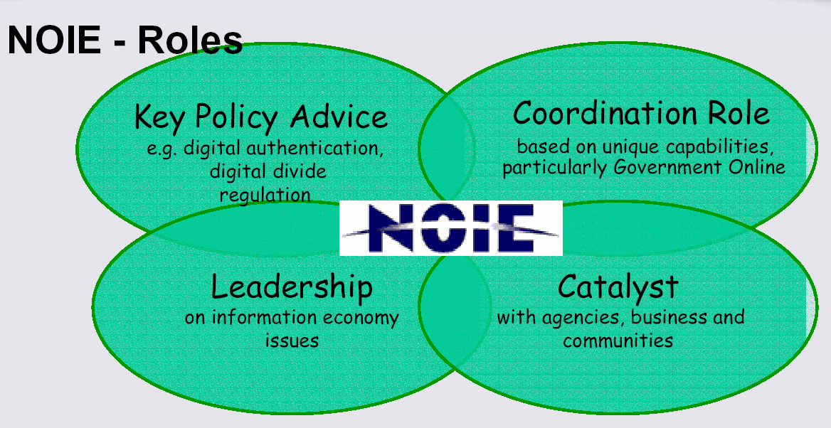
Source: National Office for the Information Economy

Released in April 2000, the Government Online strategy outlines a framework to accelerate progress towards this objective. The following diagram gives the details of this framework. The framework sets in place a consultative process to assist agencies in further developing processes, policies and standards to promote interoperability.
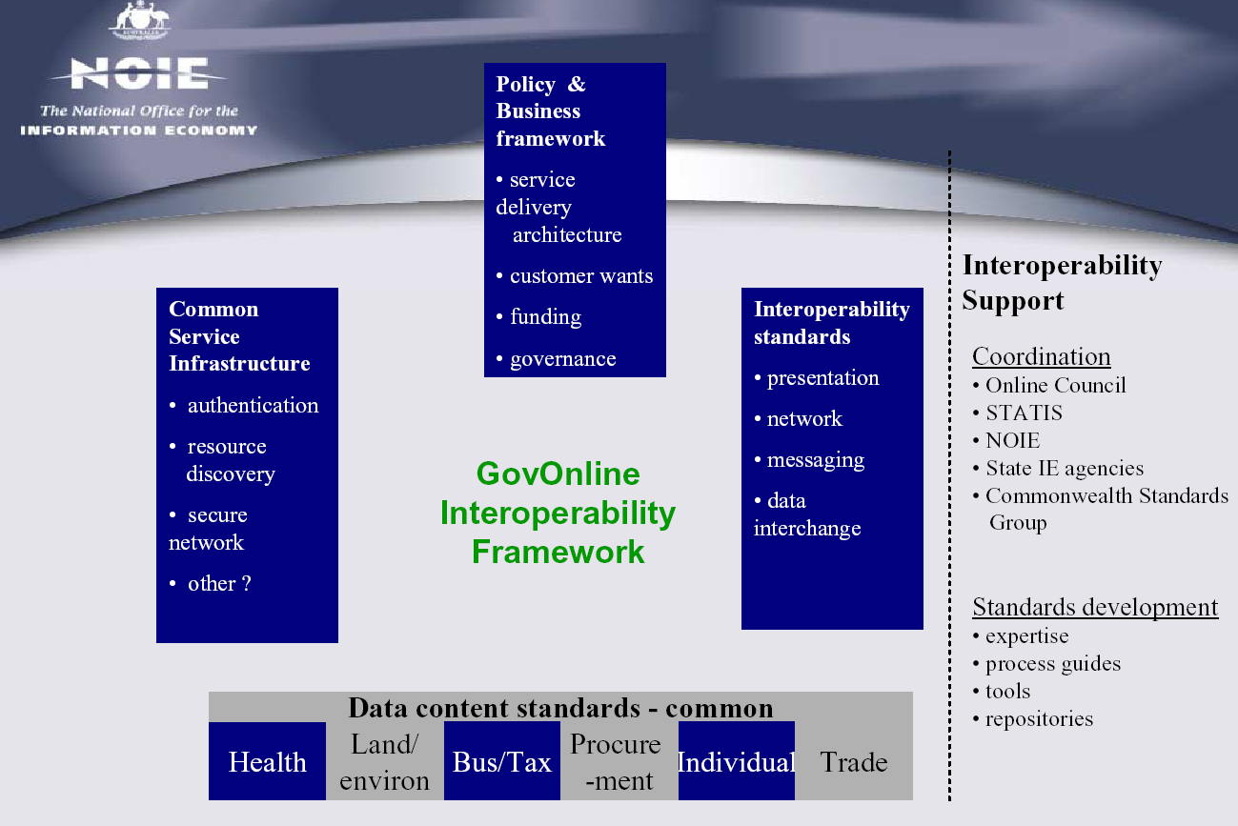
The key areas identified are:
- Policy & Business framework
- Service Infrastructure
- Interoperability standards
Current State
The main entry point for the Commonwealth Government, http://www.fed.gov.au, is an essential part of the Commonwealth’s strategy for providing transparent and comprehensive access to government agencies and information. There are opportunities to enhance these facilities and make them simpler and more powerful through the use of metadata and by the creation of customer-oriented portals. To greatly improve ease of access, the government has endorsed a whole-of-government online portals framework to provide a customer-focused, coordinated approach to the Commonwealth’s online presence. This framework consists of: a set of portals based on customer groups; a set of portals based on topics or subjects; the key point of access at the Commonwealth Government Entry Point; a staged development approach, where applicable; agency consortia to develop and manage the portals to facilitate close coordination and cooperation among resource providers across agencies to provide customer oriented services; responsibility for the development and delivery of online services remaining with primary agencies; an agreed set of cross-portal standards, such as AGLS (Australian Government Locator Service) metadata; and governance arrangements. The portals will all be available through their own Internet address and through the Commonwealth Government Entry Point. These portals will not replace the existing set of agency-based and subject-oriented websites, which will remain fundamental to the objective of placing all appropriate services online. The portals will complement these sites, and place them in a customer-oriented framework. The development of the portals will be staged and variable. This approach will see new portals initially developed to an agreed minimum requirement and over time grow through to fully mature portals offering more sophisticated capabilities. This approach recognizes the rapid pace associated with the development of the Internet and a process of continuous improvement based around user requirements. It also leverages existing significant initiatives, such as the Business Entry Point (BEP) and National Business Information Service (NBIS), Education Network Australia (EDNA), the Source (DETYA youth website), Healthinsite, the Environment Resources Information Network (ERIN) and Infoterra (Environment Australia).
Future Plan:
It is anticipated that an early priority will be the development of a distributed interactive online repository to support the Framework. It will be the vehicle for the web publication of the Interoperability Framework, the key communication channel for agencies developing the Framework further, and the mechanism for sharing XML schema. Opportunities exist for this repository or registry to be scoped, developed, populated and used by the public and the private sector.
Other potential priority areas for development, identified through consultations to date, include:
- Identify which business processes need schema;
- Set the specifications for, and coordinate the production of XML schemas for use across government; and
- Develop standards and XML schema in consultation with agencies.
Other issues that might be considered are:
- Embedding interoperability concepts in other technical frameworks, such as authentication frameworks, procurement frameworks, frameworks for specific sectors and frameworks for specific communities of interest;
- Directory system interoperability;
- Network interoperability issues;
- Web service security;
- Non text data such as voice, graphics, sound, video images;
- Redesign of business processes so that they can benefit from online delivery:
- how business rules are applied to integrated services;
- how trust and risk are handled across organizational boundaries; and
- Integration in the context of outsourced environments

Approach to integration across federal, state and local government

One of the issues governments face while offering the various services is the integration that is required across the different departments at all levels of the government. The Australian government addresses this issue with the creation of Portals that serve as junctures (see figure below).
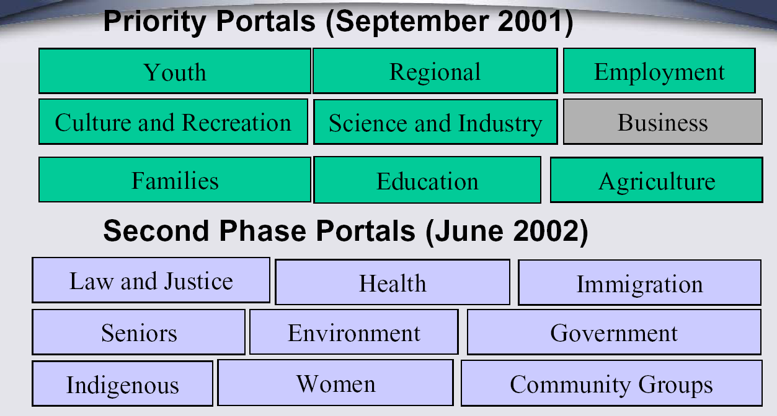
Source: National Office for the Information Economy
These portals offer a single point access to the services offered by the different levels of the government (federal, state, local government) organized by type of service rather than by provider. The US government has addressed this issue by creating the http://firstgov.gov portal.
The various players within a government portal do not usually strike agreements with each other on an exclusive basis. In the same way that a government agency would not give a certain chain of sports stores the exclusive right to sell fishing licenses online, government should allow multiple service providers and public portals to offer public services. Public portals need to be affiliated with as many service providers as possible in order to connect to a variety of government agencies. Service providers require affiliations with various public portals and Web merchants in order to reach as many users as possible. To have the integration that is required to ensure that relationships are non-exclusive, each player relies on open and standardized technical requirements and published business rules for providing a service.
Also, the relationship with the customer must be managed end-to-end. For example, a government employee might have some questions and will need to contact a citizen who has filed his/her tax declaration through a public portal. But, since that citizen is not a direct customer of tax office, the government has to be prepared to use the relationship with the service provider and public portal to send queries and reply to him/her. Further, the service provider and public portal must provide the government the ability to reply and ensure that when an email is sent, for example, that it is actually delivered. In order to manage the customer relationship end-to-end, government, service provider and public portals must all use common or interoperable tools.
Collaboration through organizations, such as the Congressional Internet Caucus, the Council for Excellence in Government and Office of E-Government, that provide forums for the interaction of all levels of government with the e-business industry is key. These organizations/forums provide:
- Forums for learning the best practices from every level of government (Local, State, and Federal) as well as many international governments
- Incentives for award winning solutions that engage multiple levels of government and industry
- Safe pilot/prototype environments to test new e-government solutions
- Collective market dynamics to hone and increase the effectiveness of solutions

It is through these efforts that E-Government will be successfully implemented across Local, State, Federal and International governments.
Approach to interoperability across federal, state and local government using Web services
One key technical challenge of E-Government is fundamental in any complex system composed of other systems: how can the many separate parts work together to achieve common objectives? This "interoperability" challenge involves not only the large scale of government systems, but the complex ways that technology interacts with public policy and social issues. The policy goal of obviating the "digital divide", for example, sets a requirement that interoperability efforts encompass the wide range of ways that governments interact with the people they serve, from high-tech systems down to print products and personal contact. In technology terms, interoperability is needed within and among technologies such as telephone, television, automated kiosks, off-line media, and wireless devices, as well as public and dedicated electronic networks (see diagram below).
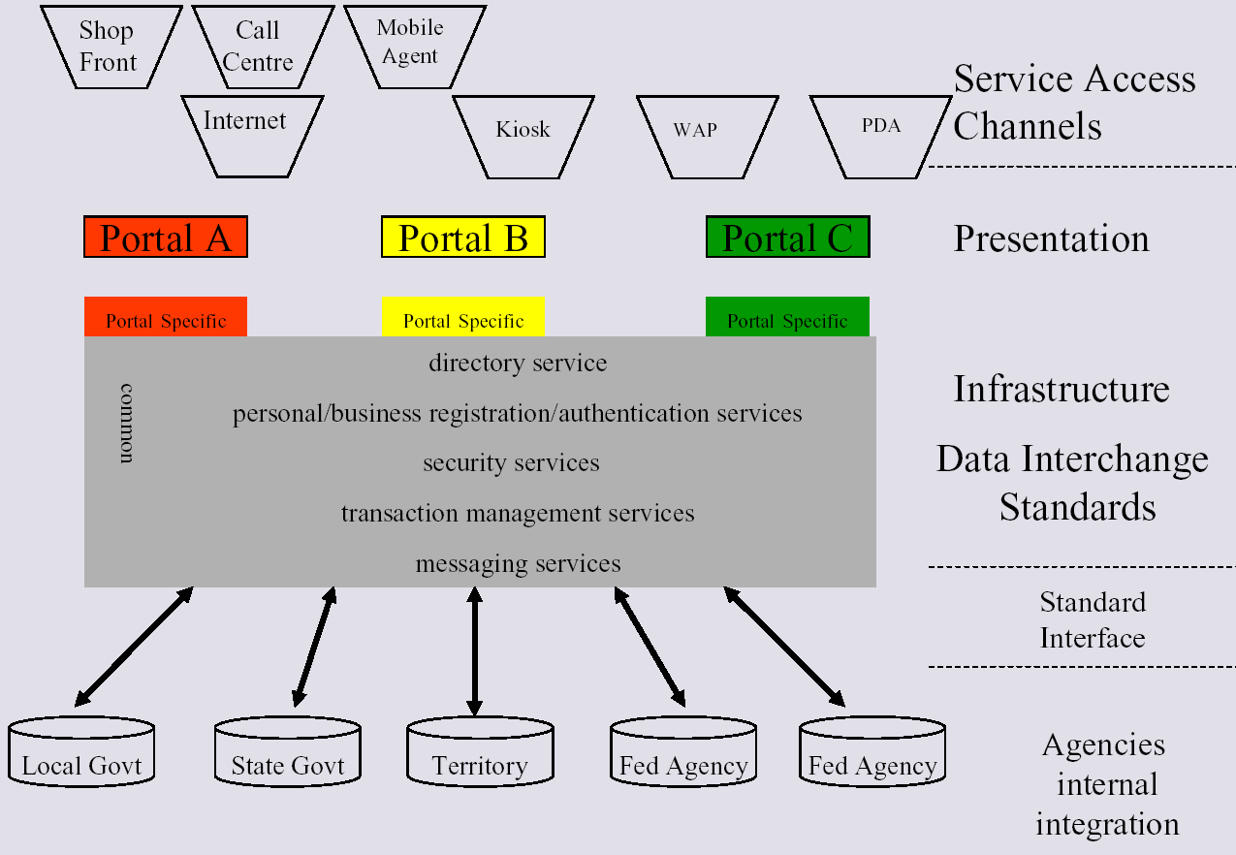
Source: National Office for the Information EconomyError: Reference source not found
Given such technology complexity and the wide variety of government services, it is apparent that E-Government interoperability must be approached in an incremental fashion.
The ongoing need to enhance government-wide "information and services discovery" is a perfect opportunity to deploy interoperability solutions, as has often been cited by advisors to government in the technology arena. In this narrow slice of E-Government, issues of technology complexity rooted in public policy concerns are relatively well-understood from experiences stretching back to the earliest public libraries. It is safe to say that initiatives in this area are likely to garner strong interest among the public and opinion leaders. From the perspective of incremental progress, the discovery challenge is also a good choice in that virtually all other government services have some dependence on discovery mechanisms. Work on discovery mechanisms would help expose some of the most profound E-Government technical challenges, such as data integration challenges in cross-agency service delivery.
E-Government interoperability in the area of information discovery already has a robust law and policy base within the U.S., and a mature set of international standards on which to build. Projects such as the National Spatial Data Infrastructure and the Global Information Locator Service (GILS) have demonstrated that inter-governmental collaboration works very well in this area and that current technology is effective even with the very large scales needed for government-wide deployment.
Recently, hundreds of information technology companies have begun to collaborate on a common infrastructure for such an information and service discovery mechanism focused on business-to-business interoperability challenges. This mechanism, known as Universal Description Discovery and Integration (UDDI) is already being extended to include government organizations and services. Oxford University has even built an automated gateway connecting UDDI with all of the directories, catalogs, and inventories available through the GILS information discovery mechanism.
One objective of an initiative focused on information and services discovery using UDDI and GILS could be to establish and maintain an online, authoritative directory of the current U.S. Federal Government organizations and their services. This directory would re-use existing sources in several agencies, but these various information sources would gain a common and coherent interface through UDDI. Establishment and maintenance of such a resource could be decentralized as needed and other levels of government could participate at will.
Web services offered by each organization would be accessible online in the directory, although the text content could also be printed for distribution to any citizen or company that wants it. One could locate organizations by classified type of service, as well as by location, organizational hierarchy, or any other characteristics particular to that organization. Government "portals" such as AOL Government Guide, FirstGov and GPO Access could add value to this directory with additional facilities to help people find organizations, services, and sources of information across government.
By exploiting industry’s building block Web services, government integrated services can move online – agency, service provider and public portal can interact with each other using Web services. A service provider wanting to issue fishing licenses, for example, can submit an online query to UDDI which will respond with the Web site of the government department responsible. Another query will tell if a government Web service is available for issuing fishing licenses and, if so, what the service provider has to do to interact with the government back-end system and what business protocols are required to provide the service. The service provider will have to, for example, establish the identity of the citizen applying for a fishing license, which can be accomplished using a web service. A government web service such as filing a tax declaration will require a stronger identification service, but the mechanisms will be the same. A business or citizen might file a return through their accounting firm, which will use Passport together with a digital signature and an authentication code obtained from government.
The fastest moving e-government application is probably e-procurement. Using the Web services, contractors do not have to visit the Web site of every municipality, regional authority, and central government department to see what each has put out tender. Instead, vendors can go to the Web and see requests related to their expertise from all organizations and all levels of government. XML indexing, through UDDI, enables the ability to search and find services and information automatically, without the need for a middleman to pull everything together. The technology matches the services and people who are interested in each other.
The public sector is a service by definition, so it is in one of the best positions to leverage the web service approach. Organizations can start today to build their e-government solutions, first by using XML-based Servers to secure and extend their government infrastructure. Pushing an existing corporate LAN or WAN out to provide citizens with Internet access, email and services available through multiple channels over a range of devices will help government bridge the digital divide and manage their customer relationship.

XIII. Conclusion and Recommendations
An analysis of the two architectures, ebXML and Web services, brings out essential similarities underlying the two frameworks. At this point in time, the two architectures are in a way competing with one another. The vendors led by Microsoft, IBM, Oracle, Intel, etc. are actively backing Web services while
various industry associations (Covisint, Open Travel Alliance), especially those with EDI background, are active supporters of ebXML.
Web services have a ready to use product, though with basic integration functionalities. ebXML, by contrast, offers standards based on which these services/software can be provided by a software vendor (for e.g. ebXML Connector 1.0 - btrade, Inc.) Increasingly, companies are viewing with curiosity the development of these frameworks before making a decision on investment. There is immense potential for companies to start integration with services at the edge, such as the existing outsourced functions, before looking at adopting one of these frameworks for the organization's core activities.
Considering the existing state of integration and interoperability functions in various companies, the probability of most of the projects based on these frameworks to be intra-company rather than inter-companies is real. This is all the more likely considering the security issues involved in moving beyond the firewalls of the company. Also with regard to realizing the optimal potential of Web services there are trust issues involved in companies doing business (for example, consuming applications) with other companies simply based on contacts made on the UDDI. Moreover, the process of achieving a comprehensive UDDI and deciding on the entity to govern it, has some time to go before companies would start warming up to the concept. Thus we look at Web services serving the integration/ interoperability functionalities primarily within the organization for the next three years. Interoperability between different organizations is also possible only when the business processes are defined for the industry and the Document type Definitions or the Schemas are standardized. It would not be possible for an individual vendor to do this industry-wide unless he is given such project by an industry association. The most likely situation for the next two years is each vendor defining business processes for the client depending on the requirements of the integration project.
ebXML has an advantage in this regard as the standards boards are already working on the business processes and creation of schemas for various industry-wide transactions. This makes it easier for a company to adopt an integration/ interoperability solution based on these defined standards. Thus the demand from clients would push the existing vendors who aren’t actively associated with ebXML to use ebXML standards and come up with cost effective solutions. However, at this point in time, with the exception of some software packages for messaging based on ebXML standards, there is no existing comprehensive ebXML product.
In the light of this background, we offer the following recommendations:
- Web services are here to stay; using either the standards being put forward by W3C, WSI, etc. (in the Web services camp) or the ebXML standards. Web services currently offer lower level functionalities. However, for the interoperability/ integration to be achieved, the business processes and the business schemas need to be developed. As the complexity of the business processes increase, so does the time and cost involved in defining the dynamic schemas, especially for governmental transactions. Considering the magnitude of government business, the whole process of defining the business processes and creating the schemas would be a long,
drawn-out affair.
Government should qualify and prioritize the processes that derive the maximum benefit from application integration and interoperability. For example, in the realm of Government-Citizen interaction, there exists Web based (HTTP standards) interaction at this point of time with respect to a variety of services. If these service areas are identified as priority, the existing understanding of the business processes can be used with advantage. Similarly identifying those areas for which a certain level of integration (customized applications) currently exists would facilitate easier implementation of application integration/ interoperability at higher levels. The probability of success increases due to existing appreciation for technology in these service areas.
- Complementarity between ebXML and Web services: We see the two frameworks / standards as complementary and not in conflict with each other; they are parts of the complete solution. Despite the fact that at this point of time, there seems to be two different camps in Web services and ebXML, the strengths of the two frameworks are in different areas. On account of its immediate utility and revenue generation possibilities, the existing Web services technology is appropriate for deployment within the firewall operation. As integration/interoperable applications are developed (or consumed via the Web) for non-core business activities, and the companies see the potential for integrating company wide and inter-company transactions, the need for industry wide standards for business processes and schemas gain importance. Considering the head start that ebXML and its various standard setting bodies had in the arena of business processes and repository/ registry, it would be advantageous for vendors to make use of the progress in these standards and come out with cost effective solutions. The government may find it advantageous to consider these complementarities as it decides on the enterprise architecture.
- Government should work with ebXML standard bodies, other industry and private standards bodies towards including use cases for government transactions. Considering the magnitude of government business, it may be prudent to start working towards defining schemas and business processes as soon as possible. It may be advisable for the government to come up with an e-Gov standards body on the lines of the Office of e-Envoy in UK entrusted with the work relating to business processes specification schemas. This body should be proactive in interacting with the various standards bodies and deciding on the appropriateness of their work for government transactions. This e-Gov standards body should, in league with industry and citizen, formulate technical specifications for interoperability based on open standards. Ad hoc working groups can be formed to focus on individual areas such as a technology advisory group, a government processes group, and a government schemas group. This approach has the advantage of bringing the government up to speed with developments in these technologies, besides having the advantage of ensuring that the final standards are open and acceptable to industry and citizen.
- Government backend systems should be ready to be exposed to external applications using service-based frameworks. With the concept of Web services gaining increased visibility as an optimum way of integrating applications, 2003 may be a threshold year in terms of acceptance by businesses. It may be advisable for government to prepare the groundwork for implementation of Web services. This requires updating the servers to XML capabilities, mapping out the existing integration capabilities, and charting out a map for achieving interoperability at the agency/department level; and ultimately for the entire government viz. federal, state and local.

Appendix I: Interviews

1. Chris Kurt, Microsoft. October 16, 2002.
2. Mike Jacobs, USN. October 16, 2002
3. Mark Crawford, LMI. October 16, 2002
4. Alan Kotok, DESA. October 25, 2002
5. Arthur Ryman, Phd IBM, November 1, 2002
6. Hao Jiang, University of Maryland Netcentric Lab, November 6, 2002.
7. Brand Niemann, EPA. December 2, 2002
8. Velan Thillaiyaraja, Enterprise Application Integration Technologies Inc., December 5, 2002

Appendix II: Additional Resources

1. Holmes. Douglas. eGov. eBusiness Strategies for Government. Nicholas Brealey Publishing.
London. 2001
2. Datz, Todd. "Integrating America". December 1, 2002 Issue of CIO Magazine.
<http://www.cio.com/archive/120102/america.html >
3. O'Looney, John. Wiring Governments: Challenges and Possibilities for Public Managers.
Quorum Books. London. 2002
4. Lenk, Klaus and Traunmüller,Roland. "Broadening the Concept of Electronic Government."
J.E.J. Prins (ed.) Designing E-Government. Kluwer Law International. 2001. Netherlands.
5. "Electronic Government's Role in Implementing the President's Management Agenda."
July, 2002. <http://www.egov.gov/it_policy.cfm#role >
6. eGov 24 initiatives. <http://www.egov.gov/egovreport-3.cfm>
7. "EGovernment and the Secure Channel Vision." Copyright 2000 icorp.ca.
<http://www.icorp.ca/eGovernment_and_the_Secure_Channel_Vision.pdf >
8. Draft Executive Summary & Recommendations. 2nd National Workshop on "IT Applications in e-Governance". 20-21 September 2002. <http://www.ascihyd.org/exsum.htm>
9. Zweers, Koen and Planqué, Kees. "Electronic Government from and Organization Based Perspective Towards a Client Oriented Approach." Designing E-Government. J.E.J. Prins (ed.), 2001. Kluwer Law Intenational
10. "Supporting the Homeland Security information infrastructure with Web-based integration, collaboration, data management and security solutions." IBM Software Group. 2002.
11. McIver and Elmagarmid. "Policy and Portals: A doorway to an electronic government." (ed.) Advances in Digital Government. Technology, Human Factors, and Policy. 2002. Kluwer Academic Publishers.
12. Strover, McIver and Elmagarmid. "Citizens' Perspectives on E-Government." (ed.) Advances in Digital Government. Technoly, Human Factors, and Policy. 2002. Kluwer Academic Publishers.
13. Reynolds, Margery M. "Challenges - Interoperability. Microsoft E-Government Initiatives. Advisory Committee." Congressional Internet Caucus. <http://www.netcaucus.org/books/egov2001/pdf/EGovInte.pdf >
14. Dignan, Larry. "Will the government ever go paperless?." Anchor Desk. December 23, 2001. <http://zdnet.com.com/2100-1107-504156.html>
15. Herman, Jim. "E-enabling your enterprise", Business Communications Review. BCR
Enterprises. April 2002.
16. April, Carolyn A., "OASIS serves up messaging standard; ebXML Messaging service spec to
enable secure business transactions." Inforworld.com. September 5, 2002
17. "Demystifying Web Services" webMethods, Inc., 2002
18. "Auto exchange to promote two XML standards" Modern Materials Handling. Cahners Business Information. March 2002
19. "E-government Interoperability framework." Version 3. Crown copyright 2001
20. Kiely, Don. "E-business language of choice?" Informationweek. May 7, 2001
21. Kotok, Alan. "The e-business continuum: Web services, ebXML and EDI." published on webservices.org 26/06/2002. <http://webservices.org/article/articleprint/479/-1/22>
22. Kotok, Alan. "Taking ebXML and Web services to the cleaners."
<http://webservices.org/article/articleprint/499/-1/62>
23. Baljko Shah, Jennifer. "Beyond Babble" EBN. Manhasset. October 1, 2001.
24. Meehan, Michael. "EDI, ebXML groups agree to cooperate." Computerworld.
Framingham. July 2,2001.
25. "Toward a Common Language." EBN. Manhasset. July 2, 2001.
26. Montalbano, Elizabeth. "ebXML: What's ahesd?" CRN. Jericho. March 12,2001.
27. Hickman, Sam and De Smedt, Philippe. "ebXML Is Emerging Asa Reliable Standard --
Proof of Concept Demonstrates its Viability As EDI Alternative." Electronic Buyers News.
October 9, 2000.
28. Webster, John. "An Alphabet Soup of B2B Standards --SOAP, ebXML, UDDI and others
will slowly gain momentum." InternetWeek. Dec. 18, 2000.
29. Web Services Primer <http://www.xml.com/pub/a/2001/04/04/webservices/>
30. W3C SOAP Version 1.2 Primer <http://www.w3.org/TR/2001/WD-soap12-part0-20011217/
UDDI – http://UDDI.org, UDDI to GILS http://www.gils.net/uddi.html>
31. WSDL (W3C) <http://www.w3.org/TR/wsdl>
32. Web Services Architectural Requirements (W3C) <http://www.w3c.org/TR/2002/WD-wsa-reqs-20020429>
33. Web Services Activity Statement (W3C) <http://www.w3.org/2002/ws/Activity>
34. Niemann, Brand L., EPA “Peer-to-Peer XML Content Networks of Web Services,”
<http://www.gsa.gov/attachments/GSA_PUBLICATIONS/extpub/11-BLNiemann-EPA_7.htm>
35. U.S. Federal E-Government Strategy <http://www.cio.gov/Documents/EgovStrategy%2Ehtml>
36. NASCIO Enterprise Architecture <https://www.nascio.org/hotIssues/EA/>
37. XML Applications in Government Newsletter – Office of Intergovernmental Solutions <http://www.gsa.gov/Portal/content/pubs_content.jsp?contentOID=120147&contentType=1008&PMGZ=1>
38. GAO: Electronic Government: Challenges to Effective Adoption of the Extensible Markup <Language http://www.gao.gov/new.items/d02327.pdf>
39. Di Maio, Andrea. “Government Insights: What Do Web Services Mean?” Gartner Research. August 22 2002
40. Kreizman, Gregg. “Predictions: Web Services in E-Government Architecture.” Gartner Research. December 20, 2001
41. Smith, David. “Explaining Web services Apparent Contradictions.” Gartner Research.
June 4, 2002.
42. Daryl Plummer, Mark Driver, Yefim Natis, Larry Perlstein, David Smith. “Requirements for Web Services: Terms and Technology.” Gartner Research. May 2, 2001
43. Daryl Plummer, David Smith, Whit Andrews “What Web Services Will and Won't Do.”
February 19, 2002
44. Smith, David. “Web Services: 2002 and Beyond.” Gartner Research. December 14, 2001

Chabrow, Eric. One Nation, Under I.T. Nov. 11, 2002 “The feds say they need more unified architecture to tackle problems such as homeland security” Information Week. <http://www.informationweek.com/story/IWK20021107S0010>
Clabby, Joe Web services Explained - Solutions and Applications for the Real World. Upper Saddle River, New Jersey. Prentice Hall PTR. 2002.
Kotok, Alan & Webber, David R.R. ebXML-The New Global Standard, Indianapolis. New Riders. 2002
<http://www.ibm.com/developerWorks>
“Evolution of Integration Functionality” Technology White Paper. Sybase Web services, 2002
Ogbuji, Uche “The Past, Present and Future of Web services, Part 1”, Published 28.9.2002 Web services.org <http://www.webservices.org>
<http://www.oasis-open.org/who>
<http://www. unece.org/cefact/>
Ogbuji, Uche “The Past, Present and Future of Web services, Part 1”, Published 28.9.2002 on Web services.org <http:// www.webservices.org>
DM Review, “PwC Technology Forecast Explores Trends” Published in DM Review Online April, 2002 <http://www.dmreview.com>
DM Review, “PwC Technology Forecast Explores Trends” Published in DM Review Online April, 2002
Jenz., Dieter E. “ebXML is Getting Closer” Published 21.10.2002 on Web services.org <http://www.webservices.org/index.php/article/articleprint/713/-1/24>
Web services Shortcomings - Bloor Research-North America, May 2002 <http://www.bloor-research.com/>
Enabling Electronic Business with ebXML, December 2000 <http://www.ebXML.org/white_papers/whitepaper.htm>
Medbiquitous <http://www.medbiq.org/technology/tech_architecture/>
ebXML <http://www.ebXML.org/white_papers/whitepaper.htm>
ebXML Overview Report given 27 March, 2002. Hong Kong University Center for e-commerce Infrastructure Development<http://www.cecid.hku.hk/Resources/ebXMLOverview.pdf>
Crawford, Mark "The Universal Business Language Initiative" <http://www.xmlconference.org/xmlusa/2002/plenaries_crawford.asp>
Crawford, Mark, XML Lead, Logistics Management Institute (LMI), Personal Interview Oct.17, 2002
Scmeltzer, Rolnald (analyst) "The Open Applications Group: Business Object Documents Fill a Critical B2B Role" <http://www.openapplications.org/news/OAGI-092001-(ZTBN-0131).pdf>
Scott Durchslag “Beyond the Hype… the Reality of Early Web services Adoption”. March 2002. SYS-CON Media <http://www.wsj2.com>
Hagel, John "Edging into Web services" The McKinsey Quarterly, November 2002
Darnell, Dave “Utilities Industry XML – Business Case Example”, Uniform Code Council U Connect Conference, May 22-24, 2002, Salt Lake City
Kotok, Alan “Utility Deregulation Requires Effective E-Business Standards”, June 2002, p.23
Darnell, Dave “Utilities Industry XML – Business Case Example”, Uniform Code Council U Connect Conference, May 22-24, 2002, Salt Lake City
The Drummond Group. Products list. <http://www.drummondgroup.com/html-v2/products-ebXML.html>
Jenz, Dieter E. “A view at Total Cost of Ownership and Return on Investment - parts 1-4”, Published 21.10.2002 on Web services.org <http://www.webservices.org/index.php/article/articleview/197/1/24, 03/18/2002>
Hagel, John “The strategic value of Web services”, The McKinsey Quarterly, November 2002
e-Government Interoperability Framework. Part One: Framework, Version 4.0
e-Government Interoperability Framework. Part One: Framework, Version 4.0
e-Government Interoperability Framework. Part One: Framework, Version 4.0
Local GovOnline: Interoperability and Standards. Peter Hallams, Manager Integrated Services, National Office for the Information Economy. GEAC Users Conference 5 Nov 2001 <http://www.gmc.geac.com/media/5111PHStandard.pdf >
DigitalPlays.com Charting the rise of the Digital Age... E-Government. March 23, 2002. <http://www.digitalplays.com/Links/e-government.htm>
Interoperability Framework for the Commonwealth Government http://www.noie.gov.au/projects/egovernment/Better_Practice/Interoperability.htm
Hallams, Peter. Manager Integrated Services, National Office for the Information Economy. Local GovOnline: Interoperability and Standards.Proceedings of GEAC Users Conference 5 Nov 2001.
Reynolds, Margery M. "Challenges and Opportunities - Intergovernalism- eGovernment is pervasive" Microsoft eGovernment initiatives <http://www.netcaucus.org/books/egov2001/pdf/EGovChal.pdf>
An Immediate Opportunity in E-Government Interoperability. Submitting Organization: GILS Maintenance Agency, U.S. Geological Survey, Department of the Interior. Contact: Eliot Christian. Congressional Internet Caucus <http://www.netcaucus.org/books/egov2001/pdf/caucus_b.pdf>
Challenges contact: Interoperability. Margery M. Reynolds. Microsoft eGovernment initiatives. <http://www.netcaucus.org/books/egov2001/pdf/EGovInte.pdf>

