

Minority Business

E-Commerce Survey

On July 12, 2001, The U.S. Department of Commerce, through collaborative efforts with Wells Fargo and U.S. West, commissioned the Tomas Rivera Policy Institute to conduct a field study, entitled Minority Businesses’ Use of Internet Technology: A Preliminary Case Study of Large Firms. The report noted (in brief):

Low E-Commerce Participation Rates
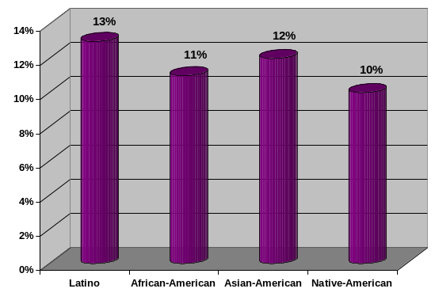The level of e-commerce participation for larger minority firms’ range was 10% to 13%. E-commerce sites were relatively new and had been around for only a short period, about 1.5 years on average.
Minority Business E-Commerce
Participation

Moderate Levels of Website Availability
Between 42% and 56% of larger minority firms surveyed established a web site presence. Therefore, 44% to 58% of these firms represent an opportunity gap.
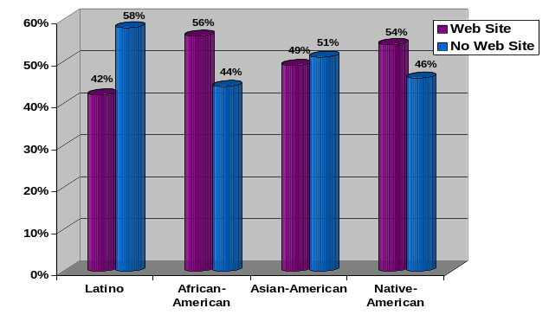
Minority Business
Web Site Availability

Table 1: Minority Business Participation Rates in E-Commerce
Group | Latino | African American | Asian American | Native American
E-Commerce | 13% | 11% | 12% | 10%
Web/ No E-Commerce | 29% | 45% | 36% | 44%
Firms w/ Website | 42% | 56% | 49% | 54%
Firms w/o Website | 58% | 44% | 51% | 46%
Internet Only | 5% | 5% | 5% | 3%
Number of Firms | 500 | 406 | 479 | 287

Participation rates are based on 1,673 minority-owned businesses (from a national sampling frame of 39,098) that conformed with the following criteria: 1. Annual sales of $500,000 or higher; 2. Firm is at least 51% minority-owned; 3. Good to excellent credit rating; 4. No record of bankruptcies. Sampling is in accordance with methodology described in Tomas Rivera Policy Institute, Minority Businesses’ Use of Internet Technology: A Preliminary Case Study of Large Firms, 2001, pp 7-9.

Lower Entrepreneurial Activity
The majority of respondents in companies without e-commerce indicated that they had no plans to launch an e-commerce site soon. [See Table 2]

Table 2: Major Reasons Cited as to Why Minority Firms do not have an E-Commerce Site
 | Latino | African American | Asian American | Native American
Product does not lend to e-commerce | 20% | 23% | 21% | 24%
Does not want to and does not need to | 15% | 11% | 14% | 13%
Company infrastructure is not ready | 10% | 14% | 17% | 12%
Too much competition, market is too small | 6% | 6% | 5% | 9%
Offer services, not products | 5% | 8% | 4% | 9%
Not a priority/waiting to see what happens | 7% | 9% | 4% | 4%
Lack of expertise | 6% | 7% | 5% | 4%
Too costly | 6% | 6% | 5% | 3%

Achieving Entrepreneurial Parity – The E-Commerce Opportunity Gap
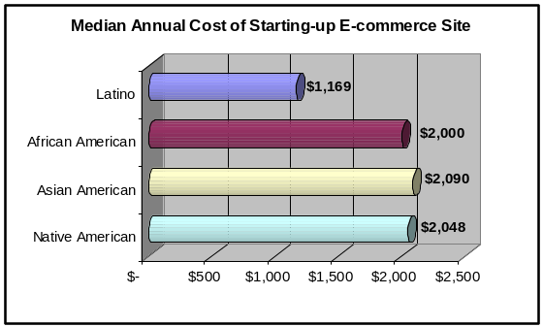The majority of minority firms surveyed viewed e-commerce as an important tool. However, one-third of these businesses did not view e-commerce as an important tool, disagreed with the idea or did not understand its potential.

Median Annual Cost of Starting-up an

E-Commerce Site
In this survey, the investment range to establish an E-commerce site had a median low of $1,169 with Latino firms and a high of $2,090 with Asian American firms.

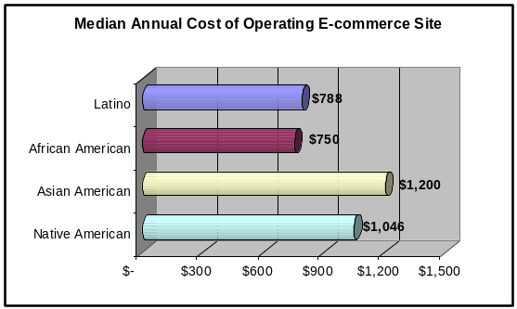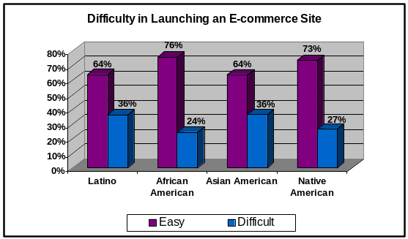
Median Annual Cost of Operating an
E-Commerce Site
Difficulty in Launching an E-Commerce Site
In this survey, the investment range to maintain and operate an E-commerce site had a median low of $750 with African American firms and a high of $1,200 with Asian American firms.

Minority firms surveyed report the degree of difficulty for launching an e-commerce site as easy.

