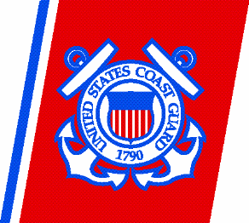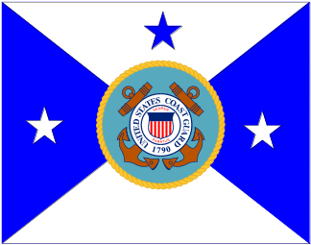VADM Terry M. Cross

Vice Commandant

U.S. Coast Guard

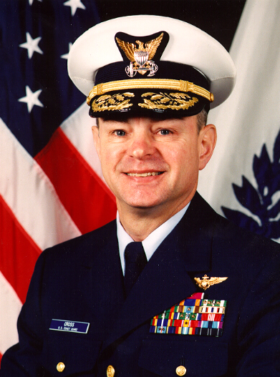
Vice Admiral Terry M. Cross assumed the duties as Vice Commandant of the United States Coast Guard in July 2004. He serves as the Coast Guard’s second in command and is the Agency Acquisition Executive.
Prior to his assignment as Vice Commandant, he served as Commander, Pacific Area. VADM Cross was responsible for all Coast Guard operations west of the Rocky Mountains and throughout the Pacific Basin to the Far East, an area encompassing over 73 million square miles. Under his leadership, Pacific Area units established the first Coast Guard maritime intelligence fusion center, participated in Operations Iraqi Freedom and Liberty Shield and set new records for illegal drug seizures. VADM Cross previously served as the Assistant Commandant for Operations, where he was responsible for management oversight of all Coast Guard operating programs, including maritime safety, law enforcement, intelligence, and national defense. He initiated the Coast Guard’s Maritime Domain Awareness initiative, succeeded in gaining Coast Guard formal membership in the Intelligence Community and led efforts that rapidly supported the Coast Guard’s Homeland Security Strategy, including the development of deployable Maritime Safety and Security Teams.
VADM Cross’ other flag assignments included service as Commander, Eleventh Coast Guard District; Commander, Seventeenth Coast Guard District and Director of Operations Policy at Coast Guard Headquarters.
VADM Cross’ previous operational assignments include service as a Deck Watch Officer aboard Coast Guard Cutter MCCULLOCH, Operations Officer of Air Station Cape Cod, Mass., and Commanding Officer of Air Station San Francisco, Calif. Staff assignments included service as the Chief of Staff, Atlantic Area; Chief, Office of Programs; Chief, Office of Budget and Chief, Office of Acquisition Resource Management at Coast Guard Headquarters.

VADM Cross graduated from the Coast Guard Academy in 1970 with a Bachelor of Science degree in Engineering. He also earned a master’s degree in Industrial Administration from Purdue University and is a graduate of the National War College. VADM Cross is married to the former Susan Dufort of Cumberland, R.I. They have two children: a son Sean, a Coast Guard Lieutenant, and a daughter Shannon, a consultant in the Chicago area.

