SECTION IV: Committee Management Officer (CMO) Management Tools and Access to Advisory Committee Data

The Committee Management Officer (CMO) uses the system to add and manage advisory committees, add and manage agency users of the system, update the information on advisory committees during the current reporting year, and produce reports on advisory committee trends across fiscal years. The Federal Advisory Committee Act (FACA) requires that the CMO provide information about the agency’s advisory committees for an annual comprehensive review, both internally to the agency, and externally, as part of a government-wide review. The web-based database accommodates and builds upon those requirements by allowing the continual updating of committee information throughout the reporting year and providing committee management functionality. Keeping the data continuously up-to-date converts the system from a focus on history and records to a focus on management and immediate relevancy. With frequent and timely updates, the system becomes more useful to everyone, ranging from the public users to interested agency officials to congressional staff with oversight responsibility.

What is the FACA Database?

The FACA database is a specialized database on the web. The Federal Advisory Committee Act originally required that specific data items about advisory committees be collected by the President annually and transmitted to Congress for review. Since 1997 this web-based database has been used by all the government agencies that have advisory committees to collect that data. This online system was demonstrated to Congress at a Government Reform Committee Hearing in 1998 and, since 1999, Congress has determined that it no longer requires the “printed and transmitted” annual report. The annual reviewing and reporting needs of the Congress and the President are met through the maintenance of the online system. The “CMO” user has access with edit and update rights to the current fiscal year’s data for their committees via the Internet. The CMO is given their access rights, their logon (username) and their initial password by the Committee Management Secretariat. The CMO, like any other public user, can view all of the information on all of the committees of all the agencies available for the current reporting year in a read-only mode. At the same time, only the Designated Federal Official (DFO), or their designee, the agency CMO, or their designee, or a Committee Management Secretariat (CMS) staff member can edit or update the CMO’s own agency’s committee data for the current year.

What kind of data is being collected and maintained?

For the CMO, the program collects, totals, accesses, and/or displays all the information available to the DFO, which includes
- Charters and related information,
- Members and their appointment information,
- Costs,
- The agency’s recommendation for continuation or termination of the committee,
- The committee’s recommendations to the agency and the actions taken on the recommendations (this will be added in the immediate future),
- Report titles, publication dates, and the text of the report,
- Meeting purposes, dates, location, whether the meetings were open or closed, and the minutes or transcripts,
- Activity and justification (raison d’etre) information,
- DFO appointment and contact information,
- Decision maker contact information,
- Annual Performance Measures Data,
- Web site addresses for the committee or accessing committee information like the minutes, reports, and recommendations, and
- Committee interest or issue areas.

Specifically for the CMO the program also collects, totals, accesses, and displays information that includes
- A current year list of agency advisory committees and the committees’ update status,
- An agency totals report of the distribution among committees of establishment authorities and committee functions, and the total meetings, reports, costs, and members,
- A listing of committee DFOs with their contact information,
- A complete set of the current annual comprehensive reviews for all the committees in the agency,
- Filters to limit the number of committees viewed on the Committee List page at any one time,
- The ability to add and manage agency users of the agency’s committees’ editable and reportable data,
- The ability to add a new committee to the FACA committee list online,
- A current status overview to quickly put the CMO in touch with the activity level of their committees as recorded in the online system and a growing set of heads-up/potential problem comparisons about and between agency committees and government averages,
- The available discretionary ceiling,
- The ability to create and manage sub-groups of committees within the agency, and
- E-mail listings for individuals in agency groups responsible for advisory committee activity.
In addition, when viewing an individual committee, the program allows the CMO to establish, renew, re-establish, amend, or terminate a committee, and upload a copy of the charter to the system (with the Consultation button). The DFO does not see the Consultation button when viewing their Committee Menu page. The database does not collect meeting announcements or other Federal Register announcements at the present time, but it does have a page devoted to committee recommendations to the agency, the agency’s use of those recommendations, and other performance measures.

How does the CMO use the system?

FACA requires that each agency shall establish uniform administrative guidelines and management controls for advisory committees established by that agency, and that each agency shall maintain systematic information on the nature, functions, and operations of each advisory committee within its jurisdiction.
The law’s language states that the head of each agency that has an advisory committee shall designate an Advisory Committee Management Officer (CMO) who shall –
- Exercise control and supervision over the establishment, procedures, and accomplishments of advisory committees established by that agency;
- Assemble and maintain the reports, records, and other papers of any such committee during its existence; and
- Carry out, on behalf of that agency, the provisions of section 552 of title 5, United States Code, with respect to such reports, records, and other papers.
The law also states that
- There shall be designated an officer or employee of the Federal Government to chair or attend each meeting of each advisory committee. The officer or employee so designated is authorized, whenever he determines it to be in the public interest, to adjourn any such meeting. No advisory committee shall conduct any meeting in the absence of that officer or employee.
- Advisory committees shall not hold any meetings except at the call of, or with the advance approval of, a designated officer or employee of the Federal Government, and in the case of advisory committees (other than Presidential advisory committees), with an agenda approved by such officer or employee.

The FACA database system is designed to support the above requirements by capturing relevant information when the committee is created online by the CMO, and to carry that information forward as it is edited and updated by the DFO or her designee from year to year until the information is no longer required. When a committee is first established and chartered by an agency, the information on the committee is generally entered by the CMO or his designee and should address most of the committee’s general information, membership information, and estimated cost information requirements. Obviously, to function appropriately, the DFO should already be officially appointed, up-to-date, and involved in the committee’s mission and charter when a committee is established (officially chartered). At the highest level, the process ordinarily proceeds as follows:
- The President, Congress, or a federal official in an agency decides that advice on an issue is needed and an advisory committee is the appropriate vehicle for getting that advice,
- The President executes an order or the congress passes a law that includes language assigning the responsibility for the committee to an agency. The agency, given it has the means and latitude, simply starts the process of developing a charter.
- The agency uses the administrative guidelines and management controls it established under the law (FACA) to develop the charter, secure members, appoint a CMO for the agency, appoint the DFO for the committee being established, and delegate or assign the other responsibilities established under FACA.
- The CMO confers with the Committee Management Secretariat (CMS) regarding the new committee, ensures that a DFO has been appointed, creates the new committee online using the system, files the charter with the appropriate congressional oversight committees, and provides the appointed DFO and his designees with logons to the system.

The CMO’s step-by-step process with a new committee and the FACA Database system generally looks something like the following:
1) When a committee is going to be established and chartered, the CMO uses the Add a Committee hyperlink on the Committee List page to create a new committee online. The information added during the online creation process should be complete enough to address the new committee’s general information, membership information, meeting information, and estimated cost information requirements.
2) The CMO and the Committee Management Secretariat (CMS) use the Consultation process found on the new committee’s Committee Menu page to complete the committee establishment.
3) The CMO uses the User List hyperlink to add the DFO and/or the DFO’s designee as a user to the system.
4) The CMO has the DFO log onto the system and
- Complete the edits to the General Information page. This contributes to the annual comprehensive review requirements and keeps the Heads Up Reports timely and useful,
- Add meetings as they are planned or as they occur, add the reports as they occur, and upload the meeting transcripts or minutes and reports as they become available,
- Add or delete members as they are appointed or replaced,
- Add or update costs as they occur,
- Add or update the web address if a web site is created for the committee,
- Add or update DFO contact information as it changes. This keeps the DFO Report useful.
- Recommend the continuance or termination of the committee by the end of the fiscal year,
- Report the Performance data at the end of the reporting year,
- Report the recommendations of the advisory committee to the agency and the agency’s response or use of the recommendations, and
- Verify the accuracy and completeness of the committee data for the reporting year at the end of the reporting year.
The DFO, or the CMO if she or he chooses to do any or all of the tasks above, will find that the general information, costs, and member data added during the establishment of the committee has been carried forward to the relevant annual comprehensive review pages. At the end of any reporting year the program carries all of the committee data forward into the newly created year except for meetings and reports.

The CMO will also find the read-only Public Access modules of the system useful to their management concerns. Using the Search feature (when it is switched on and working), the CMO can discover what other committees exist in other agencies with issues and concerns similar to committees they are planning to charter. With that knowledge, the CMO can Drill Down to the specific committees and determine if the system has information useful to them, or they can identify people in the other agency to contact for further investigation. From the Public Access area, the CMO drills down from the Year to the Agency to the specific Committee to view the desired information. At any time the CMO can Search the entire collection for any word or phrase, use a Filter or Database Search to limit the data displayed, and/or Download selected data to a spreadsheet or data table. Topical Committee Reports, the printed Annual Reports submitted by the President to Congress from 1972 through 1998, and the Annual Comprehensive Reviews conducted each year will be added to the Public Access section as they become available.

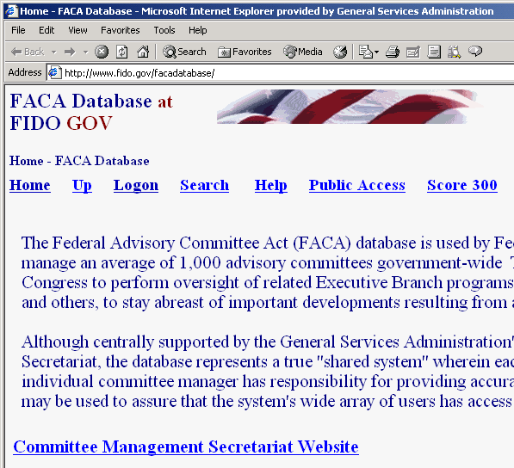
The opening screen for the FACA Database lets CMOs know that they have found the data repository and lists their options. The most direct address for the system is http://www.facadatabase.gov. The FACADatabase is part of the shared-interagency-database family at http://www.fido.gov. Buttons and hyperlinks control navigation throughout the system. The Navigation Buttons and hyperlinks that are visible change depending upon the purpose of the page and the requirements (or access rights) of the user. The navigation buttons and hyperlinks are located in the top border and the left border areas of the browser page. CMOs should move from page to page with the navigation buttons and hyperlinks as much as possible and avoid use of the browser menu and buttons (like the arrows to go back or forward) unless specifically instructed to do so on the web page they are viewing.

We emphasize the avoidance of the browser buttons because the FACA Database is truly a database and an online application. A database and online application operates differently on the Internet than purely informational net pages. Normal browser buttons are designed to take the user backwards and forwards to pages of static, unchanged, and perhaps unrelated content. The pages of a database system change in content with every selection, filter, edit, save, insert, and delete, but have a distinct, “keyed” relationship with the preceding and following pages as the user drills down or moves back up through the data. The user is involved in a content-limited work session, and if you start jumping around using the browser commands and button menus, it is possible for the database application to lose track of who you are and what committee you are working on. It doesn’t happen often, and the technology is improving to prevent this conundrum, but a word to the wise.

The eight hyperlinks on the opening screen navigate to
Home,
Up,
Logon,
Search,
Help,
Public Access,
Score 300, and the
Committee Management Secretariat
pages.
The cursor becomes a hand as the mouse moves over the hyperlink so the user can tell which link is being selected.

Up moves the user up (or back) to the Federal Interagency Databases Online (FIDO) page.

Search allows the user to search for any text or phrase in the entire set of data stored as part of this system. That includes the data comprising the fiscal year summaries, the committee charters, and any stored meeting minutes or reports. A complete discussion of the search feature is found in the Public Access (Section 1) part of the system manual. The search capability will always be constrained by the Internet search technology, our web site programming ability, and the quality and completeness of the data entered.

Help explains the syntax, terms, and meaning of items of information collected in previous years as part of that year’s Annual Report (before 1999) or Annual Comprehensive Review (after 1998). It also displays a selection of manuals that explain the system’s functionality to the different types of users. This manual is for the part of the system designed for CMO access. The manuals can be viewed on the screen with Microsoft Word or Adobe Acrobat Reader and printed.
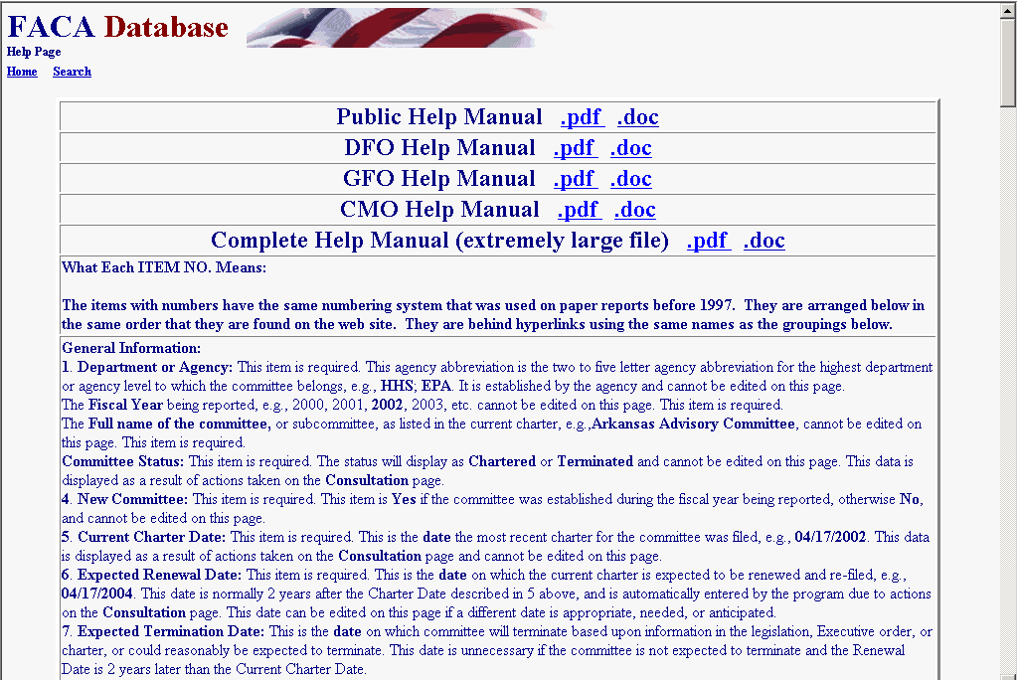
Public Access takes the CMO to a page listing the Fiscal Years of reported data in the system, the Database Search, the Member Search, the Download Center, and the available Annual Comprehensive Reviews/Summaries completed since the cessation of the printed, transmitted, annual report. All the data is read-only. A reviewer must always consider the data for the current fiscal year incomplete unless they know with certainty that the DFO updates the information throughout the year as events take place. At the end of the fiscal year, however, each DFO and the agency’s CMO are required by law to verify the accuracy and completeness of each committee’s data. The standard operating procedure is that the information on a committee should not be deemed official and complete until that committee’s data has been verified by the agency CMO for that fiscal year.

Logon allows CMOs or their designees who are responsible for the committee data and who have editing rights to log on to the current year and view and update the management data. Users with DFO rights can edit and update their individual committees, users with CMO rights can edit and update all of their agency’s committees, and the Committee Management Secretariat’s staff can edit and update all the agencies’ data.

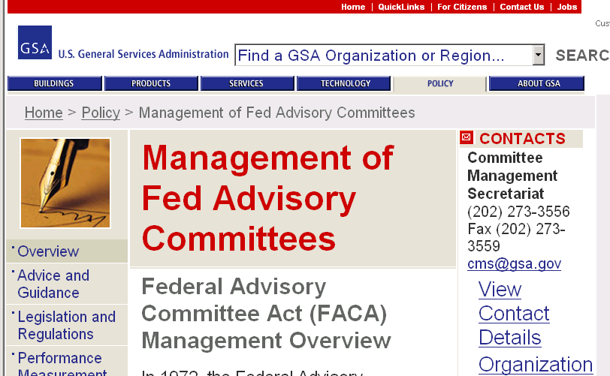
Committee Management Secretariat links the CMO to the Committee Management Secretariat’s home page on the GSA Portal. This home page is the launching point for a comprehensive examination of the advisory committee process, practices, history, case law, advice and training.

Logging onto CMO Committee Maintenance Activities

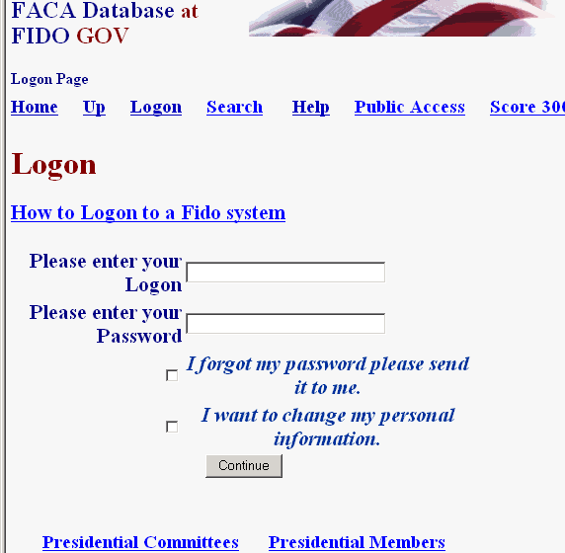
Clicking the Logon button displays the Logon page. The Logon page has four main navigation hyperlinks, three quick-report hyperlinks, four data fields and one submit button. The Navigation hyperlinks are Home, Up, Search, and Help. Home returns to the system’s opening page and ends the work session. We discussed Up, Search, and Help above. The report hyperlinks are Score 300, Presidential Committees, and Presidential Members, which are helpful status reports. The data fields are the LOGON Text Box, the PASSWORD Text Box, the OOPS Check Box, and the I WANT TO CHANGE Check Box. The submit button is Continue.

To Logon, the CMO enters his/her username in the Logon: Text Box field and their password in the Password: Text Box field. When the Continue button is clicked, the program advances to the CMO’s Committee List page. The CMO can change their user information any time they are logging in by checking the I WANT TO CHANGE Check Box before they click the Continue button.
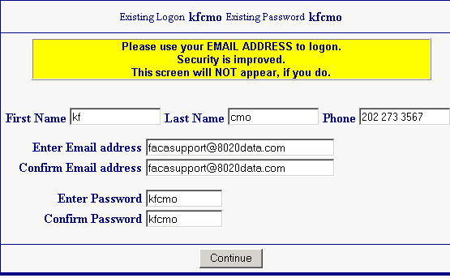
If the user fills out the User Profile/Information page, including their e-mail, than the OOPS Check box will work. To receive an email with their password, on the Logon Screen shown on the previous page the user enters their LOGON, checks OOPS, and clicks the Continue button.

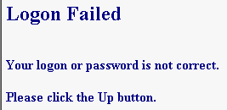
If the CMO receives a Logon Error, they should note the error explanation and contact the Committee Management Secretariat to adjust their access rights. If you enter an incorrect Logon or Password, you receive the “Logon-Password not correct” error.

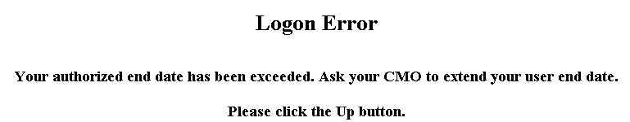
If your dates for access have expired, you receive “the Logon Date has been exceeded” error. The error displays “ask your CMO”, but in the case of the CMO getting the error, it really means “Ask Ken”.

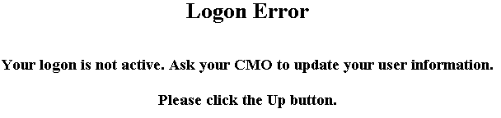
If the Committee Management Secretariat has designated you as an “inactive” user, you see the “inactive logon” error when you attempt to logon. In this case, the CMO also calls Ken.
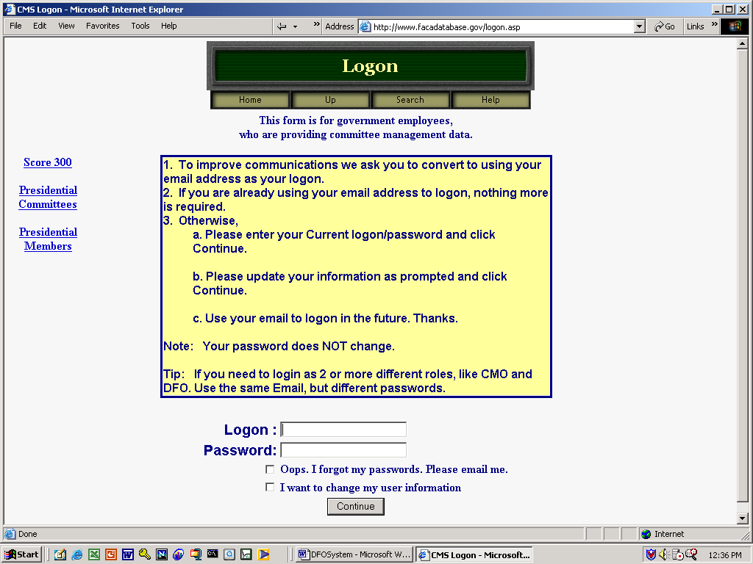
The “Score 300” hyperlink displays an activity ranking of agencies for the current fiscal year. It is a quick way to rank both the usage of the system by agencies as well as the likeliness of completeness and accuracy in the data for the public user. The color and the number of committees updated reveal how much data entry/updating activity has occurred thus far this year. Think of it as friendly competition. The user returns from the Score 300 page using the Up hyperlink.
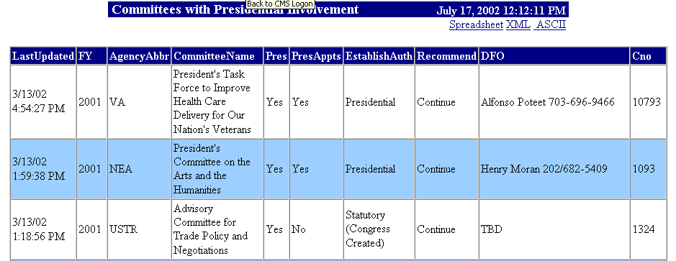
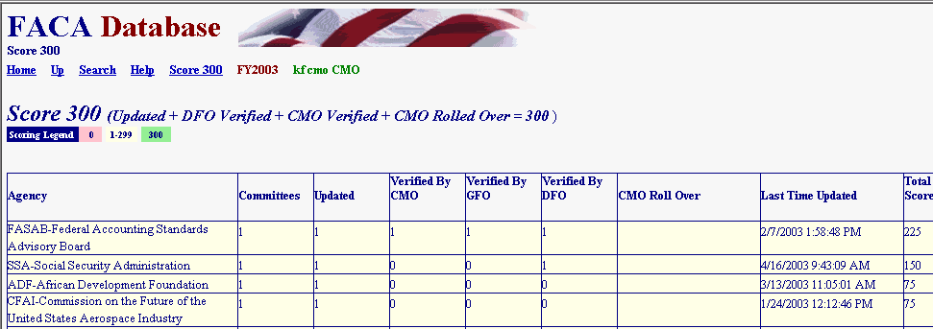
Clicking the Presidential Committees hyperlink displays basic committee information on committees that are either Presidential in type or established by the President. A committee is Presidential in type if it reports to the president even though it may have been established by Congressional Act. The committee listed in the third row is an example of Presidential type.

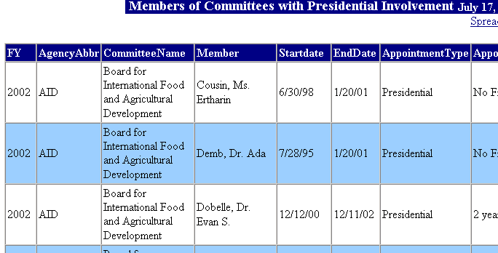
Clicking the Presidential Members hyperlink displays a list of committee members appointed by the President that are in the current year’s member list. These two hyperlinked reports are on the logon page to remind users logging on that these reports exist at the request of the White House Personnel office. These reports, like all of the database’s reports for the current year, are only as useful and accurate as the data is kept up-to-date. They are also good reasons for weekly updates to the system.

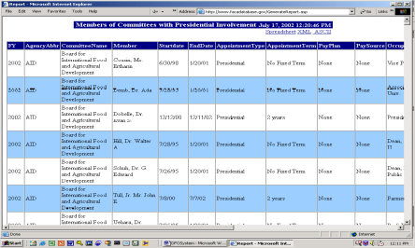These reports, like all of the database’s reports, can be downloaded to the user’s computer for more direct use and customization via the Spreadsheet, XML, and ASCII hyperlinks. The XML selection allows import into almost any kind of database. The ASCII selection creates a text file that can be imported into any word processor. None of the data kept for public accession online is subject to privacy provisions. Any public user may download all of the publicly accessible stored data in the online system.

The CMO’s Committee List and Management Activities

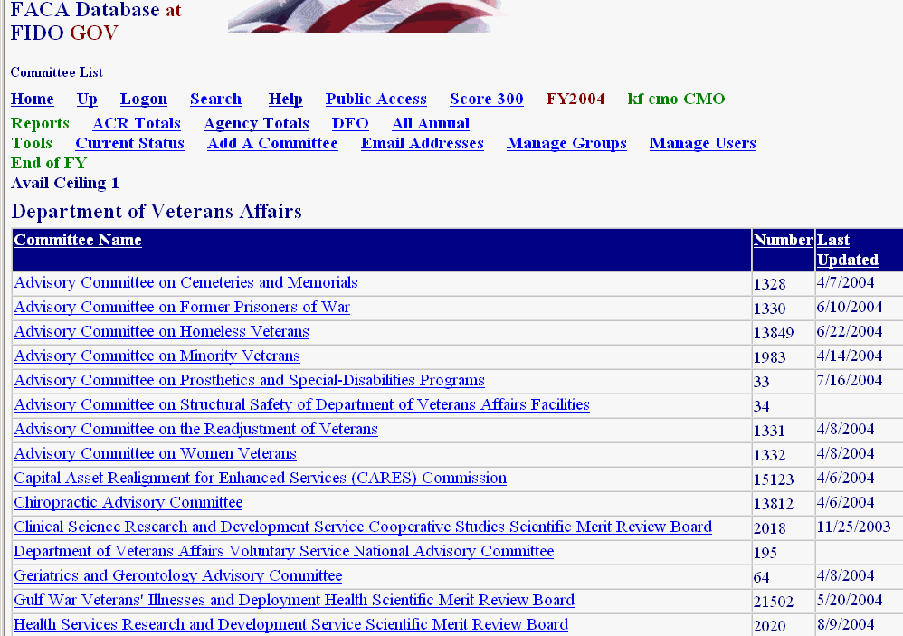
When the CMO logs on to the system, they are taken straight to the Committee List Page for their agency. The Committee List page provides the CMO with access to any of their committees, and displays the hyperlinks that navigate to most of the management functionality in this web system. We will discuss the hyperlinks first, then the option buttons, and finally, access to the individual committees.
The Committee List page currently displays fourteen hyperlinks in addition to the links to the agency’s committees. We have already discussed Home, Up, Search, Help, and Score 300. The new links are to other report and management areas that the CMO should find useful. The links are grouped by:
Reports:
- ACR Totals
- Agency Totals,
- DFO Report, and
- All Annual Reports.
Tools:
- Current Status,
- Add a Committee,
- Emails Addresses,
- Manage Groups, and
- Manage Users.
End of FY:
ACR Totals
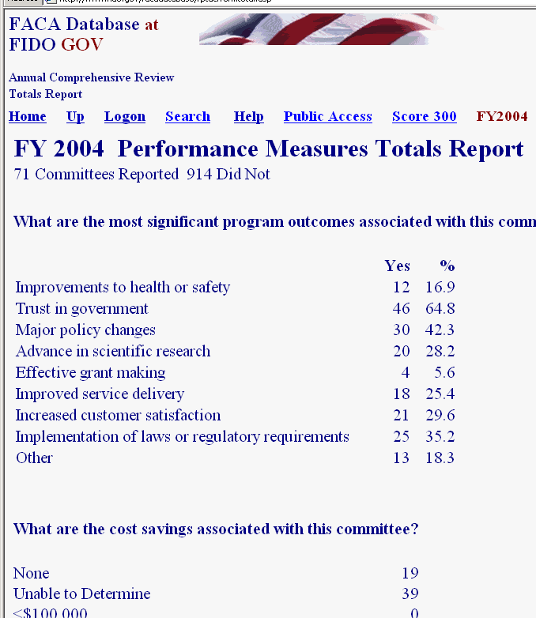
The ACR Totals Report link displays the ACR Totals page. These totals are for the categories of performance measures that are of interest to the agency, Congress, and the public during and after the reporting year.

Agency Totals

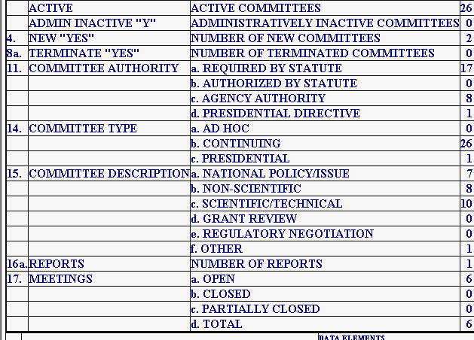
The Agency Totals Report link displays the Agency Totals page. These totals are for categories of committee activity that are of interest to the agency, Congress, and the public during and after the reporting year. The report totals new committees, terminated committees, the distribution of committees by authority or function, the number of meetings, reports, members, costs, and federal staff time engaged in the agency’s advisory committee effort.

The accuracy of the report at any point in time during a current, active reporting year depends upon the frequency and timeliness of committee information data entry on the part of the DFOs. The timeliness and frequency of DFO data entry depends, for a large part, on the requirements, interest, and guidance demonstrated or provided by the agency leadership and the agency CMO.

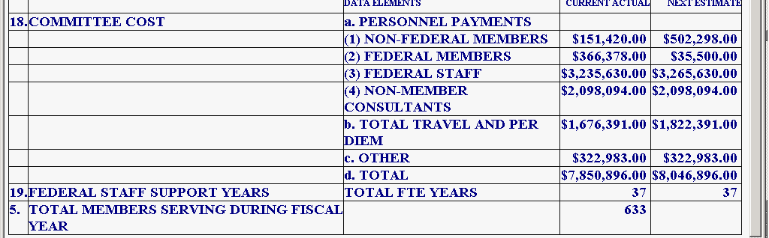
DFO Report
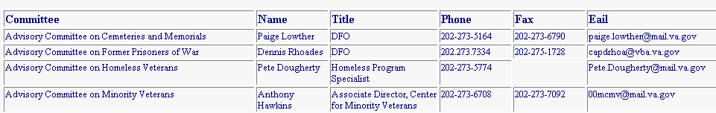
The DFO Report link displays the DFO Report page, a listing of the Committees and the assigned DFOs’ contact information. Like all the system’s current year reports, this information is only as useful as the DFOs’ timeliness in keeping their information up to date.

All Annual Reports

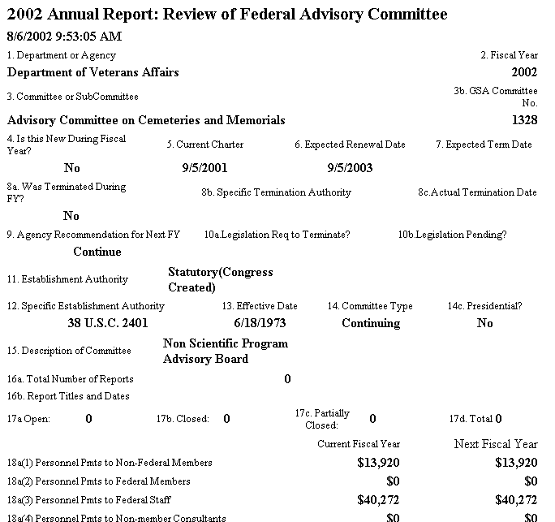
The All Annual Reports link displays a printer-friendly, continuous, scrollable page of all the reportable information for all the committees in the agency for that year to date. This report is generally only useful after the end of the reporting cycle after the end of the fiscal year. Depending upon the number of committees in the agency, this page can take a “very” long time to generate the first time it is created, loaded to the web site, and displayed on the screen. This page can also be saved to a Word document, although the larger the number of committees, the larger the file size and the longer the save process. Once in Word, the user can add page breaks and other formatting features to display the reports as required. To return from this page to the system menu pages is an instance of when the CMO will have to use the browser Back button.

Current Status

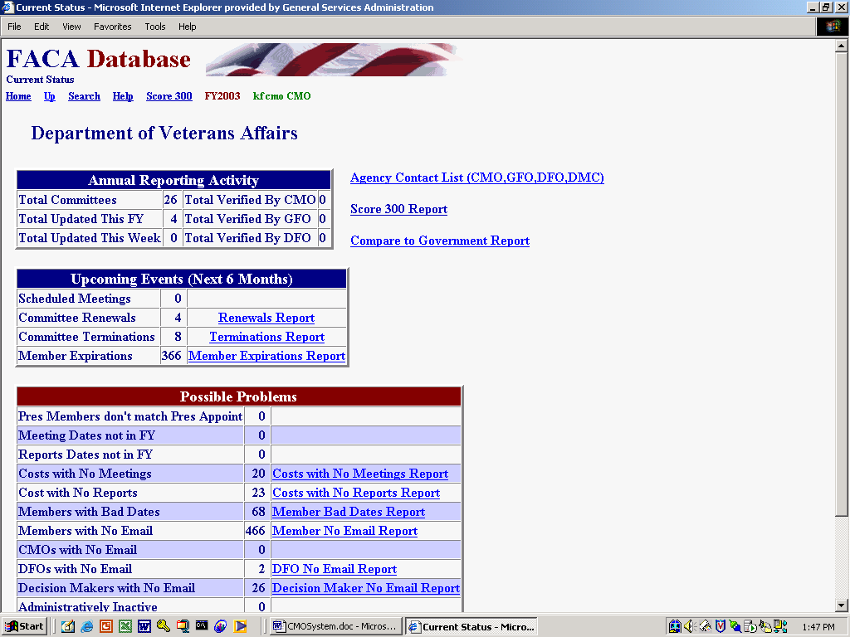
The Current Status link in the Tools group is an assortment of helpful, heads-up and on-guard reports for the CMO and other parts of the agency leadership.
Reports (signified by a hyperlink) are only generated if data is present that makes the report potentially relevant or suggests that a “possible” problem could exist.

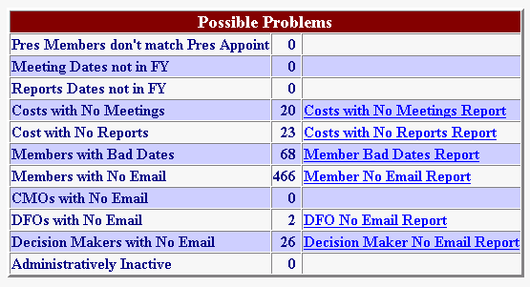
For instance, the General Info page has a Yes/No response field regarding whether any committee members are Presidential Appointments. The Members List page has an appointments field that indicates the source authority of the appointment. Is there a problem if the pages don’t agree? Usually! Could there be a reasonable explanation for the conflicting information? Possibly? In all cases, intelligence is to be applied. These report items are potential alerts, not flags that specific content is wrong.

Agency Contacts List

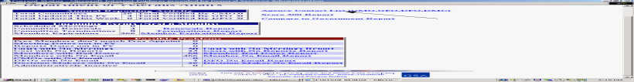The Agency Contacts List includes everyone in the agency with Logon rights in the Users List.

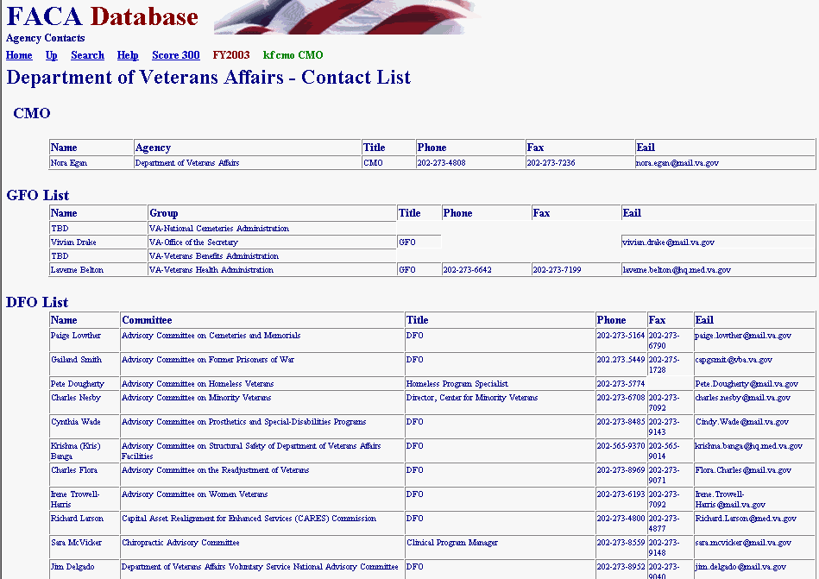
Compare to Government Report

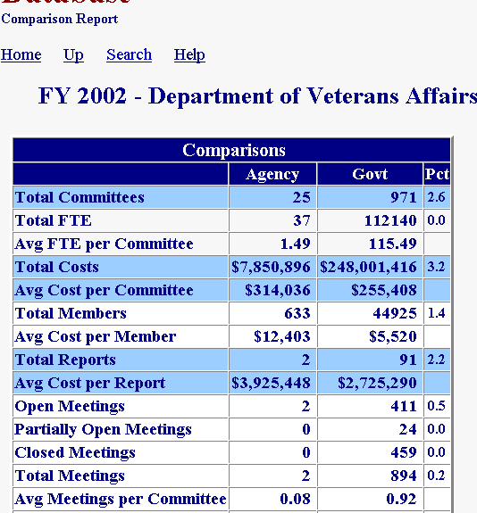
The Compare to Government Report on the next page in this manual compares agency averages to government-wide averages. Of course, this kind of report is only as useful as the agency data is up-to-date and the rest of the government data is up-to-date. We will be adding functionality to allow agencies and committee to do some data mining and to compare themselves across years, i.e., the agency to itself and the committee to itself in previous years.
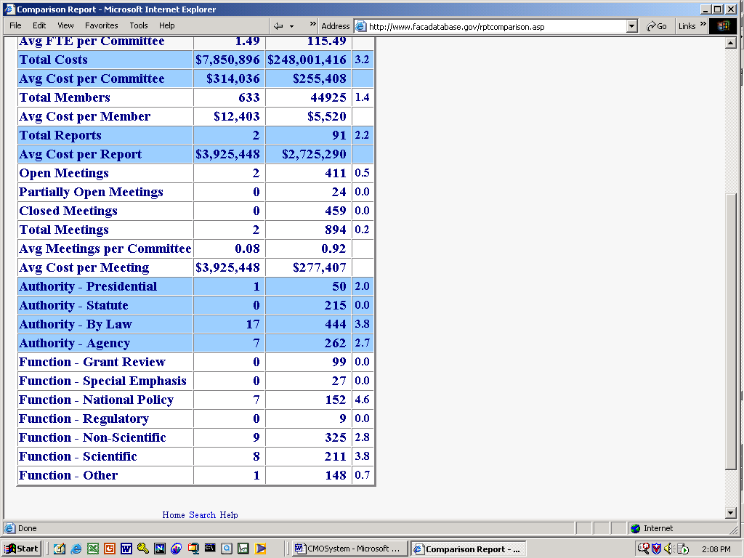

Add a New Committee

Despite the fact that at least one government agency has more than 250 advisory committees, creating a new Federal Advisory Committee is not a casual act and usually requires an enormous amount of collaboration and coordination. When the agency has completed all the background work and the CMO is ready to add a new advisory committee to the agency roster, doing so can occur online with the Add a Committee link from the Tools group.

The New Committee Information form has fields for all the information required by the Federal Advisory Committee Act to establish a new committee. The CMO should fill each field out completely and specifically. No field should be left blank. If, for some unimaginable reason, the CMO does not replace the “directions” in the data-entry fields with committee-specific information, the “directions” should be left intact to be answered by whoever will be filling them out, as every field is a required field. The information required by this form was developed by the agency in the process of formulating the charter. Once entered, the data will carry forward to all the committee pages used for the annual review process.

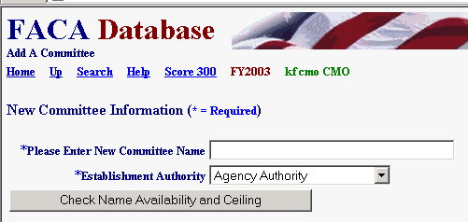
The first text box requires a unique committee name. The name must be unique not only to the agency but to the entire list of advisory committees, hence the Check Name Availability button. The second text box asks the CMO to select the establishment authority under which the committee is being created. When the CMO clicks the Check Name Availability and Ceiling button, the program checks to see if the name is already in use and, when the authority is discretionary, if the agency has available slots for new discretionary committees.

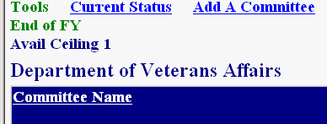
The CMO should be aware of the agency’s room to create new “discretionary” committee since their available “ceiling” (or room to grow) is displayed on the Committee List page below the Add a Committee hyperlink. This is not an issue if the committee is established with Presidential or Congressional Authority.

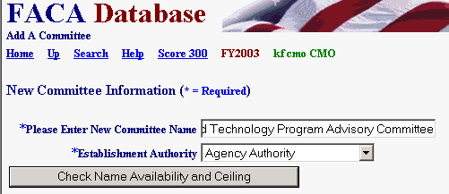
If either of those tests fail, the CMO is alerted immediately with a message similar to the one below. If the CMO should get an unexplainable error, they should stop what they are doing immediately or their computer could blow up. Well, maybe not, but at least call Dr. Fussell and clue him in that there is a problem.

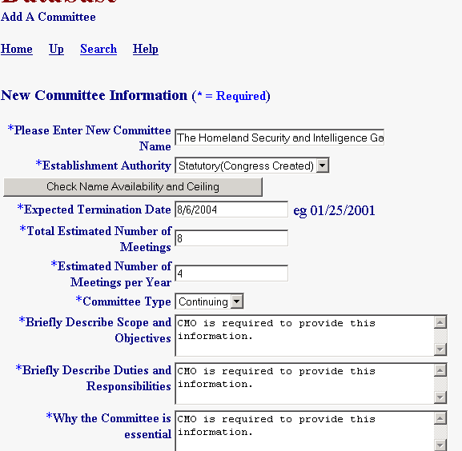
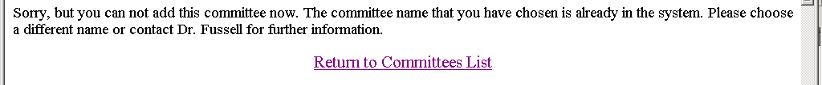
If the name is unique and the agency has sufficient ceiling, the CMO continues to fill out the information. The required information already exists in electronic format in documents, previously exchanged e-mails, and word-processing files generated within the agency while formulating the new committee’s charter and mission. The CMO displays the relevant document in a word-processing program, “copies ” the needed information from that document, and “pastes” that information into the appropriate fields in the FACA online New Committee Information form. The CMO may find it occasionally helpful to point out to others urgently trying to set up a new committee, that if this information does not already exist in some kind of accessible electronic media, perhaps the agency is not quite ready to establish the committee.

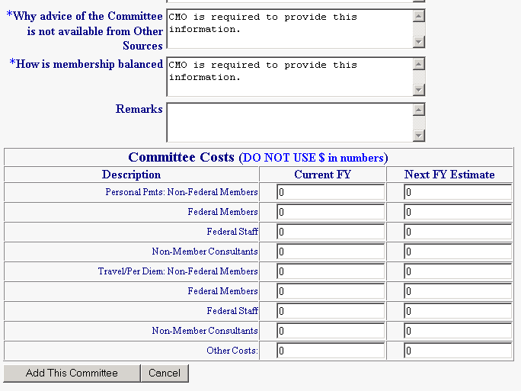
Every single entry will find its way into the FACADatabase. Please don’t give in to the temptation to be as pithy as the example. The data entry page continues below the bottom of the screen. Scroll down to fill all of it out. The Total Estimated Number of Meetings field and the Estimated Number of Meetings per Year field use a numeric response. Please type in the number “20” instead of “20 meetings”, and type in “4” instead of “4 per year”. There should be some projected costs shown as well. The data that is entered will be copied into the fields used for the comprehensive annual review. It is understood that all these entries are probably estimates that will be updated and corrected later. Every field except “Remarks” requires an entry. Costs are in whole dollars, so use numbers without dollar signs ($), commas (,), and decimals (.).

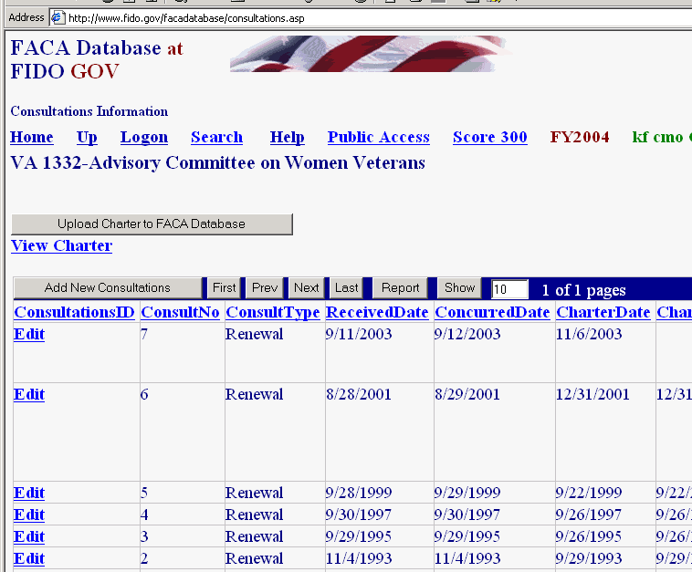
As mentioned above, when the new committee is submitted by clicking the Add This Committee button, the data is transferred to the comparable fields for the annual review process. The new committee is created in the system and the Consultation page for the new committee is presented to the CMO user. An automatic “alert” e-mail is generated by the system and sent to the agency’s Desk Officer at Committee Management Secretariat. Whenever the Consultation page is Updated and saved, the program will generate an e-mail to the Agency CMO and the Desk Officer at Committee Management Secretariat, alerting the staff to the new committee. If the CMO creates a committee and does not notice an e-mail proclaiming the action, it would behoove them to contact CMS and let their Desk Officer know. At this point in the creation of a new committee online, the CMO can open any of the pages accessible from the Committee Menu and further edit the data they added to the fields in the Add A Committee form. As an alternative, of course, the CMO could add the DFO to the Agency user list and have the DFO log on and bring all the committee information up-to-date. The DFO System Manual discusses the complete scope of committee information that should be added or maintained in each discrete fiscal year.

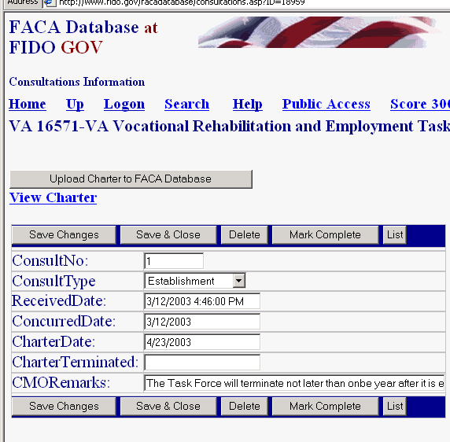
Before leaving the Consultation page the CMO should click the Edit link and add any data necessary to complete their part of the initial consultation process. The consultation record shows that the type of consultation is an Establishment. Creating a new committee with the Add a Committee form is always an Establishment. You can also assume that the establishment process generally needs further explanation, so let your Desk Officer know what you are planning to do next in the Comments field. After the CMO adds any comments or dates, they save the changes with the Save button. Several emails go back and forth between the CMO and Desk Officer because whenever anyone saves a change to a consultation record, the system again generates e-mail to the usual suspects.

The Consultation button, which is found on each committee’s Committee Menu page, is also used for Renewals, Re-establishments, Amendments, and Terminations. The Consultation page includes the Upload Charter to FACA Database button. Charters can be uploaded so they can be displayed on the online system if they have been saved as a file in a word processing format like .doc, .txt, .rtf, or saved as a .pdf file, and if they have been saved in a folder accessible to your computer.

Emails Addresses

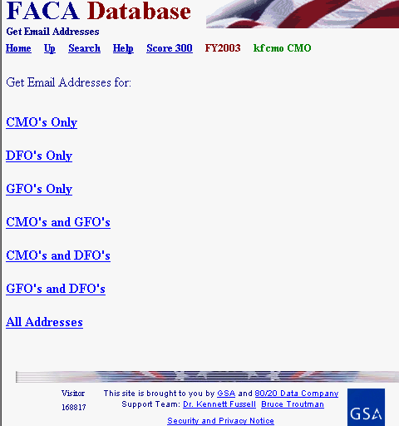
The Get Emails link displayed in the Tools group provides different combination of email addresses. These emails belong to the agency users of the online system. The emails are found in the user profiles and the DFO page data and the CMO page data kept in the online system. This information extends beyond the formal agency DFO list to everyone with responsibility for data management from the agency in the system that has been given a login or otherwise added to the system list, including decision makers, supervisors, and administrative staff. We expect a contact list like this to become more and more useful, so it is best to urge everyone to keep his or her information up-to-date.

Manage Groups

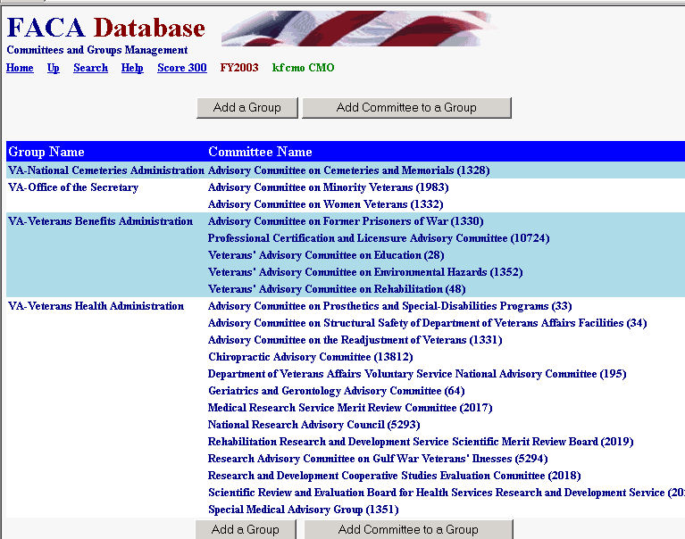
Larger agencies often manage and report their advisory committees in significant sub-group breakdowns in addition to the Agency-Wide Totals. The Department of Defense often has a need to report about committees concerned with Army issues separate from Navy issues. The Manage Groups link opens a module that allows a CMO to create a useful sub-group name (National Park Service) and then attach advisory committees from the agency to the sub-group.

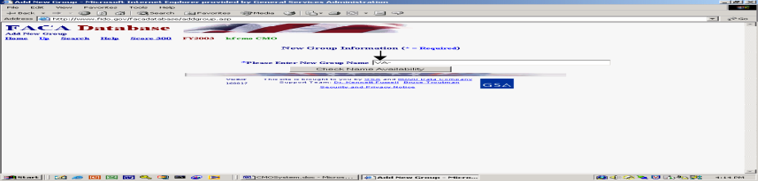The Add a Group button allows the creation of a new group. Committee Management has established a standard naming convention in that all new groups will have the agency abbreviation as an initial prefix (see the screen-shot). We leave the rest of the group name to your needs and imagination. It helps when creating group names to remember that our online system has a public access component. Any new group names should be distinct and intelligible to the small remaining public part of the US population that does not have a military or government work experience.

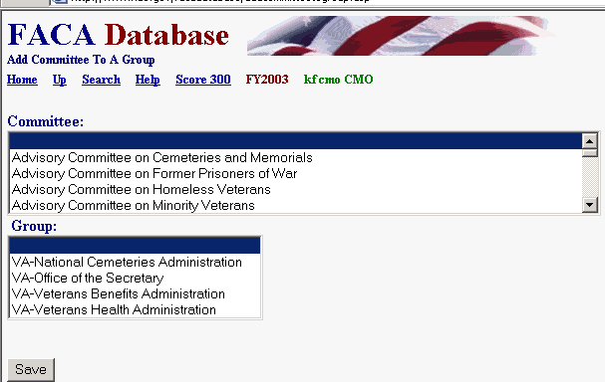
The Add a Committee to a Group button allows the CMO to add an agency committee to an existing agency group. The process involves selecting a single committee, selecting a single group name, and then clicking the Save button. To add a second committee to a new group the same sequence is repeated. This may appear tiresome if you are creating a new group with 50 committees, but it only has to be done once. Newly created committees can be added to existing groups the same way. While we have hopefully made the process of adding groups, and committees to groups, easy, careful thought should precede the willy-nilly creation of groups of committees. One reason for care is that we have not provided a way for the CMO to remove a committee from a group or a group from an agency. This remains a manual operation, although “terminated” committees are automatically dropped from the group the year after the committees are terminated.

Manage Users

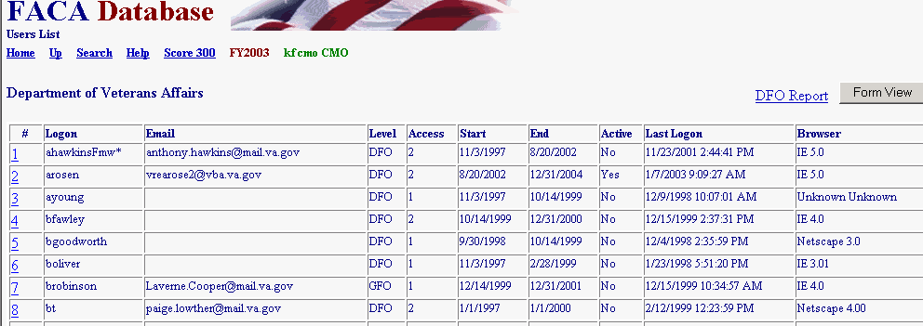
The Manage Users link displays the list of agency users and their access rights on the system. After the Committee Management Secretariat staff gives the user CMO status on the system, the CMO can
- Add users at the GFO and DFO levels of use and assign them a group or a committee,
- Control whether users can edit the current year’s data,
- Limit when a user will have access to the system, and
- Look up the user’s password.

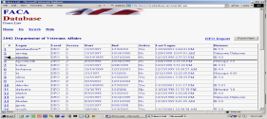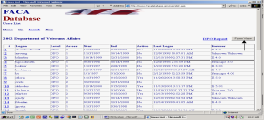By clicking the hot link, which is the underlined number at the left of the row of user information (see the screenshot to the left), or by clicking the FormView Navigation Button (see the screenshot to the right), the CMO displays a user record to edit. The Form View Button displays the first record in the list in a form. The records are reviewed alphabetically. The Hot Link displays the record of the user identified in the Logon field. The DFO Report link displays all the user data in a list view.

User Form Rules and Codes to Assign User Rights

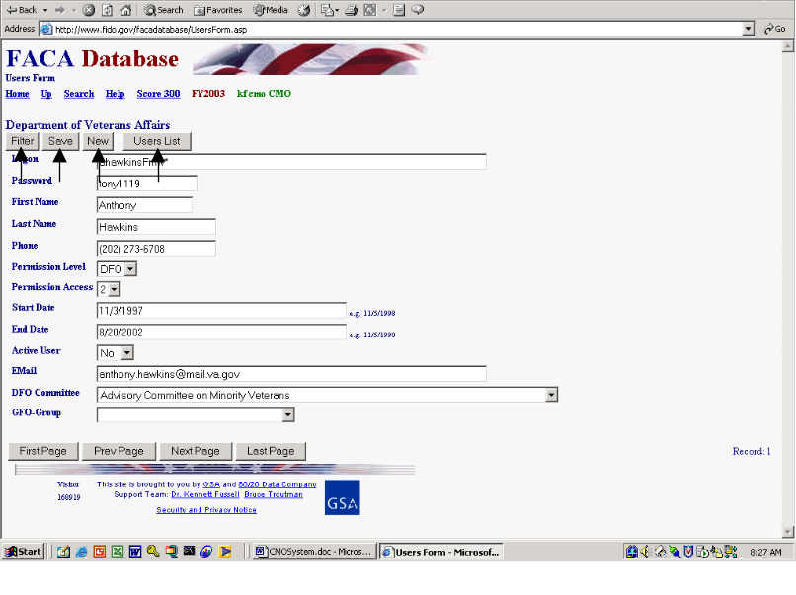On the User Form the CMO will find buttons to Filter for a specific Logon, Save an edited record, add a New user, and return to the User List, but the CMO will not find a button to delete a user. Once a user is added to the system, they are kept in the system forever so that there is an audit trail regarding who created or edited the data in this record of the system. The personal identification information is displayed in a profile form when the new user logs on. When adding a new user, the CMO should focus on the logon, password and the user’s access rights. The DFO and GFO will have an opportunity to complete any contact-information-fields that are left blank in the user profile form when they first logon.

The rules and codes regarding the user information and access rights (permission levels) follow.
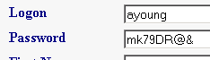
- The user’s Logon name and Password together form a unique key field that is not duplicated in the system. The username (Logon) should normally be in the form of the user’s government email address, but the logon can be a combination of the first letter from the first name and the full last name if necessary. The actual user should be identifiable and recognizable from the username.

- The Password can be any combination letters, numbers, symbols, characters, and case of up to 16 positions long. The password can be duplicated in the system with other users’ passwords. However, if the individual user has more than one login, each of the individual user’s passwords associated with each login must be unique. Passwords are generally a system’s weakest point of defense from unwanted intrusion, so, unfortunately, the best password is such a complicated combination of letters, numbers, characters, and symbols that you will never be able to remember it.

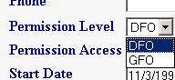
- The CMO can add users at two Permission Levels, GFO and DFO. The DFO can only view and edit their single committee when logged on, the GFO can view and edit all the committees in their assigned group.

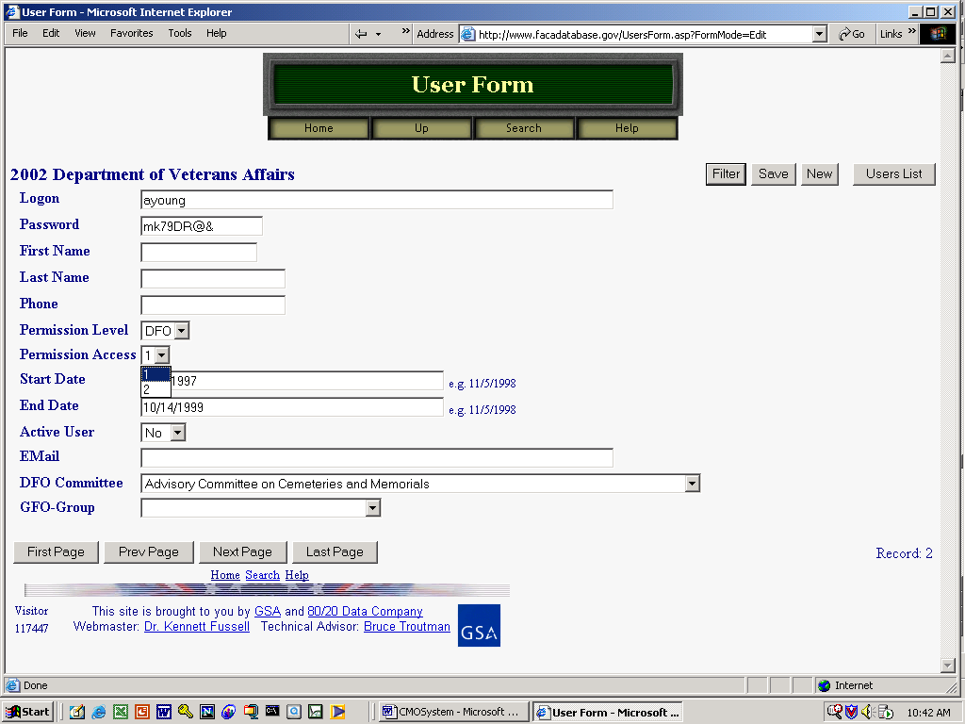
- Permission Access is either read-only: 1, or edit: 2. A user needs a Permission Access of 2 (EDIT) to make changes to the data and add new information.

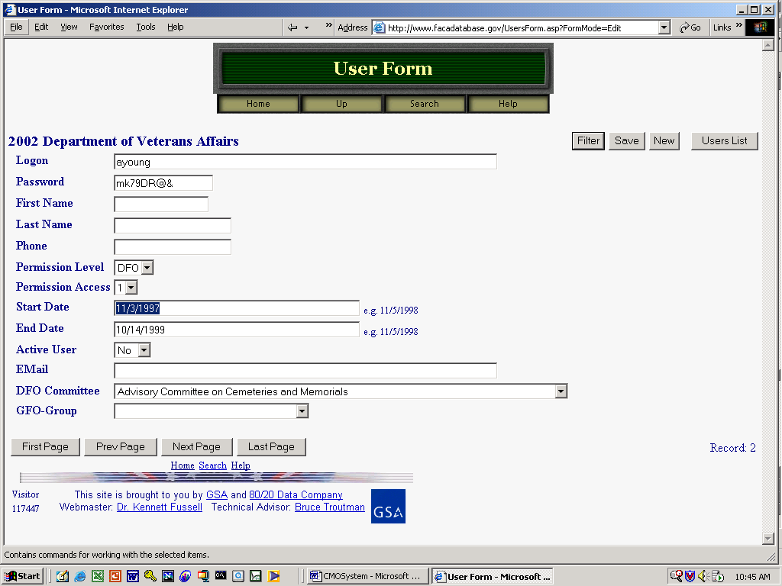
- The Start Date is the earliest date that a user can logon and the End Date is the last date that a user can logon.

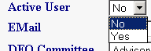
- The Active User can be set to “Yes” or “No”. This field is used to turn a user’s logon rights on or off without having to change all the other settings. Committee Management Secretariat regularly switches the Active User setting to no for users who have not logged in for a full year.

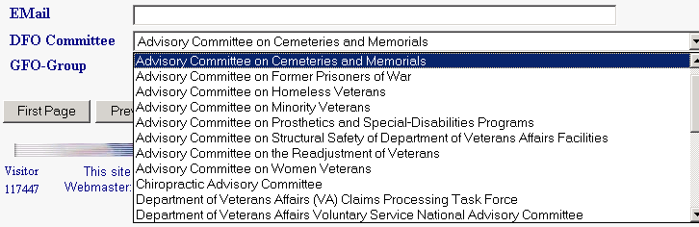
- The Committee for which the DFO user is responsible can be set from the “DFO Committee” pull-down. The pull down list will display all the possible committees for the agency. To select the DFO’s committee, the CMO clicks on the correct committee.
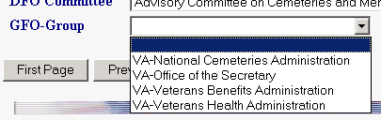
- The CMO can assign a GFO to an existing group. The CMO must set up a group before a GFO can be assigned to that group. The CMO should click “Save” before leaving the page after completing any changes to a user form.

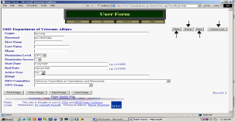The Filter button on the User Form displays a filter page so that the CMO can quickly find a user record based on the most relevant criteria. The New button displays a blank data entry page for adding a new user. The CMO returns to the full read-only User List page with the Users List button.

Filtering for Specific Users

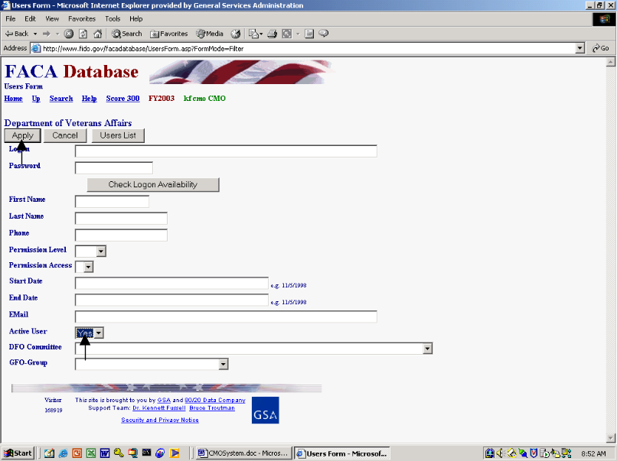To use the Filter page, the CMO selects criteria like Yes for the Active User text box and clicks the Apply button. The Cancel button cancels the Filter page.

Saving New Users

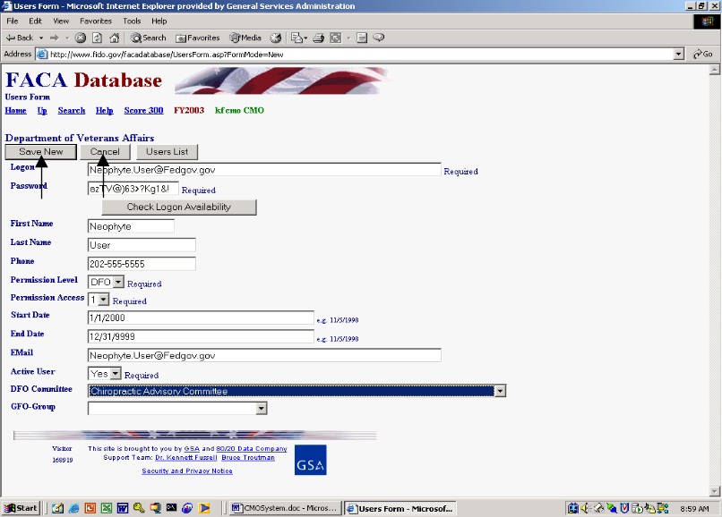The CMO fills in all the contact information and applies the permissions and rules to create a new user, finally “saving” the information on the new user by clicking the Save New button. The CMO can abandon the new record at any time before the “SAVE” action by clicking the Cancel button. If the CMO suspects that they are creating a duplicate logon combination, they can fill in the Logon and Password and click the Check Logon Availability button. The system may overreact quite negatively if you attempt to create a duplicate user, so cover your eyes before you click the Save New button in doubtful situations.

The End of FY group

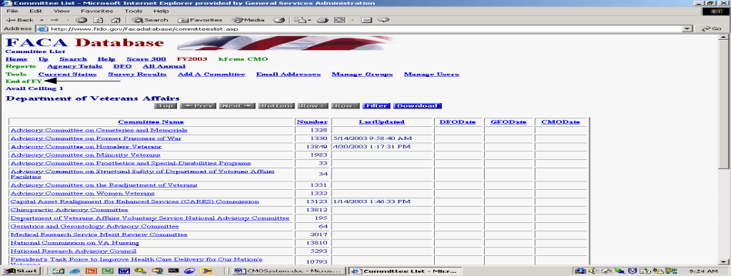Generally, CMOs and the Committee Management Secretariat have the need during the first quarter of any new FY to continue to manage the advisory committee process for the current FY. At the same time, they need to finalize and verify the data reported for the Fiscal Year that was just completed. While advisory committees are a continuous and ongoing fact of government, the Congress in the Federal Advisory Committee Act requires that each individual FY of each Advisory Committee’s life be treated as a separate, discrete, reportable unit. When we are involved in that period, there are several additional links found in the End of FY group to support the completion of that process while trying to avoid confusion. The added links are usually somewhat intuitive, and the CMOs receive regular and inundating communications from Committee Management about how to use the links and treat the reporting period. You should check the online help at that time for updated versions of this help manual that has a section speaking directly to the use of the added links.

The Committee List page and Committee Name Hyperlinks
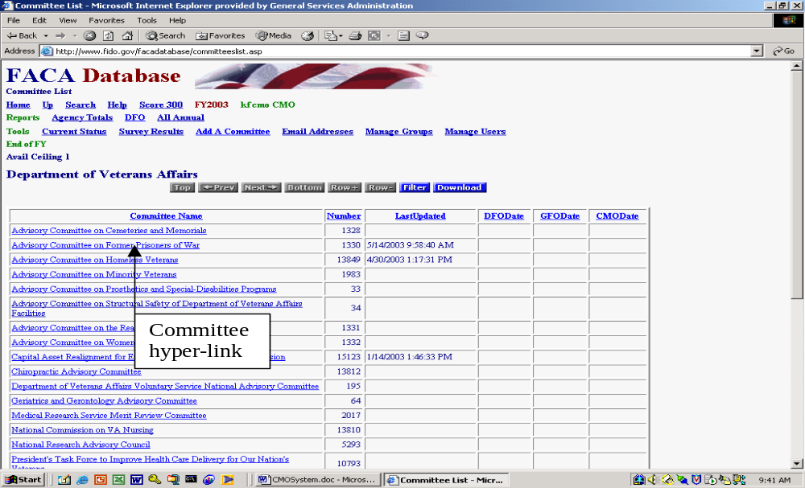

The CMO has complete editing rights to all the committee data. Changes to the pages are made, and meetings, reports, and members are added by linking to the correct data entry page through the Committee Menu page. The CMO reaches the Committee Menu page via the Committee Name hyperlink from the Committee List page.

The Committee List page also keeps the CMO informed of the last time a committee’s data was updated. The data validation status for completing the reporting year is managed by means of the date stamps in the DFODate, GFODate, and CMODate columns.

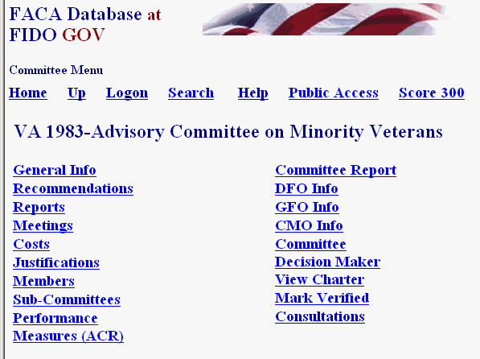
For further data entry directions, the DFO System Manual has a complete explanation of the Committee Menu page options. The links shown in this manual may be able to display that manual if you have opened this document in Microsoft Word. The menu options include
- General Info,
- Recommendations.
- Reports,
- Meetings,
- Costs,
- Justifications,
- Members,
- Sub-Committees,
- Performance Measures (ACR)
- Committee Report,
- DFO Info,
- GFO Info,
- CMO Info,
- Committee Decision Maker,
- View Charter,
- Web Site,
- Mark Verified, and
- Consultations.

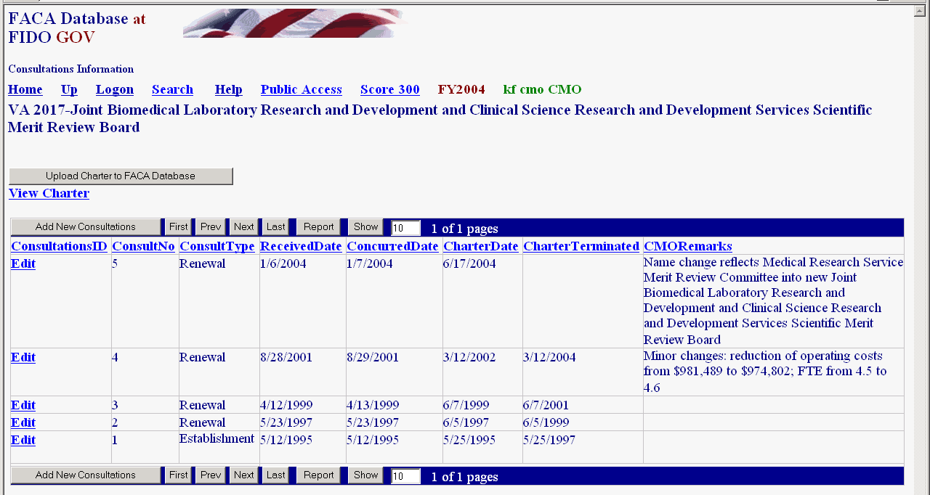 You may remember from our discussion long ago and many pages above, when the CMO views the Committee Menu page from their logon, the CMO sees a link (Consultations) that is not available to the DFO. The CMO can edit all data (consistent with the system’s security and design), but sometimes changes have to be made on a different page then the page that displays the information. An example is that some General Information page data can only be updated through the Consultation page by the CMO.

The Rest of the Story

There are many other features and reports available to assist the CMO in the FACA Database online system, most of which are found and described in the Public System part of the manual. All of the features and reports are only as useful and accurate as the data is kept up-to-date. This task falls primarily to the DFOs or their designees. Keeping the system up-to-date whenever the committee data changes transforms the FACA database into a highly sought commodity in government: a useful, interagency data sharing and management tool. The FACA Database online system has been available since 1997. It is a living system in the sense that it has grown in usefulness and functionality (and size) every year that it has existed. Some of the improvement is due to the improved technology of the Internet, and a little can be counted due to the increasing skill of the development team. However, most of the improvement is due to the feedback, patience, and willingness of the users to participate both in the development process and with on-line record keeping. The FACADatabase is truly a shared system that belongs to all of us.

