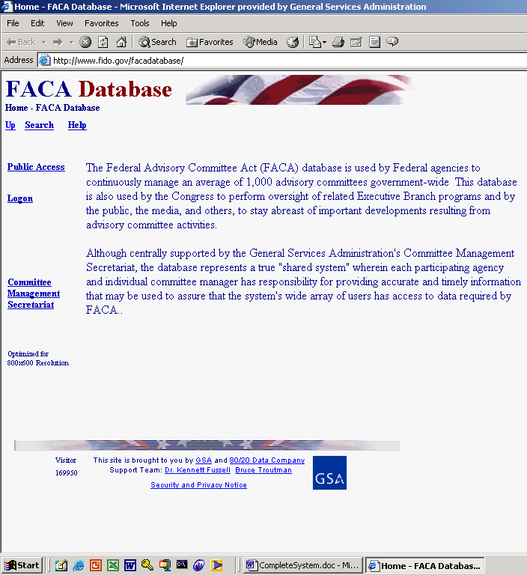

The FACA Database System

Committee Management Secretariat
SECTION I: Public Access to Advisory Committee Data

What is the FACA Database?

The FACA database is a specialized, Federal Government, interagency, information-sharing database available publicly on the web. The Federal Advisory Committee Act (FACA) originally required that specific data items about advisory committees be collected by the President at least annually and transmitted to Congress for review. This data collection and summarization was done annually, after the end of the calendar year, in the seventies. When the government changed to a Fiscal Year starting in October, the data collection was done in the fall, after the end of the FY. This data collection, collation, summarization, and publication continued, with minor changes in data items, content, and presentation, for 26 years from 1972 through 1998. The process would begin each year with the more than 1000 committees throughout the government submitting paper reports on approved forms and in an approved format to their agencies. Some of the reports were hundreds of pages long due to the number of members and the numbers of meetings. The agencies duplicated the reports (8 copies per committee), summarized the numeric data (member counts, meeting counts, costs breakdowns, etc.) by their agencies, and sent the sets of duplicates and summaries to the Committee Management Secretariat. The Secretariat, with a small staff of usually less than 6 employees, spent most of a year 1) combining the committee reports, arranged by agency, into multiple loose-leaf bound sets for shipment to the Library of Congress; 2) summarizing and analyzing the numeric data by agency into a publication; and 3) submitting the printed report annually to Congress over the President’s signature.

In 1997 this web-based database began to be used by all the government agencies that have advisory committees to collect and report that data. In 1998, this online system was demonstrated to Congress (in the form of a Government Oversight Committee Hearing). In 1999, Congress determined that “the printed and transmitted hard-copy annual report” was no longer required. With this online, publicly accessible, continuously updated, data-collection and management system, the Congress, the President, the Agencies, the Committee Management Secretariat, and the “public” user have complete access to the data in the system via the Internet in a read-only mode, almost in real time. The reason for the caveat, almost, is the reality that the data for the current year can only be considered complete and accurate after it is verified and certified by the agencies at the conclusion of the fiscal year.

The Federal Advisory Committee Act continues to require that the agencies, through their Committee Management Officers (CMOs), provide information about the agency’s advisory committees for an annual comprehensive review. This web-based database accommodates and builds upon that requirement by both allowing the continual updating of committee information throughout the reporting year and providing ongoing committee-management functionality. Each advisory committee’s Designated Federal Official (DFO) primarily uses the system to update the information on their advisory committee during the current fiscal year, but doing so allows them to both 1) manage the committee information flow within the agency as frequently as required, as well as to 2) report the data required by law. The DFO is given their access rights to this online system, their logon (username) and their initial password, by their agency CMO. The CMO is given their access rights by the Committee Management Secretariat. The DFOs and CMOs, like any other public users, can view all of the information on all of the committees of all the agencies of the federal government available for the current fiscal year in a read-only mode. At the same time, only the DFO, or their designee, the agency CMO, or their designee, or a Committee Management Secretariat (CMS) staff member can edit or update the committee data for the current year.

Keeping the data continuously up-to-date converts the system and the process of record keeping from a focus on history, to a focus on management and immediate relevancy. With frequent and timely updates, the system becomes more useful to everyone. Everyone, in this extraction, ranges from the public user interested in a specific issue, to the agency official wanting an overview of specific committee activity, to the agency manager who would like a broader view of committee activity across the agency, to researchers at the Library of Congress, to congressional or executive branch staff with oversight responsibility.

What kind of data has been collected?

For the DFO, the program collects and displays
- Charters and related information,
- Members and their appointment information,
- Costs,
- The agency’s recommendation for continuation or termination of the committee,
- The committee’s recommendations to the agency and the actions taken on the recommendations (this will be added in the immediate future),
- Report titles, publication dates, and the text of the report,
- Meeting purposes, dates, location, whether the meetings were open or closed, and the minutes or transcript,
- Activity and justification (raison d’etre) information,
- DFO appointment and contact information,
- Committee Decision Maker contact information,
- Web site addresses for the committee or accessing committee information like the minutes, reports, and recommendations, and
- Committee interest or issue areas.
This information exists for each committee and is aggregated by the agency as well as by the whole government, by year. The database does not contain meeting announcements, although proposed future meetings can be listed and there are provisions for other additions in the future. Some of the committees upload their meeting minutes or reports to this system. Some of the committees also put their meeting minutes, transcripts, meeting content information, reports, and recommendations to the agency on their committee web site or the agency web site. While the law requires that the minutes and reports be maintained in a central and accessible location, during and well beyond the active life of the committee, it does not require that the minutes and reports be uploaded to this system.

For the CMO, the program collects, totals, accesses, and/or displays all the information available to the DFO mentioned above. Specifically for the CMO the program also collects, totals, accesses, and displays information that includes
- A current year list of agency advisory committees and the committees’ update status,
- An agency totals report of the distribution among committees of establishment authorities and committee functions, and the total meetings, reports, costs, and members,
- A listing of committee DFOs with their contact information,
- A complete set of the current annual comprehensive reviews for all the committees in the agency,
- Filters to limit the number of committees viewed on the Committee List page at any one time,
- The ability to add and manage agency users of the agency’s committees’ editable and reportable data,
- The ability to add a new committee to the FACA committee list online,
- A current status overview to quickly put the CMO in touch with the activity level of their committees as recorded in the online system and a growing set of heads-up/potential problem comparisons about and between agency committees and government averages,
- The available discretionary ceiling pertinent to the agency for new committees,
- The ability to create and manage sub-groups of committees within the agency, and
- E-mail listings for individuals in agency groups responsible for advisory committee activity.
In addition, when viewing an individual committee, the program allows the CMO to establish, renew, re-establish, amend, or terminate a committee, and upload a copy of the charter to the system (with the Consultation button). Most users do not see the Consultation button when viewing a Committee Menu page. Users only see the data and functions their permission level allows. Most of the meetings and work of federal advisory committees are considered public information, and all the data stored in the system except for committee members e-mail addresses are available for downloading and viewing. At the same time, the system provides management functionality to the committee managers and the Committee Management Secretariat, so some functional parts of the system are not viewable by all users.
How does one use the system?

FACA established that each agency shall establish uniform administrative guidelines and management controls for advisory committees established by that agency, and that each agency shall maintain systematic information on the nature, functions, and operations of each advisory committee within its jurisdiction.
The law’s language directs that the head of each agency that has an advisory committee shall designate an Advisory Committee Management Officer (CMO) who shall –
- Exercise control and supervision over the establishment, procedures, and accomplishments of advisory committees established by that agency;
- Assemble and maintain the reports, records, and other papers of any such committee during its existence; and
- Carry out, on behalf of that agency, the provisions of section 552 of title 5, United States Code, with respect to such reports, records, and other papers.

The law also states that
- There shall be designated an officer or employee of the Federal Government to chair or attend each meeting of each advisory committee. The officer or employee so designated is authorized, whenever he determines it to be in the public interest, to adjourn any such meeting. No advisory committee shall conduct any meeting in the absence of that officer or employee.
- Advisory committees shall not hold any meetings except at the call of, or with the advance approval of, a designated officer or employee of the Federal Government, and in the case of advisory committees (other than Presidential advisory committees), with an agenda approved by such officer or employee.

The FACA database system is designed to support the above requirements by capturing relevant information when the committee is created online by the CMO, and to carry that information forward as it is edited and updated by the DFO or her designee from year to year until the information is no longer required. When a committee is first established and chartered by an agency, the information on the committee is generally entered by the CMO or his designee and should address most of the committee’s general information, membership information, and estimated cost information requirements under the law. Normally, when the CMO adds a committee to the system, the DFO is already officially appointed, and involved in the committee’s mission and charter. The process ordinarily proceeds as follows:
- The President, Congress, or a federal official in an agency decides that advice on an issue is needed and an advisory committee is the appropriate vehicle for getting that advice,
- The President executes an order or the congress passes a law that includes language assigning the responsibility for the committee to an agency. The agency, given it has the means and latitude, starts the process of developing a charter.
- The agency uses the administrative guidelines and management controls it established under the law to develop the charter, secure members, appoint a CMO for the agency, appoint the DFO for the committee being established, and delegate or assign the other responsibilities established under the law.
- The CMO confers with the Committee Management Secretariat (CMS) regarding the new committee, ensures that a DFO has been appointed, creates the new committee online using the system, files the charter with the appropriate congressional oversight committees, and provides the appointed DFO and his designees with logons to the system.

When notified that she has been given a logon, the DFO logs onto the system and
- Edits all of the information entered by the CMO for completeness and accuracy. Most DFOs confer with the agency CMO before changing data entered by another user, but any user given edit rights by a CMO to a committee’s data can make the changes they deem necessary. Two users can even be changing data in the same committee at the same time. The last data saved wins.
- Adds meetings and reports as they are scheduled or occur,
- Adds or deletes members as they are appointed or replaced,
- Adds or updates costs as they occur,
- Adds, updates, changes, or clarifies the justifications, activities, and committee recommendations to the agency if the situation warrants,
- Adds or updates the web addresses if a web site is created for the committee or committee information is available at other web sites,
- Adds or updates the committee performance measures,
- Adds or updates their own contact information as it changes, and,
- At the end of the fiscal year, the DFO, in consultation with the CMO, recommends the continuance or termination of the committee, and
- Verifies the accuracy and completeness of the committee data for the closing year.
At the beginning of each fiscal year, the system carries all of the data entered for the previous year forward for the new fiscal year, except for meetings and reports. Terminated committees are dropped from the agency list in the fiscal year following their termination, but their history and information will continue to be accessible and displayed under the Public Access button.

The Public Access part of the system is a useful tool to the DFO and CMO as well as to the public, especially in areas related to their management concerns. Using the Search feature, when it is switched on and working, the DFO can discover what other committees exist with issues and concerns similar to their committee’s own charter. With that committee information, the user can Drill Down to the specific committees and determine if the system has information useful to them, or they can identify people to contact for further investigation. In the Public Access part of the system the user drills down from the general Year to the Agency to the specific Committee to view the desired information. At any time the user can Search the entire collection for any word or phrase. Like the public user, the government user can
- Perform a Database Search using criteria to limit the data displayed,
- Perform a Member Search using criteria to limit the members displayed,
- Download selected data to a spreadsheet from the Download Center,
- Check the Annual Comprehensive Reviews from previous years, and
- Examine the printed annual reports submitted by the president since 1972.
Other reports and features will be added to the Public Access section as they are developed.

Finding and Using the System

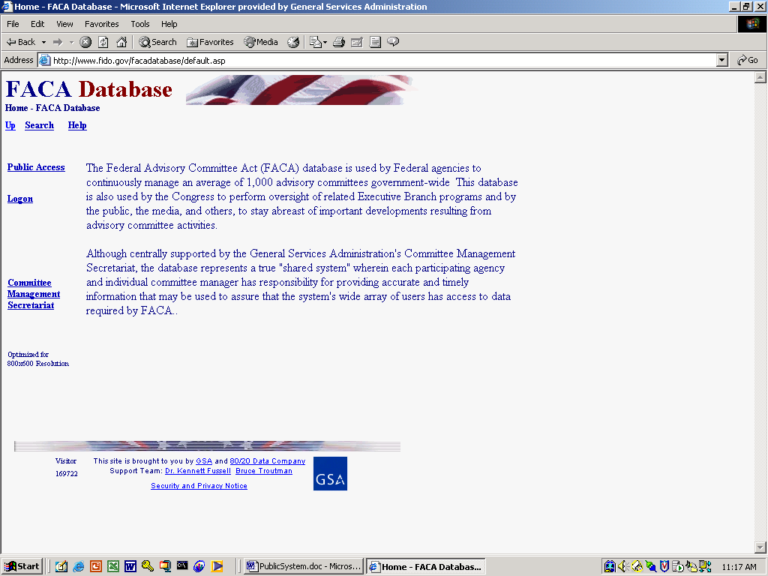
The opening screen for the FACA Database lets users know that they have found the data repository and lists their options. The most direct address for the system is http://www.facadatabase.gov.
The FACADatabase is part of a family of shared-interagency-databases located at http://www.fido.gov.
Hyperlinks and buttons control navigation throughout the system. The hyperlinks that are visible change depending upon the purpose of the page and the requirements (or access rights) of the user. The hyperlinks are located in the top border and the left border areas. Users should move from page to page with the links in the program as much as possible and avoid use of the browser buttons (like the “arrows” to go back or forward) unless specifically instructed to do so on the web page they are viewing.

We emphasize the avoidance of the browser buttons because the FACA Database is truly a database and an online application. A database and online application operates differently on the Internet than purely informational Internet pages. Browser buttons are designed to take the user backwards and forwards to pages of static, unchanged, and perhaps unrelated content. The pages of a database system change in content with every selection and filter, but have a distinct, “keyed” relationship with the preceding and following pages as the user drills down or moves back up through the data. The user is involved in an online work session viewing specific content in a specific context. If the user starts jumping around using the browser menu, it is possible for the database application to lose track of who the user is and what committee the user is examining. It doesn’t usually happen and the technology is improving to prevent this conundrum, but a word to the wise.

The five hyperlinks on the opening screen navigate to the
Up,
Search,
Help,
Public Access,
Logon, and
Committee Management Secretariat pages.
The cursor displays a hand as the mouse moves over a hyperlink.

Up, from this screen moves the user up (or back) to the Federal Interagency Databases Online (FIDO) page. Generally, the link Up moves the user up (or back) to the previous screen.

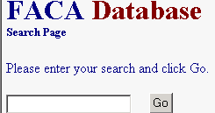
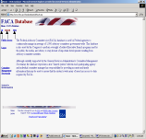Search, when the search feature is switched on and working, allows the user to search for any text or phrase in the entire set of data stored as part of this system. That includes the data comprising the fiscal year summaries, the committee charters, and any stored meeting minutes or reports. A complete discussion of the search feature is found below. The search capability will always be constrained by the Internet search technology, our web site programming ability, and the quality and completeness of the data entered.

Help explains the syntax, terms, and meaning of items of information collected in previous years as part of that year’s Annual Report (before 1999) or Annual Comprehensive Review (after 1998). It also displays a selection of manuals that explain the system’s functionality to the different users. This manual is for the part of the system designed for public access. The manuals can be viewed on the screen and printed with Microsoft Word or Adobe Acrobat Reader.

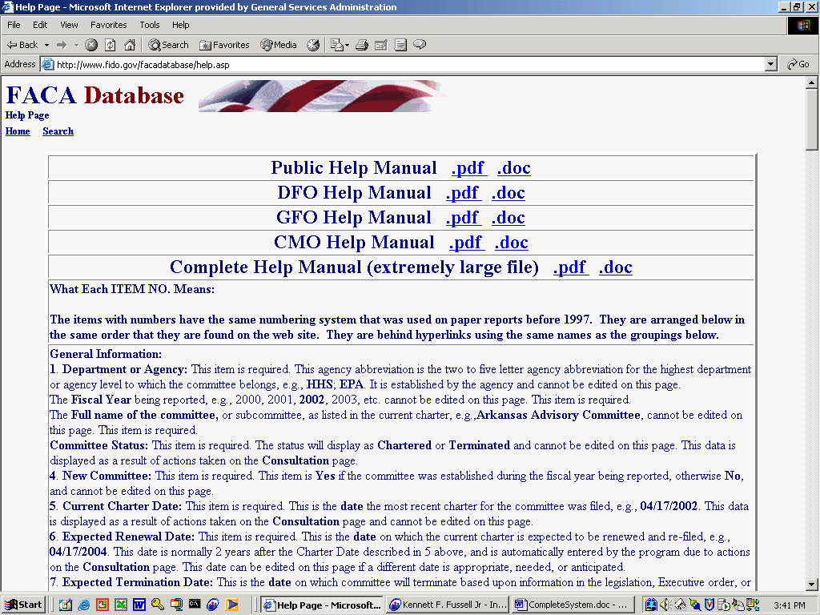
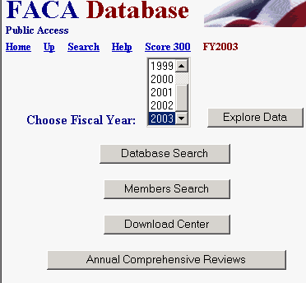
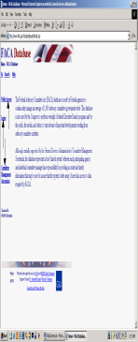Public Access takes the user to a page listing the Fiscal Years of reported data in the system, the Database Search, the Members Search, the Download Center, and the available Annual Comprehensive Reviews/Summaries since the cessation of the printed, transmitted, annual report. All the data is read-only. A reviewer must consider the data for the current fiscal year incomplete unless they know with certainty that the DFO updates the information throughout the year as events take place. At the end of the fiscal year, however, each DFO and the agency’s CMO are required by law to verify the accuracy and completeness of each committee’s data. The standard operating procedure for the present is that the information on a committee should not be deemed official and complete until that committee’s data has been verified by the agency CMO for that fiscal year. The rest of the manual for the use of the Public Access section follows below.

Logon allows federal employee users who are responsible for the committee data and who have editing rights to log on to the current year and view and update the management data. DFOs can update their committees, CMOs can update all of their agency’s committees, and the Committee Management Secretariat’s staff can update all the agencies’ data.

Committee Management Secretariat links the user to the Committee Management Secretariat’s home page on the GSA Portal. This home page can also be found at http://www.gsa.gov/committeemanagement, the launching point for a comprehensive examination of the advisory committee process, practices, history, case law, advice and training.
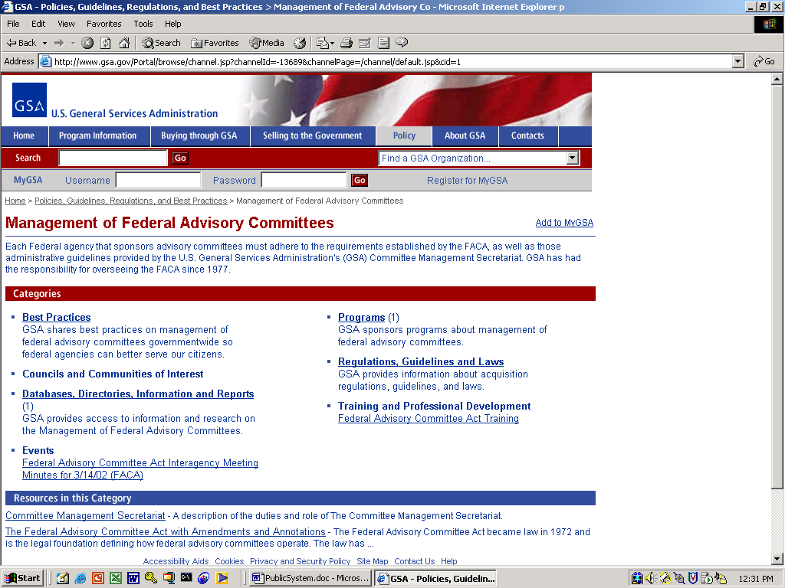

The Drill Down Feature

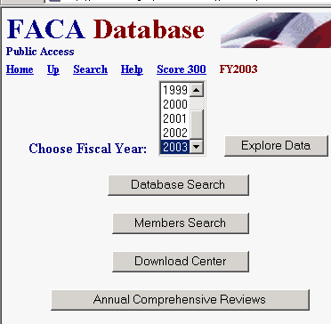
The Public Access hyperlink is useful for the user interested in information on a specific committee or with questions about specific advisory committee operations. This manual was revised most recently when the system displayed data from 1997-2003. The database will continue to expand as data is added from earlier years and as new years are completed. Database Search provides for an endless variety of comparisons and questions. Using either the Database Search or the Download Center the user can download the selected data to a spreadsheet program and perform further analysis

The Public Access page has the
- Home,
- Up,
- Search, and
- Help hyperlinks that we have already discussed.
In addition, the Public Access page has the
- Choose Fiscal Year with the Explore Data button, and the
- Database Search,
- Members Search,
- Download Center, and
- Annual Comprehensive Reviews buttons.
To use the Explore Data feature, users make choices as they drill down into the data. The Up hyperlink takes the user back up a level.

Agency List

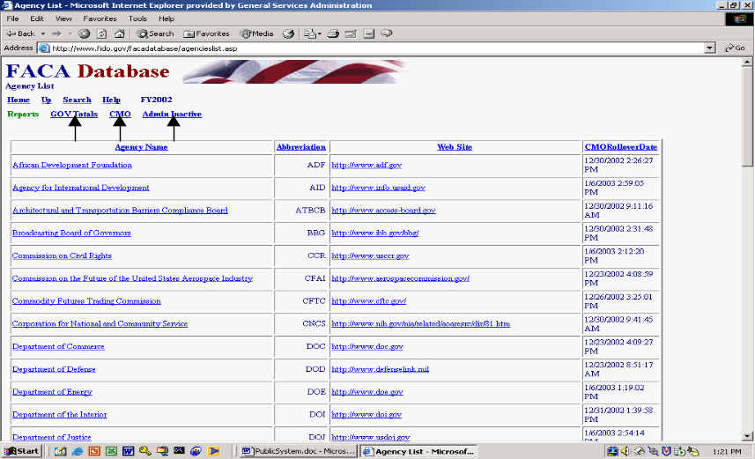When the user selects a year and clicks the Explore Data button, the program presents an Agency List page listing all the agencies that had advisory committees that year.
If the column heading is underlined, clicking on the column heading sorts the column. If field contents, like the agency names in the picture, are underlined, they are drill-down hot links that jump directly to that agency’s data on another page.

The Agency List page has three additional report links.
- GOV Totals,
- CMO Reports, and
- Admin Inactive.

Government Totals Report

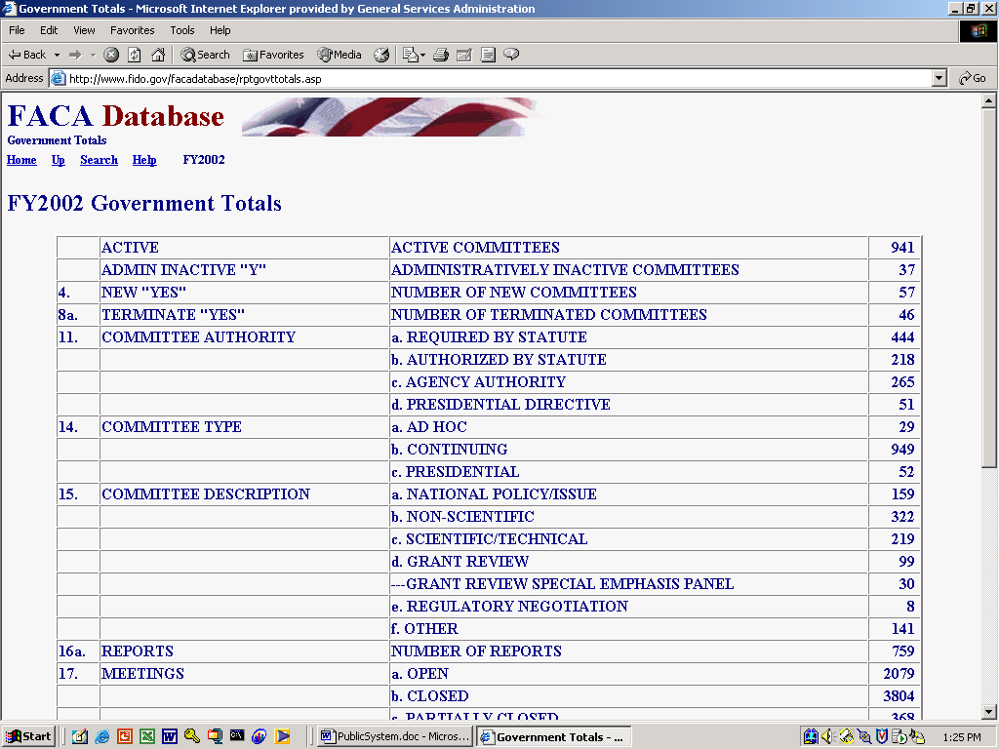
The GOV Totals report link presents the totals for what were originally the data items of interest and concern to Congress for the first 26 years of the FACA Annual Reports. Congress and the President generally wanted to know for measurement purposes,
- The number of new committees,
- The number of terminated committees,
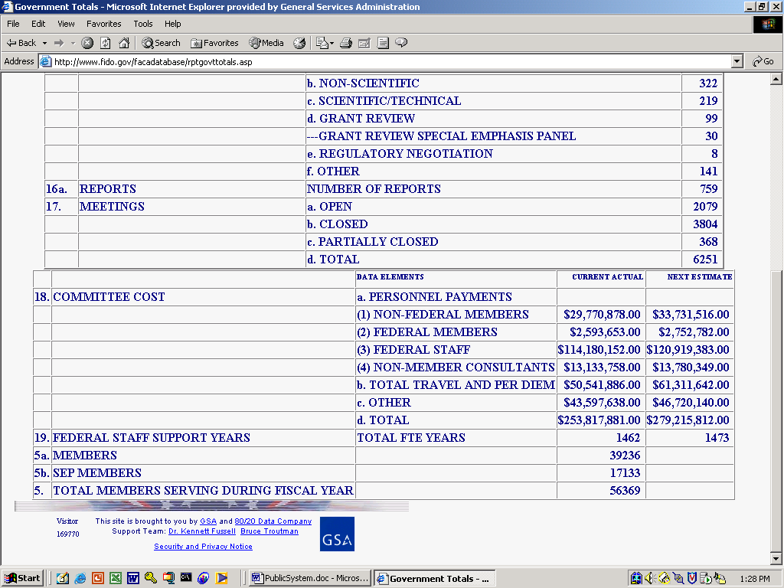
- The distribution of the committees established by Congress or the President or Agencies,
- The general focus of the committees,
- The number of reports submitted,
- The number of meetings held and whether the meetings were open or closed,
- The total cost to the government, and
- The number of people involved.
To return to the Agency List page from the GOV Totals page, the user clicks the Up hyperlink.
Committee Management Officer Report

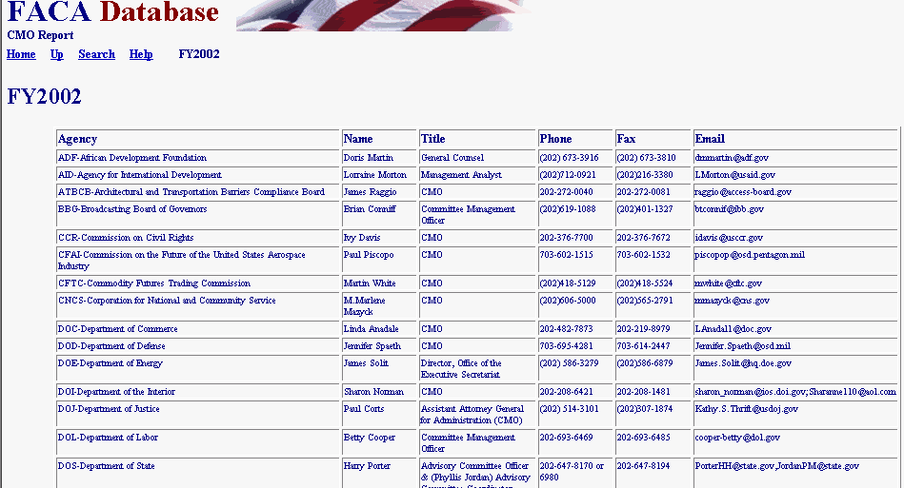
The CMO Report link deploys the CMO Report page that displays the Committee Management Officer list for that year.

The Up hyperlink returns the user to the Agency List Page.

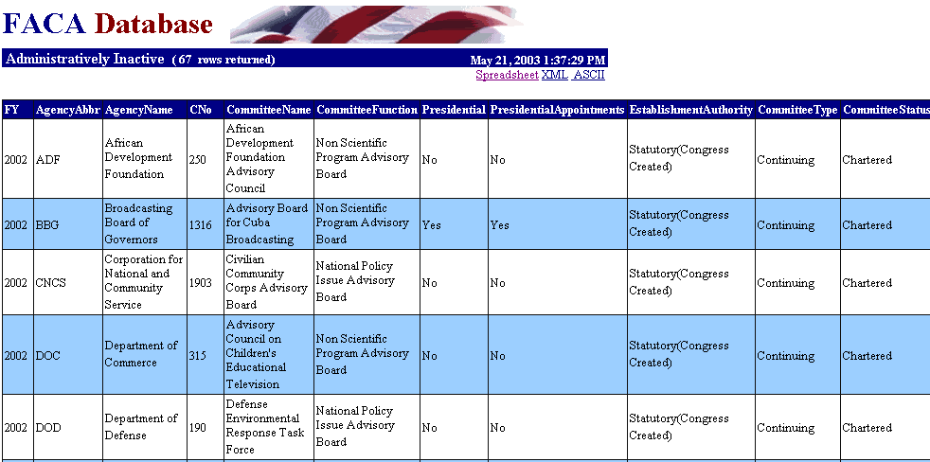
Administratively Inactive Report

A significant number of advisory committees were established by legislation. Some of these committees did not have sunset clauses in the legislation. When such a committee has finished its work, the committee has to be kept on the books until Congress passes legislation to abolish the committee.

Sorting the Columns

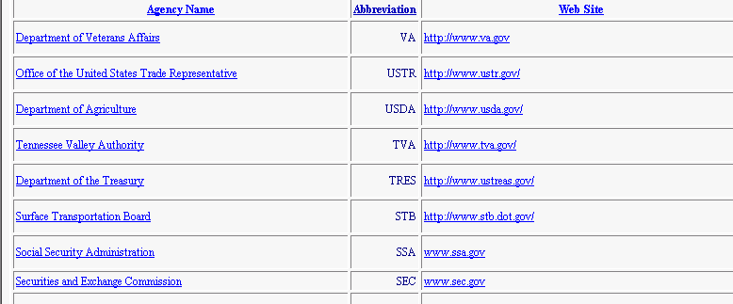
Sorting the column can help the user to find an item in the list more efficiently. By clicking on the underlined column headings (Agency Name or Abbreviation or Web Site) the user can order the display by that column. The first click sorts in ascending (A-Z or low to high) order. Following clicks reverse the previous order. Ascending becomes descending (Z-A and high to low). The columns above were sorted by Abbreviation in reverse order.

Selecting an Agency and Drilling Down to a Committee List
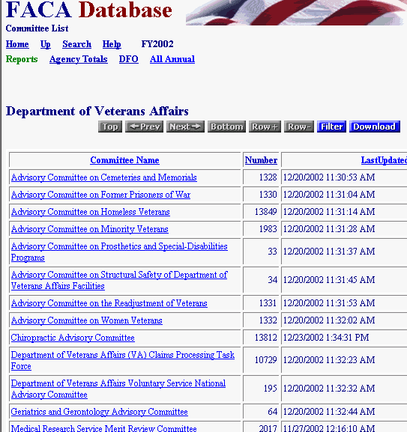
After an agency has been selected, the user can drill down to the next level (i.e., from agencies down to a list of the agency’s committees) by clicking on the hyperlinked text (in this case, the agency name). As mentioned earlier, the user knows that text is hyperlinked if it is underlined. Hyperlinked text is often also a different color than the remaining displayed text. The cursor will change from an Arrow to a Hand when the cursor is positioned over hyperlinked text.

The Committee List page has three report links:
Agency Totals,
DFO, and
All Annual.

Agency Totals

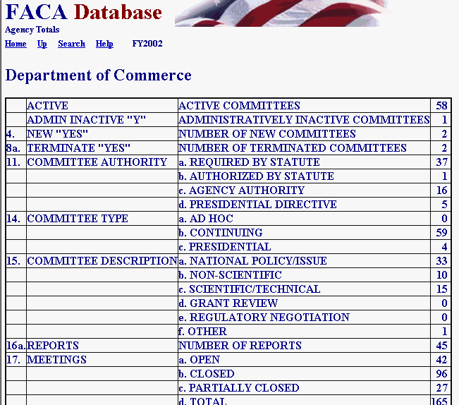
The Agency Totals hyperlink provides the same kind of information to the agency that GOV Totals provided to the government as a whole, the data items of interest and concern to Congress for the first 26 years of the FACA Annual Reports.

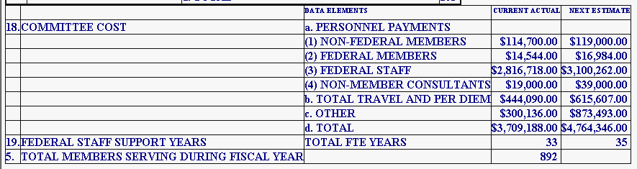

Designated Federal Official (DFO) Report

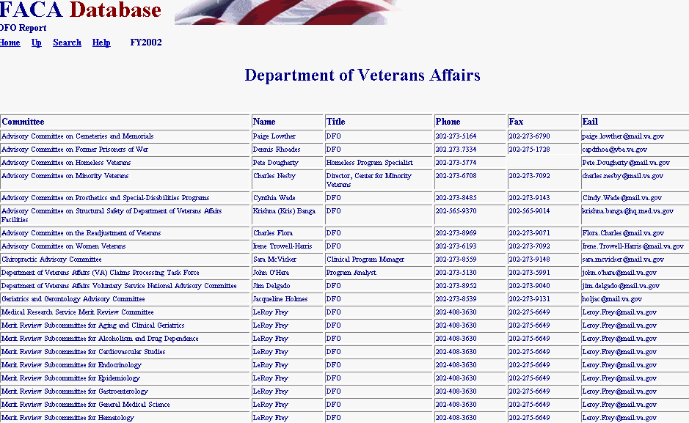
The DFO Report link displays the Designated Federal Official List for the agency’s advisory committees for the year.

All Annual Reports

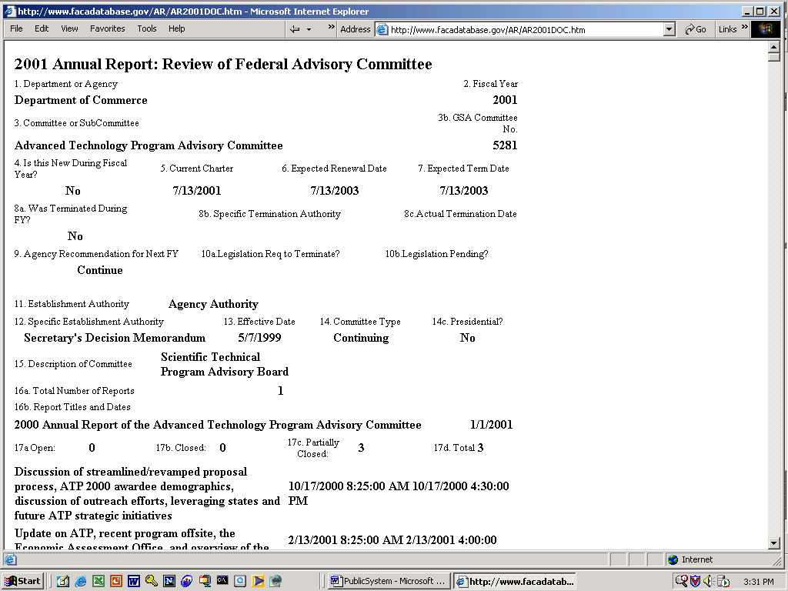
The All Annual Reports hyperlink provides a quick way to display and print all of the Annual Comprehensive Review information for the selected agency for the selected year.

Selecting a Committee

To select a specific committee, the user clicks on the hyperlinked committee name (the underlined committee name). This selection will take the user to the Committee Menu page for that committee. Note in the screenshot to the right that the data is from FY2002 and that the CMO has verified the completeness and accuracy of the data provided.

The hyperlinks on the Committee Menu page group the information about the committee into related units. Information reported at least annually is grouped in the left column of buttons and agency information relative to the committee is grouped in the right column of buttons. The Committee Menu page hyperlinks are
- General Info,
- Recommendations,
- Reports,
- Meetings,
- Costs,
- Justifications,
- Members,
- Sub-Committees,
- Annual Report,
- DFO Info,
- GFO Info,
- CMO Info,
- Committee Decision Maker,
- View Charter,
- Web Site, and
- Participant Logon.
The General Information Page

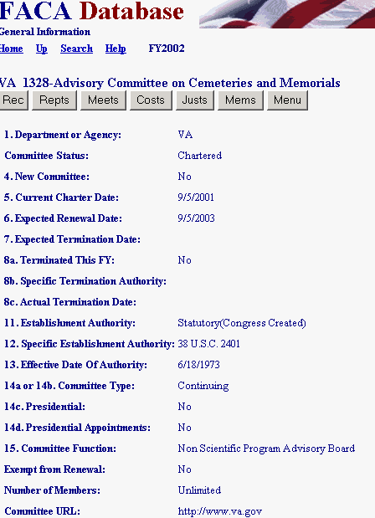
The General Info hyperlink displays the General Info page. Most of the information on the General Info page doesn’t change from year to year, other than the current charter date and the dates a committee is renewed or terminated. The committee name, function, and authority under which the committee was established tend to remain the same for the life of the committee. The buttons on the General Info page under the Committee Name are to facilitate movement and data entry to the rest of the information pages without having to return each time to the Committee Menu page.

The Recommendations Page

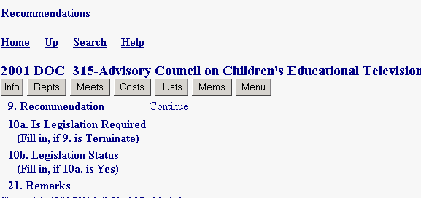
The Recommendations hyperlink on the Committee Menu page and the Rec navigation button on the General Info page display the Recommendations page. The Recommendations page is sometimes misinterpreted. It does not report the committee recommendations to the government official it advises. This page actually reports the agency’s recommendations regarding the continued usefulness of the committee. The advisory committee’s recommendations to the federal official asking for the advisory committee’s advice have not been reported in the Comprehensive Annual Reviews of the past. They will be a vital part of advisory committee performance measures in the future.
The Reports List and Form Pages
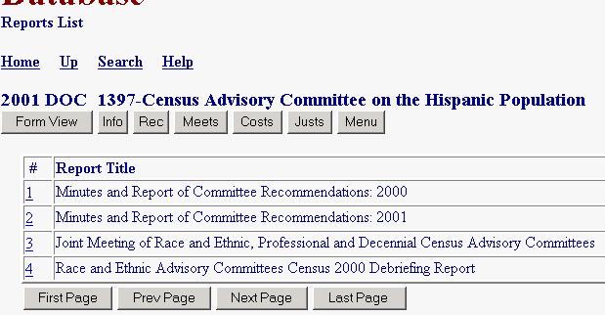
The Reports hyperlink on the Committee Menu page and the Repts navigation button on the Recommendations page display the Reports page. The Reports page is a list of reports. When a list is shown, the user can drill down to see if further detail is available with either the Form View navigation button or with the hyperlinked number on the left side of the report list.

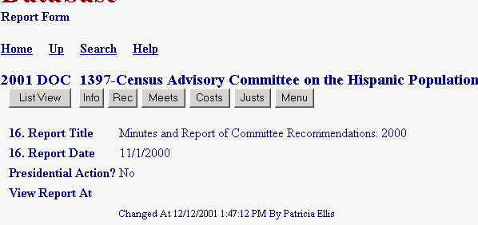
The detail on the individual Reports page might not display any more information than the user had available while looking at the report list. However, the system does support the capture and display of committee reports if the DFOs choose to provide them here online rather than requiring a request at their office. Some committees also maintain their own web sites and provide access to reports at that site.

The Meetings List and Form Pages

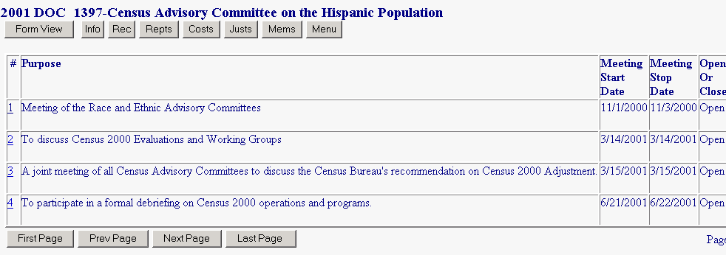
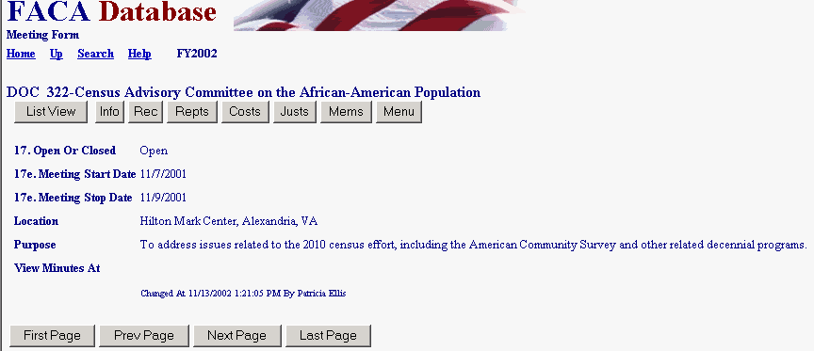
Either the Meetings hyperlink from the Committee Menu page or the Meets navigation button from the Reports page displays the Meetings page. Like the Reports (list) page, the Meetings page is a list page. The user can drill down to the Meetings detail page with the Form View navigation button or can click the hyperlinked number on the left side of the meetings list. The Meetings (form) page did not previously require the notation of a purpose and location, but it does from 2002 forward. The DFOs can upload the meeting minutes for display on the online system if they do not have the minutes available on their own web sites.

The Costs Page

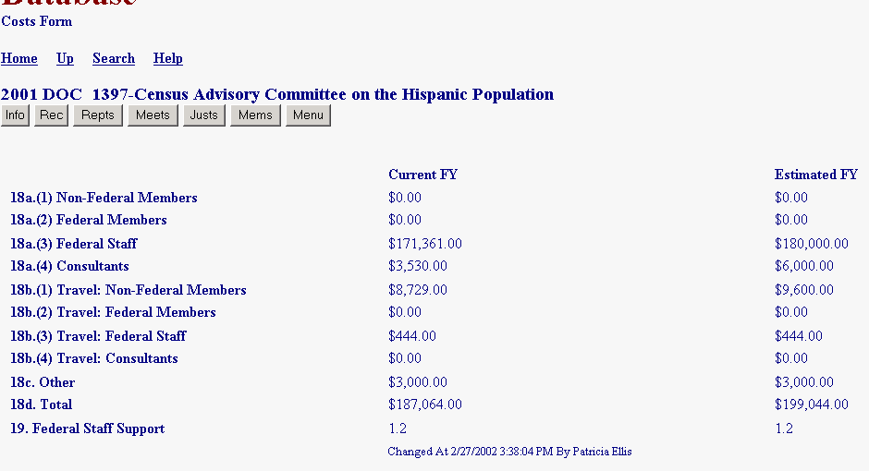
By clicking the Costs hyperlink from either the Committee Menu page or the navigation button from the Meetings page, the user displays the Costs page.

The Justifications Page

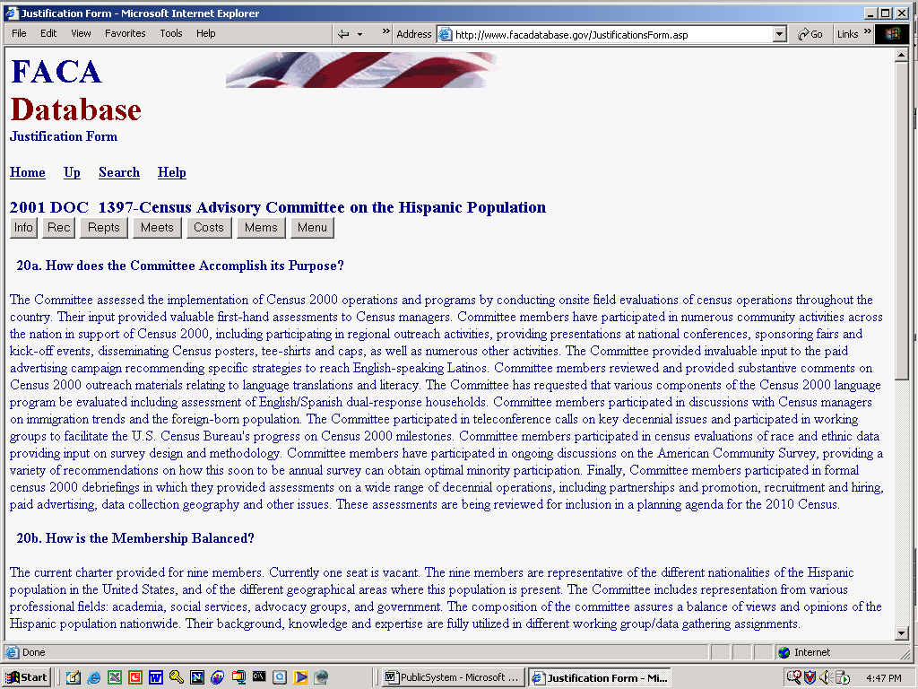
By using either the Justs navigation button from the Costs page or the Justifications hyperlink from the Committee Menu page, the user displays the Justifications page.

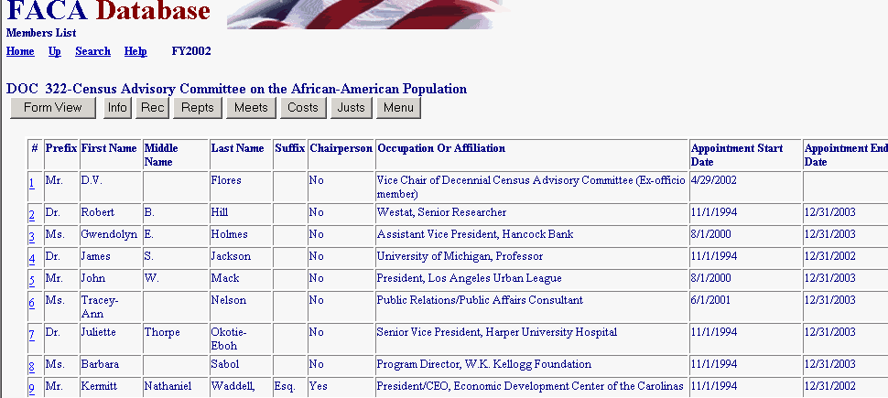
The Members List and Form Pages

The user clicks the Members navigation button from either the Committee Menu page or the Justifications page to display the Members page. From the Member List page, the user clicks Form View or the hyperlinked hot number to the left of the member’s name to view the member’s detailed data.
Like the Reports and Meetings pages discussed previously, the Members page above is a list page.

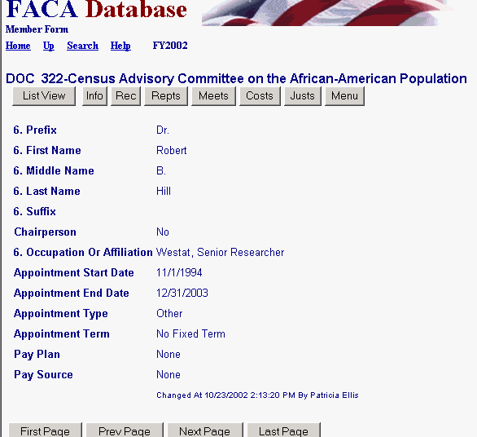
Internet Pages are usually arranged with the most important and/or used information at the top and left of the screen display to try to minimize the need to scroll. In previous years, the agencies were not required to provide all of the information found on the Members form page. The Appointment Start Date, Appointment Stop Date and other fields were there for clarity and convenience. The annual report did require that everyone who served during the year be listed. This can be misleading because, often, a committee might have 15 members identified in the charter, but some members serve only part of the year. When everyone is listed the count of the members of a 15-member committee could easily be any number between 15 and 30. The Appointment Start and Stop dates add clarity to whom served when, especially when two terms overlap the same report year. The other appointment information helps manage the laws requirements that committee membership be balanced.

The user can return to the Committee Menu page via either the Up hyperlink twice, first to the Members list page and then the Up hyperlink again to the menu page, or directly to the Committee Menu page with the Menu navigation button below the Committee Name.

Sub-Committees

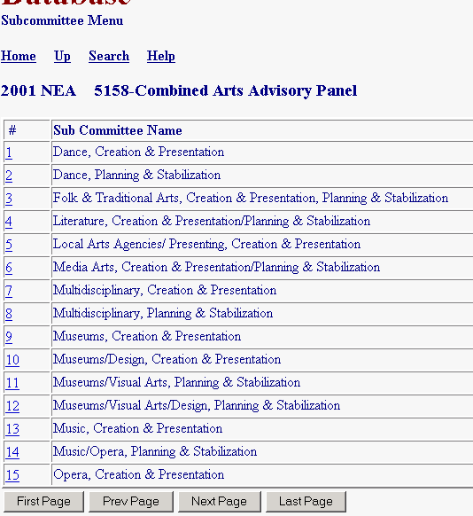
The Sub-Committees hyperlink is available for those committees that want to break out their data for Reports, Meetings, Costs, and Members among subcommittees. Subcommittees normally bring all of their work to the parent committee for review and the parent committee’s understanding and approval and/or further development. The chartered parent committee advises the federal government, not the subcommittee. However, sometimes the DFO wants to break out the distribution of cost and effort by the subcommittees’ work. In those cases the hyperlinks, navigation buttons, and data entry pages function for the subcommittee just the same as those already described at the committee level. The data from the subcommittee pages is combined with the data from the parent committee pages to produce a single summary report.

Annual Report

The Annual Report hyperlink displays a single, printable report specific to the selected committee of the year’s summary information.

Designated Federal Official (DFO) Information

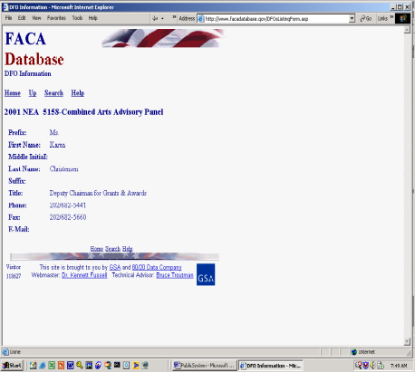The DFO Info hyperlink displays the DFO Info page, the information screen for the Designated Federal Official assigned to the advisory committee.

The DFO assigned to maintain the committee information updates the information on the DFO Info page during the reporting year. The CMO can update this information as well, although the DFO cannot update the CMO information. In the same fashion the CMO can update the CMO information.

The user can return to the Committee Menu page by using the Up hyperlink.

Group Federal Official (GFO) Information

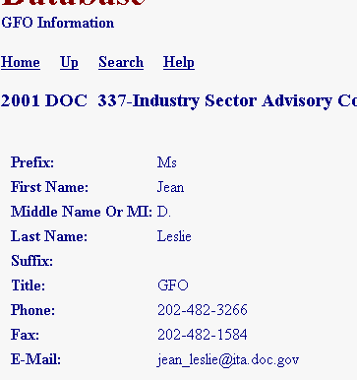
If a GFO Info hyperlink is visible, clicking the link displays the GFO Info page, which has information specific to the Group Federal Officer. This is a totally made-up name that you will not find in the Federal Advisory Committee Act (FACA). Some larger agencies have enough committees that they form subsets of the committees as specially named groups with a group coordinator assigned to each group, hence, the GFO. The Department of the Interior has all the advisory committees to the National Park Service in a group, all of the advisory committees to the Bureau of Land Management in a second group, etc., etc. But not all of the advisory committees to the Department of the Interior are in groups. The GFO Info hyperlink is only visible when a group coordinator is involved.
Committee Management Officer (CMO) Information

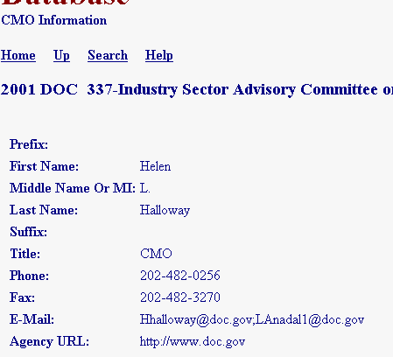
The CMO Info link displays the CMO Info page when clicked. There is always a Committee Management Officer (CMO) for every agency with an advisory committee, just as there is always a Designated Federal Official (DFO) for each advisory committee. The contents of the E-Mail Address field plays an important part in the workflow process of this system, since e-mails are sent to this address alerting the CMO of changes made to the committee data.

The user returns to the Committee Menu page via the Up hyperlink. Of course, the user could, at any time, when experiencing severe ennui from the never-ending presentation of the World Of Online FACA (WOOF), return to the opening page of the system by clicking the Home hyperlink.

Committee Decision Maker

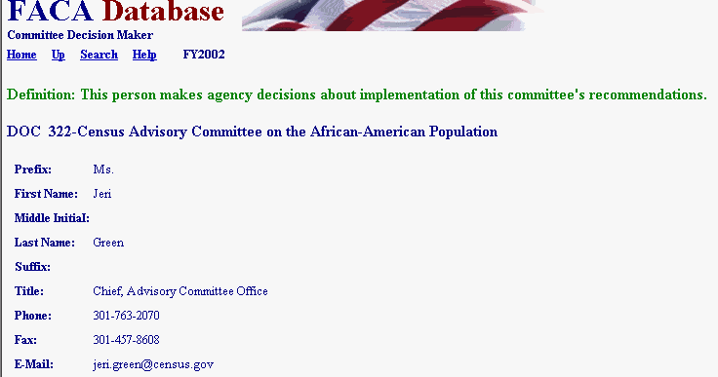
Most committees exist to provide advice to a federal official. This page is designed to capture the contact information of the person who decides to use or not use the committee’s recommendations.
View Charter

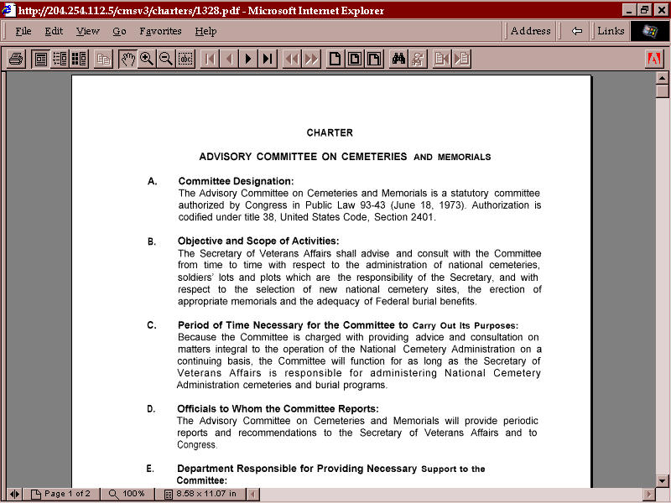
The View Charter hyperlink displays the committee’s current Charter. Either the agency or the Committee Management Secretariat has uploaded the charter to the online storage system. For some older charters, which exist only in hard copy, the document has been scanned into a readable .pdf format and uploaded to the system (not all committee charters require renewal and some date back to the Whiskey Rebellion). Returning from the View Charter screen to the Committee Menu page is one of the few times that it is appropriate to click the browser back button.

The user returns to the Committee Menu page with the Up hyperlink.

Committee Web Site

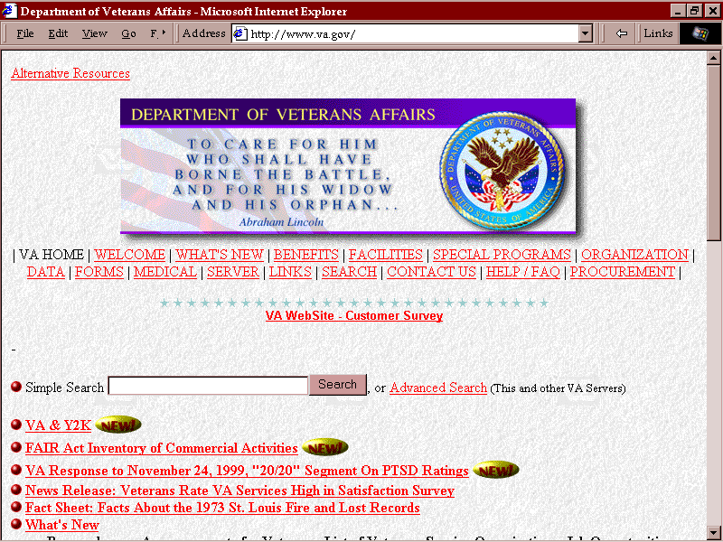
If the Committee Menu page displays a Web Site hyperlink, the page is linked directly to a web site for either the advisory committee or the advisory committee’s agency. Some agencies and some committees place their charters, reports, minutes, committee activities and meeting dates, etc. directly on their own web site. If the user has jumped to the web site and wishes to return to the tracking system, the user clicks the web browser’s back button. If the user has browsed deeply into the agency’s or committee’s web site, it may be necessary to click Go Back many, many times to return to the FACADatabase Online System.

Participant Logon

At the beginning of FY 2003, the Committee Management Secretariat, EPA, and VA funded work performed by Gallup, Inc. to survey the advisory committee experience of committee members participating during FY 2002. This activity was undertaken to establish a useful baseline for Performance Measures for Advisory Committees. The Participant Logon provides a means for committee members to access the reports generated by that survey. Committee members entitled to see the survey results could expect to receive directions from their Designated Federal Officials (DFOs) on how to access this information online.
The Database Search

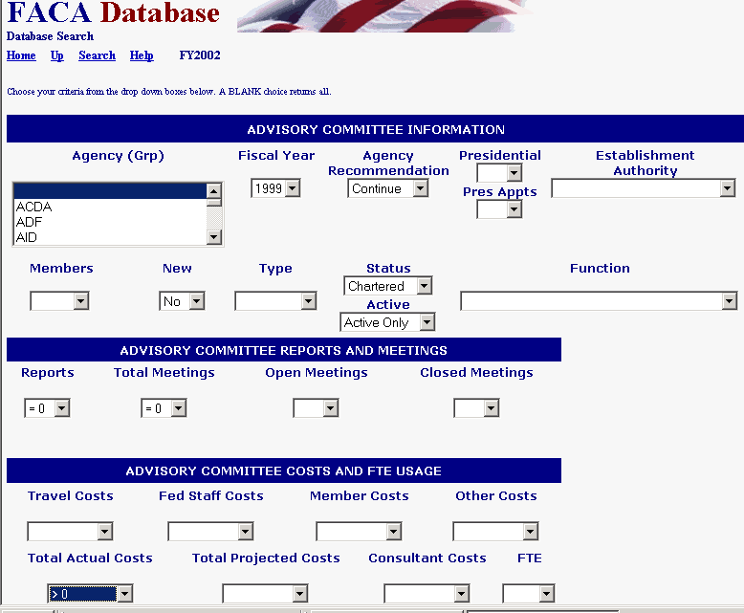
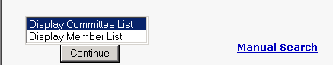
The Database Search button displays the Database Search page. To see all the options available to refine a query or fine-tune a search it is necessary to scroll down to the bottom of the page. The Database Search feature allows the user to pose a query to the database and get the response back as a web page.
A typical inquiry could be “Give me all the committees in 1999 that were chartered,
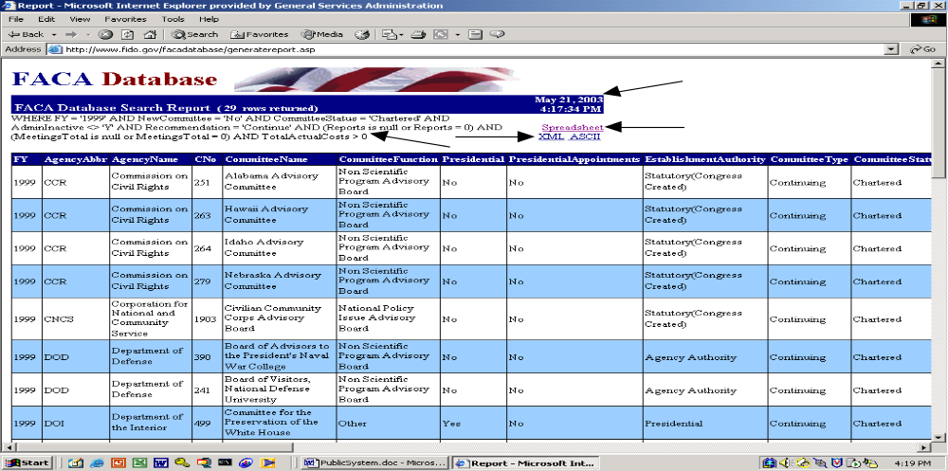recommended to continue, and spending money but did not hold any meetings or issue any reports.”

The user can decide to save the search result as a spreadsheet file, an XML file (useful if you want to dump the data into a database), or an ASCII file (a text file that can be used in any word processor). The query criteria are displayed in case the user wants to refine the query further.

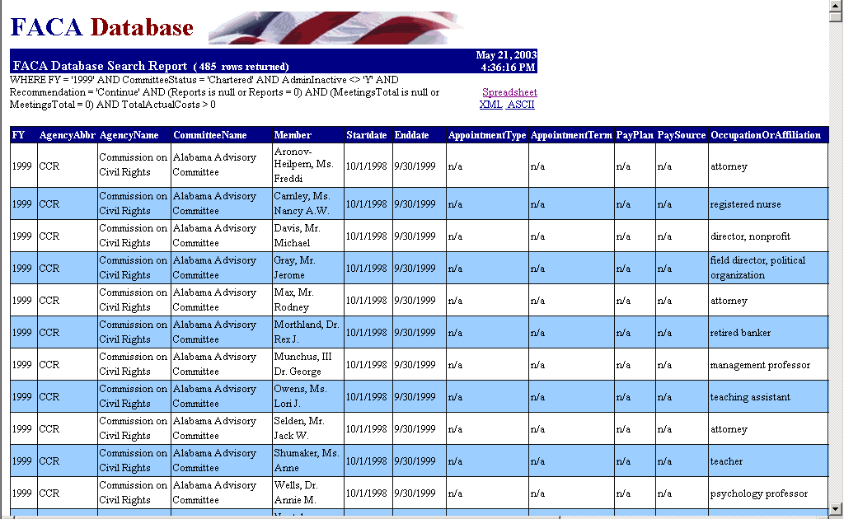
In addition to a committee list, the user can opt for a member list based on the same or different query.

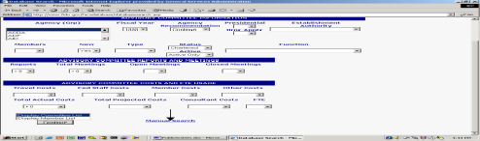A user with some knowledge of SQL can use the Manual Search to refine the query used to parameters that are not found in the drop down lists.

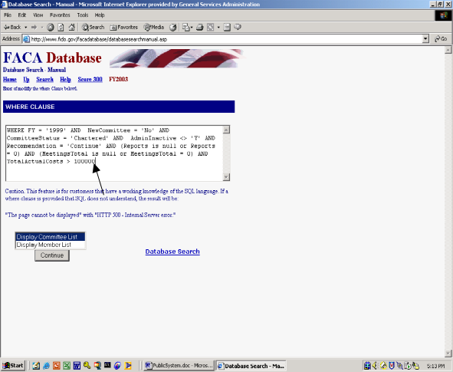For instance, the Costs drop down list does not have an option for Greater Than 100000. If the user changes the query to reflect that, the result can get very specific. In the screen shot to the right, after clicking Manual Search, the > 0 was changed to > 100000. When Continue is clicked, the number of committees is reduced to none.

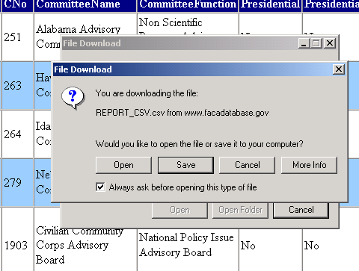
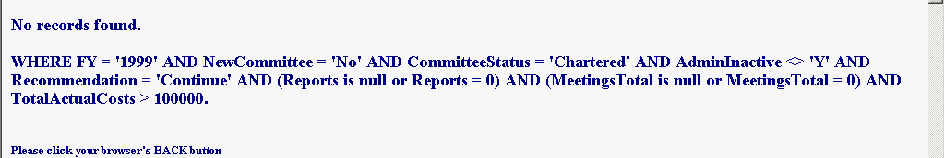
If the user should decide to save the query data to a file on their own computer, doing so can be done quickly and efficiently. Select the file type to use to analyze the query data produced above (Spreadsheet, XML, or ASCII) and the browser opens a download message box. Click “Open” to display the response data in an Excel spreadsheet.

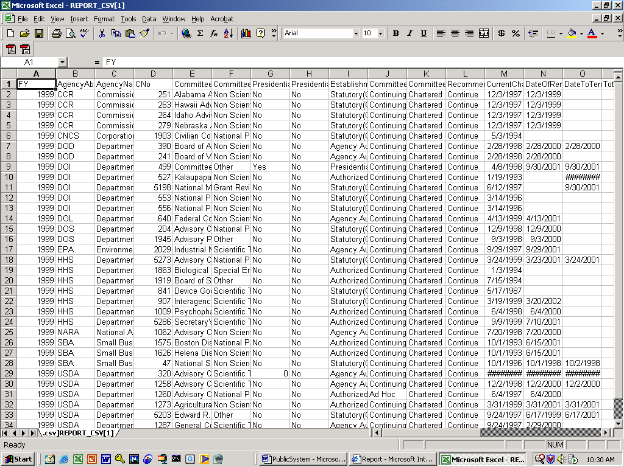
Well, does the answer of 33 committees and 810,390 dollars make this a question worth further analysis? Depending upon your decision, the spreadsheet could be saved to a file on your local computer for future consideration. The response data set will always contain the same set of fields, but the record-set will change based upon the search criteria. The fields returned are:
- Fiscal Year (Currently, 1997-2003. The year 2003 will be updated continuously through the end of the calendar year.)

Agency Abbreviation

Agency Name
- Committee Number (GSA assigned this number when the committee was established to track the committee over its life and history)

Committee Name
- Committee Function (generic classification of the committee concerned)
- Presidential (Reports to the President: Yes or No)
- Presidential Appointments (President appoints some members: Yes or No)
- Establishment Authority (Statutory, Presidential, Agency, or Authorized by Law. Not all advisory committees established by the President report to the President)
- Type of Committee (Continuing from year to year or Ad Hoc [less than one year])
- Committee Status (Chartered, Terminated, Pending)
- Agency Recommendation (to continue or terminate the committee)
- Total Number of Members
- Current Charter Date (as of the year being reported)
- Date to renew Charter (as of the year being reported)
- Date to terminate committee (if stated in charter or legislation)
- Total Number of Members
- Total Number of Reports

Number of Open Meetings
- Number of Closed Meetings (includes meetings that were partially closed)

Total Number of Meetings
- Travel Costs (all members, consultants, and staff reported)
- Federal Staff Costs (includes applicable percentage of salary and benefits)
- Member Costs (includes Federal members)

Consultants Costs
- Other Costs (all other costs of meetings and committee activities)
- Total Actual Costs
- Total Projected Costs (for the next fiscal year)
- Full Time Equivalent (FTE) (the number of full time staff supporting the committee)
- CMO Contact Information
- DFO Contact Information
- Date committee data was last updated (for reported year)
- Administratively Inactive (Yes or No, this field was added in 2002)
- Primary key information for database (Committee record)
- New Committee the year reported: Yes or No.
- Primary key information for database (Agency record)

In an attempt to make the system useful for the largest number of users, the Database Search design quickly provides the most frequently requested data set.

The Members Search

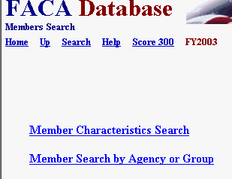
Since there are usually as many as 55,000 citizens contributing their time to advisory committee concerns in any given year, the system would be considered vastly incomplete without a Member Search capability. There are limitations to our member data, however, and most of those are self-imposed. This is a publicly accessible database and the database contains no more information than the minimal the law requires on the citizens contributing their time to the improved and effective functioning of the federal government.

Members Characteristics Search

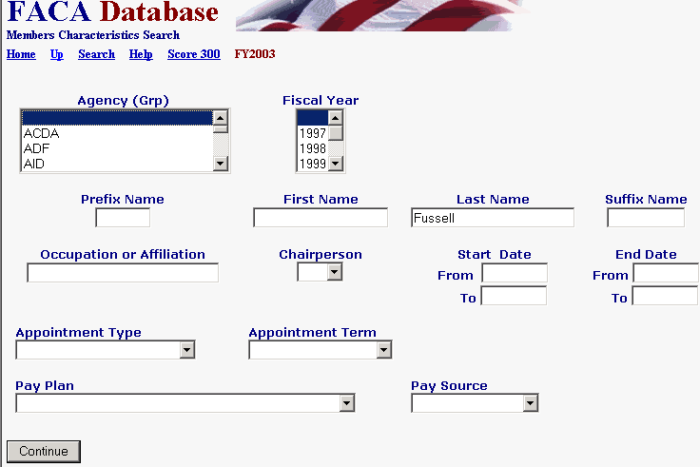
The Members Characteristics Search allows searching the Member table by any or all of the listed characteristics. Searching all years and all agencies for members with a last name like Fussell (not an overly common name) produces the page below.

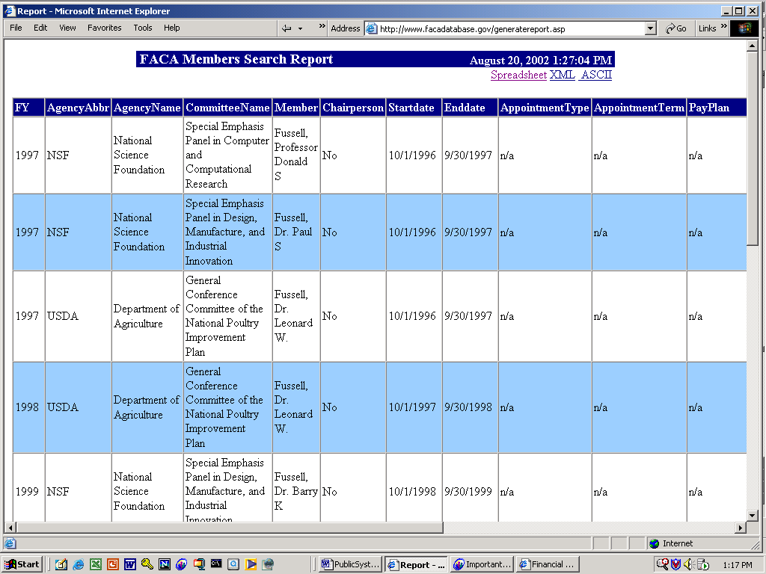
Member Search By Agency Or Group

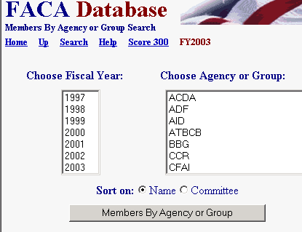
The Members by Agency or Group Search produces a list of committee members contributing their time to a particular agency or sub group (like the National Park Service, and within the NPS, the Alaska Region) for a particular year. When using this feature, please remember that some groups and some agencies are very large (the Department of Health and Human Services [HHS] would have a list 25,000 members long during any single year and the National Institutes of Health, a sub group of HHS, has 13,000 of those committee members during the same period). Asking your computer to download lists of those sizes, or your printer to print the list out can be wasteful of your resources as well as ours.

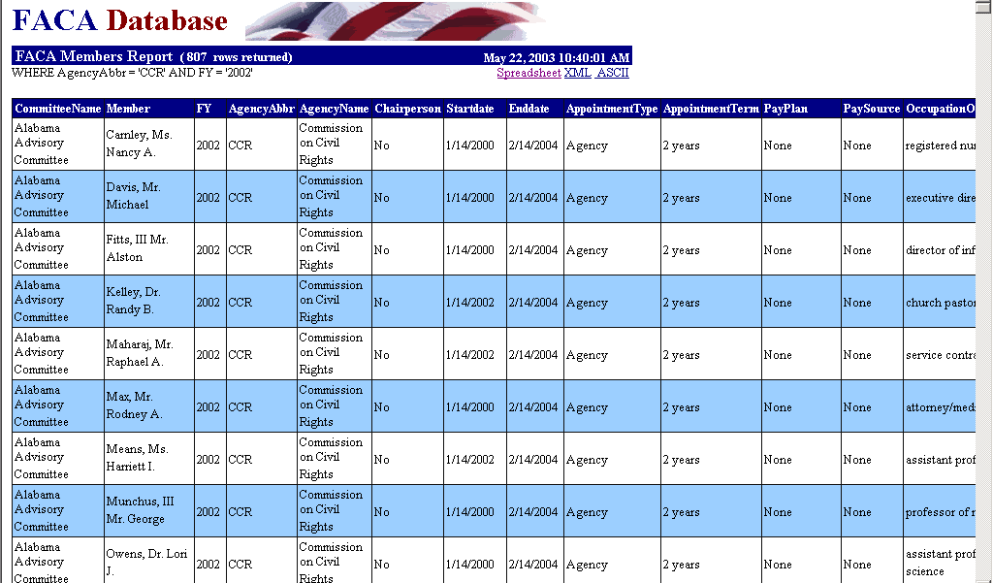
The other kind of data set most requested from the database is a list – members, meetings, reports, etc. Our approach here also is provide the user with a fixed data set of fields while allowing a selection of records via the most appropriate search criteria suited to our data design. This feature is called the Download Center and it is discussed next.

The Download Center

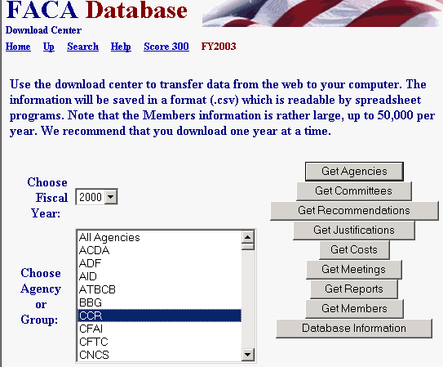
Clicking the Download Center button displays the Download Center page. The user can download all the data in the database except a couple of fields of data that are restricted due to privacy concerns (i.e., committee members’ e-mail addresses, etc.). The data results are first displayed in a web page. From there the data can be downloaded to a spreadsheet file, an XML file, or an ASCII file. Selection criteria can be the fiscal year or the agency or group. The user may select any single fiscal year, or all of them, by leaving the Fiscal Year criteria blank in the Choose Fiscal Year selection box. The user can select a single agency or group, or all the agencies from the agency criteria selection box. Once the selections are made, the user clicks the appropriate button to list the agencies or committees or members, etc., etc. The downloaded data includes the key information that relates the tables to each other, and all downloads except the GetAgencies option includes the Agency, the Committee Number, and the Committee Name.
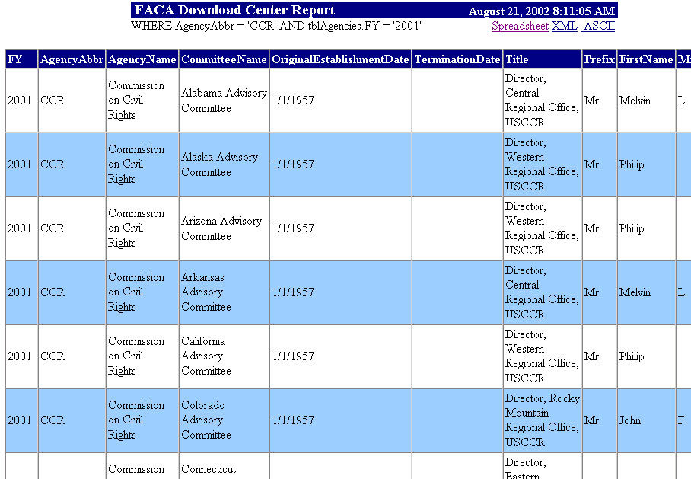
There are a couple of caveats. Selecting “blank’ from Choose Fiscal Years gets “All the fiscal years”, which includes selecting the current fiscal year. Not only does this select a lot of data, there is the additional problem that the current fiscal year is usually incomplete until the end of that calendar year, and any download including the current year will likely provide incomplete and inaccurate results until then. It is best to select a single year at a time.

There are a lot of members, so selecting all agencies and clicking on Get Members will potentially produce a huge download (300,000 records now and adding 50,000 more each year). HHS had almost 25,000 members in their advisory committees in 1999.

Database Information
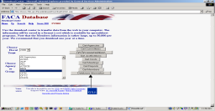
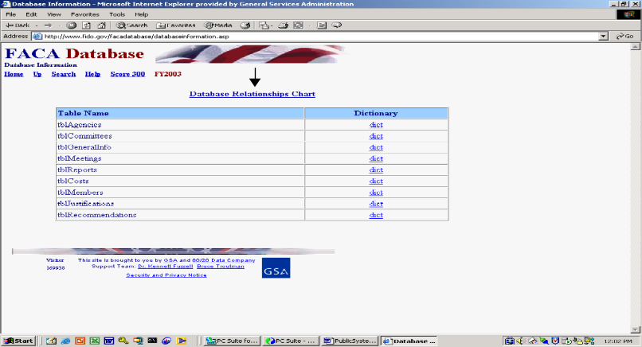The Database Information button displays information on the structure of the data tables stored in the system. With the key fields in each download table identified and the relationships between the tables displayed, the data provided in these downloads can be recombined on the user’s local system for practically any kind of further analysis and reports.

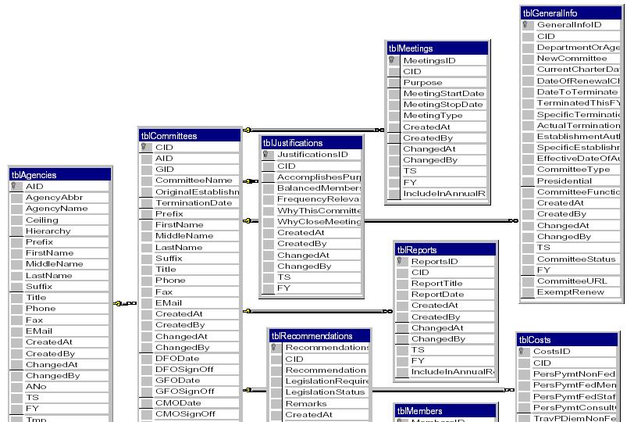
The Committee Management Secretariat’s intention is to provide the user with all the data available in our system that does not intrude on public committee members’ privacy, and the means to use it as useful and relevant information. Feedback and suggestions will always be considered for the next system iteration (the system has been in continuous development for the past seven years and we expect that there will always be a next system iteration until the developers retire, quit, or die).

The Annual Comprehensive Reviews

Congress determined in 1998 that, when updated regularly and consistently, this online system provided the information they required as the “annual report” on advisory committees. Also in 1998, in the interest of eliminating the production of superfluous, costly, “printed” reports, Congress added “the ‘printed and transmitted by the President’ FACA Annual Report” to a list of printed reports they no longer required be provided to Congress after December, 1999.

The Federal Advisory Committee Act passed in 1972 and every amendment since then has required that the Committee Management Secretariat and the agencies having advisory committees subject to the Act utilize a process referred to in the law as the “Annual Comprehensive Review”. The Annual Comprehensive Review is an examination of the committees for usefulness, efficiency, relevance and compliance with the law’s requirements. The means utilized by the Secretariat to conduct that annual review through 1998 was an analysis of the data collected by the “annual report” data collection process. Since the inception and utilization of this online system, the data in this system provides the data for analysis. While this system has matured to the point where it can now be utilized and updated 24 hours a day, 7 days a week, the transition of the federal employee users from an annual data collection process to a weekly or monthly update process is still a work in progress (often a committee responsibility is in addition to other work). That transition is one of the reasons that there is still a period in the fall where every CMO and DFO brings the data in the system on their committee for that year to a verified state of accuracy and completeness. We expect that fall clean-up process will continue to be the SOP for some years to come.

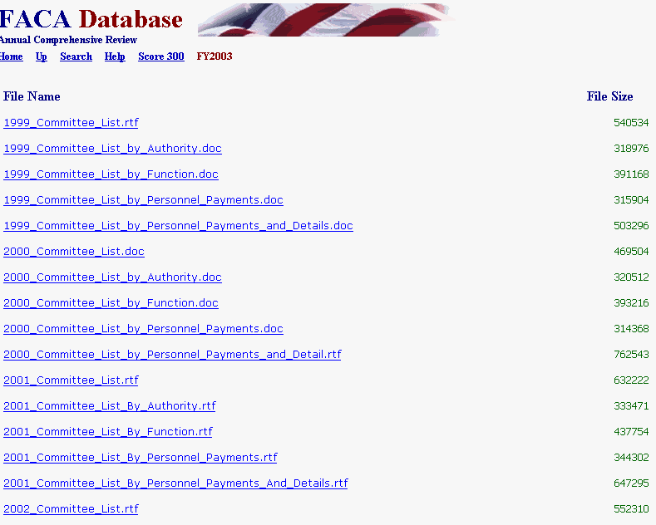
In the same vein, there were some reports in the printed annual report that certain audiences still desire. To satisfy that requirement reports that are compiled from the data, .pdf files of previously printed annual reports, and new analyses when requested and prepared, will all be gathered in this section.

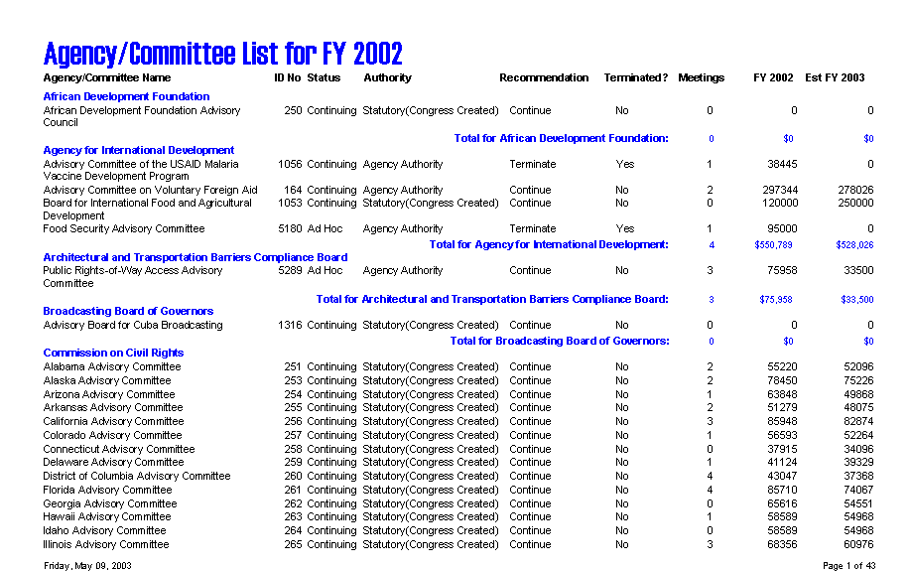

SECTION II: Designated Federal Official Access to Advisory Committee Data

The Designated Federal Official (DFO) primarily uses the system to update the information on their advisory committee during the current fiscal year. Doing so allows them to 1) manage the committee information flow within the agency and 2) report the data required by law. The Federal Advisory Committee Act (FACA) requires that the DFO, with the Committee Management Officer (CMO), report complete and accurate information about the advisory committee, at a minimum, annually. The web-based database and management system accommodates that requirement by allowing the continual updating of committee information throughout the fiscal year. Keeping the data continuously up-to-date converts the system and record keeping from a focus on history and records, to a focus on management and immediate relevancy. With frequent and timely updates, the system becomes more useful to everyone. Everyone, in this context, ranges from public users interested in specific issues, to the agency official wanting a view of specific committee activity as well as the broader view of committee activity across the agency, to congressional staff with oversight responsibility.

What kind of data is being collected and maintained?

For the DFO, the program collects and displays
- Charters and related information,
- Members and their appointment information,
- Costs,
- The agency’s recommendation for continuation or termination of the committee,
- The committee’s recommendations to the agency and the actions taken on the recommendations (this will be added in the immediate future),
- Report titles, publication dates, and the text of the report,
- Meeting purposes, dates, location, whether the meetings were open or closed, and the minutes or transcripts,
- Activity and justification (raison d’etre) information,
- DFO appointment and contact information,
- Decision maker contact information,
- Annual Performance Measures,
- Web site addresses for the committee or accessing committee information like the minutes, reports, and recommendations, and
- Committee interest or issue areas.
This information exists for each committee and is aggregated by the agency as well as by the whole government, by year. The database does not contain meeting announcements, although proposed future meetings can be listed and there are provisions for additions like meeting announcements and federal resister notices in the future. Meeting Minutes and formal committee reports can be uploaded to the online system. Some of the committees also put their meeting minutes, transcripts, meeting content information, reports, and recommendations to the agency on their own committee web site or on the agency web site. While the law requires that the minutes and reports be maintained in a central and accessible location, during and well beyond the active life of the committee, it does not require that the minutes and reports be uploaded to this system.

How does the DFO use the system?

FACA required that each agency establish uniform administrative guidelines and management controls for advisory committees established by that agency, and that each agency maintain systematic information on the nature, functions, and operations of each advisory committee within its jurisdiction.
The law’s language states that the head of each agency that has an advisory committee shall designate an Advisory Committee Management Officer (CMO) who shall –
- Exercise control and supervision over the establishment, procedures, and accomplishments of advisory committees established by that agency;
- Assemble and maintain the reports, records, and other papers of any such committee during its existence; and
- Carry out, on behalf of that agency, the provisions of section 552 of title 5, United States Code, with respect to such reports, records, and other papers.
The law also states that
- There shall be designated an officer or employee of the Federal Government to chair or attend each meeting of each advisory committee. The officer or employee so designated is authorized, whenever he determines it to be in the public interest, to adjourn any such meeting. No advisory committee shall conduct any meeting in the absence of that officer or employee.
- Advisory committees shall not hold any meetings except at the call of, or with the advance approval of, a designated officer or employee of the Federal Government, and in the case of advisory committees (other than Presidential advisory committees), with an agenda approved by such officer or employee.

The FACA database system is designed to support the above requirements by capturing relevant information when the committee is created online by the CMO, and to carry that information forward as it is edited and updated by the DFO or her designee from year to year until the information is no longer required. When a committee is first established and chartered by an agency, the information on the committee is generally entered by the CMO or his designee and should address most of the committee’s general, membership, and estimated cost information requirements. Obviously, to function appropriately, the DFO should already be officially appointed, up-to-date, and involved in the committee’s mission and charter when a committee is established (officially chartered). The process ordinarily proceeds as follows:
- The President, Congress, or a federal official in an agency decides that advice on an issue is needed and an advisory committee is the appropriate vehicle for getting that advice,
- The President executes an order or the congress passes a law that includes language assigning the responsibility for the committee to an agency. The agency, given it has the means and latitude, simply starts the process of developing a charter.
- The agency uses the administrative guidelines and management controls it established under the law to develop the charter, secure members, appoint a CMO for the agency, appoint the DFO for the committee being established, and delegate or assign the other responsibilities established under the law.
- The CMO confers with the Committee Management Secretariat (CMS) regarding the new committee, ensures that a DFO has been appointed, creates the new committee online using the system, files the charter with the appropriate congressional oversight committees, and provides the appointed DFO and his designees with logons to the system.

When notified that she has been given a logon, the DFO logs onto the system and
- Edits all of the information already entered for the committee for completeness and accuracy. Most DFOs confer with the agency CMO before changing data entered by another user, but any user given edit rights to a committee’s data can make the changes they deem necessary. Two users can even be changing data in the same committee at the same time. The last data saved wins.
- Adds meetings and reports as they are scheduled or occur,
- Adds or deletes members as they are appointed or replaced,
- Adds or updates costs as they occur,
- Adds, updates, changes, or clarifies the justifications, activities, and committee recommendations to the agency if the situation warrants,
- Adds or updates the web addresses if a web site is created for the committee or committee information is available at other web sites,
- Completes the Performance Measure information annually,
- Adds or updates their own contact information as it changes, and,
- At the end of the fiscal year, the DFO, in consultation with the CMO, recommends the continuance or termination of the committee, and
- Verifies the accuracy and completeness of the committee data for the closing year.
At the beginning of each fiscal year, the system carries all of the data entered for the previous year forward for the new fiscal year, except for meetings and reports. Terminated committees are dropped from the agency list in the fiscal year following their termination, but their history and information will continue to be accessible and displayed under the Public Access button.

The Public Access part of the system is also a useful tool to the DFO, especially in areas related to their management concerns. Using the Search feature, the DFO can discover what other committees exist with issues and concerns similar to their own committee’s charter. With that knowledge, the DFO can Drill Down to the specific committees and determine if the system has information useful to them, or they can identify people to contact for further investigation. In the Public Access part of the system the DFO drills down from the general Year to the Agency to the specific Committee to view the desired information. At any time the DFO can Search the entire collection for any word or phrase. The DFO can also use the Public Access Button to
- Perform a Database Search using criteria to limit the data displayed,
- Perform a Member Search using criteria to limit the members displayed,
- Download selected data to a spreadsheet from the Download Center,
- Check the Annual Comprehensive Reviews from previous years, and
- Examine the printed annual reports submitted by the president since 1972.
Other reports and features will be added to the Public Access section as they are developed. A complete help manual like this one for Public Access can be found by clicking the Help Button.

Finding and Logging Onto the System

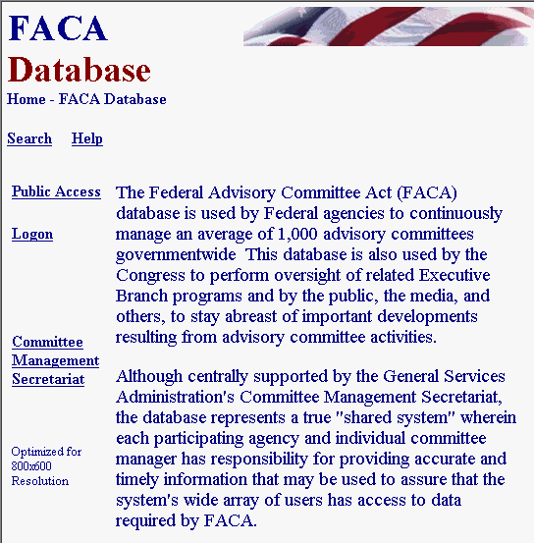
The opening screen for the FACA Database lets DFOs know that they have found the data repository and lists their options. The most direct address for the system is http://www.facadatabase.gov. The FACADatabase is part of a family of shared-interagency-databases located at http://www.fido.gov.
Buttons control navigation throughout the system. The Hyperlinks visible on each page to the user change depending upon the purpose of the page and the requirements (or access rights) of the user. The hyperlinks are located in the top border and the left border areas. DFOs should move from page to page with the hyperlinks as much as possible and avoid use of the browser buttons (like the arrows to go back or forward) unless specifically instructed to do so on the web page they are viewing.

We emphasize the avoidance of the browser buttons because the FACA Database is truly a database and an online application. A database and online application operates differently on the Internet than purely informational net pages. Browser buttons are designed to take the user backwards and forwards to pages of static, unchanged, and perhaps unrelated content. The pages of a database system change in content with every selection, filter, edit, save, insert, and delete, but have a distinct,”keyed” relationship with the preceding and following pages as the user drills down or moves back up through the data. The user is involved in a time-constrained and subject-constrained work session, and if the user starts jumping around using the browser menu, it is possible for the database application to lose track of who you are and what committee you are working on. It doesn’t usually happen and the technology is improving to prevent this conundrum, but a word to the wise.

The six hyperlinks on the opening screen navigate to the
Up,
Search,
Help,
Public Access,
Logon, and
Committee Management Secretariat pages.
The cursor displays a hand as the mouse moves over a hyperlink.

Up, from this screen moves the user up (or back) to the Federal Interagency Databases Online (FIDO) page. Generally, Up moves the user up (or back) to the previous screen.

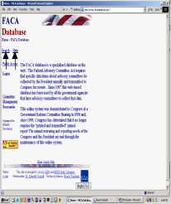Search (when it is working) allows the user to search for any text or phrase in the entire set of data stored as part of this system. That includes the data comprising the fiscal year summaries, the committee charters, and any stored meeting minutes or reports. A complete discussion of the search feature is found in the Public Access (Section 1) part of the system manual. The search capability will always be constrained by the Internet search technology, our web site programming ability, and the quality and completeness of the data entered.

Help explains the syntax, terms, and meaning of items of information collected in previous years as part of that year’s Annual Report (before 1999) or Annual Comprehensive Review (after 1998). It also displays a selection of manuals that explain the system’s functionality to the different users. This manual is for the part of the system designed for DFO access. The manuals can be viewed on the screen and printed with Microsoft Word or Adobe Acrobat Reader.

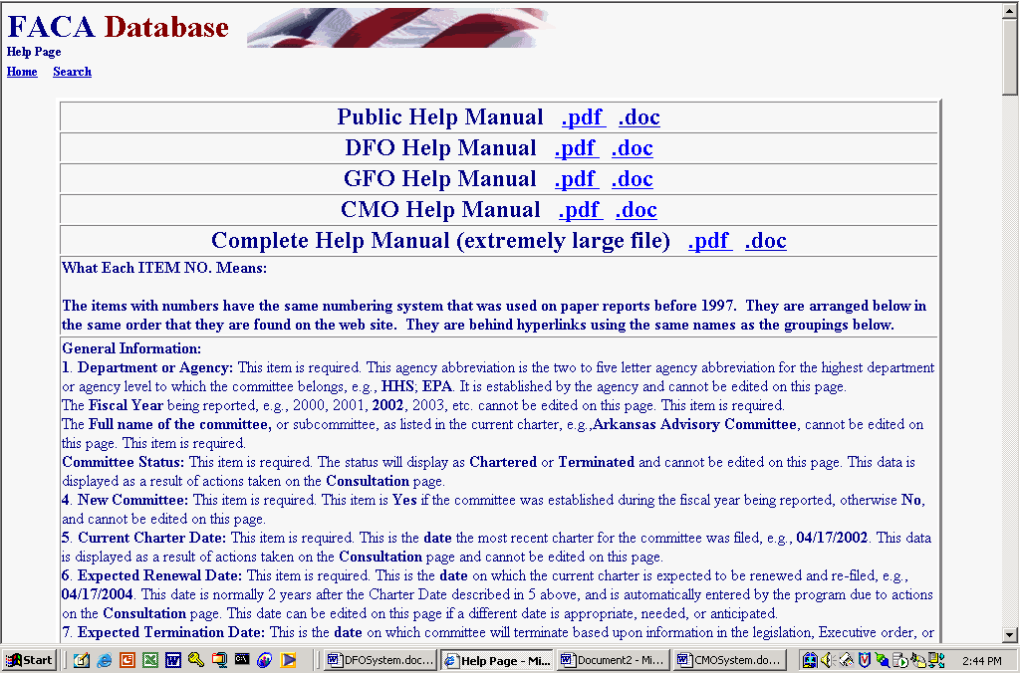
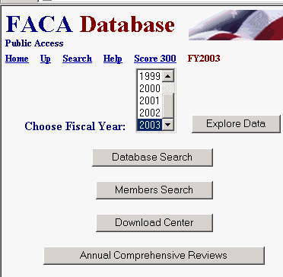
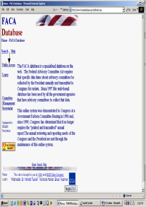Public Access takes the DFO to a page listing the Fiscal Years of reported data in the system, the Database Search, the Member Search, the Download Center, and the available Annual Comprehensive Reviews/Summaries available online since the cessation of the printed, transmitted, annual report. All the data is read-only. A reviewer must consider the data for the current fiscal year incomplete unless they know with certainty that the DFO updates the information throughout the year as events take place. At the end of the fiscal year, however, each DFO and the agency’s CMO are required by law to verify the accuracy and completeness of each committee’s data. The standard operating procedure for the present is that the information on a committee should not be deemed official and complete until that committee’s data has been verified by the agency CMO for that fiscal year. As mentioned above, the Help link provides a complete manual for the use of the Public Access section.

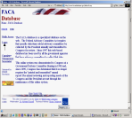Logon allows DFOs who are responsible for the committee data and who have editing rights to log on to the current year and view and update the management data. DFOs can update their committees, CMOs can update all of their agency’s committees, and the Committee Management Secretariat’s staff can update all the agencies’ data.

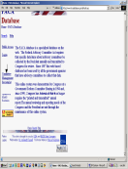Committee Management Secretariat links the DFO to the Committee Management Secretariat’s home page on the GSA Portal. The home page can also be found at http://www.gsa.gov/committeemanagement, the launching point for a comprehensive examination of the advisory committee process, practices, history, case law, advice and training.
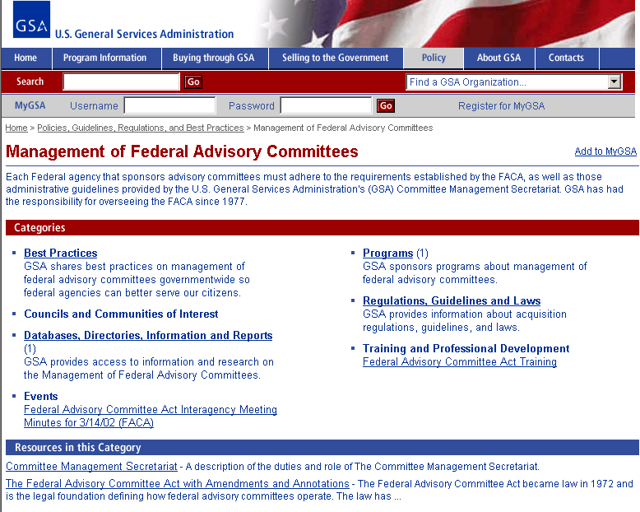

Logging onto DFO Data Maintenance Activities

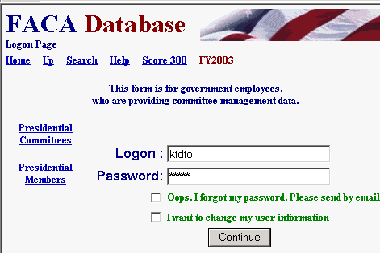
Clicking the Logon button displays the Logon page. The Logon page has seven hyperlinks, four data fields and one submit button. The main hyperlinks are Home, Up, Search, and Help. Home returns to the system’s opening page and ends the work session. We discussed Up, Search, and Help above. The additional hyperlinks are Score 300, Presidential Committees, and Presidential Members, which are helpful status reports. The data fields are the LOGON Text Box, the PASSWORD Text Box, the OOPS Check Box, and the I WANT TO CHANGE Check Box. The submit button is Continue.

To Logon, the DFO enters his/her username in the Logon: Text Box field and their password in the Password: Text Box field. When the Continue button is clicked, the program advances to the DFO’s User Profile page. If the DFO user logs on with their e-mail address as the username, the program advances to the Committee Menu page without stopping at the User Profile page.
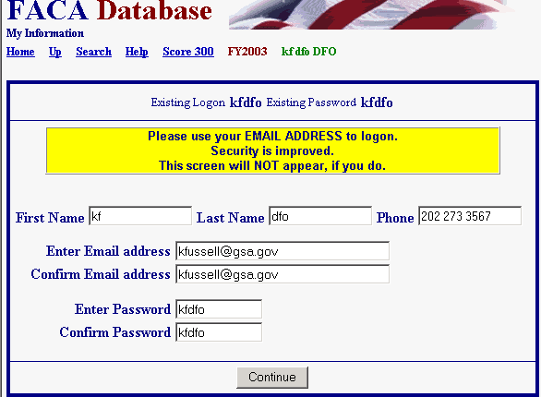
The DFO can change their user information any time they are logging in by checking the I WANT TO CHANGE Check Box before they click the Continue button. If the user fills out the User Profile page, including their e-mail, than the OOPS Check box will work. To receive an email with their password, the user enters their LOGON (E-mail address), checks OOPS, and clicks the Continue button.
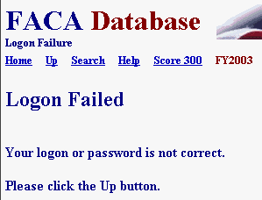
If the DFO receives a Logon Error, they should note the error explanation and contact their CMO to adjust their access rights. If you enter an incorrect Logon or Password, you receive the “Your logon or password is not correct” error.

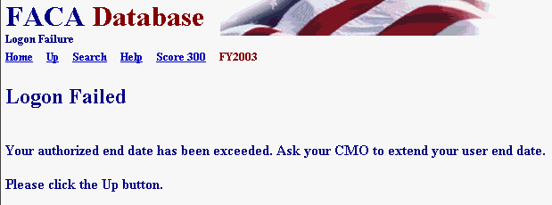
If your dates for access have expired, you receive “the Logon Date has been exceeded” error.

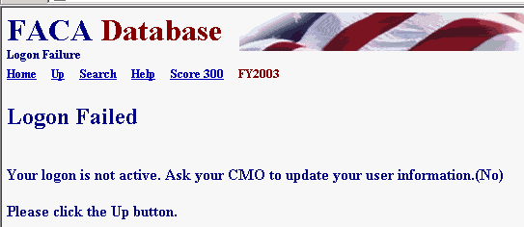
If your CMO has designated you as an “inactive” user, you see the “inactive logon” error when you attempt to logon.

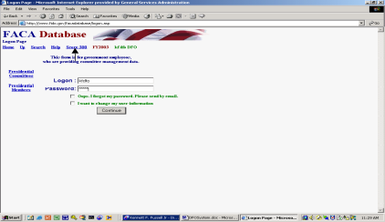The Score 300 hyperlink displays an agency’s ranking in online updates for the current fiscal year. It is a quick way to rank both the usage of the system by agencies as well as the completeness and accuracy of the data, since one can tell from the color and the number of committees updated just how much data entry/updating activity is occuring. Think of it as friendly competition. The user returns from the Score 300 page using the Up hyperlink.
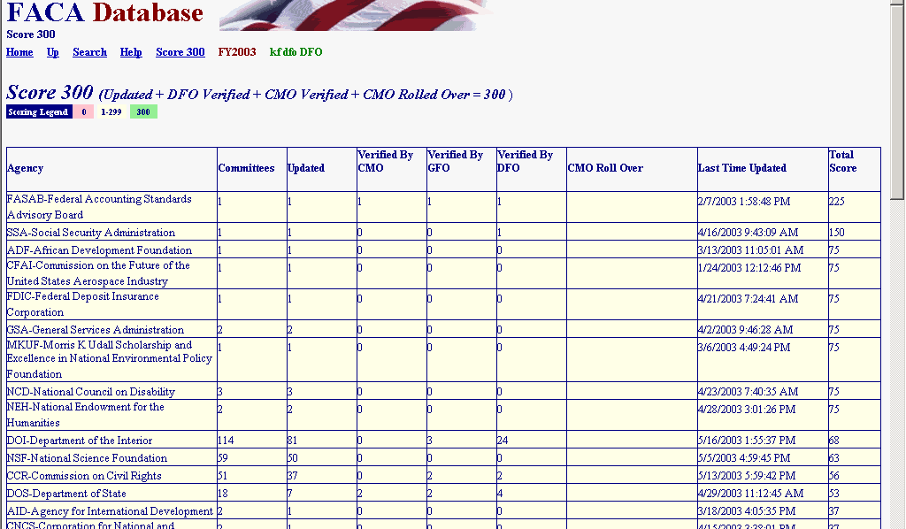

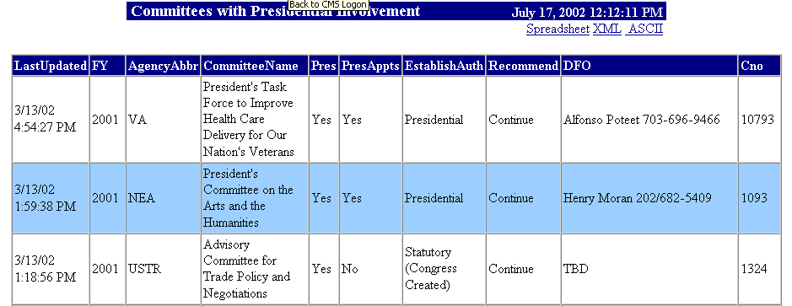
Clicking the Presidential Committees hyperlink displays basic committee information on committees that are either Presidential in type or established by the President. A committee is Presidential in type if it reports to the president even though it may have been established by Congressional Act. The committee listed in the third row is an example of Presidential type.

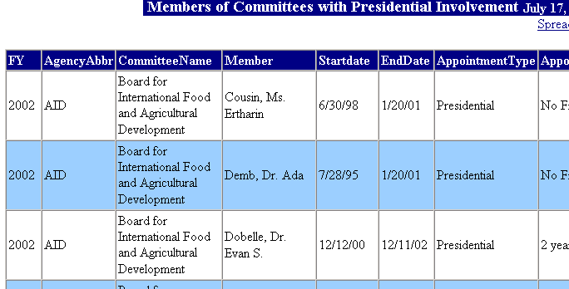
Clicking the Presidential Members hyperlink displays a list of committee members appointed by the President that are in the current year’s member list. These two hyperlinked reports are on the logon page at the request of the White House Personnel office. These reports, like all of the database’s reports for the current year, are only as useful and accurate as the data is kept up-to-date.
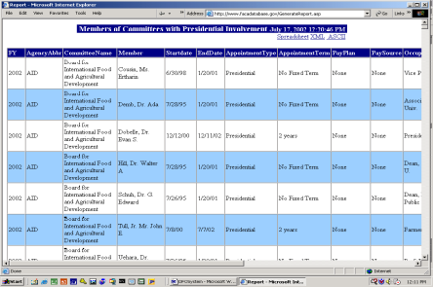
These reports, like eventually all of the database’s reports, can be downloaded to the user’s computer for more direct use and customization via the Spreadsheet, XML, and ASCII hyperlinks. No part of the data kept for public accession online is subject to privacy provisions. Any public user may download all the stored data in the online system.

The DFO’s Committee Management Activities

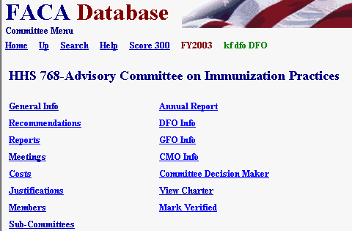
When the DFO logs in, he or she proceeds straight to the Committee Menu page. This page provides access to all the data that the DFO needs to keep up to date to meet FACA requirements. The menu options include
General Info,
Recommendations,
Reports,
Meetings,
Costs,
Justifications,
Members,
Sub-Committees,
Annual Report,
DFO Info,
GFO Info,
CMO Info,
Committee Decision Maker,
View Charter, and
Mark Verified.
An additional menu option related to the recommendations made to the agency by the committee and performance measures applicable to the committees work will be added soon. This page will be called Annual Comprehensive Review. Many committees also display a link on the Committee Menu page to the committee web site.
Editing the Committee’s General, Categorizing Information

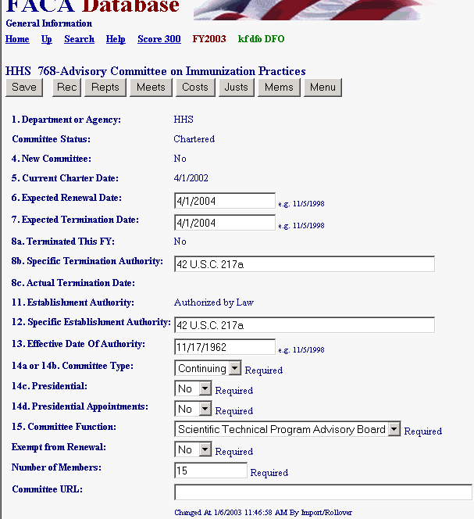
The General Info page allows data entry and updating to the fields:
Expected Renewal Date,
Expected Termination Date,
Specific Termination Authority,
Specific Establishment Authority,
Effective Date of Authority,
Committee Type,
Presidential,
Presidential Appointments,
Committee Function,
Exempt from Renewal,
Number of Members, and
Committee URL. The other fields on the page are filled by the CMO when the Committee is created, or changed by the CMO when they are consulting with the Committee Management Secretariat. Those items require a new charter and the information is added at the new charter time by the CMO. Other than the expected Renewal or Termination dates, most of the information does not change from year to year.
- The Charter Date should be the date the last charter is/was filed with the agency’s Congressional Oversight Committee and will appear changed on this page when the CMO files a new charter via the Consultation process, a link on the CMO’s Committee Menu page. The consultation process (with the Committee Management Secretariat) is a CMO function and the DFO does not see a Consultation link on the Committee Menu page.
- The Renewal and Termination dates are generally 2 years from the Current Charter date. The DFO (and CMO) should check this information at least once, early during the current fiscal year, to make sure that the information is accurate and up-to-date. Keeping the Expected Renewal and Expected Termination dates current improves workflow reports the system generates for the CMO, the agency, and the Secretariat. The consultation process of the CMO with the Secretariat usually takes care of updating these dates automatically, but when the charter mentions a specific renewal or termination date, the CMO or DFO can enter that date in these fields.
- A committee is only reported New = Yes the year it is established and is only reported Terminated = Yes the year it is terminated.
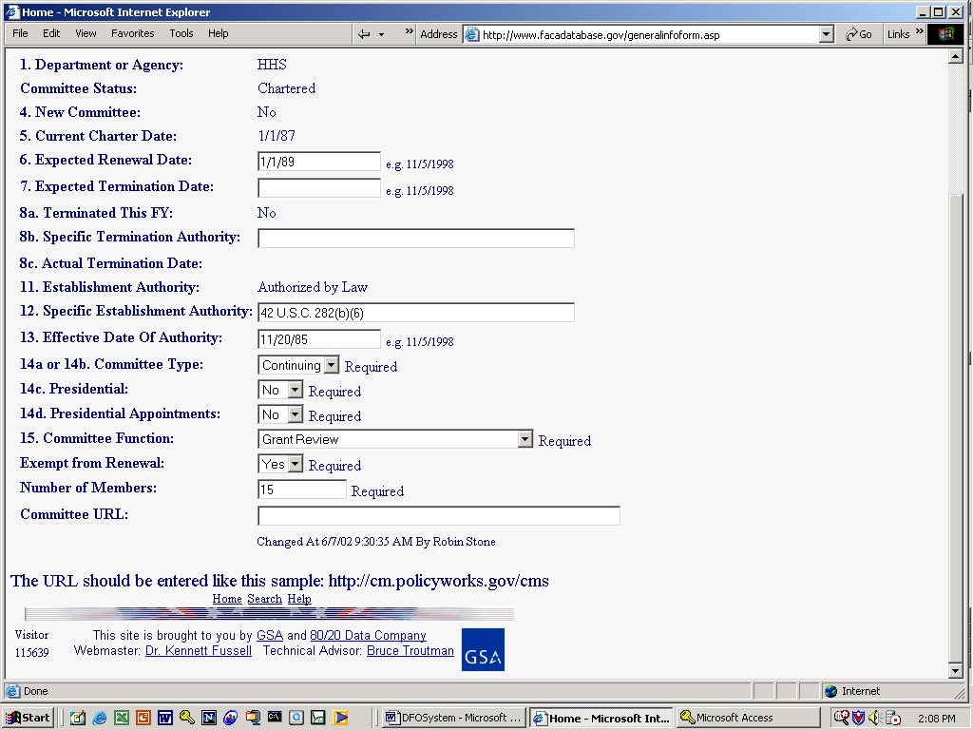
Most of the remaining fields require an answer from a limited set of options. Where this is so, a pulldown list of the correct options is provided.
- A Committee Type is Continuing (i.e., lasts more than 6 months and extends over a fiscal year boundary) or Ad Hoc.
- A committee is Presidential if it reports to the President. When a committee is set up by the president, but for some reason does not report to the president, the committee is considered established by Presidential Authority. Since the committee does not report to the president it is not a Presidential (type) committee.
- A committee has Presidential Appointments if the President appoints any member of the committee to serve on the committee. This condition is normally specified in the charter or the law creating the committee.
- If a committee is statutorily exempt from renewal, Exempt should be Yes. This is rare.
- If the charter includes a specified Number of Members, that number should be entered as numeric digits in place of the default field contents. When the General Info page is created, the program inserts “Unlimited,” as the default contents of the Number of Members field.
- 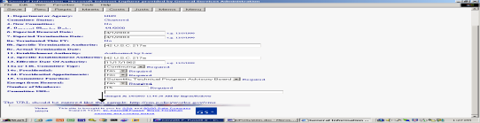 If a committee has a Web site, the web address (URL) should be filled in. Doing so will automatically create a web site hyperlink (Go) on the Committee Menu page at the end of the Committee URL field block. The URL should be complete as displayed in the example at the bottom of the General Information web page.

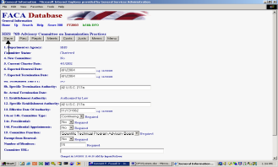When data had been added or changed on the General Info page, the DFO should click the Save button. The DFO should always save any changes made on a page before moving to a new web page. When the data is changed and saved, the system updates the Changed At line with the logged in person’s user information.
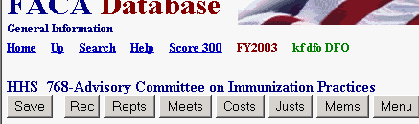
The other navigation buttons on the General Info page are short cuts to the other data entry pages and are included to save a click and page load between pages that are frequently used by the DFO. The Up hyperlink takes the DFO back up the path from the General Info page to the Committee Menu page. The Menu navigation button also goes to the Committee Menu page.

Editing the Committee’s “Continuation Recommendation” and General Remarks

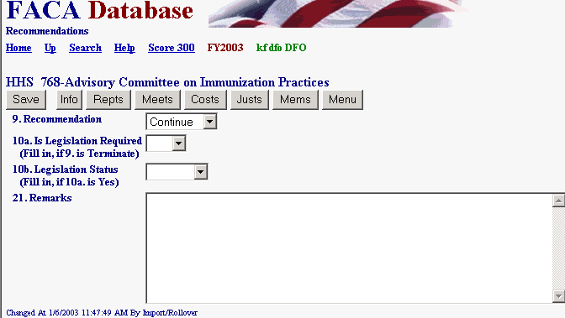
The Rec link (Recommendations) displays the Recommendations page. This page is for the agency’s recommendation regarding the continuing usefulness of the advisory committee and is not for the advisory committee’s recommendations to the agency. The advisory committee’s recommendations to the agency are a performance measure feature that will be added to the system in the near future on an Annual Comprehensive Review page. Information can be added to the Remarks field any time the DFO feels that some activity or event deserves clarification or elaboration and cannot find another place in the system to include the information. The Remarks field could contain up to 64 pages of comments. The Recommendations page fields need to be addressed only once a year before the data for the committee is verified by the DFO and the CMO. Recommending to Continue or Terminate a committee is generally an agency decision. Some statutory committees require legislation in order to be terminated. Producing legislation is never simple and can never be assumed, hence the need for questions 10 a Is Legislation Required and 10 b the Legislations Status in the legislation pipeline. If the work of a committee has been completed for over a year and the termination legislation is not visibly on the horizon, the DFO can discuss with the CMO the possibility of shifting the committee to an “Inactive” Status in the data system so that it does not continue to require reporting year after year.
Listing the Reports Generated by the Committee

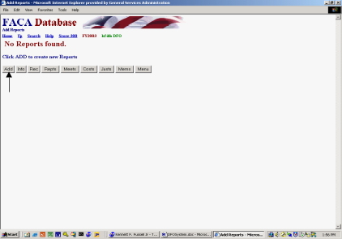Clicking the Repts link displays the Reports page. These are the reports generated by the committee to the agency (or the specific government official being advised) and not the committee’s “annual report” or “annual comprehensive review” required by FACA’s reporting requirements. Each committee begins the current reporting year with no reports listed since the committee has not yet issued any. As reports are published or submitted to the government official being advised, the titles and dates of publications are added to the Reports list by the DFO. If the publication is available in an electronic format, the online system has an upload feature to store the report for viewing by the public. To add a report title and date, the DFO clicks the Add option button.

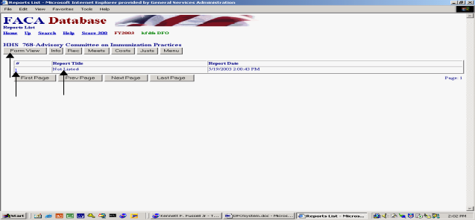Clicking the Add button generates a new report record with the words “Not listed” in the Report Title field and the current date in the Report Date field. The Reports List-view page is a listing of all of the reports for the committee in date order, so the page is presented read-only and cannot be edited. As a general rule in the current system, data cannot be edited when it is presented in a list (a List View). Data is edited only when it is presented as a single record in a Form View. This approach is currently common Internet SOP for data entry, but we hope to make the process friendlier and more efficient in the near future. From the List View, read-only, Reports page, there are two ways to display a Form View Reports page. The most commonly used is clicking the hotlink, the underlined number in the leftmost column of the record to be edited. The second is to click the Form View option button and use the appropriate Page button to move to the correct record.

Once in the edit mode, the Report Title field contents “Not Listed” should be replaced with the actual report title, and the Report Date field contents should be replaced with the actual date the report was issued. Presidential Action is Yes if the committee is a Presidential Type committee. For Presidential Type Committees, Congress requires that the Agency and DFO report a year after the submissions of the report and recommendations on what the President did with the recommendations in the report that was submitted. If the committee maintains a web site with the committee reports posted on the web site, a URL for the location of the specific report page can be added to the View Report At Text Box. Reports in an electronic format can be uploaded to the system with the Upload Reports File to FACA Database button, but the Report record should be saved at least once before the Upload button is used. Adding either the URL to the text box or uploading the file will create a GO button on the form that is a hyperlink to the report when the page is saved. When the DFO is satisfied with the edits, the changes should be saved by clicking the Save button. The DFO should not leave a page on which changes have been made without clicking the Save button, or if the page is a new record, the Save New button. Please remember that we are using the Internet. The system does not save automatically when leaving a page since saving requires data transfer between the user’s computer and the web server. The Internet works this way because performing “unnecessary” data transfers would slow down the system for users who were browsing but not editing the data. We are isolating the various functions to make this part of the system more responsive to the DFO user as a goal for the very near future. The system also has a two-hour time-out limit. The “time-out limit” means that if the user leaves the system on the same page for longer than two hours without saving a change or requesting a new page, the system forgets the user.

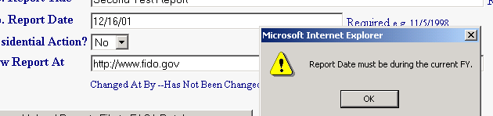
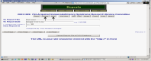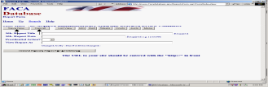The DFO can add a second or third or any number of report titles with the New option button. The DFO can delete reports entered by mistake with the Delete option button. Clicking the New option button presents a blank record and two additional buttons, Save New and Cancel. After saving the “new” record the DFO is returned to the first record, which is the top of the list of reports on the Form View Reports page. One of the most common errors in data entry occurs when the year part of a date for a meeting or report is entered as the last two digits. The date to the right is actually correct during the FY 2002 reporting year, but our program doesn’t allow a two-digit year entry. Remember the Y2K problem when we rolled from 1999 to 2000. Ever since, we have set up our data tables for four-digit year entry so the computer does not get confused about what year it is.

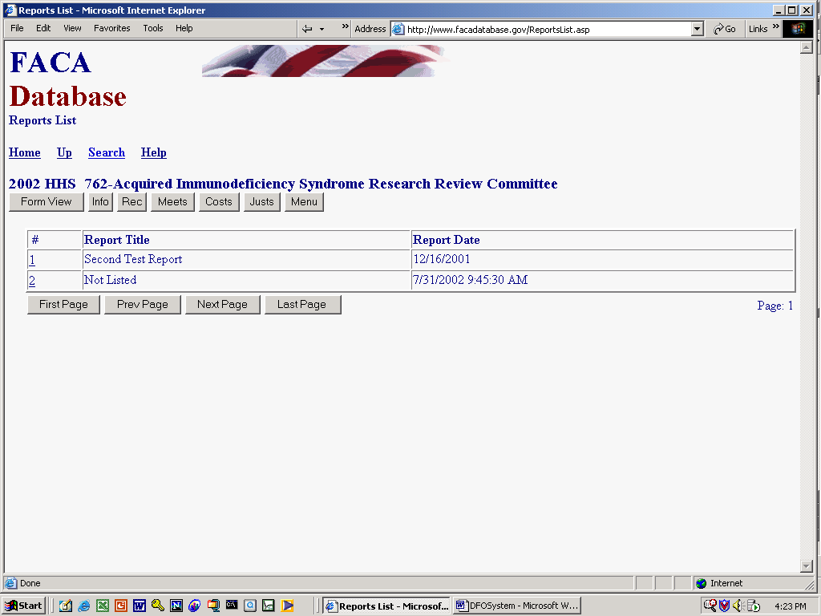
To see the list of reports that have been added, the DFO clicks the List View option button. This returns the user to the Reports List View page, with all of the reports listed that have been added for the committee in a read-only format, ordered by the date of publication of the report.

Listing the Meetings Held by the Committee

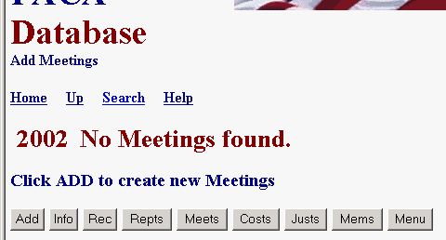
Clicking the Meets link displays the Meetings page. Each committee begins the reporting year with no meetings listed. As meetings are planned or held, the purpose, dates, locations, and whether the meeting will be or was open or closed are added to the Meetings List View page

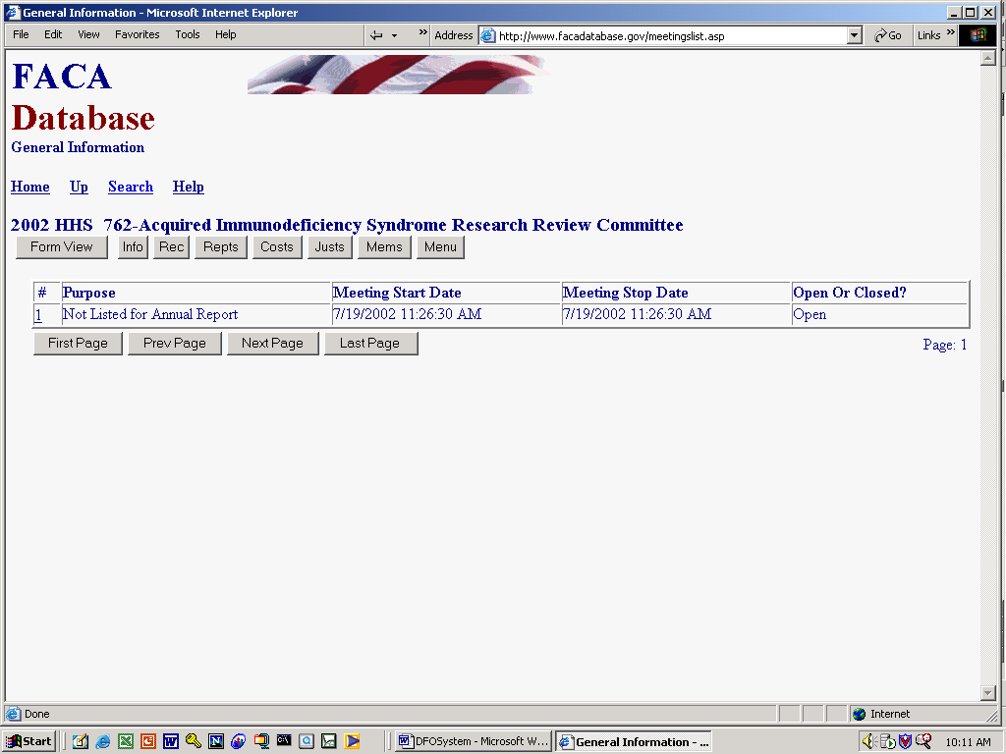
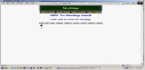To add the first meeting, the DFO clicks the Add option button. Clicking the Add button generates a new record with the words “Not listed for Annual Report” in the Purpose text box, the current date in the Meeting Start Date and Meeting Stop Date fields, and “Open” as the default entry in the Open or Closed text box. The Meetings page is a listing of the meetings planned for the committee or held by the committee for the year being reported, so the page is read-only and cannot be edited. As mentioned in the report section above, data is not edited when it is presented in a list (a List View). Data is edited only when it is presented as a single record in a Form View. This may/will change as the technology improves and our coding skills increase.

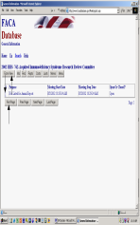From the List View, read-only, Meetings page, there are two ways to display a Form View Meetings page to edit or enter the data. The most commonly used method is clicking the hotlink, which is the underlined number in the leftmost column of the record to be edited. Your second option is to click the Form View button and use the appropriate Page button to move to the record you wish to edit.
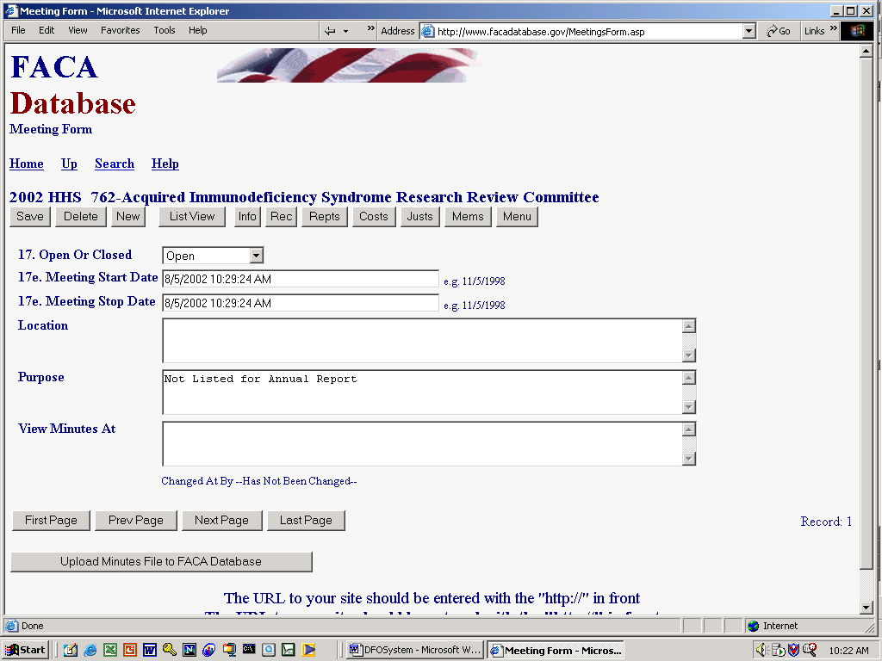
Once in the edit/data entry mode, the Open or Closed field contents should be replaced with the correct option, and the Meeting Date fields should be replaced with the dates the meeting started and the meeting stopped. The Open or Closed option choices include Open, Closed, Partially Closed, and N/A. While “Open” and “Closed” are obvious in their use, “Partially Closed” should be used when any part of the scheduled meeting is closed. “N/A” can be used if the DFO is reporting a committee event that is a committee work-related activity, like an administrative logistics meeting between the chairperson and the DFO, or the committee’s tour of a park site under discussion. The difference is that the event in question is not a reportable scheduled meeting under FACA. The meeting start and stop dates are necessary but the actual times are not necessary. Multiple dates are needed to calculate the length of the meeting in days. The Location and the Purpose fields are required entries, but your agency may have some guidance regarding how detailed those entries need to be. The View Minutes At text box can be used to enter an agency or committee web site where the minutes can be found when they are prepared, and the minutes or the transcript in an electronic format can be uploaded with the Upload Minutes File to FACA Database button. If you wish to upload the minutes to the online system, be sure to save the meeting record so that the meeting record already exists when you click the upload button to upload the minutes. When the DFO is satisfied with all of the edits, clicking the Save button saves the changes.

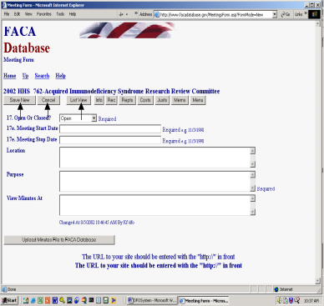The DFO can add more meetings with the “New” option button or can delete meetings entered by mistake with the Delete option button. Clicking the New option button presents a blank record and two additional buttons, Save New and Cancel. Save applies to saving the changes to an existing and edited record, and Save New applies to saving a new record. All of the fields in a new record are blank except for the Open Or Closed field. Clicking the New button while on a Form View Meetings page creates additional new meetings. The user edits the Open or Closed field, the Meeting Date fields, and the Purpose, Location, and View Minutes At fields. The user finishes saving the new meeting record with the Save New button. After saving the “new” record the DFO is returned to the first meeting chronologically on the meeting list for the current fiscal year. From that point they can page through the meetings, create new meetings, delete incorrectly added meetings, or display the read-only meeting List Page.
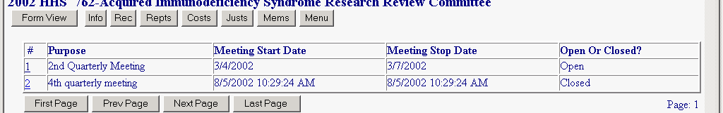
Editing the Committee’s Costs

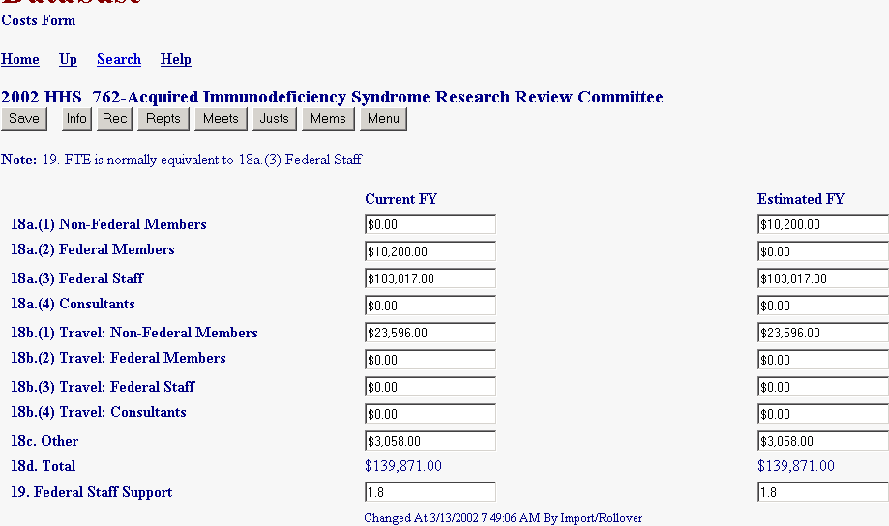
A committee’s Costs Page reflects all of the costs attributable to the committee’s existence for the reporting year. A Committee begins the reporting year with either the cost data that was estimated when the committee was established, or the cost data for the current year that was estimated the previous year, or the cost data of the previous year. The agency’s FACA administrative guidelines and the agency CMO provide guidance for collecting and computing the costs. For most committees the payments to Non-Federal Members and Federal Members are nominal and the bulk of the costs are in staff, consultants and travel. The user should enter totals for each category into the text boxes 18a through 18c. The system totals the results in item 18d when the page is saved. The cost of the number of FTE entered in item 19. Federal Staff Support, is expected to normally be equivalent to item 18a(3), Federal Staff. In the example, an FTE of 1.8 is reported as costing the government $103,000 towards the cost of the committee. Your staff costs could be more or less per person than the example depending upon the grade of the staff assigned to committee work. The Other text boxes are for committee costs not attributable to staff or travel. The precision of the data entered in the Estimated FY column of text boxes is also a matter of agency guidance. It is used by some agencies for planning and was an original part of the Federal Advisory Committee Act reporting requirement. If the Changed At/By line says import/Rollover, then the Costs page has not been edited by the DFO during this reporting year. Finally, as usual, the DFO should be careful to click “Save” before leaving the page after making any edits.
Editing the Committee’s Justifications

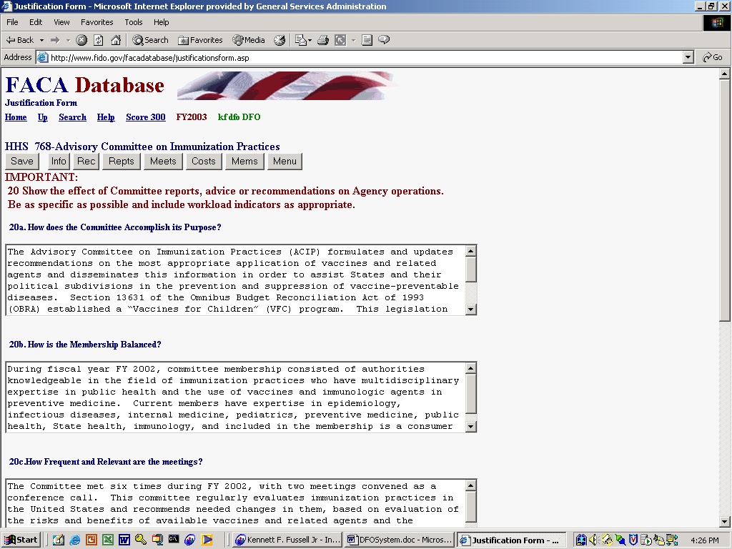
A committee’s Justifications Page begins the year with either the justifications that were provided when the committee was chartered or the justifications that were reported the previous year. While the purpose of a committee and therefore its Justifications sometimes do not really change much from year to year, the DFO should make sure that the information is accurate, timely, up-to-date, and complete. The information is on the web and readily available to the public. It helps to view the Justifications as an opportunity to communicate the value of the committee’s work.

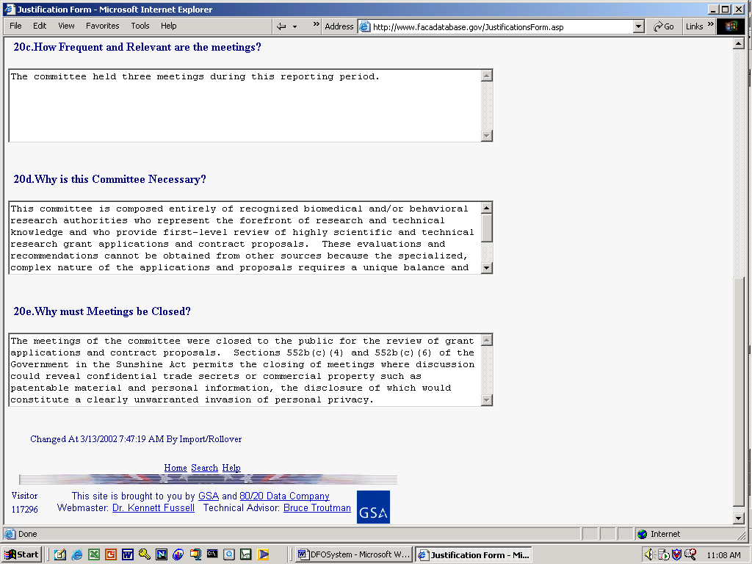
The Committee Justifications page is not the place for minimalism. A useful approach that avoids the possibility of wasting data entry effort is to prepare the committee justifications off line with a word processing program. Then, after the DFO is satisfied that the composition satisfies their informational requirements and the word processing effort has been saved, the text can be cut from the word processing program and pasted into the individual Justifications fields. The web program does have a 2-hour time-out. A two-hour-time-out means that you must send data to or retrieve data from the web server at least once every two hours or your logon will be dropped. With a two-hour window most users could safely composed their responses on-line, but we recommend that you compose the justifications in your word processor and avoid any chance of losing your work. There are five questions to be considered. Be sure to use the Save button after you make any edits or changes to the Justifications page.
Listing the Members of the Committee
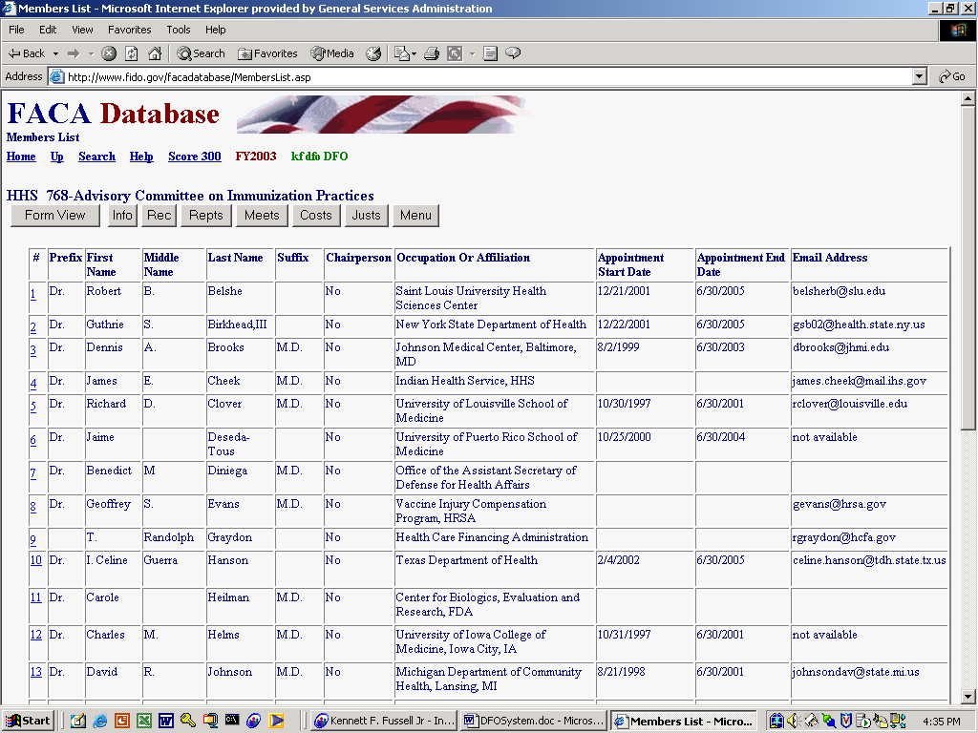

Clicking the Mems link displays the Members List View page. Each committee begins the year with the list of members it finished with the previous year. If a committee has just been established and the members have not yet been added, the page displays the statement:

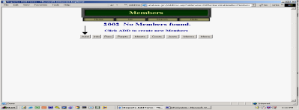Like Meetings and Reports above, Members are added and deleted from the Members Form View Page. Clicking the Add button if there are no members added yet, or the Form View button, or the underlined hotlink number in the leftmost column of the individual record accesses the Form View data entry page.
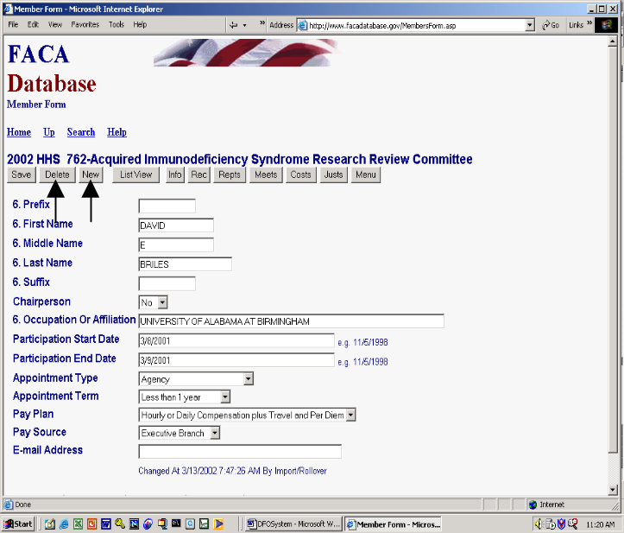As new members are appointed and existing members’ appointments end, the DFO adds the new members with the New button and deletes members with the Delete button. A member must be reported for the year if he or she serves any part of the year. The information required to be collected about each member is
- Any title (Dr.) or Prefix,
- First Name
- Middle Name or Initial,
- Last Name,
- Any title (Ph.D., MD, III) or Suffix,
- A Yes or No indication of Chairperson status,
- An Occupation or Affiliation,
- The Date the member was first appointed or started participating on the committee,
- The Date the member’s appointment ended or the member stopped participating on the committee,
- Who appointed the member (usually members are appointed by the head of the agency, but the charter may specify appointments by the President or Congress, etc),
- The appointment term length (The charter or legislation may specify this or the agency may have a general statement of typical term length in the formal administrative guidance document prepared to comply with FACA),
- The pay plan (most members serve without a pay plan, but follow the agency guidance on this),
- The pay source (the pay source has to be one of the branches of government if there is a pay plan and the committee is constituted under FACA. If the agency is paying the member anything out of the Agency budget, the pay plan is executive branch), and
- The committee member’s e-mail (if the member allows it and it is agency policy to include it). The public user cannot view the member’s e-mail from the public part of the system.
If members’ terms end during the year, reporting all the members serving during the year, as required, can make it appear that the committee has many more members than it actually has at any one time. Including the Start and Stop dates served helps more realistically portray the total current membership at any point in time. There are also many reports in the system that can be used by the agency, the congress, the president’s staff, yourselves, and the public that only work when this information is kept fairly current. It is generally a helpful practice to delete members who were no longer serving at the beginning of the fiscal year as early in the year as possible to make the current year information more accurate to the public and governmental user.

Subcommittees

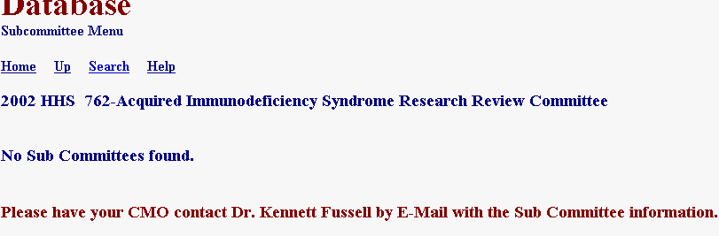
Most committees do not have subcommittees and when the Subcommittees hyperlink is clicked, the system reports that no subcommittees are found. At the same time some large advisory committees organize their work by tasks performed by dozens of subcommittees.

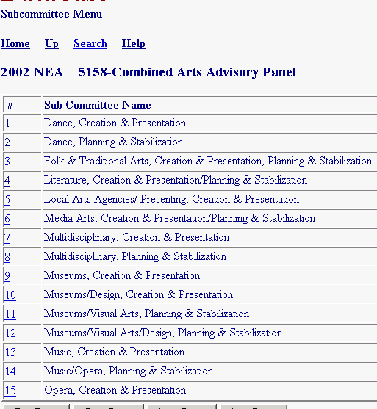
The subcommittee feature exists to allow the reporting of meetings, reports, costs, and members by subcommittee when the advisory committee or agency wishes to do so.

While an extra step is required in setting up subcommittees, once they exist (are given a distinctive name), the data entry process is the same as for Meetings, Reports, Members, and Costs above. If subcommittees are used, the data for meetings, reports, members, and costs should be added to either the subcommittee or the parent committee, but not both. The online system’s summary process (the program coding) adds the information from the subcommittees and the parent committee into a single total report and if the data is entered in more than one place it is duplicated or counted multiple times. The extra step required to establish subcommittees is to let the CMO and the Committee Management Secretariat know of the desire to use subcommittees. The CMO provides a list of subcommittee names along with the parent committee name and number to the Secretariat. The process of adding and maintaining the list of subcommittees for a committee in the system will change in the future so that it is completely under the control of the CMO.
Annual Report

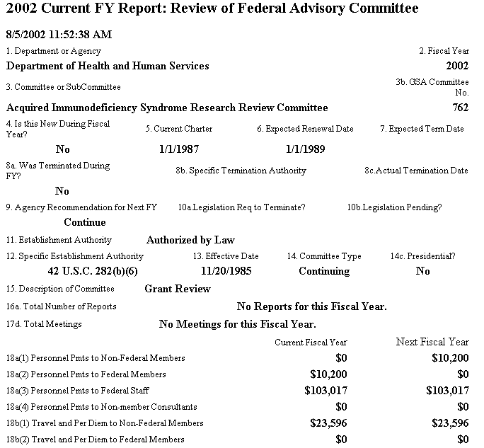
The Annual Report link displays a single, printable, read-only summary report specific to the selected committee for the reported year. If key information is missing from the reporting process, like the recommendation to continue or terminate the committee, the Annual Report page will display a warning where the data is missing.

Designated Federal Official Information

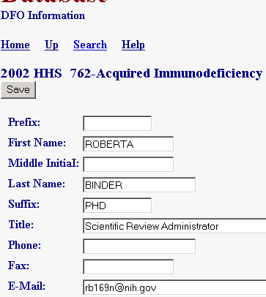
The DFO Info hyperlink displays the DFO Info page, the information and data entry screen for the Designated Federal Official. The DFO has edit rights to this information and the information should be kept up to date, since information like the Phone number and the E-Mail address are used in reports and workflow processes. Be sure to click the Save button after making changes to the data.

Group Federal Official (GFO) Information

Some agencies have quite a few committees (HHS: over 250, DOI: over 110) and have organized their committees into sub groups within offices in the agency. Examples of sub groups are NIH in HHS, The Park Service in DOI, and The Forest Service in USDA. If the committee is part of such a working group, GFO information exists and is displayed on the Committee Menu. In such cases, the DFO can view the GFO info but cannot change it.
Committee Management Officer (CMO) Information

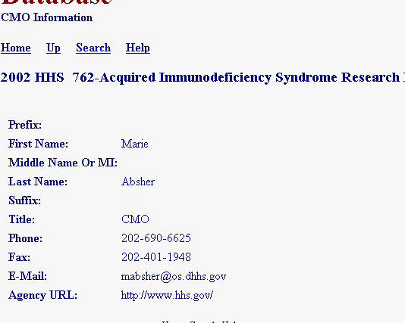
The CMO Info hyperlink displays the CMO Info page when clicked. There is a CMO for every agency with an advisory committee, just as there is a DFO for each advisory committee. The contents of the E-Mail Address field plays an important part in the workflow process of this system, since e-mails are sent to this address alerting the CMO of changes made to the committee data. The CMO data cannot be modified by the DFO and you can see that in the example because none of the information fields are editable boxes. Only agency CMO or Committee Management Secretariat personnel have edit rights to the CMO data, although more than one person in the agency may have CMO edit rights.

Committee Decision Maker

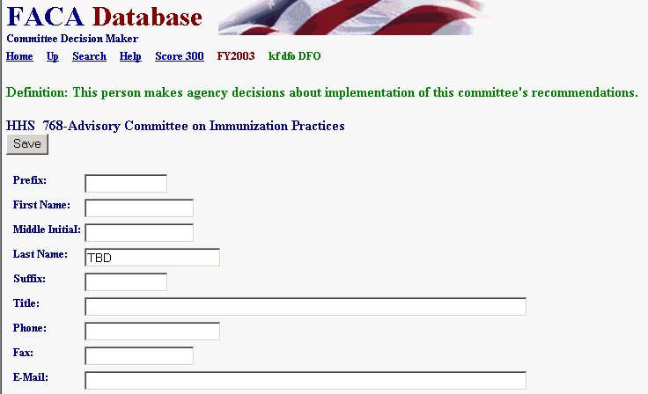
The Committee Decision Maker link displays the contact information for the person who makes the decision for the agency to use the committee’s recommendations and advice. 2003 is the first year that this information has been reported. Advisory committees, like the rest of government, are being considered in the context of performance and performance measures. One measure of an “advisory” committee is the advice it provides. An essential component of the advisory process is the advice receiver and/or the person who decides to use the advice received. As we well know, these are sometimes, but not always, the same person or groups. Since we occasionally have to choose, we choose to know the decision maker. The fields for this page are the same as for the DFO, GFO, and CMO pages above.
Viewing the Committee’s Charter
The View Charter link displays the committee’s current Charter. The charter is displayed in a read-only word-processing format. We prefer a word processing format because most word processor programs produce a document format in Internet Browsers like Netscape or Explorer that can be read by “screen-readers” for the blind. To the extent possible and feasible, the FACA online system stays consistent with or tries to exceed the requirements of the American with Disabilities Act regarding Internet accessibility. If the charter is older and not available as a word processing document, either the Committee Management Secretariat or the agency scanned the charter to an Adobe .PDF file. The filenames used are a combination of the GSA assigned Committee ID numbers-a period-and a .doc (or .pdf) extension. To add the charter to the database web site,
- The agency CMO will upload the approved and filed charter using the Upload button on the Consultation page. Since the Committee Consultation procedure is a CMO function, the DFO Committee Menu page does not display that Button for DFO use.
- Sometimes, when the agency is especially concerned about displaying a charter with the approving official signature, the agency will scan the official charter copy and upload the .pdf file.
- Of course, when necessary, the agency and Committee Management will use any other practical process that can be devised and agreed upon to load a charter into the system.

Accessing the Committee’s Web Site

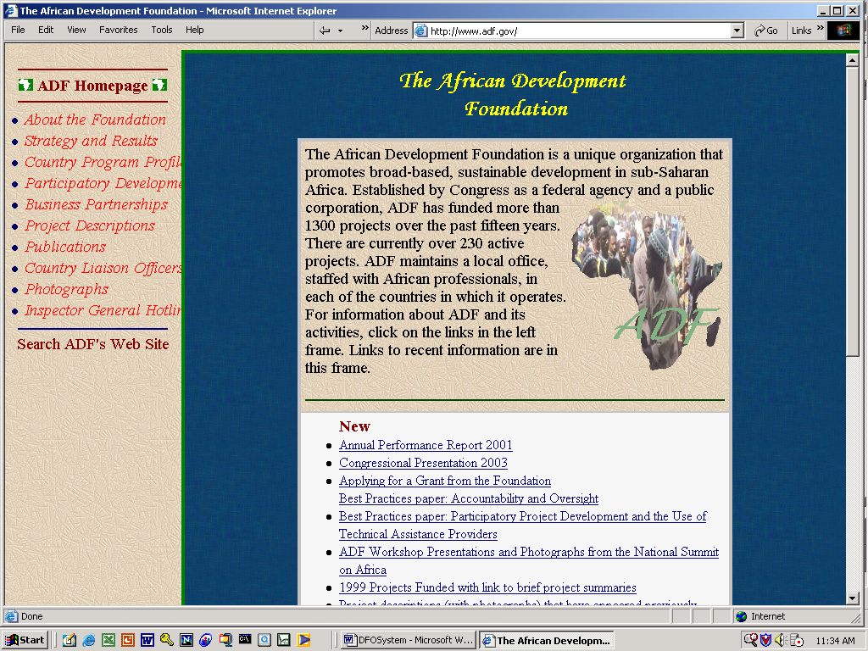
If the Committee Menu page displays a Web Site hyperlink, the page is linked directly to a web site for either the advisory committee or the advisory committee’s agency. The data to link to the web site is entered on the Committee’s General Information page and the web address, the Universal Resource Locator (URL), should be entered as demonstrated in the example at the bottom of the General Information page. If the user goes to the committee web site, and wants to return to the FACA Database where they left off, they need to click the Browser’s back button.

Verifying the Committee’s Data

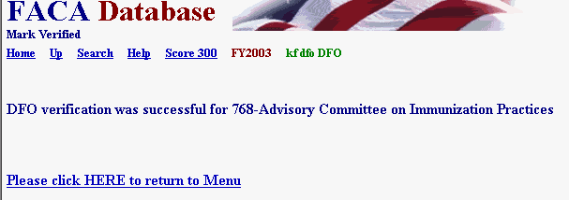
Annually, in the fall, on a schedule distributed and managed by the agency CMO, the DFO should recheck the data entered for the past year and verify its accurateness and completeness. Clicking the Mark Verified hyperlink presents the DFO with a “Verification was successful” page similar to the page seen to the right.

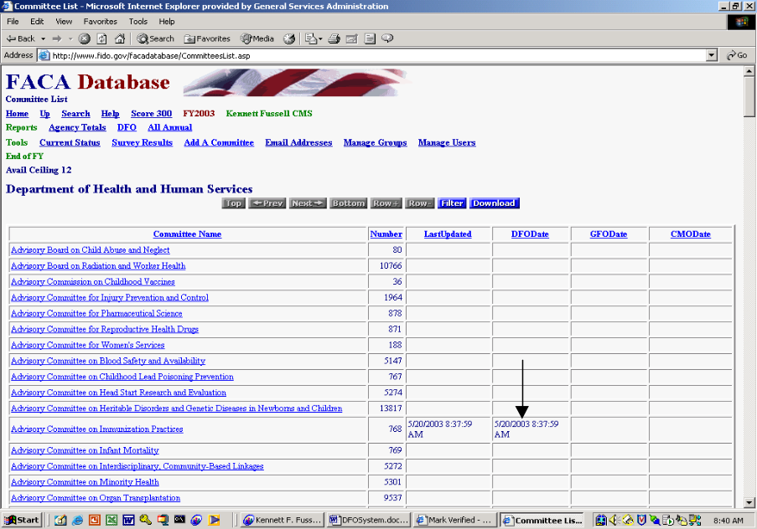Clicking the Mark Verified hyperlink also adds a time stamp to the database and the time stamp appears on the CMO’s Committee List page. This alerts the CMO that the DFO considers the data complete. This verification process also temporarily locks the data, although the DFO can unlock the data and make further changes by clicking the Save button on any editable page. If the DFO clicks the Save button and unlocks the data, the time stamp is removed from the CMO’s Committee List page. If the CMO checks the data and clicks the Mark Verified button, the data is locked, a time stamp is added under the GFO and CMO date columns for the committee, and the DFO cannot change the data further. Of course, the CMO can also unlock the data by clicking the Save button on any editable committee page.
SECTION III: Group Federal Officer Management Tools and Access to Advisory Committee Data

The Group Federal Officer (GFO) is not an official term with regards to the Federal Advisory Committee Act (FACA) or any other official government employee that we know of. The GFO was made up by the Committee Management Secretariat to identify the role of a person who holds an agency supervisory position over a group of committees, i.e., the National Park Service in the Department Of the Interior or the National Institutes of Health in the Department of Health and Human Services. The GFO uses the on-line system to manage the sub-group of advisory committees, manage agency users of the system within the sub-group, and, if necessary, to update the information on advisory committees during the current fiscal year. FACA requires that information about the advisory committee be provided at least annually. The web-based database accommodates and builds upon that requirement by both allowing the continual updating of committee information throughout the fiscal year and providing committee management functionality. Keeping the data continuously up-to-date converts the system from a focus on history and records to a focus on management and immediate relevancy. With frequent and timely updates, the system becomes more useful to everyone, ranging from the public user to congressional staff with oversight responsibility.

The “GFO” user has access with edit and update rights to the current fiscal year’s data for their specific committees via the Internet. The GFO is given their access rights, their logon (username) and their initial password by the agency Committee Management Officer (CMO). The GFO, like any public user, can view all of the information on all of the committees available for the current fiscal year in a read-only mode in the Public section of the system. At the same time, only the DFO, or their designee, the GFO or their designee, the agency CMO, or their designee, or a Committee Management Secretariat (CMS) staff member can edit or update the committee data being reported for the current year.

What kind of data is being collected and maintained?

For the GFO, the program collects, totals, and displays
- Committee charters and related information,
- Projected committee renewal or termination dates,
- Distribution of establishment authorities and committee functions,
- Committee members,
- Committee costs,
- Agency’s recommendations for continuation or termination of the committee,
- Report titles, publication dates, and electronic copies of the reports,
- Meeting dates, purposes, locations, whether the meetings were open or closed, and electronic copies of the meeting minutes,
- Ongoing committee justification information,
- Performance measurement data,
- GFO contact information,
- Agency users and editing rights, and
- Any web site addresses (URLs).
The database does not contain meeting announcements or committee recommendations to the agency, although the designers have included provisions for those additions in the near future.

How does the GFO use the system?

The system is designed to capture relevant information when first entered by the CMO and DFO, and to carry that information forward from year to year until the information is no longer required.
1) When a committee is first established and chartered by the agency and added to the system by the CMO, the information entered addresses the committee’s general information, membership information, and estimated cost information requirements.
2) The CMO and/or the Committee Management Secretariat (CMS) use the Consultation process found on the Committee Menu page to complete the committee establishment. Since they usually do not use the Consultation feature or make frequent consultations with the Committee Management Secretariat, the GFO and DFO do not have the Consultation hyperlink displayed on the Committee Menu page they normally view.
3) The CMO adds the DFO as a user to the system and provides the DFO access to the newly created committee.
4) The CMO creates a group of committees for intermediate management.
5) The CMO adds the new committee to the appropriate group (or, in some rare cases, more than one group).
6) The CMO adds the GFO as a user to the system and provides access to the committee group for which the GFO is responsible.
7) The CMO has the DFO or the GFO log onto the system and
- Edit the general information for completeness and accuracy which contributes to the annual report requirements and keeps the Renewal or Terminate Report timely and useful,
- Add meetings and reports as they occur,
- Add or delete members as they come and go,
- Add or update costs as they occur,
- Add or update the web address if a web site is created for the committee,
- Add or update their own contact information as it changes,
- Add or update the annual performance measurement data,
- Recommend the continuance or termination of the committee by the end of the fiscal year, and
- Verify the accuracy and completeness of the committee data for the closing year.
The guidance for the above data entry activities is found in the DFO Help manual, since the DFO or her designee normally does the data entry and information maintenance. The GFO, or the CMO if she or he chooses to do any or all of the tasks above, would find that the general information data, cost information data, and member information data added during the establishment of the committee has been carried forward to the relevant report pages for each reportable year. At the end of the year being reported and closed, the program carries all of the data entered forward into the new year except for meetings and reports.

The GFO also has access to the public read-only section of the system. This section can be very helpful and useful to their management needs. Using the Search feature, the GFO can discover what other committees exist in other agencies with issues and concerns similar to committees they are responsible for or planning to charter. With that knowledge, the GFO can Drill Down to the specific committees of interest and determine if the system has information useful to them, or they can identify people in the other committee’s agency to contact for further investigation. In the Public Access section, the GFO drills down from the general Year to the Agency to the specific Committee to view the desired information. At any time the GFO can Search the entire collection for any word or phrase, use a Filter or Database Search to limit the data displayed, and/or Download selected data to a spreadsheet.

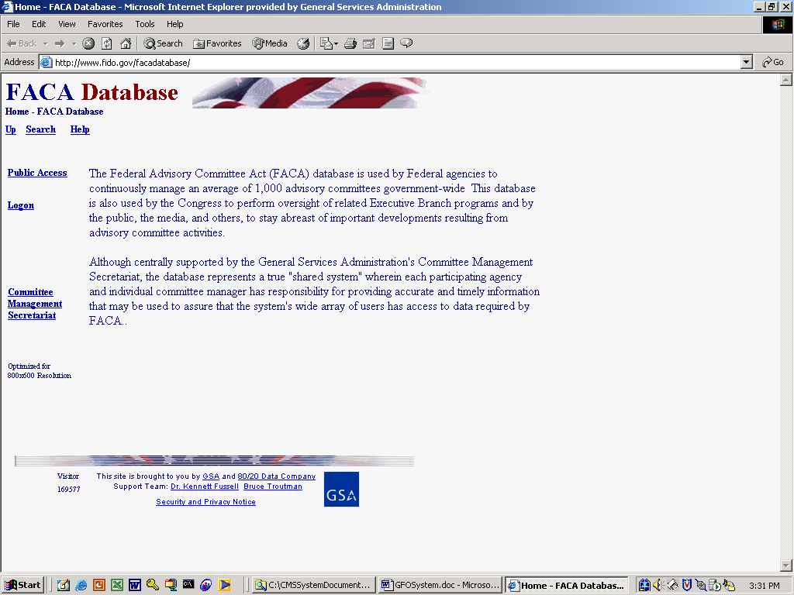
The opening screen for the FACA Database lets GFOs know that they have found the data repository and lists their options. The most direct address for the system is http://www.facadatabase.gov. The FACADatabase is part of a family of shared-interagency-databases located at http://www.fido.gov.
Hyperlinks and buttons control navigation throughout the system. The Navigation hyperlinks and buttons that are visible change depending upon the purpose of the page and the requirements (or rights) of the user. The navigation hyperlinks are located in the top border and the left border areas of each page. GFOs should move from page to page with the navigation hyperlinks or buttons as much as possible and avoid use of the browser buttons (like the arrows to go back or forward).

The reason to avoid use of the browser button where possible is that the FACA Database is truly a database, an application running on the web. A database/application operates differently on the Internet than purely informational net pages. Browser buttons and menu options are designed and normally intended to take the user back to previously displayed pages of static, unchanged, and usually, minimally-related or unrelated content. On the other hand, while the pages of a database system might appear to change in content with every “selection, filter, edit, save, insert, or delete”, each page has a distinct, “keyed” relationship that the page maintains with the preceding and following pages as the user drills down or moves up through the data.

The six navigation hyperlinks on the opening screen navigate to the
Up,
Search,
Help,
Public Access,
Logon, and
“Committee Management Secretariat” pages.
The cursor becomes a hand as the mouse moves over the hyperlinks so the user can be certain which link is being selected.

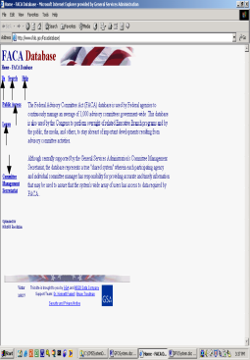Up, from the home page opening screen moves the user up (or back) to the Federal Interagency Databases Online (FIDO) page. Generally, the Up link moves the user up (or back) to the previous screen.

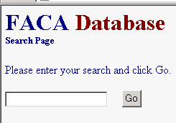
Search, when it is switched on and working, allows the user to search for any text or phrase in the entire set of data stored as part of this system. That includes the data comprising the annual comprehensive reviews, the committee charters, and any stored meeting minutes or reports.

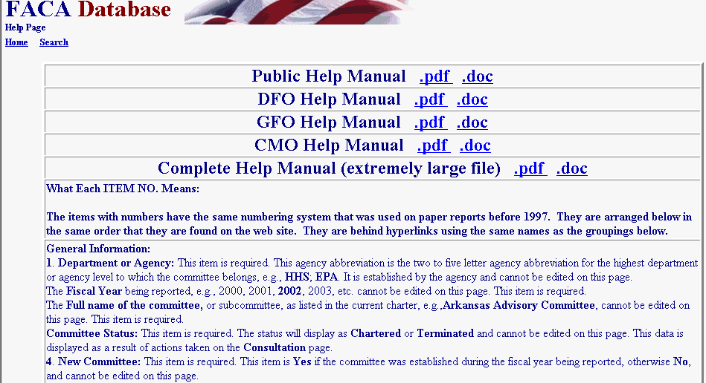
Help explains the syntax, terms, and meaning of items of information collected as part of that year’s Annual Comprehensive Review. Help displays a selection of manuals that explain the system’s functionality to the system’s different users. This specific manual we are currently examining is for the part of the system designed for GFO access. The manuals can be viewed on the screen with Microsoft Word or Adobe Acrobat Reader and printed.

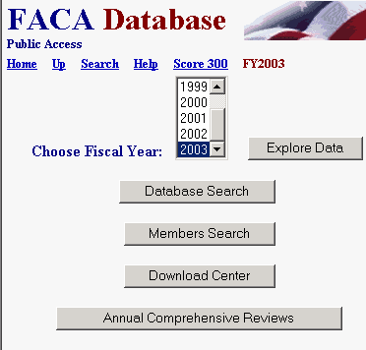
Public Access takes the GFO to a page listing the fiscal years in the system and a download center for extracting selected data from the system. The data for the current fiscal year is considered incomplete unless the user is confident that the DFOs for each committee update the information continuously and regularly throughout the year as events take place. At the end of the fiscal year each DFO, GFO, and CMO verify the accuracy and completeness of each committee’s data. The information on a committee is not considered or reported as official and complete until that committee has been verified by the CMO for that fiscal year.

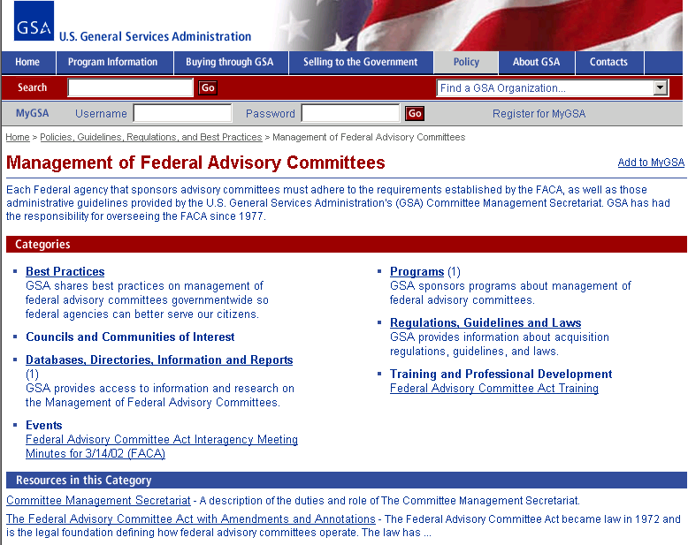
Committee Management Secretariat links the GFO to the Committee Management Secretariat’s home page, the launching point for a comprehensive examination of the advisory committee process, practices, history, case law, advice and training.

Logging onto GFO Data Maintenance Activities

Logon allows GFOs who are responsible for the committee data and who have editing rights to log on to the current year and view and update the management data. DFOs can update their committees, GFOs can update the committees in their group, CMOs can update all of their agency’s committees, and the Committee Management Secretariat’s staff can update all the agencies’ data. Unless the GFO wants to add or edit some specific committee data or limit the display to just the committees for which they are responsible, there may be no need to log on. All of the information, searches, and most of the reports are available from the Public Access section, the difference being that the Public section is read-only.

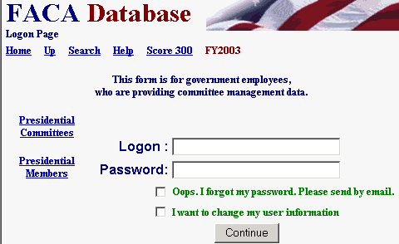
Clicking the Logon button displays the Logon page. The Logon page has seven hyperlinks, four data fields and one submit button. The main hyperlinks are Home, Up, Search, and Help. Home returns to the system’s opening page and ends the work session. We discussed Up, Search, and Help above. The additional hyperlinks are Score 300, Presidential Committees, and Presidential Members, which are potentially helpful status reports. The data fields are the LOGON Text Box, the PASSWORD Text Box, the OOPS Check Box, and the I WANT TO CHANGE Check Box. The submit button is Continue.

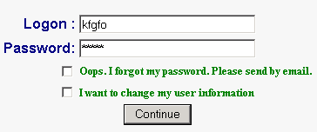
To Logon, the GFO enters his/her username in the Logon: Text Box field and their password in the Password: Text Box field. When the Continue button is clicked, the program advances to the GFO’s My Information page. If the GFO user logs on with their e-mail address as the username, the program advances to the Committee List page.

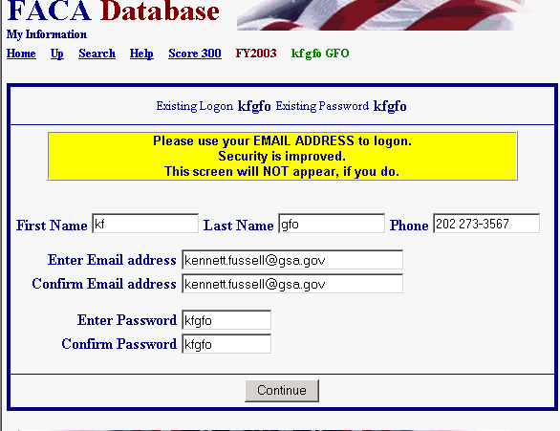
The GFO can change their user information any time they are logging in by checking the I WANT TO CHANGE Check Box before they click the Continue button. If the user fills out the My Information page, including their e-mail, than the OOPS Check box will work. To receive an email with their password, the user enters their LOGON (E-mail address), checks OOPS, and clicks the Continue button. Then the user waits for an e-mail from the system that reminds them of their password.

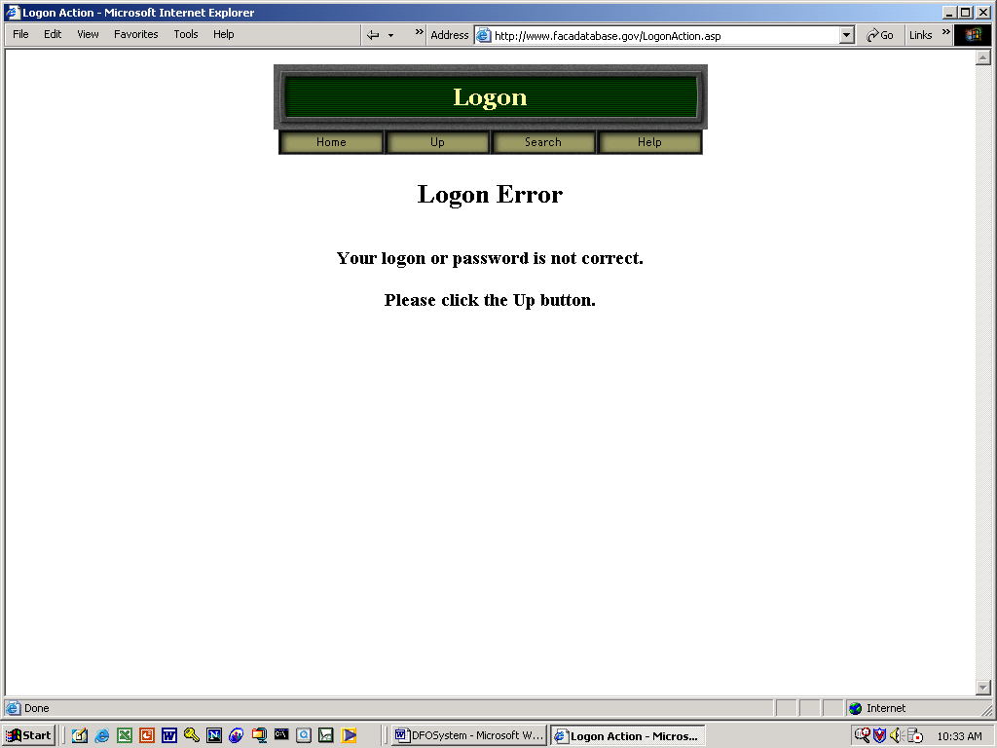
If the GFO receives a Logon Error, they should note the error explanation and contact their CMO to adjust their access rights. If you enter an incorrect Logon or Password, you receive the “Your logon or password is not correct” error.

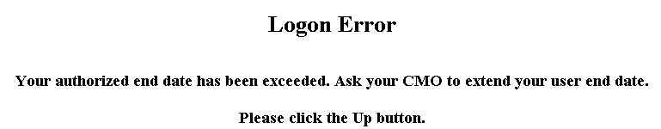
If your dates for access have expired, you receive “the Logon Date has been exceeded” error.

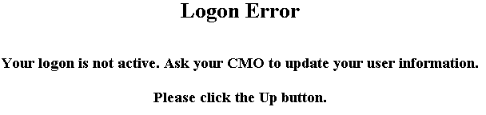
If your CMO has designated you as an “inactive” user, you see the “inactive logon” error when you attempt to logon.

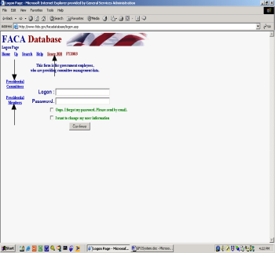The Score 300 hyperlink displays a color-coded ranking of agencies for the current fiscal year. It is a quick way to rank both the usage of the system by agencies as well as the completeness and accuracy of the data, since one can tell from the color and the number of committees updated just how much data entry/updating activity has occurred. Don’t regard it as a “ding”. Think of it as a reminder and friendly competition among government employees. The user returns from the Score 300 page using the Up hyperlink.

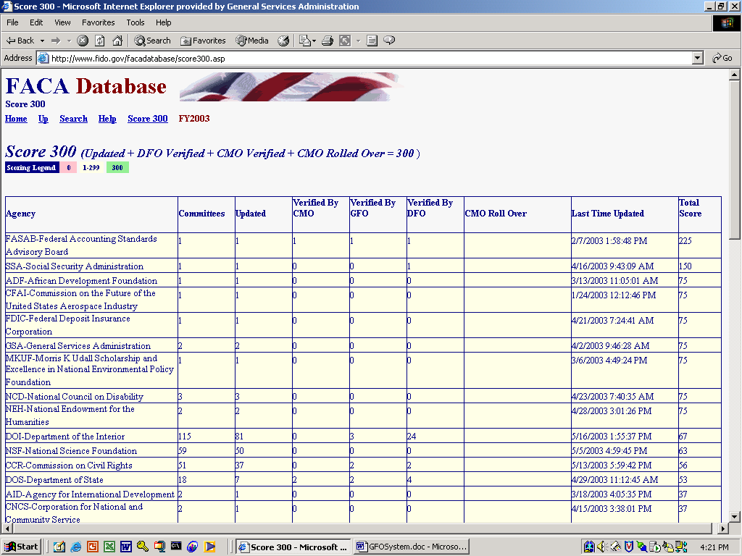

Clicking the Presidential Committees hyperlink displays basic committee information on committees that are either Presidential in type or established by the President. A committee is Presidential in type if it reports to the president even though it may have been established by Congressional Act. The committee listed in the third row is an example of Presidential type.

Clicking the Presidential Members hyperlink displays a list of committee members appointed by the President that are in the current year’s member list. These two hyperlinked reports are on the logon page at the request of the White House Personnel office. These reports, like all of the database’s reports for the current year, can only be as useful and accurate as the DFOs are consistent and regular in keeping the data up-to-date.

These reports, like most and eventually all of the database’s reports, can be downloaded to the user’s computer for more direct use and customization via the Spreadsheet, XML, and ASCII hyperlinks. No part of the data kept for public accession online is subject to privacy provisions. Any public user may download all of the publicly displayed data in the online system.

The GFO’s Committee List and Management Activities

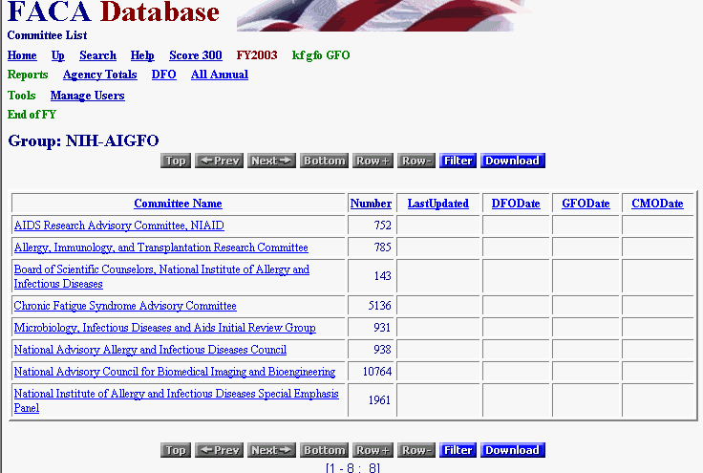
When the GFO logs on to the system, they proceed straight to the Committee List Page for their group. The Committee List page provides the GFO with access to any of their committees, and displays the navigation hyperlinks that activate most of their management activities in this web system. We will discuss the navigation hyperlinks first, and then the hyperlinks that access the individual committees.
The Committee List page currently displays eight hyperlinks in three groups. The new hyperlinks on this page are
For the Reports group:
- Agency Totals,
- DFO Report, and
- All Annual Reports
For the Tools group:
- Manage Users.
And for the End of FY group:
- None for the moment
There will be additional GFO management reports added to this page in the very near future.

Agency Totals

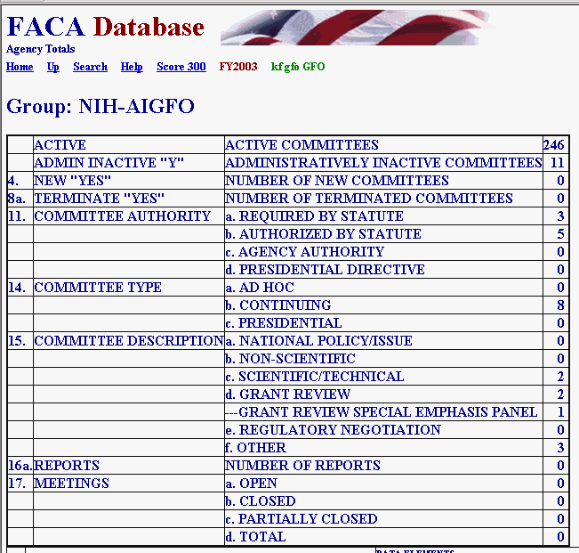
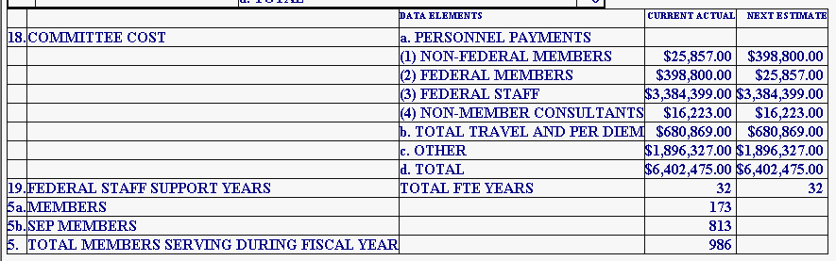
The Agency Totals hyperlink displays the Totals page for the group, which are totals of the collected data elements for the current year thus far. The Active and Inactive lines refer to committees for the entire agency. The rest of the lines refer to the distribution of the committees in the group among the elements. New or terminated committees in the group, the distribution of committees by authority or function in the group, the number of meetings, reports, members, costs, etc., etc. The accuracy of the report at any point in time during the current year depends upon the frequency and timeliness of committee information data entry on the part of the DFOs, and that, to some extent, depends on the guidance provided by the GFO to the DFOs.

DFO Report

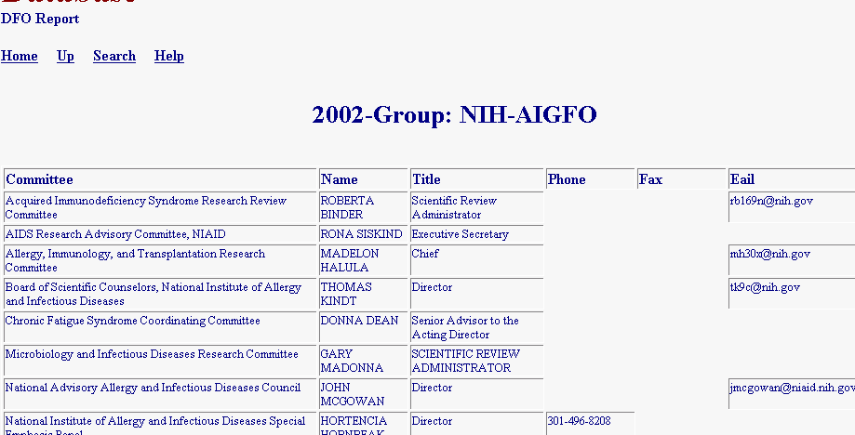
The DFO Report hyperlink displays the DFO Report page, a listing of the Committees and the DFOs’ contact information. Again, this information is only as useful as the DFOs’ timeliness in keeping their information current. Of course, the GFO has to give the DFOs access to their committee data for the DFOs to keep their information up to date or the GFOs have to do the data entry themselves.

All Annual Reports

The All Annual Reports hyperlink (which is really useful only after the end of the FY and all of the data is reported and verified) should display a single, continuous, scrollable, printer-friendly page of all the annual reports for all the committees in the group for that year. Depending upon the number of committees in the group, this page can take a while to load and display. This page can also be saved to a Word document and once in Word, the user can add page breaks and other formatting features to display the reports as formally as required. To return from this page to the Committee List page is an instance of when the GFO will have to use the browser Back button.

Manage Users

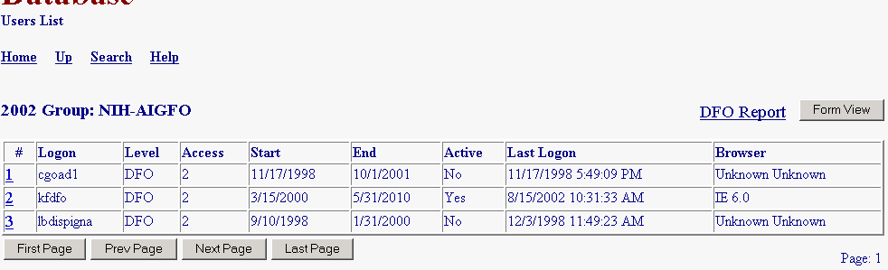
The Users List hyperlink displays the list of agency users responsible to the GFO and their permissions on the system. After the Committee Management Officer gives the GFO status on the system, the GFO can
- Add users at the DFO levels of use,
- Control whether users can edit the current year’s data,
- Determine when a user will have access to the system, and
- Look up the user’s password.
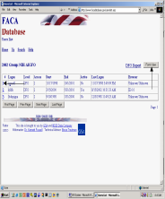
By clicking the hot key, which is the underlined number at the left of the row of user information, or by clicking the FormView Navigation Button, the GFO displays a user record to edit. The Form View Button selects the first record in the list to display. The Hot Link displays the record of the user identified in the Logon field.

User Form Rules and Codes to Assign User Rights

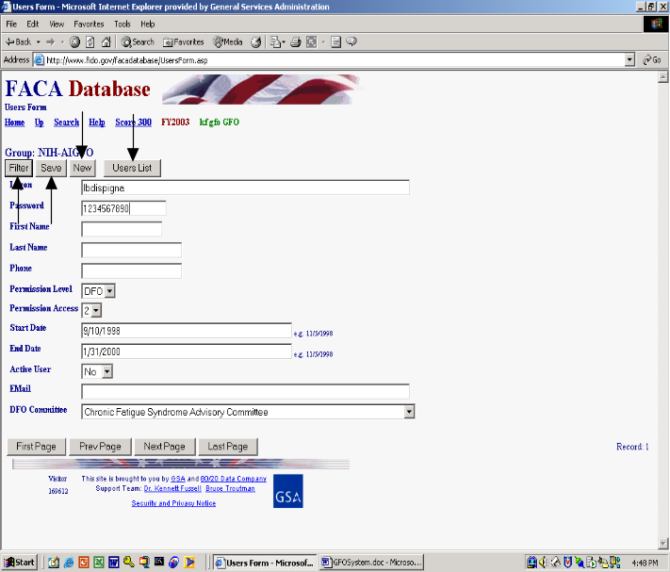On the User Form the GFO will find buttons to Filter for a specific Logon, Save an edited record, add a New user, and return to the Users List, but will not find a button to delete a user. Once a user is added to the system, they are kept in the system so that there is an audit trail regarding who created or edited the data in the system during what year. When adding a new user, the GFO should add the name and contact information and the user’s rights. The DFO will have to complete any contact-information-fields that are left blank when they first logon.

The rules and codes regarding the user information and access rights (permission levels) follow.

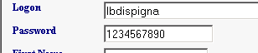
- The user’s Logon name and password together form a unique key field that is not duplicated within the agency or even in the whole system. The username (Logon) should be in the form of the user’s government email address, but it can be simply a combination of the first letter from the first name and the full last name. The user should be easily identifiable from the username.

- The password can be any combination of up to 16 characters and it can be duplicated in the system with other users’ passwords. If the same user has more than one login, each of the user’s passwords must be unique. Passwords are generally a system’s weakest point of defense from unwanted intrusion, so, unfortunately, the best password is such a complicated combination of letters, numbers, and characters that you will never be able to remember it.

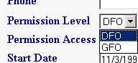
- The GFO can add users at the DFO Permission Level. The DFO can only view and edit their single committee when logged on; the GFO can view and edit all the committees in the group.

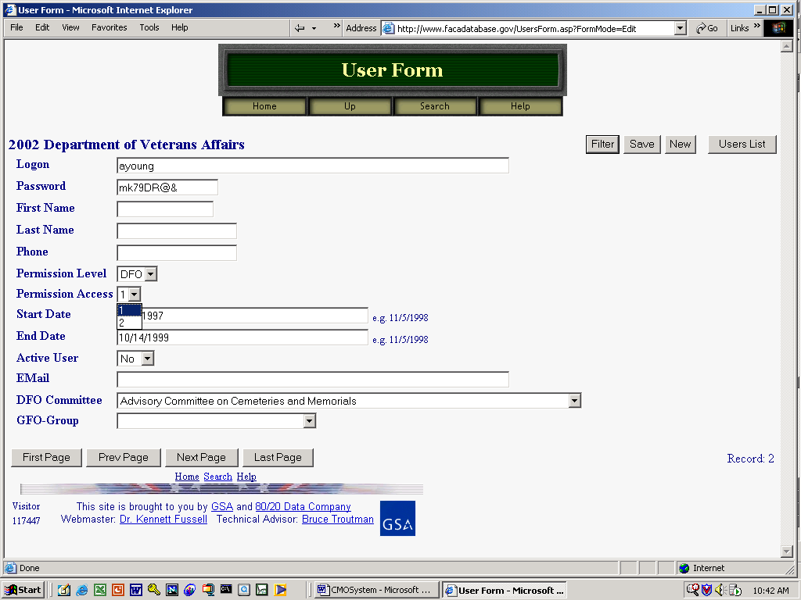
- Permission Access is either read-only: 1, or edit: 2. A user needs a Permission Access of 2 to make changes to the data and add new information.

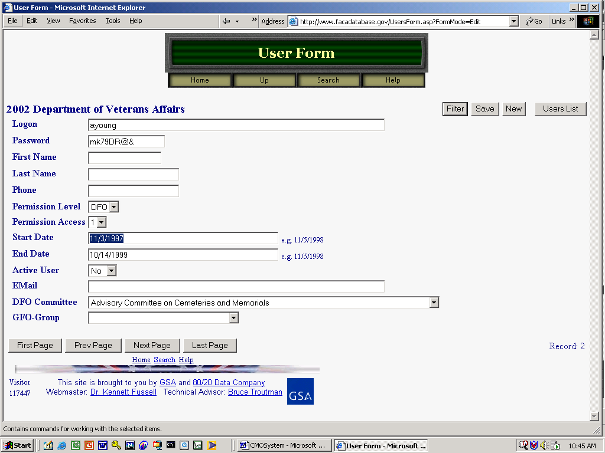
- The Start Date is the earliest date that a user can logon and the End Date is the last date that a user can logon.

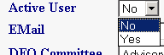
- The Active User can be set to “Yes” or “No”. This field is used to turn a user’s logon rights on or off without having to change all the other settings.

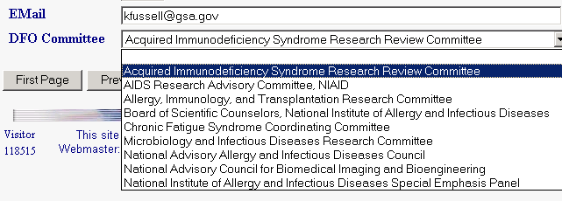
- The Committee for which the DFO user is responsible can be set from the “DFO Committee” pull-down. The pull down list will display all the possible committees for the agency, and the GFO clicks on the correct committee.

- The CMO must set up a group before a GFO can be assigned to that group. A GFO must be set up and assigned to a group before she can set up DFOs for that group. The GFO should always click “Save” before leaving the page after completing any changes to a user form.

The Filter button on the User Form displays a filter page so that the GFO can quickly find a user record based on the most relevant criteria. The New button displays a blank data entry page for adding a new user. The GFO returns to the full read-only User List page with the Users List button.
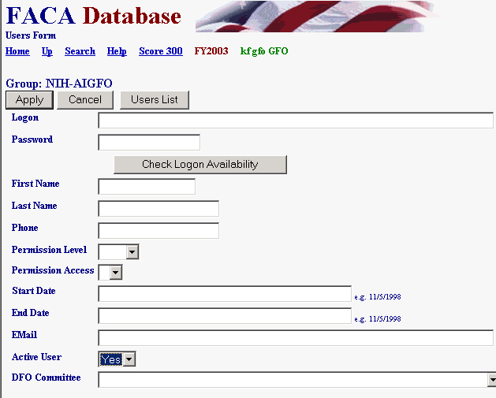
To use the Filter page, the GFO selects criteria like Yes for the Active User text box and clicks the Apply button. The Cancel button cancels the Filter page.

To create a new user, the GFO click the New button on the Form View page shown above.

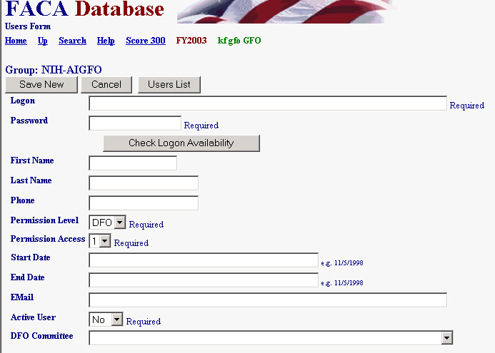
The GFO fills in all the contact information and applies the permissions and rules to create a new user and then “saves” the new user by clicking the Save New button. The GFO can abandon the new record by clicking the Cancel button.

Editing a Committee’s Data

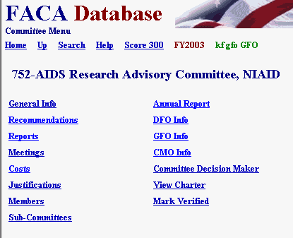
The GFO should check out the DFO System Manual for a thorough introduction to the process of editing the committee information.

The GFO has complete editing rights to all the committee data and all changes are made, meetings and reports and members are added through the Committee Menu page. The links below display the editable pages. The menu options include
- General Info,
- Recommendations.
- Reports,
- Meetings,
- Costs,
- Justifications,
- Members,
- Sub-Committees,
- Annual Report,
- DFO Info,
- GFO Info,
- CMO Info,
- Committee Decision Maker,
- View Charter,
- Web Site (if the committee has one), and
- Mark Verified.

SECTION IV: Committee Management Officer (CMO) Management Tools and Access to Advisory Committee Data

The Committee Management Officer (CMO) uses the system to add and manage advisory committees, add and manage agency users of the system, update the information on advisory committees during the current reporting year, and produce reports on advisory committee trends across fiscal years. The Federal Advisory Committee Act (FACA) requires that the CMO provide information about the agency’s advisory committees for an annual comprehensive review, both internally to the agency, and externally, as part of a government-wide review. The web-based database accommodates and builds upon those requirements by allowing the continual updating of committee information throughout the reporting year and providing committee management functionality. Keeping the data continuously up-to-date converts the system from a focus on history and records to a focus on management and immediate relevancy. With frequent and timely updates, the system becomes more useful to everyone, ranging from the public users to interested agency officials to congressional staff with oversight responsibility.

What kind of data is being collected and maintained?

For the CMO, the program collects, totals, accesses, and/or displays all the information available to the DFO, which includes
- Charters and related information,
- Members and their appointment information,
- Costs,
- The agency’s recommendation for continuation or termination of the committee,
- The committee’s recommendations to the agency and the actions taken on the recommendations (this will be added in the immediate future),
- Report titles, publication dates, and the text of the report,
- Meeting purposes, dates, location, whether the meetings were open or closed, and the minutes or transcripts,
- Activity and justification (raison d’etre) information,
- DFO appointment and contact information,
- Decision maker contact information,
- Annual Performance Measures Data,
- Web site addresses for the committee or accessing committee information like the minutes, reports, and recommendations, and
- Committee interest or issue areas.

Specifically for the CMO the program also collects, totals, accesses, and displays information that includes
- A current year list of agency advisory committees and the committees’ update status,
- An agency totals report of the distribution among committees of establishment authorities and committee functions, and the total meetings, reports, costs, and members,
- A listing of committee DFOs with their contact information,
- A complete set of the current annual comprehensive reviews for all the committees in the agency,
- Filters to limit the number of committees viewed on the Committee List page at any one time,
- The ability to add and manage agency users of the agency’s committees’ editable and reportable data,
- The ability to add a new committee to the FACA committee list online,
- A current status overview to quickly put the CMO in touch with the activity level of their committees as recorded in the online system and a growing set of heads-up/potential problem comparisons about and between agency committees and government averages,
- The available discretionary ceiling,
- The ability to create and manage sub-groups of committees within the agency, and
- E-mail listings for individuals in agency groups responsible for advisory committee activity.
In addition, when viewing an individual committee, the program allows the CMO to establish, renew, re-establish, amend, or terminate a committee, and upload a copy of the charter to the system (with the Consultation button). The DFO does not see the Consultation button when viewing their Committee Menu page. The database does not collect meeting announcements or other Federal Register announcements at the present time, but it does have a page devoted to committee recommendations to the agency, the agency’s use of those recommendations, and other performance measures.

How does the CMO use the system?

FACA requires that each agency shall establish uniform administrative guidelines and management controls for advisory committees established by that agency, and that each agency shall maintain systematic information on the nature, functions, and operations of each advisory committee within its jurisdiction.
The law’s language states that the head of each agency that has an advisory committee shall designate an Advisory Committee Management Officer (CMO) who shall –
- Exercise control and supervision over the establishment, procedures, and accomplishments of advisory committees established by that agency;
- Assemble and maintain the reports, records, and other papers of any such committee during its existence; and
- Carry out, on behalf of that agency, the provisions of section 552 of title 5, United States Code, with respect to such reports, records, and other papers.
The law also states that
- There shall be designated an officer or employee of the Federal Government to chair or attend each meeting of each advisory committee. The officer or employee so designated is authorized, whenever he determines it to be in the public interest, to adjourn any such meeting. No advisory committee shall conduct any meeting in the absence of that officer or employee.
- Advisory committees shall not hold any meetings except at the call of, or with the advance approval of, a designated officer or employee of the Federal Government, and in the case of advisory committees (other than Presidential advisory committees), with an agenda approved by such officer or employee.

The FACA database system is designed to support the above requirements by capturing relevant information when the committee is created online by the CMO, and to carry that information forward as it is edited and updated by the DFO or her designee from year to year until the information is no longer required. When a committee is first established and chartered by an agency, the information on the committee is generally entered by the CMO or his designee and should address most of the committee’s general information, membership information, and estimated cost information requirements. Obviously, to function appropriately, the DFO should already be officially appointed, up-to-date, and involved in the committee’s mission and charter when a committee is established (officially chartered). At the highest level, the process ordinarily proceeds as follows:
- The President, Congress, or a federal official in an agency decides that advice on an issue is needed and an advisory committee is the appropriate vehicle for getting that advice,
- The President executes an order or the congress passes a law that includes language assigning the responsibility for the committee to an agency. The agency, given it has the means and latitude, simply starts the process of developing a charter.
- The agency uses the administrative guidelines and management controls it established under the law (FACA) to develop the charter, secure members, appoint a CMO for the agency, appoint the DFO for the committee being established, and delegate or assign the other responsibilities established under FACA.
- The CMO confers with the Committee Management Secretariat (CMS) regarding the new committee, ensures that a DFO has been appointed, creates the new committee online using the system, files the charter with the appropriate congressional oversight committees, and provides the appointed DFO and his designees with logons to the system.

The CMO’s step-by-step process with a new committee and the FACA Database system generally looks something like the following:
1) When a committee is going to be established and chartered, the CMO uses the Add a Committee hyperlink on the Committee List page to create a new committee online. The information added during the online creation process should be complete enough to address the new committee’s general information, membership information, meeting information, and estimated cost information requirements.
2) The CMO and the Committee Management Secretariat (CMS) use the Consultation process found on the new committee’s Committee Menu page to complete the committee establishment.
3) The CMO uses the User List hyperlink to add the DFO and/or the DFO’s designee as a user to the system.
4) The CMO has the DFO log onto the system and
- Complete the edits to the General Information page. This contributes to the annual comprehensive review requirements and keeps the Heads Up Reports timely and useful,
- Add meetings as they are planned or as they occur, add the reports as they occur, and upload the meeting transcripts or minutes and reports as they become available,
- Add or delete members as they are appointed or replaced,
- Add or update costs as they occur,
- Add or update the web address if a web site is created for the committee,
- Add or update DFO contact information as it changes. This keeps the DFO Report useful.
- Recommend the continuance or termination of the committee by the end of the fiscal year,
- Report the Performance data at the end of the reporting year,
- Report the recommendations of the advisory committee to the agency and the agency’s response or use of the recommendations, and
- Verify the accuracy and completeness of the committee data for the reporting year at the end of the reporting year.
The DFO, or the CMO if she or he chooses to do any or all of the tasks above, will find that the general information, costs, and member data added during the establishment of the committee has been carried forward to the relevant annual comprehensive review pages. At the end of any reporting year the program carries all of the committee data forward into the newly created year except for meetings and reports.

The CMO will also find the read-only Public Access modules of the system useful to their management concerns. Using the Search feature (when it is switched on and working), the CMO can discover what other committees exist in other agencies with issues and concerns similar to committees they are planning to charter. With that knowledge, the CMO can Drill Down to the specific committees and determine if the system has information useful to them, or they can identify people in the other agency to contact for further investigation. From the Public Access area, the CMO drills down from the Year to the Agency to the specific Committee to view the desired information. At any time the CMO can Search the entire collection for any word or phrase, use a Filter or Database Search to limit the data displayed, and/or Download selected data to a spreadsheet or data table. Topical Committee Reports, the printed Annual Reports submitted by the President to Congress from 1972 through 1998, and the Annual Comprehensive Reviews conducted each year will be added to the Public Access section as they become available.

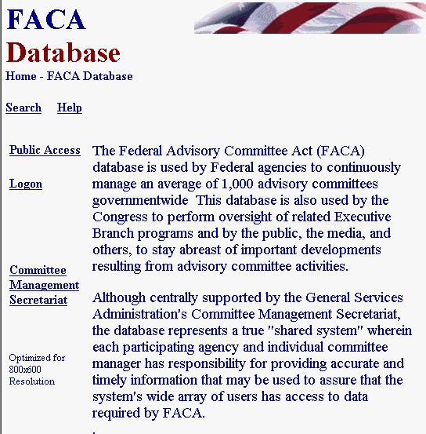
The opening screen for the FACA Database lets CMOs know that they have found the data repository and lists their options. The most direct address for the system is http://www.facadatabase.gov. The FACADatabase is part of the shared-interagency-database family at http://www.fido.gov. Buttons and hyperlinks control navigation throughout the system. The Navigation Buttons and hyperlinks that are visible change depending upon the purpose of the page and the requirements (or access rights) of the user. The navigation buttons and hyperlinks are located in the top border and the left border areas of the browser page. CMOs should move from page to page with the navigation buttons and hyperlinks as much as possible and avoid use of the browser menu and buttons (like the arrows to go back or forward) unless specifically instructed to do so on the web page they are viewing.

We emphasize the avoidance of the browser buttons because the FACA Database is truly a database and an online application. A database and online application operates differently on the Internet than purely informational net pages. Normal browser buttons are designed to take the user backwards and forwards to pages of static, unchanged, and perhaps unrelated content. The pages of a database system change in content with every selection, filter, edit, save, insert, and delete, but have a distinct, “keyed” relationship with the preceding and following pages as the user drills down or moves back up through the data. The user is involved in a content-limited work session, and if you start jumping around using the browser commands and button menus, it is possible for the database application to lose track of who you are and what committee you are working on. It doesn’t happen often, and the technology is improving to prevent this conundrum, but a word to the wise.

The six hyperlinks on the opening screen navigate to the
Up,
Search,
Help,
Public Access,
Logon, and the
Committee Management Secretariat pages.
The cursor becomes a hand as the mouse moves over the hyperlink so the user can tell which link is being selected.
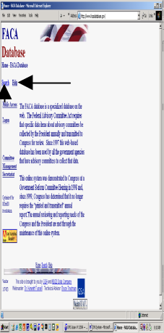Up moves the user up (or back) to the Federal Interagency Databases Online (FIDO) page.

Search allows the user to search for any text or phrase in the entire set of data stored as part of this system. That includes the data comprising the fiscal year summaries, the committee charters, and any stored meeting minutes or reports. A complete discussion of the search feature is found in the Public Access (Section 1) part of the system manual. The search capability will always be constrained by the Internet search technology, our web site programming ability, and the quality and completeness of the data entered.

Help explains the syntax, terms, and meaning of items of information collected in previous years as part of that year’s Annual Report (before 1999) or Annual Comprehensive Review (after 1998). It also displays a selection of manuals that explain the system’s functionality to the different types of users. This manual is for the part of the system designed for CMO access. The manuals can be viewed on the screen with Microsoft Word or Adobe Acrobat Reader and printed.
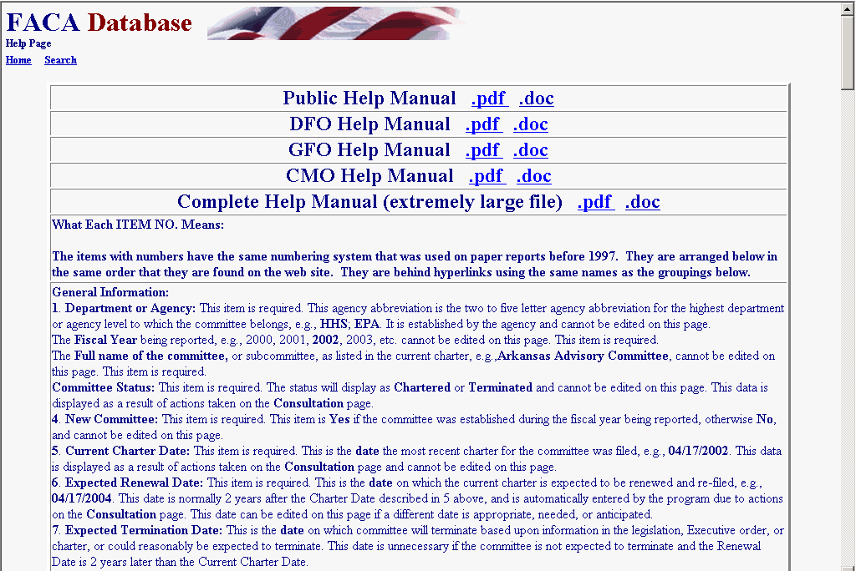
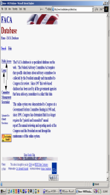Public Access takes the CMO to a page listing the Fiscal Years of reported data in the system, the Database Search, the Member Search, the Download Center, and the available Annual Comprehensive Reviews/Summaries completed since the cessation of the printed, transmitted, annual report. All the data is read-only. A reviewer must always consider the data for the current fiscal year incomplete unless they know with certainty that the DFO updates the information throughout the year as events take place. At the end of the fiscal year, however, each DFO and the agency’s CMO are required by law to verify the accuracy and completeness of each committee’s data. The standard operating procedure is that the information on a committee should not be deemed official and complete until that committee’s data has been verified by the agency CMO for that fiscal year.

Logon allows CMOs or their designees who are responsible for the committee data and who have editing rights to log on to the current year and view and update the management data. Users with DFO rights can edit and update their individual committees, users with CMO rights can edit and update all of their agency’s committees, and the Committee Management Secretariat’s staff can edit and update all the agencies’ data.

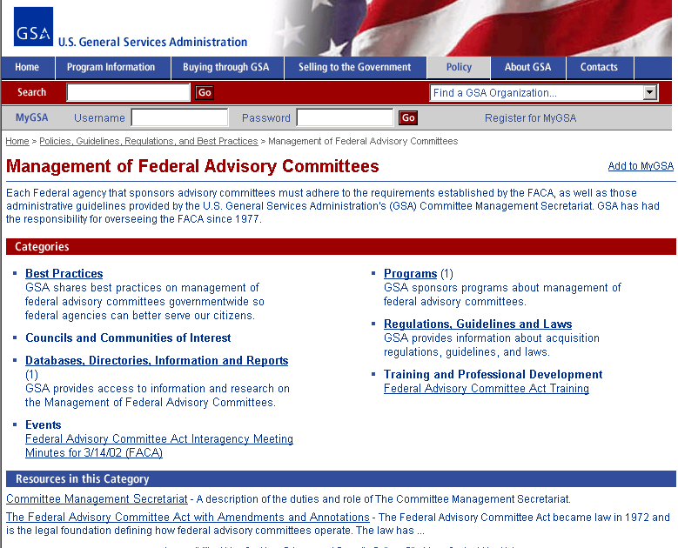
Committee Management Secretariat links the CMO to the Committee Management Secretariat’s home page on the GSA Portal. This home page is the launching point for a comprehensive examination of the advisory committee process, practices, history, case law, advice and training.

Logging onto CMO Committee Maintenance Activities

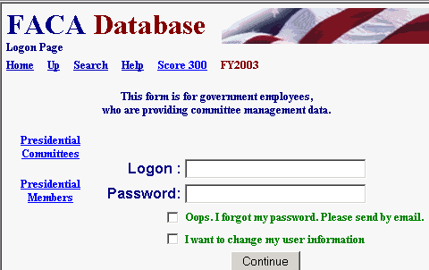
Clicking the Logon button displays the Logon page. The Logon page has four main navigation hyperlinks, three quick-report hyperlinks, four data fields and one submit button. The Navigation hyperlinks are Home, Up, Search, and Help. Home returns to the system’s opening page and ends the work session. We discussed Up, Search, and Help above. The report hyperlinks are Score 300, Presidential Committees, and Presidential Members, which are helpful status reports. The data fields are the LOGON Text Box, the PASSWORD Text Box, the OOPS Check Box, and the I WANT TO CHANGE Check Box. The submit button is Continue.

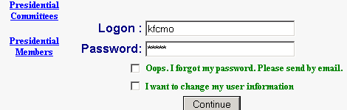
To Logon, the CMO enters his/her username in the Logon: Text Box field and their password in the Password: Text Box field. When the Continue button is clicked, the program advances to the CMO’s Committee List page. The CMO can change their user information any time they are logging in by checking the I WANT TO CHANGE Check Box before they click the Continue button.

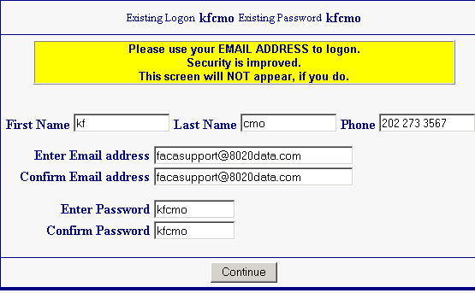
If the user fills out the User Profile/Information page, including their e-mail, than the OOPS Check box will work. To receive an email with their password, on the Logon Screen shown on the previous page the user enters their LOGON, checks OOPS, and clicks the Continue button.

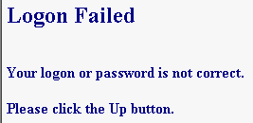
If the CMO receives a Logon Error, they should note the error explanation and contact the Committee Management Secretariat to adjust their access rights. If you enter an incorrect Logon or Password, you receive the “Logon-Password not correct” error.

If your dates for access have expired, you receive “the Logon Date has been exceeded” error. The error displays “ask your CMO”, but in the case of the CMO getting the error, it really means “Ask Ken”.

If the Committee Management Secretariat has designated you as an “inactive” user, you see the “inactive logon” error when you attempt to logon. In this case, the CMO also calls Ken.
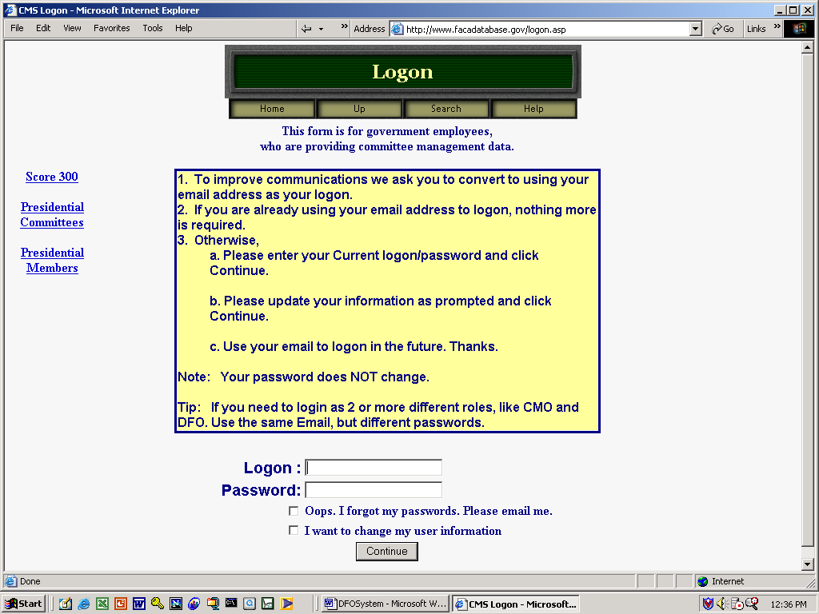
The “Score 300” hyperlink displays an activity ranking of agencies for the current fiscal year. It is a quick way to rank both the usage of the system by agencies as well as the likeliness of completeness and accuracy in the data for the public user. The color and the number of committees updated reveal how much data entry/updating activity has occurred thus far this year. Think of it as friendly competition. The user returns from the Score 300 page using the Up hyperlink.

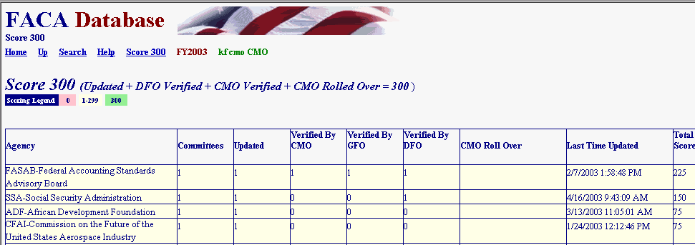
Clicking the Presidential Committees hyperlink displays basic committee information on committees that are either Presidential in type or established by the President. A committee is Presidential in type if it reports to the president even though it may have been established by Congressional Act. The committee listed in the third row is an example of Presidential type.

Clicking the Presidential Members hyperlink displays a list of committee members appointed by the President that are in the current year’s member list. These two hyperlinked reports are on the logon page to remind users logging on that these reports exist at the request of the White House Personnel office. These reports, like all of the database’s reports for the current year, are only as useful and accurate as the data is kept up-to-date. They are also good reasons for weekly updates to the system.

These reports, like all of the database’s reports, can be downloaded to the user’s computer for more direct use and customization via the Spreadsheet, XML, and ASCII hyperlinks. The XML selection allows import into almost any kind of database. The ASCII selection creates a text file that can be imported into any word processor. None of the data kept for public accession online is subject to privacy provisions. Any public user may download all of the publicly accessible stored data in the online system.

The CMO’s Committee List and Management Activities

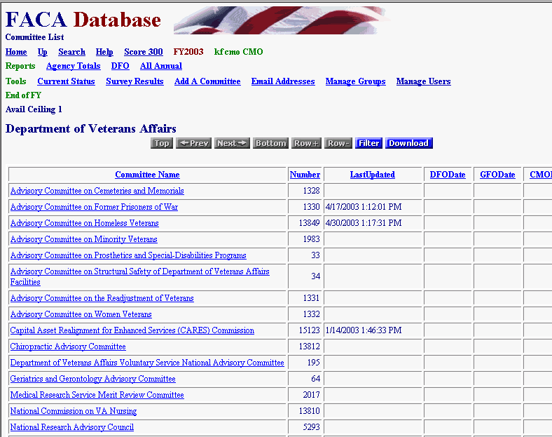
When the CMO logs on to the system, they are taken straight to the Committee List Page for their agency. The Committee List page provides the CMO with access to any of their committees, and displays the buttons and hyperlinks that navigate to most of the management functionality in this web system. We will discuss the hyperlinks first, then the option buttons, and finally, access to the individual committees.
The Committee List page currently displays fourteen hyperlinks in addition to the links to the agency’s committees. We have already discussed Home, Up, Search, Help, and Score 300. The new links are to other report and management areas that the CMO should find useful. The links are grouped by:
Reports:
- Agency Totals,
- DFO Report, and
- All Annual Reports.
Tools:
- Current Status,
- Add a Committee,
- Survey Results,
- Emails Addresses,
- Manage Users, and
- Manage Groups.
End of FY:

Agency Totals

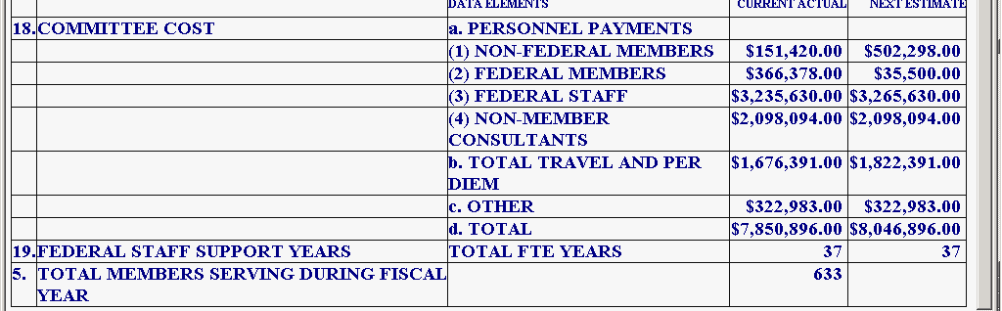
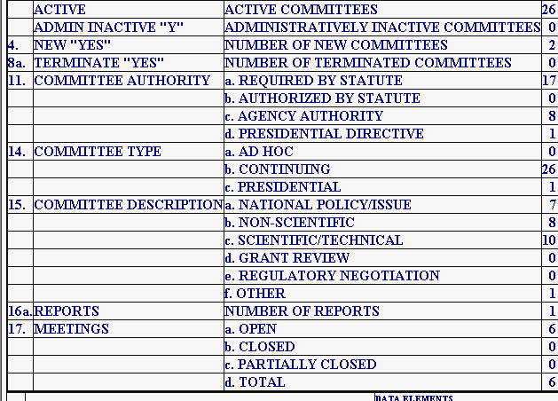
The Agency Totals Report link displays the Agency Totals page. These totals are for categories of committee activity that are of interest to the agency, Congress, and the public during and after the reporting year. The report totals new committees, terminated committees, the distribution of committees by authority or function, the number of meetings, reports, members, costs, and federal staff time engaged in the agency’s advisory committee effort.
The accuracy of the report at any point in time during a current, active reporting year depends upon the frequency and timeliness of committee information data entry on the part of the DFOs. The timeliness and frequency of DFO data entry depends, for a large part, on the requirements, interest, and guidance demonstrated or provided by the agency leadership and the agency CMO.
DFO Report
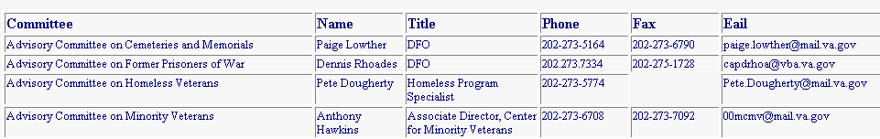
The DFO Report link displays the DFO Report page, a listing of the Committees and the assigned DFOs’ contact information. Like all the system’s current year reports, this information is only as useful as the DFOs’ timeliness in keeping their information up to date.

All Annual Reports

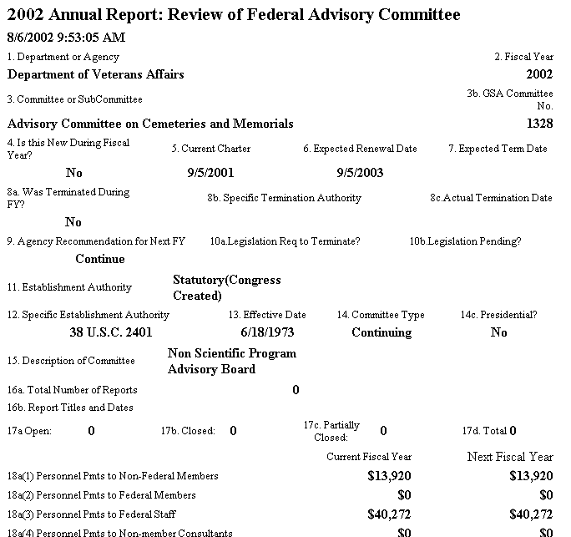
The All Annual Reports link displays a printer-friendly, continuous, scrollable page of all the reportable information for all the committees in the agency for that year to date. This report is generally only useful after the end of the reporting cycle after the end of the fiscal year. Depending upon the number of committees in the agency, this page can take a “very” long time to generate the first time it is created, loaded to the web site, and displayed on the screen. This page can also be saved to a Word document, although the larger the number of committees, the larger the file size and the longer the save process. Once in Word, the user can add page breaks and other formatting features to display the reports as required. To return from this page to the system menu pages is an instance of when the CMO will have to use the browser Back button.
Current Status

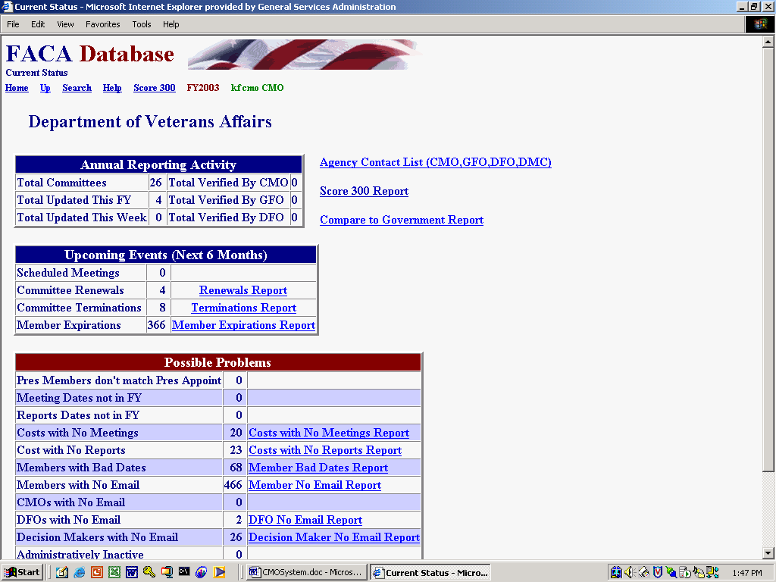
The Current Status link in the Tools group is an assortment of helpful, heads-up and on-guard reports for the CMO and other parts of the agency leadership.
Reports (signified by a hyperlink) are only generated if data is present that makes the report potentially relevant or suggests that a “possible” problem could exist.

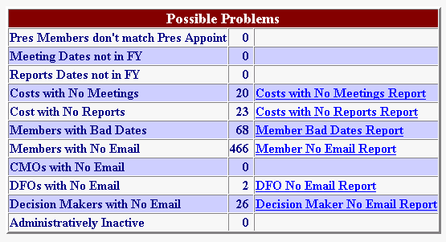
For instance, the General Info page has a Yes/No response field regarding whether any committee members are Presidential Appointments. The Members List page has an appointments field that indicates the source authority of the appointment. Is there a problem if the pages don’t agree? Usually! Could there be a reasonable explanation for the conflicting information? Possibly? In all cases, intelligence is to be applied. These report items are potential alerts, not flags that specific content is wrong.

Agency Contacts List

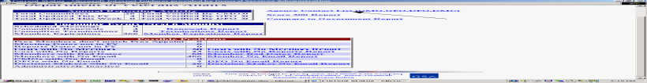The Agency Contacts List includes everyone in the agency with Logon rights in the Users List.

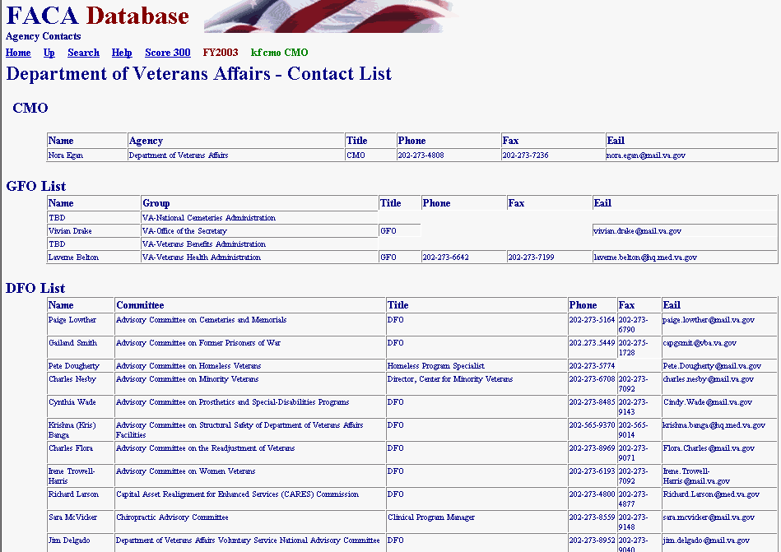
Compare to Government Report

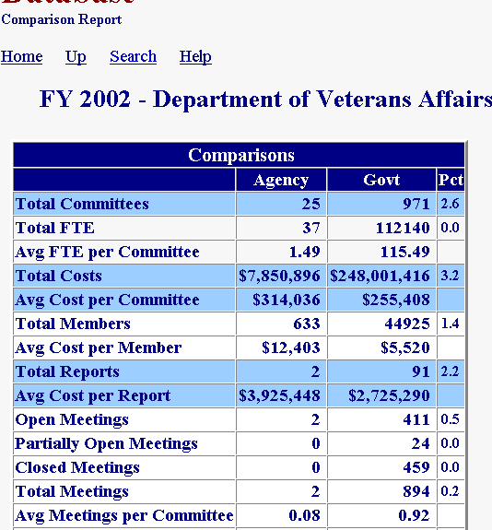
The Compare to Government Report on the next page in this manual compares agency averages to government-wide averages. Of course, this kind of report is only as useful as the agency data is up-to-date and the rest of the government data is up-to-date. We will be adding functionality to allow agencies and committee to do some data mining and to compare themselves across years, i.e., the agency to itself and the committee to itself in previous years.
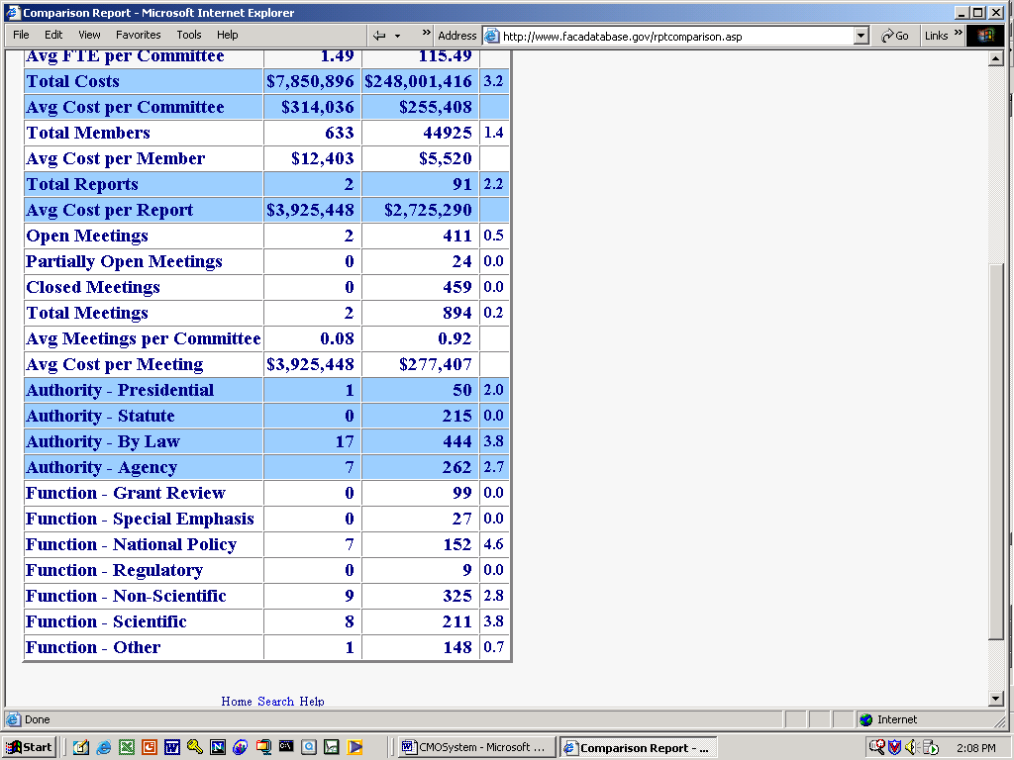
Survey Results

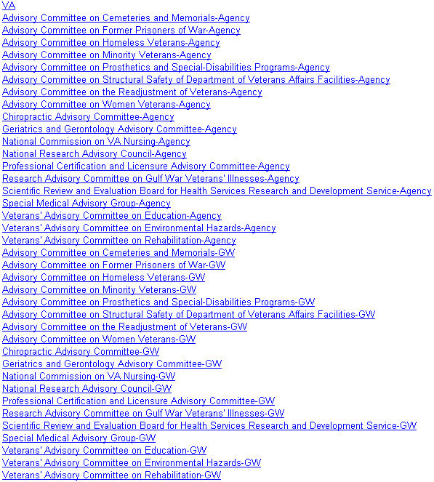
Early in FY 2003 a significant number of Federal Advisory Committees participated in a Stakeholder Engagement Survey conducted by Gallup. As part of the current government-wide focus on the development of useful performance measures, 4000+ committee members were surveyed on their advisory committee experience. The Survey Results link displays the individual committee reports Gallup produced for the CMO’s agency. Clicking on VA displays the agency rollup report. Clicking on the CommitteeName-Agency displays a report of the committee relative to the agency. Clicking on the CommitteeName-GW displays the committee relative to committees with similar functions government-wide.

Add a New Committee

Despite the fact that at least one government agency has more than 250 advisory committees, creating a new Federal Advisory Committee is not a casual act and usually requires an enormous amount of collaboration and coordination. When the agency has completed all the background work and the CMO is ready to add a new advisory committee to the agency roster, doing so can occur online with the Add a Committee link from the Tools group.

The New Committee Information form has fields for all the information required by the Federal Advisory Committee Act to establish a new committee. The CMO should fill each field out completely and specifically. No field should be left blank. If, for some unimaginable reason, the CMO does not replace the “directions” in the data-entry fields with committee-specific information, the “directions” should be left intact to be answered by whoever will be filling them out, as every field is a required field. The information required by this form was developed by the agency in the process of formulating the charter. Once entered, the data will carry forward to all the committee pages used for the annual review process.
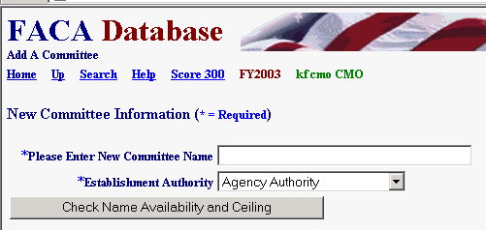
The first text box requires a unique committee name. The name must be unique not only to the agency but to the entire list of advisory committees, hence the Check Name Availability button. The second text box asks the CMO to select the establishment authority under which the committee is being created. When the CMO clicks the Check Name Availability and Ceiling button, the program checks to see if the name is already in use and, when the authority is discretionary, if the agency has available slots for new discretionary committees.

The CMO should be aware of the agency’s room to create new “discretionary” committee since their available “ceiling” (or room to grow) is displayed on the Committee List page below the Add a Committee hyperlink. This is not an issue if the committee is established with Presidential or Congressional Authority.

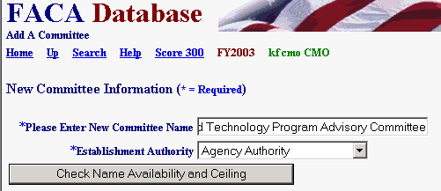
If either of those tests fail, the CMO is alerted immediately with a message similar to the one below. If the CMO should get an unexplainable error, they should stop what they are doing immediately or their computer could blow up. Well, maybe not, but at least call Dr. Fussell and clue him in that there is a problem.

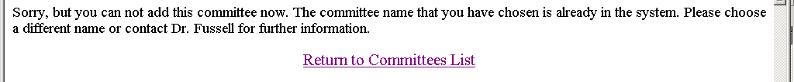
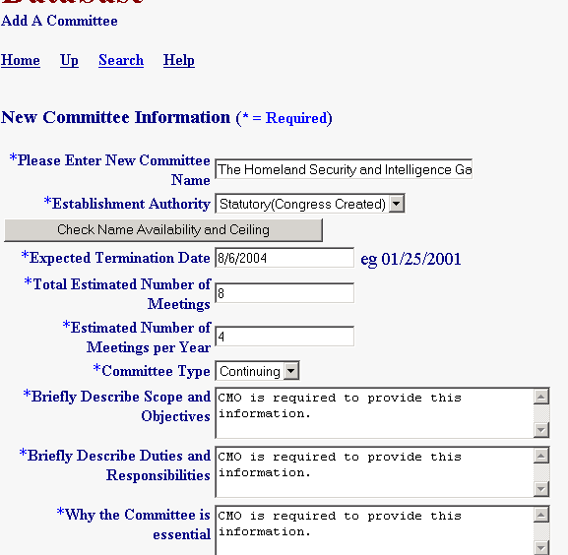
If the name is unique and the agency has sufficient ceiling, the CMO continues to fill out the information. The required information already exists in electronic format in documents, previously exchanged e-mails, and word-processing files generated within the agency while formulating the new committee’s charter and mission. The CMO displays the relevant document in a word-processing program, “copies ” the needed information from that document, and “pastes” that information into the appropriate fields in the FACA online New Committee Information form. The CMO may find it occasionally helpful to point out to others urgently trying to set up a new committee, that if this information does not already exist in some kind of accessible electronic media, perhaps the agency is not quite ready to establish the committee.

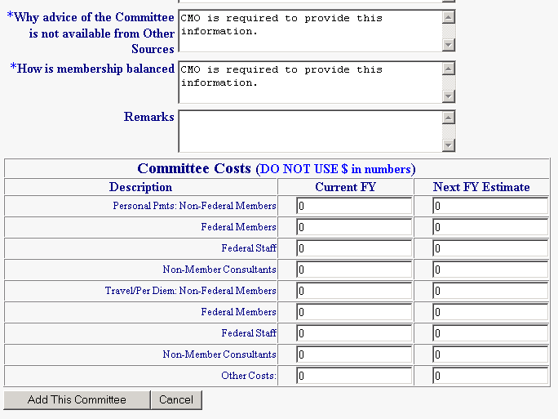
Every single entry will find its way into the FACADatabase. Please don’t give in to the temptation to be as pithy as the example. The data entry page continues below the bottom of the screen. Scroll down to fill all of it out. The Total Estimated Number of Meetings field and the Estimated Number of Meetings per Year field use a numeric response. Please type in the number “20” instead of “20 meetings”, and type in “4” instead of “4 per year”. There should be some projected costs shown as well. The data that is entered will be copied into the fields used for the comprehensive annual review. It is understood that all these entries are probably estimates that will be updated and corrected later. Every field except “Remarks” requires an entry. Costs are in whole dollars, so use numbers without dollar signs ($), commas (,), and decimals (.).
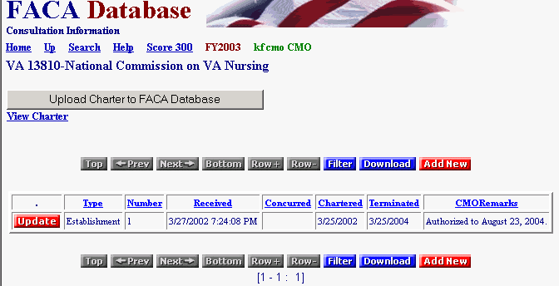
As mentioned above, when the new committee is submitted by clicking the Add This Committee button, the data is transferred to the comparable fields for the annual review process. The new committee is created in the system and the Consultation page for the new committee is presented to the CMO user. An automatic “alert” e-mail is generated by the system and sent to the agency’s Desk Officer at Committee Management Secretariat. Whenever the Consultation page is Updated and saved, the program will generate an e-mail to the Agency CMO and the Desk Officer at Committee Management Secretariat, alerting the staff to the new committee. If the CMO creates a committee and does not notice an e-mail proclaiming the action, it would behoove them to contact CMS and let their Desk Officer know. At this point in the creation of a new committee online, the CMO can open any of the pages accessible from the Committee Menu and further edit the data they added to the fields in the Add A Committee form. As an alternative, of course, the CMO could add the DFO to the Agency user list and have the DFO log on and bring all the committee information up-to-date. The DFO System Manual discusses the complete scope of committee information that should be added or maintained in each discrete fiscal year.

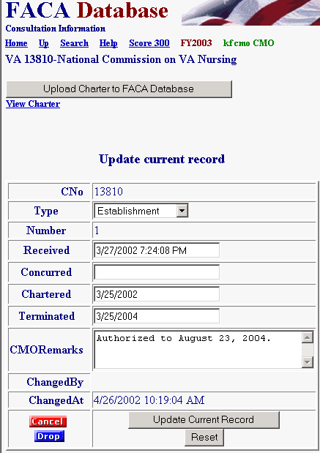
Before leaving the Consultation page the CMO should click the Update button and add any edits necessary to complete their part of the initial consultation process. The consultation record shows that the type of consultation is an Establishment. Creating a new committee with the Add a Committee form is always an Establishment. You can also assume that the establishment process generally needs further explanation, so let your Desk Officer know what you are planning to do next in the Comments field. After the CMO adds any comments or dates, they save the changes with the Save button. Several emails go back and forth between the CMO and Desk Officer because whenever anyone saves a change to a consultation record, the system again generates e-mail to the usual suspects.

The Consultation button, which is found on each committee’s Committee Menu page, is also used for Renewals, Re-establishments, Amendments, and Terminations. The Consultation page includes the Upload Charter to FACA Database button. Charters can be uploaded so they can be displayed on the online system if they have been saved as a file in a word processing format like .doc, .txt, .rtf, or saved as a .pdf file, and if they have been saved in a folder accessible to your computer.

Emails Addresses

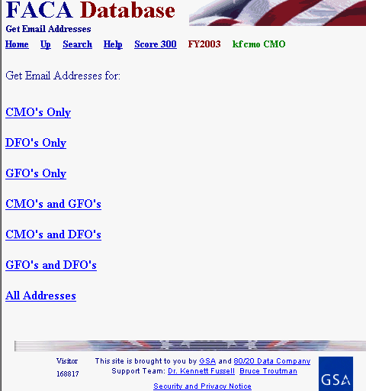
The Get Emails link displayed in the Tools group provides different combination of email addresses. These emails belong to the agency users of the online system. The emails are found in the user profiles and the DFO page data and the CMO page data kept in the online system. This information extends beyond the formal agency DFO list to everyone with responsibility for data management from the agency in the system that has been given a login or otherwise added to the system list, including decision makers, supervisors, and administrative staff. We expect a contact list like this to become more and more useful, so it is best to urge everyone to keep his or her information up-to-date.

Manage Groups

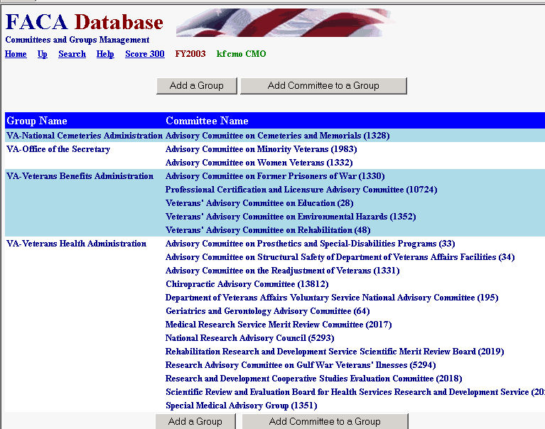
Larger agencies often manage and report their advisory committees in significant sub-group breakdowns in addition to the Agency-Wide Totals. The Department of Defense often has a need to report about committees concerned with Army issues separate from Navy issues. The Manage Groups link opens a module that allows a CMO to create a useful sub-group name (National Park Service) and then attach advisory committees from the agency to the sub-group.

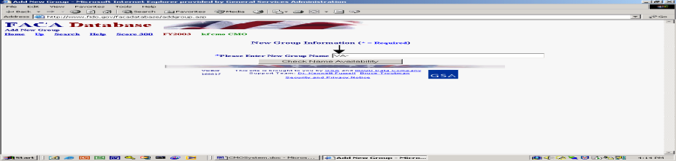The Add a Group button allows the creation of a new group. Committee Management has established a standard naming convention in that all new groups will have the agency abbreviation as an initial prefix (see the screen-shot). We leave the rest of the group name to your needs and imagination. It helps when creating group names to remember that our online system has a public access component. Any new group names should be distinct and intelligible to the small remaining public part of the US population that does not have a military or government work experience.

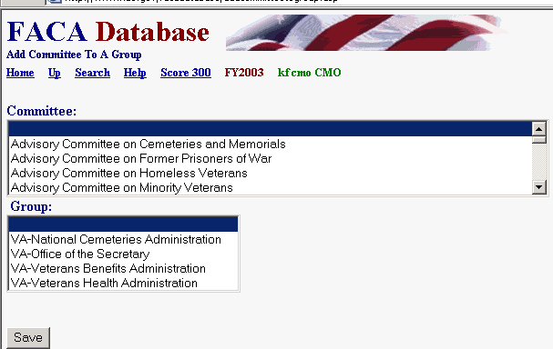
The Add a Committee to a Group button allows the CMO to add an agency committee to an existing agency group. The process involves selecting a single committee, selecting a single group name, and then clicking the Save button. To add a second committee to a new group the same sequence is repeated. This may appear tiresome if you are creating a new group with 50 committees, but it only has to be done once. Newly created committees can be added to existing groups the same way. While we have hopefully made the process of adding groups, and committees to groups, easy, careful thought should precede the willy-nilly creation of groups of committees. One reason for care is that we have not provided a way for the CMO to remove a committee from a group or a group from an agency. This remains a manual operation, although “terminated” committees are automatically dropped from the group the year after the committees are terminated.

Manage Users

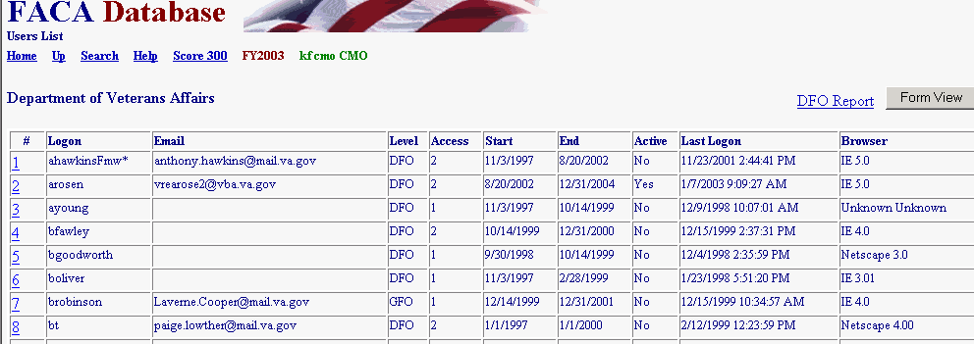
The Manage Users link displays the list of agency users and their access rights on the system. After the Committee Management Secretariat staff gives the user CMO status on the system, the CMO can
- Add users at the GFO and DFO levels of use and assign them a group or a committee,
- Control whether users can edit the current year’s data,
- Limit when a user will have access to the system, and
- Look up the user’s password.

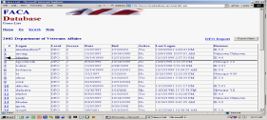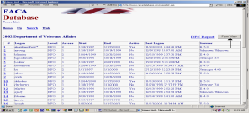By clicking the hot link, which is the underlined number at the left of the row of user information (see the screenshot to the left), or by clicking the FormView Navigation Button (see the screenshot to the right), the CMO displays a user record to edit. The Form View Button displays the first record in the list in a form. The records are reviewed alphabetically. The Hot Link displays the record of the user identified in the Logon field. The DFO Report link displays all the user data in a list view.
User Form Rules and Codes to Assign User Rights

On the User Form the CMO will find buttons to Filter for a specific Logon, Save an edited record, add a New user, and return to the User List, but the CMO will not find a button to delete a user. Once a user is added to the system, they are kept in the system forever so that there is an audit trail regarding who created or edited the data in this record of the system. The personal identification information is displayed in a profile form when the new user logs on. When adding a new user, the CMO should focus on the logon, password and the user’s access rights. The DFO and GFO will have an opportunity to complete any contact-information-fields that are left blank in the user profile form when they first logon.

The rules and codes regarding the user information and access rights (permission levels) follow.
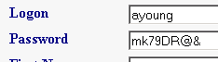
- The user’s Logon name and Password together form a unique key field that is not duplicated in the system. The username (Logon) should normally be in the form of the user’s government email address, but the logon can be a combination of the first letter from the first name and the full last name if necessary. The actual user should be identifiable and recognizable from the username.

- The Password can be any combination letters, numbers, symbols, characters, and case of up to 16 positions long. The password can be duplicated in the system with other users’ passwords. However, if the individual user has more than one login, each of the individual user’s passwords associated with each login must be unique. Passwords are generally a system’s weakest point of defense from unwanted intrusion, so, unfortunately, the best password is such a complicated combination of letters, numbers, characters, and symbols that you will never be able to remember it.

- The CMO can add users at two Permission Levels, GFO and DFO. The DFO can only view and edit their single committee when logged on, the GFO can view and edit all the committees in their assigned group.

- Permission Access is either read-only: 1, or edit: 2. A user needs a Permission Access of 2 (EDIT) to make changes to the data and add new information.

- The Start Date is the earliest date that a user can logon and the End Date is the last date that a user can logon.

- The Active User can be set to “Yes” or “No”. This field is used to turn a user’s logon rights on or off without having to change all the other settings. Committee Management Secretariat regularly switches the Active User setting to no for users who have not logged in for a full year.

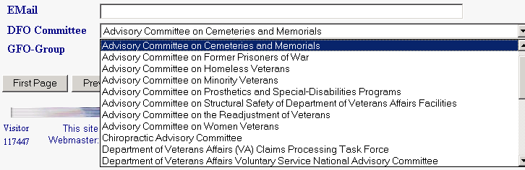
- The Committee for which the DFO user is responsible can be set from the “DFO Committee” pull-down. The pull down list will display all the possible committees for the agency. To select the DFO’s committee, the CMO clicks on the correct committee.
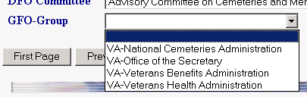
- The CMO can assign a GFO to an existing group. The CMO must set up a group before a GFO can be assigned to that group. The CMO should click “Save” before leaving the page after completing any changes to a user form.

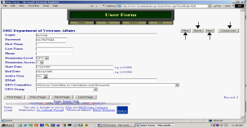The Filter button on the User Form displays a filter page so that the CMO can quickly find a user record based on the most relevant criteria. The New button displays a blank data entry page for adding a new user. The CMO returns to the full read-only User List page with the Users List button.
Filtering for Specific Users

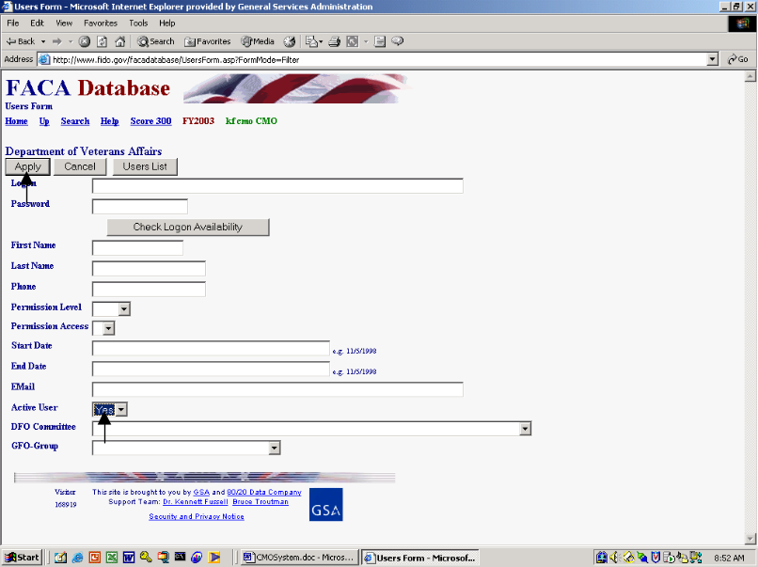To use the Filter page, the CMO selects criteria like Yes for the Active User text box and clicks the Apply button. The Cancel button cancels the Filter page.

Saving New Users

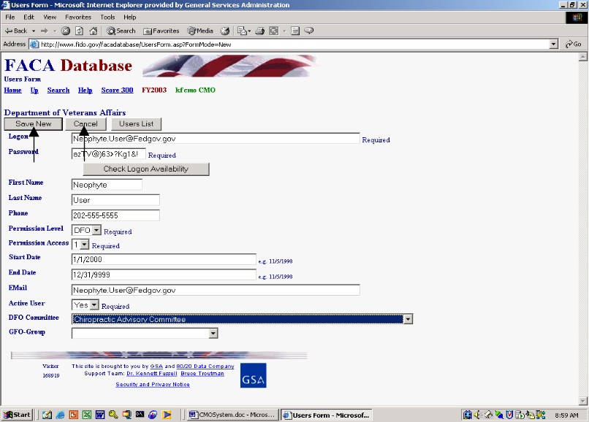The CMO fills in all the contact information and applies the permissions and rules to create a new user, finally “saving” the information on the new user by clicking the Save New button. The CMO can abandon the new record at any time before the “SAVE” action by clicking the Cancel button. If the CMO suspects that they are creating a duplicate logon combination, they can fill in the Logon and Password and click the Check Logon Availability button. The system may overreact quite negatively if you attempt to create a duplicate user, so cover your eyes before you click the Save New button in doubtful situations.
The End of FY group

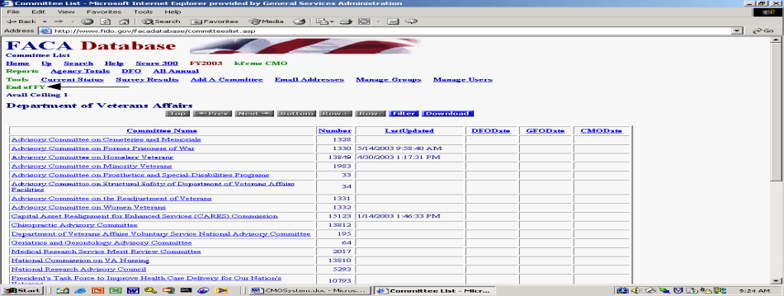Generally, CMOs and the Committee Management Secretariat have the need during the first quarter of any new FY to continue to manage the advisory committee process for the current FY. At the same time, they need to finalize and verify the data reported for the Fiscal Year that was just completed. While advisory committees are a continuous and ongoing fact of government, the Congress in the Federal Advisory Committee Act requires that each individual FY of each Advisory Committee’s life be treated as a separate, discrete, reportable unit. When we are involved in that period, there are several additional links found in the End of FY group to support the completion of that process while trying to avoid confusion. The added links are usually somewhat intuitive, and the CMOs receive regular and inundating communications from Committee Management about how to use the links and treat the reporting period. You should check the online help at that time for updated versions of this help manual that has a section speaking directly to the use of the added links.

The Committee List page and Committee Name Hyperlinks

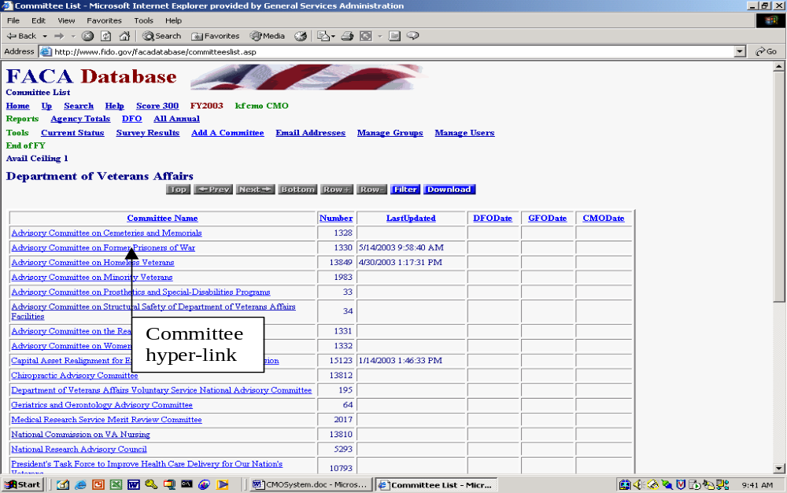
The CMO has complete editing rights to all the committee data. Changes to the pages are made, and meetings, reports, and members are added by linking to the correct data entry page through the Committee Menu page. The CMO reaches the Committee Menu page via the Committee Name hyperlink from the Committee List page.

The Committee List page also keeps the CMO informed of the last time a committee’s data was updated. The data validation status for completing the reporting year is managed by means of the date stamps in the DFODate, GFODate, and CMODate columns.

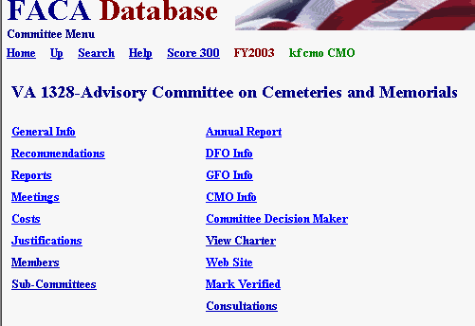
For further data entry directions, the DFO System Manual has a complete explanation of the Committee Menu page options. The links shown in this manual may be able to display that manual if you have opened this document in Microsoft Word. The menu options include
- General Info,
- Recommendations.
- Reports,
- Meetings,
- Costs,
- Justifications,
- Members,
- Sub-Committees,
- Annual Report,
- DFO Info,
- GFO Info,
- CMO Info,
- Committee Decision Maker,
- View Charter,
- Web Site,
- Mark Verified, and
- Consultations.
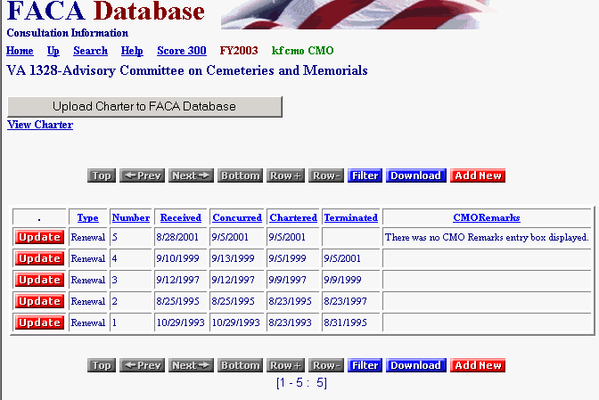
You may remember from our discussion long ago and many pages above, when the CMO views the Committee Menu page from their logon, the CMO sees a link (Consultations) that is not available to the DFO. The CMO can edit all data (consistent with the system’s security and design), but sometimes changes have to be made on a different page then the page that displays the information. An example is that some General Information page data can only be updated through the Consultation page by the CMO.

The Rest of the Story

There are many other features and reports available to assist the CMO in the FACA Database online system, most of which are found and described in the Public System part of the manual. All of the features and reports are only as useful and accurate as the data is kept up-to-date. This task falls primarily to the DFOs or their designees. Keeping the system up-to-date whenever the committee data changes transforms the FACA database into a highly sought commodity in government: a useful, interagency data sharing and management tool. The FACA Database online system has been available since 1997. It is a living system in the sense that it has grown in usefulness and functionality (and size) every year that it has existed. Some of the improvement is due to the improved technology of the Internet, and a little can be counted due to the increasing skill of the development team. However, most of the improvement is due to the feedback, patience, and willingness of the users to participate both in the development process and with on-line record keeping. The FACADatabase is truly a shared system that belongs to all of us.

