
The United States Environmental Protection Agency (EPA) and [insert your water system name] are concerned about lead in your drinking water. Some drinking water samples taken from this facility have lead levels above the EPA action level of 15 parts per billion (ppb), or 0.015 milligrams of lead per liter of water (mg/L). Under Federal law, we are required to have a program in place to minimize lead in your drinking water by [insert date when corrosion control will be completed for your system].

This program includes:

1. Corrosion control treatment (treating the water to make it less likely that lead will dissolve into the water);

2. Source water treatment (removing any lead that is in the water at the time it leaves our treatment facility); and

3. A public education program.

If you have any questions about how we are carrying out the requirements of the lead regulation please give us a call at [insert water system’s phone number here].

This brochure also explains the simple steps you can take to protect yourself by reducing your exposure to lead in drinking water.

HEALTH EFFECTS OF LEAD

Lead is found throughout the environment in lead-based paint, air, soil, household dust, food, certain types of pottery porcelain and pewter, and water. Lead can pose a significant risk to your health if too much of it enters your body.

Lead builds up in the body over many years and can cause damage to the brain, red blood cells and kidneys. The greatest risk is to young children and pregnant women. Amounts of lead that won’t hurt adults can slow down normal mental and physical development of growing bodies. In addition, a child at play often comes into contact with sources of lead contamination - like dirt and dust - that rarely affect an adult. It is important to wash children’s hands and toys often, and to try to make sure they only put food in their mouths.

LEAD IN DRINKING WATER

Lead in drinking water, although rarely the sole cause of lead poisoning, can significantly increase a person’s total lead exposure, particularly the exposure of infants who drink baby formulas and concentrated juices that are mixed with water. EPA estimates that drinking water can make up 20% or more of a person’s total exposure to lead.

HOW LEAD ENTERS OUR WATER

Lead is unusual among drinking water contaminants in that it seldom occurs naturally in water supplies like rivers and lakes. Lead enters drinking water primarily as a result of the corrosion, or wearing away, of materials containing lead in the water distribution system and household plumbing. These materials include lead-based solder used to join copper pipe, brass and chrome-plated brass faucets, and in some cases, pipes made of lead that connect houses and buildings to water mains (service lines). In 1986, Congress banned the use of lead solder containing greater than 0.2% lead, and restricted the lead content of faucets, pipes and other plumbing materials to 8.0%.

When water stands in lead pipes or plumbing systems containing lead for several hours or more, the lead may dissolve into your drinking water. This means the first water drawn from the tap in the morning, or later in the afternoon if the water has not been used all day, can contain fairly high levels of lead.

STEPS TO REDUCE EXPOSURE TO LEAD IN DRINKING WATER

1. FLUSH YOUR SYSTEM.
Let the water run from the tap before using it for drinking or cooking any time the water in a faucet has gone unused for more than six hours. The longer water resides in plumbing the more lead it may contain. Flushing the tap means running the cold water faucet for about 15-30 seconds. Although toilet flushing or showering flushes water through a portion of the plumbing system, you still need to flush the water in each faucet before using it for drinking or cooking. Flushing tap water is a simple and inexpensive measure you can take to protect your health. It usually uses less than one or two gallons of water.

2. USE ONLY COLD WATER FOR COOKING AND DRINKING.
Do not cook with, or drink water from the hot water tap. Hot water can dissolve more lead more quickly than cold water. If you need hot water, draw water from the cold tap and then heat it.

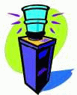
3. USE BOTTLED WATER.
The steps described above will reduce the lead concentrations in your drinking water. However, if you are still concerned, you may wish to use bottled water for drinking and cooking.

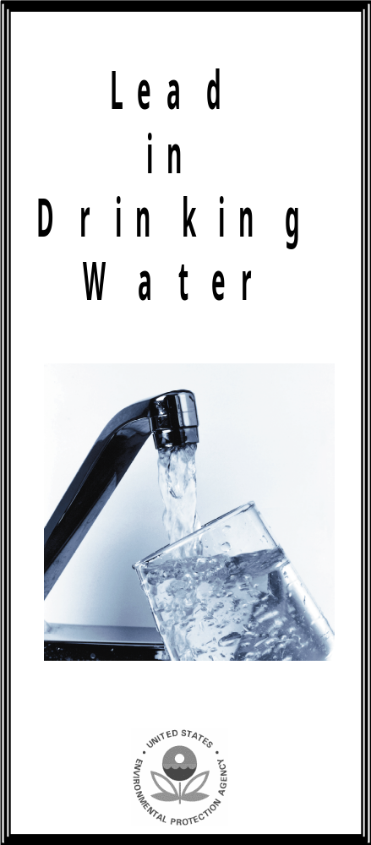
FOR MORE INFORMATION

You can consult a variety of sources for additional information. Your family doctor or pediatrician can perform a blood test for lead and provide you with information about the health effects of lead.

State and local government agencies that can be contacted include: [insert the name or title of facility official if appropriate] at [insert phone number] can provide you with information about your facility’s water supply;

an [insert the name or title of the State Department of Public Health] at [insert phone number] or the [insert the name of the city or county health department] at [insert phone number] can provide you with information about the health effects of lead.

