Temporary Assistance for Needy Families (TANF)



Program

Second

Annual Report
to Congress
August 1999

U.S. DEPARTMENT OF HEALTH AND HUMAN SERVICES

Administration for Children and Families

Office of Planning, Research and Evaluation

TANF REPORT TO CONGRESS

TABLE OF CONTENTS

I. INTRODUCTION AND EXECUTIVE SUMMARY 3

- TRENDS IN CASELOADS AND EXPENDITURES 13

- WORK PARTICIPATION RATES 34

- EMPLOYMENT AND EARNINGS OF NEEDY FAMILIES 43

- TANF REGULATIONS AND OTHER INITIATIVES 48

- CHILD SUPPORT COLLECTIONS 57

- OUT-OF-WEDLOCK PREGNANCIES AND BIRTHS 64

- INCOME AND CHILD POVERTY 69

- DEMOGRAPHIC AND FINANCIAL CHARACTERISTICS 74

OF TANF FAMILIES

- TRIBAL PROGRAMS 109

- CHILD CARE 130

- CHARACTERISTICS OF EACH STATE PROGRAM FUNDED 138
UNDER TANF

- SPECIFIC PROVISIONS OF STATE PROGRAMS 146

- TANF RESEARCH 182

You may also access this report as follows:
http://www.acf.dhhs.gov/programs/opre/director.htm

I. INTRODUCTION AND EXECUTIVE SUMMARY

EXECUTIVE SUMMARY

On August 22, 1996, President Clinton signed the bipartisan welfare reform plan that is dramatically changing the nation’s welfare system. The Personal Responsibility and Work Opportunity Reconciliation Act (PRWORA) of 1996 replaced the old welfare system (AFDC) with Temporary Assistance for Needy Families (TANF), to focus on work and responsibility and to provide States with flexibility to create the best approaches for their individual circumstances. Even before the Personal Responsibility Act became law, many States were well on their way to changing their welfare programs into jobs programs. By granting Federal waivers, the Clinton Administration allowed 43 States – more than all previous Administrations combined – to require work, time limit assistance, make work pay, improve child support enforcement and encourage parental responsibility.

This strategy of requiring work and responsibility and rewarding families who have gone to work is paying off. Since welfare reform there has been a dramatic increase in employment among welfare recipients. The percent of current TANF adults who are working has nearly quadrupled. In addition the Census Bureau’s Current Population Survey reports that between 1992 and 1998, the employment rate of previous year TANF recipients increased by 70%. Finally, all States met the first overall work participation rates required under the welfare reform law for FY 1997 and 1998.

A recent General Accounting Office report found that between 63 and 87 percent of adults have worked since leaving the welfare rolls. Preliminary findings from six of the HHS funded studies of families leaving welfare indicate that between one-half and three-fifths of former TANF recipients found work in jobs which were covered by their States’ Unemployment Insurance program. Employment rates were even higher – 75 to 82 percent – when measured as the percentage of those who were ever employed within the first 12 months.

Welfare reform has shown promising results among those most vulnerable to welfare dependency in a continuing rise of employed single mothers. In 1998, according to the Census Bureau, almost three-fifths (57 percent) of single mothers with incomes under 200 percent of poverty were employed as compared to 44 percent in 1992.

Welfare caseloads are at their lowest level since 1969 and the welfare rolls have fallen by nearly half since the beginning of this Administration. The number of recipients fell from 14.1 million in January 1993 to 7.3 million in March 1999, a decline of nearly 6.8 million or 48% fewer since President Clinton took office. The rolls have declined by 4.9 million people, or 40 percent, since President Clinton signed the welfare law in August 1996. Since 1993, welfare rolls have declined in all States, with 29 States recording declines of half or more. A new report by the Council of Economic Advisers finds that the implementation of welfare reform accounts for one

third of the decline between 1996 and 1998, and is the single most important factor contributing to the widespread and continuous caseload declines during this period.

The President started reforming welfare early in his first term, granting waivers, expanding the Earned Income Tax Credit and the minimum wage to make work pay, and pushing the Congress
for historic nationwide welfare reform legislation. Since 1996, he has launched the Welfare-to-Work Partnership which now includes over 12,000 businesses that have hired over 410,000 welfare recipients; issued an executive order to ensure the Federal government hired its share of welfare recipients – over 14,000 have been hired to date; encouraged the launching of the Vice President’s Coalition to Sustain Success, a coalition of national civic, service and faith-based groups who are working to help these new workers with the transition to self sufficiency; and fought for and won additional funds for welfare to work efforts for long term recipients in high poverty areas including $3 billion in Department of Labor Welfare-to-Work funds enacted in the Balanced Budget Act; a new tax credit to encourage the hiring of long term welfare recipients; funding for welfare to work transportation ($75 million in FY 1999); welfare to work housing vouchers (50,000 enacted to date); and putting in place new welfare rules that make it easier for States to use TANF funds to provide supports for working families such as child care, transportation, and job retention services.

With more parents entering the work force, the need for child care has risen as a critical support to help parents keep their jobs. The 1996 welfare law did provide $4 billion in additional funds to States to provide more care and help improve the quality of programs, but the unmet need remains large. There are approximately 10 million children eligible for federal funded support, yet in 1997 only 1.25 million children received assistance.

Ensuring that families who leave welfare for jobs stay employed is one of the next challenges of welfare reform. Reliable, safe and affordable childcare is one of the critical ingredients for parents succeeding in work. A recent GAO study demonstrated that parents who receive child care assistance more often complete training, get jobs and experience positive outcomes. To address this growing challenge, President Clinton proposed an $19.3 billion child care initiative comprising increased subsidies to States, expanded tax credits and an early learning fund so States have a dedicated source of funding to improve the choices parents can make for child care programs. The President’s proposals to invest an additional $1 billion to extend the Welfare-to-Work program, increased funding for Access to Jobs transportation, provide 25,000 more welfare to work housing vouchers, and extend employer tax credits will also help people make a successful transition from welfare to work.

This report compiles early data about welfare caseloads, family employment and earnings, and State policy choices, to give a picture of these first two years of welfare reform. Below are some more extensive highlights describing the information available to date as well as the research underway to learn more.

EMPLOYMENT AND EARNINGS OF NEEDY FAMILIES

There has been a dramatic increase in employment of current welfare recipients.
The percentage of employed recipients reached an all-time high at 23 percent, compared to less than 7 percent in 1992 and 13 percent in 1997. Thus, almost one in four recipients was employed in a typical month, the highest level ever recorded. Similarly, the proportion of recipients who were working (including employment, work experience and community service) reached 27 percent, a nearly fourfold increase over the 7 percent recorded in 1992.

All States met the all family participation rate standard for 1998. All States plus the District of Columbia met the all family participation rate standard. Of the forty-three States plus the District of Columbia that are subject to meet the two parent work participation rate, twenty-nine met the FY 1998 two-parent participation standard.

Between 1992 and 1998, the employment rate of TANF recipients increased by 70%. In 1992 one in five previous year recipients was working the following spring, whereas in 1998, the figure had increased to one in three. Each March the Current Population Survey, which is used to calculate unemployment rates, collects information about households' income and program participation in the previous calendar year as well as employment and earnings data reflecting individuals' March employment status. As a result we know whether adults who received AFDC or TANF in the preceding calendar year (who may or may not still be receiving welfare) were employed the following March. Between 1992 and 1996, the employment rate increased from 20 percent (its approximate level for the previous four years) to 27 percent. In the last two years it jumped even more dramatically to 34 percent in 1998.

Employment of single mothers has grown significantly. By 1998, the latest year for which Census figures are available, the percentage of single mothers with incomes under 200% of poverty who were employed rose from 44% in 1992 to 57% in 1998.

A variety of State research studies show that most adults have worked once leaving the welfare rolls. Studies summarized by the GAO show that between 67% and 87% of adults had worked since leaving the welfare rolls. These findings from these interim reports also indicate that between one-half and three-fifths of former TANF recipients found work in jobs that were covered by their State’s Unemployment Insurance program at the time they left welfare which found employment rates of families leaving welfare were from 75 to 82 percent when measured as the percentage of those who were ever employed within the first 12 months. While these employment rates are not radically different from the patterns of AFDC leavers in earlier studies, they indicate a dramatically large increase in the absolute number of families leaving welfare with earnings, given the significant caseload decline in the past few years.

MAKING WORK PAY

The average earnings of employed TANF recipients increased from $506 per month to $553, an increase of about 11 percent between 1997 and 1998. Eight percent of adult recipients had unearned income averaging about $232 per month.

A recent GAO study found annual earnings of $9,512 - $15,144 among those who had left welfare. Especially when earnings are combined with other supports for working families such as EITC, food stamps, and child care, families are better off than they were on welfare.

The Administration has taken key steps to support working families and make work pay. These initiatives include: expanding the Earned Income Tax Credit to lower taxes for 15 million working families; raising the minimum wage to $5.15 an hour and fighting for an additional $1 per hour increase; adding $4 billion more in child care and fighting to provide even more, and enacting the $24 billion Children’s Health Insurance Program to extend health care coverage to millions of uninsured children. Most recently, the President announced a series of executive actions to ensure working families access to food stamps. Through $4 billion in additional child care investments added in the welfare reform law, an additional 441,000 children have been provided child care so parents could work. The EITC lifted 4.3 million Americans out of poverty in 1997 and reduced the number of children living in poverty by 2.2 million.

The poverty rate, as measured by the Census Bureau’s official poverty measure, has fallen to 13 percent, down from 15 percent in 1993. Since 1993, the African American poverty rate dropped from 33.1 percent to 26.5 percent – the lowest level on record and the largest four-year drop in more than a quarter century. Last year, the Hispanic poverty rate dropped from 29.4 percent to 27.1 percent – the largest one-year drop since 1978. The child poverty rate declined from 22.7 percent in 1993 to 19.9 percent in 1997, the biggest four-year drop in nearly 30 years. While these are encouraging trends, there is more work to do in all these areas. The Department will be monitoring child poverty rates in States through regulation.

Although welfare reform is having a positive effect on the earnings of some categories of recipients, early information provides a complicated story. Along with the employment gains described above, the CPS data suggests average earnings for all female-headed families with children have increased substantially between 1993 and 1997 from $14,668 to $17,646 (both in 1997 dollars). However, the early CPS analysis suggests preliminarily that the gains are not evenly distributed over the period with roughly three-quarters of the gain occurring between 1993 and 1995, and only one-quarter between 1995 and 1997.

Family income on average has increased for some families, but there is also preliminary evidence that some families are experiencing losses. For the period 1993 to 1997, CPS data indicate that the average annual income of all female-headed families with children increased, as did employment and earnings as described above. This measure of income includes both earnings and a broad range of transfer programs. Again, the income increases were unevenly distributed over the period, with larger gains in the 1993 - 1995 period, and across the income distribution. The bottom quintile did not fare as well as the top four fifths, especially in the 1995-1997 period, underscoring the need for additional welfare to work efforts.

TRENDS IN CASELOADS AND EXPENDITURES

There continue to be dramatic declines in welfare caseloads. Overall, between August 1996 and March 1999 there has been a 40 percent decrease in the number of recipients on the rolls. The percent of the U.S. population receiving assistance in March 1999 was the lowest since 1969.

Date | Estimated U.S.  Population | AFDC/TANF Recipients | Percent of U.S.  Population
1992 | 254,489,083 | 13,625,342 | 5.4
1993 | 257,563,667 | 14,142,710 | 5.5
1994 | 260,103,333 | 14,225,651 | 5.5
1995 | 262,560,167 | 13,659,206 | 5.2
1996 | 264,990,250 | 12,644,076 | 4.8
1997 | 267,510,917 | 10,935,151 | 4.1
1998 | 270,063,250 | 8,770,376 | 3.2
March 1999 | 272,445,000 | 7,334,976 | 2.7

A new report by the Council of Economic Advisers finds that the implementation of welfare reform is the single most important factor contributing to the widespread and continuous caseload declines from 1996 to 1998. CEA estimates that the federal and State program and policy changes implemented as a result of welfare reform account for approximately one-third of the caseload reduction during this period. While the strong economy has also played an important role, accounting for approximately ten percent of the decline between 1996 and 1998, it was the larger factor in declines from 1993 to 1996 when the largest declines in the unemployment rate occurred.

In FY 1998, States continued to make large investments in their work first welfare programs. Overall, based both on the level of spending in FY 98 reported by States and on the cash assistance levels established by the States under the TANF program, there is clearly no "race to the bottom" occurring. When FY 1997 and 1998 funds are combined, States spent or committed to spend 90 percent of the TANF Federal block grant funds. By the end of FY 98, nineteen States had already spent or committed all of their FY 98 federal funds. All States met the minimum requirement in State maintenance of effort (MOE) spending in 1997 and 1998, with some States spending more. Also, to meet the critical need of child care for parents moving from welfare to work, States increased the amount of TANF funds (up to $652 million) transferred to the child care block grant. In May, HHS provided guidance on how States and communities can

use the flexibility and resources available under TANF to support working families and address the needs of families facing challenges to self-sufficiency.

STATE POLICY CHOICES.

States are emphasizing work in their TANF programs. Under the TANF program, parents or caretakers receiving assistance are required to engage in work (as defined by the State) within 24 months or less at the State’s option. Currently, 20 States require immediate participation in work, 6 States require participation in work between 45 days and 6 months of receipt of cash assistance, 23 States require participation within 24 months, and 2 States within other timeframes.

States vary in limiting the time that families can receive TANF assistance. Currently, 28 States are using the Federal five-year limit, 6 States are using “intermittent” time limits up to a total of five years, 8 States are using shorter time limits than the five-year threshold, 5 States are using options involving supplements for families exceeding the five-year limit, and 5 States are applying time limits for adults only.

States are offering up-front payments or services to divert families from entering the welfare rolls. To date, 27 States have opted to offer diversion payments or services to families applying for TANF benefits as part of their TANF plan. In several States, this includes lump-sum payments to the families who in turn agree not to seek additional assistance for a specified period of time. In other States, the diversion includes job search and related services designed to help the family go directly to work.

States are seizing the opportunity to become certified under the “Domestic Violence Option” of TANF. The TANF program offers flexibility to States in offering special treatment to the victims of domestic violence under the “Domestic Violence Option.” To date, 27 States have certified that they will assist victims of domestic violence, with 4 more States in the formal process of becoming certified.

States are engaging in forums to share information and lessons learned. The Department is supporting the Welfare Peer Technical Assistance Network Project as an opportunity for States to link up and share information as well as cross-train each other on emerging best practices in areas such as transportation, substance abuse, and post-employment services. The project is challenging States to develop and share solutions for issues ranging from assuring adequate transportation for TANF families in rural areas, offering substance abuse treatments to TANF families, particularly those with a history of domestic violence or with mental health issues, to strengthening supportive services for TANF families that enter the world of work.

CHILD SUPPORT COLLECTIONS

In 1998, the number of child support cases with collections rose dramatically. Children need the support of both parents, which is why the Administration has worked closely with Congress and the States to increase child support collections. In 1998, child support was collected for 4.5 million families, an increase of 33% from 3.4 million in 1994. In fiscal year 1997, $13.4 billion was collected in child support. In 1998, the State and federal child support enforcement program collected a record $14.4 billion for children, an increase of 80% from 1992, when $8.4 billion was collected. The Office of Child Support Enforcement established a record 1.5 million paternities in 1998, two and a half times the 1994 figure of 676,000 and triple the 1992 figure.
A key to improvements in the nation's child support enforcement program is the use of modern automated technology. The new National Directory of New Hires has located 1.2 million delinquent parents during the first year of operation since its October 1, 1997 launch. The Administration’s Welfare-to-Work reauthorization proposal will help even more low-income fathers increase their employment and child support.

OUT OF WEDLOCK BIRTHS

We will soon award bonuses to reward reduction in Out-of-Wedlock births. The Bonus to Reward Decreases in Illegitimacy Ratio will be awarded later this year to up to five States who have had the largest decrease in their ratio of out-of-wedlock births, and also decreased their abortion rates. Out-of-wedlock births and teenage births continue to decline. Final data for 1997 (calendar year) indicate that the birth rate for unmarried women aged 15-44 years decreased from 44.8 births per 1,000 women in 1996 to 44.0 in 1997. The actual number of out-of-wedlock births declined very slightly from 1,260,306 in 1996 to 1,257,444 in 1997. Over the same period, the proportion of all births that were out-of-wedlock was unchanged at 32.4. Approximately 500,000 teenagers give birth each year. Nationally, the birth rate for teenagers continued to decline in 1997, and has now fallen by 16 percent to 52.3 births per 1,000 women aged 15-19 years, compared with 62.1 in 1991. During the 1991-97 period, teenage birth rates fell in all States and the District of Columbia and the Virgin Islands.

DEMOGRAPHIC AND FINANCIAL CHARACTERISTICS OF FAMILIES RECEIVING ASSISTANCE

Families received an average monthly amount of $358 in cash assistance under the TANF program. This is consistent with past years.

The average number of persons in TANF families was 2.1 persons. The TANF families averaged 2 recipient children, which remained unchanged. Two in five families had only one child. One in ten families had more than three children.

While the percentage of child-only cases on the welfare rolls has risen steadily since 1988, the rate of increase seems to be slowing in the recent 3 years. For the 49 States that reported child-only cases, 23.4 percent of TANF families had no adult recipients, a less than one percentage point increase for the comparable States for the October 1996 - June 1997 period. Even though the overall percentage of child-only cases has continued to increase, the total number of child-only cases has actually declined by about 200,000 since FY 1996.

There was little change in the racial composition of TANF families. Three of five TANF adult recipients were members of minority races or ethnic groups. Thirty-seven percent of adult recipients were black adults, 36 percent were white, 20 percent were Hispanic, 5 percent were Asian, and 1.6 percent were Native Americans.

Understanding the reason for case closure is severely limited by the fact that States reported 56.1 percent of all cases that closed did so due to “other” reasons. TANF families are no longer receiving assistance for the following reasons: 21.7% due to employment, 15.5% due to State policy, and 6.2% due to sanction. There is evidence that these case closure data understate employment rates when compared to State leaver studies.

TRIBAL TANF

As of April 30, 1999, DHHS has approved TANF plans for seventeen Tribes and two consortiums with Tribal TANF plans, involving 72 Tribes and Alaska Native Villages. An additional 13 plans are pending approval and several other Tribes are known to be exploring the option of operating a TANF program.

Tribal TANF programs served slightly more than 3 thousand families in a typical month in FY 1998. Another 47,502 American Indian families were served by State governments. Some Tribes and TANF programs also operate Native Employment Works (NEW) programs.

Native Americans make up a considerable amount of the caseload in certain States. In Fiscal Year 1998, the percentage of TANF adults in the TANF caseload served by the States who are American Indians was almost 73 percent in South Dakota, over 54 percent in North Dakota, almost 41 percent in Alaska, and over 46 percent in Montana.

CHILD CARE

Child care continues to be a critical support for families moving from welfare to work. The increase in the proportion of TANF families who are working and the increase in number of hours they must work makes the availability of child care critical in allowing TANF families to retain jobs and avoid seeking cash assistance. PRWORA added $4 billion for child care, providing child care for an additional 441,000 children. As State minimum work participation rates increase, from 25 percent of all parents in FY 1997 to 30 percent in FY 1998 and rising to 50 percent in FY 2002, parents will need more child care to get and keep jobs. States made significant investments in child care, spending over $1 billion of their own funds. In addition, in FY 1998 States transferred a total of $652 million in TANF funds to the Child Care Development Block Grant, an over three-fold increase from FY 1997.

Despite our investments in child care, there is still a large unmet need. Nationally, there are approximately 10 million children who are income eligible for CCDBG child care. The Department estimated that in 1997 about 1.25 million children were receiving child care assistance through the CCDBG.

Another indicator of the high demand for child care services is the rate of State spending of their federal child care funds. While States have two years to obligate and expend the CCDBG funds, States have obligated or expended 100% of the funds available in FY 98 in that same fiscal year.

A recent GAO study demonstrates the issues around finding affordable child care by analyzing the trade-offs low-income mothers confront when they want to work but face high child care costs. According to that study, child care subsidies are often a strong factor in a parent’s ability to work, and reducing child care costs increases the likelihood that poor and near-poor mothers will be able to work. The GAO observed that affordable child care is a decisive factor that encourages low-income mothers to seek and maintain employment. In an earlier study, the GAO found that single parents who received child care assistance more often successfully completed their training, obtained jobs or experienced other positive outcomes.

PUBLICATION OF FINAL TANF RULES AND OTHER INITIATIVES

The TANF final rules reflect PRWORA's strong focus on moving recipients to work and self-sufficiency, on ensuring that welfare is a short-term, transitional experience, and on States’ accountability for moving families toward self-sufficiency. The final rules encourage and support State flexibility, innovation, and creativity to develop programs that can reach all families and use TANF funds to provide supports to working families such as child care, transportation and job retention services. At the same time, they incorporate the core TANF accountability provisions, including work requirements, time limits, State penalties, and data collection and reporting requirements. This final rule announced by the President on April 10^{th,} will take effect on October 1, 1999.

We will soon award the high performance bonus (HPB) provision in the new welfare reform block grant legislation as a way to reward States that are the most successful in achieving the goals and purposes of the TANF program. A total of $1 billion (or an average of $200 million each year) is available in FYs 1999 through 2003. The four work measures for the bonus in FY 1999 and FY 2000 are: Job Entry, Success in the Work Force (a measure based on job retention and earnings), and improvement from the prior fiscal year in each of these measures. The participation in the HPB is optional and States may compete in some or all measures. Forty-six States have submitted data to compete for the HPB for FY 1999. We anticipate awarding the FY 1999 bonuses later this year.

The President’s FY 2000 budget includes key initiatives that build on the Administration’s continuing efforts to help families move from welfare to work and succeed in the workforce. The FY 2000 budget requests $1 billion to extend the Welfare-to-Work program to help 200,000 long-term welfare recipients and low-income fathers move into lasting unsubsidized employment and support their families. The budget requests $430 million for 75,000 welfare-to-work housing vouchers, including $144 million in new funds for 25,000 additional vouchers, and doubles Access to Jobs transportation funding from $75 million to $150 million. The President is proposing to extend both the Welfare-to-Work Tax Credit and the Work Opportunity Tax Credit to encourage the hiring and retention of long-term welfare recipients and other groups of job seekers. Finally, the President is proposing significant new funding for child care to help working families meet the cost of child care. Central to this child care initiative is an expansion of the CCDBG by 7.5 billion over 5 years.

HHS has a critical role in ensuring that the nation has the answers to major questions regarding welfare reform. These questions can only be answered through rigorous and systematic studies. HHS’s welfare reform research agenda has two broad goals: to increase the likelihood that the objectives of welfare reform are achieved by developing credible information that can inform State and local policy and program decisions, and to inform the Congress, the Administration and other interested parties on the progress of welfare reform.

- TRENDS IN CASELOADS AND EXPENDITURES

Caseload Data

Welfare caseloads have declined dramatically since their peak at 14.4 million recipients in March 1994. This decline has continued at an even more rapid pace since the enactment of welfare reform in August 1996. Overall, between January of 1993 and March of 1999 there has been a 46 percent decline in the number of families, and a 48 percent decline in recipients on welfare. The percent of the U.S. population receiving assistance in March 1999 was the lowest since 1969. As Chart 2:1 shows, these declines are spread across almost all of the States. Tables 2:1 and 2:2 provide information on a monthly basis for States for FY 1998 for both recipients and families. Tables 2:3 and 2:4 provide information on State by State welfare caseloads since 1993 for both recipients and families.

A new report by the Council of Economic Advisers finds that the implementation of welfare reform is the single most important factor contributing to the widespread and continuous caseload declines from 1996 to 1998. CEA estimates that the Federal and state program and policy changes implemented as a result of welfare reform account for approximately one-third of the caseload reduction from during this period. While the strong economy has also played an important role, accounting for approximately ten percent of the decline between 1996 and 1998, it was a larger factor in the declines from 1993 to 1996 when the largest declines in the unemployment rate occurred. An additional ten percent of the caseload decline between 1996 and 1998 was due to the higher minimum wage, and 1 – 5 percent was due to the lower real value of cash welfare benefits. In comparison, between 1993 and 1996, 26 – 36 percent of the decline was due to the improved labor market, 12 – 15 percent was due to waivers granted by the Administration to States to experiment with welfare reform, and 6 – 22 percent due to the lower real value of cash welfare benefits.

FY 1998 STATE SPENDING UNDER THE NEW WELFARE PROGRAM

Overview

Fiscal Year 1998 was the first full year that all States implemented the new Temporary Assistance for Needy Families (TANF) program. In FY 1998, States continued to make large investments in their work first welfare programs. Overall, as States have time to adjust to the caseload decreases and make decisions on appropriate program investments, they are increasing the amount of money they obligate in the program. By the end of the fiscal year, States spent or committed to spend 84 percent of their FY 1998 federal funds. When FY 1997 and 1998 funds are combined, States spent or committed 90 percent of the federal funds. All States met the minimum maintenance of effort requirement for State spending, with some States spending more. Also, to meet the critical need of child care for parents moving from welfare to work, States increased the transfer of TANF funds to the child care block grant. Even with their significant spending of both federal and State funds, States are now facing new challenges in reaching families with greater barriers to work and supporting families to remain in work.

The Department of Health and Human Services encourages States to use their federal and State funds for non-traditional welfare services, such as non-medical substance abuse and domestic violence services, to help all families attain and succeed in work. In May, HHS provided guidance on how States and communities can use the flexibility and resources available under TANF to support working families and address the needs of families facing challenges to self-sufficiency.

FY 1998 Highlights

Maintenance of Effort. The new welfare reform law requires States to continue to spend State funds at a level equal to at least 80 percent of their FY 1994 levels. If States meet the minimum work participation rates, the law also allows them to reduce their minimum-spending requirement to 75 percent. In FY 1998, all States expended enough to meet the 75% maintenance of effort amount, with aggregate State spending at 79% of FY 1994 levels. Thirteen States reported State spending above 80%, with 1 State -- West Virginia -- exceeding 100 percent. Since States are not required to report any expenditures in excess of the maintenance of effort requirement, States may actually be spending more than reported.

Child Care. Child care continues to be a critical support for families moving from welfare to work. As State minimum work participation rates increase, from 25 percent of all parents in FY 1997 to 30 percent in FY 1998 and rising to 50 percent in FY 2001, parents will need more child care to get and keep jobs. States made significant investments in child care, spending over $1.6 billion of their own funds (this includes child care MOE and child care State matching funds). In addition, States transferred a total of $652 million in TANF funds to the child care block grant, an over three-fold increase from FY 1997. Also, States report they are committing 100 percent of their CCDBG funds.

Work Activities. States furthered the goal of the welfare law by making work first the priority for their programs. In FY 1998 States spent $1.2 billion in combined federal and State funds on work activities.

Cash and Work-Based Assistance. States spent $6.8 billion, or 69 percent, of their FY 98 federal TANF funds on cash assistance and work-based assistance. The work-based assistance in this category may include paychecks earned by TANF recipients in return for community service jobs or subsidized employment.

Transferring TANF Funds. The new welfare law gives States the authority to transfer portions of their TANF grant to either the Child Care and Development Block Grant or the Social Services Block Grant. Thirty-three States reported transferring funds in amounts ranging from 2 to 29 percent of their TANF grant. In total, $652 million or 4 percent of TANF funds were transferred to the child care block grant and $1.1 billion or 7 percent was transferred to the Social Services Block Grant.

Administrative Costs. States continue to invest in transforming their welfare offices into employment centers, and their eligibility workers into trained job counselors. They are also using their funds efficiently and cost effectively. In FY 1998, State administrative expenditures amounted to $913 million, or 9 percent of total federal TANF expenditures -- well below the TANF administrative cost limit of 15 percent.

Separate State Programs. In FY 1998 15 States chose to fund programs with separate State funds. This is fewer than in FY 1997 when 16 States reported expended funds in separate State programs. Expenditures on separate programs as a percentage of total State spending ranged from 0.2 to 54 percent. States with separate programs spent most of their separate State program funds -- 55 percent -- on cash and work-based assistance by providing support to primarily two-parent families and qualified legal immigrants. Most of the remaining funds were spent on child care (35 percent) and non-direct services categorized as other expenditures.

Other Expenditures. States reported spending $1.1 billion in federal TANF funds and $1.3 billion in State maintenance of effort funds on other expenditures, which included fraud control programs, emergency assistance (e.g. one-time benefits to divert families from having to rely on welfare), staff training, domestic violence services, and child welfare programs.

Unobligated Balances. States can carry forward unobligated TANF funds for use in future years, for example to meet unanticipated needs or reserve dollars for "rainy day" funds. In FY 1998 States spent or obligated $13.9 billion or 84 percent of the total federal funds. The remaining $2.7 billion in unobligated funds remain in the federal treasury, with no time limit, until States draw down the dollars.

Tables and Charts:

Chart 2:1 Recipient Count, FY 1993 – December 1998

Table 2:1 State by State Welfare Caseloads, FY 1998 (Recipients)

Table 2:2 State by State Welfare Caseloads, FY 1998 (Families)
Table 2:3 State by State Welfare Caseloads Since 1993 (Recipients)
Table 2:4 State by State Welfare Caseloads Since 1993 (Families)
Table 2:5 Combined Expenditures of Federal TANF Funds in FY 1998
Table 2:6 TANF Federal Awards, Transfers and Expenditures Through 4th
Quarter, FY 1998
Table 2:7 Federal Transfer Amounts, and Amounts Available for TANF Through 4th Quarter, FY 1998 (with Percentages Shown)
Table 2:8 State Expenditure of Federal Funds for TANF Through 4th Quarter, FY 1998 (with Percentages Shown)
Table 2:9 Total State Expenditure of Federal Funds and Remaining Unexpended Funds for TANF Through 4th Quarter, FY 1998 (with Percentages Shown)
Table 2:10 State TANF Maintenance of Effort (MOE), Expenditures of State Funds Through Fourth Quarter, FY 1998
Table 2:11 State TANF Maintenance of Effort (MOE), Expenditure of State Funds in Separate State Programs Through 4th Quarter, FY 1998
Table 2:12 State MOE Analysis Through 4th Quarter, FY 1998

Chart 2:1

Recipient Count, FY 1993 – March 1999

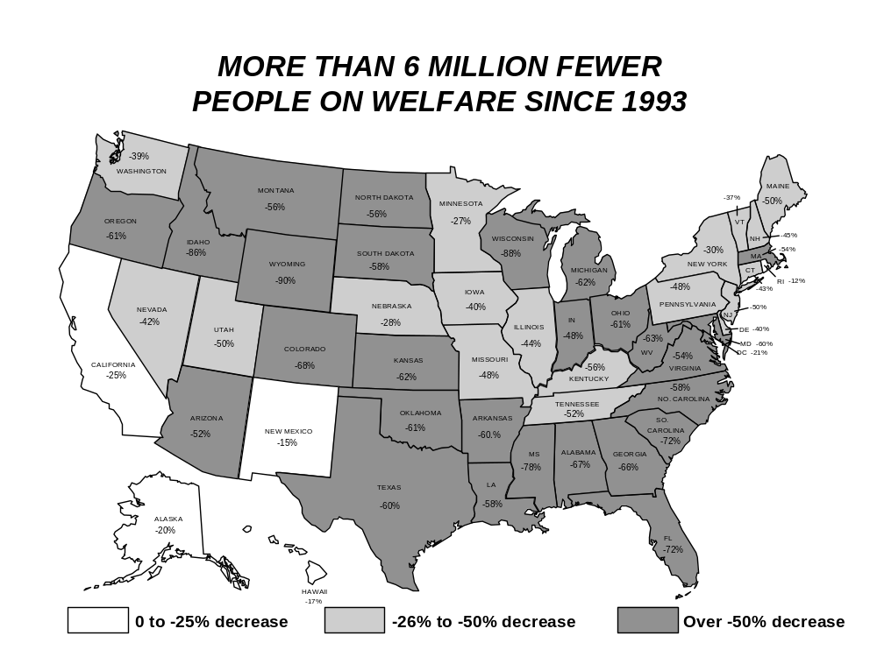

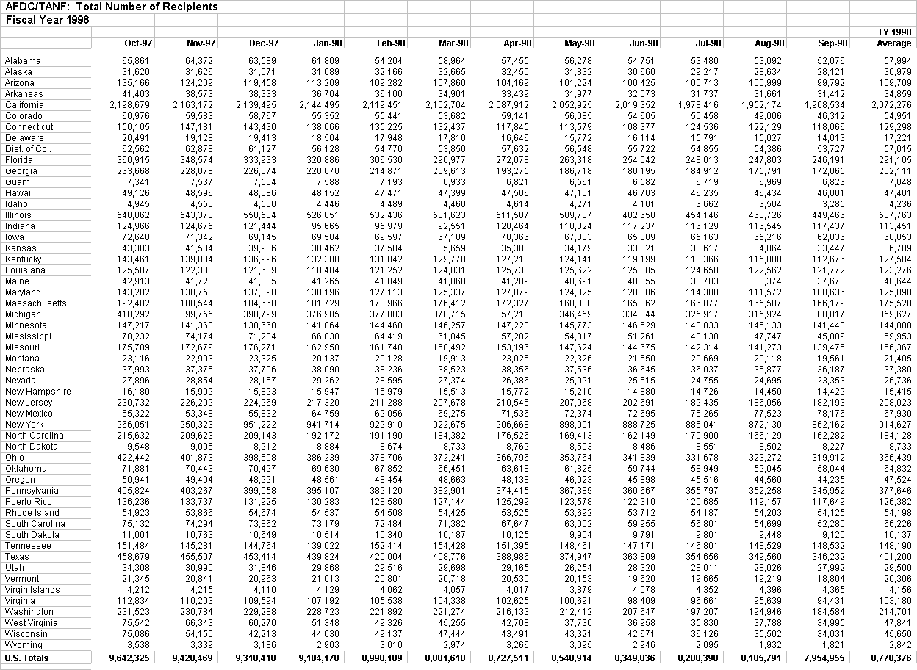
Table 2:1

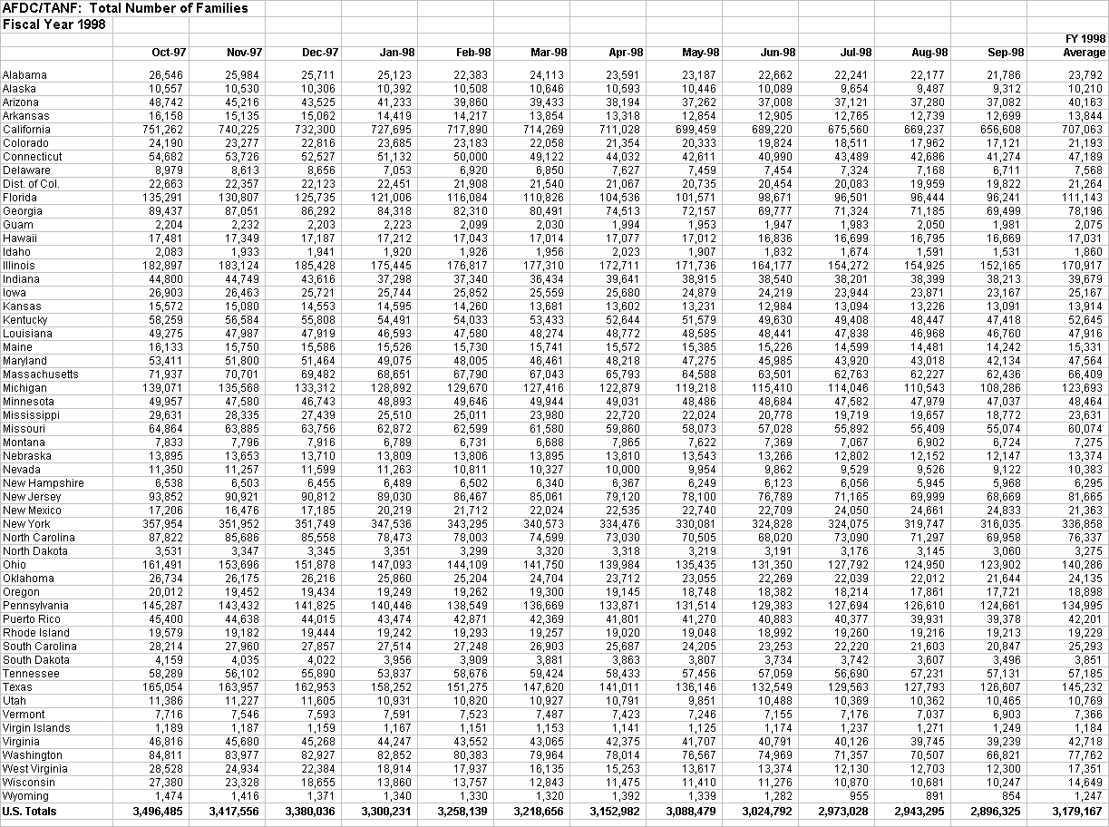Table 2:2

Table 2:3

CHANGE IN AFDC/TANF CASELOADS

Total AFDC/TANF families and recipients
(in thousands)
 |  |  |  |  |  |  |  | Percent
 | Jan 93 | Jan 94 | Jan 95 | Jan 96 | Jan 97 | Jan 98 | Mar 99 | (93-99)
Families | 4,963 | 5,053 | 4,963 | 4,628 | 4,114 | 3,300 | 2,668 | -46%
2,295,000 fewer families

Recipients | 14,115 | 14,276 | 13,931 | 12,877 | 11,423 | 9,104 | 7,335 | -48%
6,780,000 fewer recipients

Total AFDC/TANF recipients by State

 |  |  |  |  |  |  |  | Percent
STATE | Jan 93 | Jan 94 | Jan 95 | Jan 96 | Jan 97 | Jan 98 | Mar 99 | (93-99)
Alabama | 141,746 | 135,096 | 121,837 | 108,269 | 91,723 | 61,809 | 46,934 | -67%
Alaska | 34,951 | 37,505 | 37,264 | 35,432 | 36,189 | 31,689 | 28,000 | -20%
Arizona | 194,119 | 202,350 | 195,082 | 171,617 | 151,526 | 113,209 | 96,467 | -52%
Arkansas | 73,982 | 70,563 | 65,325 | 59,223 | 54,879 | 36,704 | 29,340 | -60%
California | 2,415,121 | 2,621,383 | 2,692,202 | 2,648,772 | 2,476,564 | 2,144,495 | 1,818,197 | -25%
Colorado | 123,308 | 118,081 | 110,742 | 99,739 | 87,434 | 55,352 | 39,346 | -68%
Connecticut | 160,102 | 164,265 | 170,719 | 161,736 | 155,701 | 138,666 | 90,799 | -43%
Delaware | 27,652 | 29,286 | 26,314 | 23,153 | 23,141 | 18,504 | 16,581 | -40%
Dist. of Col. | 65,860 | 72,330 | 72,330 | 70,082 | 67,871 | 56,128 | 52,140 | -21%
Florida | 701,842 | 689,135 | 657,313 | 575,553 | 478,329 | 320,886 | 198,101 | -72%
Georgia | 402,228 | 396,736 | 388,913 | 367,656 | 306,625 | 220,070 | 137,976 | -66%
Guam | 5,087 | 6,651 | 7,630 | 7,634 | 7,370 | 7,588 | 8,620 | +69%
Hawaii | 54,511 | 60,975 | 65,207 | 66,690 | 65,312 | 48,152 | 45,515 | -17%
Idaho | 21,116 | 23,342 | 24,050 | 23,547 | 19,812 | 4,446 | 2,897 | -86%
Illinois | 685,508 | 709,969 | 710,032 | 663,212 | 601,854 | 526,851 | 382,937 | -44%
Indiana | 209,882 | 218,061 | 197,225 | 147,083 | 121,974 | 95,665 | 109,675 | -48%
Iowa | 100,943 | 110,639 | 103,108 | 91,727 | 78,275 | 69,504 | 60,151 | -40%
Table 2:3 Continued

Total AFDC/TANF Recipients by State

 |  |  |  |  |  |  |  | Percent
State | Jan. 93 | Jan 94 | Jan 95 | Jan 96 | Jan 97 | Jan 98 | Mar 99 | (93-99)
Kansas | 87,525 | 87,433 | 81,504 | 70,758 | 57,528 | 38,462 | 32,873 | -62%
Kentucky | 227,879 | 208,710 | 193,722 | 176,601 | 162,730 | 132,388 | 99,560 | -56%
Louisiana | 263,338 | 252,860 | 258,180 | 239,247 | 206,582 | 118,404 | 111,074 | -58%
Maine | 67,836 | 65,006 | 60,973 | 56,319 | 51,178 | 41,265 | 34,108 | -50%
Maryland | 221,338 | 219,863 | 227,887 | 207,800 | 169,723 | 130,196 | 89,003 | -60%
Massachusetts | 332,044 | 311,732 | 286,175 | 242,572 | 214,014 | 181,729 | 151,592 | -54%
Michigan | 686,356 | 672,760 | 612,224 | 535,704 | 462,291 | 376,985 | 263,583 | -62%
Minnesota | 191,526 | 189,615 | 180,490 | 171,916 | 160,167 | 141,064 | 140,128 | -27%
Mississippi | 174,093 | 161,724 | 146,319 | 133,029 | 109,097 | 66,030 | 38,426 | -78%
Missouri | 259,039 | 262,073 | 259,595 | 238,052 | 208,132 | 162,950 | 135,383 | -48%
Montana | 34,848 | 35,415 | 34,313 | 32,557 | 28,138 | 20,137 | 15,508 | -55%
Nebraska | 48,055 | 46,034 | 42,038 | 38,653 | 36,535 | 38,090 | 34,662 | -28%
Nevada | 34,943 | 37,908 | 41,846 | 40,491 | 28,973 | 29,262 | 20,283 | -42%
New Hampshire | 28,972 | 30,386 | 28,671 | 24,519 | 20,627 | 15,947 | 16,090 | -44%
New Jersey | 349,902 | 334,780 | 321,151 | 293,833 | 256,064 | 217,320 | 175,223 | -50%
New Mexico | 94,836 | 101,676 | 105,114 | 102,648 | 89,814 | 64,759 | 80,686 | -15%
New York | 1,179,522 | 1,241,639 | 1,266,350 | 1,200,847 | 1,074,189 | 941,714 | 828,302 | -30%
North Carolina | 331,633 | 334,451 | 317,836 | 282,086 | 253,286 | 192,172 | 138,570 | -58%
North Dakota | 18,774 | 16,785 | 14,920 | 13,652 | 11,964 | 8,884 | 8,355 | -55%
Ohio | 720,476 | 691,099 | 629,719 | 552,304 | 518,595 | 386,239 | 282,444 | -61%
Oklahoma | 146,454 | 133,152 | 127,336 | 110,498 | 87,312 | 69,630 | 56,640 | -61%
Oregon | 117,656 | 116,390 | 107,610 | 92,182 | 66,919 | 48,561 | 45,450 | -61%
Pennsylvania | 604,701 | 615,581 | 611,215 | 553,148 | 484,321 | 395,107 | 312,364 | -48%
Puerto Rico | 191,261 | 184,626 | 171,932 | 156,805 | 145,749 | 130,283 | 107,447 | -44%
Rhode Island | 61,116 | 62,737 | 62,407 | 60,654 | 54,809 | 54,537 | 53,859 | -12%
South Carolina | 151,026 | 143,883 | 133,567 | 121,703 | 98,077 | 73,179 | 42,504 | -72%
South Dakota | 20,254 | 19,413 | 17,652 | 16,821 | 14,091 | 10,514 | 8,445 | -58%
Tennessee | 320,709 | 302,608 | 281,982 | 265,320 | 195,891 | 139,022 | 152,695 | -52%
Texas | 785,271 | 796,348 | 765,460 | 714,523 | 626,617 | 439,824 | 313,823 | -60%
Utah | 53,172 | 50,657 | 47,472 | 41,145 | 35,493 | 29,868 | 26,428 | -50%
Vermont | 28,961 | 28,095 | 27,716 | 25,865 | 23,570 | 21,013 | 18,230 | -37%
Virgin Islands | 3,763 | 3,767 | 4,345 | 5,075 | 4,712 | 4,129 | 3,533 | -6%
Table 2:3 Continued

Total AFDC/TANF Recipients by State

 |  |  |  |  |  |  |  | Percent
State | Jan. 93 | Jan 94 | Jan 95 | Jan 96 | Jan 97 | Jan 98 | Mar 99 | (93-99)
Virginia | 194,212 | 194,959 | 189,493 | 166,012 | 136,053 | 107,192 | 88,910 | -54%
Washington | 286,258 | 292,608 | 290,940 | 276,018 | 263,792 | 228,723 | 174,099 | -39%
West Virginia | 119,916 | 115,376 | 107,668 | 98,439 | 98,690 | 51,348 | 44,367 | -63%
Wisconsin | 241,098 | 230,621 | 214,404 | 184,209 | 132,383 | 44,630 | 28,863 | -88%
Wyoming | 18,271 | 16,740 | 15,434 | 13,531 | 10,322 | 2,903 | 1,770 | -90%
U.S. TOTAL | 14,114,992 | 14,275,877 | 13,930,953 | 12,876,661 | 11,423,007 | 9,104,178 | 7,334,976 | -48%

Table 2:4

CHANGE IN AFDC/TANF CASELOADS

Total AFDC/TANF families and recipients
(in thousands)
 |  |  |  |  |  |  |  | Percent
 | Jan 93 | Jan 94 | Jan 95 | Jan 96 | Jan 97 | Jan 98 | Mar 99 | (93-99)
Families | 4,963 | 5,053 | 4,963 | 4,628 | 4,114 | 3,300 | 2,668 | -46%
2,295,000 fewer families

Recipients | 14,115 | 14,276 | 13,931 | 12,877 | 11,423 | 9,104 | 7,335 | -48%
6,780,000 fewer recipients

Total AFDC/TANF Families by State

 |  |  |  |  |  |  |  | Percent
 | Jan 93 | Jan 94 | Jan 95 | Jan 96 | Jan 97 | Jan 98 | Mar 99 | (93-99)
Alabama | 51,910 | 51,181 | 47,376 | 43,396 | 37,972 | 25,123 | 20,009 | -61%
Alaska | 11,626 | 12,578 | 12,518 | 11,979 | 12,224 | 10,392 | 9,059 | -22%
Arizona | 68,982 | 72,160 | 71,110 | 64,442 | 56,250 | 41,233 | 34,851 | -49%
Arkansas | 26,897 | 26,398 | 24,930 | 23,140 | 21,549 | 14,419 | 12,095 | -55%
California | 844,494 | 902,900 | 925,585 | 904,940 | 839,860 | 727,695 | 630,301 | -25%
Colorado | 42,445 | 41,616 | 39,115 | 35,661 | 31,288 | 21,912 | 14,609 | -66%
Connecticut | 56,759 | 58,453 | 60,927 | 58,124 | 56,095 | 51,132 | 35,823 | -37%
Delaware | 11,315 | 11,739 | 11,306 | 10,266 | 10,104 | 7,053 | 6,574 | -42%
Dist. of Col. | 24,628 | 26,624 | 26,624 | 25,717 | 24,752 | 22,451 | 19,148 | -22%
Florida | 256,145 | 254,032 | 241,193 | 215,512 | 182,075 | 121,006 | 81,957 | -68%
Georgia | 142,040 | 142,459 | 141,284 | 135,274 | 115,490 | 84,318 | 55,720 | -61%
Guam | 1,406 | 1,840 | 2,124 | 2,097 | 2,349 | 2,213 | 2,532 | +80%
Hawaii | 17,869 | 20,104 | 21,523 | 22,075 | 21,469 | 23,578 | 16,565 | -7%
Idaho | 7,838 | 8,677 | 9,097 | 9,211 | 7,922 | 1,920 | 1,435 | -82%
Illinois | 229,308 | 238,967 | 240,013 | 225,796 | 206,316 | 175,445 | 128,700 | -44%
Indiana | 73,115 | 74,169 | 68,195 | 52,254 | 46,215 | 37,298 | 32,987 | -55%
Iowa | 36,515 | 39,623 | 37,298 | 33,559 | 28,931 | 25,744 | 22,284 | -39%
Table 2:4 Continued
Total AFDC/TANF Families by State

 |  |  |  |  |  |  |  | Percent
 | Jan 93 | Jan 94 | Jan 95 | Jan 96 | Jan 97 | Jan 98 | Mar 99 | (93-99)
Kansas | 29,818 | 30,247 | 28,770 | 25,811 | 21,732 | 14,595 | 12,932 | -57%
Kentucky | 83,320 | 79,437 | 76,471 | 72,131 | 67,679 | 54,491 | 42,682 | -49%
Louisiana | 89,931 | 88,168 | 81,587 | 72,104 | 60,226 | 46,593 | 39,868 | -56%
Maine | 23,903 | 23,074 | 22,010 | 20,472 | 19,037 | 15,526 | 12,922 | -46%
Maryland | 80,256 | 79,772 | 81,115 | 75,573 | 61,730 | 49,075 | 34,901 | -57%
Massachusetts | 113,571 | 112,955 | 104,956 | 90,107 | 80,675 | 68,651 | 54,356 | -52%
Michigan | 228,377 | 225,671 | 207,089 | 180,790 | 156,077 | 128,892 | 97,089 | -57%
Minnesota | 63,995 | 63,552 | 61,373 | 58,510 | 54,608 | 48,893 | 46,798 | -27%
Mississippi | 60,520 | 57,689 | 53,104 | 49,185 | 40,919 | 25,510 | 16,478 | -73%
Missouri | 88,744 | 91,598 | 91,378 | 84,534 | 75,459 | 62,872 | 51,843 | -42%
Montana | 11,793 | 12,080 | 11,732 | 11,276 | 9,644 | 6,789 | 5,320 | -55%
Nebraska | 16,637 | 16,145 | 14,968 | 14,136 | 13,492 | 13,809 | 11,653 | -30%
Nevada | 12,892 | 14,077 | 16,039 | 15,824 | 11,742 | 11,263 | 8,030 | -38%
New Hampshire | 10,805 | 11,427 | 11,018 | 9,648 | 8,293 | 6,489 | 6,563 | -39%
New Jersey | 126,179 | 121,361 | 120,099 | 113,399 | 102,378 | 89,030 | 65,341 | -48%
New Mexico | 31,103 | 33,376 | 34,789 | 34,368 | 29,984 | 20,219 | 25,995 | -16%
New York | 428,191 | 449,978 | 461,006 | 437,694 | 393,424 | 347,536 | 297,897 | -30%
North Carolina | 128,946 | 131,288 | 127,069 | 114,449 | 103,300 | 78,473 | 60,720 | -53%
North Dakota | 6,577 | 6,002 | 5,374 | 4,976 | 4,416 | 3,351 | 3,132 | -52%
Ohio | 257,665 | 251,037 | 232,574 | 209,830 | 192,747 | 147,093 | 110,817 | -57%
Oklahoma | 50,955 | 47,475 | 45,936 | 40,692 | 32,942 | 25,860 | 20,200 | -60%
Oregon | 42,409 | 42,695 | 40,323 | 35,421 | 25,874 | 19,249 | 17,271 | -59%
Pennsylvania | 204,216 | 208,260 | 208,899 | 192,952 | 170,831 | 140,446 | 113,193 | -45%
Puerto Rico | 60,950 | 59,425 | 55,902 | 51,370 | 48,359 | 43,474 | 36,539 | -40%
Rhode Island | 21,900 | 22,592 | 22,559 | 21,775 | 20,112 | 19,242 | 18,918 | -14%
South Carolina | 54,599 | 53,178 | 50,389 | 46,772 | 37,342 | 27,514 | 17,942 | -67%
South Dakota | 7,262 | 7,027 | 6,482 | 6,189 | 5,324 | 3,956 | 3,314 | -54%
Tennessee | 112,159 | 111,946 | 105,948 | 100,884 | 74,820 | 53,837 | 58,690 | -48%
Texas  Utah  Vermont | 279,002 | 285,680 | 279,911 | 265,233 | 228,882 | 158,252 | 115,600 | -59%
Texas  Utah  Vermont | 18,606 | 18,063 | 17,195 | 15,072 | 12,864 | 10,931 | 9.996 | -46%
Texas  Utah  Vermont | 10,081 | 9,917 | 9,789 | 9,210 | 8,451 | 7,591 | 6,656 | -34%
Virgin Islands | 1,073 | 1,090 | 1,264 | 1,437 | 1,335 | 1,167 | 932 | -13%
Virginia | 73,446 | 74,717 | 73,920 | 66,244 | 56,018 | 44,247 | 36,713 | -50%
Table 2:4 Continued

Total AFDC/TANF Families by State

 |  |  |  |  |  |  |  | Percent
 | Jan 93 | Jan 94 | Jan 95 | Jan 96 | Jan 97 | Jan 98 | Mar 99 | (93-99)
Washington | 100,568 | 103,068 | 103,179 | 99,395 | 95,982 | 82,852 | 63,202 | -37%
West Virginia | 41,525 | 40,869 | 39,231 | 36,674 | 36,805 | 18,914 | 9,653 | -77%
Wisconsin | 81,291 | 78,507 | 73,962 | 65,386 | 45,586 | 13,860 | 8,723 | -89%
Wyoming | 6,493 | 5,891 | 5,443 | 4,975 | 3,825 | 1,340 | 836 | -87%
U.S. TOTAL | 4,963,050 | 5,052,854 | 4,963,071 | 4,627,941 | 4,113,775 | 3,304,814 | 2,783,456 | -46%

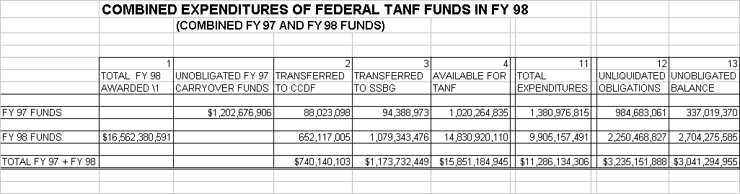
Table 2:5

Combined Expenditures of Federal TANF Funds in FY 1998

(1. Please note that this data is derived from cumulative TANF Financial reports received through 4th Quarter, 1998).
Table 2:6
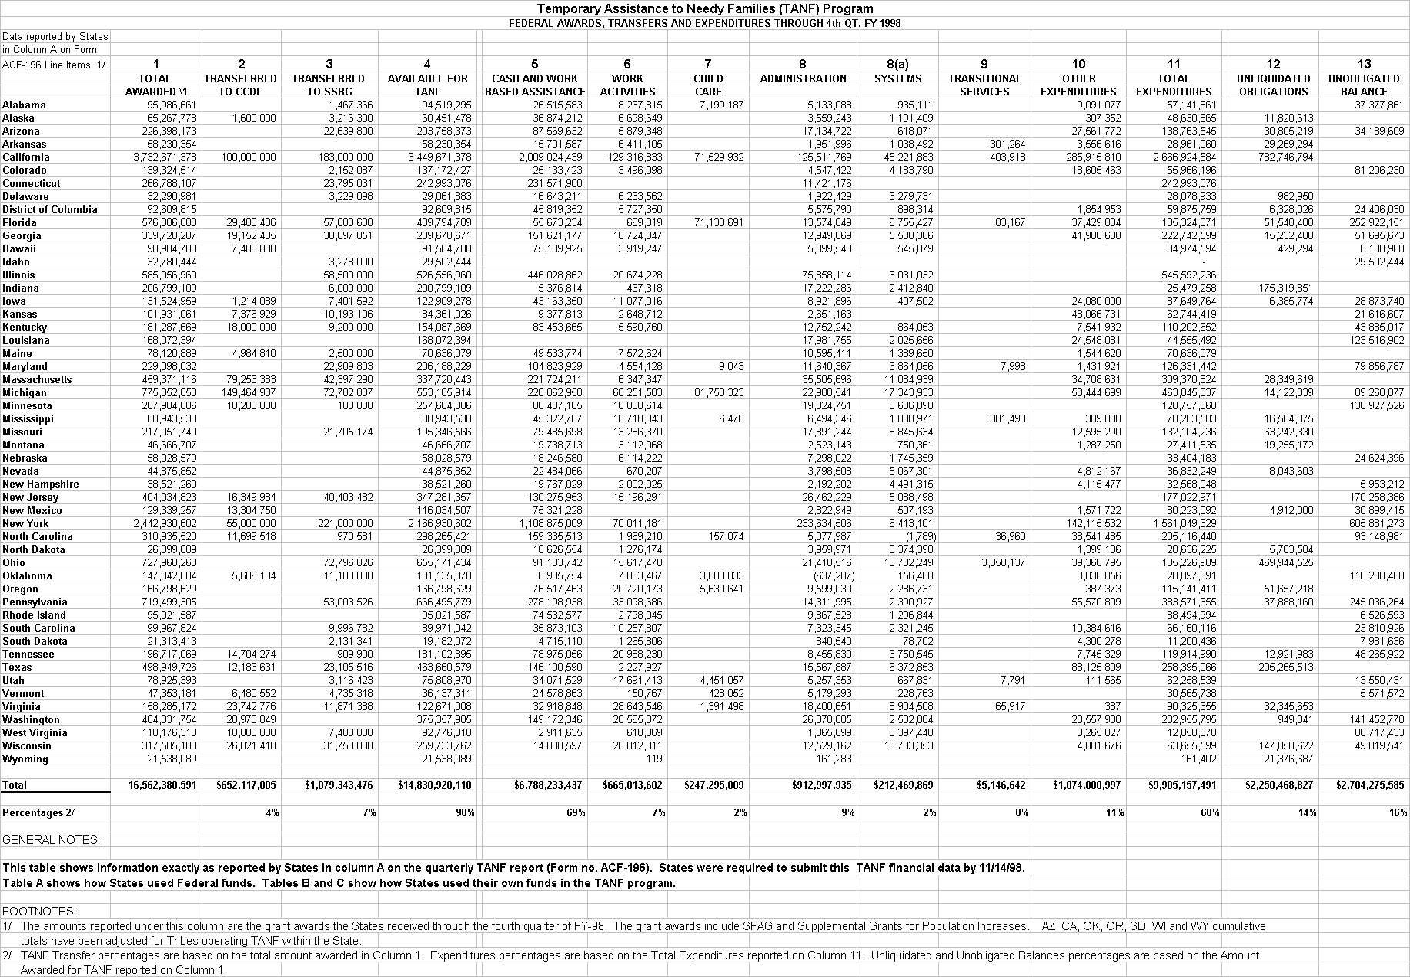
TANF Federal Awards, Transfers and Expenditures Through 4th Quarter, FY 1998

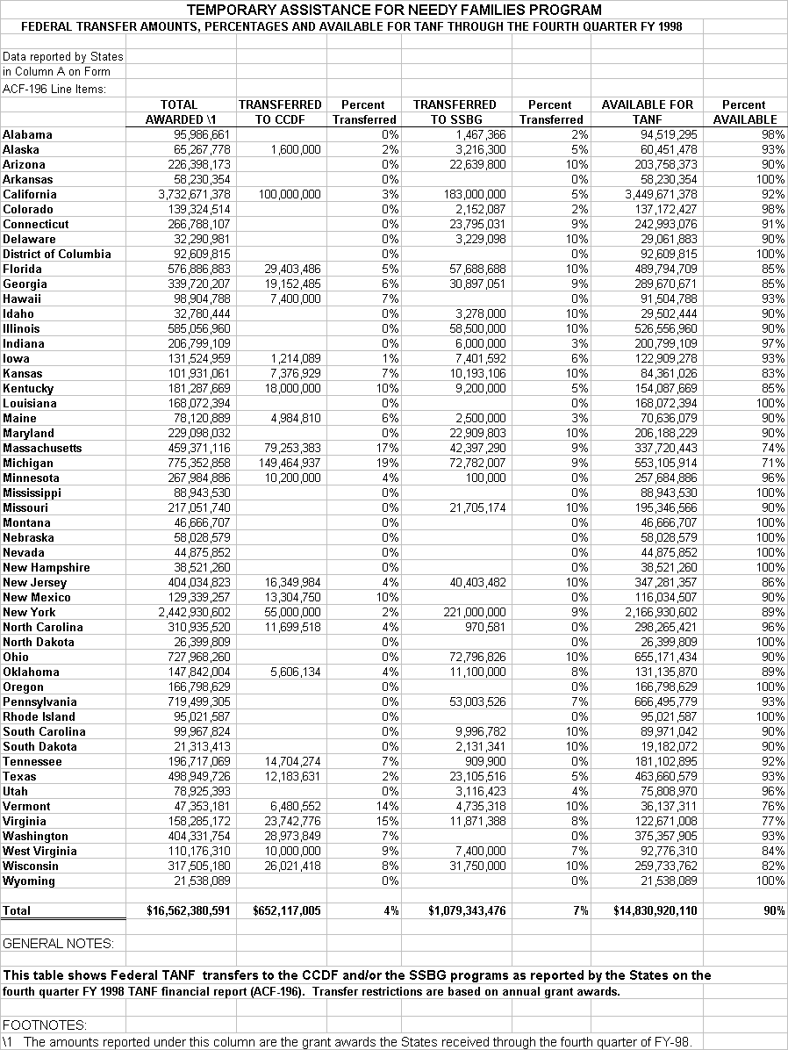
Table 2:7
Federal Transfer Amounts, and Amounts Available for TANF through the 4th Quarter, FY 1998 (with Percentages Shown)

Table 2:8
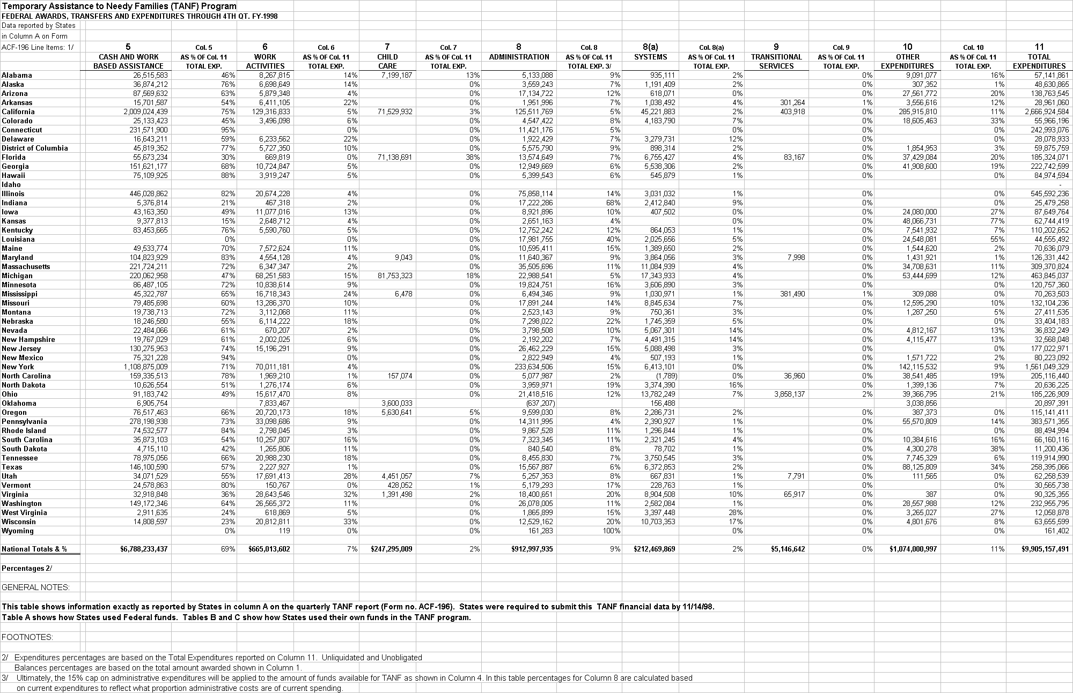Federal Awards, Transfers and Expenditures Through 4th Quarter, FY 1998

Table 2:9
Total State Expenditure of Federal Funds and Remaining Unexpended Funds for TANF through the 4th Quarter, FY 1998 (with Percentages Shown)

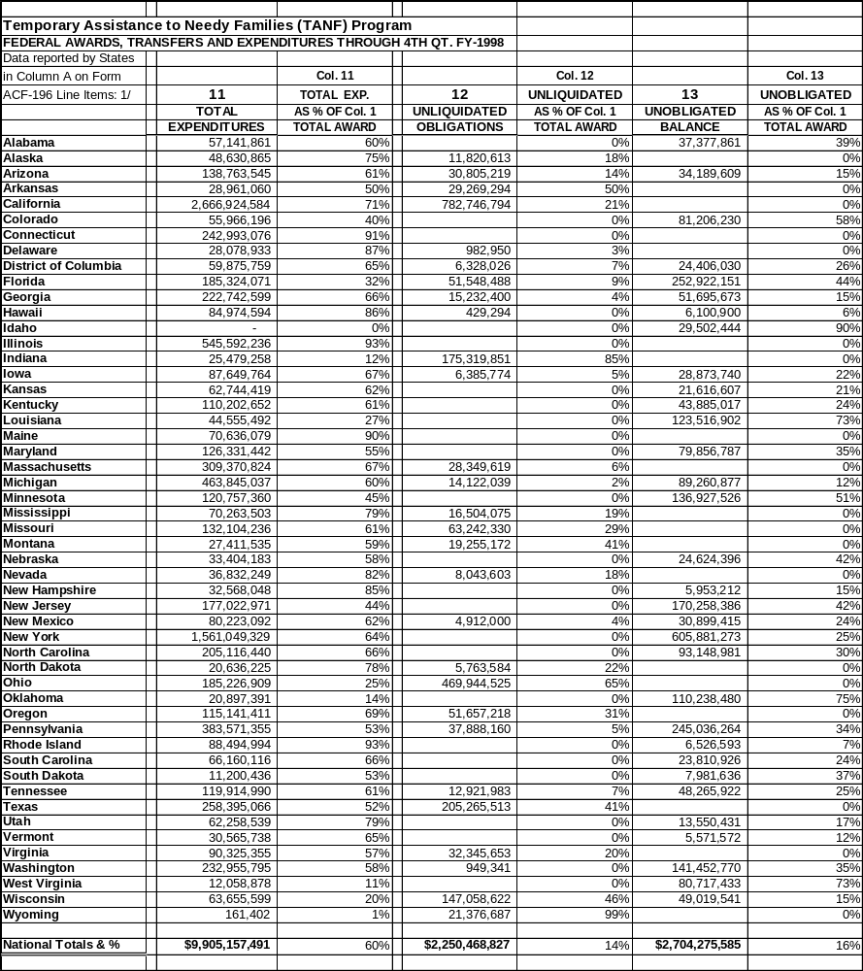

Please note for States that do not add up to 100%, some States transfer out awards to SSBG or CCDBG, and these funds are not reported under column 11 as an expenditure.

Table 2:10
State TANF Maintenance of Effort (MOE), Expenditures of State Funds Through 4th Quarter,
FY 1998

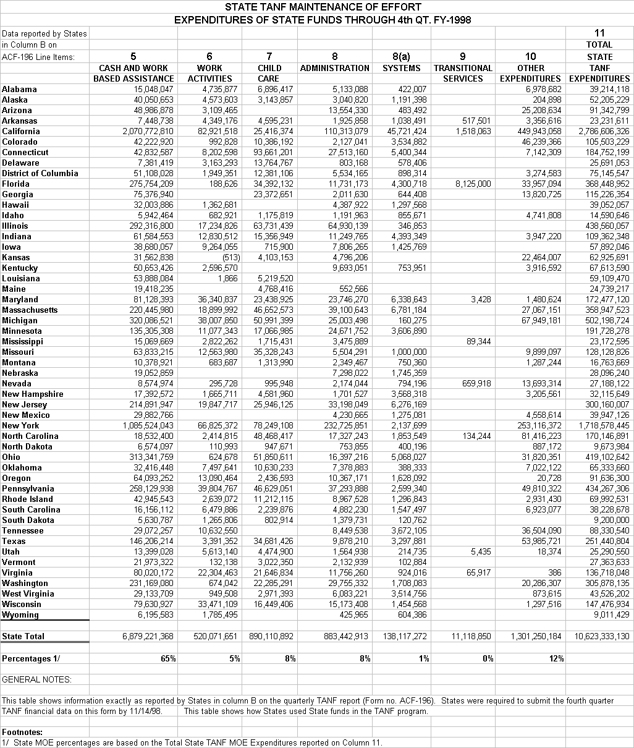
Table 2:11
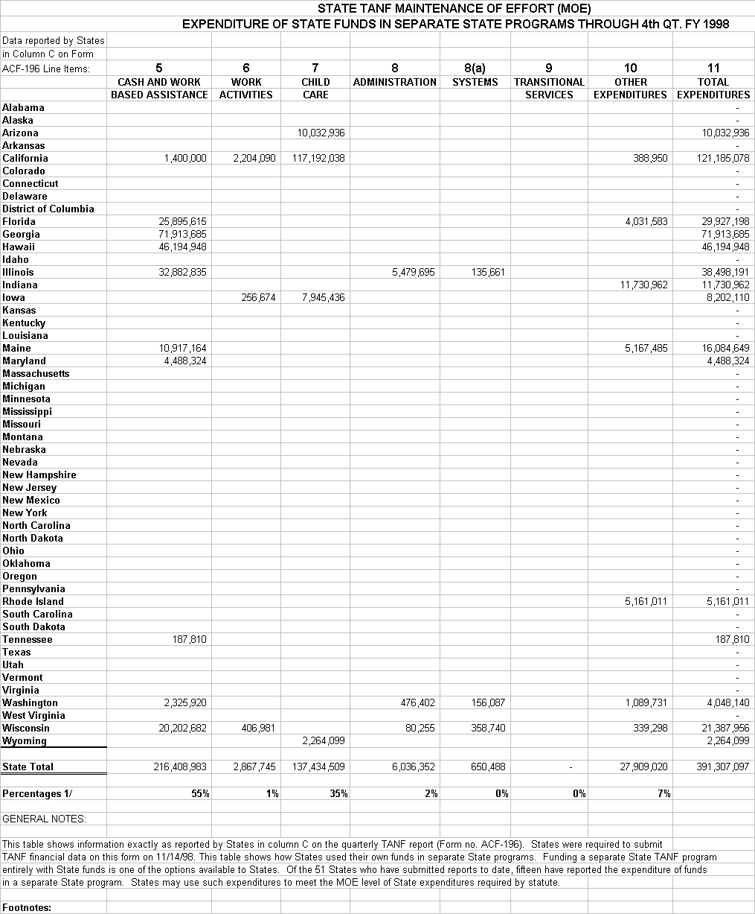
State TANF Maintenance of Effort (MOE) Expenditure of State Funds in Separate State Programs Through 4th Quarter, 1998
1/ State MOE percentages are based on the Total State TANF MOE Expenditures in separate State programs reported on Column 11.

Table 2:12
State MOE Analysis Through the Fourth Quarter FY 1998

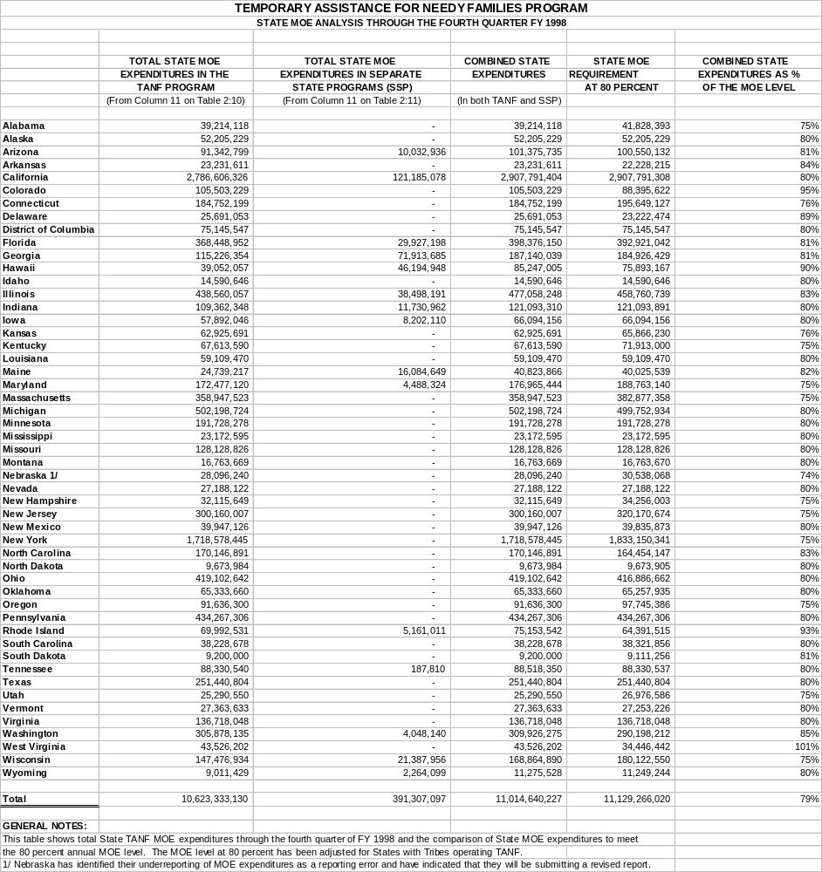
III. WORK PARTICIPATION RATES

PRWORA provided for a transition period for States to implement their new TANF programs. Although all States were required to implement TANF by July 1, 1997, the participation rate and data reporting requirements under TANF are based on the effective date of a State's implementation of TANF. States that implemented TANF by April 1, 1997 became subject to the participation rate standards and were required to begin reporting information on the TANF program with the July-September 1997 quarter. All other States became subject to participation rates and were required to begin reporting TANF information six months after implementation of TANF. Under section 116 of PRWORA, all States were required to continue to meet the reporting requirements under parts A and F of title IV of the Social Security Act until July 1, 1997 or until the TANF reporting requirements were effective as provided for under the Balanced Budget Reconciliation Act of 1997.

TANF requires that States report individual level data, on either a population or sample basis. Based upon these data, HHS calculates participation rates.

The Act establishes separate minimum work participation rate standards each year for all families and two-parent families receiving TANF. The minimum participation rate for FY 1997 is 25 percent for all families and 75 percent for two-parent families. The standard for FY 1998 is 30 percent for all families and 75 percent for two-parent families. PRWORA provides for the reduction in the minimum work participation rate standards based on a decline in caseload. If the State’s average monthly assistance caseload decreased in the previous year in comparison to the State’s average caseload in FY 1995, the participation rate standard is reduced by the number of percentage points the caseload declined. Caseload reductions resulting from changes in State or federal eligibility rules are excluded from this calculation.

1997 Work Participation Rates

Thirty-nine States were subject to the TANF work participation requirements for the July-September 1997 period. All of these States met the all family participation rate standard. However, nineteen States failed to meet the two-parent standard and were subject to a fiscal penalty. The FY 1997 (July-September 1997) national average all family work participation rate was 28.1 percent. The national average two-parent work participation rate for FY 1997 was 34.3 percent. (The FY 1997 penalty process and status is discussed below.)

1998 Work Participation Rates

All States were subject to the work participation requirements for FY 1998. All States met the all family participation rate standard as did the District of Columbia. The three territories – Guam, Puerto Rico and the Virgin Islands - - did not. Of the forty-three States and the District of Columbia that have two-parent family programs subject to a work participation rate, twenty-nine met the FY 1998 two-parent participation standard.

The all family national average rate increased to 35.4 percent for FY 1998. The two-parent national average rate increased to 42.3 for FY 1998.

1998 Work Activities

During FY 1998 an average of 700,000 adults participated in specified work activities for sufficient hours to be counted in the participation rate, even without consideration of activities that qualify through waivers. (States with welfare reform waivers prior to the enactment of PRWORA were allowed to retain provisions of their waivers even when they were inconsistent with PRWORA. This exception allows some States to count different activities or hours in the calculation of their work participation rates.) Over 70 percent of these adults were engaged in unsubsidized employment. Another 16 percent were engaged in either work experience or community service activities, and 12 percent were engaged in job search. About 12 percent were involved in education or training that count toward the work rates. Since people may be in multiple activities, these figures total more than 100 percent.

Process for Calculating the Work Participation Rates and Compliance with Requirement

ACF uses the following process with the States for calculating compliance with work participation rates:

- States submit to ACF their work participation rate and recipient characteristics data, caseload reduction and waiver information.

- ACF then determines a caseload reduction credit for each State. (To ensure fair treatment of States that help families become self-sufficient and exit the welfare rolls, Congress created the caseload reduction credit. The credit reduces the minimum participation rate a State must meet by the reduction in the State's TANF caseload in the prior year compared to its AFDC caseload in FY 1995. It excludes reductions due to federal law or to changes in eligibility criteria). ACF also determines and applies the waiver provisions, and calculates the final rate as well as appropriate penalties.

- ACF sends notification letters to States, which have 60 days to submit any requests for reasonable cause exceptions and corrective compliance plans.

To ensure State accountability, a limited number of circumstances under which States may demonstrate reasonable cause are defined. Although the final TANF regulations do not go into effect until October 1, 1999, ACF is following the same basic principles concerning reasonable cause exceptions that the regulations embody. The general factors that a State may use to claim reasonable cause exceptions are: (a) natural disasters and other calamities; (b) federal guidance that provided incorrect information; or (c) isolated problems of minimal impact. There are also two specific reasonable cause factors for failing to meet the work participation rate: (a) federally recognized good cause domestic violence waivers; and (b) alternative services provided to certain refugees. Finally, the Secretary has discretion to grant reasonable cause in other circumstances.

The statute provides for reductions in the work participation penalty based on the degree of the State’s noncompliance. ACF is carrying this requirement out as follows: (a) if a State fails only the two-parent work participation rate, its penalty is prorated based on the proportion of two-parent cases in the State; and (b) a State receives a penalty reduction based on the percentage it achieves of the target rate (as reduced by its caseload reduction credit).

If a State does not demonstrate that it had reasonable cause, it may enter into a corrective compliance plan that will correct the violation and insure continued compliance with the participation requirements. If a State achieves compliance with work participation rates in the time frame that the plan specifies, then we do not impose the penalty.
Status of FY 97 Work Participation Rates Compliance and Penalties

- We issued penalty notices to 19 States for failure to meet the two-parent work rate. (AL, AZ, CA, DC, IA, KS, ME, MI, MS, NE, NV, NJ, NC, OH, OK, TX, VA, WA, WV)

- We did not impose the penalty for 2 States (AL and MS) because the penalty amount was less than $500, the threshold below which it costs more to issue the penalty than its value.

- One State (AZ) disputed our participation rate calculation for two-parents, and upon retransmission the State’s data showed it met the two-parent rate; therefore it is not subject to the penalty.

- Two States (IA, OK) accepted the penalty.

- The remaining 14 States have entered into corrective compliance plans.

Tables:

Table 3:1 TANF Work Participation Rates, FY 1997
Table 3:2 TANF Work Activities, Excluding Waivers, For Families Meeting the All Family Work Requirements, FY 1997
Table 3:3 TANF Work Activities, Excluding Waivers, For Two-Parent Families Meeting the Participation Requirements, FY 1997
Table 3:4 TANF Work Participation Rates, FY 1998
Table 3:5 TANF Work Activities, Excluding Waivers, For Families Meeting the All Family Work Requirements, FY 1998
Table 3:6 TANF Work Activities, Excluding Waivers, For Two-Parent Families Meeting the Participation Requirements, FY 1998

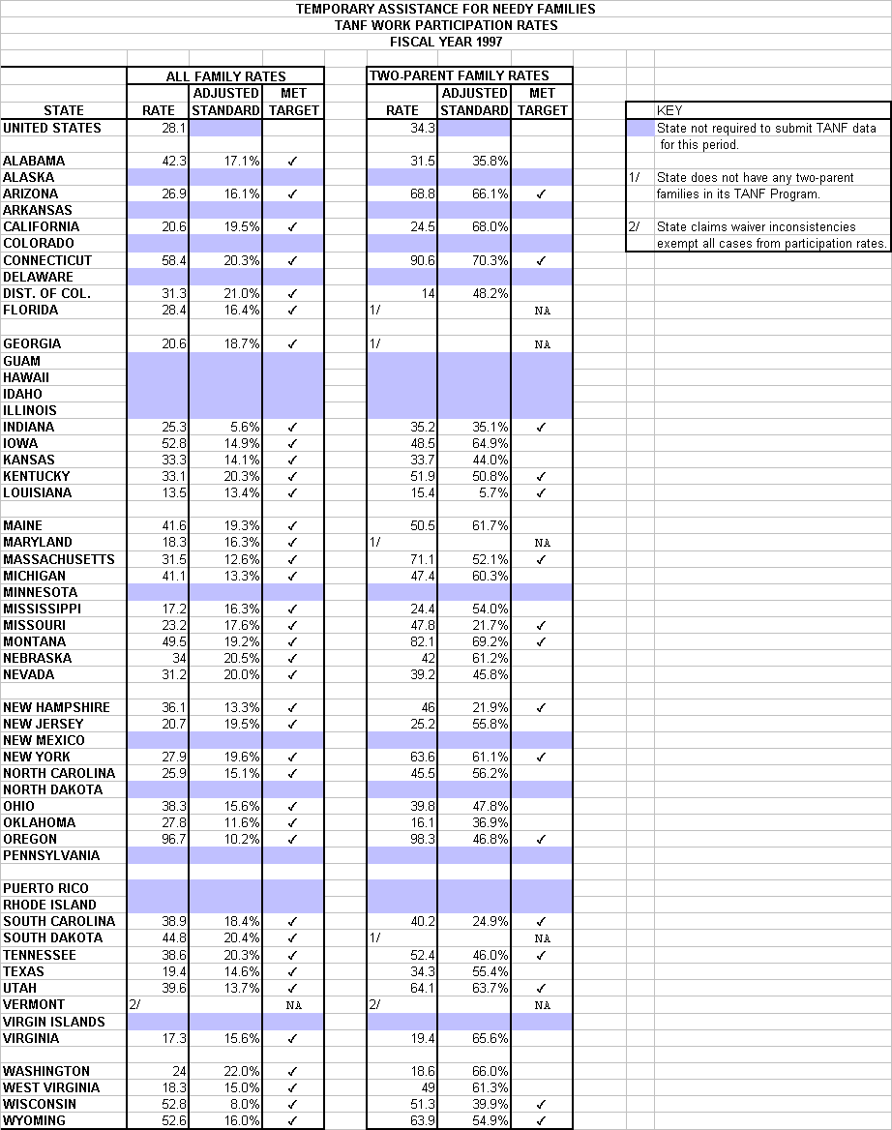
Table 3.1

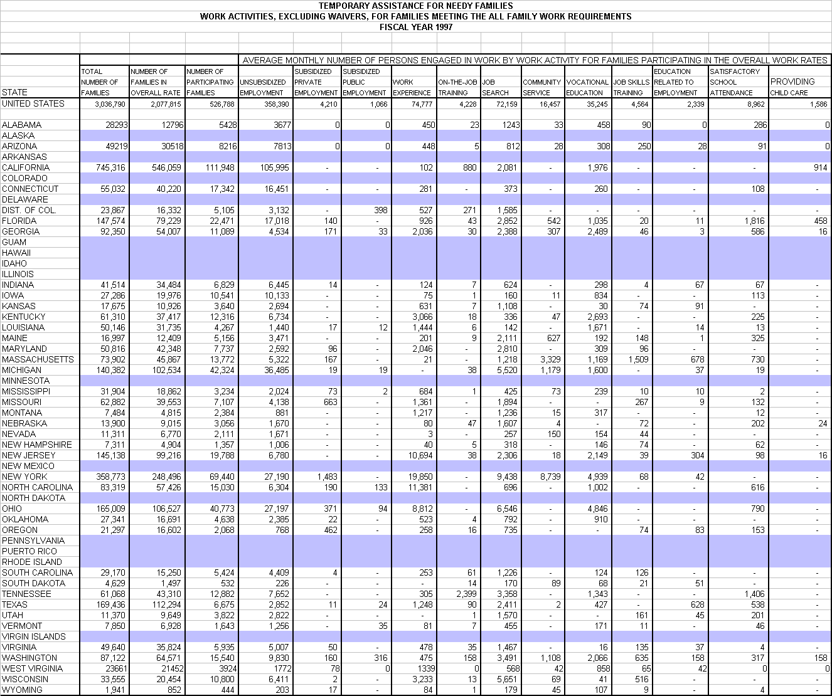
Table 3:2

Table 3:3
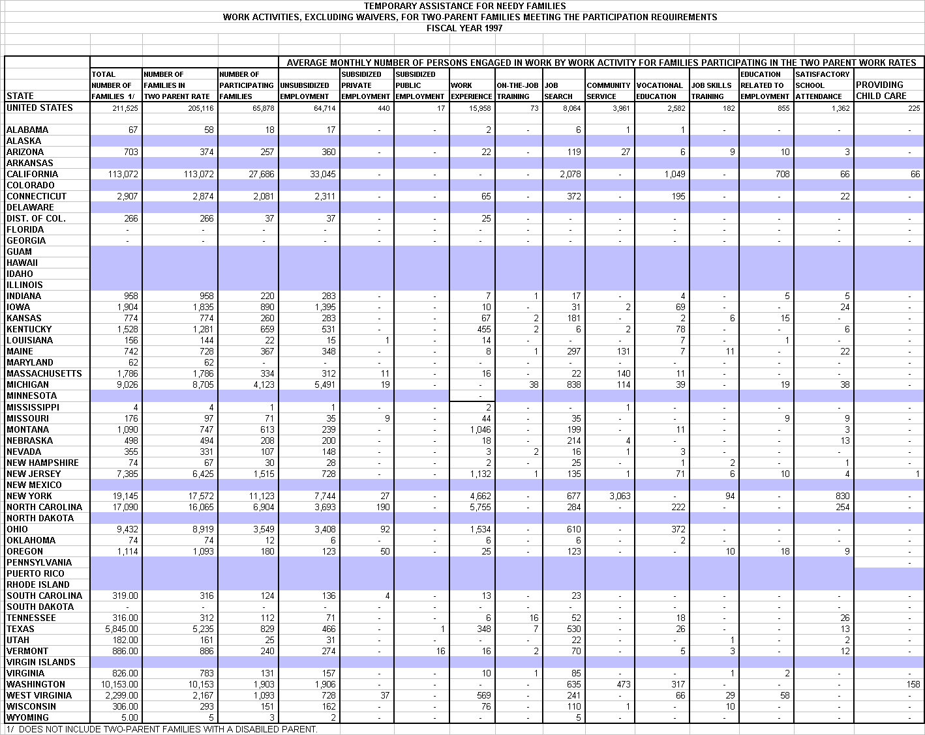

Table 3:4

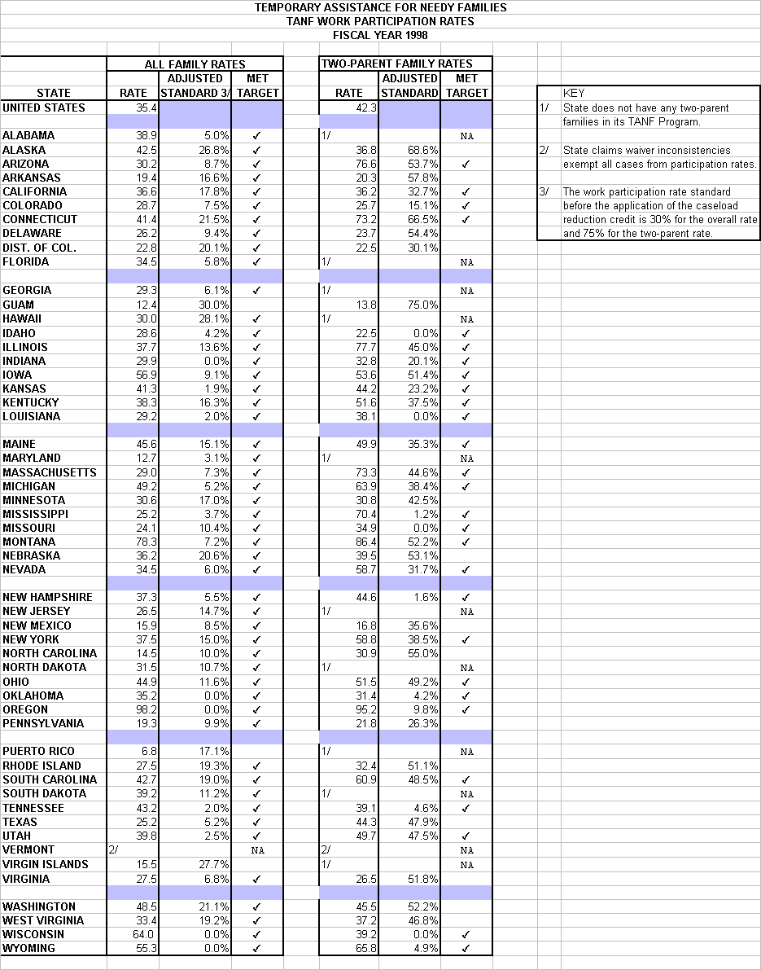

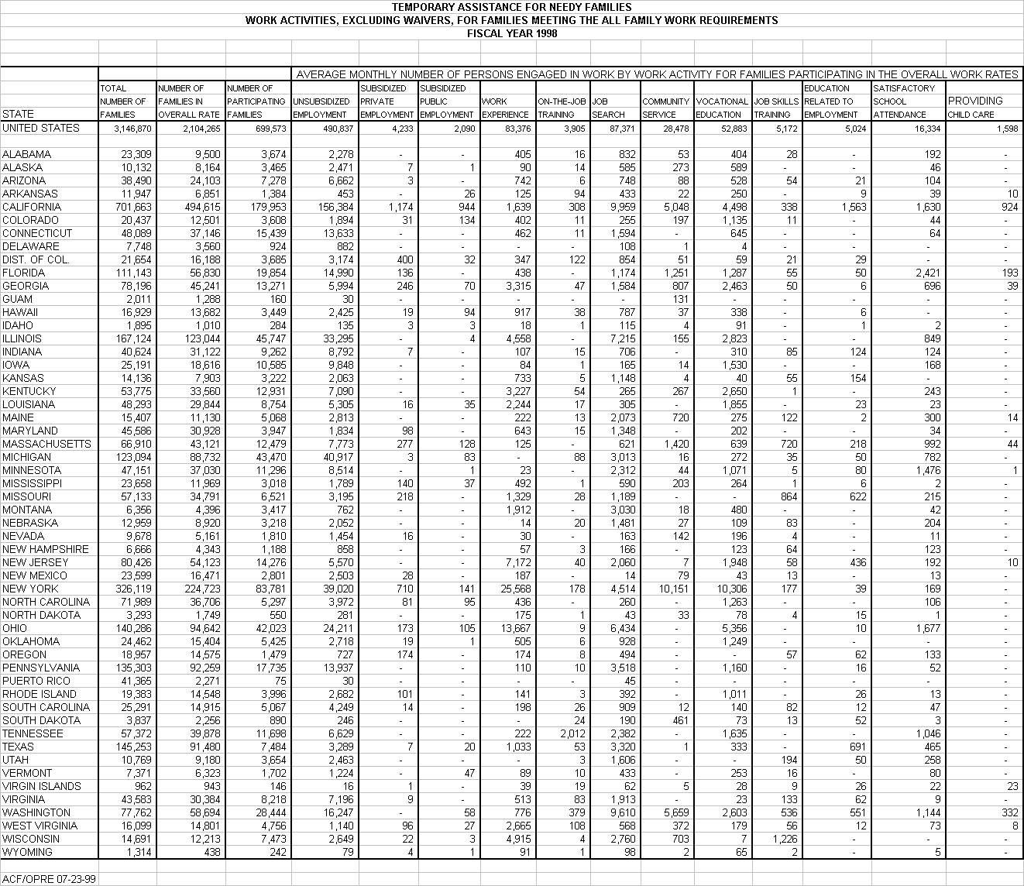
Table 3:5
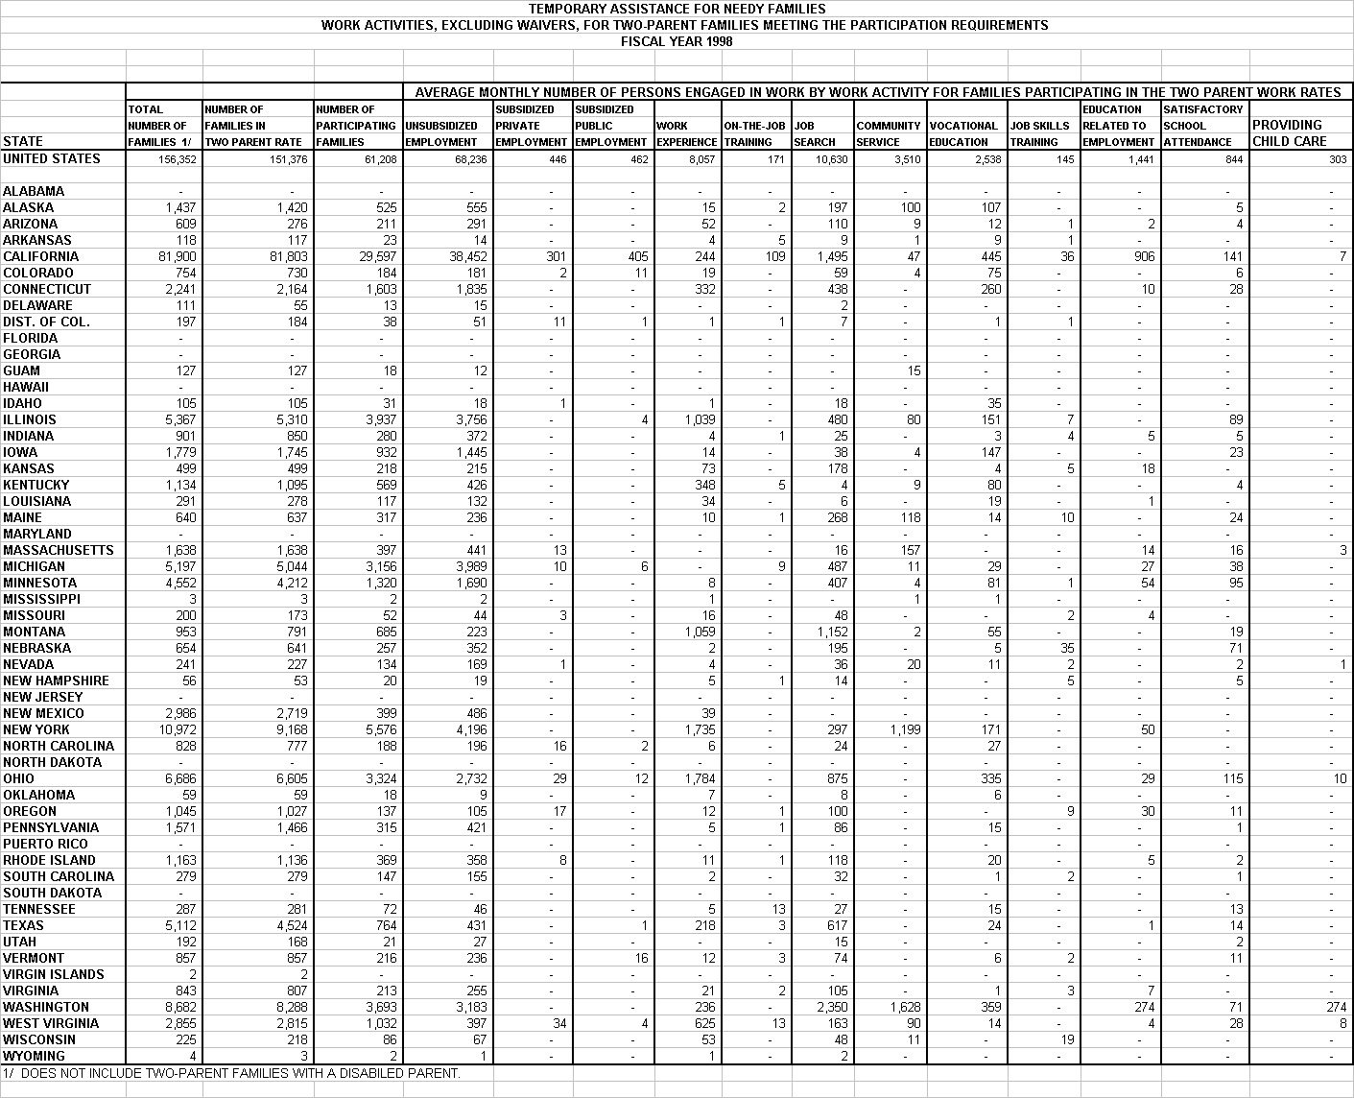
Table 3:6

IV. EMPLOYMENT AND EARNINGS OF NEEDY FAMILIES

Employment
A key measure of the success of welfare reform is its effect on employment. Analysis of all available sources of information shows that the employment rate of current and former TANF recipients has increased significantly.

The percentage of employed recipients reached an all-time high at 23 percent, compared to less than 7 percent in 1992 and 13 percent in 1997. Thus, almost one in four recipients was employed in a typical month, the highest level ever recorded. Similarly, the proportion of recipients who were working (including employment, work experience and community service) reached 27 percent, a nearly fourfold increase over the 7 percent recorded in 1992.

Between 1992 and 1998, the employment rate of TANF recipients increased by 70%. In 1992 one in five previous year recipients was working the following spring, whereas in 1998, the figure had increased to one in three. Each March the Current Population Survey, which is used to calculate unemployment rates, collects information about households' income and program participation in the previous calendar year as well as employment and earnings data reflecting individuals' March employment status. As a result we know whether adults who received AFDC or TANF in the preceding calendar year (who may or may not still be receiving welfare) were employed the following March. Between 1992 and 1996, the employment rate increased from 20 percent (its approximate level for the previous four years) to 27 percent. In the last two years it jumped even more dramatically to 34 percent in 1998.

Large employment gains are also evident from rigorous waiver evaluations that measure the effects of reform policies by comparing randomly assigned individuals who were subject to either welfare reform or standard AFDC rules. Unlike the CPS analysis, which does not separate out the effects of State welfare reform policies from those of the economy, other policies which promote employment such as the enhancement of the EITC or the expansion of child care subsidies, the strength of experimental studies is that they isolate the impacts of specific policies enabling researchers to attribute outcomes directly to the policies put in place. Several studies examined policies which are representative of State TANF programs in that they increase participation in mandatory work activities and/or increase the amount of assistance families can receive when they go to work. The persistent employment effects of these programs are in the five to 13 percentage point range. These are probably quite conservative estimates in that the treatment groups are compared to control groups, which received a substantial level of mandatory employment services and also were not isolated from the atmosphere of welfare reform, even though they did not directly experience welfare reform policies.

Preliminary findings from six of the Assistant Secretary for Planning and Evaluation funded studies of families leaving welfare indicate that between one-half and three-fifths of former TANF recipients found work in jobs which were covered by their States’ Unemployment Insurance program. Employment rates were even higher – 75 to 82 percent – when measured as the percentage of those who were ever employed within the first 12 months. These employment rates are consistent with findings in many other leavers’ studies, although methodological differences cause rates to be slightly higher in some studies (e.g., rates are sometimes higher in studies using survey data, or limiting study population to leavers who do not return to welfare). While these employment rates are not radically different from the patterns of AFDC leavers in earlier studies, they indicate a dramatically large increase in the absolute number of families leaving welfare with earnings, given the significant caseload decline in the past few years. A variety of State studies summarized by GAO found that between 63 and 87 percent of adults have worked since leaving the welfare rolls.

Thus, each of these sources of information consistently points to higher levels of employment among current and former welfare recipients.

Earnings
A second important measure of success in welfare reform is whether welfare recipients and former recipients are earning more. Although welfare reform is having a positive effect on the earnings of some categories of recipients, early preliminary data tell a story somewhat more complicated than the employment story. For example, an examination of welfare reform waiver demonstrations suggests that those programs which were strongly oriented toward increasing employment activities and mandatory participation (as measured by an increase in participation and sanction rates) achieved annual earnings gains in the range of $600-$700 for at least one primary target group of applicants or recipients. One employment and training program in Portland, which combined a strong employment focus, an emphasis on moving recipients into higher paying jobs with benefits, and the provision of necessary child care, produced even larger effects with average earnings gains of over $900 per year.

A recent GAO study found annual earnings of $49,512 - $15,144 among those who had left welfare. Finally, TANF administrative data just for welfare recipients who remain on the rolls indicate that the average monthly earnings of those employed increased from about $506 per month in October 1997 to $553 in September 1998, an increase of about 11 percent.

Along with the employment gains described above, the CPS data suggest average earnings for all female-headed families with children have increased substantially between 1993 and 1997 from $14,668 to $17,646 (both in 1997 dollars). However, the early CPS data suggest preliminarily that the gains are not evenly distributed over the period with roughly three-quarters of the gain occurring between 1993 and 1995, and only one-quarter between 1995 and 1997. In addition, while employment gains for the bottom fifth of female-headed families with children were stronger from 1995 to 1997, the average earnings of this group increased from 1993 to 1995 but did not increase from 1995 to 1997. Better understanding of these trends will require both longer term follow up and analysis of other national data sets as they become available.

Making Work Pay
The evidence about impacts on family income, on food security and hunger, on health insurance status, on child outcomes, and on other family experiences are much less clear at this point.

Expansions in the EITC included in the President’s 1993 Economic Plan are making work pay for 15 million working families, including former welfare recipients. A study conducted by the Council of Economic Advisors reported that in 1997 the EITC lifted 4.3 million Americans out of poverty – more than double the number in 1993. The findings also suggest that the increase in labor force participation among single mothers who received welfare is strongly linked to the EITC expansion.

When earnings are combined with the EITC and other benefits, most families who go to work have a higher income than if they had remained on welfare. In the average State, a woman with two children could be better off working 20 hours a week than she would be on welfare. However, not all eligible families are accessing tax credits and benefits, such as Food Stamps, Medicaid, child care, and transportation subsidies.

DHHS believes that it is important that working families have a package of supports available to assist them as they transition from welfare to self-sufficiency. As indicated by the findings in the GAO study “Welfare Reform: Information on Former Recipients’ Status” (GAO/HEHS-99-48), a low-wage job may be the first step for many former welfare recipients. In fact, given the work experience and skill level of many recipients, we believe that it will be the likely first successful step for many parents. That is why it is critical for such families to receive support from other programs, such as Food Stamps, Medicaid, the Earned Income Tax Credit and subsidized child care. Families receiving such assistance, even with a sub-poverty wage, can have sufficient income to move out of poverty. We also believe, and have reflected in all of our activities, that a key investment area for States are employment advancement strategies which can move families who enter the workforce at low wages up to higher wage jobs.

Participation in Medicaid and Food Stamps
Enrollment in both Medicaid and Food Stamps has fallen recently, for a variety of reasons.

The Administration believes strongly that both Medicaid and Food Stamps play an important role in helping families make a successful transition from welfare to work. Nonetheless, Medicaid enrollment dropped by about 1 million from 1996 to 1997. Though there are many potential reasons for the decline, we do not have any definitive answers about why it has occurred. Improvements in earnings and employment resulting from the strong national economy have probably played an important role in this decline, making it possible for some low-income Medicaid families to find jobs that offer health insurance. It is also important to note that while Medicaid enrollment has declined, the number of people under the poverty level who are uninsured has not increased from 1996 to 1997. Changes in attitudes toward public assistance may also be playing a role in falling TANF, Food Stamp, and Medicaid caseloads.

To help States navigate the opportunities and challenges inherent in providing Medicaid to all eligible families, DHHS developed and issued "Supporting Families in Transition; A Guide to Expanding Health Coverage in the Post-Welfare Reform World." This publication was sent to all State Medicaid Directors and other interested parties. We have a follow-up strategy that includes an educational component, aggressive outreach, and a proactive enforcement process. For example, in New York, the State has agreed to provide Medicaid applications without delay at all TANF offices and in Maryland we have worked with the State to identify and correct a problem that existed when TANF cases closed. We are also undertaking research activities to promote increased participation of eligible individuals in these programs.

Like child care, the Earned Income Tax Credit, Medicaid, and food stamps are an important support for working families, and our colleagues at USDA are committed to ensuring eligible families obtain food stamps. Families with incomes up to 130 percent of the poverty line or $17,748 for a family of three can be eligible for food stamps. A typical family of three with a full time worker earning the minimum wage can get $220 a month in food stamps. The President recently announced a series of actions to help ensure working families access to food stamps, including: (1) allowing States to make it easier for working families to own a car and still be eligible for food stamps; (2) simplifying food stamp reporting rules to reduce bureaucracy and encourage work; and (3) launching a nationwide public education campaign and a toll-free hotline to help working families know whether they’re eligible for food stamps. As part of this effort, USDA has published a companion piece to the HHS Medicaid guide, “The Nutrition Safety Net at Work for Families: A Primer for Enhancing the Nutrition Safety Net for Workers and Their Children” that will assist State, local and community leaders in understanding Food Stamp Program access requirements and include best practices for serving working families already implemented in some communities. As it pursues these public education efforts, USDA is committed to vigorous enforcement of food stamp law, and will investigate complaints about State and local practices and pursue administrative and legal action as required.

Conclusion

Making work pay — and thus lifting families out of poverty — has always been one of this Administration’s major goals. Initiatives to expand the EITC and child care, to raise the minimum wage, and to encourage States to expand their earnings disregards through waivers, have been important steps toward the goal of every working parent being able to provide for their children’s basic needs.

To make work pay and ensure the long-term success of welfare reform, forceful action is needed in several areas: supporting low-income working families who no longer receive, or never received, cash assistance; helping the less employable TANF recipients secure stable jobs; making sure all those eligible know about and gain access to Medicaid, food stamps and child care services; and continuing our efforts to ensure that legal immigrant families are treated fairly.

Appendices:

Table 4:1 Employment Status of Single Mothers and Previous Year AFDC Recipients

Table 4:1

Employment Status of Single Mothers and Previous Year AFDC Recipients,

in Percentages

Category | 1992 | 1993 | 1994 | 1995 | 1996 | 1997 | 1998
All previous year AFDC recipients: employed | 19.9 | 21.5 | 23.0 | 23.7 | 26.5 | 31.8 | 33.8
Single mothers under 200% of poverty with kids under 18: employed | 44.1 | 46.0 | 46.1 | 48.2 | 51.1 | 54.4 | 56.6
Single mother under 200% of poverty with kids under 6: employed | 34.8 | 39.1 | 39.4 | 42.6 | 44.4 | 50.4 | 51.1
Married mothers under of poverty with kids under 18: employed | 41.0 | 41.8 | 43.7 | 44.2 | 44.2 | 44.4 | 44.5
Married mothers under 200% of poverty with kids under 6: employed | 35.3 | 36.0 | 38.5 | 39.1 | 39.0 | 39.7 | 41.2

V. TANF REGULATIONS AND OTHER INITIATIVES

Final TANF Rules

On April 12, 1999, the Administration for Children and Families (ACF) published final rules that govern key provisions of the TANF program. They incorporate the core TANF accountability provisions, including work requirements, time limits, State penalties, and data collection and reporting requirements. This final rule will take effect on October 1, 1999.

ACF considered approximately 300 comments that were received following publication of a Notice of Proposed Rulemaking on November 20, 1997. As a result of these comments and the continuing progress of States in implementing their welfare reform programs, the final rules incorporated a number of changes from the proposed rules.

The TANF final rules reflect PRWORA's strong focus on moving recipients to work and self-sufficiency, on ensuring that welfare is a short-term, transitional experience, and on States’ accountability for moving families toward self-sufficiency. At the same time, they encourage and support State flexibility, innovation, and creativity to develop programs that can reach all families and provide supports to working families.

The following information summarizes many of the key policies in the final rules. It focuses on areas that were the subject of significant comment and/or statutory interpretation.

I. Definition of Assistance

The term "assistance" is important because the major TANF program requirements (e.g., work requirements, time limits on Federal assistance, and data reporting) apply only to families receiving assistance. In the final rules at §260.31, "assistance" includes primarily payments directed at ongoing, basic needs – even when individuals are participating in community service and work experience (or other work activities) as a condition of receiving payments. This definition excludes non-recurrent, short-term benefits; child care, transportation and supports provided to employed families; and a variety of other services and benefits, including education and training, case management, job search, and counseling.

II. Separate State Programs

The final rules affirm that States may spend their State maintenance-of-effort (MOE) funds within the TANF program or in "separate State programs" (SSPs) that are not subject to many of the TANF requirements. The operation of SSPs does not affect any penalty relief available to States (see section IX. penalties, below) but ACF will collect data on SSPs and consider future action if needed.

III. Child Only Cases

The final rules affirm that States may define “families” for the purpose of providing assistance. Work participation rate and time limit calculations apply only to families that include adults (or minor heads-of-household). ACF will collect data on child-only cases (including cases converted since the past month), use the data collection system to evaluate the nature of child-only cases, and monitor trends in the number and type of these cases.

IV. Work

The final rules clarify several issues surrounding work.

a. Caseload Eligibility Requirement

Each State must meet two separate work participation rates that reflect how well it succeeds in engaging adults in work activities. The minimum participation rate for adults in all families (the overall rate) started at 25 percent in FY 1997, but is 40 percent in FY 2000 and rises to 50 percent in FY 2002 and thereafter. The minimum participation rate for adults in two-parent families (the two-parent rate) was 75 percent in Fiscal years 1997 and 1998, but has increased to 90 percent. A State that fails to meet participation rates will be subject to a monetary penalty.

The caseload reduction credit reduces the minimum participation rate a State must meet by the reduction in the State's TANF caseload in the prior year compared to its AFDC caseload in FY 1995. It excludes reductions due to federal law or to changes in eligibility criteria. Under the final rules, States must submit information on eligibility changes since 1995 and the effects of those changes. The State's estimated caseload reduction credit must factor out caseload decreases due to federal requirements or State changes in eligibility (e.g., more stringent income and resource limitations or time limits). Full-family sanctions and behavioral requirements represent eligibility changes. If a State expanded eligibility, it may factor out caseload increases due to that expansion.

The reduction in the State's total caseload determines the credit applicable to the overall rate. The State may choose whether the reduction in the two-parent caseload or the reduction in the overall caseload applies to the two-parent rate.

b. Time Limits

In general, States may not use federal funds to provide assistance to a family if it includes an adult or minor head-of-household or the spouse of a head-of-household who has received assistance for a cumulative total of more than 60 months. (There are certain specific statutory exceptions to this limitation.)

If a State opts to extend assistance, it may apply the extension to a particular family only when an adult in the family has received 60 cumulative months of assistance.

c. Domestic Violence Waivers and Penalty Relief

The Family Violence Option in the statute permits a State to waive program requirements for a victim of domestic violence if complying with the requirements would make it more difficult for the victim to escape domestic violence or would unfairly penalize the individual.

Under the final rules, a State will receive reasonable cause for failing to meet the work participation rates or to comply with the five-year limit on federal assistance, if its failure was due to its provision of good cause domestic violence waivers, provided that such waivers meet the standards for Federal recognition established in the rules. In brief: (1) waivers must be granted appropriately and under the Family Violence Option; (2) waivers may be for as long as necessary, but the need for a waiver must be re-determined every six months; (3) the waivers must be accompanied by a service plan designed to lead to work, to the extent that work is consistent with helping the victim achieve safety; and (4) States must submit information on their service strategies and procedures and the total number of waivers granted in the annual report.

We will also consider federally recognized good cause domestic violence waivers in determining whether a State qualifies for a work penalty reduction based on degree of noncompliance and in deciding whether to grant a State penalty relief through corrective compliance.

V. Welfare Reform Waivers

The statute establishes that States need not follow TANF requirements to the extent that they are "inconsistent" with welfare reform waivers in effect. The final rules provide guidance as to how we will determine whether a State that had either a work-related waiver or a waiver that time-limited cash assistance is subject to a TANF penalty for failing to meet work requirements, impose pro rata sanctions, or comply with the five-year limit on Federal assistance.

The definition of "waiver" enables States to continue waivers while clarifying the extent to which we will recognize inconsistencies related to meeting the TANF work and time-limit requirements.

A “work-related waiver” includes both the explicitly granted technical waiver and the cluster of related work policies, as addressed by section 407 (i.e., regarding allowable activities, hours, exemptions from the denominator, and sanctions), that were in effect under prior law and continued as part of the State's demonstration. "Waiver" for a time limit, is the cluster of policies implementing an explicitly granted waiver that terminated assistance for an individual or a family based on the passage of time, the policy in section 408(a)(7).

The Governor must certify in writing which specific inconsistencies the State will continue and the applicable alternative work or time-limit policies in effect.

We will calculate work participation rates under both the TANF requirement and the State's alternative waiver rules and make that information public.

a. The Effect of Waivers on Work Requirements

If the State has an approved waiver that explicitly addresses a policy that is also addressed in section 407 of PRWORA (i.e., a policy regarding allowable activities, hours, exemptions from the denominator, and sanctions), we consider provisions of prior law (e.g., activities and exemptions allowed under JOBS) that relate to the policies in section 407 of PRWORA to be part of its waiver.

b. The Effect of Waivers on the Time Limit

If the five-year limit is inconsistent with a State's waiver, the State may continue its waiver policies until the waiver expires.

The five-year limit is inconsistent with the State's waiver if the State:

1. has an approved waiver that provides for terminating cash assistance to individuals or families because of the receipt of assistance for a period of time; and

2. would have to change its waiver policy in order to comply with the five-year limit.

Generally, under an approved waiver, a State will count toward the five-year limit all months for which the adult subject to a State waiver time limit receives assistance with federal TANF funds, just as it would if it did not have an approved waiver. The State need not count toward the five-year limit any months for which an adult receives assistance with federal TANF funds, while the adult is exempt from the State's time limit, under the terms of the State's approved waiver or if the adult is subject to (but has not reached) an adult-only time limit.

The State may continue to provide assistance with federal TANF funds for more than 60 cumulative months, without a numerical limit, to families with extensions to the time limit, under the provisions of the terms and conditions of its approved waiver.

VI. Fiscal Provisions

States have broad flexibility on how to expend federal TANF funds and State (MOE) funds to accomplish the purposes of TANF. These purposes are: to provide assistance to needy families so that children can be cared for in their own homes; to reduce dependency by promoting job preparation, work and marriage; to prevent out-of-wedlock pregnancies; and to encourage the formation and maintenance of two-parent families. However, the following limitations are described below.

a. Expenditures

"Expenditures" means outlays. States may not claim revenue losses as expenditures. They may claim refundable earned income tax credits that result in payments to families, but they may not claim nonrefundable tax credits or other kinds of tax measures that result in foregone revenue.

b. Administrative Costs

By statute, each State is subject to separate 15-percent caps on the amount of the federal and MOE funds it may spend on administrative activities.

"Administrative costs" includes the costs for general administration, eligibility determination, and program coordination, including indirect (or overhead) costs. It does not include the direct costs (including salaries and benefits) associated with providing program services.

Expenditures for contract activities are treated as program or administrative costs based on the nature or purpose of the contract.

c. Maintenance-Of-Effort (MOE)

In order to count towards MOE, expenditures must be on behalf of "eligible families." Under the rule, this means that expenditures must be on families with a child who lives with a custodial parent or other adult caretaker relative and who meet the financial eligibility criteria under the State's TANF plan.

States may claim, as MOE, expenditures on legal aliens who are not eligible for benefits under the State's TANF program and expenditures for families who have received 60 months worth of federally funded benefits.

As part of an annual report, States must submit information on any program for which they are claiming MOE. The information includes the name and purpose of program, eligibility criteria, a description of applicable work activities, total program expenditures, and total expenditures claimed for MOE. If the program was not previously a part of the prior title IV-A programs, a "new spending" test applies. If this test applies, the State must also report the total program expenditures in fiscal year 1995. It may only claim as MOE the difference between the expenditures on eligible families in the year and the total program expenditures in 1995.

d. Use of Federal Funds

Any use of funds that violates the provisions of the Act, section 115(a)(1) of PRWORA, the provisions of 45 CFR part 92 or OMB Circular A-87 will be considered to be a misuse of funds. Misuse of funds will be considered intentional if there is supporting documentation, such as federal guidance or policy instructions, indicating that federal TANF funds could not be used for that purpose.

Transfers to the Child Care and Development Block Grant or the Social Services Block Grant must occur during the year of the grant. Transferred funds are subject to the rules of the program to which they are transferred (including the administrative cost caps).

States may reserve federal funds for future years. Reserved funds may only be spent on assistance and associated administrative costs.

VII. Recipient and Workplace Protections

The final rules clarify that, notwithstanding specific language limiting the scope of the TANF rules, TANF programs are subject to Federal employment and non-discrimination laws.

In the annual report, States must provide descriptions of their procedures for handling displacement complaints.

VIII. Data Collection and Reporting

The data reporting requirements in the final rule maintain accountability and collect data in critical program areas, but are generally streamlined relative to those in the proposed rule. The number of required elements were reduced, some data elements were made optional for certain family members, and (under the revised definition of assistance) the number and types of SSPs on which a State must report and the number of data elements on which a State must report case-record data were reduced. However, in certain key areas -- e.g., reporting of expenditures, MOE programs, and program characteristics -- the final rule expanded the reporting requirements.

The final rule requires States to submit three quarterly reports (the TANF Data Report, the SSP-MOE Data Report, and the TANF Financial Report) and an annual report (that contains some program characteristics information, certain definitions, information on TANF child care disregards, and information on MOE programs).

The first quarterly reports are due February 14, 2000. However (as we clarified in Policy Announcement 99-1), if a State clearly demonstrates that its failure to submit the first two quarters of data is due to Y2K compliance activities and it submits the missing data by September 30, 2000, it will receive reasonable cause and not be subject to a reporting penalty.

IX. Penalties

To ensure State accountability, the rules have narrowly defined the limited circumstances under which States may demonstrate reasonable cause or receive penalty reductions.

Audits authorized by the Single Audit Act -- and supplemented by other audits, reviews, and other information -- are the primary vehicle for monitoring a State's compliance with several requirements. Another vehicle for monitoring a State's compliance with statutory requirements is analysis of program and financial data.

a. Reduction of Work Penalties Based on Degree of Noncompliance

The statute provides for reductions in the work participation penalty based on the degree of noncompliance.

If a State fails only the two-parent work participation rate, its penalty will be prorated based on the proportion of two-parent cases in the State.

A State will receive a reduction in penalty before the reasonable cause and corrective compliance process if the State achieves a threshold of 50 percent of the applicable participation rate. It will receive an adjustment to the penalty amount based on the degree to which its exceeds this 50-percent threshold standard, whether the State met one or both standards, the amount of any applicable caseload reduction credit, and whether the State has failed rates for more than one year in a row.

b. Reasonable Cause

The general factors a State may use to claim reasonable cause (for those penalties where it is available) are:

natural disasters and other calamities;
federal guidance that provided incorrect information; or
isolated problems of minimal impact.

There are also three specific reasonable cause factors.

- A State may claim reasonable cause for failing to meet the work participation rate or time-limit requirements based on federally recognized good cause domestic violence waivers (as discussed above).

- A State may claim reasonable cause for failing to meet its work participation rates based on alternative services provided to refugees (under a Fish-Wilson demonstration project).

- A State may claim reasonable cause for failing to meet reporting requirements for the first two quarters of FY 2000 if it can clearly demonstrate that its failure was due to Y2K compliance activities and it submits the required data for those two quarters by September 30, 2000.

The Secretary has discretion to grant reasonable cause in other circumstances.

c. Corrective Compliance

For a number of the penalties, if a State does not demonstrate that it had reasonable cause, it may enter into a corrective compliance plan that will correct or discontinue a violation, in order to avoid the penalty. A State will not receive a penalty if it completely corrects or discontinues the violation within the period covered by the plan.

For failing to meet a work participation rate or to comply with the five-year limit, a State must achieve compliance by the end of the first year that ends at least six months after receipt of the plan. The State may negotiate the compliance period for the other penalties.

To receive a reduced penalty under corrective compliance, the State must demonstrate that it met one or both of the following conditions:

the State made substantial progress towards correcting or discontinuing the violation (for work participation, a State must reduce by 50 percent the difference between the participation rate it achieved in the year for which it is subject to a penalty and the rate applicable during the penalty year; or

the State's failure to comply fully was attributable to either a natural disaster or regional recession.

d. Using Flexibility To Avoid Program Requirements

Although we do not believe States will use statutory flexibility to avoid program requirements for children and families, we will monitor State policies to insure that States do not:

- divert families to a separate State program in order to avoid the work participation rates or divert the federal share of child support collections; or

- convert cases to child-only cases to avoid the work participation rates, time limits, or other TANF program requirements.

X. Expected Effect of the Final Rule

With the issuance of the final rule, States can better assess the implications of some of the program and funding options available to them and move forward on the implementation of additional welfare reform initiatives. The final rules should reduce any hesitancy States may have felt about undertaking creative new initiatives. Thus, the rules should also facilitate new investments in services for needy families.

TANF Spending Guide

To facilitate understanding of the spending rules and broader understanding about the spending options available to States, we developed a guide on use of funds. This publication, “Helping Families Achieve Self –Sufficiency: A Guide on Funding Services for Children and Families through the TANF Program,” available at http://www.acf.dhhs.gov/programs/ofa/funds2.htm provides examples of how States may use their federal or State funds in support of families. For example, States may use TANF funding for substance abuse, mental health, domestic violence or other new initiatives to better support needy families; to provide employment or training services to custodial or non custodial parents; to provide a broad range of activities designed to prevent teen pregnancy or out-of-wedlock births; or to provide parenting skills and counseling to promote two-parent families.

After the final rules take effect, we expect to see improvements in the consistency and completeness of data reporting in some critical program areas, including work participation, MOE programs, expenditures of funds, program characteristics, and eligibility criteria. We also expect to see continued progress in the timeliness of State reporting.

As State data improve and State reporting becomes more timely, we should be able to speed up the processing of these data. That will enable us to determine work participation rates and State penalty liability sooner and submit the annual report to Congress on a more timely basis.

The TANF High Performance Bonus

Congress included a high performance bonus (HPB) provision in the new welfare reform block grant legislation as a way to reward States that are the most successful in achieving the goals and purposes of the TANF program.

The law specifies that the bonus award must be based on a State's performance in the previous year and may not exceed five percent of a State's TANF grant. A total of $1 billion (or an average of $200 million each year) is available in FYs 1999 through 2003. The statute requires DHHS to develop a formula for measuring State performance in consultation with the National Governors' Association and the American Public Human Services Association.

We conducted extensive consultation with the staff of these two organizations as well as staff of the National Conference of State Legislatures and representatives of approximately 30 States as well as other interested parties.

Based on these consultations and the comments we received on draft proposals, we issued program guidance specifying the measures, data sources, and other provisions on which we would base the bonus awards for FY 1999 and FY 2000 (performance years 1998 and 1999).

The bonus awards in FY 1999 and FY 2000 will be based on four work measures and will award funds to the ten States with the highest scores in each measure. The work measures reflect the critical importance of and strong emphasis on employment and self-sufficiency both in the law and in the States' implementation of the law.

The four work measures are: Job Entry, Success in the Work Force (a measure based on job retention and earnings), and improvement from the prior fiscal year in each of these measures. The participation in the HPB is optional and States may select the measures on which they wish to compete. Forty-six States have submitted data to compete for the HPB for FY 1999. We anticipate awarding the FY 1999 bonuses later this year.

The Department has been interested in developing a broader set of measures that more fully reflect the non-work goals of the TANF program but, until recently, had been unable to identify measures for which a reliable data source existed or which did not duplicate other bonus provisions in the law. A Notice of Proposed Rulemaking, however, expected out in the near future, will address these issues.

Out-Of-Wedlock Bonus

One of the purposes of the TANF program is to prevent and reduce the incidence of out-of-wedlock pregnancies. As one part of the TANF program, Congress included a performance bonus entitled “Bonus to Reward Decrease in Illegitimacy Ratio.” In enacting this provision, Congress intended to provide greater impetus to State efforts in this area and encourage State creativity in developing effective solutions. The Administration for Children and Families issued final regulations implementing section 403(a)(2) of the Social Security Act that establishes a bonus to reward decreases in out-of-wedlock births on April 14, 1999. As specified in section 403(a)(2) of the Act, we will award up to $100 million annually in each of fiscal years 1999 through 2002. The amount of the bonus for each eligible State in a given year will be $25 million or less.

Child Poverty Rate Rule

Section 413(i) of the Act requires the Department to issue regulations establishing a methodology by which a State will determine the child poverty rate in the State. If the State experiences an increase in its child poverty rate of five percent or more as a result of the TANF program, it must submit and implement a corrective action plan. Pursuant to section 413(i) of the PRWORA, HHS has issued a notice of proposed rule making describing the methodology that each State shall use for determining the child poverty rate in the State. HHS expects to issue a final rule this year.

VI. CHILD SUPPORT COLLECTIONS

The goal of the nation's child support enforcement program is to ensure that children are supported by both their parents both financially and emotionally. PRWORA provides strong measures for ensuring that children receive this support.

In 1998, the number of child support cases with collections rose to 4.5 million, an increase of 33% from 3.4 million in 1994. As Graph 6:1 shows, in fiscal year 1997, $13.4 billion was collected in child support. In 1998, the State and federal child support enforcement program collected a record $14.46 billion for children, an increase of 68% from 1994, when $9.9 billion was collected and up 80% from 1992 when 8 billion was collected. The Administration’s goal is to increase collections to $20 billion a year by the year 2000.

The Office of Child Support Enforcement established a record 1.5 million paternities in 1998, two and a half times the 1994 figure of 676,000 and triple the 1992 figure of 512,000. Much of this success is due to the in-hospital voluntary paternity establishment program begun in 1994 which encourages fathers to acknowledge paternity at the time of the child's birth. This includes over 564,000 paternities established through the in-hospital program, which was a Clinton Administration initiative that pre-dated passage of PRWORA.

A key to improvements in the nation's child support enforcement program is the use of modern automated technology. The new National Directory of New Hires has located 1.2 million delinquent parents during the first year of implementation since its October 1, 1997 launch. The directory, proposed by the President in 1994 and enacted as part of the 1996 welfare reform law, helps track parents across State lines and withhold their wages by enabling child support officials to match records of delinquent parents with wage records from throughout the nation. Approximately one-third of all child support cases involves parents living in different States.

Table 6:1 provides information on TANF Child Support Collections from FY 1994 - FY 1998, and Table 6:2 gives data on the average child support caseload by TANF/Foster Care, Non-TANF, and TANF/Foster Care Arrears Only, FY 1994 - FY 1998. Please note for this table: some States voluntarily report in-hospital information. These numbers include an unknown number of acknowledgements for children in the IV-D caseload. Due to system problems, the number of orders established were inconsistent for fiscal years 1997 and 1998 for the State of Tennessee. Therefore, the total number of orders established do not include those for Tennessee. Table 6:3 provides data on Financial Program Status, FY 1998.

Graphs and Tables:

Table 6:1 Financial Overview for Five Consecutive Fiscal Years, FY 1998
Table 6:2 Statistical Overview for Five Consecutive Fiscal Years, FY 1998
Table 6:3 Financial Program Status, FY 1998
Graph 6:1 Total Child Support Collections, FY 1998

Graph 6:2 TANF/Foster Care Collections, FY 1998
Table 6:1

PRELIMINARY
Office of Child Support Enforcement
FINANCIAL OVERVIEW FOR FIVE CONSECUTIVE FISCAL YEARS
 | 1994 | 1995 | 1996 | 1997 | 1998
TOTAL COLLECTIONS ($000) | $9,850,159 | $10,827,167 | $12,019,789 | $13,363,972 | $14,347,707
TANF/FC COLLECTIONS | 2,549,723 | 2,689,392 | 2,855,066 | 2,842,681 | 2,649,930
State Share | 890,717 | 938,865 | 1,013,666 | 1,158,831 | 1,089,385
Federal Share | 762,341 | 821,551 | 888,258 | 1,044,288 | 960,653
Payments to TANF/FC Families | 457,125 | 474,428 | 480,406 | 157,033 | 151,738
Incentive Payments (estimated) | 407,242 | 399,919 | 409,142 | 411,527 | 396,388
Medical Support Payments | 32,299 | 54,629 | 63,570 | 70,683 | 51,766
NON-TANF COLLECTIONS | 7,300,436 | 8,137,775 | 9,164,723 | 10,521,291 | 11,697,777
TOTAL ADMINISTRATIVE* | $2,556,372 | $3,012,385 | $3,054,821 | $3,431,840 | $3,589,335
EXPENDITURES ($000)
TOTAL PROGRAM SAVINGS | (496,072) | (852,050) | (738,182) | (813,086) | (1,143,310)
COST-EFFECTIVENESS RATIOS
Total/Total | 3.85 | 3.59 | 3.93 | 3.90 | 4.00
TANF/FC/Total | 1.00 | 0.89 | 0.93 | 0.83 | 0.74
Non-TANF Total | 2.86 | 2.70 | 3.00 | 3.07 | 3.26

NOTE: Data for fiscal year 1998 are preliminary. The cost-effectiveness ratio is total collections per dollar of total administrative expenditures, not the cost-effectiveness ratio used to calculate incentives. State and Federal share expenditures are still being calculated.
* 97 & 98 Administrative Expenditure data are estimated.

Table 6:2

PRELIMINARY
Office of Child Support Enforcement
STATISTICAL OVERVIEW FOR FIVE CONSECUTIVE FISCAL YEARS
 | 1994 |  | 1995 | 1996 | 1997 |  | 1998
TOTAL IV-D CASELOAD | 18,609,805 |  | 19,162,137 | 19,318,691 | 19,057,164 |  | 19,652,195
TANF/FC Caseload | 7,985,983 |  | 7,879,725 | 7,379,629 | 6,461,877 |  | 5,672,361
Non-TANF Caseload | 8,189,569 |  | 8,783,238 | 9,347,875 | 9,947,322 |  | 10,957,933
TANF/FC Arrears Only Caseload | 2,434,253 |  | 2,499,174 | 2,591,187 | 2,647,965 |  | 3,021,901
TANF/FC and TANF/FC  Arrears Only Caseload | 10,420,236 |  | 10,378,899 | 9,970,816 | 9,109,842 |  | 8,694,262
TOTAL CASES FOR WHICH | 3,403,287 |  | 3,727,516 | 3,952,347 | 4,207,824 |  | 4,511,389
A COLLECTION WAS MADE
TANF/FC Cases | 926,214 |  | 975,607 | 939,755 | 864,709 |  | 789,897
Non-TANF Cases | 2,168,630 |  | 2,408,411 | 2,612,188 | 2,850,491 |  | 3,070,932
TANF/FC Arrears Only | 308,443 |  | 343,498 | 404,404 | 492,624 |  | 650,560
TANF/FC and TANF/FC  Arrears Only Caseload | 1,234,657 |  | 1,319,105 | 1,340,159 | 1,357,333 |  | 1,440,457
TOTAL PERCENTAGE OF CASES | 18.3 |  | 19.5 | 20.5 | 22.1 |  | 23.1
WITH COLLECTIONS
TANF/FC Cases | 11.6 |  | 12.4 | 12.7 | 13.4 |  | 13.9
Non-TANF Cases | 26.5 |  | 27.4 | 27.9 | 28.7 |  | 28.0
TANF/FC Arrears Only | 12.7 |  | 13.7 | 15.5 | 18.6 |  | 21.5
TANF/FC and TANF/FC  Arrears Only Caseload | 11.8 |  | 12.8 | 13.4 | 15.1 |  | 17.3
TOTAL IV-D CASES WITH ORDERS ESTABLISHED | 10,429,167 |  | 10,972,667 | 11,413,684 | 11,006,016 |  | 11,729,975
TANF/FC Caseload | 2,956,224 |  | 2,942,789 | 2,811,063 | 2,289,902 |  | 2,060,766
Non-TANF Caseload | 5,038,690 |  | 5,530,704 | 5,591,434 | 6,068,149 |  | 6,647,308
TANF/FC Arrears Only Caseload | 2,434,253 |  | 2,499,174 | 2,591,187 | 2,647,965 |  | 3,021,901
TANF/FC and TANF/FC  Arrears Only Caseload | 5,390,477 |  | 5,441,963 | 5,462,250 | 4,937,867 |  | 5,082,667
TOTAL PERCENTAGE OF CASES WITH COLLECTIONS TO CASES WITH ORDERS | 32.6 |  | 34.0 | 34.6 | 38.2 |  | 38.5
TANF/FC Caseload | 31.3 | 33.2 |  | 33.4 | 38.1 | 38.3
Non-TANF Caseload | 43.0 | 43.6 |  | 46.7 | 47.1 | 46.2
TANF/FC Arrears Only Caseload | 12.7 | 13.7 |  | 15.6 | 18.6 | 22.1
TANF/FC and TANF/FC  Arrears Only Caseload | 22.9 | 24.2 |  | 24.6 | 27.5 | 28.3
TOTAL LOCATIONS MADE | 4,204,004 | 4,949,912 |  | 5,808,147 | 6,441,451 | 6,557,438
TOTAL PATERNITIES ESTABLISHED & ACKNOWLEDGED | 676,459 | 932,102 |  | 1,058,288 | 1,294,230 | 1,459,266
Total IV-D Paternities Established | 592,048 | 659,373 |  | 733,693 | 814,136 | 844,881
In-hospital Paternities Acknowledged | 84,411 | 272,729 |  | 324,595 | 480,094 | 614,385
TOTAL SUPPORT ORDERS ESTABLISHED* | 1,024,675 | 1,051,336 |  | 1,092,992 | 1,260,458 | 1,139,560
TOTAL SUPPORT ORDERS ENFORCED | 5,805,452 | 6,546,411 |  | 7,912,685 | 9,934,411 | 11,907,898
OR MODIFIED

Table 6:3

PRELIMINARY

Office of Child Support Enforcement
Financial Program Status, FY 1998
 |  | -------------------- | IV-D COLLECTIONS --------------------
States | TOTAL |  |  | TANF/FC | NON-TANF | ADMINISTRATIVE* EXPENDITURES
ALABAMA | $172,407,203 |  |  | $ 15,486,257 | $156,920,946 | $50,747,000
ALASKA | 64,262,422 |  |  | 17,690,635 | 46,571,787 | 18,244,000
ARIZONA | 144,347,745 |  |  | 20,631,588 | 123,716,157 | 54,188,000
ARKANSAS | 99,373,428 |  |  | 14,759,855 | 84,613,573 | 34,541,000
CALIFORNIA | 1,372,354,157 |  |  | 611,023,488 | 761,330,669 | 515,391,000
COLORADO | 140,311,116 |  |  | 29,957,797 | 110,353,319 | 45,083,000
CONNECTICUT | 154,373,662 |  |  | 56,903,538 | 97,470,124 | 47,853,000
DELAWARE | 42,005,824 |  |  | 7,594,950 | 34,410,874 | 16,490,000
DISTRICT OF COLUMBIA | 32,715,624 |  |  | 4,689,310 | 28,026,314 | 16,545,000
FLORIDA | 507,112,518 |  |  | 61,624,671 | 445,487,847 | 166,882,000
GEORGIA | 300,772,452 |  |  | 58,404,611 | 242,367,841 | 85,109,000
GUAM | 7,251,380 |  |  | 1,465,044 | 5,786,336 | 4,215,000
HAWAII | 62,314,371 |  |  | 11,577,740 | 50,736,631 | 23,961,000
IDAHO | 53,778,625 |  |  | 7,873,702 | 45,904,923 | 14,561,000
ILLINOIS | 300,239,940 |  |  | 80,565,587 | 219,674,353 | 119,900,000
INDIANA | 227,203,313 |  |  | 38,070,056 | 189,133,257 | 41,694,000
IOWA | 185,098,729 |  |  | 42,357,762 | 142,740,967 | 38,646,000
KANSAS | 122,229,999 |  |  | 24,763,992 | 97,466,007 | 40,066,000
KENTUCKY | 185,549,683 |  |  | 37,785,747 | 147,763,936 | 47,620,000
LOUISIANA | 170,555,482 |  |  | 21,552,936 | 149,002,546 | 42,329,000
MAINE | 73,782,781 |  |  | 30,408,557 | 43,374,224 | 17,364,000
MARYLAND | 357,094,944 |  |  | 31,480,290 | 325,614,654 | 82,899,000
MASSACHUSETTS | 274,662,473 |  |  | 58,241,894 | 216,420,579 | 59,950,000
MICHIGAN | 1,151,824,001 |  |  | 150,356,782 | 1,001,467,219 | 160,376,000
MINNESOTA | 394,670,957 |  |  | 56,176,935 | 338,494,022 | 102,461,000
MISSISSIPPI | 112,224,456 |  |  | 16,926,840 | 95,297,616 | 30,376,000
MISSOURI | 286,734,739 |  |  | 58,139,912 | 228,594,827 | 85,274,000
MONTANA | 36,921,587 |  |  | 7,212,886 | 29,708,701 | 11,706,000
NEBRASKA | 117,127,490 |  |  | 12,893,075 | 104,234,415 | 25,108,000
NEVADA | 69,133,221 |  |  | 7,507,939 | 61,625,282 | 23,866,000
NEW HAMPSHIRE | 60,975,803 |  |  | 8,994,605 | 51,981,198 | 13,562,000
NEW JERSEY | 581,901,606 |  |  | 77,519,674 | 504,381,932 | 125,291,000
NEW MEXICO | 37,310,412 |  |  | 9,381,495 | 27,928,917 | 23,406,000
NEW YORK | 834,476,910 |  |  | 187,613,358 | 646,863,552 | 200,763,000
NORTH CAROLINA | 311,684,239 |  |  | 51,171,022 | 260,513,217 | 108,863,000
NORTH DAKOTA | 36,064,761 |  |  | 4,744,083 | 31,320,678 | 7,594,000
OHIO | 1,151,228,761 |  |  | 102,348,309 | 1,048,880,452 | 202,888,000
OKLAHOMA | 86,664,599 |  |  | 22,482,608 | 64,181,991 | 27,935,000
OREGON | 209,181,643 |  |  | 25,003,102 | 184,178,541 | 39,516,000
PENNSYLVANIA | 1,042,987,090 |  |  | 117,670,354 | 925,316,736 | 147,723,000
PUERTO RICO | 145,131,794 |  |  | 2,323,558 | 142,808,236 | 26,994,000
RHODE ISLAND | 41,902,316 |  |  | 19,131,070 | 22,771,246 | 10,016,000
SOUTH CAROLINA | 153,915,622 |  |  | 20,071,757 | 133,843,865 | 32,649,000
SOUTH DAKOTA | 34,488,847 |  |  | 5,294,107 | 29,194,740 | 5,629,000
TENNESSEE | 188,406,296 |  |  | 34,186,587 | 154,219,709 | 56,973,000
TEXAS | 685,028,480 |  |  | 121,982,308 | 563,046,172 | 181,978,000
UTAH | 97,013,689 |  |  | 21,261,676 | 75,752,013 | 32,059,000
VERMONT | 31,712,200 |  |  | 8,554,864 | 23,157,336 | 7,557,000
VIRGIN ISLANDS | 6,122,511 |  |  | 573,439 | 5,549,072 | 2,294,000
VIRGINIA | 276,875,539 |  |  | 43,326,488 | 233,549,051 | 61,083,000
WASHINGTON | 474,432,883 |  |  | 102,533,074 | 371,899,809 | 126,830,000
WEST VIRGINIA | 109,384,212 |  |  | 13,213,448 | 96,170,764 | 24,471,000
WISCONSIN | 499,272,091 |  |  | 53,597,331 | 445,674,760 | 90,924,000
WYOMING | 33,110,055 |  |  | 2,826,930 | 30,283,125 | 8,892,000
NATIONWIDE TOTALS | $14,347,706,681 |  |  | $2,649,929,623 | $11,697,777,058 | $3,589,335,000

NOTE: Data for fiscal year 1998 are preliminary.
*98 Administrative Expenditure data is estimated.

Graph 6:1

Total Child Support Collections, FY 1998

(Preliminary)

Over $14 billion was collected in fiscal year 1998, a 46 percent increase from the $9.8 collected in FY 1994. (Figure 2) During the five-year span, TANF/Foster Care collections increased from $2.5 billion in FY 1994 to $2.6 billion in fiscal year 1998. Non-TANF collections jumped from $7.3 billion in 1994 to $11.7 billion in 1998, a 60 percent increase from 1994 to 1998.

Preliminary Total Collections
(In $Billions)

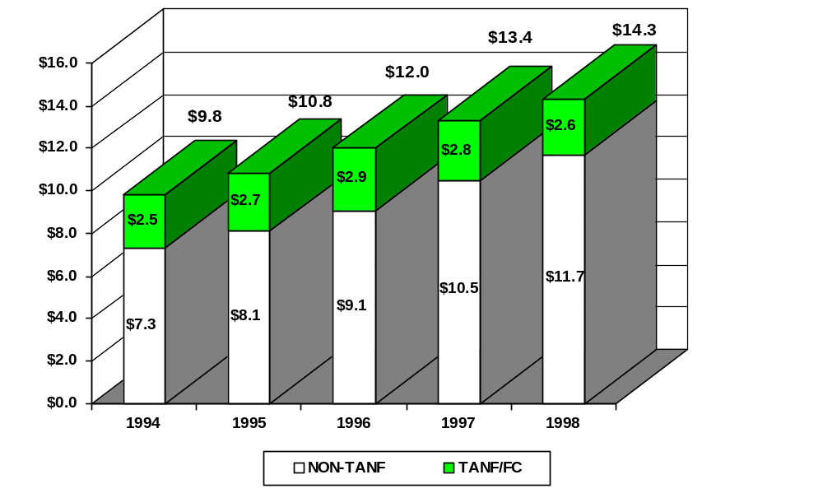

Graph 6:2

TANF/Foster Care Collections

Preliminary TANF/Foster Care collections amounted to $2.6 billion in fiscal year 1998, a decrease of 6.8 percent over the previous year. This decrease is due to the drop in the TANF caseload. The States’ share of TANF/Foster Care collections were $1.1 billion, 41 percent of the collections. The Federal share was $960 million or 36 percent. TANF/Foster Care families received $152 million or 6 percent of these payments. States’ received $396 million or 15 percent for incentive payments. $52 million or 2 percent were for medical support payments (Figure 3).

Preliminary Distribution of TANF/Foster Care Collections, FY 1998
$2.6 Billion

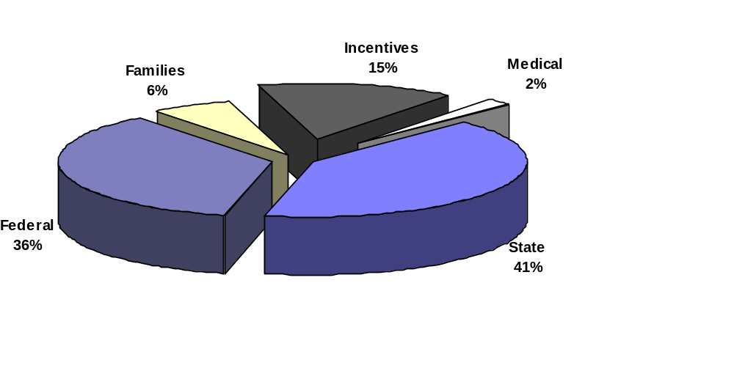

VII. OUT-OF-WEDLOCK PREGNANCIES AND BIRTHS

One of the purposes of the TANF program is to prevent and reduce the incidence of out-of-wedlock pregnancies. As one part of the TANF program, Congress included a performance bonus entitled “Bonus to Reward Decrease in Illegitimacy Ratio.” In enacting this provision, Congress intended to provide greater impetus to State efforts in this area and encourage State creativity in developing effective solutions.

The Administration for Children and Families issued final regulations implementing section 403(a)(2) of the Social Security Act that establishes a bonus to reward decreases in out-of-wedlock births on April 14, 1999. As specified in section 403(a)(2) of the Act, we will award up to $100 million annually, in each of fiscal years 1999 through 2002. The amount of the bonus for each eligible State in a given year will be $25 million or less. For the purposes of this award,
States include the 50 States of the United States, the District of Columbia, the Commonwealth of Puerto Rico, Guam, the United States Virgin Islands, and American Samoa. While the criteria for determining bonus eligibility for Guam, the Virgin Islands, and American Samoa are the same as for the States, their eligibility is determined separately and the determination of their bonus amount is different, as specified in the statute in sections 403(a)(2)(B)(ii) (Amount of Grant) and 403(a)(2)(C)(i)(I) (definition of eligible State).

Briefly, ACF will award the bonus as follows:

- ACF will calculate the ratio of out-of-wedlock births to total births for each State for the most recent two-year period for which data are available and for the prior two-year period. To compute these ratios, we will use the vital statistics data compiled annually by the National Center for Health Statistics and based on records submitted by the States.

- For States other than Guam, the Virgin Islands, and American Samoa, ACF will identify the five States that had the largest proportionate decrease in their ratios between the most recent two-year period for which data are available and the prior two-year period. These States are potentially eligible.

- For Guam, the Virgin Islands, and American Samoa, ACF will identify which jurisdictions had a comparable decrease in their ratios (i.e., a decrease at least as large as the smallest decrease among the other qualifying States or a decrease that ranks among the top five decreases when all States and Territories are ranked together). These additional States will also be potentially eligible.

- ACF will notify the potentially eligible States that, to be considered for the bonus, they need to submit data and information on the number of abortions performed in their State for the most recent year and for 1995.

- ACF will determine which of the potentially eligible States also experienced a decrease in their rate of abortions (defined for the purposes of this bonus to be ratio of the abortions to live births) for the most recent calendar year compared to 1995, the base year specified in the Act. These States will receive a bonus award.

We plan to announce the FY 1999 bonus awards in September, 1999.

Data presented below highlight the status of out-of-wedlock births and teen births in the United States. Final data for 1997 indicate that the birth rate for unmarried women aged 15-44 years decreased from 44.8 births per 1,000 women in 1996 to 44.0 in 1997. The actual number of out-of-wedlock births declined very slightly from 1,260,306 in 1996 to 1,257,444 in 1997. Over the same period, the proportion of all births that were out-of-wedlock was unchanged at 32.4.

Approximately 500,000 teenagers give birth each year. Nationally, the birth rate for teenagers continued to decline in 1997, and has now fallen by 16 percent to 52.3 births per 1,000 women aged 15-19 years, compared with 62.1 in 1991. Teenage birth rates by State vary substantially, from 26.9 (Vermont) to 73.7 (Mississippi); the highest rate reported was 106.3 (Guam). Birth rates for teenage subgroups 15-17 and 18-19 years also vary substantially by State.

During the 1991-97 period, teenage birth rates fell in all States and the District of Columbia and the Virgin Islands. Declines ranged from 6 to 32 percent and were statistically significant in all but one State (Rhode Island). Between 1991 and 1997, rates fell by 20.0 percent or more in 10 States and the District of Columbia; declines in five of these States exceeded 25.0 percent. Eleven States registered declines of 16.0 to 19.9 percent, and 18 States registered declines of 12.0 to 15.9 percent. Declines of 5.9 to 11.9 percent were found for 11 States. (The decline for Rhode Island was not statistically significant.)

There has been success in lowering the birth rate for both young and older teens, with rates for those 15-17 years of age down 17 percent between 1991 and 1997 and the rate for those 18 and 19 down 11 percent. Between 1991 and 1997, teen birth rates declined for white, black, American Indian, Asian or Pacific Islander, and Hispanic women ages 15-19. The rate for black teens -- until recently the highest -- experienced the largest decline, down 24 percent from 1991 to 1997 to reach the lowest rate ever reported for blacks.

These recent declines partly reverse the 24 percent rise in teenage birth rate from 1986 to 1991. Despite the recent declines however, the rate for 1997 is still higher than it was during the early to mid-1980’s (50-51 per 1,000) when the rate was at its lowest point. The teenage birth rate was substantially higher in the 1950’s and early 1960’s than it is now. Most teenagers giving birth prior to 1980 were married, whereas most teenagers giving birth recently are unmarried. In 1997, the percent of unmarried teenage mothers aged 15-17 was 87 percent. It is important to note however, that while most teenage births are non-marital, the majority of births to unmarried women are not to teenagers.

Tables:

Table 7:1 Number, rate and percentage of births to unmarried women: United States, 1980 and 1985-97.
Table 7:2 Number and percent of births to unmarried women: United States and each State, 1997, and percent of births to unmarried women
Table 7:3 Birth rate per 1,000 unmarried women ages 15 - 44 years for 1990.

Table 7.1

Number, rate, and percentage of births to unmarried women: United States, 1980 and 1985-97.
 | Births to unmarried women
Year | ^Number | Rate (1) |  |  | Percent (2)
1997 | 1,257,444 | 44.0 |  |  | 32.4
1996 | 1,260,306 | 44.8 |  |  | 32.4
1995 | 1,253,976 | 45.1 |  |  | 32.2
1994 | 1,289,592 | 46.9 |  |  | 32.6
1993 | 1,240,172 | 45.3 |  |  | 31.0
1992 | 1,224,876 | 45.2 |  |  | 30.1
1991 | 1,213,769 | 45.2 |  |  | 29.5
1990 | 1,165,384 | 43.8 |  |  | 28.0
1989 | 1,094,169 | 41.6 |  |  | 27.1
1988 | 1,005,299 | 38.5 |  |  | 25.7
1987 | 933,013 | 36.0 |  |  | 24.5
1986 | 878,477 | 34.2 |  |  | 23.4
1985 | 828,174 | 32.8 |  |  | 22.0
1980 | 665,747 | 29.4 |  |  | 18.4
(1) Births to unmarried women per 1,000 unmarried women aged 15-44 years.
(2) Percent of all births to unmarried women.

Note: In 1990, for 44 States and the District of Columbia, marital status of the mother is reported on the birth certificate; in six States, mother’s status is inferred from other information on the birth certificate.

Table 7.2

Number and percent of births to unmarried women: United States and each State, 1997, and percent of births to unmarried women:
United States and each State, 1992-97;
[By place of residence. Rates are births to unmarried women per 1,000 unmarried women aged 15-44 years in each State]

 | Number |  |  |  |  |  |  |  |  |  | Percent of all births to unmarried women
State | 1997 |  |  |  |  |  | 1997 |  | 1996 |  | 1995 |  |  | 1994 |  |  | 1993 |  | 1992
United States | 1,257,444 |  |  |  |  |  | 32.4 |  | 32.4 |  | 32.2 |  |  | 32.6 |  |  | 31.0 |  | 30.1
Alabama | 20,635 |  |  |  |  |  | 33.9 |  | 33.7 |  | 34.5 |  |  | 34.5 |  |  | 33.5 |  | 32.6
Alaska | 3,048 |  |  |  |  |  | 30.6 |  | 31.0 |  | 29.9 |  |  | 29.3 |  |  | 28.0 |  | 27.4
Arizona | 28,495 |  |  |  |  |  | 37.6 |  | 38.8 |  | 38.2 |  |  | 38.3 |  |  | 37.9 |  | 36.2
Arkansas | 12,478 |  |  |  |  |  | 34.2 |  | 33.9 |  | 32.9 |  |  | 32.6 |  |  | 31.7 |  | 31.0
California | 172,017 |  |  |  |  |  | 32.8 |  | 31.4 |  | 32.1 |  |  | 35.7 |  |  | 35.3 |  | 34.3
Colorado | 14,273 |  |  |  |  |  | 25.2 |  | 24.8 |  | 24.9 |  |  | 25.0 |  |  | 24.8 |  | 23.8
Connecticut | 14,116 |  |  |  |  |  | 32.7 |  | 31.3 |  | 30.6 |  |  | 30.5 |  |  | 29.8 |  | 28.7
Delaware | 3,693 |  |  |  |  |  | 36.0 |  | 35.5 |  | 34.9 |  |  | 34.7 |  |  | 33.8 |  | 32.6
District of Columbia | 5,041 |  |  |  |  |  | 63.6 |  | 66.1 |  | 65.8 |  |  | 68.8 |  |  | 67.8 |  | 66.9
Florida | 69,285 |  |  |  |  |  | 36.0 |  | 35.9 |  | 35.8 |  |  | 35.7 |  |  | 35.0 |  | 34.2
Georgia | 41,879 |  |  |  |  |  | 35.4 |  | 35.0 |  | 35.2 |  |  | 35.5 |  |  | 35.8 |  | 35.0
Hawaii | 5,202 |  |  |  |  |  | 29.9 |  | 30.3 |  | 29.2 |  |  | 28.3 |  |  | 27.2 |  | 26.2
Idaho | 3,848 |  |  |  |  |  | 20.7 |  | 21.3 |  | 19.9 |  |  | 18.7 |  |  | 18.7 |  | 18.3
Illinois | 60,443 |  |  |  |  |  | 33.4 |  | 33.7 |  | 33.8 |  |  | 34.3 |  |  | 34.1 |  | 33.4
Indiana | 27,184 |  |  |  |  |  | 32.6 |  | 32.3 |  | 31.9 |  |  | 31.5 |  |  | 30.8 |  | 29.5
Iowa | 9,601 |  |  |  |  |  | 26.2 |  | 26.3 |  | 25.2 |  |  | 24.8 |  |  | 24.6 |  | 23.5
Kansas | 10,274 |  |  |  |  |  | 27.6 |  | 26.9 |  | 25.9 |  |  | 26.0 |  |  | 25.9 |  | 24.3
Kentucky | 15,669 |  |  |  |  |  | 29.5 |  | 29.8 |  | 28.5 |  |  | 27.6 |  |  | 27.2 |  | 26.3
Louisiana | 29,011 |  |  |  |  |  | 43.9 |  | 43.4 |  | 42.4 |  |  | 42.6 |  |  | 42.0 |  | 40.2
Maine | 4,060 |  |  |  |  |  | 29.7 |  | 28.7 |  | 27.8 |  |  | 28.2 |  |  | 27.0 |  | 25.3
Maryland | 23,493 |  |  |  |  |  | 33.5 |  | 33.5 |  | 33.3 |  |  | 33.7 |  |  | 32.5 |  | 30.5
Massachusetts | 20,836 |  |  |  |  |  | 25.9 |  | 25.5 |  | 25.6 |  |  | 26.6 |  |  | 26.4 |  | 25.9
Michigan | 44,454 |  |  |  |  |  | 33.2 |  | 33.8 |  | 34.3 |  |  | 35.0 |  |  | 26.0 |  | 26.8
Minnesota | 16,141 |  |  |  |  |  | 25.0 |  | 24.8 |  | 23.9 |  |  | 24.0 |  |  | 23.4 |  | 23.0
Mississippi | 18,859 |  |  |  |  |  | 45.4 |  | 45.0 |  | 45.3 |  |  | 45.4 |  |  | 44.4 |  | 42.9
Missouri | 24,516 |  |  |  |  |  | 33.1 |  | 33.2 |  | 32.1 |  |  | 32.5 |  |  | 32.4 |  | 31.5
Montana | 3,119 |  |  |  |  |  | 28.7 |  | 27.9 |  | 26.5 |  |  | 25.5 |  |  | 27.3 |  | 26.4
Nebraska | 6,021 |  |  |  |  |  | 25.8 |  | 24.8 |  | 24.3 |  |  | 24.8 |  |  | 23.5 |  | 22.6
Nevada | 9,555 |  |  |  |  |  | 35.5 |  | 42.7 |  | 42.0 |  |  | 35.0 |  |  | 34.0 |  | 33.3
New Hampshire | 3,404 |  |  |  |  |  | 23.8 |  | 23.4 |  | 22.2 |  |  | 22.1 |  |  | 20.6 |  | 19.2
New Jersey | 31,738 |  |  |  |  |  | 28.0 |  | 28.0 |  | 27.6 |  |  | 28.1 |  |  | 27.1 |  | 26.4
New Mexico | 11,696 |  |  |  |  |  | 43.5 |  | 42.1 |  | 42.6 |  |  | 41.7 |  |  | 41.4 |  | 39.5
New York | 90,673 |  |  |  |  |  | 35.2 |  | 39.6 |  | 37.9 |  |  | 37.6 |  |  | 37.2 |  | 34.8
North Carolina | 34,468 |  |  |  |  |  | 32.2 |  | 32.0 |  | 31.4 |  |  | 31.9 |  |  | 32.1 |  | 31.3
North Dakota | 2,174 |  |  |  |  |  | 26.0 |  | 25.1 |  | 23.5 |  |  | 23.0 |  |  | 23.0 |  | 22.6
Ohio | 51,544 |  |  |  |  |  | 33.9 |  | 33.1 |  | 33.0 |  |  | 32.9 |  |  | 33.0 |  | 31.6
Oklahoma | 15,660 |  |  |  |  |  | 32.4 |  | 30.9 |  | 30.5 |  |  | 29.8 |  |  | 29.1 |  | 28.4
Oregon | 12,631 |  |  |  |  |  | 28.8 |  | 29.7 |  | 28.9 |  |  | 28.7 |  |  | 28.2 |  | 27.0
Pennsylvania | 47,234 |  |  |  |  |  | 32.8 |  | 32.3 |  | 32.4 |  |  | 32.8 |  |  | 32.2 |  | 31.6
Rhode Island | 4,128 |  |  |  |  |  | 33.1 |  | 33.3 |  | 31.1 |  |  | 32.1 |  |  | 31.7 |  | 29.6
South Carolina | 19,857 |  |  |  |  |  | 38.0 |  | 37.3 |  | 37.4 |  |  | 36.8 |  |  | 36.0 |  | 35.5
South Dakota | 3,166 |  |  |  |  |  | 31.1 |  | 29.5 |  | 28.0 |  |  | 27.7 |  |  | 27.7 |  | 26.6
Tennessee | 25,383 |  |  |  |  |  | 34.1 |  | 33.4 |  | 33.1 |  |  | 33.4 |  |  | 33.6 |  | 32.7
Texas | 102,496 |  |  |  |  |  | 30.7 |  | 30.4 |  | 30.0 |  |  | 28.9 |  |  | 17.0 |  | 17.5
Utah | 7,145 |  |  |  |  |  | 16.6 |  | 16.2 |  | 15.7 |  |  | 15.7 |  |  | 15.5 |  | 15.1
Vermont | 1,726 |  |  |  |  |  | 26.1 |  | 26.4 |  | 24.9 |  |  | 25.3 |  |  | 24.2 |  | 23.4
Virginia | 26,908 |  |  |  |  |  | 29.3 |  | 28.8 |  | 29.3 |  |  | 29.2 |  |  | 29.0 |  | 28.3
Washington | 21,218 |  |  |  |  |  | 27.1 |  | 27.3 |  | 26.7 |  |  | 26.0 |  |  | 26.3 |  | 25.3
West Virginia | 6,495 |  |  |  |  |  | 31.3 |  | 31.3 |  | 30.5 |  |  | 30.2 |  |  | 29.0 |  | 27.7
Wisconsin | 18,707 |  |  |  |  |  | 28.1 |  | 27.4 |  | 27.4 |  |  | 27.2 |  |  | 27.1 |  | 26.1
Wyoming | 1,747 |  |  |  |  |  | 27.4 |  | 27.0 |  | 26.4 |  |  | 27.5 |  |  | 25.8 |  | 24.0
Puerto Rico | 29,345 |  |  |  |  |  | 45.8 |  | 44.2 |  | 42.7 |  |  | 41.9 |  |  | 40.4 |  | 39.3
Virgin Islands | 1,368 |  |  |  |  |  | 67.8 |  | 64.3 |  | 62.5 |  |  | 66.7 |  |  | 67.1 |  | 63.2
Guam | 2,125 |  |  |  |  |  | 49.3 |  | 48.5 |  | 46.4 |  |  | 46.6 |  |  | 44.8 |  | 41.3
American Samoa | 567 |  |  |  |  |  | 34.7 |  | 34.0 |  | 34.0 |  |  | 31.9 |  |  | --- |  | ---
---Data not available.

Table 7.3
Birth rate per 1,000 unmarried women aged 15-44 years for 1997
By Alphabetical Order |  |  |  |  | By Rank
United States | 43.8 |  |  |  | United States | 43.8
Alabama | 45.6 |  | 1 |  | New Hampshire | 25.5
Alaska | 56.7 |  | 2 |  | Vermont | 26.4
Arizona | 57.5 |  | 3 |  | North Dakota | 29.3
Arkansas | 50.2 |  | 4 |  | Massachusetts | 29.3
California | 56.4 |  | 5 |  | Utah | 29.7
Colorado | 31.1 |  | 6 |  | Minnesota | 30.3
Connecticut | 35.0 |  | 7 |  | Colorado | 31.1
Delaware | 41.5 |  | 8 |  | Iowa | 31.3
District of Columbia | 64.4 |  | 9 |  | Texas | 31.4
Florida | 48.8 |  | 10 |  | Idaho | 31.4
Georgia | 50.2 |  | 11 |  | Maine | 31.5
Hawaii | 42.5 |  | 12 |  | Nebraska | 33.2
Idaho | 31.4 |  | 13 |  | Rhode Island | 33.3
Illinois | 47.6 |  | 14 |  | Wisconsin | 33.9
Indiana | 38.5 |  | 15 |  | New Jersey | 33.9
Iowa | 31.3 |  | 16 |  | Wyoming | 34.1
Kansas | 36.3 |  | 17 |  | West Virginia | 34.2
Kentucky | 35.8 |  | 18 |  | Connecticut | 35.0
Louisiana | 56.7 |  | 19 |  | Kentucky | 35.8
Maine | 31.5 |  | 20 |  | Kansas | 36.3
Maryland | 41.8 |  | 21 |  | Washington | 36.6
Massachusetts | 29.3 |  | 22 |  | Michigan | 37.1
Michigan | 37.1 |  | 23 |  | Montana | 37.9
Minnesota | 30.3 |  | 24 |  | Virginia | 38.3
Mississippi | 62.0 |  | 25 |  | Oregon | 38.5
Missouri | 43.6 |  | 26 |  | Indiana | 38.5
Montana | 37.9 |  | 27 |  | Pennsylvania | 38.6
Nebraska | 33.2 |  | 28 |  | South Dakota | 39.8
Nevada | 43.7 |  | 29 |  | Ohio | 40.8
New Hampshire | 25.5 |  | 30 |  | Oklahoma | 41.2
New Jersey | 33.9 |  | 31 |  | Delaware | 41.5
New Mexico | 59.6 |  | 32 |  | Maryland | 41.8
New York | 44.5 |  | 33 |  | Hawaii | 42.5
North Carolina | 44.5 |  | 34 |  | Missouri | 43.6
North Dakota | 29.3 |  | 35 |  | Nevada | 43.7
Ohio | 40.8 |  | 36 |  | North Carolina | 44.5
Oklahoma | 41.2 |  | 37 |  | New York | 44.5
Oregon | 38.5 |  | 38 |  | Tennessee | 44.8
Pennsylvania | 38.6 |  | 39 |  | Alabama | 45.6
Rhode Island | 33.3 |  | 40 |  | Illinois | 47.6
South Carolina | 50.6 |  | 41 |  | Florida | 48.8
South Dakota | 39.8 |  | 42 |  | Arkansas | 50.2
Tennessee | 44.8 |  | 43 |  | Georgia | 50.2
Texas | 31.4 |  | 44 |  | South Carolina | 50.6
Utah | 29.7 |  | 45 |  | California | 56.4
Vermont | 26.4 |  | 46 |  | Louisiana | 56.7
Virginia | 38.3 |  | 47 |  | Alaska | 56.7

VIII. INCOME AND CHILD POVERTY

Child Poverty

The child poverty rate, as measured by the Census Bureau’s official poverty measure has fallen by 12 percent since 1993, from 22.7 to 19.9 percent. The rate declined from 1993 to 1995; there was no significant change in 1996 and 1997 (see table 8.1).

Child poverty rates vary widely for different demographic groups. In particular, there are significant differences in child poverty rates by marital status and race. A child living in a single parent family is five times more likely to be poor than a child living in a two-parent family. In married, two-parent families about one in ten children are poor (9.5%), whereas half the children living in a female headed, single parent family are poor. Poverty rates for African Americans, and Hispanic Children have fallen dramatically, although the poverty rate for children living in an African American or Hispanic family still is more than twice the rate of children living in a white, non-Hispanic family. Since 1993, the African American poverty rate dropped from 33.1 percent to 26.5 percent – the lowest level on record and the largest four-year drop in more than a quarter century. Last year, the Hispanic poverty rate dropped from 29.4 percent to 27.1 percent – the largest one-year drop since 1978. The child poverty rate declined from 22.7 percent in 1993 to 19.9 percent in 1997, the biggest four-year drop in nearly 30 years. While the poverty rate for white, non-Hispanic children is 16.1%, the poverty rate for African American or Hispanic children is 37% or almost two of every five children.

The official poverty measure is based on a definition of income that includes cash income received by the individual or family. Near cash and non-cash transfers are not included in the income definition nor are subtractions or additions to income made through the tax system. To determine an individual’s or family’s poverty status the total cash income is compared to a standard of basic needs, the poverty threshold. The poverty threshold varies by the size of the family. In 1997, the poverty threshold for a family of four (2 adults plus 2 children) was $16,276.

The Census Bureau also produces a series of additional definitions of income that incorporate other additions and reductions to income, such as capital gains and losses, near cash transfers, including (e.g. food stamps and housing) and federal and State taxes, including the payroll tax and the Earned Income Tax Credit (EITC).

Using a definition of income that includes near cash government benefits and taxes. Using this expanded definition, the 1997 child poverty rate decreases to 15.6%. The EITC alone (net of other Federal taxes) lifts 1.4 million poor children out of poverty and 4.3 million Americans of all ages.

While the poverty rate indicates the proportion of a population that is poor the poverty gap indicates the income deficit for those in poverty, that is, the amount of income that would be needed to raise all poor families to the poverty line. Table 8:2 displays the poverty gap for families with children from 1990 to 1997 using a pre-transfer measure of the poverty gap, the official measure of poverty and an alternative measure of poverty that includes near-cash transfers and federal and State taxes including the EITC.

Section 413(i) of the Act requires the Department to issue regulations establishing a methodology by which a State will determine the child poverty rate in the State. If the State experiences an increase in its child poverty rate of five percent or more as a result of the TANF program, it must submit and implement a corrective action plan. Pursuant to section 413(i) of the PRWORA, HHS has issued a notice of proposed rule making describing the methodology that each State shall use for determining the child poverty rate in the State. HHS expects to issue a final rule this year.

Income

Income is another central measure of how families are faring under welfare reform. Here results are even more preliminary than for employment and earnings, although better data will be available over time. Most current information relies on administrative records that typically examine family income defined as the total of TANF, Food Stamps and earnings. However, this information does not take into account other sources of income, such as the EITC, child support and Supplemental Security Income (SSI); the income of other household members; in-kind supports such as child care or Medicaid; nor, on the other side of the ledger, the expenses that families incur when they are working. The CPS and some early studies of families leaving welfare are based on household surveys. These surveys along with others in progress ultimately will have this information.

Data from four waiver evaluations in which the welfare reform program succeeded in increasing mandatory work activities, employment and earnings suggest mixed effects on family income, depending on the generosity of benefit levels and earnings disregards. In the two States with both generous benefits and earnings disregards, there were increases in average annual income of $762 for applicants in Iowa, and $1,065 for long term recipients in Minnesota. In Florida, a program that accomplished comparable earnings gains, but had low benefits and generous earnings disregards, raised family income by $289, whereas a fourth program in Indiana that accomplished comparable earnings gains but had low benefits and retained the standard AFDC earnings disregards had no effect on income.

Examination of the Florida findings also suggests that these effects are not uniform across recipients and that higher-skilled recipients may gain income, whereas the income of lower-skilled recipients may decline. In Florida, recipients who had both a high school degree and recent work experience averaged $752 higher average annual income for the three years following entry into a welfare reform program, while those with neither experienced losses of about $485. This gain/decline pattern is consistent with patterns in some earlier leaver studies. For example, a study in Iowa of families that lost their entire benefit because they failed to establish a self-sufficiency plan showed that about 40 percent increased their income, about 50 percent suffered a decrease, and about 10 percent had unchanged income.

CPS data for the period 1993 to 1997 indicate that the average annual income of all female-headed families with children increased, as did employment and earnings as described earlier in this chapter. This measure of income includes both earnings and a broad range of transfer programs. Again, the income increases were unevenly distributed over the period, with larger gains in the 1993 - 1995 period, and across the income distribution. The bottom quintile did not fare as well as the top four fifths, especially in the 1995-1997 period, suggesting preliminarily that we need to be alert to monitoring more disadvantaged families.

Appendices:

Table 8:1 Poverty Rates for All Children For Selected Years, 1979 - 1997
Table 8:2 Poverty Gap for all Children, 1991 – 1997

Table 8:1

Poverty Rates For All Children For Selected Years, 1979 – 1997

Poverty Rate | 1979 | 1983 | 1989 | 1993 | 1994 | 1995 | 1996 | 1997
Official Measure | 16.4 | 22.3 | 20.1 | 22.7 | 21.8 | 20.8 | 20.5 | 19.9
Alternative Measure | 13.6 | 21.3 | 18.0 | 20.0 | 18.0 | 16.2 | 16.1 | 15.6

Table 8:2

Poverty Gap for All Families with Children 1990 – 1997
Official and Alternative Definitions of Income
(In Billions of Dollars)

YEAR | PRE-TRANSFER  POVERTY GAP | OFFICIAL POVERTY MEASURE | REDUCTION IN GAP  (pretransfer - official) | ALTERNATIVE MEASURE OF POVERTY | REDUCTION IN GAP  (pretransfer - alternative)
1990 | 69.1 | 41.5 | 27.6 | 28.2 | 40.9
1991 | 76.3 | 46.0 | 30.3 | 30.1 | 46.2
1992 | 78.9 | 47.8 | 31.1 | 32.0 | 46.9
1993 | 85.7 | 51.1 | 34.6 | 35.6 | 50.1
1994 | 79.8 | 47.8 | 32 | 32.1 | 47.7
1995 | 71.5 | 42.6 | 28.9 | 24.9 | 46.6
1996 | 71.5 | 43.9 | 27.6 | 25.3 | 46.2
1997 | 69.0 | 43.5 | 25.5 | 26.7 | 42.3
* constant 1997 dollars
Note: The poverty gap calculation includes all families, and related and unrelated sub families with related children under 18. The alternative measure poverty gaps for 1993 and 1994 have been adjusted downward to account for changes in the way the Bureau of the Census reported state income taxes on the micro-data file.

IX. DEMOGRAPHIC AND FINANCIAL CHARACTERISTICS OF TANF FAMILIES

The data described in this chapter provide information on the demographic and financial characteristics of families receiving and exiting from assistance. The data provided are for FY 1998 (October 1997 - September 1998). When comparing data from previous information, please note that this chapter compares FY 1998 data to the data reported in last year’s TANF report -- this data was for the first nine months of FY 1997 (October 1996 - June 1997) when all States were required to continue reporting AFDC data irrespective of their TANF implementation status. While 39 States provided TANF data for the last quarter of FY 97 (July – September 1997), we believe the better comparison to be AFDC data for all States.

The information describing the characteristics of TANF families has been central to an understanding of how the population served by AFDC has changed over time. For example, key trends such as the decline in family size and the increasing proportion of children served in the program who were born out-of-wedlock have been identified through this data source. Some key characteristics of TANF families at the outset of the program are described, along with how they compare to the prior year.

The TANF Family

The average monthly number of TANF families was 3,176,000 in FY 1998. The estimated average number of TANF recipients was 8,904,000 of which 2,631,000 (30%) were adults and 6,273,000 (70%) were children. The average monthly number of TANF families decreased in all States and reflects an overall 22 percent decrease from 4,058,000 families in October 1996 - June 1997. During FY 1998, 2,897,000 TANF families stopped receiving assistance (for example, to leave for employment, or the application of a State policy).

About seventy percent of families had only one adult recipient, and five percent included two or more adult recipients. For the 49 States that reported child-only cases, 23.4 percent of TANF families had no adult recipients, up about 0.7 percentage points for the comparable States for the October 1996 - June 1997 period. While the percentage of child-only cases on the welfare rolls has risen steadily since 1988, the rate of increase seems to be slowing in the past 3 years. Even though the overall percentage of child-only cases has continued to increase, the total number of child-only cases has actually declined by about 200,000 since October 1996.

The average number of persons in TANF families was 2.8. The TANF families averaged 2 recipient children, which remained unchanged. Two in five families had only one child. One in ten families had more than three children.

Of TANF families, 98 percent received cash and cash equivalents assistance with the monthly average amount of $358 under the State TANF program. Of such TANF families, 84 percent received Food Stamp assistance, which is consistent with previous levels. Also, almost every TANF family was eligible to receive medical assistance under the State plan approved under title XIX. (See table 9:8 for a list of which States provide medical assistance).
Approximately 18 percent of TANF families had assistance reduced in an average month. Reasons for these reductions in assistance for the reporting month were: sanction (3.8 percent), recoupment

of a prior overpayment (8.2 percent) and other (6.4 percent). “Other” reasons for a reduction in assistance could include receiving a lower benefit based on a State policy to pay families that move from another State at a lower level, or the application of a family cap.

The reasons for TANF cases closing include employment (21.7 percent), State policies (15.5 percent) and sanctions (6.2 percent). However, understanding the reason for case closure is severely limited by the fact that States reported 56.1 percent of all cases that closed did so due to “other” reasons and in some States nearly all case closures were classified as “other.” For example, while independent studies of the reason for families leaving welfare typically find that somewhat over half leave as a result of employment, States reported only 21.7 percent of cases closing due to employment, clearly an understatement of the true rate. The final rule of TANF data collection requirements, effective October 1999, provides a detailed reason for case closure classification codes. These data specifications should result in more accurate determination of the reason for families leaving TANF.

TANF Adults

The average age of TANF adult recipients was 30 years. Of TANF adult recipients, 6 percent were teenagers and 19 percent were 40 years of age or older. About 4 percent of TANF adult recipients were teen parents whose child was also a member of the TANF family. Sixteen percent of adult recipients were married and living together.

There was no significant change in the racial composition of TANF families. Three of five TANF adult recipients were members of minority races or ethnic groups. Thirty-seven percent of adult recipients were black, 36 percent were white, and 20 percent were Hispanic, and 1.6 percent were American Indian or Alaska Native.

Most TANF adult recipients were U.S. citizens. Non-citizens residing legally in this country comprised 11 percent of TANF adults.

Employment increased dramatically by about 75 percent among TANF adult recipients. Compared to October 1996 - June 1997, when 13 percent of adult recipients were employed, about 23 percent were employed in FY 1998. Furthermore, the average earnings of those employed rose from about $506 per month to $553, an increase of about 11 percent. Seven percent of adult recipients had unearned income averaging about $229 per month. Forty-five percent of TANF adult recipients were in the labor force, i.e., seeking work but not employed, and almost one third of adult recipients were not in the labor force.

Work participation was mandatory for almost three of every five adult recipients. Of TANF adult recipients, about 8 percent were exempt from the work participation because they were single custodial parents with child under 12 months. Only three percent were exempt because of a sanction or participation in a Tribal Work Program. Nearly 17 percent were exempt from the work participation status because of a good cause exception, e.g., disabled, in poor health, or other. About 12 percent were teen parents who were required to participate in education.

TANF Children

TANF recipient children averaged about 7.7 years of age. Seven percent of recipient children were under 2 years of age, while 35 percent were of preschool age under 6. Only 7 percent of the children were 16 years of age or older.

Most recipient children were children of the head of household in TANF families. Nationally, only 6 percent were grandchildren of the head of household, however there is considerable variation among States.

The racial distribution of TANF recipient children was relatively unchanged in recent years. Black children continued to be the largest group of welfare children, comprising about 41 percent of recipient children. About 29 percent of TANF recipient children were white and 24 percent were Hispanic. The percentage of black children on TANF is up about 2 percentage points with a corresponding 1 percentage point decline in the percentage of white and Hispanic children between October 1996 – June 1997 and FY 1998.

The data described in this chapter provides information on the demographic and financial characteristics of families receiving and exiting from assistance. The data provided are for FY 1998.

Tables:

Table 9:1 Distribution of TANF Families by Number of Family Members,

October 1997 – September 1998

Table 9:2 Distribution of TANF Families by Number of Recipient Children,

October 1997 – September 1998
Table 9:3 Distribution of TANF Families with no Adult Recipients by Number of Recipient Children, October 1997 – September 1998
Table 9:4 Distribution of TANF families with One Adult Recipient by Number of Recipient Children, October 1997 – September 1998
Table 9:5 Distribution of TANF Families with Two or More Adult Recipients by Number of Recipient Children, October 1997 – September 1998
Table 9:6 Distribution of TANF Families by Race, October 1997 – September 1998
Table 9:7 Distribution of TANF Families by Type of Family for Work Participation, October 1997 – September 1998
Table 9:8 Distribution of TANF Families Receiving Assistance (Medical, Food Stamps), October 1997 – September 1998
Table 9:9 TANF Families Receiving Cash Assistance, October 1997 – September 1998
Table 9:10 Distribution of TANF Families by Reason for Grant Reduction,
October 1997 – September 1998
Table 9:11 Distribution of TANF Adult Recipients by Age Group, October 1997 – September 1998
Table 9:12 Distribution of TANF Adult Recipients by Race, October 1997 – September 1998
Table 9:13 Distribution of TANF Adult Recipients by Martial Status, October 1997 – September 1998
Table 9:14 Distribution of TANF Adult Recipients Receiving Federal Disability Benefits, October 1997 – September 1998
Table 9:15 Distribution of TANF Adult Recipients by Relationship to Head of Household, October 1997 – September 1998
Table 9:16 Distribution of TANF Adult Recipients with Teen Parent Status in the Family, October 1997 – September 1998
Table 9:17 Distribution of TANF Adult Recipients by Education Level, October 1997 – September 1998
Table 9:18 Distribution of TANF Adult Recipients by Citizenship Status,
October 1997 – September 1998
Table 9:19 Distribution of TANF Adult Recipients By Work Exemption Status,
October 1997 – September 1998
Table 9:20 Distribution of TANF Adult Recipients by Employment Status,
October 1997 – September 1998
Table 9:21 TANF Adult Recipients with Income by Type of Non-TANF Income, October 1997 – September 1998
Table 9:22 Distribution of TANF Recipient Children by Age Group, October 1997 – September 1998
Table 9:23 Distribution of TANF Youngest Recipient Child By Age Group,
October 1997 – September 1998
Table 9:24 Distribution of TANF Recipient Children By Race, October 1997 – September 1998
Table 9:25 Distribution of TANF Recipient Children Receiving Federal Disability Benefits , October 1997 – September 1998
Table 9:26 Distribution of TANF Recipient Children By Relationship to Head of Household, October 1997 – September 1998
Table 9:27 Distribution of TANF Recipient Children with Teen Parent Status in the Family, October 1997 – September 1998
Table 9:28 Distribution of TANF Recipient Children by Education Level,
October 1997 – September 1998
Table 9:29 Distribution of TANF Recipient Children by Citizenship Status,
October 1997 – September 1998
Table 9:30 TANF Recipient Children with Unearned Income, October 1997 – September 1998
Table 9:31 Distribution of TANF Closed Cases By Reason for Closure, October 1997 – September 1998

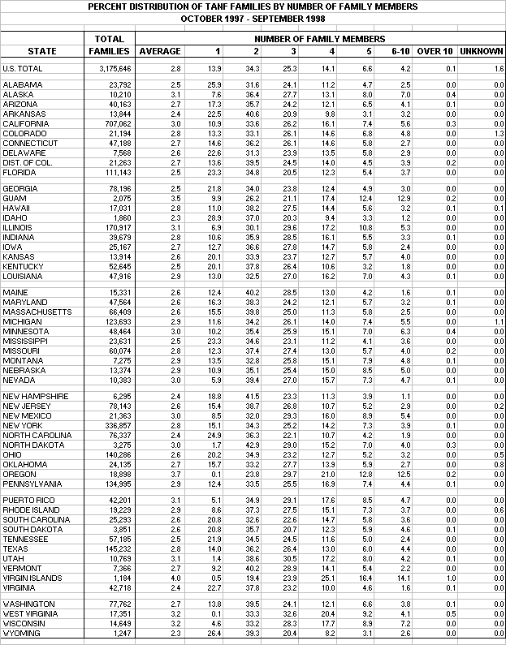
Table 9:1
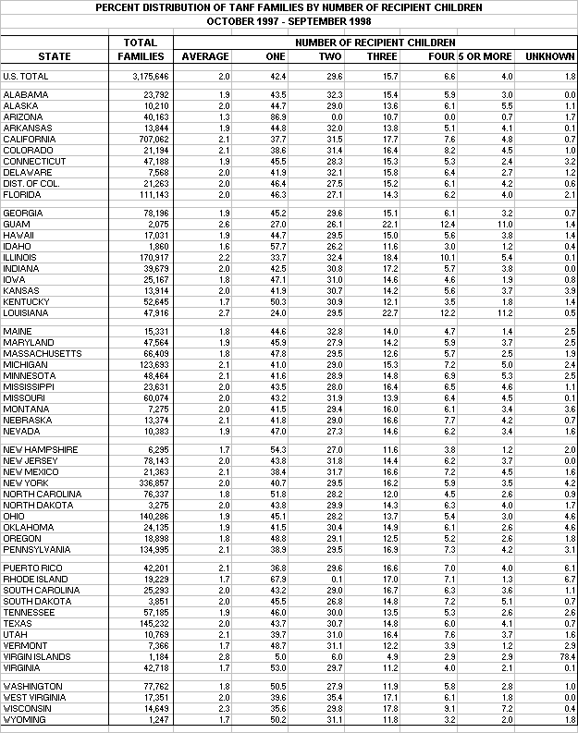
Table 9:2

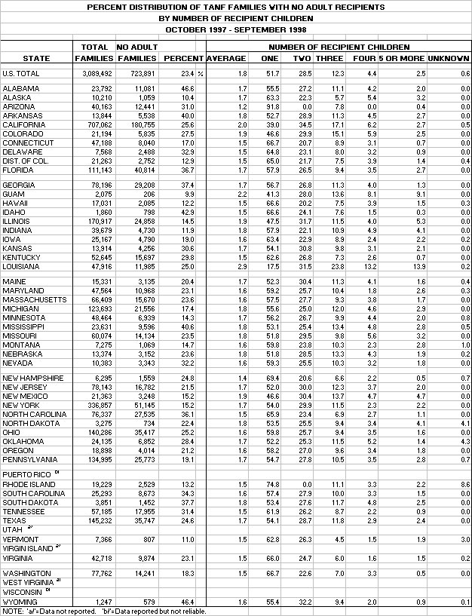
Table 9:3

Table 9:4
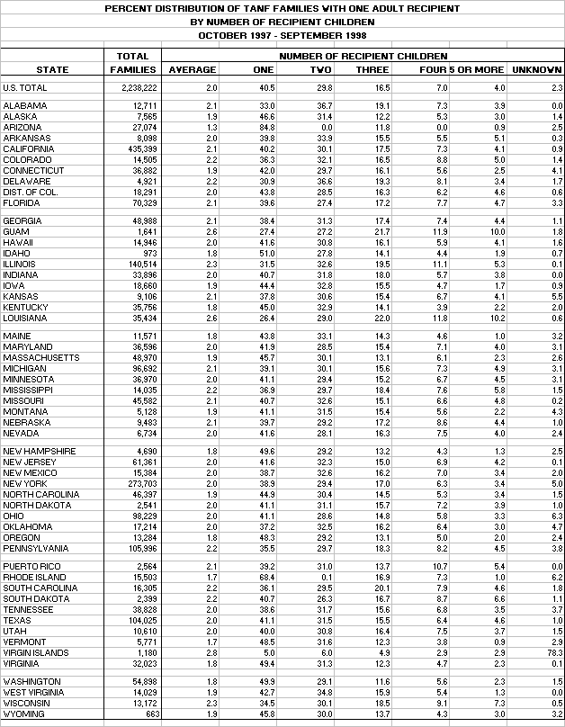
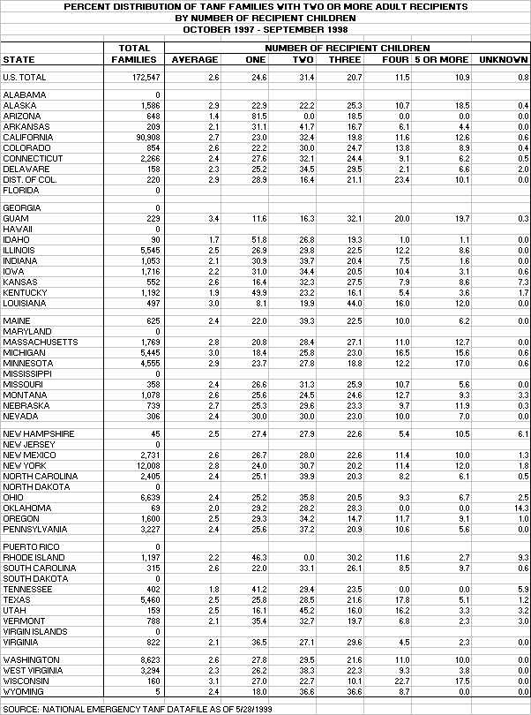
Table 9:5
Table 9:6
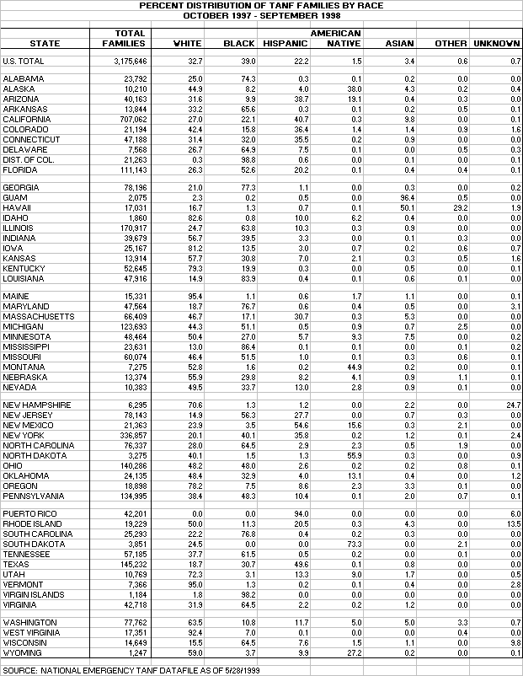

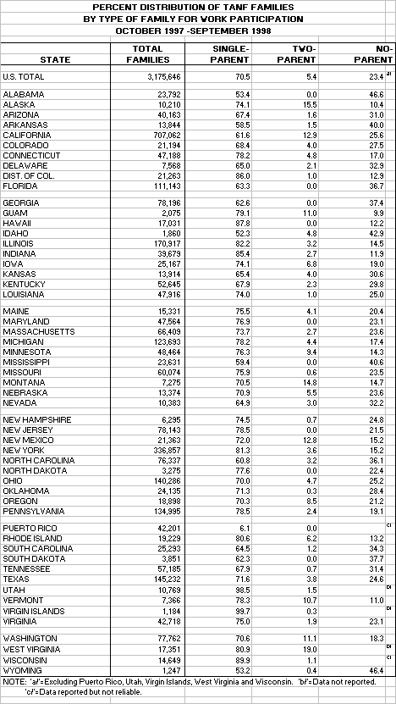
Table 9:7

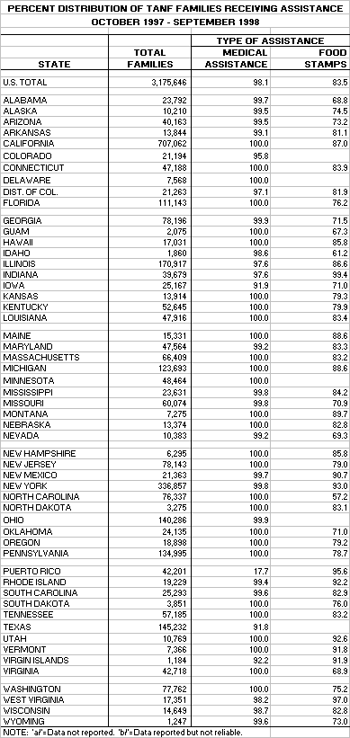
Table 9:8

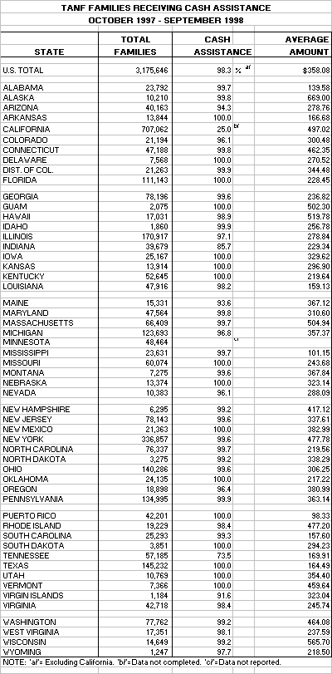
Table 9:9
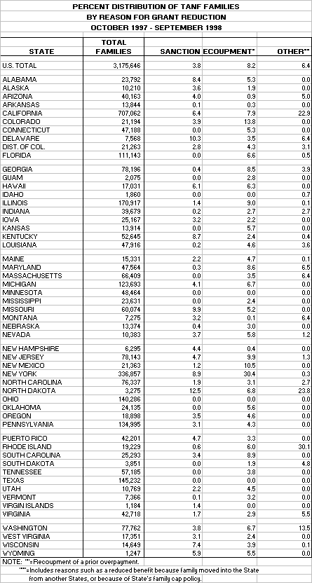
Table 9:10

Table 9:11
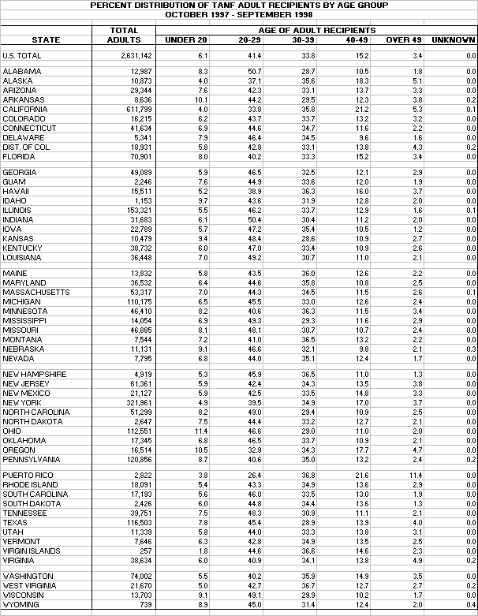

Table 9:12
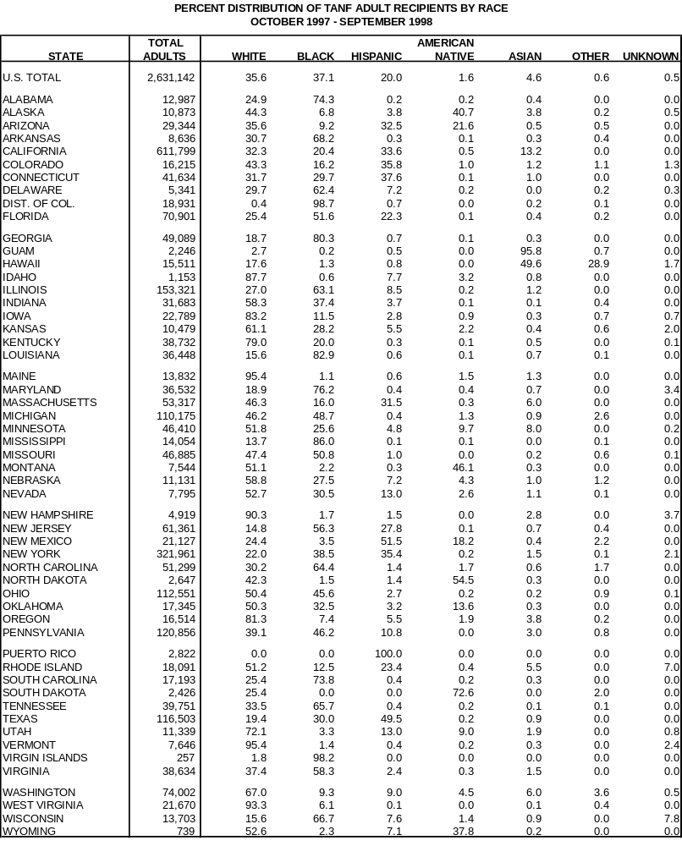

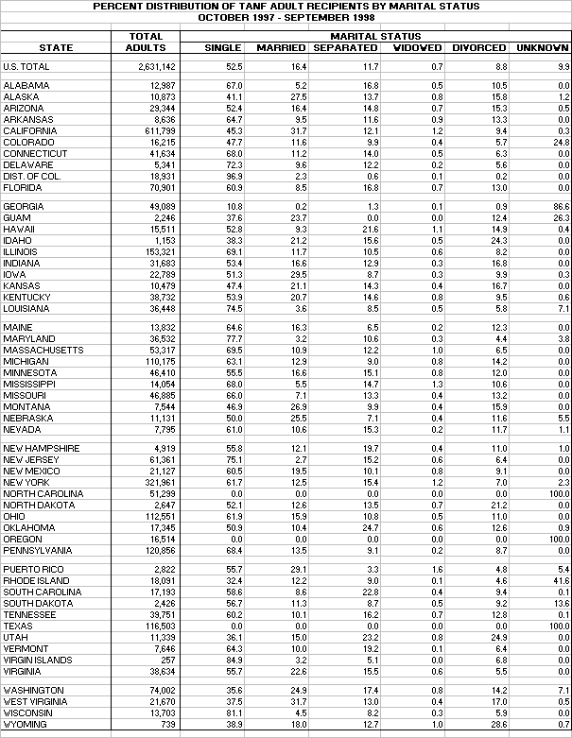
Table 9:13

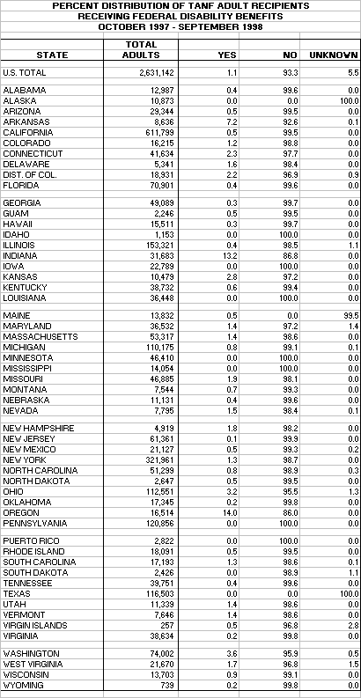
Table 9:14

Table 9:15
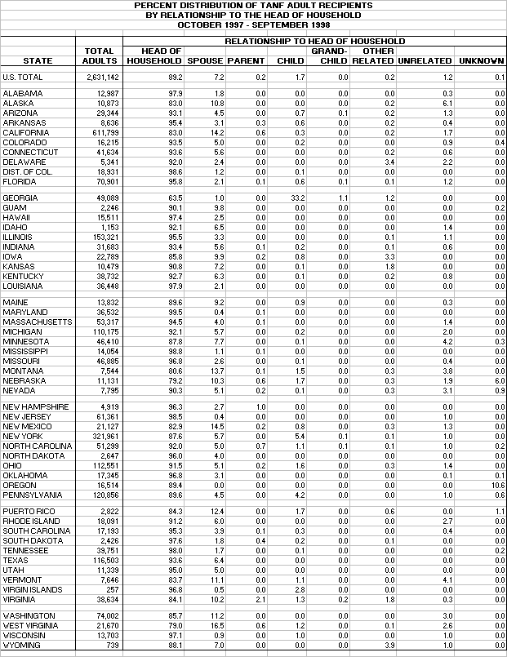

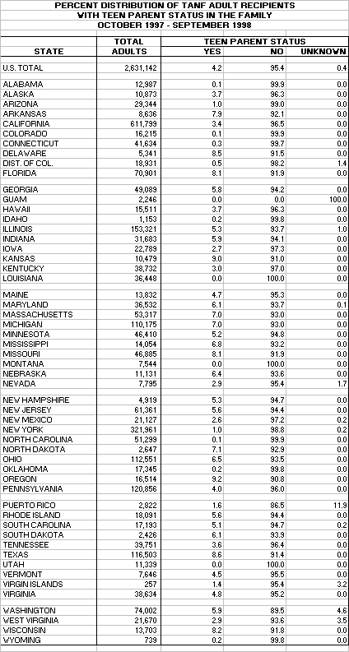
Table 9:16

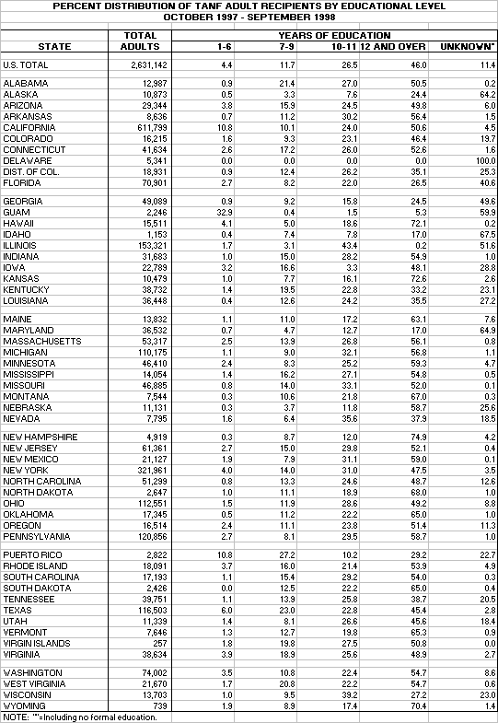
Table 9:17

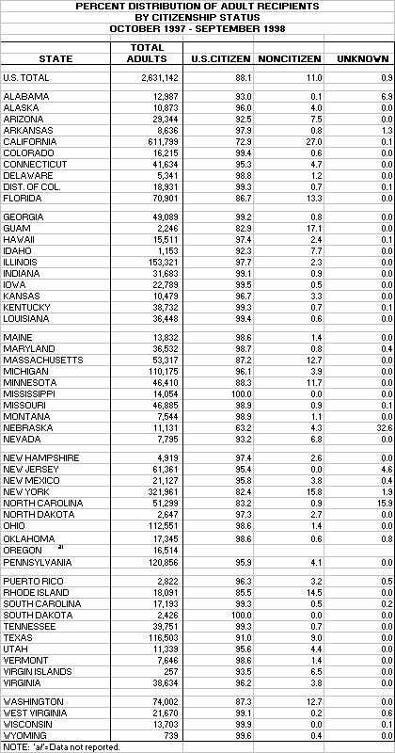
Table 9:18

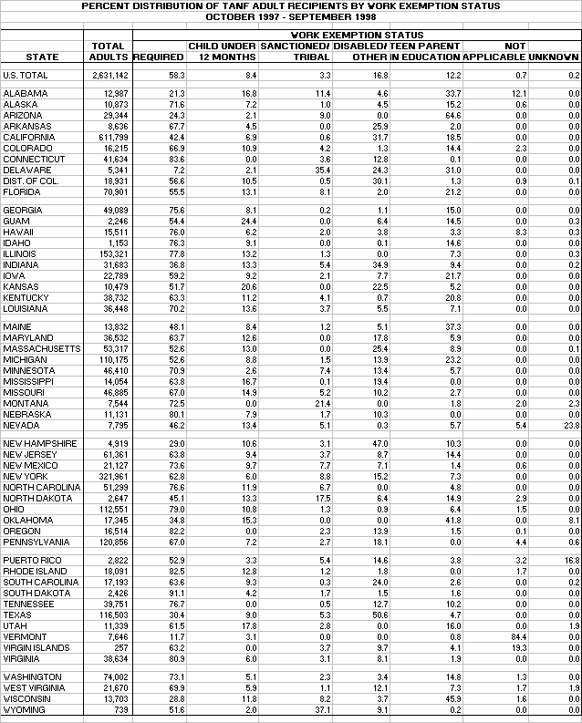
Table 9:19

Table 9:20
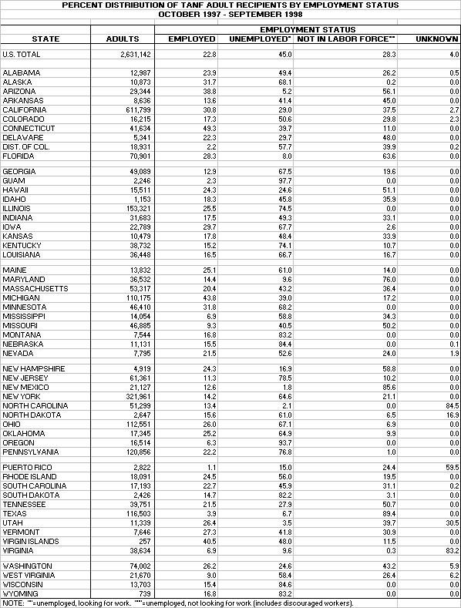

Table 9:21
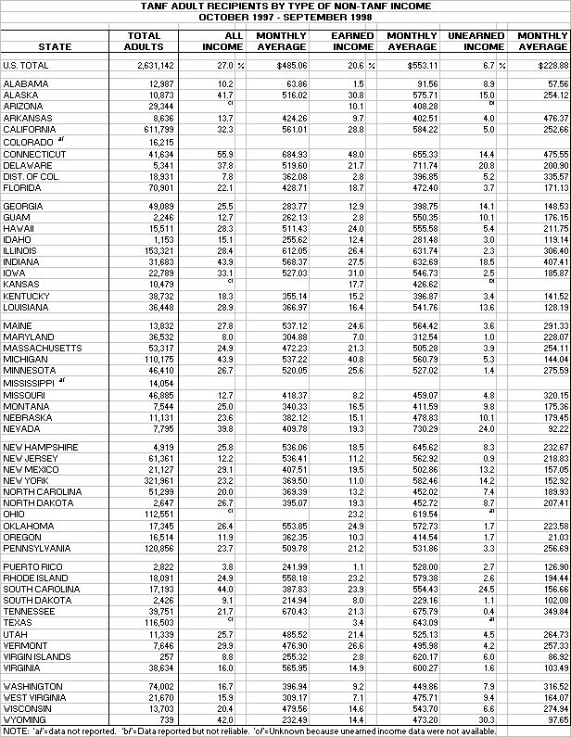
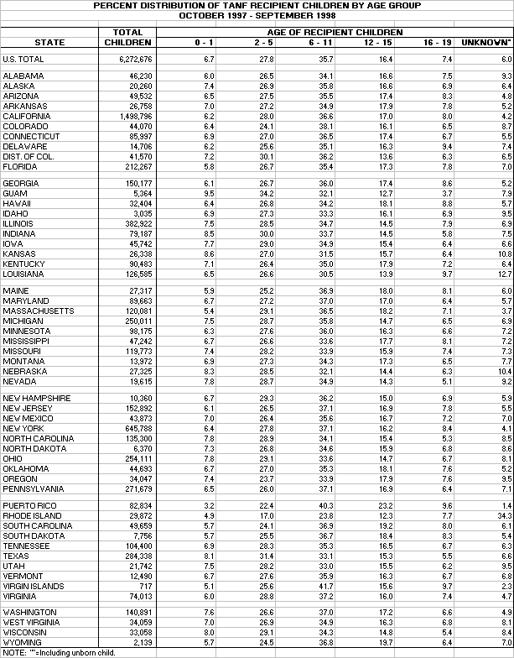
Table 9:22

Table 9:23
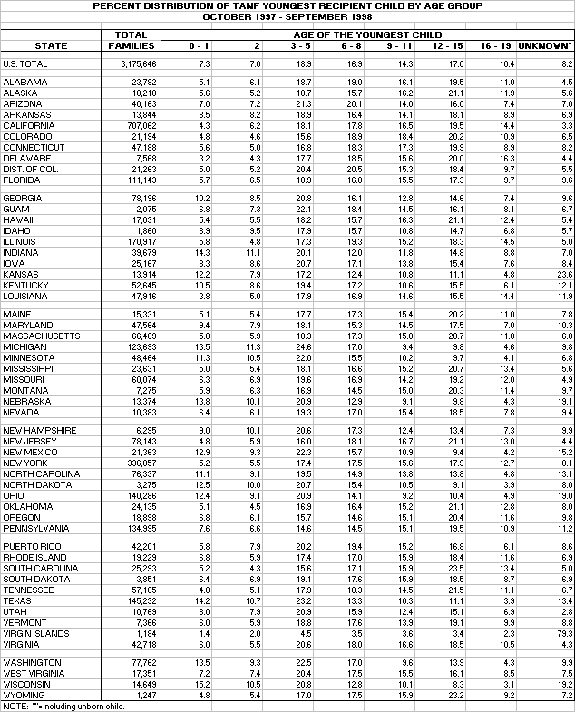

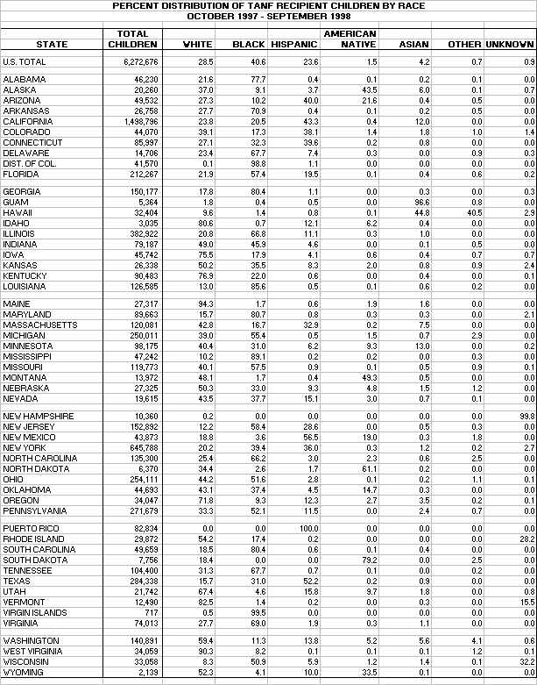
Table 9:24

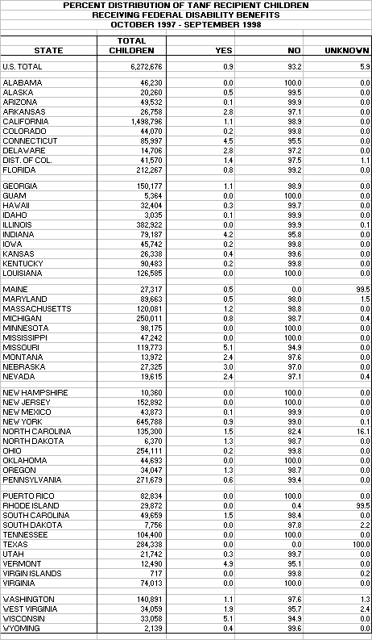
Table 9:25

Table 9:26
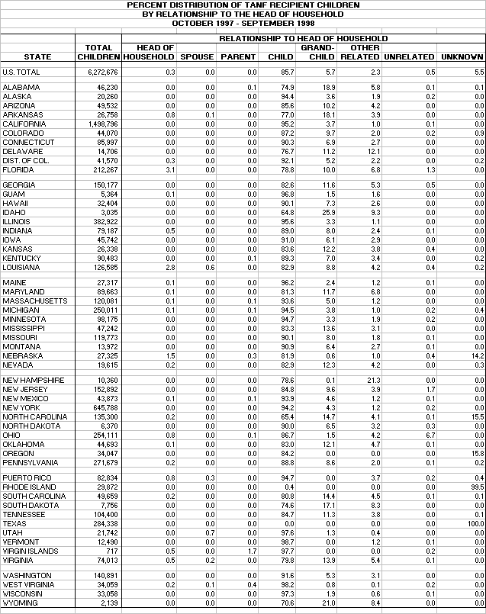

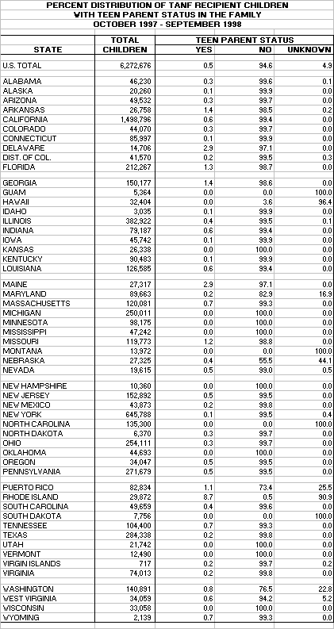
Table 9:27

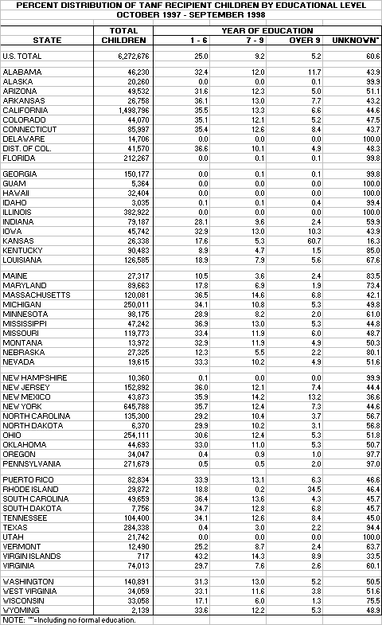
Table 9:28

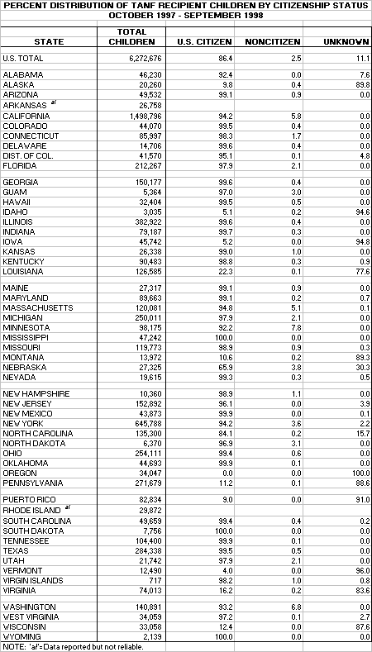
Table 9:29

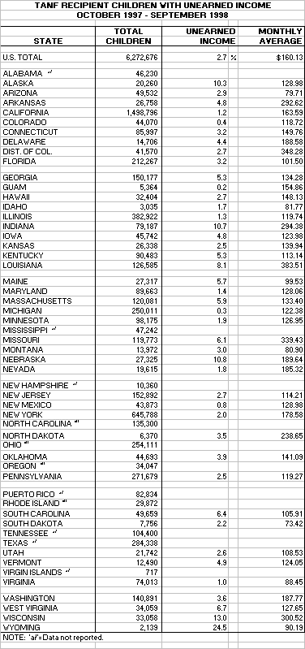
Table 9:30

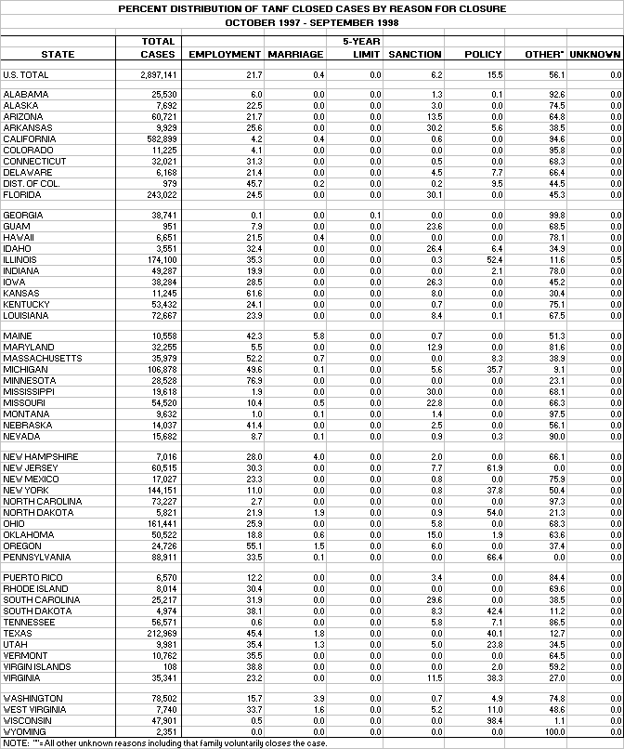
Table 9:31

X. TRIBAL PROGRAMS

The TANF program provides States and Tribes with unprecedented flexibility to design welfare programs to meet the particular needs of families in moving to work and self-sufficiency. Tribal governments, at their option, may receive direct Federal funding to independently design, administer, and operate the TANF program or may choose to allow States to continue providing these services to tribal families.

In addition to the creation of TANF, welfare reform legislation replaced the former Tribal JOBS program with the Native Employment Works (NEW) program. The NEW program provides funding for Tribes and inter-tribal consortia to design and administer tribal work activities that meet the unique employment and training needs of their populations while allowing States to provide other TANF services.

Tribes that administer their own TANF or NEW programs have the flexibility to design their programs, define who will be eligible, establish what benefits and services will be available, and develop their own strategies for achieving program goals, including how to help recipients become self-sufficient. Further, welfare reform provided Tribes with expanded child care funding and broader authority to administer the child support program. Tribes can enter into new partnerships with States to ensure that tribal families receive the support services necessary to become self-sufficient. At the federal, State, tribal and community level, new relationships are being forged. Early findings of research conducted by Dr. Eddie Brown with the Washington University School of Social Work and funded by the ACF indicate that "communication, coordination, and collaboration among Tribes, between Tribes and States and Tribes and the federal government has increased."

There are 330 American Indian entities in the contiguous 48 States identified in the Federal Register on November 13, 1996 and 13 Alaska entities — the 12 Alaska Native Regional Nonprofit Associations and the Metlakatla Indian Community of the Annette Islands Reserve identified in the Statute as eligible to administer the TANF program.

Tribal TANF programs served approximately three thousand families in Fiscal Year 1998. Another 47,502 American Indian families were served by State governments. Some Tribes also operate Native Employment Works (NEW) programs. A complete list of TANF programs and NEW programs with grant amounts is shown in table 10:1.

In several States, American Indians still constitute a large percentage of the TANF caseload. In Fiscal Year 1998, the percentage of TANF adults who are American Indians was almost 73 percent in South Dakota, over 54 percent in North Dakota, almost 41 percent in Alaska, and over 46 percent in Montana.

Tribal TANF and NEW

As of June 1, 1999, there were 19 approved Tribal TANF plans in operation. Seventeen of these involved individual Tribes. The other two were inter-tribal consortia. One consortium in southern California involves 19 Tribes and the other in Alaska involves 37 Alaska Native villages or Tribes. Further, several Tribes are known to be exploring the option of operating a TANF program.

The amount of Tribal TANF funding is based on federal expenditures attributable to American Indians in the State in fiscal year 1994 and these funds are to be subtracted from the State TANF grant. The impact of this is significant for some States.
Tribal TANF Work Participation

Under the PWRORA statute, Tribes negotiate work participation rates under the Tribal TANF plan with the Secretary. Thus, the rates vary from Tribe to Tribe. In addition, the effective dates for the Tribal TANF plans also vary. Because of the multi-faceted issues associated with the data, it is too early to come to any firm conclusions about the success of Tribal TANF programs in meeting their negotiated work participation rates.

There are several data issues. To begin, program plans for American Indian Tribes were approved for various effective dates (see chart 10:1). Under TANF legislation, data reporting is not required until the seventh month of the plan (a six-month grace period). Thus, the number of months for which data were reported is not the same for all Tribes. It is, therefore, difficult to compare across Tribes. Secondly, no Tribe was required to report data for any month prior to January 1998. Third, technical system difficulties in transmission of data have led to incomplete data for some Tribes. Fourth, some Tribes have an agreement with States to transmit the data and this has yet to be accomplished. Finally, it is important to note that TANF families, adults, and children are counted once for each month in which they were reported as receiving assistance.

While all data should be considered preliminary, it appears that the overall work participation rate for all families in Tribal TANF plans is 64 percent. Please note that tribes are authorized to count work activities that differ from the State TANF definition of work. For example, hunting, fishing, gathering, and traditional culturally related activities can be counted as work activities. Hence, the data reflects a higher work activity rate than would otherwise be reported using the much narrower State definitions.

Table 10.5 shows that there were 674 adults with a work activity. Because each adult was counted once for each month they had a work activity, it is a duplicated count in terms of individuals working. Within this limitation, table 10.5 shows that only about 11 percent were working in unsubsidized employment while almost 46 percent had unpaid work experience and over a third were doing job search and job readiness activities.

Tables 10:6 through 10:10 provide Tribal TANF characteristics data. This includes information on adult TANF recipients by relationship to head of household, family type for families in Tribal TANF Programs, and the number of TANF recipient children in the family.

The Native Employment Works Program

Background

The Tribal JOBS Program ended June 30, 1997 and on July 1, 1997 the NEW Program began, as authorized by PRWORA. Funds were appropriated for operation of the NEW Program for FY 1997 through FY 2002.

The NEW Program provides grantees with more flexibility to design programs to make work activities and services available to the populations and service area the Tribe designates. In designing programs, eligible Tribes are able to give consideration to unique economic, social, and political conditions that may exist in the community. Summary 10.1 provides a summary of program reports pertaining to grantees operating NEW Programs under Public Law Demonstration Program as reported by the U.S. Department of the Interior, Bureau of Indian Affairs (BIA). Summary 10:2 provides a summary of P.L. 102-477 Grantee Reports which have Incorporated the NEW Program.

Statistical Overview of the NEW Program for Program Year 1997
Seventy-eight Tribes and Alaska Native organizations were eligible to operate NEW programs during the 1997 NEW program year (July 1, 1997 – June 30, 1998). Each of the eligible Tribes operated a program. Fifteen tribal grantees included NEW Programs as part of their Public Law 102-477 Demonstration Projects. Grants for each eligible Tribe are restricted by statute to the amount the Tribe received in FY 1994 to operate its tribal JOBS Program, and ranged from $5,187 to $1.7 million. Approximately 36% of the grants were $10,000 - $50,000. Over 70% were less than $100,000.

Clients Served and General Program Outcomes

Eligible Tribes served a total of 6,809 NEW program clients during the 1997 NEW program year. Fifty-eight percent of clients completed the program after reaching an objective of their enrollment. Of this population: 38% of program participants completed the program after entering unsubsidized employment and 19% of participants completed the program after finishing an education or training activity that was an objective of their program enrollment.

Client Characteristics

Of clients served, 84% of program participants were female and 16 % were male. There were 375 teen parents, representing 6% of the total client population. 35 % of the 6,809 NEW Program clients also participated in the TANF Program. Twenty-nine Tribal grantees (37%) provided NEW activities and services exclusively to individuals who received TANF benefits. 48% of program participants were recipients of the Bureau of Indian Affairs (BIA) General Assistance Program. 45% of grantees established target groups for determining eligibility for services. Most frequently identified target groups were: TANF recipients; unemployed parents; unskilled applicants; single parents; teen parents; and non-custodial parents. 30% of program participants faced barriers to employment (e.g. ex-offender or substance abuser, having an intermittent work history, etc.)

NEW Program Activities and Services

The most frequent NEW program activities included job search, classroom training, work experience, and on-the-job-training. Clients spent their time on a variety of tasks including the following: job search (17%); work experience and/or on-the-job-training (12%); and classroom training (12%).

Approximately one-fifth of the grantees implemented job creation and economic development projects including: entrepreneurial training; self-employment in forestry; home child care; after school tutoring; and telemarketing services.

Services to NEW clients included child care, transportation, job retention and/or work related expenses (e.g. equipment, tools, and uniforms), counseling, and medical services. Approximately 27% of program participants received child care services, 37% received transportation assistance; 16% received assistance to cover job retention and/or work related expenses; 14% received counseling services; and 3% were provided medical services.

State Administered TANF Programs

In addition to being served by Tribal Administered TANF Programs, Tribal families are also served by State TANF programs. In these areas, Tribal communities and Tribal members are subject to the same responsibilities and eligible for the same opportunities that a State elects for its population at large. As we learn more about the effect these service design choices are having on Tribal families, we certainly will share this information with the Congress. This type of outcome data is particularly important in light of the unique challenges to self-sufficiency faced by Tribal families related to high unemployment and lack of transportation and child care assistance.

As a start in gathering this critical data, in FY 1997, ACF approved a five-year research and evaluation project entitled "Welfare to Work: Monitoring the Impact of Welfare Reform on American Indian Families with Children." The overall purposes of this longitudinal study are to monitor and document the implementation, and assess the impact, of welfare reform on American Indian families and reservations in Arizona resulting from the State and Tribal responses to TANF. Extensive demographic, contextual, socio-economic and case-level data will be compiled from a variety of sources, including administrative records, tribal documents, interviews and site visits.

One of the preliminary findings of the study is that many Tribes, while interested in self-administration of the program, are unsure about the best strategy to follow. They are interested in learning from the experiences of other Tribes in order to examine their options and make informed choices.

Additionally, a component of HHS’s evaluation of the Department of Labor’s Welfare-to-Work Grant program will examine what activities and services Tribes provide through this program, and how various tribal programs are coordinated at the local level.

Summaries, Charts and Tables:

Summary 10:1 Summary of Program Reports Pertaining to Grantees Operating NEW Programs Under Public Law 102-477 Demonstration Program
Summary 10:2 Summary of P. L.102-477 Grantee Reports which have Incorporated the Native Employment Works (NEW) Program

Chart 10:1 Effective Dates of Tribal TANF Programs
Chart 10:2 Hours which are used to Calculate Participation Rates and Groups
Table 10:1 Federal TANF and NEW Grants to American Indian Entities
Table 10:2 Estimated Number AFDC Cases with an American Indian In the Assistance Unit in States with a Federally Recognized Tribe, FY 1992 – FY 1998
Table 10:3 Estimated Number of AFDC Cases with an American Indian in the Assistance Unit and Maintenance Assistance Dollars for Such Cases in States with a Federally Recognized Tribe, FY 1994
Table 10:4 Change in Estimated AFDC/TANF Cases with an American Indian Compared to Changes in All Cases in States with a Federally Recognized Tribe from FY 1992 to FY 1998

Table 10:5 Number of Tribal Adults in Tribal Work Programs with Work Activities and Percent Distribution by Work Activity, FY 1998
Table 10:6 Adult Recipients in Tribal TANF Programs by Work Participation Status, FY 1998
Table 10:7 Adult TANF Recipients in Tribal TANF Programs by Relationship to Head of Household, FY 1998
Table 10:8 Families in Tribal TANF Programs by Reported Family Type,
FY 1998
Table 10:9 Percent Distribution of TANF Families by Number of TANF Recipient Children in the Family, FY 1998
Table 10:10 Percent Distribution of TANF Recipient Children by Age,
FY 1998

Summary 10:1

Summary of Program Reports Pertaining to Grantees Operating NEW Programs Under Public Law 102-477 Demonstration Program as reported by the U.S. Department of the Interior, Bureau of Indian Affairs (BIA)

THE 102-477 PROGRAM

Background:

Public Law 102-477, Indian Employment, Training and Related Services Demonstration Act of 1992, was enacted October 23, 1992. It authorized the integration of employment, training and related programs to improve overall effectiveness, and reduce joblessness and paperwork. A Tribe must have two or more of the eligible programs to participate in the demonstration. Eligible programs administered by the Department of Health and Human Services (DHHS) are: Native Employment Works (NEW), Tribal Temporary for Needy Families (TANF) and Child Care and Development Block Grant (CCDBG). Under the P. L. 102-477 demonstration program, the grantee may combine funding from all eligible funding sources in different federal agencies and submit a single plan and report. The plan is reviewed by each federal agency that contributes funding. BIA is responsible for management and oversight of this program. However, each federal partner is involved in the plan process and operations.

When NEW was implemented, P. L. 102-477 grantees that had incorporated the predecessor Tribal JOBS Program were allowed to incorporate the NEW Program. At the beginning of the NEW program year, funds are transferred from the Administration for Children and Families (ACF) to BIA for operation of the involved P. L. 102-477 programs. As subsequent P. L. 102-477 plans are submitted, they are reviewed by NEW staff to insure that work activities are a part of the P. L. 102-477 programs as required by the Personal Responsibility Work Opportunity Reconciliation Act.

Overview:

P. L. 102-477 grantees report separately to BIA, Office of Economic Development. The report formats for both programs are similar but not identical. The P. L. 102-477 grantee report information is listed on the attached tables. Basically the NEW funding is combined with funding from other employment and training and related programs. The grantee does one plan and one report which is submitted to BIA and shared with the other federal partners. Consequently, the resources available are enhanced beyond what would be offered under a typical NEW program. The report numbers are higher because the amount of resources utilized is greater.

During the report period covered, fifteen P. L. 102-477 grantees operated NEW under their P. L. 102-477 demonstration. Some of the reporting periods for these grantees overlap the NEW program year. However, the data presented represents 12 months of program activities.
Summary 10:2

Summary of P. L.102-477 Grantee Reports which have Incorporated the Native Employment Works (NEW) Program

- 14,404 participants were served.

- There were 9,230 positive completions of program activities over a twelve-month period. 54% of the participants who completed the program were female and 46% male.

- The majority of participants were adults. Approximately 23% were youth.

- 883 of those that completed the program were BIA General Assistance (GA) recipients, 166 were veterans and 1,118 were TANF recipients.

- 1,533 of those that entered the program were not attending school at the time of entry and did not have a high school diploma or GED. Another 1,837 were attending school at the time of entry, but did not have a high school diploma or GED. 4,225 had high school diplomas or a GED, but no post high school education and 1,791 had had some formal post-secondary education.

- Of those program participants that completed the program, 4,323 (including 865 TANF recipients) entered unsubsidized employment; 2,403 completed education/training; and 2,006 completed other program objectives.

- At the end of the report period, there were 4,774 participants still enrolled in the program.

- About 38% of the participants were reported as having experienced barriers to employment.

- 4,840 participants that completed the program had been in classroom training. 361 had been in on-the-job training (OJT) programs. 1,136 participated in supported work activities such as work experience/training and 4,191 received other support services, such as, childcare, transportation, counseling and medical services.

- 3,856 terminees participated in other tribal services, as defined by the Tribe.

- Many of the P. L. 102-477 grantees have included the CCDBG in their programs or provide child care services under their programs. 1,765 families received child care services funded through the Tribes' P. L. 102-477 program.

- The total number of children served by the program was 3,254. Of those, 40% were three years of age or younger, 27% were between four and five years old and 33% were over six years of age.

Chart 10:1

Effective Dates of Tribal TANF Programs

Effective Date Reporting Begins
Tribe MONTH YEAR MONTH YEAR

ARAPAHOE, WIND RIVER JULY 1998 JANUARY 1999
SALISH & KOOTENAI, FLATHEAD JANUARY 1999 JULY 1999
SILETZ OCTOBER 1997 APRIL 1998
FOREST CO. POTAWATOMI JULY 1997 JANUARY 1998
KLAMATH JULY 1997 JANUARY 1998
LOWER ELWHA OCTOBER 1998 APRIL 1999
NEZ PERCE JANUARY 1999 JULY 1999
OSAGE NATION MAY 1998 NOVEMBER 1998
PASCUA YAQUI NOVEMBER 1997 MAY 1998
PORT GAMBLE OCTOBER 1998 APRIL 1999
RED CLIFF OCTOBER 1997 APRIL 1998
SALT-RIVER PIMA-MARICOPA JUNE 1999 OCTOBER 1999
SISSETON-WAHPETON OCTOBER 1997 APRIL 1998
SOKAOGON CHIPPEWA OCTOBER 1997 APRIL 1998
STOCKBRIDGE-MUNSEE OCTOBER 1997 APRIL 1998
WHITE MOUNTAIN NOVEMBER 1997 MAY 1998
OJIBWE, MILLE LACS JANUARY 1999 JULY 1999
S. CL. TRIBAL CHR. ASSN. MARCH 1998 SEPTEMBER 1998
TANANA CHIEFS CONFERENCE OCTOBER 1998 APRIL 1999
NOTE: In some instances the effective date is other then the first of the month.

Chart 10:2

Hours which are used to Calculate Participation Rates and Groups for which it is Calculated

 |  | PARTI-
 | HOURS | CIPATION
 | WORKED | RATE
TRIBE | FOR | FOR
ARAPAHOE, WIND RIVER | SINGLE PARENT | SINGLE PARENT
SALISH & KOOTENAI, FLATHEAD | ALL FAMILIES | ALL FAMILIES
SILETZ | ALL FAMILIES | ALL FAMILIES AND 2 PARENT
FOREST CO. POTAWATOMI | LIKE SEC. 407 | LIKE SEC. 407
KLAMATH | ALL FAMILIES AND 2 PARENT | ALL FAMILIES AND 2 PARENT
LOWER ELWHA | ALL FAMILIES | ALL FAMILIES
NEZ PERCE | ALL FAMILIES | ALL FAMILIES
OSAGE NATION, OK | ALL FAMILIES AND 2 PARENT | ALL FAMILIES AND 2 PARENT
PASCUA YAQUI | ONE AND TWO PARENT | ONE AND TWO PARENT
PORT GAMBLE | ALL ADULTS | ALL ADULTS
RED CLIFF | LIKE SEC. 407 | LIKE SEC. 407
SALT-RIVER PIMA-MARICOPA | SINGLE PARENT & 2 PARENT | SINGLE PARENT & 2 PARENT
SISSETON-WAHPETON | SINGLE PARENT | SINGLE PARENT
SOKAOGON CHIPPEWA | LIKE SEC. 407 | LIKE SEC. 407
STOCKBRIDGE-MUNSEE | LIKE SEC. 407 | LIKE SEC. 407
WHITE MOUNTAIN | ONE AND TWO PARENT | ONE AND TWO PARENT
OJIBWE, MILLE LACS | OTHER | OTHER
S. CL. TRIBAL CHR. ASSN. | ONE AND TWO PARENT | ONE AND TWO PARENT
TANANA CHIEFS CONFERENCE | ONE AND TWO PARENT | ONE AND TWO PARENT

NOTE: “LIKE SEC. 407” MEANS LIKE SECTION 407 OF THE SOCIAL SECURITY ACT.
Note also that in a single parent family the hours reflects the number of hours in which the parent, custodian, or caretaker relative is engaged in a work activity to meet the minimum work participation requirements of the program. The Balance Budget Act of 1997 amended section 407(c)(1)(B)(i) of the Act allows both parents in a two parent family to share the number of hours engaged in work activities to meet the State TANF requirements, we allow the same in Tribal TANF programs. Thus, the numbers reported for a two-parent family could reflect the hours engaged in by either one or both of the parents, on a shared basis.

Table 10:1

Federal TANF and NEW Grants
To American Indian Entities

ENTITY | TANF |  | NEW
ALL ENTITIES | $15,598,404 |  | $7,633,286
Arapahoe Tribe of the Wind River Reservation, Wyoming | 965,472 |  | ----
Assiniboine and Sioux Tribes of the Fort Peck Indian Reservation, Montana | ---- |  | 64,671
Blackfeet Tribe of the Blackfeet Indian Reservation of Montana | ---- |  | 116,825
Cheyenne-Arapaho Tribes of Oklahoma | ---- |  | 53,288
Cheyenne River Sioux Tribe of the Cheyenne River Reservation, South Dakota | ---- |  | 69,415
Chickasaw Nation of Oklahoma | ---- |  | 29,960
Chippewa-Cree Indians of the Rocky Boy's Reservation, Montana | ---- |  | 24,512
Cocopah Tribe of Arizona | ---- |  | 5,187
Coeur D'Alene Tribe of the Coeur D'Alene Reservation, Idaho | ---- |  | 6,568
Comanche Indian Tribe, Oklahoma | ---- |  | 34,991
Confederated Salish & Kootenai Tribes of the Flathead Reservation, Montana | 1,599,224 |  | 60,238
Confederated Tribes of the Colville Reservation, Washington | ---- |  | 111,945
Confederated Tribes of the Grand Ronde Community of Oregon | ---- |  | 54,426
Confederated Tribes of the Siletz Reservation, Oregon | 661,625 |  | ----
Confederated Tribes and Bands of the Yakama Indian Nation of the Yakama Reservation, Washington | ---- |  | 131,731
Crow Tribe of Montana | ---- |  | 69,365
Devils Lake Sioux Tribe of the Devils Lake Sioux Reservation, North Dakota | ---- |  | 55,904
Eastern Band of Cherokee Indians of North Carolina | ---- |  | 90,972
Forest County Potawatomi Community of Wisconsin Potawatomi Indians, Wisconsin | 115,793 |  | 13,184
Gila River Pima-Maricopa Indian Community of the Gila River Indian Reservation of Arizona | ---- |  | 126,512
Ho-Chunk Nation of Wisconsin | ---- |  | 52,217
Hualapai Indian Tribe of the Hualapai Indian Reservation, Arizona | ---- |  | 6,089
Kickapoo Tribe of Indians of the Kickapoo Reservation in Kansas | ---- |  | 27,269
Klamath Indian Tribe of Oregon | 464,259 |  | ----
Table 10:1

Federal TANF and NEW Grants
To American Indian Entities
(continued)

ENTITY | TANF |  | NEW
La Courte Oreilles Band of Lake Superior Chippewa Indians of the Lac Courte Oreilles Reservation of Wisconsin | ---- |  | 58,483
Lower Brule Sioux Tribe of the Lower Brule Reservation, South Dakota | ---- |  | 8,184
Lower Elwha Tribe of the Lower Elwha Reservation, Washington | 501,343 |  | ----
Lummi Tribe of the Lummi Reservation, Washington | ---- |  | 57,274
Makah Indian Tribe of the Makah Indian Reservation, Washington | ---- |  | 12,496
Menominee Indian Tribe of Wisconsin | ---- |  | 114,615
Mescalero Apache Tribe of the Mescalero Reservation, New Mexico | ---- |  | 22,244
Mississippi Band of Choctaw Indians, Mississippi | ---- |  | 42,598
Navajo Nation of Arizona, New Mexico & Utah | ---- |  | 1,752,666
Nez Perce Tribe of Idaho | 504,990 |  | 34,752
Nooksack Indian Tribe of Washington | ---- |  | 45,819
Northern Cheyenne Tribe of the Northern Cheyenne Indian Reservation, Montana | ---- |  | 59,456
Oglala Sioux Tribe of the Pine Ridge Reservation, South Dakota | ---- |  | 219,158
Omaha Tribe of Nebraska | ---- |  | 39,606
Oneida Tribe of Wisconsin | ---- |  | 19,320
Osage Nation of Oklahoma | 417,449 |  | ----
Pascua Yaqui Tribe of Arizona | 966,828 |  | 55,025
Penobscot Tribe of Maine | ---- |  | 23,915
Port Gamble Indian Community of the Port Gamble Reservation, Washington | 516,580 |  | ----
Puyallup Tribe of the Puyallup Reservation, Washington | ---- |  | 22,910
Red Cliff Band of Lake Superior Chippewa Indians of Wisconsin | 347,110 |  | ----
Red Lake Band of Chippewa Indians of the Red Lake Reservation, Minnesota | ---- |  | 134,691
Rosebud Sioux Tribe of the Rosebud Indian Reservation, South Dakota | ---- |  | 164,596
Sac & Fox Nation, Oklahoma | ---- |  | 10,063
Salt River Pima-Maricopa Indian Community of the Salt River Reservation, Arizona | 710,340 |  | 51,868
Santee Sioux Tribe of the Santee Reservation of Nebraska | ---- |  | 12,576
Sauk-Suiattle Indian Tribe of Washington | ---- |  | 11,455
Sault Ste. Marie Tribe of Chippewa Indians of Michigan | ---- |  | 113,011
Seneca Nation of New York | ---- |  | 74,616
Shoshone-Paiute Tribes of the Duck Valley Reservation, Nevada | ---- |  | 5,257
Sisseton-Wahpeton Sioux Tribe of the Lake Traverse Reservation, South Dakota | 580,106 |  | 41,831
Table 10:1

Federal TANF and NEW Grants
To American Indian Entities
(continued)

ENTITY | TANF |  | NEW
Sokaogon Chippewa Community of the Mole Lake Band of Chippewa Indians, Wisconsin | 77,195 |  | 13,184
Standing Rock Sioux Tribe of North & South Dakota | ---- |  | 75,312
Stockbridge-Munsee Community of Mohican Indians of Wisconsin | 143,122 |  | ----
Stillaguamish Tribe of Washington | ---- |  | 14,319
Swinomish Indians of the Swinomish Reservation, Washington | ---- |  | 17,182
Three Affiliated Tribes of the Fort Berthold Reservation, North Dakota | ---- |  | 38,279
Tohono O'odham Nation of Arizona | ---- |  | 150,868
Tulalip Tribes of the Tulalip Reservation, Washington | ---- |  | 28,637
Turtle Mountain Band of Chippewa Indians of North Dakota | ---- |  | 207,368
Upper Skagit Indian Tribe of Washington | ---- |  | 45,819
White Mountain Apache Tribe of the Fort Apache Reservation, Arizona | 1,794,188 |  | ----
Winnebago Tribe of Nebraska | ---- |  | 19,389
Zuni Tribe of the Zuni Reservation, New Mexico | ---- |  | 54,474
Leech Lake Band Minnesota Chippewa Tribe, Minnesota | ---- |  | 168,176
Mille Lacs Band Minnesota Chippewa Tribe, Minnesota | 823,539 |  | 61,723
White Earth Band Minnesota Chippewa Tribe, Minnesota | ---- |  | 192,415
Minnesota Chippewa Tribe - Cass lake | ---- |  | 396,575
Inter-Tribal Council, Inc., Oklahoma | ---- |  | 7,776
Shoshone and Arapahoe Joint Business Council | ---- |  | 56,118
South Puget Inter-Tribal Planning Agency (SPIPA) | ---- |  | 57,274
California Indian Manpower Consortium | ---- |  | 447,885
Southern California Tribal Chairman’s Association | 1,965,268 |  | ----
Metlakatla Indian Community, Annette Island Reserve, Alaska | ---- |  | 16,917
Kawerak, Inc. | ---- |  | 80,415
Maniilag Association | ---- |  | 75,267
Association of Village Council Presidents | ---- |  | 326,075
Tanana Chiefs Conference | 2,443,973 |  | 159,115
Cook Inlet Tribal Council | ---- |  | 285,377
Bristol Bay Native Association | ---- |  | 54,427
Aleutian and Pribolof Island Association | ---- |  | 7,600
Chugachmuit | ---- |  | 17,652
Tlinget Haida Central Council | ---- |  | 124,791
Kodiak Area Native Association | ---- |  | 19,123

TABLE 10:2

Estimated Number of AFDC Cases with an American Indian
in the Assistance Unit
in States with a Federally Recognized Tribe,
FY 1992 – FY 1998

1992 1993 1994 1995 1996 1998
TOTAL | 65,922 | 66,393 | 67,817 | 67,520 | 69,720 | 44,713
ALABAMA | 104 | 0 | 0 | 42 | 42 | 24
ALASKA | 4,663 | 4,860 | 4,726 | 4,996 | 3,736 | 3,880
ARIZONA | 9,762 | 10,382 | 10,643 | 10,374 | 10,643 | 7,671
CALIFORNIA | 7,784 | 8,183 | 6,401 | 6,352 | 10,116 | 2,121
COLORADO | 515 | 421 | 505 | 416 | 562 | 297
CONNECTICUT | 0 | 49 | 97 | 96 | 0 | 94
FLORIDA | 319 | 0 | 301 | 358 | 196 | 111
IDAHO | 436 | 449 | 458 | 518 | 389 | 115
IOWA | 92 | 96 | 192 | 235 | 381 | 176
KANSAS | 160 | 367 | 438 | 501 | 371 | 292
LOUISIANA | 116 | 0 | 145 | 0 | 151 | 48
MAINE | 409 | 127 | 288 | 213 | 264 | 261
MASSACHUSETTS | 564 | 242 | 556 | 268 | 0 | 190
MICHIGAN | 1,545 | 2,027 | 2,025 | 2,565 | 1,980 | 1,113
MINNESOTA | 4,602 | 4,671 | 3,728 | 4,338 | 5,263 | 4,507
MISSISSIPPI | 97 | 233 | 140 | 49 | 148 | 24
MONTANA | 4,067 | 3,663 | 3,461 | 3,528 | 3,266 | 3,266
NEBRASKA | 727 | 674 | 978 | 803 | 784 | 548
NEVADA | 351 | 430 | 304 | 403 | 387 | 291
NEW MEXICO | 4,748 | 5,677 | 4,739 | 4,011 | 4,460 | 3,333
NEW YORK | 2,154 | 760 | 692 | 1,981 | 826 | 674
NORTH CAROLINA | 2,937 | 2,187 | 2,977 | 2,177 | 3,373 | 1,756
NORTH DAKOTA | 2,158 | 2,161 | 2,486 | 2,445 | 2,532 | 1,831
OKLAHOMA | 5,086 | 5,700 | 6,410 | 6,363 | 5,248 | 3,162
OREGON | 845 | 898 | 1,185 | 985 | 933 | 435
RHODE ISLAND | 82 | 83 | 126 | 41 | 54 | 58
SOUTH CAROLINA | 0 | 39 | 44 | 0 | 0 | 51
SOUTH DAKOTA | 3,620 | 3,739 | 4,025 | 4,041 | 3,738 | 2,823
TEXAS | 973 | 230 | 343 | 840 | 572 | 145
UTAH | 870 | 860 | 1,272 | 1,080 | 1,055 | 969
WASHINGTON | 4,106 | 4,427 | 4,853 | 4,521 | 4,897 | 3,888
WISCONSIN | 1,309 | 2,063 | 2,651 | 2,276 | 2,649 | 220
WYOMING | 720 | 694 | 629 | 705 | 704 | 339
SOURCE:1992-1996 SAMPLE DATA FROM THE NATIONAL INTEGRATED QUALITY CONTROL SYSTEM.
1998 NATIONAL EMERGENCY TANF DATA FILE AS OF 5/28/1999.

TABLE 10:3

Estimated Number of AFDC Cases with An American Indian in the Assistance Unit and Maintenance Assistance Dollars for Such Cases in States with a Federally Recognized Tribe, FY 1994
=========================================================================
% OF
ALL
CASES ALL CASES _AMERICAN INDIANS_
WITH AN ESTIMATED ESTIMATED .
STATE |  | A.I. |  | NUMBER |  | DOLLARS |  |  | CASES |  | DOLLARS
SOUTH DAKOTA |  | 58.1 |  | 6,926 |  | 2,029,892 |  |  | 4,025 |  | 1,208,212
NORTH DAKOTA |  | 42.3 |  | 5,877 |  | 2,088,851 |  |  | 2,486 |  | 912,864
ALASKA |  | 37.0 |  | 12,759 |  | 10,274,255 |  |  | 4,726 |  | 3,837,833
MONTANA |  | 29.1 |  | 11,908 |  | 4,093,827 |  |  | 3,461 |  | 1,246,241
ARIZONA |  | 14.8 |  | 71,984 |  | 21,542,808 |  |  | 10,643 |  | 2,897,437
NEW MEXICO |  | 14.1 |  | 33,633 |  | 10,937,644 |  |  | 4,739 |  | 1,503,582
OKLAHOMA |  | 13.6 |  | 46,971 |  | 13,722,226 |  |  | 6,410 |  | 1,965,783
WYOMING |  | 11.0 |  | 5,739 |  | 1,721,878 |  |  | 629 |  | 190,032
UTAH |  | 7.1 |  | 17,801 |  | 6,080,803 |  |  | 1,272 |  | 408,124
NEBRASKA |  | 6.1 |  | 15,934 |  | 5,089,335 |  |  | 978 |  | 322,520
MINNESOTA |  | 5.9 |  | 62,979 |  | 30,084,193 |  |  | 3,728 |  | 1,839,030
IDAHO |  | 5.3 |  | 8,676 |  | 2,447,938 |  |  | 458 |  | 139,172
WASHINGTON |  | 4.7 |  | 102,952 |  | 50,719,237 |  |  | 4,853 |  | 2,457,987
WISCONSIN |  | 3.4 |  | 77,188 |  | 35,738,858 |  |  | 2,651 |  | 1,189,307
OREGON |  | 2.8 |  | 42,135 |  | 16,629,598 |  |  | 1,185 |  | 545,291
NORTH CAROLINA |  | 2.3 |  | 131,220 |  | 30,097,236 |  |  | 2,977 |  | 680,798
NEVADA |  | 2.2 |  | 14,047 |  | 3,987,016 |  |  | 304 |  | 82,386
KANSAS |  | 1.5 |  | 30,102 |  | 10,405,615 |  |  | 438 |  | 152,312
MAINE |  | 1.3 |  | 22,934 |  | 9,592,801 |  |  | 288 |  | 138,468
COLORADO |  | 1.2 |  | 41,614 |  | 13,116,900 |  |  | 505 |  | 132,436
MICHIGAN |  | 0.9 |  | 223,950 |  | 96,125,945 |  |  | 2,025 |  | 837,280
CALIFORNIA |  | 0.7 |  | 908,999 |  | 501,515,502 |  |  | 6,401 |  | 3,902,720
RHODE ISLAND |  | 0.6 |  | 22,654 |  | 11,216,133 |  |  | 126 |  | 75,836
MASSACHUSETTS |  | 0.5 |  | 111,783 |  | 60,856,866 |  |  | 556 |  | 335,627
IOWA |  | 0.5 |  | 39,555 |  | 14,208,355 |  |  | 192 |  | 67,286
MISSISSIPPI |  | 0.2 |  | 56,785 |  | 6,798,459 |  |  | 140 |  | 12,846
LOUISIANA |  | 0.2 |  | 86,915 |  | 14,191,069 |  |  | 145 |  | 34,419
CONNECTICUT |  | 0.2 |  | 59,201 |  | 33,373,423 |  |  | 97 |  | 73,083
NEW YORK |  | 0.2 |  | 454,951 |  | 225,394,525 |  |  | 692 |  | 256,906
FLORIDA |  | 0.1 |  | 247,087 |  | 62,809,939 |  |  | 301 |  | 82,764
TEXAS |  | 0.1 |  | 283,744 |  | 46,107,842 |  |  | 343 |  | 35,018
SOUTH CAROLINA |  | 0.1 |  | 51,925 |  | 9,102,927 |  |  | 44 |  | 12,315
ALABAMA |  | 0.0 |  | 50,340 |  | 7,474,228 |  |  | 0 |  | 0
BASED ON SAMPLE DATA FROM THE NATIONAL INTEGRATED
QUALITY CONTROL SYSTEM (NIQCS).

TABLE 10:4
Change in Estimated AFDC/TANF Cases with an American Indian Compared to Changes in All Cases in States with a Federally Recognized Tribe from FY 1992 to FY 1998
ALL CASES AMERICAN INDIAN
DIFFERENCE DIFFERENCE
STATE | 1992 | 1998 | CASES | PERCENT | 1992 | 1998 | CASES | PERCENT
U.S. TOTAL | 3,128,798 | 2,137,066 | -991,732 | -31.7 | 65,922 | 44,713 | -21,209 | -32.2
ALABAMA | 50,631 | 23,792 | -26,839 | -53.0 | 104 | 24 | -80 | -76.9
ALASKA | 10,807 | 10,210 | -597 | -5.5 | 4,663 | 3,880 | -783 | -16.8
ARIZONA | 63,598 | 40,163 | -23,435 | -36.8 | 9,762 | 7,671 | -2,091 | -21.4
CALIFORNIA | 806,086 | 707,062 | -99,024 | -12.3 | 7,784 | 2,121 | -5,663 | -72.8
COLORADO | 42,081 | 21,194 | -20,887 | -49.6 | 515 | 297 | -218 | -42.3
CONNECTICUT | 55,499 | 47,188 | -8,311 | -15.0 | 0 | 94 | 94 | ---
FLORIDA | 221,205 | 111,143 | -110,062 | -49.8 | 319 | 111 | -208 | -65.2
IDAHO | 7,335 | 1,860 | -5,475 | -74.6 | 436 | 115 | -321 | -73.6
IOWA | 37,158 | 25,167 | -11,991 | -32.3 | 92 | 176 | 84 | 91.3
KANSAS | 28,741 | 13,914 | -14,827 | -51.6 | 160 | 292 | 132 | 82.5
LOUISIANA | 92,200 | 47,916 | -44,284 | -48.0 | 116 | 48 | -68 | -58.6
MAINE | 23,919 | 15,331 | -8,588 | -35.9 | 409 | 261 | -148 | -36.2
MASSACHUSETTS | 111,448 | 66,409 | -45,039 | -40.4 | 564 | 190 | -374 | -66.3
MICHIGAN | 225,609 | 123,693 | -101,916 | -45.2 | 1,545 | 1,113 | -432 | -28.0
MINNESOTA | 63,656 | 48,464 | -15,192 | -23.9 | 4,602 | 4,507 | -95 | -2.1
MISSISSIPPI | 60,810 | 23,631 | -37,179 | -61.1 | 97 | 24 | -73 | -75.3
MONTANA | 10,909 | 7,275 | -3,634 | -33.3 | 4,067 | 3,266 | -801 | -19.7
NEBRASKA | 16,551 | 13,374 | -3,177 | -19.2 | 727 | 548 | -179 | -24.6
NEVADA | 11,867 | 10,383 | -1,484 | -12.5 | 351 | 291 | -60 | -17.1
NEW MEXICO | 28,764 | 21,363 | -7,401 | -25.7 | 4,748 | 3,333 | -1,415 | -29.8
NEW YORK | 397,172 | 336,857 | -60,315 | -15.2 | 2,154 | 674 | -1,480 | -68.7
NORTH CAROLINA | 121,427 | 76,337 | -45,090 | -37.1 | 2,937 | 1,756 | -1,181 | -40.2
NORTH DAKOTA | 6,394 | 3,275 | -3,119 | -48.8 | 2,158 | 1,831 | -327 | -15.2
OKLAHOMA | 46,837 | 24,135 | -22,702 | -48.5 | 5,086 | 3,162 | -1,924 | -37.8
OREGON | 41,460 | 18,898 | -22,562 | -54.4 | 845 | 435 | -410 | -48.5
RHODE ISLAND | 21,288 | 19,229 | -2,059 | -9.7 | 82 | 58 | -24 | -29.3
SOUTH CAROLINA | 49,710 | 25,293 | -24,417 | -49.1 | 0 | 51 | 51 | ---
SOUTH DAKOTA | 7,223 | 3,851 | -3,372 | -46.7 | 3,620 | 2,823 | -797 | -22.0
TEXAS | 265,819 | 145,232 | -120,587 | -45.4 | 973 | 145 | -828 | -85.1
UTAH | 17,882 | 10,769 | -7,113 | -39.8 | 870 | 969 | 99 | 11.4
WASHINGTON | 96,407 | 77,762 | -18,645 | -19.3 | 4,106 | 3,888 | -218 | -5.3
WISCONSIN | 81,680 | 14,649 | -67,031 | -82.1 | 1,309 | 220 | -1,089 | -83.2
WYOMING | 6,625 | 1,247 | -5,378 | -81.2 | 720 | 339 | -381 | -52.9
TABLE 10:5

Number of Tribal TANF Recipient Adults in Tribal Programs with Work Activities and Percent Distribution by Work Activity, FY 1998

==============================================================
WORK ACTIVITY | ADULTS |  | PERCENT
TOTAL | 674 |  | 100.0%
UNSUBSIDIZED EMPLOYMENT | 74 |  | 11.0
SUBSIDIZED PRIVATE EMPLOYMENT | 2 |  | 0.3
SUBSIDIZED PUBLIC EMPLOYMENT | 1 |  | 0.1
UNPAID WORK EXPERIENCE | 309 |  | 45.8
O.J.T. | 2 |  | 0.3
JOB SEARCH / READINESS | 226 |  | 33.5
COMMUNITY SERVICE | 0 |  | 0.0
VOCATIONAL EDUCATION | 37 |  | 5.5
JOB SKILLS | 13 |  | 1.9
EMPLOYMENT EDUCATION | 0 |  | 0.0
SCHOOL ATTENDANCE | 40 |  | 5.9
OTHER | 1 |  | 0.1

NOTE: ADULTS INCLUDE TEEN HEAD-OF-HOUSEHOLDS AND MARRIED TEENS.
ONLY ONE ADULT PER FAMILY COUNTED AND ONLY IF THEY WORKED TWENTY OR MORE HOURS, TOTAL
ADULTS ARE COUNTED ONCE FOR EACH MONTH IN WHICH THEY HAD A WORK ACTIVITY.
DATA ARE INCOMPLETE FOR SOME TRIBES.

TABLE 10:6
Adult Recipients in Tribal TANF Programs By Work Participation Status
FY 1998

========================================================================
STATUS | NUMBER | PERCENT
TOTAL | 1,067 | 100.0
DISREGARDED  CHILD UNDER 1 | 78 | 7.3
DISREGARDED  SANCTIONS | 15 | 1.4
DISREGARDED  NEW PARTICIPANT | 24 | 2.2
EXEMPT  DISABLED | 70 | 6.6
EXEMPT  OTHER | 160 | 15.0
DEEMED  TEEN-HEAD IN  SCHOOL | 20 | 1.9
DEEMED  CHILD UNDER 6 | 42 | 3.9
REQUIRED TO WORK | 658 | 61.7
NOTE: ADULTS INCLUDE TEEN HEAD-OF-HOUSEHOLDS AND MARRIED TEENS.
ADULTS ARE COUNTED ONCE FOR EACH MONTH IN WHICH THEY WERE REPORTED.
DATA ARE INCOMPLETE FOR SOME TRIBES.

TABLE 10:7

Adult TANF Recipients in Tribal TANF Programs By Relationship to Head of Household, FY 1998

RELATIONSHIP |  | NUMBER |  | PERCENT
TOTAL |  | 1,890 |  | 100.0
HEAD |  | 1,516 |  | 80.2
SPOUSE |  | 245 |  | 13.0
PARENT |  | 59 |  | 3.1
CHILD |  | 15 |  | 0.8
STEPCHILD |  | 0 |  | 0.0
GRANDCHILD |  | 0 |  | 0.0
OTHER |  | 1 |  | 0.1
FOSTER CHILD |  | 0 |  | 0.0
UNRELATED CHILD |  | 0 |  | 0.0
UNRELATED ADULT |  | 54 |  | 2.9
NOTE: ADULTS INCLUDE TEEN HEAD-OF-HOUSEHOLDS
AND MARRIED TEENS.
ADULTS ARE COUNTED ONCE FOR EACH MONTH
IN WHICH THEY WERE REPORTED.
DATA ARE INCOMPLETE FOR SOME TRIBES.
TABLE 10:8

Families in Tribal TANF Programs by Reported Family Type, FY 1998

FAMILY TYPE |  | NUMBER |  | PERCENT
ALL TYPES |  | 1,421 |  | 100.0
ONE PARENT |  | 832 |  | 58.6
TWO PARENT |  | 196 |  | 13.8
NO PARENT:
WITH ADULT |  | 303 |  | 21.3
WITHOUT ADULT |  | 0 |  | 0.0
NOT CODED |  | 90 |  | 6.3
NOTE: ADULTS INCLUDE TEEN HEAD-OF-HOUSEHOLDS
AND MARRIED TEENS.
FAMILIES ARE COUNTED ONCE FOR EACH
MONTH THEY WERE REPORTED.
DATA ARE INCOMPLETE FOR SOME TRIBES.

TABLE 10:9
Percent Distribution of Tribal TANF Families by Number of TANF Recipient Children in the Family, FY 1998

NUMBER OF  CHILDREN IN  FAMILY |  | PERCENT
ALL FAMILIES |  | 100.0
ONE CHILD |  | 35.0
TWO CHILDREN |  | 29.0
THREE CHILDREN |  | 16.O
FOUR CHILDREN |  | 12.0
FIVE CHILDREN |  | 0.8
SIX OR MORE  CHILDREN |  | 3.5
NOTE: FAMILES ARE COUNTED ONCE FOR EACH MONTH THEY
ARE REPORTED.
DATA ARE INCOMPLETE FOR SOME TRIBES.
THERE ARE AN AVERAGE OF 2.2 CHILDREN PER FAMILY.

TABLE 10:10

Percent Distribution of Tribal TANF Recipient Children by Age, FY 1998

AGE OF CHILD | PERCENT |  | AGE OF CHIID | PERCENT
ALL AGES | 100.0 |  | ----------- | ----------
LESS THAN ONE | 6.2 |  | 10 YEARS OLD | 5.8
1 YEAR OLD | 7.5 |  | 11 YEARS OLD | 6.1
2 YEARS OLD | 5.5 |  | 12 YEARS OLD | 5.5
3 YEARS OLD | 5.0 |  | 13 YEARS OLD | 4.8
4 YEARS OLD | 8.1 |  | 14 YEARS OLD | 5.1
5 YEARS OLD | 7.6 |  | 15 YEARS OLD | 3.0
6 YEARS OLD | 5.2 |  | 16 YEARS OLD | 3.2
7 YEARS OLD | 6.8 |  | 17 YEARS OLD | 1.6
8 YEARS OLD | 5.3 |  | 18 YEARS OLD | 0.5
9 YEARS OLD | 5.5 |  | AGE UNKNOWN | 0.0
NOTE: CHILDREN ARE COUNTED ONCE FOR EACH MONTH THAT THEY ARE REPORTED.
DATA ARE INCOMPLETE FOR SOME TRIBES.

TANF RECIPIENT CHILDREN’S AVERAGE AGE IS 8.0 YEARS.

XI. CHILD CARE

Introduction

Child care is a critical support for working families and can be especially important to families seeking to become or remain self-sufficient. This is evident when the high, and growing, labor force participation of parents -- even before PRWORA -- is considered. For example, in 1995 almost 13 million infants, toddlers and pre-school children under the age of 6 were in child care. In 1996, 96% of fathers and 63% of mothers with children under age 6 worked. By 1998, the latest year for which Census figures are available, the percentage of single employed mothers with incomes under 200% of poverty, rose from 44% in 1992 to 57% in 1998.
The increased number of TANF families who are working and the increased number of hours they must work have resulted in a much greater demand for child care services. Near-poor working families must also have child care if they are to retain their jobs and avoid having to seek cash assistance. The continued strength of the economy, along with the continued effectiveness of welfare reform and the increasing work participation of TANF recipients will continue to place great pressure on the nation’s child care resources. Ensuring quality child care is not only essential for working parents, but finding high quality child care is important for child health and well being.
Recent data show that States across the country report extensive waiting lists and unmet need. Iowa has subsidized child care slots for almost 75,000 children from birth to age 5 – less than half of the reported need. In California, between 100,000 and 200,000 families are waiting for slots. In Texas, approximately 30,000 – 35,000 names are on waiting lists. In Florida, 25,000 are on waiting lists, as are 13,500 families in Massachusetts. Michigan has identified the growth in the need for child care as the principal issue it expects to face in the near future.
Another indicator of the high demand for child care services is the rate of spending in the program. While States have two years to obligate and expend the CCDBG funds, States have obligated or expended 100% of the funds available in FY 98 in that same fiscal year. In addition, States spent over $1.6 billion of their own funds on child care (this includes child care MOE and State child care matching funds).

Background

PRWORA repealed the Federal child care programs formerly authorized in the Social Security Act -- AFDC child care, Transitional child care and At-Risk child care. It also provided new child care funds and consolidated most Federal child care funds under the rules of the Child Care and Development Block Grant (CCDBG) Act of 1990. PRWORA unified what was a fragmented child care subsidy system under a single set of rules, giving States the flexibility to serve all families through a single, integrated child care system.
PRWORA specifically requires States to ensure that not less than 70 percent of the new child care funds be used to provide child care assistance to families receiving TANF, families attempting through work activities to transition off of TANF, and families at risk of becoming dependent on TANF. In 1998, PRWORA provided over $2 billion in entitlement funding for child care in addition to the over $1 billion provided to States through the discretionary CCDBG. Table 11:1 shows the amounts of this entitlement child care funding and the amount of the CCDBG available to each State in 1998.
Although PRWORA provided additional mandatory funds for child care through the Social Security Act, almost one-quarter of the States also chose to expend TANF funds directly on child care services. Recognizing the critical importance of child care to their self-sufficiency efforts, more than one-half of the States elected to transfer additional amounts of TANF funds to the CCDBG in 1998 as shown in table 11:2. Similarly, Table 11:3 shows that one-third of the States reported expending over $391 million on child care through separate State programs for TANF maintenance of effort purposes.

Unmet Need
Nationally, there are approximately 10 million children under age 13 who are income eligible for CCDBG child care. For 1997, we estimated that about 1.25 million children received child care assistance through the CCDBG in an average month. Many children may also receive child care assistance through a State TANF child care program and are not included in this estimate. Confronted with great unmet need and scarce resources, States are adopting a variety of approaches in their utilization of child care dollars. Most States set income eligibility levels that are considerably lower than federal law allows. Additionally, States set high co-payments to parents and almost all States allow providers to charge additional out of pocket costs to parents in order to make up for very low reimbursement rates.

Current Research

A large and growing body of research shows that young children who grow up in families with limited incomes are at risk for poor social outcomes. The most effective early childhood programs can positively influence a child's social and emotional development, enhance the likelihood of successful school performance in the early grades, and in some instances, reduce the later risks of involvement with the special education and juvenile justice systems. Scientists have recently made many discoveries about how a child’s earliest experiences affect the way the brain is organized. For example, brain research now confirms that interactions and experiences in a child's early years have a big impact on a child's emotional development, learning abilities and functioning in later life. Researchers are also finding that the kind of care-giving parents and others provide has an even greater effect on brain development than most people previously suspected.
A strong body of research indicates that high quality care improves children’s well-being and development, promotes school readiness, and is a positive predictor of children’s performance well into their school careers. For example, recently released findings from the NICHD Study of early child care shows that children attending centers that meet professional standards for quality, score higher on school readiness and language tests and have fewer behavioral problems than do their peers in centers not meeting such standards. The study found that children fared better when child-staff ratios were lower and also when teachers had more training and education.

Although it is clear that better quality care results in better outcomes for children, there are serious concerns, likewise supported by research, about the quality of care many children receive. Even the basic health and safety of children in care has become a national concern. In the NICHD study, most of the child care settings studied did not meet all the standards. Compliance ranged from 10 percent for infant classrooms to 34 percent for 3-year-olds. Of the 50 sets of State child care regulations only three were found to meet the recommended child/staff ratio for toddlers. In addition, only nine States met the teacher training standards for infants.
In another recently reported study, high quality child care positively affected children's cognitive and social skills through the second grade. In a four-year follow-up of children studied in the 1995 Cost, Quality and Child Outcomes Study, researchers at four universities found that children in high quality care programs when they were 3 and 4 years old scored better on math, language and social skills development through the early elementary years than did children who had been in poor-quality preschool care.
Parents need the assurance of knowing that their children are in safe, healthy and nurturing care that the family can afford if they are to focus their attention on the demands of the workplace. The complex interplay of child care supply, cost, quality and convenience create tremendous stresses for parents who are trying to make ends meet and balance the competing demands of work and family life. When parents are worried about their children’s well-being, the worry and stress are likely to affect their job performance.
A recent GAO study demonstrates the pervasiveness of these issues by analyzing the trade-offs low-income mothers confront when they want to work but face high child care costs. According to that study, child care subsidies are often a strong factor in a parent’s ability to work, and reducing child care costs increases the likelihood that poor and near-poor mothers will be able to work. The GAO observed that affordable child care is a decisive factor that encourages low-income mothers to seek and maintain employment. In another study, the GAO found that single parents who received child care assistance more often successfully completed their training, obtained jobs or experienced other positive outcomes.
Research being conducted by the Child Care Bureau’s Child Care Policy Research Consortium is showing that States attempting to make sufficient funds available to meet demand are experiencing tremendous growth in use of child care subsidies. This growth in demand is especially among the low-income working families who were formerly on TANF. For example, in Illinois between 1997 and 1999, the number of children in current and former TANF families receiving subsidies connected to cash assistance and using certificates grew by 80 percent. The largest proportion of that growth came from former TANF families whose usage grew by 200 percent. In Maryland, during the same two years, the number of children receiving subsidies grew by over 30 percent. Again, the largest growth rate was seen among former TANF families, whose use of subsidized care increased by over 100 percent.
Our research is further showing that increased funding for child care subsidies increases the likelihood that TANF recipients will work. For example, a longitudinal study of child care, employment and earnings during the early stages of Welfare Reform in Miami-Dade County, Florida shows that increases in child care subsidies are associated with an increase of approximately ten percent in the likelihood that work-ready welfare recipients will become employed. Increased funding for child care subsidies also significantly increases the earnings of current and former welfare recipients, with the impact on earnings among the hard-to-employ being almost double the impact on earnings of work- ready recipients. While this study reflects conditions in only one site and is not representative of other areas, it may be an important barometer for other States and locales.
Although evidence to confirm the importance of child care subsidies in helping families transition from welfare to work is mounting, States are unable to meet the enormous demand for child care, even given the lower-eligibility levels that they have adopted. As a result, States across the country report extensive waiting lists and unmet need. Supply studies by the Child Care Policy Research Consortium using new geo-coding (mapping) techniques are beginning to document the extent to which the existing supply of child care is unevenly distributed, with severe shortages in many local communities for families in a variety of circumstances.
Employers also say that child care is a major obstacle in their attempts to build a stable, productive workforce. In a study sponsored by the National Conference of State Legislatures (1997) employers cited child care as causing more problems in the workplace than any other family-related issue. Increases in absenteeism and tardiness due to difficulties with child care were reported in nine out of 10 companies. Eighty percent of the companies surveyed said that workdays were cut short because of child care problems. A body of previous research on child care and the workplace also suggests that child care is a critical factor in parents’ ability to obtain and sustain employment and in their consistency and productivity on the job. Improvements in employee absenteeism, lateness, and turnover have also been related to the availability of employer-supported child care services.

Ongoing and Future Research
Many child care research activities are currently underway within ACF, the Department and other Federal Government agencies, as well as foundations. Many studies are examining the relationships between State and local welfare reform policies and practices and their child care programs and the implications for parents applying for, or receiving, TANF benefits. These studies will provide substantial information on the complex interrelationships between TANF and child care.
Child care research being carried out by DHHS includes the following representative projects:
- “A National Study of Child Care for Low Income Families,” being conducted by Abt Associates in cooperation with the National Center for Children in Poverty at Columbia University, will provide information on (1) the effects of federal, State and local policies and programs on the child care market; (2) the employment and child care decisions of low-income families; (3) the characteristics and functioning of family child care; and (4) the experiences children and families have with family child care.
- A study by Mathematica Policy Research (MPR), entitled "The Role of Child Care in Low Income Families' Labor Force Participation," has produced a set of options for future research, as well as three review papers synthesizing the research on aspects of child care --flexibility, quality and cost -- that may affect the ability of low-income families to obtain and maintain employment over time and to obtain higher earnings.
- Another ongoing project with MPR, entitled "Study of Infant Care under Welfare Reform," will establish a preliminary knowledge base of policies, programs and strategies that States have adopted in order to help parents of infants transition into work or school. This study will incorporate a paper on proposed future research designs to study infant care.
- The Child Care Policy Research Consortium, some of whose early findings are noted above, will continue studying critical child care issues affecting welfare recipients and low-income working parents. The consortium is composed of colleges, universities and private research organizations; State and local child care agencies; resource and referral agencies; parent and provider groups, national organizations, and businesses. The lead organizations and States in which the partnerships are working include: (1) California Child Care Resource and Referral Network in San Francisco (working in California, Connecticut, and Florida); (2) Columbia University, School of Public Health, National Center on Children in Poverty in New York City (working in Illinois, Maryland, New Jersey and New York); (3) Harvard University, School of Public Health in Cambridge, Massachusetts (working in Chicago, Illinois); (4) Linn Benton Community College in Albany, Oregon (working in Oregon); and (5) Wellesley College, Department of Economics in Wellesley, Massachusetts (working in Massachusetts, Florida and Alabama).

- The Office of the Assistant Secretary for Planning and Evaluation has sponsored a report examining how early childhood programs and TANF agencies are working together to better meet the needs of families with young children and families affected by welfare reform. The report, entitled "Enhancing the Well-Being of Young Children and Families in the Context of Welfare Reform: Early Lessons from Early Childhood, TANF and Family Support Programs” was produced by the National Center for Children in Poverty in collaboration with MPR, Inc. The report provides in-depth profiles of 11 early childhood, family support, and TANF agencies which are finding innovative ways to promote the well-being of young children and to provide family support in the context of welfare reform. It also describes the range of strategies these programs are using, possibilities for replicating these strategies in other settings, and issues that require further work.

Continued research and evaluation of issues affecting child care are essential to improve State and local policies, promote effective practice, and increase our capacity to better serve low-income children and parents. With this in mind, Congress recently authorized $10 million for child care research and evaluation that will become available in fiscal year 2000. This new research funding authority provides us an important opportunity to enhance our knowledge in critical areas and in ways that will be helpful to parents, providers, employers, communities, States, and the country as a whole.

Appendices:
Table 11:1 Child Care Funding, State Allocations, 1998.
Table 11:2 TANF Transfers to CCDBG, 1998
Table 11:3 Expenditures of State Funds in Separate State Programs - Expenditures for Child Care, 1998

Table 11:1
Child Care Funding, State Allocations, 1998.

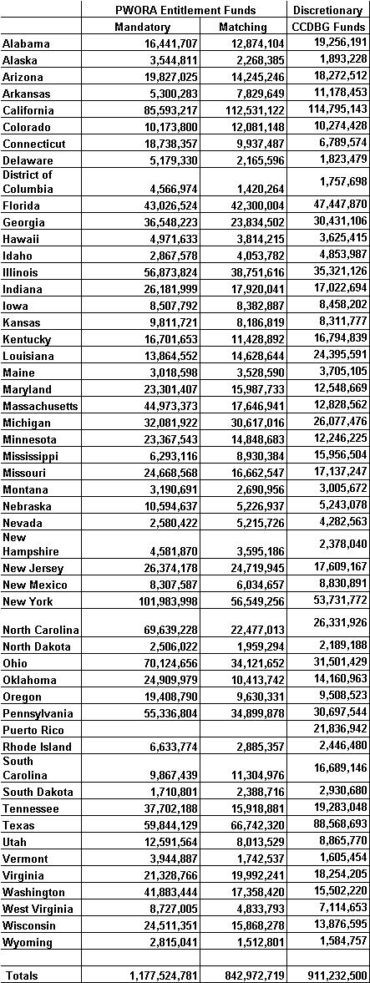
Table 11:2
TANF Transfers to CCDBG, 1998

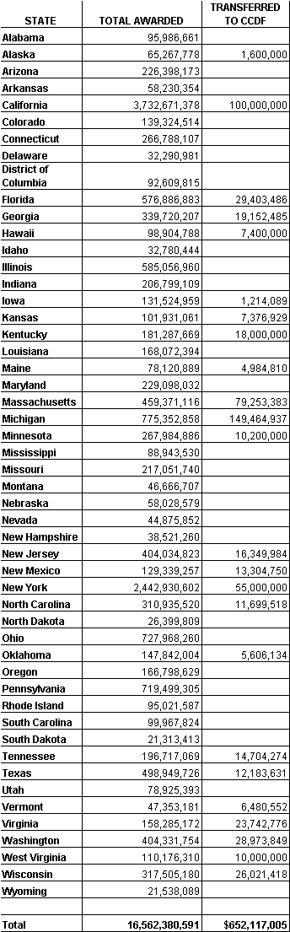
Table 11:3
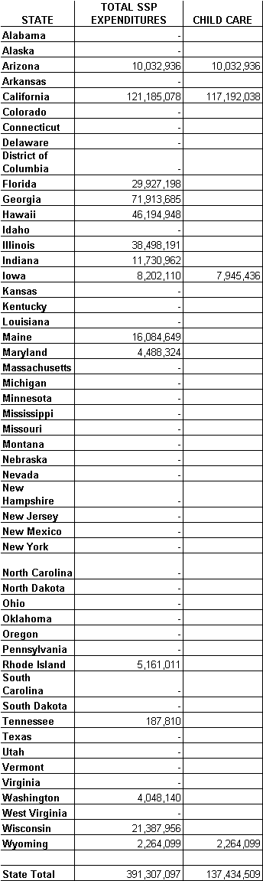
Expenditures of State Funds in Separate State Programs - Expenditures for Child Care,

XII. CHARACTERISTICS OF EACH STATE PROGRAM FUNDED UNDER TANF

States have a wide array of choices when it comes to designing their programs. However, the primary focus of State policy choices continues to be encouraging, requiring, and supporting work. A major study of the implementation of welfare reform by the Nelson Rockefeller Institute of Government noted that the pervasive changes in social programs since enactment of PRWORA “have occurred in large part because strong signals have been sent by governors and State legislators that a work-based approach to welfare reform is no longer just one federal priority among many but is now a central objective within each State.” Almost all States have moved to “Work First” models, requiring recipients to move quickly into available jobs.

Beyond the focus on work, four other themes stand out about State policy choices:

First, as envisioned in the statute, there is considerable variety in the State’s choices about policies such as time limits, sanctions, diversion, and policies for families who face specific barriers to work. Further, in some States, there is considerable program diversity within some States. Thus, there is no single, typical program.

- Second, States choices regarding eligibility requirements for their TANF programs appear to have the impact of increasing caseloads rather than decreasing the caseloads. For example, some States have expanded eligibility for two-parent families and increased asset and resource limits. It is too early to forecast the longer term implications of these eligibility changes.

Third, State choices about TANF policy and implementation can affect families’ ability to receive other benefits for which they are eligible (such as Medicaid and Food Stamps), sometimes in unintended ways. The “de-linking” of eligibility for Medicaid and TANF, for example, offers States both new challenges and new opportunities. When families learn they may receive Medicaid coverage without having to receive welfare, they may be less likely to turn to welfare in the first place. Because eligibility for the two programs is de-linked, families might not be obtaining Medicaid coverage.

Fourth, many States have yet to significantly reinvest the TANF resources freed up by declining caseloads to help families with more intensive needs to move to self-sufficiency before the time limits take effect. (For example, families with a disabled parent or child with a disability, families with a member who needs substance abuse or mental health treatment, and families suffering from domestic violence.)

Requiring Work and Making Work Pay

States have shown diversity in implementing the statutory requirement that parents or caretakers receiving assistance are required to engage in work (as defined by the State) within 24 months, or less at State option. Most States have opted for a shorter period, with 20 States requiring immediate participation in work; 6 States requiring work within 45 days to 6 months; 23 States requiring work within 24 months; and 2 States with other time frames for work. In addition, some States use a narrow definition of “work,” whereas others allow for a broader range of activities, including training or volunteering.

Another major feature of State policy regarding work is the increased use of sanctions if family members fail to participate in required activities. While reliable national data is not available at this point, the State waiver studies suggest that there is much more aggressive State use of sanctions under welfare reform. For example, waiver demonstrations indicate that a demonstration county in Florida increased its sanction rate from seven to 30 percent and Delaware’s sanction rate increased from nearly zero to 50 percent. Under PRWORA, if the individual in a family receiving assistance refuses to engage in required work, the State has the option to either reduce or terminate the amount of assistance payable to the family, subject to good cause. Thirty-seven States have elected to terminate the amount of assistance payable to a family for not cooperating with work requirements (typically after several infractions), and fourteen States have chosen to reduce the amount of cash payable to a family (by a pro rata share).

States have also enacted policies to make work pay, generally by increasing the amount of earnings disregarded in calculating welfare benefits. Forty-three States made changes to simplify and expand the treatment of earnings compared to the AFDC treatment. In conjunction, all States have raised their limits on assets and/or vehicles thus allowing families to keep a vehicle that may be their only means of transportation to work, and to accumulate savings.

Time Limiting Assistance

The Federal law limits the percent of cases that may receive federally-funded assistance for more than 60 months in order for the State to avoid a time-limit penalty. Within that framework, States have broad flexibility to set policies on time-limits, including policies on the duration for which benefits may be received, exemptions, and criteria for hardship extensions.

State policies related to time limiting assistance to a family vary greatly. States have chosen the following time limit policies:

- 27 States use the five-year federal time limit (Alabama, Alaska, Colorado, District of Columbia, Hawaii, Iowa, Kansas, Kentucky, Maine, Maryland, Minnesota, Mississippi, Missouri, Montana, New Hampshire, New Jersey, New Mexico, New York, North Dakota, Oklahoma, Pennsylvania, South Dakota, Vermont, Washington, West Virginia, Wisconsin, and Wyoming);

- 8 States (Louisiana, Nebraska, Nevada, North Carolina, Oregon, South Carolina, Tennessee, and Virginia) have chosen “intermittent” time limits (for example, Louisiana limits TANF receipt to 24 months in any 60 month period, with a lifetime limit of 60 months);

- 8 States have chosen a lifetime time limit shorter than the federal limit (Arkansas, Connecticut, Delaware, Florida, Georgia, Idaho, Ohio, and Utah);

- 3 States have chosen options that do not involving supplements for families reaching the federal time limit (Illinois, Massachusetts, and Michigan); and

- 5 States have chosen time limits for adults only (Arizona, California, Indiana, Rhode Island, and Texas).

Diversion

Many States are experimenting with a variety of strategies to divert families from receiving cash assistance. These diverse strategies include: lump-sum cash payments, where families receive a payment sufficient to resolve an immediate emergency (such as a car breakdown) and keep the family working and off cash assistance; applicant job search, where the applicant is required to look for a job for some period of time (with or without structured assistance from the welfare office) before receiving benefits; and other alternative support services (such as linkages to child care or community resources). These strategies are quite new, and there is little research yet on their effects.

However, a recent study by the Center for Health Policy Research at the George Washington University, funded by the Department, has examined the emergence of diversion programs as a welfare reform strategy and the potential for diversion to affect access to Medicaid. The study reported on the use of diversion in all 50 States and the District of Columbia, and also included an examination of the experiences of five local communities in establishing and operating diversion programs (See chapter Summary 14:3). In addition to noting the importance of processing Medicaid applications even in cases in which TANF assistance is deferred, it highlights promising approaches that other States may follow to ensure access to Medicaid and other supports, such as child care, for those who obtain employment through diversion or are otherwise diverted from the TANF rolls.

One of Montana's local programs was examined in the study. In that program, child care and Medicaid-only option are provided for families with work or child support income. The study found that this option has greatly increased demand for child care.

Families Facing Specific Barriers to Employment

Although there have been dramatic gains in work for many TANF families, too many families with multiple barriers to success are at risk of being left behind. While many parents on welfare have succeeded in moving to work, despite extraordinary obstacles, others will need additional treatment and support services to work and succeed at work. The States vary a great deal in the extent to which they have planned and invested in programs to provide these supports. There are no completely reliable estimates of specific family needs among welfare families, but recent studies suggest that as many as 27 percent of adults in the caseload have a substance abuse problem; up to 28 percent have mental health issues; up to 40 percent have learning disabilities or low basic skills; and up to 32 percent are current victims of domestic violence.

The Department (including both ACF and the Substance Abuse and Mental Health Administration) has co-sponsored with the Department of Labor a series of conferences on Promising Practices under welfare reform, featuring practitioners and researchers providing information on the approaches to treatment and support that enable parents facing these obstacles to prepare for work and succeed at work. One important accomplishment to note is that many States have made policy decisions and investments that focus for the first time on protecting and supporting women on welfare who have experienced domestic violence.

State Eligibility Changes

A recent analysis of States’ caseload reduction credit submissions finds that many States have made changes to the eligibility requirements for their TANF programs that appear to have the impact of increasing rather than decreasing the caseloads. The following is a list of many changes found in this analysis. Note that this is not a comprehensive list, but it does demonstrate the types of changes States are making.

Eligibility changes States made that increase caseload
- Eliminating the rule that two-parent families work less than 100 hours a month
- Eliminating the quarters of work restriction on two-parent families
- Increasing income disregards
- Increasing asset limits
- Increasing the vehicle exemption
- Increasing the standard of need

Eligibility changes States made that decrease caseload
- Eliminating the $50 child support pass-through (the practice of disregarding the first 50 dollars in child support a family receives when computing their grant)
- Prohibition on serving certain immigrants with federal TANF funds
- Federal restriction on serving teen parents not living in adult-supervised settings
- Federal requirement that teen parents attend high school or equivalent training
- Requirement to follow an individual responsibility plan
- Full-family sanctions (instead of grant reduction)
- Counting SSI income
- Child immunization
- Deeming of immigrant sponsor’s income
- Fingerprinting or other verification requirements

Challenges and Lessons Learned

The Welfare Peer Technical Assistance Network Project, funded through the Department, was established to facilitate the sharing of information across State lines and build linkages between organizations serving the needs of TANF recipients. During its first year in operation, the Network conducted a national needs assessment on the challenges and successes of States' implementation of their welfare reform initiatives. Data gathering, transportation, clients with substance abuse problems, and post-employment services were the major challenges identified by the States. Based on these findings, the Network facilitated 11 technical assistance workshops with participation from 40 States, Puerto Rico, and the Virgin Islands. The workshops allowed States to exchange information about their concerns and learn from each other about the implementations of different initiatives addressing those concerns. The following is a synopsis of the lessons learned through our technical assistance activities.

Transportation

Challenges

States noted that the lack of transportation is a challenge for TANF clients for several reasons including:

- Long-distance commutes, particularly in rural areas
- Lack of mass transit or connections with transit
- Conflicts in schedules and services
- Conflicts in transit and employment schedules (odd hour commutes)
- Reverse commute issues for clients in urban settings working in the suburbs.

Overall, States noted a need for affordable and available transportation for clients in both urban rural areas.

Lessons Learned

Most States are developing collaboration between TANF agencies and Departments of Transportation. There are a number of innovative approaches being used by States:
- Providing free bus passes
- Promoting and establishing van pools
- Utilizing school buses
- Utilizing Head Start buses
- Supporting transportation infrastructures.

The Anne Arundel County, Maryland, Department of Social Services has created the AdVANtage Transportation Program to help TANF recipients access employment. Operating as a micro-enterprise, the program trains and licenses welfare recipients to become van drivers and provides them with their own van upon completion of the training. In addition to providing transportation services to the community, recipients utilize their vans to transport welfare recipients to their interviews and jobs.

To help States meet the transportation needs of TANF clients and other low income workers, the Department of Transportation’s (DOT) Federal Transit Administration (FTA) is making $750 million available over the next five years (through FY2003) for competitive grants under the Job Access and Reverse Commute grant program. These grants, available under the Transportation Equity Act for the 21st Century (TEA-21) will facilitate the provision of transportation services in urban, suburban, and rural areas to assist welfare recipients and low income individuals access employment opportunities and will increase collaboration among transportation providers and human service agencies. The first round of competitive applications were awarded on May 13, 1999.

Substance Abuse

Challenges

States noted the major challenges with working with clients with substance abuse problems included:

- Proper screening and assessment
- Appropriate treatment and referral mechanisms
- Systems capacity
- Confidentiality issues
- Linkages between substance abuse and domestic violence
- Linkages between substance abuse and mental health.

States noted that a successful TANF substance abuse program must have a holistic (i.e., family oriented) approach to service delivery, offer a continuum between prevention and treatment, creatively utilize available resources, offer wrap-around services, and have an outcome-based treatment approach.

Lessons Learned

North Carolina's Enhanced Employee Assistance Program (EEAP) within the North Carolina Division of Mental Health, Developmental Disabilities, and Substance Abuse Services utilizes a number of these approaches. The focus of the EEAP is to reduce the rate of alcohol and substance abuse, and increase the hiring rate of participants by businesses. A key component of the EEAP is the mentoring of welfare recipients. In conjunction with the EEAP, North Carolina has created a substance abuse screening and assessment tool that is gender-sensitive, easy to use, reliable, and that recognizes issues of confidentiality.

Similarly, New York is moving forward with a plan to develop its own EEAP. Additionally, due to the emphasis placed on the connection between substance abuse and domestic violence, New York has initiated a grant program, using TANF funds, to focus on increasing local level collaborations. New York has also made a total of $12 million of its Federal TANF block grant funds available to provide enhanced wraparound services for substance abuse treatment. The services include transportation, family and individual counseling and parenting classes.

In a joint effort between the Department of Human Services (DHS) and the Department of Health and Senior Services, New Jersey recently implemented the "Work First New Jersey Substance Abuse Initiative” to provide services to TANF recipients with substance abuse problems. The State integrated its TANF Maintenance of Effort (MOE) funds and other State funds to implement this project -- approximately $20 million in funding. There are currently 125 treatment providers offering services to TANF recipients under this initiative.

To better serve clients with substance abuse problems, Oregon has also invested its resources in developing screening and assessment tools and training front-line staff on the use of these tools. Among the instruments developed by Oregon are a safety assessment, a medical self-assessment, a drug and alcohol self-assessment, a JOBS assessment, and a coping survey.

Post-Employment Services

Challenges

The issues discussed were primarily the need for the implementation of flexible strategies that will allow States and counties to provide services that support participants’ entrance into the labor market and employment retention.

Lessons Learned

An example of a program utilizing flexible strategies is the Pathways System, created through Project Match -- a welfare-to-work program in Chicago. Pathways provides a service delivery system focused on job retention, re-employment, and job advancement assistance for welfare recipients. The Pathways System acknowledges that most people move from welfare to work in an uneven process and provides program participants with supportive services throughout this process. The program also broadens the definition of work preparation to include non-traditional activities, such as volunteer and self-improvement activities. States participating in the workshops discussed different ways in which they could help recipients obtain and maintain employment. Among the ideas discussed was the provision of both pre-employment and post-employment services so that participants can access support services on an as-needed basis. Support services can include:

- Counseling
- Treatment services
- Child care
- Housing
- Transportation assistance.

Many employers hiring welfare recipients have highlighted the need to build collaborations with partners at the community level--specifically employers--who can assist in the provision of support services. The Welfare to Work Partnership is a nonpartisan, nationwide effort designed to encourage and assist private sector businesses with hiring people on public assistance. Companies working with the organization such as United Parcel Service, United Airlines, and CVS are aware of workers’ needs and circumstances and offer supportive services that address these needs to keep clients employed. For example, United Airlines provides newly hired TANF employees with peer mentors and is currently working with the Regional Transportation Administration in Chicago extend and expand basic transportation services.

Maryland was one of the States participating in the “Making Job Retention and Post-Employment Services Work” workshop in Arlington, VA. The State’s participation in the workshop was a motivating factor in its decision to apply for a Employment Retention and Advancement Planning Grant from ACF. The State received the grant and is currently working with three universities and advocacy organizations to develop its evaluation plan.

In the Post-Employment Services workshop in Arlington, VA, Hawaii noted that it has implemented the following policy changes in its TANF program:

- Guaranteed child care for all former TANF recipients as long as they meet their income requirements for child care
- Strengthened their information “giving” process both initially and when people are leaving to reinforce available services
- Initiated a domestic violence component and counseling program as part of their employment support program.

Hawaii also plans to incorporate a substance abuse component as part of its training program, is developing a Grant Diversion program to increase available employment resources, and is reviewing the feasibility of emergency assistance to help with relocation in and out of the State.

Summary of Lessons Learned

Perhaps the most important outcome of these events is the relationships built and the linkages established between different States, and between different agencies and partners within the same State. Over the course of the next year, the Network will continue facilitating peer-to-peer technical assistance between States and localities.

XIII. SPECIFIC PROVISIONS OF STATE PROGRAMS

States are required to submit a State plan to the Secretary that outlines how the State intends to conduct a program in all political subdivisions of the State (not necessarily in a uniform manner) that provides cash aid to needy families with (or expecting) children and provides parents with job preparation, work, and support services. States are allowed to determine what benefit levels to set and what categories of families are eligible. With few exceptions, States have the flexibility to design and operate a program to better match their residents’ needs and to help families gain and maintain self-sufficiency.

The following information is based on TANF State plans and amendments, augmented by information contained in State policy manuals, and discussions between regional staff and State officials. Table 13:1 contains the dates and time periods covered for each State plan. Four States (Massachusetts, Michigan, Vermont and Wisconsin) needed to renew eligibility status for FY 1999 no later than the close of the first quarter of the FY 1999, 12/31/98. These States completed this process. All remaining States, which submitted completed plans after 9/30/96, need to renew eligibility status for FY 2000 no later than the close of first quarter 12/31/99.

We have organized the multitude of policy choices into some common themes: (1) requiring work; (2) making work pay; (3) time limiting assistance; (4) encouraging personal responsibility; and (5) other key provisions.

REQUIRING WORK AND MAKING WORK PAY

Time Frame For Work

TANF Provision: Under TANF, parents or caretakers receiving assistance are required to engage in work (as defined by the State) when determined ready or within 24 months. States may impose work requirements sooner.

- Twenty-three States impose work requirements when the recipient is determined able to engage in work or 24 months, whichever comes first. (In Delaware, two-parent households are required to participate in work immediately.)

- Twenty States impose immediate work requirements.

- Eight States impose other time frames for participating in work, e.g., 60 days or 6 months.

State | When Determined Ready or Within 24 Months | Immediate | Other
Alabama |  | X
Alaska | X
Arizona |  |  | X  Individually determined based on Individual Responsibility Plan
Arkansas |  | X
California | X
Colorado | X
Connecticut |  | X
Delaware | X  Workfare for single parent households. | X  Able-bodied 2 parent households.
Dist. of Col. | X
Florida |  | X
Georgia |  | X
Hawaii | X
Idaho |  | X
Illinois | X
Indiana | X
Iowa |  | X  Upon completion of a "Family Investment Agreement"
Kansas |  | X
Kentucky |  |  | X  6 months
Louisiana | X
Maine | X
Maryland |  | X
Massachusetts |  |  | X  60 days for non-exempt with school age children.
Michigan |  |  | X  60 days
Minnesota |  |  | X  6 months
Mississippi | X
Missouri | X
Montana | X
Nebraska |  | X
Nevada | X
New Hampshire |  | X  26 weeks of job search followed by 26 weeks of work activities.
New Jersey | X
New Mexico |  |  | X  60 days
New York | X
North Carolina | X  Must register with Employment Assistance before benefits approved.
North Dakota | X
Ohio | X
Oklahoma |  | X
Oregon |  | X
Pennsylvania | X
Rhode Island | X
South Carolina | X
South Dakota |  |  | X  60 days
Tennessee |  | X
Texas |  | X
Utah |  | X
Vermont |  |  | X  Within 15 months for 2-parent households.  Within 30 months for single-parent households.
Virginia |  | X
Washington |  | X
West Virginia | X
Wisconsin |  | X
Wyoming |  | X  Under Pay After Performance.

Age of Youngest Child Exemption From Work Requirement

TANF Provision: States have the option to exempt single parents with children up to 1 year of age from work requirements, and to disregard them from the calculation of the work participation rates for a cumulative lifetime total of 12 months.

Age of Youngest Child Exemption From Work Requirement | Number of States
Over 1 Year of Age: | 5
Up to 1 Year of Age: | 23
6 Months or Younger: | 16
County Option: | 3
No Automatic Exemptions: | 4

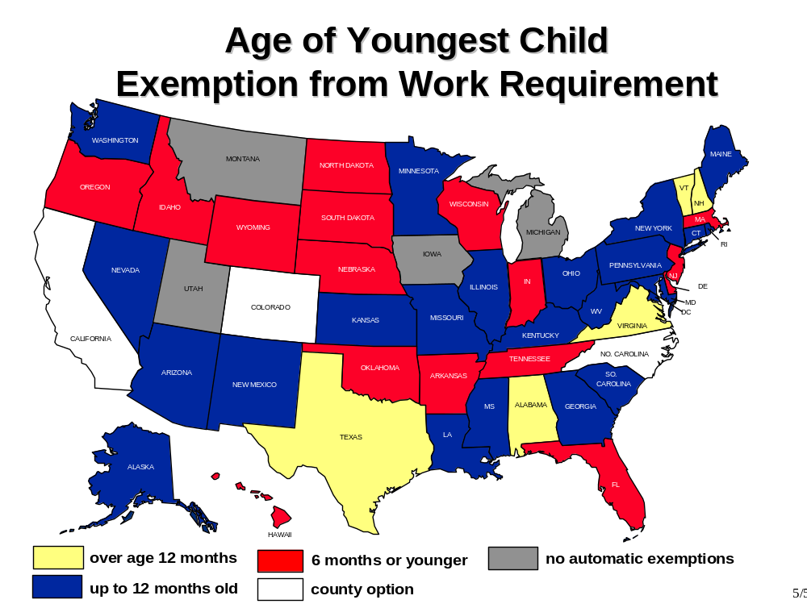

Treatment of Earnings

TANF Provision: PRWORA does not specify how States should treat earnings in determining families’ eligibility for TANF. States have the flexibility to determine the income eligibility rules that best meet their resident's needs.

- Forty-five States made changes to the income eligibility rules under TANF. Generally, these States simplified and expanded the treatment of earnings compared to the AFDC treatment.

- Six States maintained the income eligibility test that existed under the former AFDC program.

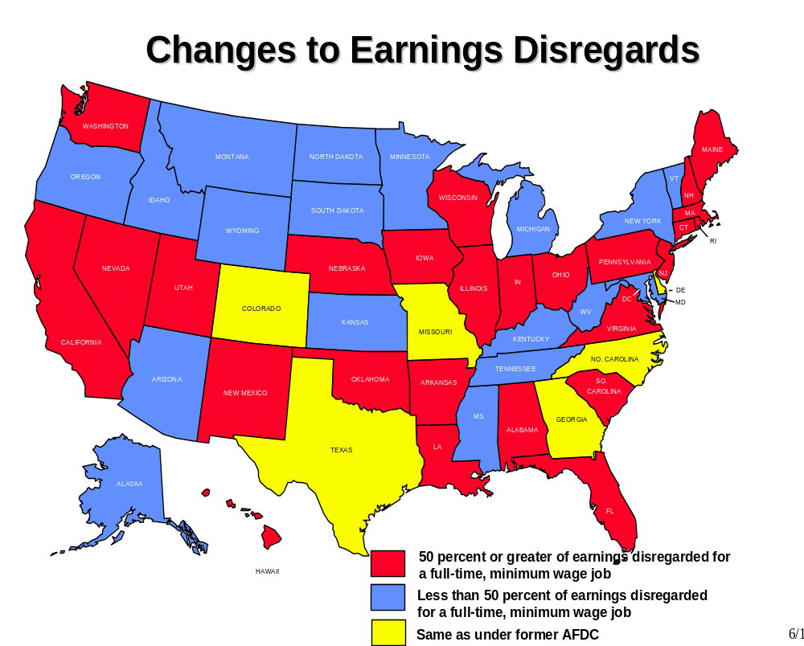

Resources and Assets

TANF Provision: PRWORA does not specify the total resource level that States are to use to determine eligibility for families. States have the flexibility to set a maximum resource level that best meets the needs of their residents'.

• Forty-three States made changes to the total resource level used to determine eligibility for families. The amended limits for families range from $1,500 to an unlimited amount. Increases to the asset level will make it easier for recipients to accumulate savings that might lead to self-sufficiency and might reduce recidivism, e.g., when a minor setback puts a family back on the rolls.

• Eight States maintained the $1,000 level of the former AFDC program.

Individual Development Accounts

TANF Provision: States may establish Individual Development Accounts (IDAs) by or on behalf of a TANF applicant or recipient. IDAs are restricted savings accounts that allow recipients to accumulate savings to be used for postsecondary educational expenses, first home purchase, or business capitalization. An individual may only contribute to an IDA such amounts as are derived from earned income. Funds in an IDA do not count as resources and any interest earned does not count as income in determining TANF eligibility. (The Assets for Independence Act created a new IDA program; IDA programs that States have implemented under this separate authority are not reflected here.)

• Twenty-nine States allow TANF funds to be placed in IDAs. The limits for such restricted accounts range from $1,000 to an unlimited amount.

Resource Levels and Individual Development Accounts

State | Resource Level | Individual Development Accounts  (Amount)
Alabama | $2,000  $3,000 if assistant unit has member age 60 or over | No
Alaska | $1,000 | No
Arizona | $2,000 | $9,000
Arkansas | $3,000 | Pilot planned
California | $2,000 | $5,000  ("Restricted Accounts" under CalWORKS)
Colorado | $2,000 | Yes  County option
Connecticut | $3,000 | Set-aside for future post-secondary education
Delaware | $1,000 | No
Dist. of Col. | $2,000 with non-elderly living in household  $3,000 with an elderly person living in household | No
Florida | $2,000 | No
Georgia | $1,000 | $5,000
Hawaii | $5,000 | Yes  Amount not specified
Idaho | $2,000 | No
Illinois | $3,000 | Yes  Amount not specified
Indiana | Recipients: $1,500  Applicants: $1,000 | IDA's are element of State Welfare-to-Work plan
Iowa | Recipients: $5,000  Applicants: $2,000 | Yes  Amount not specified
Kansas | $2,000 | No
Kentucky | $2,000 | $5,000
Louisiana | $2,000 | $6,000
Maine | $2,000 | $10,000 from a non-recurring lump sum for specific purposes, such as purchase of home or business
Maryland | $2,000 | No
Massachusetts | $2,500 | No
Michigan | $3,000 (Countable cash assets only) | No
Minnesota | Applicants: $2,000  Recipients: $5,000 | No
Mississippi | $2,000 | No
Missouri | $1,000 at application  $5,000 for active participants  Under the 21st Century Communities waiver:  limit increased by an additional $10,000 | Yes  Amount not specified
Montana | $3,000 | Yes  Amount not specified
Nebraska | $6,000 | No
Nevada | $2,000 | No
New Hampshire | Applicants: $1,000  Recipients: $2,000 | No
New Jersey | $2,000 | Yes  Amount not specified
New Mexico | $1,500 in liquid resources  $2,000 in non-liquid resources | First time home-buyer $1,500  Others- no limit
New York | $2,000 | Yes  Amount not specified
North Carolina | $3,000 | Yes
North Dakota | $5,000 for one person  $8,000 for two or more | No
Ohio | No limit. | $10,000
Oklahoma | $1,000 | $2,000
Oregon | Progressing in IRP: $10,000  All others: $2,500 | Yes  Individual Education Account; $1 / hour after 30 initial days of employment  (JOBS Plus Participants Only)
Pennsylvania | $1,000 | No
Rhode Island | $1,000 | $2,500
South Carolina | $2,500 | $10,000
South Dakota | $2,000 | No
Tennessee | $2,000 | $5,000
Texas | $2,000  $3,000 if elderly person in home | $10,000
Utah | $2,000 | In Process
Vermont | $1,000 | No
Virginia | $1,000 plus a savings account exemption | $5,000 (no match)
Washington | $1,000 | Yes  Amount not specified
West Virginia | $2,000 | No
Wisconsin | $2,500 | Yes  Amount not specified
Wyoming | $2,500 | No

Vehicle Asset Level

TANF Provision: PRWORA does not specify the vehicle asset level that States are to use under TANF. States have the flexibility to set the vehicle asset limit at the level that best meets their residents' needs.

- All States increased the vehicle asset level under TANF. Twenty-six States have chosen to simply disregard the value of at least one automobile for a family. Other increases in the vehicle asset level range from a value of $4,500 up to $10,000. Recent in-kind TANF guidance issued by the USDA will make it easier for working families eligible for in-kind benefits such as child care, transportation and on-the-job training to own a car without losing eligibility for food stamps.

Primary Vehicle Asset Level

State | Exclude Primary Car | $3,500-$15,000
Alabama | X
Alaska | X
Arizona | X
Arkansas | X
California |  | $4,650
Colorado | X
Connecticut |  | $9,500
Delaware |  | $4,650
Dist. Of Col. |  | $4,650
Florida |  | Cars may not exceed combined value of $8,500.
Georgia |  | $4,650
Hawaii | X
Idaho |  | $4,650
Illinois | X
Indiana |  | $5,000
Iowa |  | $3,889
Kansas | X
Kentucky | X
Louisiana |  | $10,000
Maine | X
Maryland | X
Massachusetts |  | $5,000
Michigan | X
Minnesota |  | $7,500
Mississippi | X
Missouri | X
Montana | X
Nebraska | X
Nevada | X
New Hampshire | X
New Jersey |  | $9,500
New Mexico | X
New York |  | $4,650
North Carolina | X
North Dakota | X
Ohio | X
Oklahoma |  | $5,000
Oregon |  | $10,000
Pennsylvania | X
Rhode Island |  | $4,600
South Carolina | X
South Dakota |  | $4,650
Tennessee |  | $4,600
Texas |  | $4,650
Utah |  | $8,000²
Vermont | X
Virginia |  | $7,500
Washington |  | $5,000
West Virginia | X
Wisconsin |  | $10,000
Wyoming |  | $12,000

Transitional Medicaid Assistance

TANF Provision: Families losing Medicaid benefits due to increased earnings from work may receive 1 year of Transitional Medicaid Assistance (TMA). Families that lose benefits due to collection of child or spousal support will receive TMA for 4 months. These policies are similar to the former AFDC program. However, several States have elected to provide TMA for longer than the specified 12 and 4 months periods

- Twelve States provide TMA for more than 12 months, with extensions ranging from 18 months to unlimited periods as long as income is below a specified level.

Transitional Child Care

TANF Provision: The law replaced the child care entitlements with a consolidated funding stream, provided additional resources, and folded funding into a block grant, the Child Care and Development Fund (CCDF).

- Thirty-three States extend transitional child care for longer than 12 months for families moving off welfare.

State | Transitional Medicaid Available (Months) | Transitional Child Care Available (Months)
Alabama | 12 | 12
Alaska | 12 | 12
Arizona | 24 | 24
Arkansas | 12 | 36
California | 12 | 24
Colorado | 12 | No Limit for Low Income Families
Connecticut | 24  No Income Limit | No Limit for Low Income Families, Based on Sliding Fee Scale
Delaware | 24 | 24
Dist. Of Col. | 12 | Ongoing to Meet Needs
Florida | 12 | 24
Georgia | 12 | 12
Hawaii | 12 | No Limit, Sliding Fee Based on Income
Idaho | 12 | No Limit for Low Income Families
Illinois | 12 | No Limit for Low Income Families; Copayment for All With Earned Income
Indiana | 12 | 12
Iowa | 12 | 24
Kansas | 12 | Child Care provided up to 185% of poverty
Kentucky | 12 | No Limit for Low Income Families
Louisiana | 12 | 12
Maine | 12 | Until Youngest Child Reaches Age 13 or Family Becomes Ineligible
Maryland | 12 | 12
Massachusetts | 12 | 12
Michigan | 12 | Based on income
Minnesota | 12 | 12
Mississippi | 12 | 12
Missouri | 12  24 month extension | No Limit for Low Income Families
Montana | 12 | Sliding Fee Immediately
Nebraska | 24 | 24
Nevada | 12 | 12
New Hampshire | 12 | No Limit for Families Below 190% of Poverty
New Jersey | 24 for Employment  4 for Increased Child or Spousal Support | 24
New Mexico | 12 | 12 months No Limit for Low Income Families
New York | 12 | 12
North Carolina | 12 | 12
North Dakota | 12 | 12
Ohio | 12 | 12
Oklahoma | 12 | 12
Oregon | 12 | No Limit for Low Income Families
Pennsylvania | 12 | Based on income.
Rhode Island | Adults: 18;  Children under 250% FPL: No time limit | No Limit for Low Income Families
South Carolina | 24 | 24
South Dakota | 12 | 12
Tennessee | 18 | 18
Texas | 12  Exempt volunteers 18 | 12  Exempt volunteers 18
Utah | 24 | No Limit for Low Income Families
Vermont | 36 | No limit for Low Income Families
Virginia | 12 | 12
Washington | 12 | No limit for families that are below 175% of the FPL. Co-payments based on sliding fee.
West Virginia | 12 | 12
Wisconsin | Yes  (Months  not  specified) | Yes (No time limit for family eligibility)
Wyoming | 12 | No Limit for Low Income Families

TIME LIMITING ASSISTANCE

Time Limits

TANF Provision: States may not use federal funds to provide assistance to a family that includes an adult who has received federally-funded assistance for 60 months (whether or not consecutive). States have the option to set lower time limits on the receipt of TANF benefits. Table 13:2 will provide more detailed information on time limits.

State | Time Limit
Alabama, Alaska, Colorado, Dist. Of Col., Hawaii, Kansas, Kentucky, Maine, Maryland, Minnesota, Mississippi, Missouri, Montana, New Hampshire, New Jersey, New Mexico, New York, North Dakota, Oklahoma, Pennsylvania, South Dakota, Vermont, Washington, West Virginia, Wisconsin, Wyoming | 60 months
Louisiana, Nebraska, Nevada, North Carolina, Oregon, South Carolina, Tennessee, Virginia | intermittent, e.g., 24 out of 60 months; lifetime of 60 months
Arkansas, Connecticut, Delaware, Florida, Georgia, Idaho, Ohio, Utah | less than 60 months lifetime
Arizona, Indiana | (1) 24 out of 60 months; lifetime of 60 for adults only
California | (1) For adult applicants: 18 months but can be extended to (1) 24 months based on local economic conditions or if extension will lead to employment or (2) 60 months if no job available and adult participates in community service  (2) For adult recipients: 24 months but can be extended to 60 months if no job available and adult participates in community service (3) Safety-net program for children beyond adult time limit
Illinois | (1) No limit if family has earned income and work 20 hours per week (2) 24 months for families with nor child under age 13 and has no earnings  (3) 60 months for all other families
Massachusetts | 24 out of 60 months; no lifetime limit
Michigan, Rhode Island | will use State funds after 60 months
Texas | 12, 24, and 36 months lifetime for adults only, time period depends on employability of head of household

Exemptions to the Time Limit

TANF Provision: States are allowed to extend assistance for up to 20 percent of their caseloads beyond the 60 months time limit. States have the flexibility to determine the criteria by which families are excluded from being subject to the time limit, except all States are required under PRWORA to exempt: families not containing an adult receiving assistance; months of assistance received by an adult as a minor child; not the head of household or married to the head of the household; and any month in which the family lived on an Indian reservation or Alaskan Native village with an unemployment rate above 50 percent.

- Most States exemption policies fall into the following categories:

- Age of parent or caretaker;
- Mentally or physically disabled parent or caretaker;
- Caring for a disabled dependent;
- Victim of domestic violence;
- Actively seeking employment, and
- High unemployment.

Extensions to the Time Limit

TANF Provision: States are subject to a financial penalty if they extend federally-funded assistance beyond 60 months for more than 20 percent of their caseload.

- Some States allow families that have reached the time limit to continue receiving assistance for an extended period of time. The length of time for extensions range from 3 months to 48 months. The most common reasons for extensions are:

- To allow individuals to finish a training program; or
- The family is unable to find work and is making a good faith effort to find employment.

Diversion Assistance

TANF Provision: While there is no specific provision to cover diversion programs in PRWORA, the law allows States to provide diversion benefits. Half of the States now offer some form of diversion benefits or services to families as an alternative to on-going TANF assistance. Generally, these payments are intended to provide short-term financial assistance to meet critical needs in order to secure or retain employment. Typically, States provide several months of benefits in one lump sum or, in a few States, a flat amount. By accepting the diversion payment, the family generally agrees not to re-apply for cash assistance for a specified period of time, e.g., receipt of a diversion payment equal to 3 months of benefits results in family agreeing to not reapply for benefits for 3 months. Other States operate diversion programs that focus on providing applicant job search and related services designed to divert families from welfare to work prior to receiving any welfare benefits.

- Twenty-seven States have opted to offer diversion assistance.

Months of benefits | States
2 months of benefits | Alaska, Florida, and South Dakota
3 months of benefits | Arkansas, Connecticut, Dist. of Col., Idaho, Maine, Montana, North Carolina, Rhode Island, Utah, and West Virginia
4 months of benefits | Minnesota and Virginia
Flat amount | Texas ($1,000), Washington ($1,500), and Wisconsin ($1,600)
Amount not specified | Georgia, Illinois, Iowa, Kentucky, and Oregon
County option | California (varies), Colorado (up to 6 months of benefits), Maryland (up to 12 months of benefits), and Ohio (unspecified amount)

ENCOURAGING PERSONAL RESPONSIBILITY

Individual Responsibility Plan

TANF Provision: States are required to make an initial assessment of the skills, prior work experience, and employability of each recipient 18 years or older. The State, in consultation with the individual, may develop an individual responsibility plan.

• Every State requires TANF applicants and recipients to complete an Individual Responsibility Plan (IRP). Most IRPs include provisions to require immunization, school attendance, and cooperation with child support enforcement. Refusal to sign an IRP generally results in ineligibility. Sanctions for non-cooperation with plan activities after signing the plan result in immediate termination or benefit reduction, or initial benefit reduction with continued non-cooperation leading to termination.

- In 32 States, the maximum sanction can result in the loss of the entire grant for refusal to sign the IRP or for non-cooperation after signing.

- In 14 States, the maximum sanction for non-cooperation with plan activities can result in reducing the family’s benefit.

- In 5 States, the sanction was not specified.
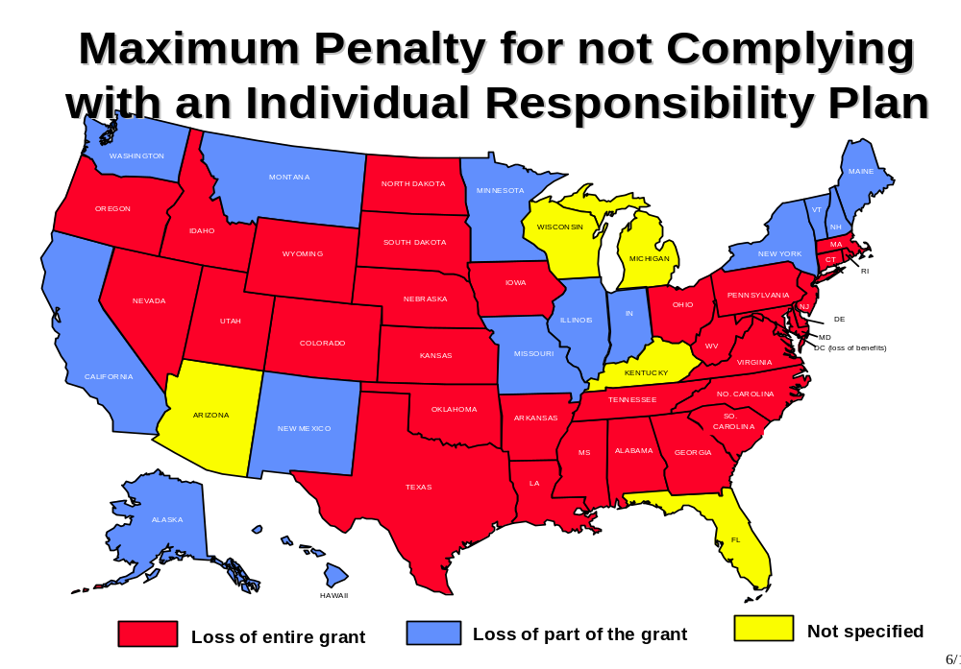

Maximum Sanctions for Not Complying With Work Requirements

TANF Provision: If an individual in a family receiving assistance refuses to engage in required work, the State has the option to either reduce or terminate the amount of assistance payable to the family, subject to good cause.

- Thirty-seven States impose a maximum sanction for refusing to comply with work requirements which results in a loss of cash assistance. In most of these States, the total loss of cash assistance results after several instances of noncompliance. For example, in Connecticut, the first sanction is a 20 percent reduction of cash assistance, the second sanction is a 35 percent reduction, and the third and subsequent sanctions result in termination of cash assistance.

- The thirty-seven States that terminate include: Alabama, Arizona, Colorado, Connecticut, Delaware, District of Columbia., Florida, Georgia, Hawaii, Idaho, Illinois, Iowa, Kansas, Louisiana, Maryland, Massachusetts, Michigan, Mississippi, Nebraska, Nevada, New Jersey, New Mexico, North Carolina, North Dakota, Ohio, Oklahoma, Oregon, Pennsylvania, South Carolina, South Dakota, Tennessee, Utah, Vermont, Virginia, West Virginia, Wisconsin, and Wyoming.

- Fourteen States reduce cash assistance: Alaska, Arkansas, California, Indiana, Kentucky, Maine, Minnesota, Missouri, Montana, New Hampshire, New York, Rhode Island, Texas, and Washington.

Sanctions for Non-Cooperation With Child Support Requirements

TANF Provision: Title III of PRWORA establishes stricter child support enforcement policies. States must certify that they are operating a child support enforcement program meeting general requirements in order to be eligible for TANF. Recipients must assign rights to child support and cooperate with paternity establishment efforts. States have the option to either deny cash assistance or reduce assistance by at least 25 percent to those individuals who fail to cooperate with paternity establishment or obtain child support.

- Thirty States elected to terminate cash assistance to families for failure to cooperate with child support requirements: Alabama, Arkansas, Colorado, Connecticut, Delaware, Florida, Georgia, Illinois, Indiana, Louisiana, Maryland, Michigan, Mississippi, Nebraska, Nevada, New Jersey, North Carolina, North Dakota, Ohio, Oklahoma, Oregon, South Carolina, South Dakota, Tennessee, Utah, Vermont, Virginia, West Virginia, Wisconsin, and Wyoming. In most States, cash will be restored upon cooperation with requirements.

- Twenty-one States elected to reduce assistance to families for failure to cooperate with child support requirements: Alaska, Arizona, California, District of Columbia., Hawaii, Idaho, Iowa, Kansas, Kentucky, Maine, Massachusetts, Minnesota, Missouri, Montana, New Hampshire, New Mexico, New York, Pennsylvania, Rhode Island, Texas, and Washington.

OTHER KEY PROVISIONS

Family Violence Option

TANF Provision: States have the flexibility to give special treatment to the victims of domestic violence. Under the "Family Violence Option," States may certify that they will assist victims of domestic violence by: screening for them when they apply for TANF; referring these clients to counseling and supportive services; and waiving program requirements (such as time limits, residency requirements, child support cooperation requirements, or family cap provisions).

- Twenty-eight States have certified they will assist victims of domestic violence.

- Five States are developing screening and counseling standards.

- Eighteen States are addressing the issue, but have not submitted a signed certification.

Screen for Domestic Violence

 | Optional Certification¹ | In Process² | Other Discussion³
Alabama |  | ✓
Alaska | ✓
Arizona | ✓
Arkansas | ✓
California |  |  | ✓
Colorado | ✓
Connecticut |  | ✓
Delaware | ✓
Dist. of Columbia | ✓
Florida |  |  | ✓
Georgia | ✓
Hawaii | ✓
Idaho |  |  | ✓
Illinois |  |  | ✓
Indiana |  |  | ✓
Iowa | ✓
Kansas |  |  | ✓
Kentucky | ✓
Louisiana | ✓
Maine |  |  | ✓
Maryland | ✓
Massachusetts | ✓
Michigan |  |  | ✓
Minnesota | ✓
Mississippi |  |  | ✓
Missouri | ✓
Montana | ✓
Nebraska | ✓
Nevada |  |  | ✓
New Hampshire |  | ✓
New Jersey | ✓
New Mexico |  |  | ✓
New York | ✓
North Carolina |  | ✓
North Dakota | ✓
Ohio |  |  | ✓⁴
Oklahoma |  |  | ✓
Oregon |  |  | ✓
Pennsylvania | ✓
Rhode Island | ✓
South Carolina |  |  | ✓
South Dakota |  |  | ✓
Tennessee | ✓
Texas | ✓
Utah | ✓
Vermont |  | ✓
Virginia |  |  | ✓
Washington | ✓
West Virginia | ✓
Wisconsin |  |  | ✓
Wyoming |  |  | ✓

¹ Submitted a signed certification (commonly called the Wellstone/Murray provision).
² Submitting certification and implementing program soon.
³ Addressing issue but did not certify.
⁴ County Option.

Family Cap

TANF Provision: There is no family cap provision included in the statute. States have the flexibility not to increase cash assistance after the birth of additional children while the family is on TANF.

- Nineteen States have elected not to increase cash assistance after the birth of additional child while the family is on TANF.

- Connecticut and Florida provide a partial increase in benefits after the birth of additional child(ren) while the family is on TANF.

- Maryland provides the increase to a third party, and Oklahoma provides an increase in the form of vouchers.

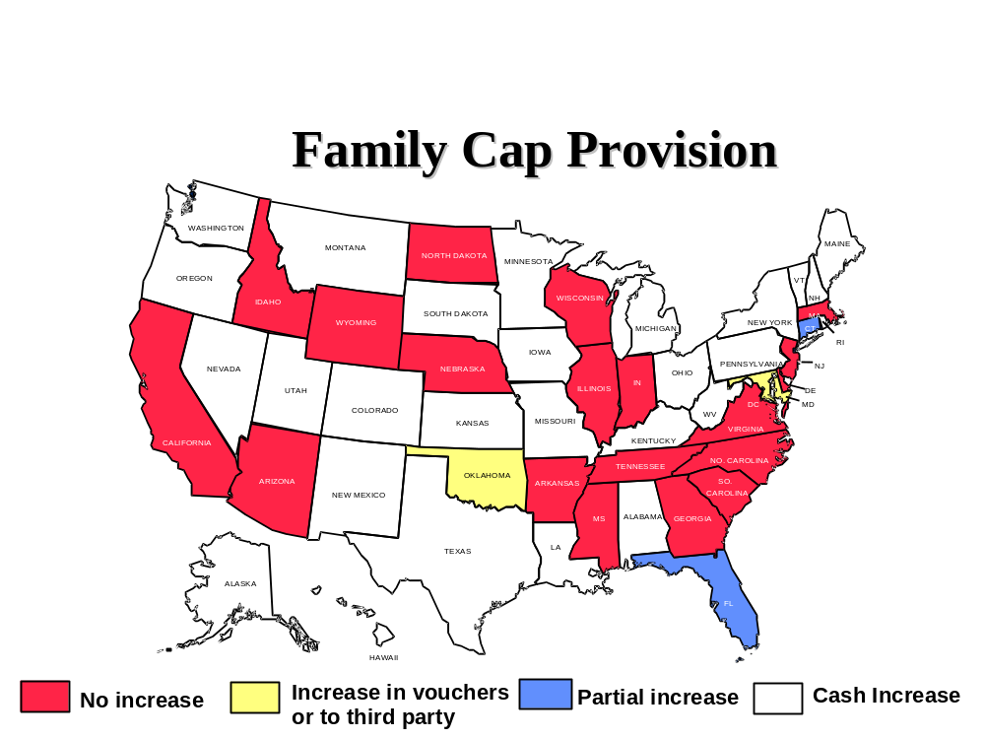

Table 13:1

State TANF Plan Effective Dates

STATE | PERIOD COVERED
AL | 11/15/96 – 12/31/99
AK | 07/01/97 – 12/31/99
AZ | 10/01/96 – 12/31/99
AR | 07/01/97 – 12/31/99
CA | 11/26/96 12/31/99
CO | 07/01/97 – 12/31/99
CT | 10/01/96 – 12/31/99
DE | 03/10/97 – 12/31/99
DC | 03/01/97 – 12/31/99
FL | 10/01/96 – 12/31/99
GA | 01/01/97 – 12/31/99
GU | 07/01/97 – 12/31/99
HI | 07/01/97 – 12/31/99
ID | 07/01/97 – 12/31/99
IL | 07/01/97 – 12/31/99
IN | 10/01/96 – 12/31/99
IA | 01/01/97 – 12/31/99
KS | 10/01/96 – 12/31/99
KY | 10/18/96 – 12/31/99
LA | 01/01/97 – 12/31/99
ME | 11/01/96 – 12/31/99
MD | 12/09/96 – 12/31/99
MA | 10/01/98 – 12/31/01
MI | 10/01/98 – 12/31/01
MN | 07/01/97 – 12/31/99
MS | 10/01/96 – 12/31/99
MO | 12/01/96 – 12/31/99
MT | 12/16/96 – 12/31/99
NE | 12/01/96 – 12/31/99
NV | 12/03/96 – 12/31/99
NH | 10/01/96 – 12/31/99
NJ | 02/01/97 – 12/31/99
NM | 07/01/97 – 12/31/99
NY | 12/02/96 – 12/31/99
NC | 01/01/97 – 12/31/99
ND | 07/01/97 – 12/31/99
OH | 10/01/96 – 12/31/99
OK | 10/01/96 – 12/31/99
OR | 10/01/96 – 12/31/99
PA | 03/03/97 – 12/31/99
PR | 07/01/97 – 12/31/99
RI | 05/01/97 – 12/31/99
SC | 10/12/96 – 12/31/99
SD | 12/01/96 – 12/31/99
TN | 10/01/96 – 12/31/99
TX | 11/05/96 – 12/31/99
UT | 10/01/96 – 12/31/99
VT | 10/01/98 – 12/31/01
VA | 02/01/97 – 12/31/99
VI | 07/01/97 – 12/31/99
WA | 01/10/97 – 12/31/99
WV | 01/11/97 – 12/31/99
WI | 10/01/98 – 12/31/01
WY | 01/01/97 – 12/31/99

Table 13:2 Time Limits

 |  | Exemptions:
State | Time Limit  (In Months) | Age | Physically  or  Mentally  Disabled | Caring for  Disabled  Family  Member | Victim  of  Domestic  Violence | No Job  Available/  High  Unemployment |  | Other | Extensions
Alabama  TANF  Subject to TANF: 11/96  First Families Reach Time Limit: 12/01 | 60 | Teen Parents under 18 | X | X | X |  |  | In substance abuse treatment  (participating in counseling) | None
Alaska  TANF  Subject to TANF: 07/97  First Families Reach Time Limit: 07/02 | 60 |  | X | X | X |  |  | Hardship | None
Arizona *  TANF  Subject to TANF: 10/96  First Families Reach Time Limit: 10/97 | 24 out of 60;  60 lifetime  (adults only) | X | X | X | X |  |  |  | Up to 8 months to complete education or training.  Up to 6 months if unable to find work.
Arkansas*  TANF  Subject to TANF: 07/97  First Families Reach Time Limit: 07/00 | 24 | 60 and older | X | X | X |  |  |  | If exempt from work requirements.  Unlimited
California *  TANF  Subject to TANF: 11/96  First Families Reach Time Limit: 06/99 | Recipients: 24  Applicants: 18  60 (if participates in community service) (adults only) | X | X | X | X |  |  | Caring for dependent/ ward or the court or child determined at-risk of entering foster care. | Up to 60 months if participate in community service . Safety net for minors thereafter. Any month when cash aid is fully reimbursed by child support is not counted.
Colorado *  TANF  Subject to TANF: 07/97  First Families Reach Time Limit: 07/02 | 60 |  |  |  |  |  |  |  | No extensions will be formally granted until adult has received TANF benefits for 60 months. All exemptions will be reviewed each six months or sooner.

 |  | Exemptions:
State | Time Limit  (In Months) | Age | Physically  or  Mentally  Disabled | Caring for  Disabled  Family  Member | Victim  of  Domestic  Violence | No Job  Available/  High  Unemployment | Other | Extensions
Connecticut *  TANF  Subject to TANF: 10/96  First Families Reach Time Limit: 10/97 | 21 | Under 18 | X | X |  |  | Pregnant or postpartum individual (physician verification required) | 6 months renewable.
Delaware *  TANF  Effective: 03/97  First Families Reach Time Limit: 10/99 | 48 |  | X | X | X | X |  | Number of months agency failed to provide service specified in Contract; maximum up to 12 months.
District of Columbia *  TANF  Effective: 03/97  First Families Reach Time Limit: 03/02 | 60 |  | X | X | X | X | Pregnant in last trimester | None
Florida *  TANF  Effective: 10/96  First Families Reach Time Limit: 2/96 | (1) 24 out of 60;  48 lifetime  (2) 36 out of 72;  48 lifetime | Under 16 | X |  |  |  | Limited exemptions: minor children, elderly, and disabled. | Hardship exemptions are limited to 10% of the caseload in the first year; 15% in the second, and 20% in the third and future years.
Georgia *  TANF  Effective: 01/97  First Families Reach Time Limit: 10/01 | 48 |  |  |  |  |  |  | A task force has been formed to determine the exemptions, if any, that will be granted. At present, no determination has been made. There is a possibility that a panel will review each case individually.

 |  | Exemptions:
State | Time Limit  (In Months) | Age | Physically  or  Mentally  Disabled | Caring for  Disabled  Family  Member | Victim  of  Domestic  Violence | No Job  Available/  High  Unemployment | Other | Extensions
Hawaii *  TANF  Effective: 07/97  First Families Reach Time Limit: 07/02 | 60 | Under 16 | X | X |  |  | Caring for a dependent/ ward or the court or child determined at-risk of entering foster care.  Full-time recipients in Volunteers in Service to America. | 3 months renewable.
Idaho *  TANF  Effective: 07/97  First Families Reach Time Limit: 07/99 | 24 |  | X | X |  |  |  | Unlimited
Illinois *  TANF  Effective: 07/97  First Families Reach Time Limit: 07/99 | (1) 60  (2) No limit if  family has  earned income  and works at  least 25 hours  per work  (3) 24 for  families  with no child  under age  13 and no  earnings |  | X | X |  |  |  | Unlimited if working.

 |  | Exemptions:
State | Time Limit  (in months) | Age | Physically  or  Mentally  Disabled | Caring for  Disabled  Family  Member | Victim  of  Domestic  Violence | No Job  Available/  High  Unemployment | Other | Extensions
Indiana *  TANF  Effective: 10/96  First Families Reach Time Limit: 05/97 | 24  (adults only) | Under 16 | X | X |  | X | Unreason-able  Commute;  Pregnant; full-time student age 16 or 17; and full-time Vista volunteers. | Recipients may earn 1 additional month of benefits for every 6 consecutive months employed full-time. Maximum credit is 24 months. Length of extensions are 1 to 12 months renewable.
Iowa *  TANF  Effective: 01/97  First Families Reach Time Limit: 01/02 | 60 |  |  |  |  |  |  | Making effort but unable to find a job. Working 30 or more hours.
Kansas *  TANF  Effective: 10/96  First Families Reach Time Limit: 10/01 | 60 |  |  |  |  |  | Exempt population undetermin-ed at this time  (Age-other) | None
Kentucky  TANF  Effective: 10/96  First Families Reach Time Limit: 10/01 | 60 |  | X | X | X |  |  | None
Louisiana *  TANF  Effective: 01/97  First Families Reach Time Limit: 01/99 | 24 out of 60;  lifetime 60 |  | X |  | X | X | Hardship | Up to 12 months to complete education or training.

 |  | Exemptions:
State | Time Limit  (in months) | Age | Physically  or  Mentally  Disabled | Caring for  Disabled  Family  Member | Victim  of  Domestic  Violence | No Job  Available/  High  Unemployment | Other | Extensions
Maine *  TANF  Effective: 11/96  First Families Reach Time Limit: 11/01 | 60 |  |  | X | X |  | Good cause determined | If no family member sanctioned in month 60 and family members have fewer than 3 sanctions, whole family can still get TANF
Maryland *  TANF  Effective: 01/97  First Families Reach Time Limit: 01/02 | 60 |  | X | X | X |  | Hardship | None
Massachusetts *  TANF  Effective: 09/96  First Families Reach Time Limit: 12/98 | 24 out of 60;  (no lifetime limit) | X | X | X | X (not automatic, must be requested) | X  (not  automatic,  must be  requested) | Pregnant; Parent whose youngest child is under age 2; Parent with child born after family cap date under the age of 3 months; Teen parent meeting school attendance and living arrangement requirements | At Commissioner's discretion.
Michigan *  TANF  Effective: 09/96  First Families Reach Time Limit: 9/30/01 will use State-only funds after 60 months | Will use State  only funds for  those complying and  are not self sufficient  after 60 months. |  |  |  |  |  |  | Unlimited

 |  | Exemptions:
State | Time Limit  (in months) | Age | Physically  or  Mentally  Disabled | Caring for  Disabled  Family  Member | Victim  of  Domestic  Violence | No Job  Available/  High  Unemployment | Other | Extensions
Minnesota *  TANF  Effective: 07/97  First Families Reach Time Limit: 07/02 | 60 | X |  |  | X |  |  | None
Mississippi *  TANF  Effective: 10/96  First Families Reach Time Limit: 10/01 | 60 |  | X | X | Up to 12 months |  | Substance abuse and pregnancy in third trimester | None
Missouri *  TANF  Effective: 12/96  First Families Reach Time Limit: 12/01 | 60  (Will deny benefits if  reapply after  completing the personal responsibility plan and  received benefits for  36 months.) | 60 and older | X |  |  |  | Hardship | Each case individually determined base on personal responsibility plan.
Montana *  TANF  Effective: 12/96  First Families Reach Time Limit: 12/01 | 60 | Over 60 | X |  |  |  | Lack of  child care  Agency failed to provide services in agreement
Nebraska *  TANF  Effective: 12/96  First Families Reach Time Limit: 01/98 | 24 out of 48;  60 lifetime |  | X | X |  | X | Hardship | Agency failed to provide services in agreement or no job.

 |  | Exemptions:
State | Time Limit  (in months) | Age | Physically  or  Mentally  Disabled | Caring for  Disabled  Family  Member | Victim  of  Domestic  Violence | No Job  Available/  High  Unemployment | Other | Extensions
Nevada  TANF  Effective: 12/96  First Families Reach Time Limit: 01/00  (Amendment received 1/28/98) | 24 then off 12;  60 lifetime | X | X | X |  |  | Hardship | Up to 6 months for those who need additional time to achieve self-sufficiency.
New Hampshire *  TANF  Effective: 10/96  First Families Reach Time Limit: 10/01 | 60 |  |  |  | X |  | Hardship  Criteria  To Be  Developed | None
New Jersey *  TANF  Effective: 02/97  First Families Reach Time Limit: 02/02 | 60 | X | X | X | X |  | Hardship | Up to 12 months.
New Mexico  TANF  Effective: 07/97  First Families Reach Time Limit: 07/02 | 60 | X | X | X | X | X  (In Indian  Country) |  | Waivers are not granted until expiration of the 60 months.
New York  TANF  Effective: 12/96  First Families Reach Time Limit: 12/01 | 60 |  | X | X | X |  |  | None
North Carolina *  TANF  Effective: 01/97  First Families Reach Time Limit: 08/98 | 24 followed by 36 months of ineligibility;  60 lifetime | X | X | X | X | X | Lack of  child care or  transporta-tion | Month to month.

 |  | Exemptions:
State | Time Limit  (in months) | Age | Physically  or  Mentally  Disabled | Caring for  Disabled  Family  Member | Victim  of  Domestic  Violence | No Job  Available/  High  Unemployment | Other | Extensions
North Dakota *  TANF  Effective: 07/97  First Families Reach Time Limit: 07/02 | 60 | X | X | X | X |  |  | None
Ohio *  TANF  Effective: 10/96  First Families Reach Time Limit: 10/00 | 36 |  |  |  |  |  | County  option | 24 months after reaching time limit, family may receive an additional 24 months of assistance if good cause exists.
Oklahoma  TANF  Effective: 10/96  First Families Reach  Time Limit: 10/01 | 60
Oregon *  TANF  Effective: 10/96  First Families Reach Time Limit: 07/98 | 24 out of 84 |  | X | X | X |  | Actively  participating in  JOBS | Unlimited.
Pennsylvania  TANF  Effective: 03/97  First Families Reach Time Limit: 03/02 | 60 |  |  |  |  |  |  | Pennsylvania has not yet determined exemptions or extensions.

 |  | Exemptions:
State | Time Limit  (in months) | Age | Physically  or  Mentally  Disabled | Caring for  Disabled  Family  Member | Victim  of  Domestic  Violence | No Job  Available/  High  Unemployment | Other | Extensions
Rhode Island  TANF  Effective: 05/97  First Families Reach Time Limit: 05/02 | 60  (adults only) | Over 59 | X | X | X |  | Child under age one | Special circumstances.
South Carolina *  TANF  Effective: 10/96  First Families Reach Time Limit: 10/98 | 24 out of 120;  60 lifetime |  | X | X | Pending |  | Child care  not available;  Transporta-tion  not available  Child only | Up to 12 months.
South Dakota *  TANF  Effective: 12/96  First Families Reach Time Limit: 12/01 | 60 |  | X |  |  |  |  | Under extenuating circumstances
Tennessee *  TANF  Effective: 10/96  First Families Reach Time Limit: 03/98 | 18 on then 3 months off;  60 lifetime | X | X | X | X |  | Adult reading level below ninth grade. State unable to provide child care or transpor-tation | Up to 24 months if resides in high unemployment area.  Case by case basis if State failed to provide services in agreement such as childcare.

 |  | Exemptions:
State | Time Limit  (in months) | Age | Physically  or  Mentally  Disabled | Caring for  Disabled  Family  Member | Victim  of  Domestic  Violence | No Job  Available/  High  Unemployment | Other | Extensions
Texas *  TANF  Effective: 11/96  First Individuals Reach Time Limit: 05/97 | 12/24/36  (adults only) |  | X | X | X | X |  | Case by case basis to reflect functional level of education.
Utah *  TANF  Effective: 10/96  First Families Reach Time Limit: 01/00 | 36 |  |  |  |  |  |  | Up to 24 months if employed 80 hours in 6 of 24 prior months. Victims of domestic violence and medically unable to work.  Monthly basis not to exceed 60 months.
Vermont *  TANF  Effective: 09/96  First Families Reach Time Limit: 09/02 | 60 |  |  |  |  |  | Will use state funds if not sufficient after 60 months | None
Virginia *  TANF  Effective: 02/97  First Families Reach Time Limit: 07/97 | 24 out of 60;  60 lifetime | X | X | X |  | X |  | Up to 12 months.
Washington *  TANF  Effective: 01/97  First Families Reach Time Limit: 01/02 | 60 |  |  |  | X |  |  | None

 |  | Exemptions:
State | Time Limit  (in months) | Age | Physically  or  Mentally  Disabled | Caring for  Disabled  Family  Member | Victim  of  Domestic  Violence | No Job  Available/  High  Unemployment | Other | Extensions
West Virginia *  TANF  Effective: 01/97  First Families Reach Time Limit: 01/02 | 60 |  |  |  |  |  |  | Case by case basis.
Wisconsin *  TANF  Effective: 10/96  First Families Reach Time Limit: 10/01 | 60 |  |  |  |  | X |  | Case by case basis.
Wyoming *  TANF  Effective: 01/97  First Families Reach Time Limit: 01/02 | 60 | 65 and over | X | X | X |  |  | Postponement may only be used, and is not an exemption for referral to work, for brief periods when assessment information is incomplete and the appropriate steps towards self sufficiency cannot be determined or when work requirements are being waived for domestic violence situations (for up to one year without reevaluation).

- State had waivers approved prior to enactment of PRWORA.

XIV. TANF RESEARCH

HHS has a critical role in ensuring that the nation has the answers to major questions regarding welfare reform. These questions can only be answered through rigorous and systematic studies. Below we lay out the framework for HHS research, our strategies for answering key questions, the multiple methods needed and in use to obtain information, and how information is integrated to meet those responsibilities.

Framework for HHS Research

HHS’s welfare reform research agenda has two broad goals:

1) to increase the likelihood that the objectives of welfare reform are achieved by developing credible information that can inform State and local policy and program decisions, and

2) to inform the Congress, the Administration and other interested parties on the progress of welfare reform.

Two broad questions are central to achieving these goals:

1) What approaches are States and localities taking to reform welfare, and what effects do these models have on low-income children and families?

2) What are the experiences of low-income children and families under a variety of welfare reform models, even if we cannot establish a direct causal linkage between welfare reform and these outcomes?

In order to answer these questions, we have focused our research on the following:

- Families who leave welfare
- Families who remain on welfare
- Applicants and families who are diverted from welfare
- Implications for children
- Special populations (such as people with disabilities, rural populations, American Indians, victims of domestic violence, etc.)
- State implementation
- Identification, evaluation and dissemination of promising program models and changes in practice
- Emerging issues, such as post-employment services, job retention and earnings gain among former welfare recipients

Outcomes

HHS’s evaluation efforts focus on outcomes that are central to the objectives of welfare reform and are the purpose for having a national program to assist families with children. These core outcomes include:

- employment status and earnings of parents
- economic effects, e.g., total family income and poverty status
- amount and duration of welfare receipt and receipt of other benefits such as Medicaid and child support
- child well-being
- family formation and structure, including teen and out-of-wedlock childbearing,
- child and family living arrangements
- the cost and benefits of State TANF programs

By measuring these outcomes we can address such questions as: whether more parents are working, whether low income parents are earning more, whether fewer families are in poverty, whether children are better prepared for school, whether more children are living in two-parent families, whether there are fewer out-of-wedlock births, and how TANF impacts the number of children in foster care.

HHS Research Strategy

HHS is working to ensure that in meeting the requirements of section 413 of PWRORA, credible information is produced on the outcomes experienced by families and children under welfare reform and how welfare reform affected those outcomes. We have taken a leadership role where it has been critical to the success of learning about welfare reform, and we have also built on existing efforts both within and outside the federal government and attempted to fill gaps using a variety of strategies. HHS has worked intensively with other federal agencies to improve data collection and analysis. Significant investments have been made in helping States link their data systems, in supporting the development of field-initiated research, and in developing new strategies for studying the effects of welfare reform. We have emphasized dissemination of findings both to inform policymakers and to provide technical assistance to those who are implementing changes in States and communities.

Studying the process and outcomes associated with PRWORA policies presents an enormous challenge.

PRWORA is not a single intervention. There is significant variation in policies, in combinations of policies, and in program design not only State-to-State, but also county-to-county.

Implementation did not start on a given date. Many of the policies and programs that States are implementing under TANF began under waivers; others have been initiated since.

Change is a dynamic process. Since changes in policy are also likely to be on-going, we will continue to observe an evolving process, not a simple change at a single point in time.

Policies affect sub-groups differently. There is very strong evidence to suggest that policies have different effects on different individuals and families. So, it is important not only to know about average effects, but also how particular sub-populations, e.g., long-term recipients, persons with disabilities, are affected.

Many factors affect the lives of children and families. Children and families will be affected by the combination of changes in their lives produced by PRWORA (for example, mothers will need to go to work and children will be in child care) as well as changes outside PRWORA--changes in the economy, changes in other government programs such as the increase in the EITC over recent years, and changes in other institutional arrangements such as the movement to managed care in the health arena. Many of the impacts of welfare reform may only appear after several years.

Sources of Information

We are using a variety of methods to find out what is happening under welfare reform. Various strategies and methods for study are essential, if we are to succeed in shedding light on the major questions. Our approach has been to encourage the use of the strongest methods available to answer particular questions. We also encourage the use of common measurements of outcomes across multiple studies in order to promote comparability of results across studies and data sources. The sources we are using are described below.

National Data Collection

TANF Administrative Data

- TANF Recipient Data Collection. HHS is devoting substantial resources to collecting and analyzing information from States on the status of families who are still on the TANF rolls. TANF (in section 411 of the Social Security Act) provides for continuing to collect basic information on the characteristics of those who are on the rolls, such as race, marital status, and employment in order to understand how the caseload is changing. In addition, information will be collected on cases that close, including reasons for closure.

- High Performance Bonus Data. Another important source of information will relate to the TANF high performance bonus which provides $1 billion over five years to reward high performing States. (See chapter five for further information.) Since almost all States will want to compete for these funds (46 have for FY 1998), we expect to have an additional source of very strong information on employment outcomes for families from these data.

Ongoing National Surveys

A critical set of resources for tracking outcomes for children and families includes the national data surveys: the Census’s Current Population Survey (CPS); Survey of Income and Program Participation (SIPP), and a special extension of it; the Survey of Program Dynamics (SPD), which was funded in PRWORA; the Panel Study of Income Dynamics (PSID); and the National Longitudinal Survey of Youth (NLSY). These data sets have been used extensively in the analysis of welfare, employment and poverty. Since they all include substantial pre-PRWORA data, they allow us to observe how the status of families and children is changing. In addition, many have been augmented with special data to include more in-depth measures of child well-being. Since the surveys are primarily funded with non-HHS resources, our role has been to work with the entities responsible for them to ensure that to the maximum extent possible the data collected will be useful for assessing welfare reform.

Special Data Collections

National data sets, because of their nationally representative character, are critical to understanding how families are faring under welfare reform. However, they are not sufficient, primarily because they often lack sufficient sample size to address important sub-populations and they seldom produce estimates that are State reliable. (The exception to this is the TANF administrative data that are State reliable).

- State Administrative Data and Surveys. With the rapid decrease in caseload, it is important to understand how families that are leaving, or who have been diverted, are faring. In addition to using national data sets such as the SPD, HHS is partnering with States to use both administrative data and surveys to determine employment status, family income, living arrangements, access to health care and other potential measures of how low-income children and families are faring. Although the State level data will not be nationally representative, it will provide an in-depth, State level perspective that national level data cannot, and it will assist States in developing the capacity to conduct these studies on their own.

- Subpopulation Studies. Finally, there are many important subpopulations which are the focus of particular studies, including immigrants, hard-to-employ, long-term welfare recipients, children, non-custodial parents, families with disabled members, American Indians, victims of domestic violence, and rural populations. HHS is funding a number of studies at the community level to examine outcomes and service system responses to these subpopulations.

Methods of Analysis

For a topic of such complexity, a multi-pronged approach is desirable. No single analytical approach adequately fits all of the essential questions to be answered. Our varied approaches are illustrated below:

Experimental Studies. Studies that randomly assign individuals to different policies or program approaches are generally regarded as the most reliable method to determine the effects of different approaches. For example, through random assignment a group of individuals may be subjected to welfare reform policies, while a second otherwise equivalent group is not. As a result, such studies automatically isolate the effects of the differential treatment from other external factors that could be the cause of a particular outcome. Based on this strength, many studies that HHS is supporting to understand the effects of different welfare reform policies are based on random assignment. Five important areas of study are described here.

- Welfare waiver evaluations. HHS is continuing to support evaluations of State TANF efforts that began pre-PRWORA as welfare waiver evaluations. These evaluations provide the opportunity to obtain the earliest possible reliable results on the effects on families of polices such as time limits, work requirements and State make-work-pay strategies. HHS funded nine States to continue their evaluations without significant change and an additional ten States to continue studies with modifications.

- Impact of Welfare Reforms on Children. HHS has augmented five of these State evaluations (Connecticut, Florida, Indiana, Iowa and Minnesota) to include in-depth, comparable measures of family processes and child well-being to determine the effects of different approaches to welfare reform on children.

- Welfare to Work Strategies. HHS is also continuing the National Evaluation of Welfare-to-Work Strategies (formerly the JOBS Evaluation) to determine which strategies for moving welfare recipients into work are most effective. This evaluation also has a major component to examine the effects of different welfare to work strategies on child well-being.

- Welfare to Work Program Evaluation. Although DOL is responsible for federal management of the Welfare-to-Work (WTW) program, HHS is responsible for its evaluation. Since WTW requires most of its funds to be targeted on harder-to-employ welfare recipients, the evaluation represents a major opportunity for learning about which approaches are most effective for more disadvantaged recipients. We will be examining both the implementation and effectiveness of a number of WTW programs, as well as collecting more limited information on all WTW programs.

- Job Retention and Progression. HHS is continuing to work with States to develop rigorous, reliable information on the effectiveness of different State strategies to increase job retention and advancement. As States are beginning to address these issues which are crucial to the success of welfare reform, it will be vitally important to be able to assess accurately which approaches are most effective.

Experimental studies are necessarily limited to certain geographical areas and typically they are unable to separate what parts of a program produced the observed effect. In addition, many features of welfare reform that are important to understand don’t lend themselves to random assignment evaluation. Finally, although a well-conducted experiment may tell us definitively what a particular program produced, it can be difficult to extrapolate from that study to other similar programs.

Non-Experimental Studies. An important part of the HHS welfare reform research strategy, therefore, is to augment experiments with analysis at the national and State level using non-experimental approaches. Analysts can use statistical methods to assess the causal relationship between policies and outcomes at a national level to compare them with experimental results at particular locations. Although the assessment of causation through statistical means is inevitably less definitive than through experimental methods, it has been a central part of our understanding of the past welfare system, and it is the only way to understand the effects of welfare reform on families from a nationally representative perspective.

Implementation Studies. Finally, an important element for understanding the effects of PRWORA are studies which describe in depth what polices are implemented, how they are implemented and how institutions change in implementing them. These studies are important for two reasons. First, although TANF embodies key federal requirements such as work participation rates and a five year time limit on assistance, State flexibility is enormous. Thus, if we are to know what TANF is we must understand how States exercise this flexibility. Second, given the breadth of State flexibility in setting policy, the most useful information that HHS can produce on the effects of welfare reform is on the causal relationship between particular policies and the set of core outcomes that we have identified above. Information about which policies and programs produce what effects allows assessment of the effects of TANF at the national level and can best inform States’ policy choices. But to do this requires knowing what actually was implemented and how it operated at the ground level. Examples of HHS activities in this area follow.

- A set of baseline documents has been published that establish the State-by-State polices and caseload characteristics at the time of the passage of PRWORA.

- Policies embodied in State plans and other policy documents along with caseload information from administrative data will be tracked to determine how they change over time. For example, we are currently conducting a project that will attempt to reach consensus on how best to describe State TANF policies for use in formal analysis and public description of State programs.

- Studies are underway to determine how welfare offices, community service providers and other agencies change in their implementation of welfare reform. For example, we are studying what is involved in State and local efforts to turn welfare offices into job centers.

- HHS has initiated an effort to examine the factors affecting welfare reform in rural areas to begin to identify promising approaches which can be tested more systematically.

- HHS has initiated a low-income child care study in twenty-five communities to examine how welfare policies and decisions affect the child care market, including parental child care choices in relation to employment for those on welfare and for the working poor.

Availability of Results

Over the next several years there will be an ongoing flow of information emerging from HHS’s welfare reform research. We are committed to making these results promptly and widely available both to the public, including through HHS websites, and to key congressional members and their staff .

Although some results necessarily take longer to develop, much is already available or will be available soon, particularly from studies that were begun earlier. The attached summaries for this chapter present much of the research findings we have collected since the last TANF report was released. We intend to spend considerable effort at disseminating broadly additional research and evaluation results as soon as they become available.

What We Will Learn

In many of the studies we are now funding, additional administrative data are being collected and surveys are being fielded or will be in the next several years. In the national surveys, data for 1997 and 1998 have been collected and are being processed. Thus, time and resources are necessary to produce more definitive results. Some of the information we will be obtaining is discussed below.

Longer Term Follow-Up

Our findings are currently based on follow-up periods ranging from 6 months to 3 years. To understand the effects and outcomes of welfare reform will require longer term follow-up on the order of four to six years. Particularly important is that in most States, very few individuals have reached time limits, and in many larger States, none have.

More Comprehensive Information

As indicated above most of our current measures of employment, earnings and income are from administrative records. Over time we will obtain much more comprehensive information through surveys, both in conjunction with waiver demonstrations and through studies of families that have left TANF. Most importantly, we will be able to learn a great deal more about the income and resources families have to support themselves and in particular, what happens to families who leave welfare and do not have earnings.

More Outcomes, Especially Related to Child Well-Being

A critical measure of the success of welfare reform is how it affects children. In 1996 HHS provided grants to 12 states to work with a team of researchers to develop measures of child well-being to examine how different welfare reform programs and policies are affecting children. The partnership proved to be very successful, and subsequently ACF has augmented the funding of five state welfare reform evaluations (Connecticut, Florida, Indiana, Iowa, and Minnesota) to rigorously evaluate the effects of welfare reform on family processes and child well-being. In addition, HHS has provided funds to 13 states to work with the Chapin Hall Center for Children at the University of Chicago and other experts to develop indicators of child well-being. Some of the 13 states are exploring using similar measures to those used in the five states as well as other administrative and survey data. The importance of measuring child well-being is vividly illustrated by the recent findings on the New Hope demonstration. A central finding of the interim effects of this program designed to support working families was that it increased significantly boys' school performance along with increasing their participation in extended day child care and other structured activities, while having other positive family effects.

More Rigorous Information about What Works and What Doesn't

Because of caseload reduction, States now have significant financial resources that are not required for immediate cash assistance, and thus are available for investments in those families still on the caseload, including those with the greatest problems, and to enable families who leave the rolls to keep their jobs and move up instead of returning to welfare. As a result, many States are increasingly focused on strategies to increase job retention and advancement for recipients and former recipients. ACF is working with thirteen States to develop, pilot and ultimately rigorously evaluate the effects of alternative strategies. Through this activity and others, we will be learning about the role of supports for working families such as child care, child support and other services in sustaining and advancing in employment. These kinds of evaluations are critical to using the flexibility provided by TANF to maintain a learning environment in which federal and State tax dollars are used to make investments that really work.

More Nationally Representative Data

Over time as more post-TANF data become available from the national surveys, especially longitudinal data, it will be possible to merge findings from in-depth studies in States and localities with nationally representative data and use the strengths of each to develop a comprehensive picture of how the nation's families are faring under welfare reform.

The preliminary results we have received thus far illustrate the promise of how investments in careful research and evaluation can produce information that can inform policy. Perseverance in these investments can play a critical role in supporting strategies that can realize the goals of welfare reform.

Appendices:

Appendix 14:1 Summary of Recent Research on Welfare Leavers to Accompany Table 14:1
Table 14:1 Summary of Recent Research on Welfare Leavers

Summary 14:1 Arizona Empower Demonstration – Review of Interim Impact Report
Summary 14:2 Early Implementation of Connecticut’s Welfare Reform Initiative

Summary 14:3 Diversion and Its Effects on Access to Medicaid
Summary 14:4 The Family Transition Program: Implementation and Three-Year Impacts of Florida’s Initial Time-Limited Welfare Program
Summary 14:5 Helping TANF Recipients Stay Employed: Early Evidence From the GAPS Initiative
Summary 14:6 The Indiana Welfare Reform Evaluation: Findings on Program Implementation and Economic Impacts After Two Years
Summary 14:7 The Indiana Welfare Reform Evaluation: Identifying and Serving The Most Dependent Cases
Summary 14:8 The Iowa Family Investment Program: Two Year Impacts
Summary 14:9 Interim Cost-Benefit Analysis of Iowa's Family Investment Program: Two-Year Results
Summary 14:10 Two-Year Process Study on the Iowa Family Investment Program (FIP)
Summary 14:11 Evaluation of Los Angeles Jobs First GAIN
Summary 14:12 Maryland Family Investment Program (FIP): First Year Report – Examining Customer Pathways and Assessment Practices
Summary 14:13 Maryland's Life After Welfare: Third Interim Report

Summary 14.14 Minnesota Family Investment Program 18-Month Impact Findings
Summary 14:15 Report on the Status of Families Leaving North Carolina's Work First Program After Reaching the 24-Month Time Limit
Summary 14:16 Interim Implementation Report on the North Dakota Training, Education, Employment, and Management Program
Summary 14:17 Interim Impact Evaluation Report on the Parents’ Fair Share Demonstration
Summary 14:18 Evaluation Report on the Parents’ Fair Share Demonstration: Preliminary Findings on Promoting Non-Custodial Parents’ Involvement with their Children
Summary 14:19 Post Employment Services Demonstration
Summary 14:20 Interim Impact Report on Achieving Change for Texans (ACT)
Summary 14:21 Interim Report: Implementation and Early Impacts of Vermont’s Welfare Restructuring Project

Summary 14:22 Virginia Independence Program Implementation Evaluation

Summary 14:23 Evaluating Two Welfare-to-Work Program Approaches: Two Year Findings on the Labor Force Attachment and Human Capital Development Programs in Three Sites
Summary 14:24 Study of Welfare Leavers in Wisconsin Institute for Research on Poverty (IRP)

Appendix 14:1

Summary of Recent Research on Welfare Leavers
(to Accompany Table 14:1)

Background

As large numbers of recipients leave the welfare rolls, there is widespread interest in understanding what is happening to them: Are they working? What is their income? Are they returning to welfare? Are they receiving assistance and supportive services through other programs?

In September 1998, the Office of the Assistant Secretary for Planning and Evaluation (ASPE) awarded approximately $2.9 million in grants to study the outcomes of welfare reform on individuals and families who leave the TANF program, who apply for cash welfare but are never enrolled because of nonfinancial eligibility requirements or diversion programs, and/or who appear to be eligible but are not enrolled. The grants were awarded to 10 states and 3 large counties or consortia of counties under a May 1998 competitive grant announcement. A grant was also made to South Carolina under a different program announcement to expand an on-going project to include a similar study of families leaving TANF.

Six of the FY 1998 ASPE-funded grantees -- Arizona, Georgia, Missouri, Washington, San Mateo County in California, and Cuyahoga County in Ohio -- have released interim reports based on use of linked administrative data sets to track families who left welfare in late 1996/early 1997. These interim reports provide interesting preliminary findings about former TANF recipients in the areas of employment, returns to TANF, and participation in other programs. Other grantees are expected to release interim reports within the next few months; more detailed findings, including information gathered through survey data, will be presented in the final reports, forthcoming over the next twelve months.

Although it is difficult to compare findings across studies, comparisons among ASPE-funded studies are facilitated by the adoption of a common definition of the “leaver” study population as “all cases that leave cash assistance for at least two months.” (This definition excludes cases that re-open within one or two months, because such cases are more related to administrative “churning” than to true exits from welfare). Moreover, these six studies focus on using administrative data to track single-parent families leaving TANF in a similar time period (late 1996 or early 1997).

The studies differ, however, in important areas of research methodology, such as how to operationalize some of the outcome measures (for example, five studies count anyone with earnings as employed, while the sixth -- Cuyahoga County -- counts as employed only those with earnings of $100 or more per quarter). Furthermore, the States differ in TANF policies (e.g., sanction policies, work requirements) and in underlying economic, social and demographic conditions. Finally, comparisons across studies are even more problematic when looking beyond the ASPE-funded studies, because of the many differences in study populations, time periods studied, sources of data, and research methodologies.

Findings

Interestingly, despite the many differences in studies, the preliminary findings from the six studies remain quite consistent, particularly in the areas of employment and recidivism.

- Employment. Between 50 and 65 percent of former TANF recipients found work immediately after leaving TANF, according to the six interim reports. Employment rates rose from less than 50 percent in the months before exit, to relatively stable rates of between 50 and 60 percent throughout the first year after exit, as shown in Figure 1. Over the 12-month period, some former recipients lost their jobs, while others found new employment, resulting in a cumulative employment rates of 68 to 82 percent, measured as those who were ever employed within the first 12 months of exit (see Table 1).

- Recidivism. Data from three of the interim reports suggests that between 8 and 12 percent of leavers were receiving welfare again one quarter after exit, as shown in Table 2. Most of these re-enter in the third month itself, since cases that re-open after one or two months were excluded from the study population. The proportion of former recipients receiving TANF increased to between 13 and 19 percent at two quarters after exit, and then increased more slowly, reaching 13 to 23 percent one year after exit. The proportion that ever returned for at least one month over the first 12 months after exit is somewhat higher, ranging from 24 percent in San Mateo County to 37 percent in the more urban environment of Cuyahoga County (Cleveland) in Ohio.

Figure 1.

Percentage of Leavers
Employed, by Quarter

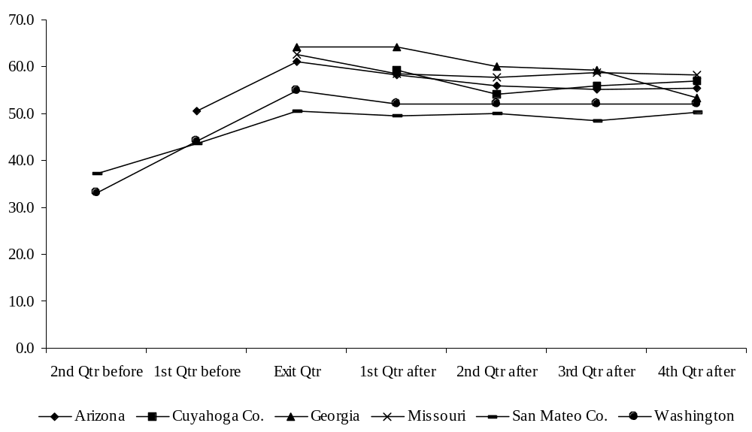

Table 1.

Percentage of Leavers Employed

Grantee | Exit Qtr | 1st Qtr post exit | 2nd Qtr post exit | 3rd Qtr post exit | 4th Qtr post exit | Ever Employed within 1 year
Arizona | 60.9 | 58.2 | 55.8 | 55.1 | 55.4 | 74.7
Cuyahoga Co. | a/ | 59.3 | 54.2 | 55.8 | 56.8 | 71.7
Georgia | a/ | 64.2 | 60.1 | 59.2 | 53.3 | 73.9
Missouri | 62.5 | 58.4 | 57.8 | 58.7 | 58.1 | a/
San Mateo Co. | 50.5 | 49.6 | 49.9 | 48.4 | 50.3 | 67.1
Washington | 55.0 | 52.0 | 52.0 | 52.0 | 52.0 | 68.2

a/ - Data not available.

Table 2.

Percentage of Leavers Receiving TANF

Grantee | 1st Qtr  post exit | 2nd Qtr  post exit | 3rd Qtr  post exit | 4th Qtr  post exit | Ever Receiving within 1 year
Arizona | a/ | a/ | a/ | a/ | 28.4
Cuyahoga Co. | b/ | b/ | b/ | b/ | 35.3
Georgia | c/ | c/ | 14.3 | 13.4 | c/
Missouri | 12.4 | 18.6 | 20.8 | 20.6 | c/
San Mateo Co. | 8.2 | 13.3 | 13.3 | 14.1 | 24.4
Washington | 12.0 | 19.0 | 22.0 | 23.0 | 29.8

a/ - Arizona reported the percentage of leavers returning to TANF in each quarter, unlike Georgia, Missouri, San Mateo, and Washington, which reported the percentage of leavers receiving TANF in each quarter, regardless of when they returned.
b/ - Cuyahoga County reported the percentage of leavers who had ever received TANF during the first 12 months after exit; they did not report quarterly data.
c/ - Data not available.

In addition to the ASPE-funded studies, a number of States have undertaken projects to collect data on what happens to welfare recipients and former recipients over time, as welfare programs change, and as program participants move into the job market and/or lose their welfare benefits. These studies vary substantially in terms of study design, cohorts, administrative data linkages, research topics, and response rates. The ASPE-funded State/county grant projects are designed to improve the quality and consistency of approach of such research across States.

The accompanying matrix includes highlights from many of the State-funded studies as well as the interim reports from ASPE-funded studies. As mentioned above, there are numerous differences across these studies. For example, some of these studies date to the pre-TANF period, while others are more recent. Some look at all cases leaving welfare, while others look at only those who exited due to sanctions, or only those who exited and remained off until the time of the survey. Some are based on linkages of administrative data, while others are based on surveys of former recipients. Some surveys achieved quite high response rates, while others did not. Because of these differences, it is not appropriate to use this chart to compare the findings from one State to another, and therefore to conclude that former recipients are doing better in one State than in another.

TABLE 14:1

SUMMARY OF RECENT RESEARCH ON WELFARE LEAVERS

Study | Iowa 1993-95 | Michigan 1996 | Tennessee 1997 | Indiana 1997
Population Covered | Sanctioned cases | Sanctioned cases | Sanctioned cases between Jan-April 1997 | Cases receiving AFDC May 1995-May1996, and not on TANF at survey (12-18 mos. after baseline)
Methodology | Experimental group in waiver evaluation. Telephone and in-person survey B 85 percent response rate (137/162) | JOBS sanctions. Telephone survey B 53 percent response rate (67/127) | Telephone survey B 43 percent response rate (361/846) | Control and experimental group in waiver evaluation. 71 percent response rate (1593 interviews conducted)
Reason for Closure | All cases studied were closed due to sanctions | All cases studied were closed due to sanctions | All cases studied in this survey were closed due to sanctions (overall, 28% of closed cases were due to sanctioning) | N/A
% working after leaving (and time) | 53% have worked since termination of benefits  (2-6 months) | 47% of interviewees reported employment | 39% working full or part time in August 1997 | 64.3 % working at time of survey  84.3 % ever worked since baseline (12-18 months)
Other Benefits  Medicaid  Food Stamps | approximately 2/3 Medicaid | 3 months after closing:  59% Medicaid  57% Food Stamps (based on administrative records) | 11% receiving other benefit checks  86% receiving TennCare | 52.9% Medicaid  37.9 % Food Stamps  10.5 % SSI  13.4 % child support
Income after leaving welfare | 40% had increase  50% had decline | 47% had income of more than $400/month  14% had no known income or employment | Average hourly wage = $5.50 | monthly hh income:  < $500 16.5%  $500-999 40.2%  $1000-1,999 33.8%  $2000+ 9.6%
Recidivism | N/A | 41 of 168 closed cases were open again 3 months later | Not studied | N/A

Study | South Carolina 1998 | Texas 1998 | Wisconsin 1998 | Wisconsin 1999
Population Covered | All cases closed Oct 96- Sept 97 | Cases closed November 1997, and not reopened by May 1998 | Cases closed Aug 95-July 96 and remained closed for at least two months, excluding those who Adisappeared@ from all administrative databases | All cases closed Jan-March 1998, and not reopened in 6 months
Methodology | Telephone and in-person survey. 78 percent response rate (395/509) | Phone and mail survey of leavers (688 cases). Overall response rate was 42 percent (1396/3298) | Administrative data gathering on all leavers (54,518 cases) | Phone and mail survey of sample of leavers. 69 percent response rate (375/547)
Reason for Closure | 43% earned income  25% sanctioned  12% procedural closures  13% voluntary withdrawal  6% ineligible | N/A | N/A | 54% employment related  34% voluntary withdrawal  16% non-compliance  11% disabled  9% change in personal conditions
% working after leaving (and time) | 63%  (6-10 months after leaving) | 59 % working at time of interview (6-10 months after leaving)  add. 17 % had worked since exit but not at interview | 72% in 1st quarter after exit  74% in 4th quarter after ext  82% ever employed in year following exit | 83% between leaving and interview  62% at time of interview  (6 months after leaving)
Other Benefits  Medicaid  Food Stamps | 77% Medicaid  62% Food Stamps | 74% Medicaid  68% Food Stamps  16% child support  10% food pantry | 1st quarter after exit:  86% Medicaid, 59% FS  4th quarter after exit:  75% Medicaid, 48% FS | 71% Medicaid; 49% food stamps; 27% child support; 25% housing subsidy
Income after leaving welfare | 55-60% of leavers said income was up since leaving | Avg. hourly wage of employed recipients was $6.35/hr. Avg. hours worked per week was 34.1 | Mean earnings:  $2440 in 1st quarter after exit  $2686 in 4th quarter after exit  $8460 in year following exit | 69% Ajust barely making it@  47% Amore $ than when on welfare@
Recidivism | N/A B excluded from sample | Of all cases closed Nov. 97, 28 percent returned to rolls by May 1998. | 20% ever returned by 6 months after exit, 28% by 12 months after exit | N/A B reopened cases were excluded from sample

Study | Washington 1999 | Maryland 1999 | Massachusetts 1999 | Arizona 1999
Population Covered | All cases closed Apr-Aug 1998 and remaining closed until time of survey (about 3 months) | All closed cases | All cases closed Jan-June 1997 | All cases closed Oct-Dec 1996 and Jan-Mar 1998 and remaining closed for at least 2 months
Methodology | Phone survey of sample of leavers. 52 percent response rate (592 cases) | Administrative data of a 5% sample of leavers during 18 months (3,171 cases) | Phone, mail, and in-person survey of leavers. 51 % response rate (341/672) | Administrative data study of leavers (Oct-Dec 1996 findings below, N=9,439)
Reason for Closure | 67% employment related  10% program requirements  9% other increased income  9% change in household composition  6% other | 29% work or income  32% procedural closures  8% explicit sanctions for non-compliance  31% other | 37% failed to cooperate  35% earnings  11% client request  5% no eligible child  6% unearned income  5% other | 43% failure to comply  28% employment  11% increased resources  6% voluntary withdrawal  6% non-financial change  6% other
% working after leaving (and time) | 71% currently working  87% ever employed within last 12 months | 50.3% worked in the quarter of exit;  66% worked in at least one quarter since exit | 67% currently working  13% had worked since leaving but currently not working  18% no work since leaving  (3 months after leaving) | 58% working in 1st quarter after exit, 55% in 4th quarter, 75% ever employed in year after exit
Other Benefits  Medicaid  Food Stamps | 64% Medicaid (children)  44% Medicaid (adults)  45% food stamps; 19% housing assistance | Unknown | 27% of households get food stamps 3 months later; 95% have children covered by Medicaid | 1st quarter after exit:  63% Medicaid, 44% FS, 15% child care subsidy  3rd quarter after exit:  53% Medicaid, 41% FS, 14% child care subsidy
Income after leaving welfare | $8.09 average hourly wage, 64% between $5-9 per hour | For those working, first quarter earnings averaged $2369/month | Average weekly earnings = $305 for full-time and $148 for part-time workers | mean quarterly earnings = $2,415 in 1st quarter after exit, $2,861 in 4th quarter after exit
Recidivism | N/A B reopened cases were excluded from sample | 19.7% returned within 3 months (5% excluding churners); 24% within a year | 18% returned within 3 months | 28% ever receiving TANF in 9 months after exit

Study | Washington 1999 | Cuyahoga Co. 1999 | San Mateo Co. 1999 | Georgia 1999 | Missouri 1999
Population Covered | All cases closed and remaining open Oct-Dec 96 and Oct-Dec 97 | All cases closed Jul-Sep 1996 and remaining closed for at least 2 months | All cases closed Oct-Dec 1996 and remaining closed for at least 2 months | All one-adult cases closed during 1997 and remaining closed at least 2 months. | All single-parent cases closed Oct-Dec 1996, and remaining closed at least 2 months.
Methodology | Administrative data study of leavers & ongoing cases (Oct-Dec 96 findings below) | Administrative data study of leavers (N=2,794 adult women, 4,860 children) | Administrative data study of leavers | Administrative data study of leavers | Administrative data study of leavers
Reason for Closure | N/A | N/A | N/A | NA | NA
% working after leaving (and time) | leavers: 52% working in 1st quarter after exit, 52% in 4th quarter, 68% ever employed in year after exit | 60% working in 1st quarter after exit, 57% in 4th quarter, 72% ever employed in year after exit | 50% working in 1st quarter after exit, 50% in 4th quarter, 67% ever working in year after exit | 64% working in 1st quarter after exit, 53% in 4th quarter, 74% ever employed in year after exit | 58% working in 1st quarter after exit, 58% in 4th quarter
Other Benefits  Medicaid  Food Stamps | N/A | 1st quarter after exit (adults): 41% Medicaid, 43% FS  4th quarter after exit:  38% Medicaid, 40% FS | 30% ever received food stamps and 50% ever received Medicaid in year after exit | N/A | 1st quarter after exit:35% Medicaid (adults), 41% Medicaid (children), 58% FS  4th quarter after exit: 15% Medicaid (adults), 37% Medicaid (children) 40% FS
Income after leaving welfare | mean quarterly earnings = $2,722 in 1st quarter after exit, $3,196 in 4th quarter after exit | mean quarterly earnings = $2,756 in 1st quarter after exit, $2,952 in 4th quarter after exit | mean quarterly earnings = $3,124 in 1st quarter after exit, $3,647 in 4th quarter after exit | mean quarterly earnings = $2,193 in 1st quarter after exit, $2,389 in 4th quarter after exit | mean quarterly earnings = $2,185 in 1st quarter after exit, $2,685 in 4th quarter after exit
Recidivism | 30% ever returned to TANF within 1 year after exit | 35% ever returned to TANF within 1 year after exit | 24% ever receiving TANF in year after exit | 13.4% receiving TANF in 4th quarter after exit | 12% receiving TANF in 1st quarter after exit, 21% in 4th quarter

Summary 14:1

Arizona Empower Demonstration – Review of Interim Impact Report

BACKGROUND
The EMPOWER welfare reform demonstration was begun under welfare reform waivers in November 1995. The Interim Impact Study reports on the first three years of the demonstration. The evaluation design involved randomizing recipients into experimental and control groups. This report only covers outcomes for recipients that were in active AFDC cases when the demonstration began.

The Arizona EMPOWER provisions are: 1) a 24-month time limit for adults, 2) a family cap provision, 3) restricted eligibility for unwed minor parents which required parents under 18 to live with a responsible adult, 4) mandatory JOBS participation for teen parents, 5) stricter JOBS sanctions, 6) extended Transitional Medical Assistance (TMA) and extended Transitional Child Care (TCC), and 7) elimination of 100-hour rule.

A little less than two years after the implementation of EMPOWER the State implemented additional policies under a program called Redesign. These policies were applied to both experimentals and controls. The important provisions include: 1) requiring that recipient sign a personal responsibility agreement, 2) a tougher sanctioning regime which consisted of sanctions applied to the entire case, 3) requiring virtually all recipients to engage in JOBS activities, and 4) collocation of eligibility determination with child support, child care, JOBS, and employment security (carried out at only 4 sites).

The research sample was chosen from three sites in the Phoenix area and one site on a Navajo reservation. Cash assistance cases as well as a relatively small number of TMA cases were sampled. Unless otherwise stated the results given below are for the cash assistance cases in the Phoenix area.

FINDINGS

- At the Phoenix sites the percent of case heads that received cash assistance was significantly less for experimentals than for controls in the third year of the demonstration (7.8 vs. 16.5%). For the first two years there was no significant difference. There were no significant differences in receipt of cash assistance by children.

- At the Navajo site there were no significant differences.

- For TMA cases, cash assistance increased significantly for experimentals in the 1st year of the demonstration (15.5% as opposed to 10.1%), but not thereafter.

- The average amount of cash assistance received was significantly reduced in the second and third year of the demonstration.

- For cash recipient cases, there was no significant effect on employment or earnings.

- There was no significant impact on total family income (includes earnings, cash assistance and food stamps).

- There were no impacts on marital status.

- The births to unwed minors was 2.9% in experimentals and 1.1% in the controls - a slightly significant difference.

- A survey of clients indicated that, because of the time limit on adults, there was some attempt to “bank” months of eligibility either by leaving the rolls earlier than they would have or not reapplying when they might have otherwise.

- Many clients were very concerned about the possible loss of benefits due to a JOBS sanction. This seemed to concern them more than loss of benefits due to the time limit.

In summary, EMPOWER appears to have significantly reduced the receipt of cash assistance by the third year of the demonstration, but did not significantly impact earnings, employment or total income.

One point to keep in mind in interpreting these findings is that results from surveys of clients suggest that experimentals and controls were not aware of which rules applied to them especially as regards the time limit and family cap. Another point to keep in mind is that the implementation of Redesign with additional new policies that were applied to both experimentals and controls could have masked some of the impacts of EMPOWER.

In addition, the evaluators speculate that the impacts may have been greater had the economy in Arizona not improved so much during the demonstration. The strong economy helped both experimentals and controls.

It should also be noted that because of a high unemployment rate, the time limit for adults was not applied at the Navajo site.

Summary 14:2

Early Implementation of Connecticut’s Welfare Reform Initiative

BACKGROUND

Connecticut’s Jobs First program is as State-wide reform initiative that began operating in January 1996. It was one of the earliest of its type to impose a time limit on cash assistance (i.e., 21 months) for most families. The program, first initiated as a federal waiver demonstration, includes generous financial work incentives and requires recipients to participate in employment-related services targeted toward rapid job placement.

This report has been prepared as part of a large-scale evaluation of Jobs First conducted by the Manpower Demonstration Research Corporation with funding from the State’s administering agency, Department of Social Services (DSS), with funding support from the Ford and Smith Richardson foundations and the U.S. DHHS. The study focuses on the New Haven and Manchester welfare offices, which include about one-fourth of the State’s welfare caseload.

The report describes implementation/operation in the research sites from early 1996 to early 1998. It focuses on the period before participants reached the 21-month time limit, but also includes information on the process that occurs when individuals approach then reach the time limit (i.e., late 1997). Data on whether Jobs First generated changes in recipients’ employment or welfare receipt patterns, income, or other pertinent measures will be presented in an interim report scheduled for 1999.

FINDINGS

Jobs First generated important changes in the message and practices of the State’s welfare system. For example, the program has shifted toward rapid job placement and away from education and training; staff report they are more likely to talk with clients about employment and self-sufficiency issues; and DSS has implemented a process to review large numbers of cases as they reach the time limit to determine whether to grant extensions.

At the same time, Jobs First has experienced some start-up problems. These reflect the far- reaching nature of the program and the fact that it was implemented in a challenging environment. For example, the program was implemented Statewide from its inception, during a period of extraordinary flux in Connecticut’s social welfare system.

Key Program Features

- 21-month limit on cash assistance;
- Enhanced earned income disregard;
- Mandatory “work first” employment services;
- Partial family cap;
- Extended transitional benefits;
- Child support changes.

The report focuses on four key tasks DSS faced during implementation and describes how these issues have been addressed in the research sites:

- Explaining the time limit and the financial incentives. Data from a survey of a small number of clients indicate that most are aware of these policies. At the same time, the program rules do not require frequent staff/client contact, and heavy worker caseload prevent aggressively marketing the new policies or working with clients to decide how best to respond. Further, there seems to be variation in the “message” staff provide to clients.

- Reorienting employment services. Jobs First aims to convert a largely voluntary, education and training based system into a mandatory program focused on immediate job placement. Clients are more likely to be sanctioned for to fulfill employment services mandates. At the same, there have been difficulties monitoring client attendance at contractor provided employment services, and client status in low-wage, part-time jobs that would qualify them for extensions if and when they reach the time limit.

- Changing the message. Jobs First seeks to shift the welfare system’s focus from income maintenance to self-sufficiency. However, staff believes that the less intense monitoring of client-earned income can result in incorrect benefit computation.

- Creating and implementing a pre-time limit review process. The system is designed to monitor whether clients who fail to attain family income thresholds despite a good-faith effort to find a job, in order to determine whether extensions should be granted when circumstances beyond the recipient’s control prevent her from working. It appears that staff have implemented the review process as intended. However, it seems clear that some clients deemed to have made a good-faith effort were in fact not being carefully monitored. Because only a few low-income clients have had their benefits canceled. There have been relatively few referrals to the “safety net” component set up to ensure that such families’ basic needs are met.

Implication of Findings

Cautionary Notes:

- Future operation may look significantly different initial implementation;
- Program implementation in other sites may look different than the research sites;
- This preliminary analysis is based on a few data sources;
- It is impossible to predict whether any implementation issues will affect Jobs First’s ability to achieve its main goals of increasing employment and reducing welfare dependence.

Implementations of limited staffing levels. It is too early to say whether the approach of short time limits and generous financial incentives with infrequent staff/client interaction will achieve the programs main goals.

The time limit review process. Almost all cases reaching the time limit have either been denied an extension because they are “over income” or been granted an extension because they are “under income” but have been deemed to have made a good-faith effort to find a job.

- Unknown future volume of clients denied extensions as “over income” who reapply if they later lose their jobs.

- Continuing and perhaps increasing problems with the lack of close monitoring during the pre-time limit period of clients who are granted extensions.

- The number of clients “under income” who lose benefits is likely to grow over time. This trend will magnify the need to clarify the parameters of the safety net component.

Summary 14:3

Diversion and Its Effects on Access to Medicaid

BACKGROUND

This research examined the emergence of diversion programs as a particular aspect of State welfare reform efforts and the potential for diversion programs to reduce access to Medicaid. Two reports have been issued. “A Description and Assessment of State Approaches to Diversion Programs and Activities” published in 1998 described the range of diversion programs and how they are implemented. The second report, entitled “Diversion as a Work-Oriented Welfare Reform Strategy and Its Effect on Access to Medicaid: An Examination of the Experiences of Five Local Communities”, published in March 1999 presented the results of case studies.

The first report, released in August 1998, presented findings from all 50 States and the District of Columbia. The second report, issued in March 1999, provides a more detailed look at the actual experiences in operating diversion programs in five local communities and describes how diversion-related changes in policy and practice might affect families with respect to their access to or eligibility for Medicaid.

FINDINGS

The researchers reported that formal strategies to divert families from welfare are an increasingly common aspect of States' efforts to shift to a work-oriented assistance system. The study found that thirty-one States had implemented at least one diversion program as of mid-1998. Twenty States were operating lump sum payment programs, 16 require applicant job search prior to application approval, and 7 actively help applicants for TANF identify alternative resources which may help them avoid the need for cash assistance. Of the three types of formal diversion, mandatory applicant job search represents the fastest growing program with the greatest potential to divert large numbers of families.

Delinking Medicaid and cash assistance creates both opportunities to ensure and/or enhance access to Medicaid and circumstances that can result in reduced access. States’ early experiences suggest that delinking Medicaid from cash assistance is a complex undertaking. The advent of diversion programs adds to this complexity. It is evident that some of these access problems/barriers can be addressed by increased attention and training regarding the need to process Medicaid applications fully irrespective of the families’ TANF and/or diversion eligibility. Section 1931 of the Social Security Act also provides States with various options to promote Medicaid coverage for diverted families although it appears that many States may not have considered these options.

The case studies point out that States must make deliberate efforts to both take advantage of the policy options available under section 1931 and implement diversion programs carefully in order to optimize access to Medicaid for families who go to work or are otherwise diverted from receiving cash assistance. Because PRWORA has fundamentally changed the character of the welfare system (i.e., the emphasis is on work and not cash assistance, and eligibility for cash assistance is no longer the trigger for other benefits such as Medicaid), State officials can and should consider whether it is an unintended and/or desirable consequence of their Medicaid and welfare policies that access to Medicaid for diverted families is limited or unavailable.

The compelling Medicaid and welfare reform policy challenge posed by diversion is how to use Medicaid effectively to support the broad goals of welfare reform to encourage working families. The extent to which State Medicaid and welfare officials can collaborate to consider the interplay between welfare and Medicaid policies will lead to results more consistent with the goal of supporting working families. A particularly important area of collaboration and joint attention is the need to focus attention on Medicaid as a stand-alone health insurance program for low-income families.

Summary 14:4

The Family Transition Program:
Implementation and Interim Impacts of Florida's

Initial Time-Limited Welfare Program (April 1998)

BACKGROUND

Florida was one of the first States to implement a time-limited welfare program, the Family Transition Program (FTP), under waiver authority. FTP is currently operating in Escambia County (Pensacola). The Manpower Demonstration Research Corporation (MDRC) is conducting a random-assignment evaluation of the impact of FTP. FTP includes a two-year (24 months out of any 60) or three-year (36 months out of any 72) time limit, depending on participant characteristics; since the program was first implemented in May 1994, a significant number of participants are now beginning to reach the time limit. Other major provisions of FTP include mandatory participation in employment-related activities and generous earned-income disregards ($200/month plus half the remainder).

FINDINGS
- FTP significantly increased employment and earnings. Over the two-year follow-up period, 7.5 percent more of the FTP group were ever employed, and average earnings of the FTP group increased 15.7 percent, relative to the control group.

- FTP did not result in significant reductions in months of AFDC/TANF receipt or total amount of AFDC/TANF benefits received over the two-year follow-up period, but did lead to food stamp benefit savings of 8.4 percent, relative to the control group.

- Time limits are being enforced. Very few extensions have been granted and no transitional employment has been given to recipients whose benefits have been terminated. There is no evidence, however, that terminated families have been reduced to destitution.

As previous studies of welfare dynamics have shown, most recipients are not on welfare continuously. Therefore, only a small fraction of recipients assigned to the 24-month time limit had reached the limit 24 months after they entered the program. Those participants assigned to the 36-month time limit are spending more time on welfare, as would be expected, since they were assigned to that limit based on their having more barriers to employment.

During the first two years of follow-up, the main impact of FTP was to increase the percentage of people combining work and welfare. Participants were more likely to be employed than control group members, received a lower amount of cash assistance and food stamps, but had higher family incomes. These changes appear to be mostly attributable to the expanded earned income disregard and the participation mandates.

However, FTP is not reducing the rate at which participants accrue months of welfare receipt, when compared to members of the control group. Supporters of time limits have argued that the knowledge of impending time limits would cause recipients to take more steps towards self-sufficiency and to leave welfare faster in order to conserve their months of benefits. This does not appear to have happened. Previous studies of earned income disregards have shown that more generous disregards tend to increase the length of time people stay on welfare. The expanded earned income disregard in FTP seems to be offsetting any effect time limits may be having on the length of receipt. Another reason FTP is not reducing time on welfare is that, particularly when FTP was first implemented, caseworkers appear to have encouraged participants to take advantage of the education and training opportunities that were available to them. Also, because time limits were a new concept, recipients may not have taken them seriously in the early years of the program.

One of the key new findings of this report is that the time limit is being strictly enforced. Of the 102 recipients who reached their time limits, just three were granted 4-month extensions, and one retained the children's portion of the grant. The rest had their grants terminated immediately. Even though the FTP model promises a State-supported work opportunity to recipients who have been compliant, and who are not earning the amount of the basic grant plus $90 per month, not a single participant was given such a job. The main reason for this is that very few recipients who were deemed to have cooperated with FTP have reached the time limit without a job or some other source of income.

This report contains findings from a survey of recipients who had their benefits terminated due to a time limit. Most reported that they had known about the time limits, kept track of their time remaining, and thought that benefits would be terminated if they reached the limit. However, 50 percent said that they had not thought they would remain on welfare long enough to use up their time limit. When asked how they would cope with loss of benefits, most talked about getting a job or, if they were already employed, getting a job that paid better. Others talked about finishing school. Several reported that they could rely on family and friends to help them in the short-run, but that this was not a viable long-term option.

MDRC was also able to survey 25 former recipients six months after their benefits were terminated due to the time limit. While these findings are extremely preliminary, they are consistent with the findings of studies that look at other populations of leavers: some people are better off, some people are worse off, almost everyone is still poor, but there is no evidence that families are being reduced to destitution.

Summary 14:5

Helping TANF Recipients Stay Employed: Early Evidence From the GAPS Initiative

BACKGROUND

In response to the changes brought about by the enactment of welfare reform at the national and State level, The Pittsburgh Foundation, in collaboration with the Allegheny County (Pennsylvania) Assistance Office of the Department of Public Welfare, developed the GAPS Initiative. GAPS is an employment retention program for county welfare recipients. It was implemented in September 1997 and is operated by four community-based organizations (CBOs) under contract to The Pittsburgh Foundation. The Foundation’s financial support was expected to provide retention services to approximately 700 participants over a two-year grant period.

Utilizing a grant awarded from ACF, The Foundation contracted with Mathematica Policy Research, Inc. to conduct an implementation and outcomes study of GAPS. This first report is based on information obtained through site visits, focus groups of participants, data collected from service use logs maintained by case managers about their contacts with or on behalf of GAPS participants, and a follow-up telephone survey of early enrollees who were enrolled in GAPS for eight months, on average. Of the 355 who qualified to be included in the survey, 298 completed the survey for a response rate of 84 percent.

FINDINGS

- Most GAPS participants succeeded in maintaining employment during the early months in the programs.

- During their first six months in GAPS, participants spent about 90 percent of their time employed. About 80 percent were employed continuously during this period. However, of those who had an unemployment spell of at least two weeks (about one in five participants), only about 20 percent were re-employed within three months.

- Most respondents reported being satisfied with their jobs and most agreed that working had greatly improved their opinions of themselves and their abilities.

- Child care and transportation problems were cited as sometimes making working difficult. About 12 percent of survey respondents reported missing time from work because of a child care problem during the previous month while 13 percent reported missing work because of a transportation problem. And, although the great majority of participants succeeded in maintaining their employment, those who chose to use relatives, friends or neighbors to provide child care were more than twice as likely to have missed a full days work in the past month because of a child care problem as were those using day care centers, preschools and other group care arrangements. Most respondents chose to use informal care (about 69 percent) while only about 28 percent were using day care centers and other group care.

- Program participants reported high levels of satisfaction with their GAPS case managers. Case managers contacted participants a little more than once per month, on average, during the first six months in the program. The average number of contacts during the six-month period varied greatly across the four CBOs, from a high of 13 to a low of 5.4. Most contacts were by telephone (about 66 percent). The most common type of service provided was supportive counseling. Approximately three-quarters of participants received this type of service in the first year and about 38 percent of all contacts included supportive counseling sessions.

- Many GAPS participants expressed a desire for more tangible services from the program to supplement the guidance and advice of case managers. Survey respondents indicated that they would like more specific help finding jobs and finding and paying for child care and transportation. Case managers also described the need among many participants for emergency financial assistance.

Although the large majority of GAPS participants maintained their employment during the study period, most continued to work for relatively low wages (just under $7 per hour). About half of employed survey respondents indicated that they were looking for another job. This finding suggests that GAPS and similar programs may need to have a greater emphasis on job advancement than exists in the current model.

This early examination of the GAPS program models and participants’ experiences provides useful insights and information for others interested in developing program models. The GAP program model also shows how employment retention strategies can help TANF recipients maintain their attachment to the labor force and advance over time to better jobs with higher wages and benefits. However, since the study was not designed to measure program impacts, the researchers cannot determine whether the outcomes reported can be attributed to the effect of GAPS program services.

Summary 14:6

The Indiana Welfare Reform Evaluation:
Findings on Program Implementation and Economic Impacts After Two Years
(November 1998)

BACKGROUND

Indiana’s welfare reform program began in 1995 under Federal waivers. Provisions of the original waiver included immunization and school attendance requirements, a family benefit cap, and a two-year time limit for adult recipients. A distinctive feature of the State’s welfare reform design during the first two years of implementation was a division of IMPACT-mandatory (IMPACT was acronym of Indiana’s JOBS program) recipients in the treatment group into two categories with distinct program rules. Clients who were determined to be job-ready based on a standardized assessment were assigned to a “Placement Track,” and those found not job-ready were assigned to a “Basic Track.” Only Placement Track clients were subject to time limits; also, they were subject to stricter sanctions for noncompliance and provided special work incentives and supports. From July 1995 to June 1997, participation requirements varied based on track assignment. Placement Track clients were required to spend at least 20 hours a week in work or work-preparation activities. Basic Track clients also had a 20-hour participation requirement, but they could meet it by combining work-related activities with education or training. (Education and training were available to Placement Track participants, but only after they met the 20-hour work requirement.)

The State amended its welfare reform program in June 1997, resulting in several policy changes. The two-track distinction was eliminated, so that most provisions formerly limited to the Placement Track now applied to all mandatory IMPACT clients. In addition, exemptions from IMPACT were narrowed, (e.g., the age of youngest child was lowered). The time limit policy also changed. For the first two years of the program, the time limit “clock” did not stop during periods of non-receipt of welfare; 24 calendar months after becoming subject to the time limit, the adult recipient lost eligibility for cash benefits for 3 years. Since June 1997, in contrast, only months of receipt count toward the time limit, but at the end of the time limit, the adult recipient becomes ineligible for cash assistance for life. A “fixed grant” provision, which allowed a recipient with earned income to keep a greater share of his or her earnings and still receive the same level of cash assistance until either the recipient reached the time limit or the total level of family income exceeded the federal poverty line, was another provision that applied during the first two years of the project but was eliminated in June 1997.

FINDINGS

- By the end of its first year of operation, the majority of features included in Indiana’s ambitious and comprehensive welfare reform were successfully implemented and fully operational.

- By December 1997, the State had imposed grant reductions on 978 families who had reached the 24-month time limit; preliminary analyses indicate that cash payments to these families fell by 43 percent in the ensuing 3 months, partly due to removal of the adult’s portion of the grant and partly because some left assistance entirely.

- Indiana’s program generated small but significant gains in participants’ earnings (5.4 percent) and reductions in welfare payments (6.5 percent) over 2 years for clients in the Welfare Reform group, compared to a control group subject to AFDC policies. Virtually all of the impacts were accounted for by the Placement Track, with earnings gains of 17 percent and welfare reductions of 20 percent; the Basic Track group showed no significant impacts on employment, earnings, or welfare receipt.

- Earnings impacts diminished over the two-year follow-up period.

Earnings and welfare benefit impacts for Indiana’s Placement Track subgroups are roughly consistent with impacts from other recent evaluations of welfare-to-work programs. The earnings impacts are generally smaller, and the welfare receipt and payment impacts generally larger, than those found in evaluations in welfare reform studies in Minnesota and Florida and in the labor force attachment groups in the National Evaluation of Welfare-to-Work Strategies (NEWWS). Also, as in these other studies, the earnings impacts tended to diminish over time, and the welfare reform program did not increase the total family income of participants.

The impact analysis results in this report do not address the school attendance and family cap provisions. The process study does, however, provide descriptive statistics from the State’s Client Eligibility System, on cases subject to these requirements. As of the end of the two-year follow-up period (December 1997), 3,285 cases (8.3 percent of applicable assistance groups in the State) included at least one family cap child. Also, as of December 1997 0.9 percent of about 32,000 cases subject to the school attendance requirement were in sanction status for failing to meet the requirement; 92.8 percent met the requirement; 2.0 percent had good cause exemptions; and 4.3 percent had missing information.

Although the current report indicates that earnings impacts are diminishing over time, there is still considerable uncertainty about the future path of impacts. The June 1997 expansion of Placement Track policies to a larger share of the caseload, and the growing reality of time limits for many clients means that, even without further policy changes, the pattern of impacts may change substantially. Future reports for this evaluation will assess how clients fare in an evolving environment.
Summary 14:7

The Indiana Welfare Reform Evaluation:

Identifying and Serving The Most Dependent Cases

BACKGROUND

This report uses data available through Indiana’s welfare reform evaluation to address issues related to identifying and serving the most dependent cases. Three main questions are discussed:

- Is the rapid caseload decline changing the caseload in ways that will require a general administrative response?

- Who are the families that reach the time limit without becoming financially self-sufficient, and what special problems do they face?

- How can agencies identify the families who will reach the time limit in order to target costly services efficiently?

FINDINGS

- The caseload decline from 1995 to 1997 did not make a large difference in the overall composition of Indiana’s caseload. The biggest change was in the proportion of long-term cases; cases that had received welfare for at least 18 consecutive months declined from 47 percent of the caseload in May 1995 to 37 percent in May 1997.

- The cases at greatest risk — the heavily dependent cases, who received welfare for 24 months out of the first 26 after they entered the sample — are diverse, with no single characteristic clearly marking them for long-term dependency. Many have little work experience and limited education, but most report at least 6 months of employment and half have a high school diploma or GED.

- Over 80 percent of the heavily dependent cases report at least one barrier to employment. Child care and transportation are most often noted, but no single barrier is shared by as many as half of the heavily dependent cases.

- The most common characteristic of the heavily dependent cases is a lack of employment in the first year after entering the sample: less than a quarter were ever employed, over half of those lost their first job within the year, and most of those whose job ended had not found a second job by the end of the year.

- The patterns noted in the Indiana sample lead to several broad messages about serving at-risk clients, all of which are consistent with the findings of research elsewhere:

- Getting welfare recipients to their first job is critical.

- Equally important are strategies for helping them retain their first job or get a second one.

- Many recipients may need help overcoming one or more barriers to employment, especially child care or transportation, even to get their first job.

- Different recipients will need different kinds of help because they face different barriers or combinations of barriers.

- Any criteria for identifying at-risk families as they enter the caseload or first become subject to time limits will be very inaccurate. The identification can become more accurate over time, however, especially if statistical analysis can take into account numerous family characteristics as well as the observed history of employment and welfare participation.

- Agencies may wish to use a targeting strategy as cases begin to receive assistance, but to regularly re-assess the likelihood that a case will become heavily dependent and adjust services accordingly.

Summary 14:8

The Iowa Investment Program
Two Year Impacts

BACKGROUND

The Iowa Family Investment Program (FIP) combines program changes designed to ease a family’s transition from welfare to work with strict requirements that recipients participate in the development and execution of a social contract, the Family Investment Agreement (FIA). The FIA details the steps parents will take to achieve economic self-sufficiency, the financial assistance and services that the State will provide to facilitate that process and the time frame for doing so. Families which opt not to develop a FIA or fail to follow through with the self-sufficiency plan outlined in the agreement are placed on a 6-month Limited Benefit Plan (LBP) which leads to the complete loss of cash assistance for a following 6-month period.

Mathematica Policy Research, Incorporated, is conducting the evaluation based on a rigorous, random-assignment design. The study began in 1993 and is scheduled to end in 1999. The evaluation comprises seven research components: process study, impact study, cost-benefit study, client survey, calculation of federal cost neutrality, client focus group discussions and customer satisfactory survey, and special studies (e.g., the study of Iowa’s Limited Benefit Plan). This report--the report on two-year impacts--covers the period October 1993 through September 1995.

FINDINGS

The interim findings show that FIP increased participation in PROMISE JOBS (Iowa’s employment and training program) and increased employment and earnings for all treatment cases. The evaluation found large impacts of FIP on the employment and earnings of families with young children--a group of families very likely to be affected by FIP’s expanded requirements for participation in PROMISE JOBS. For ongoing cases with a child under age 3, FIP increased employment in Year 2 by 6 percent and increased earnings in Years 1 and 2 by 10 percent and 13 percent, respectively. For applicant cases with a child under age 3, FIP led to 10 percent higher employment and 18 percent higher earnings per case in Year 1.

The increases in employment and earnings under FIP were not accompanied by reform-induced reductions in welfare receipt during the first two years. While it is true that caseloads declined during that period, those declines were substantially equal for treatment and control cases, indicating that they were due to factors other than welfare reform.

FIP did not reduce average benefits in the first two years but there was a modest reduction in average benefits during the second year. The lack of reduction in FIP benefits may reflect higher earnings disregards that enabled some otherwise ineligible employed applicant families to qualify for assistance and other families already receiving assistance to obtain employment without losing their FIP eligibility.

This report should be viewed as preliminary because it is based on two years of data. While preliminary data show that FIP did not reduce welfare caseloads (a goal of the State), the lack of a reduction during this initial period should not be a surprise. According to the logic underlying the reforms, there would be a lag between increases in employment and earnings and reductions in FIP participation. As recipients complete training programs and accumulate work experience, employment rates, hours of work, wage rates, and earnings would increase to the point where some families would no longer be eligible for assistance even with the expanded earnings disregards. If FIP recipients experience employment progression along the lines described above, then a reduction in welfare participation is likely to occur. We will have to await the results of the final impact analysis, which will be based on five years of data, to assess whether the findings regarding FIP participation support this logic.

Summary 14:9

Interim Cost-Benefit Analysis of Iowa's Family Investment Program: Two-Year Results

BACKGROUND

The Iowa Family Investment Program (FIP) combines program changes designed to ease a family’s transition from welfare to work with strict requirements that recipients participate in the development and execution of a social contract, the Family Investment Agreement (FIA). The FIA details the steps parents will take to achieve economic self-sufficiency, the financial assistance and services that the State will provide to facilitate that process and the time frame for doing so. Families which opt not to develop a FIA or fail to follow through with the self-sufficiency plan outlined in the agreement are placed on a 6-month Limited Benefit Plan (LBP) which leads to the complete loss of cash assistance for a following 6-month period.

Mathematica Policy Research, Incorporated, is conducting the evaluation based on a rigorous, random-assignment design. The study began in October 1993 and is scheduled to end in June 1999. The evaluation comprises seven research components: process study, impact study, cost-benefit study, client survey, calculation of federal cost neutrality, client focus
group discussions and customer satisfactory survey, and special studies (e.g., the study of Iowa’s Limited Benefit Plan). This report--the interim cost-benefit analysis--covers the period October 1993 through September 1995.

FINDINGS

The report found that FIP produced net benefits to society (for both ongoing and applicant cases). When viewed from the perspectives of specific subgroup, however, the findings were more mixed. Ongoing FIP recipients benefited only slightly from the reforms in the first two years. While applicants benefited substantially within the first year. For ongoing cases, FIP produced net benefits to government as a whole and the federal government but small net costs to State and local governments. For applicant cases, FIP produced net costs to all branches of government in the first year, largely because of an increase in Medicaid claims.

Summary 14:10

Two-Year Process Study on the Iowa Family Investment Program (FIP)

BACKGROUND

The Iowa Family Investment Program (FIP) combines program changes designed to ease a family’s transition from welfare to work with strict requirements that recipients participate in the development and execution of a social contract, the Family Investment Agreement (FIA). The FIA details the steps parents will take to achieve economic self-sufficiency, the financial assistance and services that the State will provide to facilitate that process and the time frame for doing so. Families which opt not to develop a FIA or fail to follow through with the self-sufficiency plan outlined in the agreement are placed on a 6-month Limited Benefit Plan (LBP) which leads to the complete loss of cash assistance for a 6-month period.

To encourage employment FIP does the following: eliminates the 100-hour rule for two-parent families (requiring that two-parent families work less than 100 hours per month); allows newly employed recipients to receive their full cash grant for up to four months, provided that they earned less than $1,200 during the previous twelve months; and disregards a greater percentage of earnings in determining eligibility and benefits. To encourage asset accumulation, the FIP ceiling on the amount of assets that an eligible family may hold exceeds the former AFDC ceiling, and interest and dividend income are excluded from the determination of FIP eligibility. To ease the financial burden of exiting cash assistance, FIP offers two years of transitional child care assistance to former recipients who obtain employment.

FIP was implemented Statewide with 9 counties used as research sites. Mathematica Policy Research, Incorporated and its subcontractor, the Institute for Social and Economic Development is conducting the evaluation based on a rigorous, random-assignment design. The study began in 1993 and is scheduled to end in June 2000. The evaluation comprises seven research components: process study, impact study, cost-benefit study, client survey, calculation of federal cost neutrality, recipient focus group discussions and customer satisfactory survey, and special studies (e.g., the study of Iowa’s Limited Benefit Plan). This interim process study documents the planning and implementation of FIP and identifies the lessons learned (October 1993 through December 1995), which will enable Iowa to improve the program.

FINDINGS

FIP has fundamentally reoriented welfare away from income maintenance and toward employment. Evidence of this reorientation is diverse and compelling: reports from workers and recipients of a new welfare culture that emphasizes employment, the development and signing of thousands of FIAs, an increase in the proportion of active treatment cases who have earnings, and a reduction in the average cash grant for active cases. Similar to findings from other work-focused initiatives, workers identified inadequate child care, inadequate transportation, and disabilities or chronic health problems of the recipient or a family member as the most common barriers to employment.

FIP has evolved over time. Shortcomings in the design and implementation of the program have emerged, as well as ideas for strengthening it. In some cases, policy and procedural changes have already been made in response to identified concerns. However, other issues still need to be more adequately addressed if FIP is to be more successful in moving families from welfare to work. These include: strengthening the process of developing the FIA, improving the communication of reform policies to FIP recipients, appropriating adequate resources to enable FIP recipients to fulfill their FIAs, and increasing the emphasis on moving recipients beyond employment to self-sufficiency.

Summary 14:11

Evaluation of Los Angeles Jobs First GAIN

BACKGROUND

This report presents first-year participation and impact findings from the evaluation of the Los Angeles Jobs-First GAIN program in the nation’s largest county welfare-to-work program. These findings have broad significance for welfare reform. The Los Angeles welfare population consists of about 700,000 people in about a quarter of a million cases, about 80 percent of which is Hispanic or African-American.

Key Features of the Los Angeles Program:

- Communicating a strong Work First message.

- Warning enrollees that time-limited welfare is coming and urging them to get a job right away to preserve their eligibility for assistance.

- Operating and unusually intensive program orientation.

- Providing high-quality job search assistance.

- Using job development activities to support enrollees’ job search efforts.

- Demonstrating the work pays.

- Running a relatively tough, enforcement-oriented program.

The evaluation, conducted by the Manpower Research Demonstration Corporation and jointly funded by the county, the Ford Foundation and the U.S. Department of Health and Human Services, began in 1996 and will continue through December 1999. This report explores whether the changes implemented with the program, using an experimental design based on random assignment, made a statistically significant difference. It describes participation patterns and presents estimates of the program’s effects on employment, earnings and welfare receipt during the first year following enrollment in Jobs-First GAIN and attendance at a program orientation.

FINDINGS
- As expected for a Work First program, Jobs-First GAIN produced a substantial initial boost in employment and earnings. For example, the proportion of single parents (AFDC-FGs) who worked for pay during the first year of follow-up was 11 percentage points higher than the comparable control group experience. In addition, in the two parent household families (AFDC-U) experimental cases experienced greater gains than control cases, although the differences were larger for men than for women.

- Jobs-First GAIN produced small reductions in welfare and food stamp receipt, but larger decreases in expenditures for public assistance. While between 77 and 78 percent of all experimental groups members still received payments, these proportions were 4 to 5 percent lower than control group levels. Welfare outlays were 7 percent lower for experimental single parent households and 10 percent for two-parent families than comparable control group families.

- Jobs-First GAIN helped welfare recipients replace welfare dollars with earnings. Their overall income remained about the same.

- Jobs-First GAIN achieved larger employment and earnings gains than the county’s previous, basic-education-focused program. Although the program was more successful than its predecessor, it was less successful than a comparable program operated in the neighboring Riverside county.

- Jobs-First GAIN achieved positive effects for many different types of welfare recipients. The degree of consistency achieved by the program is unusual and impressive.

- Jobs-First GAIN also achieved positive results for welfare recipients who volunteered to enter the program early.

Summary 14:12

Maryland Family Investment Program (FIP): First Year Report – Examining Customer Pathways and Assessment Practices

BACKGROUND

In the first year of this 3-year study, researchers from the University of Maryland School of Social Work’s Welfare and Child Support Research and Training Group conducted field visits to 32 of the State’s 47 local Department of Social Services offices. These visits included all offices in Maryland’s small and medium sized counties and a sample of 10 district offices in Baltimore City and the State’s three largest metropolitan counties covering all 24 Maryland jurisdictions. The evaluators collected information from these visits and through a mail survey of front-line staff involved with TANF client assessment and/or case management. The evaluators mailed surveys to 661 front line TANF workers to examine their perceptions of welfare reform and to investigate assessment processes. The response rate for this survey was 64 percent. A total of 140 staff members were interviewed during the site visits; 71 of which were non-supervisory workers, 32 were supervisors, 24 Assistant Directors, and the rest district office managers. The evaluators’ presentation of findings integrates information obtained through both field visits and the caseworker survey.

The evaluators identified three major assessment approaches among the jurisdictions examined. Half of the jurisdictions use a one-on-one approach with each client working with two different types of workers; one worker is eligibility-oriented and the other is employment-oriented. Each of these two different assessments is conducted separately. Nine jurisdictions use a one-on-one approach with one case manager handling all functions. Three jurisdictions use a team assessment process; each team is composed of a FIP worker, a child support worker, and a family services worker. Most of the jurisdictions use a semi-structured interview. In seven counties the assessment is part of the eligibility review, while in the rest a non-eligibility oriented assessment occurs as a separate interaction, either before or after an eligibility review or both before and after. However, almost 70 percent of workers interviewed described assessment as ongoing rather than as a point in time determination. Just over half of the workers interviewed described their office’s assessment approach as somewhat or very individualized, indicating that although standard forms and questions are used, workers are able to tailor questions to individual clients.

In most of the jurisdictions, one-on-one assessment typically consists of an informal interview and the completion of some type of in-house assessment form. All of the local departments have created their own in-house assessment forms. These forms range from brief one-page documents that gather primarily eligibility-oriented information to multiple page documents designed to collect extensive personal and family background information. In some departments clients fill these forms out independently while in a waiting area, while in others the forms are filled out during an interview with a case worker. Nine local jurisdictions reported using a range of standardized tests including basic reading tests, comprehensive examinations of reading and math levels, and vocational aptitude tests. Three jurisdictions use an outside organization such as the local literacy council or JTPA to conduct assessments. In 14 local departments, service vendors conduct additional customer assessment.

FINDINGS

Managers (Assistant Directors, office managers, caseworker supervisors) were asked whether client assessments were related to the clients’ pathways into the TANF/services system. Almost 80 percent of those interviewed believe they are somewhat or very related. Almost 90 percent of front-line worker survey respondents believe that it is somewhat or completely true that assessments are used to determine appropriate work activities for clients. Over 88 percent of workers believe it is somewhat or completely true that assessments are used to determine which support services to offer.

In 12 of the 24 local departments, almost all work mandatory clients follow similar work activity paths, e.g., individual job search followed by short training sessions followed by more job search. Another common path is job search followed by lengthier job readiness training sessions before returning to job search. The other 12 jurisdictions see their clients facing multiple potential paths (e.g., various types of job readiness or life skills classes) through various contracted service providers. The full report contains some discussion on the variety among these counties, and their possible relationship to the assessment process will be examined in future reports in the study.

In terms of making decisions about activities, most departments use an informal approach, examining a variety of customer characteristics. Half of the local departments reported that they are influenced by standard criteria. For example, some described a “one year rule” for referrals to service providers (vendors) that specialize in hard-to-serve clients; i.e., clients referred to such providers should have received TANF for at least one year. Other jurisdictions noted educational requirements for referral to certain service providers. In many cases, however, workers described these sorts of rules as flexible and able to be broken.

In an attempt to examine how decisions are made when a choice among work activities exists, surveyed workers who indicated that they are involved in making such decisions were asked for the three most important types of information to consider when deciding upon the most appropriate activity for a work-mandatory TANF client. The most common responses given include employment history or skills, educational level, customer goals or preferences, miscellaneous support service needs, transportation needs, and motivation level. The full report contains worker responses to a request to rank the amount of consideration given to these and other employment related factors.

The evaluators also examined workers perceptions of some of the fundamental elements of the State’s TANF program. During in-person interviews, front-line workers characterized their office’s current operation as somewhat or very different when compared to its pre-TANF operation. Most workers interviewed Stated that their jobs have changed for the better since TANF implementation. About 46 percent of the workers said they believe benefit time limits are useful for motivating customers; 34 percent do not find time limits a useful motivator, and about 19 percent had mixed feelings. A majority of workers, however (almost 60 percent), report that sanctions are useful motivators, while 22 percent had mixed feelings, and approximately 18 percent said they do not find sanctions useful for motivating clients. Over 80 percent Stated they view sanctioning as “a step in the right direction” as far as welfare reform is concerned. About half of the workers described sanctioning as occurring frequently; however, over 76 percent believed that clients are given many chances to begin cooperating before they are sanctioned.
Summary 14:13

Maryland's Life After Welfare: Third Interim Report

BACKGROUND

As part of its welfare reform efforts, the State of Maryland has contracted the University of Maryland School of Social Work to follow individuals who leave the Temporary Cash Assistance (TCA) program. The study uses administrative data systems to trace families' employment and earnings, as well as their use of TCA services and programs. Future reports will also contain results from interviews with a smaller sample of clients on topics such as attitudes, behavior and the welfare-leaving process.

This third report in the series examines the baseline characteristics and post-welfare experiences of a 5 percent random sample (N = 3171) of families who left the Maryland welfare rolls during the first 18 months of reform (October 1996 - March 1998). This report reflects between one and five quarters of follow-up, depending on when the case exited. In addition, it reports on two new analyses, the first examining whether there are cohort differences in leavers over time, and the second looking more closely at returns to welfare among the early cohort of welfare leavers.

FINDINGS

Baseline Characteristics of Leavers

- The typical family leaving TCA during this period was a two-person family consisting of a female (96.1%) African-American (68.2%) single parent (83.5%) and her one child (47.5 %). The average age of the mother was 30-31 years, and at least one in two payees had her first child before the age of 21 (about 56%).

- 4 out of 10 cases were closed after a spell on welfare that lasted less than 12 months. About one in 10 clients were exiting from a spell that had lasted for more than 5 years. However, 23 percent of clients had spent less than 12 total months on welfare and 30 percent had spent more than 5 years on welfare. There are no differences in this pattern between those cases that were closed at different periods after the start of welfare reform.

- The percentage of leavers who are African-American has risen slightly over time, from 64.6 percent of those leaving in the first 6 months, to 70.8 percent of those leaving in the 13th through 18th months. The proportion of leaving cases headed by a Caucasian has fallen from 32.7 percent to 27.0 percent. The percentage of families of other racial or ethnic groups has decreased slightly, from 2.6 percent to 2.3 percent.

- There has also been some fluctuation in the percentage of closed cases that are child-only cases. Such cases were 15.9 percent of closed cases in the first 6 months, just 11.3 percent in the second 6 months, and 14.2 percent in the third 6 months. The researchers do not have an explanation for this pattern, but are monitoring it closely.

- These figures are basically consistent with reports from other leavers studies. However, it is worth noting that Maryland’s sample includes all closed cases, even if the families return to welfare a short period later. These figures therefore include cases that would be excluded from many other studies, and that are less likely to be employed.

Recidivism

- Most returns to welfare are within the first few months after exit. The cumulative rate of returns to TCA are 19.7 percent after 3 months, 23.1 percent after 6 months, and 24.2 percent after 12 months. When churned cases -- cases that are closed and reopen within 30 days -- are excluded, the 3 months recidivism rate falls to 5.2 percent.

- As would be expected, the recidivism rate is lowest for individuals who left for reasons of work or other income, and higher for clients who failed to reapply or provide required information. Among cases that were closed due to a full-family sanction, 35.6 percent returned to cash assistance within 3 months.

- The relationship between length of welfare receipt, work experience and recidivism appears quite complex. Lifetime welfare receipt is a predictor of true recidivism, but not of churning. Clients who did not work at the time of exit or right after exit are more likely to return to welfare than those who did work at either of these points. However, a pre-exit history of UI-covered employment is associated with a high risk of churning, possibly due to the increased complexities of cases with earned income.

Reasons for Case Closure

- The fraction of cases closed due to full-family sanctions has increased steadily over the time period studied, but remains a relatively small fraction of the caseload. Just 3.9 percent of cases closed during the first 6 months were closed due to sanction, as compared to 9.7 percent of cases closed during the second 6 months, and 10.4 percent of cases closed during the third 6 months. The overwhelming majority of full-family sanctions (about 90 percent) have been due to failure to comply with work requirements, with the remainder due to noncompliance with child support requirements.

- Of the top five reasons recorded for case closure, two were directly related to earnings/ employment, including: income above limit (19.1%) and starting work or higher earnings (9.8%). Two reasons involved the failure to fulfill administrative procedures including the failure to reapply or complete re-determination (17.1%), and the failure to provide eligibility information (14.4%). Finally, the assistance unit requested closure (8.5%) was also cited a reason to close a case.

- The researchers note, however, that many of those recorded closed for the latter three reasons were employed in the quarter they left welfare. They repeat their caution from the second report that this is a potential problem, if families are not receiving transitional benefits to which they are entitled because their case managers are not aware that they are employed. Maryland has undertaken an enrollment/outreach initiative to emphasize the importance and benefits of reporting employment to their welfare case manager.

Employment Outcomes

- Just over half (50.3 percent) of exiting adults worked in UI covered employment at some point during the quarter in which they left cash assistance. Mean earnings of those who worked were $2,205; median earnings were $1,945. About two-thirds of those who had a prior history of employment worked during the quarter in which they left cash assistance; their mean and median earnings were also somewhat higher.

- These patterns generally persist through the 5th quarter post-exit. Average wages trend upward over time, rising to $2,646 by the 5th quarter. However, there is a slight decline in the percentage of leavers with a previous work history who are employed -- from 64.7 percent in the first quarter to 59.2 percent in the fifth quarter post exit. Overall, about three-fifths of leavers worked in at least one quarter after their TCA exit.

The types of employment found are mostly in low-wage service sector positions. 35% find wholesale and retail jobs (mostly at supermarkets, eating and drinking places, and department stores), 23.3% work in personal/business services, (such as temp agencies and hotels/motels); and 10.5% work in the organizational sector (mostly in health services, but some at their own businesses).

Summary 14:14

Minnesota Family Investment Program

18-Month Impact Findings

BACKGROUND

The Minnesota Family Investment Program (MFIP) is a welfare reform demonstration designed to increase work and reduce poverty among welfare recipients through a combination of financial incentives to encourage work and mandatory employment and training services for long-term recipients. Under MFIP, recipients continued to receive some benefits until their income was 40 percent above the poverty line. Single parents who have received welfare for 24 out of 36 months and who are working fewer than 30 hours per week were mandated to participate in employment and training services.

The Manpower Demonstration Research Corporation (MDRC) is conducting a random assignment evaluation of the MFIP programs, and is issuing an interim report based on 18-months of follow-up this month. MFIP was implemented by the Minnesota Department of Human Services in seven counties beginning in April 1994 under waiver authority.

FINDINGS

These findings indicate that, for single parents who are long-term recipients in urban areas, the demonstration is having its desired effects: increasing employment and earnings, and decreasing poverty. At the end of the 18-month follow-up period, MFIP resulted in a 39 percent increase in employment. The program also resulted in a 16 percent reduction in poverty. These impacts are at the upper end of impacts that have been achieved for long-term recipients in welfare-to-work programs.

Minnesota is one of the few States to emphasize reducing poverty as a major goal of welfare reform rather than concentrating on reducing welfare receipt. In fact, while increasing work and reducing poverty, over the period of the study, the financial incentives in MFIP also increased both the amount and duration of AFDC receipt, particularly for new applicants. The Minnesota Department of Human Services is willing to bear these short-term costs, because they believe they are an investment in the long-term well-being of children and families. The final MFIP report, due in 1999, will examine the program’s longer-term impacts, including child outcomes as well as financial measures.

The increased duration of AFDC receipt does raise some concerns in the context of the time limits that are now being imposed under TANF. However, it is possible that MFIP will put recipients on a more stable path towards self-sufficiency, so that in the long run they are less likely to return to welfare. Minnesota is continuing MFIP under TANF, but has made some program modifications in order to reduce this adverse effect. (Recipients are now only eligible until their income is 20 percent above the federal poverty level.)

The combination of the financial incentives and mandatory services was necessary in order to achieve the program’s effects; financial incentives alone resulted in higher welfare payments to those who would have worked anyway, without increasing employment. MDRC believes this is the primary reason why the program had less of an impact on new applicants (who were not subject to the mandatory services) than on long-term recipients. (Minnesota has since made services mandatory after six months of receipt.)

In addition to increasing recipients’ income and reducing poverty, the financial incentives helped the welfare office switch to a more employment-focused program. Caseworkers could honestly tell recipients that they would be better off if they worked than if they did not.

MFIP was less successful for single parents in rural counties. While it increased income and reduced poverty, it did not succeed in increasing earnings. Employment rose initially, but was not sustained. MDRC notes that long-term recipients in rural counties are somewhat more likely than those in urban areas to find employment on their own. In addition, the economy was somewhat weaker in the rural areas during the time of the demonstration.

Summary 14:15

Report on the Status of Families Leaving North Carolina's Work First Program After
Reaching the 24-Month Time Limit

BACKGROUND

The North Carolina Work First program was designed to help TANF parents work to support themselves and their families. The key component of Work First is the imposition of a 24-month time limit for receiving cash assistance. Nonexempt families may receive cash benefits for only 24 months. Families whose cash benefits were terminated after reaching the time limit are ineligible to reapply for welfare for three years. A month-to-month extension may be granted to families who have complied with their Personal Responsibility Contracts, but are unable to find work. Through Work First parents can receive short-term training and families can get childcare and other services to assist them in becoming self-sufficient. Other policies of the program include asset and disregard changes, welfare diversion, requiring that minor parents live at home or in a supervised living situation and a family cap.

MAXIMUS is conducting the evaluation based on administrative data, surveys and site visits. The evaluation began in 1997 and will end in September 2000. This is the first in a series of reports. An interim process/outcome report will be completed in September 1999 and the final report will be completed in the fall of 2000. This report presents the results of a telephone survey and administrative records review of 315 families who were the first to leave the Work First program as a result of reaching the time limit. The survey was conducted approximately four months after the recipients left the rolls. A follow-up survey with this core group will be conducted in December 1999.

FINDINGS

About two-thirds (63 percent) of the respondents were working at the time of the survey. This included 53.5 percent who were employed and 9.5 percent who were self-employed. Approximately two-thirds (66 percent) of those employed and self-employed were working more than 30 hours per week and 16 percent were working less than 20 hours per week. Generally, the families appear to be similar to other families who are first entering the labor market. They have more income, on average, than they had before, but not enough to always meet all their needs or even raise them above the poverty level.

Of those employed, 22 percent had extremely low wages (earnings under $500 per month). Nearly all of them worked as babysitters, and the rest were housekeepers. Even though some worked for 40 hours or more per week, most were making less than they had under Work First.

A third of the respondents were not employed at the time of the survey. The most common reasons for not working were long-term illness or disability and transportation problems. Respondents who were too ill or disabled to work could have applied for an extension of their benefits. The evaluators will examine this group and those employed with extremely low wages more closely during future surveys.
A substantial portion of the adults in the families are frequently moving from an employed to unemployed status and back. While most of the families are employed at any given point in time; it may take some time before the majority of these families achieve stable employment.

There is no evidence that families are worse off than while on Work First with regard to access to medical care, school performance, housing, or living arrangements. However, food access appears to have deteriorated for some families. The percentage of families using a food bank increased from 13 percent to 17 percent between the last 6 months on Work First and the period since leaving Work First. There is also an increase from 8 percent to 24 percent of families who say that they sometimes or often do not have enough to eat. This increase was observed whether the respondent was employed or not, across most categories of earnings, and even whether the family was receiving food stamps.

Summary 14:16

Interim Implementation Report on the North Dakota Training, Education, Employment, and Management Program

BACKGROUND
The North Dakota TEEM project consolidates TANF and Low Income Heating and Energy Assistance Program (LIHEAP) into a single cash assistance program. TEEM includes the following major provisions: a social contract, increased work incentives, sanctions, raised asset limits, a benefit cap and incentives for family stability and marriage. TEEM was first implemented as a demonstration in 11 of North Dakota’s 53 counties in July 1997. The remainder of the counties is currently in various stages of implementation. Berkeley Planning Associates is conducting a process study of the TEEM program.

The goal of this report is to provide early feedback about program implementation that the Department of Human Services (DHS) can use to refine and improve TEEM as it is extended to counties throughout the State. It assesses program implementation and describes client characteristics, activities, and progress toward self-sufficiency by examining the influence of policies and local context in program design, and the influence of program operations on client outcomes. This report also examines TEEM implementation in four demonstration counties: Cass, Richland, Stark, and Stutsman. The study is based on field visits and analysis of administrative records. This report covers the period July 1997 through June 1998.

FINDINGS

The interim findings show that TEEM has generally been successfully implemented. This success has been demonstrated in a number of ways. First, staff and clients understand the purpose of TEEM and how it differs from the old AFDC program. Second, the computerized assessment is being utilized by all TEEM managers in demonstration counties in their interactions with clients, regardless of their knowledge of computers before TEEM began. Finally, DHS has provided ongoing support for staff throughout implementation, listening to the feedback staff provide and making program changes as necessary.
This report examined implementation of six programmatic components: case management, assessment, referrals, TEEM contract, work activities, sanctions, time limits, and the benefit cap. The analysis focused on ways to make the provision of services more effective and to improve the flow of services to client. The analysis identified various deficiencies, including: 1) that two-fifths of non-exempt clients in the demonstration counties had no work activity hours recorded between January 1998 and June 1998; and 2) job retention services were needed. It also found that while the majority of clients were aware of the five-year lifetime limit on benefits, they were not well-informed about the benefit cap policy. Both staff and clients indicated through interviews and focus groups that they do not believe the benefit cap will affect fertility. Both groups believed that money does not motivate or prevent people’s decisions about childbearing.

The report also made recommendations for policy and operational changes which would assist DHS in its efforts to strengthen the TEEM program.
Summary 14:17

Interim Impact Evaluation Report on the Parents’ Fair Share Demonstration

BACKGROUND

The PFS demonstration services, which operated in seven sites, included employment and training services, peer support, enhanced child support enforcement and mediation services for unemployed non-custodial parents whose children received welfare at the time of the father's enrollment in the program. The PFS programs incorporated PFS participation into individual child support orders. Designated PFS child support enforcement staff worked with PFS case managers and the court systems to refer non-custodial parents to PFS at various points in the child support process (e.g., when orders are established or during determinations that non-payment of child support is due to unemployment). Paternity establishment was required for participation. Peer support and parenting training were required activities for every PFS participant, and mediation services were available upon requests. The programs developed a process to downward modify a father’s child support order while he attended training. Upon finding a job, the order was re-adjustment and wage withholding was re-instituted.

FINDINGS

These findings are based on data for seven quarters of follow-up for the first half of the total sample, i.e., approximately 2,600 non-custodial parents.

- The evaluation compared child support payments between fathers who received PFS program services and fathers assigned to a control group, who were called in for a hearing, found eligible for PFS, but faced no program requirements. The results show that PFS produced a small but positive increase in the number of fathers paying support (3.5 percent increase in fathers paying some support); but this impact estimated for the combined sample is produced by significant impacts in only three sites: Los Angeles, Grand Rapids, and Dayton.

- In Los Angeles the percentage of PFS fathers paying child support gradually increased to a significant positive impact of over 11 percent higher than the control group fathers. There were no consistent and significant impacts on average payments, however.

- In Grand Rapids, many more PFS fathers paid child support in the earlier quarters of the demonstration compared to control group fathers (over 22 percent more paying fathers in quarter 2 decreasing to about 7 percent in the later quarters); and the average payments were significantly higher for PFS fathers in quarters 2 through 4.

- In Dayton, over 11 percent more PFS fathers paid child support than control group fathers by quarter number 6; and average payments for PFS fathers were significantly higher in quarters 5 and 6.

- In addition, for each of these three sites, more PFS fathers made payments in four or more of the six follow-up quarters than did control group fathers, showing that the PFS fathers in these three programs paid child support more regularly because of PFS.

- PFS fathers in Jacksonville, Springfield, Trenton, and Memphis were not more likely to pay child support than control group fathers.

- PFS produced no significant impacts on employment or on average earnings. While in almost all of the sites PFS fathers increased their employment rates and earnings, the control group fathers kept up with the employment gains of the PFS fathers. By quarter number 6, 50 percent of PFS fathers were employed compared to 51 percent of control group fathers. For example, almost 63 percent of PFS fathers in Jacksonville were employed in quarter 6 compared to the same percentage of non-PFS fathers, and 36 percent of PFS fathers in Trenton were employed in quarter 6 compared to 41 percent of non-PFS fathers.

- Total earnings over 6 quarters were low: approximately $7,400 for PFS fathers and almost $7,700 for control group fathers. This combined site average includes a range from approximately $5,400 for PFS fathers in Memphis with approximately $4,900 for non-PFS fathers to approximately $8,900 for PFS fathers in Springfield with approximately $9,400 for non-PFS fathers.

- An analysis of the sample of PFS fathers in the three sites which produced child support impacts shows that although part of the increase in child support payments by PFS fathers came from men who were unemployed, most of the increase was among men who are employed in the formal economy. The fact that the program increased child support payments among unemployed fathers suggests that some fathers have unreported income or resources.

- Although the program had little overall effect on the amount of support paid, it did produce an increase in payments among fathers who were more able to pay. Subgroup analysis shows that PFS fathers with earnings greater than $2000 in the nine months prior to random assignment were more likely to make higher child support payments than fathers with lower earnings prior to PFS.

- Other significant subgroup impacts were that over 6 quarters black PFS fathers paid on average $39 less in child support than black control group fathers while non-black PFS fathers paid $285 more in child support. Although PFS has shown no impact on earnings overall, men with an arrest prior to random assignment produced a significant negative earnings impact: the PFS fathers who had been arrested earned $730 less than the control group over six quarters. PFS fathers who had not been arrested show a modest, insignificant earnings gain.

Summary 14:18

Evaluation Report on the Parents’ Fair Share Demonstration:
Preliminary Findings on Promoting Non-Custodial Parents’ Involvement with their Children

BACKGROUND

This paper presents preliminary survey results based on a follow-up period of approximately 12 to 14 months post-random assignment for the typical participant from all seven demonstration sites. The survey respondents include 2,186 custodial parents and 553 non-custodial fathers, 521 of whom are matched to custodial parent respondents. The respondents are equally divided between PFS program and control groups.

FINDINGS

PFS increased the likelihood that non-custodial fathers provided any child support, formal or informal. During the months 7-12 after random assignment, almost 68 percent of the program group made either formal or informal child support contributions compared to about 63 percent of the control group. The increase was due entirely to an 8.6 percentage point increase in the proportion of fathers making formal payments (51.7 percent versus 43.1 percent). PFS did not affect the likelihood that non-custodial fathers provided either informal cash payments or in-kind support directly to the custodial parents.

The results of the control group members in the survey sample portray interesting informal contribution activities among non-custodial fathers in the absence of the PFS program. During the six-month post-random assignment period, about 43 percent of control group members made any formal child support payments, and about the same proportion provided any informal or in-kind contributions directly to the custodial parent. The most common types of in-kind contributions were clothes for the children, followed by other types of presents and house or car repairs. Those who made informal cash payments, about 14 percent of the sample, also made in-kind contributions to the custodial mother.

PFS did not change the total average value of support provided. The average amount of formal payments increased by $89; however, control group members made higher informal or in-kind contributions. Program members’ informal or in-kind support averaged $110 during this period while control groups members’ contributions had an average value of $147. Most of the decrease in informal support from program group members came from informal cash payments rather than in-kind contributions. The researchers point out that although more people provide in-kind support than informal cash payments (approximately 38 percent versus 14 percent for the control group), the average value of any informal support that is provided over six months ($439) is considerably higher than for in-kind support provided ($226). There may be more room to reduce cash payments than in-kind contributions or patterns of in-kind support that are less sensitive to fathers’ changing economic circumstances. This may be because the father’s ability to provide a particular in-kind contribution is less reliant on his current cash income or it may be because the child and custodial mother expect him to provide that certain item or service. In contrast, the researchers suggest the father may see any increase in payments to the child support system as necessarily requiring a reduction in cash payments to the custodial parent.

Approximately 61 percent of non-custodial fathers in the control group visited with the target child within the last two months, and over 28 percent had not seen their child at all during the prior 6 months. About half of the fathers report visiting at least once per month and about half report that they discuss the child at least monthly with the custodial parent. The PFS program did not change the time since a non-custodial father last visited his child, nor did the program increase the frequency or length of visits.

PFS did increase non-custodial fathers’ engagement in positive child-oriented activities during visits. The program moderately increased fathers’ engagement in activities such as reading to their children, watching movies and sports, and having picnics. Attending religious activities, however, is the only activity for which there was a statistically significant increase, a positive impact of 10 percentage points.

In the absence of the PFS program, there was more than a small amount of contact between custodial and non-custodial parents. Nearly three-quarters of control group parents spoke with one another at some time in the six months before the survey, and about 43 percent reported discussing the child at least once per month during that period. About 30 percent report that the non-custodial parent has had any involvement in major decisions about the child. PFS did not affect the likelihood that the non-custodial and custodial parent spoke to each other in the prior six months, the frequency with which they discussed the child, or the likelihood that the non-custodial was involved in major decisions about the child.

Interesting subgroup results include the finding of positive impacts on frequency of discussions, frequency of conflict, and the presence of aggressive conflict occurring for children under age 3 but not occurring for older children. The researchers suggest that this supports the hypothesis that the trajectories of more recently separated families are more malleable. Another important subgroup finding is that those who had a legal visitation agreement experienced positive impacts on the likelihood of discussing the child at least once per month.

As for findings among subgroups representing economic circumstances, the PFS program led to statistically significant increases in the likelihood that certain program group members would make formal payments during the follow-up period. Non-custodial parents making between $2000 and $5000 in the nine months before random assignment increased their average formal payments by $157 –- a 64 percent increase over the control group. The lowest earning group increased their average payment by an insignificant amount. The control group members in the highest earning group, making over $5000 in the nine months before random assignment, were already making payments averaging $100 per month, leaving less room for the program to have an effect.

This middle earning group -- non-custodial parents making between $2000 and $5000 in the nine months before random assignment, the only group to increase its formal payments substantially, was the only group that increased its level of involvement with the child. For this group the proportion of non-custodial parents and custodial parents who discuss the child at least monthly increased by over 9 percentage points.
Summary 14:19

Post Employment Services Demonstration

BACKGROUND
The Postemployment Services Demonstration (PESD) is the first large-scale demonstration program to examine the effectiveness of providing case management services to newly employed welfare recipients to promote job retention. The demonstration responded to the increasing focus on work in State welfare reform waiver initiatives under waivers JOBS program. Efforts to increase welfare recipient’s employment, combined with the general strength of the economy, have enabled many welfare recipients to find employment. It is unclear, however, whether, and for how long, they can keep their jobs.
Previous studies showed that many recipients who exit welfare through work soon return. ACF was interested in understanding what services promote job retention. In 1993, four States received grants for demonstration programs (fashioned broadly on the Project Match approach) to provide additional case management services to newly employed welfare recipients. The major goals of these programs were to reduce welfare dependency by promoting job retention and rapid reemployment for those who lost jobs.
The passage of the PRWORA has focused further attention on job retention and the role of services in promoting job retention. Federal time limits on welfare receipt, as well as work requirements, make it critical that welfare recipients both get and keep jobs in their move toward self-sufficiency. PRWORA will require welfare recipients with few skills and limited job readiness to enter the labor market. These individuals are more likely to need help keeping jobs or finding new employment quickly. Therefore, many States are assessing the types of services or programs that will enable welfare recipients to keep jobs longer. The PESD effort provides valuable lessons for States attempting to establish job retention programs.
The PESD had three main objectives: (1) better understand and characterize the experiences of individuals after they become employed and examine the factors contributing to job loss or job stability; (2) examine the feasibility of providing services to newly employed welfare recipients and study issues related to service delivery; and (3) determine whether PESD can help individuals keep jobs longer or find new jobs more quickly after job loss. This report focuses on objective (3), updating initial findings of the program's effectiveness. The report examines the effectiveness of PESD programs in increasing employment and reducing welfare dependency over two years, using administrative records.

FINDINGS
The key findings related to program implementation and impacts are:

- Extensive outreach and rapid follow-up enabled program case managers to reach most clients and to establish prompt communications. Between 60 to 80 percent of PESD clients in the four sites received counseling and support services during the six months after program enrollment.
- Overall levels of employment among sample members (in both the program and control groups) were fairly high in all four sites. Welfare receipt among sample members also varied across the sites and reflected the level of generosity of the welfare programs in each site. The demonstration programs operated during a period of economic strength, helping many welfare recipients find, keep or replace jobs quickly. Control group members, were employed between 60 and 80 percent of the time during the two-year period after job start. Welfare receipt in all four sites decreased gradually over time. In the sites with more generous welfare programs, nearly 40 to 55 percent of all sample members continued to receive welfare at the end of 24 months after job start, compared with less than 30 percent in the sites with less generous welfare programs.
- Overall, the programs had little effect on increasing earnings, reducing welfare, or promoting the move toward self-sufficiency. In three sites, the programs had small effects on either promoting employment and/or reducing welfare receipt. In the fourth site, the program had no effect on either employment or welfare receipt. Several factors may account for these findings, including the pioneering nature of the PESD programs, the populations they served, and the contextual factors such as the strong economic conditions and services already available in the welfare offices in the communities.

The findings of modest effects of PESD services are disappointing. However, our comprehensive study of the programs and their client populations enabled identification of several operational lessons that can serve as a guide for other programs considering providing job retention services.

- Programs should attempt to tailor services to meet client needs and target clients appropriately for different types of job retention services.
- Simplifying service delivery mechanisms can enable program staff to focus more on service coordination and on meeting other needs of clients.
- Programs considering adding job retention assistance to their current set of services should carefully assess what services their programs currently provide and make changes to fill gaps in their current systems.

Summary 14:20

Interim Impact Report on Achieving Change for Texans (ACT)

BACKGROUND

Under ACT Texas instituted a three-pronged strategy of welfare reform designed to transition families from welfare to work: a strict eligibility requirement that recipients participate in a program of personal responsibility (called “Responsibilities, Employment, and Resources” - RER); stricter work requirements in a program called CHOICES (the new version of the former JOBS Program); and an adult-only three-tier time limit. A separate program component also being investigated under this evaluation is a one-time benefit payment of $1,000 designed to divert applicants from the rolls.

The salient feature of the State’s TANF program is the implementation of an adult-only time limit. Because children are not removed from assistance when the adult caretaker reaches the time limit, if they otherwise remain eligible, the time limit may alternatively be characterized as a grant reduction program. Furthermore, the time limit is three-tiered: set at 12, 24, or 36 months in duration depending on the adult recipient’s combination of prior education and work experience.

The report consists of three parts: (1) the interim process evaluation being done by the Texas Department of Human Services; (2) the interim impact analysis and (3) the in-depth interview study of leavers and recipients of Texas “One-Time” benefits (diverted applicants) being done by the University of Texas. The interim process analysis is limited. While it describes in detail the differences between the State’s AFDC program and its TANF program, a large part of the future process analysis work will involve the monitoring system to investigate how much workers understand and convey the responsibilities and rights of the TANF program to clients, and how
much clients have comprehended about the program from workers. Part of the monitoring process will assess whether any contamination of control/ experimental treatment policies occurred. Preliminary tests of random assignment indicate that the process is valid. Draft survey instruments and monitoring plans to capture these data and measure their influence on the impact analysis results are included in the process report.

The interim impact report consists of three experiments conducted in a number of sites across the State. The experiments are designed to measure the impacts of time limits alone, RER alone, and the combination of time limits and RER.

FINDINGS

After 18 months, data for experimentals and controls are almost uniformly identical for most measures of welfare exits, penalty rates, self-sufficiency, CHOICES participation, and child care use. Where there are statistically significant differences between the two groups, they are small and such findings are not reliable for interpretation at this stage in the research.

Although preliminary, there are some interesting outcomes in that few differences have been observed between experimentals and controls. For example, an almost identical percentage of time limit experimentals and controls have worked since random assignment ( 36%), with similar percentages in the other two experiments. As of the report date, only 92 individuals (those subject to the 12-month time limit) had come up against the time limit. As more cases begin to reach the time limit different impacts may be observed. A little over 8 percent of both experimentals and controls are experiencing penalties of any kind, with no significant difference between groups. Poor school attendance and lack of child support cooperation are the two largest causes for penalties.

A separate part of the process analysis focuses on interviews of recipients of the $1,000 “One-Time” payment. Preliminary interviews indicate that the money is frequently used to pay large bills, buy or fix up a car for employment commuting, move into a house or apartment, or tide the family over until a promised job starts: in short, those things for which the payment was designed. So far, no frivolous uses of the money have been found in interviews of thirty recipients. There is, however, emerging evidence that the payments do not stave off serious poverty the month after they are received. Serious deprivation often persists despite the payment, and many families do not know how to manage money effectively.

In the future, additional first round interview of “One-Time” benefit recipients will occur, and a second and third round of interviews will also be conducted. In-depth interviews of a sample of cases that have hit the time limit will also be conducted.

Summary 14:21

Interim Report: Implementation and Early Impacts of Vermont’s Welfare Restructuring Project

BACKGROUND

Vermont’s Welfare Restructuring Project (WRP) was one of the first Statewide welfare reform projects to implement a time-limit followed by work. WRP, which was implemented in July 1994, requires most recipients to participate in community work experience after time limits of 15 months (two-parent families) or 30 months (single-parent families) of receiving cash assistance if they cannot find work in wage-paying jobs. Participation in Reach Up, Vermont’s welfare-to-work program, is voluntary until two months before recipients reach these time limits. Other policies include a set of financial work incentives requiring that minor parents live at home or in a supervised living situation and requiring parents with temporary disabilities to participate in rehabilitation and training programs.

The Manpower Demonstration Research Corporation is conducting the evaluation based on a rigorous, random-assignment design. The study began in 1994 and is scheduled to be completed in 2002. In the study, parents who were applying for or receiving welfare were assigned to one of three groups: the WRP group, recipients who are both eligible for WRP’s financial work incentives and subject to its time limit; the AFDC group, recipients who are subject to the welfare rules that were in effect prior to WRP; and the WRP Incentives Only group, recipients who receive WRP’s financial incentives but are not subject to the time limits. This report covers the period July 1994 through March 1997 just as the first single-parent cases (who make up 80 percent of the caseload) were beginning to reach the 30-month time limit. Therefore, the analysis of the effects of WRP presented in this report should be viewed as preliminary because of the timing.

FINDINGS

WRP was implemented as planned and coincided with the State’s objective of involving all able-bodied recipients, including control cases, in an employment-focused welfare system. However, apart from hearing the different policies that applied to them, recipients in the three groups did not have dramatically different experiences with the welfare system during the pre-time limit period. During this period, for each of the treatment groups, single parents were not required to participate in employment-related activities. Many of the benefits offered through WRP’s incentive package were also available to parents in the AFDC group. While the time limit represents an important change, it did not affect recipients in the WRP group directly until they began to reach it.

The full WRP program—including both the financial incentives and the time limit—generated a modest increase in employment and participation in Reach Up for both single parents and two-parent families. The increased participation in Reach-Up was primarily due to a modest increase in job search activities. WRP did not affect the rate of AFDC receipt for single parents, nor did it change the average amount of welfare received or recipients’ average combined income from public assistance and earnings. Because WRP expands eligibility for AFDC, the program significantly increased welfare receipt among two-parent families. WRP modestly increased the number of parents who received child support payment. Very few recipients have entered community service employment slots. The vast majority who are meeting the work requirement are in unsubsidized jobs.

Impacts of WRP’s Financial Incentives and Early Lessons on Imposing a Work Requirement

Comparing results of the three groups for both single parents and two-parent families, the time limit was a necessary ingredient for generating impacts. By themselves, incentives had little or no impact on employment and slightly increased the percentage of people receiving AFDC. Once a small sample of recipients started reaching the time limit, WRP began to increase substantially the proportion of recipients who reported they were working while on welfare. Since this effect was based on self reports, more reliable employment data that is not yet available will be used to substantiate it.

The Department of Social Welfare (DSW) and the Department of Employment and Training (DET) staffs have a strong preference for unsubsidized employment. This may be partly responsible for the low demand for community service jobs. In some cases, staff are allowing the job search period to extend longer than eight weeks because they are unwilling to settle for placing a client in a community service job. This emphasis on unsubsidized employment may also impact WRP’s universal work requirement.

It appears that it is extremely difficult to insure that all nonexempt recipients are working at all times after the time limit. Although staff are making a serious effort to implement the post-time-limit work requirement, some recipients are falling through the cracks. At any given point in time, a substantial number of recipients are neither working nor exempt, despite having passed the time limit. Several factors account for this. First, there is some slack in the linkages between DSW and DET. Second, DET staff tend to give the clients the benefit of the doubt if they make some effort to comply and, when workers do take action, some clients are able to avoid sanctions by cycling in and out of conciliation. And third, clients are continually getting and losing jobs and moving on and off welfare; it is very difficult for staff to respond promptly to each status change.

Also, because employment-related activities are voluntary until WRP recipients reach the time limit, the extent to which clients have serious emotional and physical problems that are barriers to employment may not be known until these individuals begin reaching the time limit. Some clients qualify for medical exemptions, but others are less clear-cut; staff must work intensively with the client to understand the situation and decide how to respond.

Summary 14:22

Virginia Independence Program Implementation Evaluation

BACKGROUND

The report outlines the implementation of the Virginia Independence Program (VIP) which combines program changes designed to transition families from welfare to work with a strict eligibility requirement that recipients participate in the execution of an agreement of personal responsibility. The Virginia Initiative for Employment Not Welfare (VIEW) takes the place of the old JOBS program and requires that most TANF recipients will engage in work activities within 90 days of enrollment. VIEW promotes a work-first approach that stresses independent up-front job search, some job readiness skills training, and de-emphasizes general and occupational education and training, except as a last resort to prepare seriously disadvantaged people for employment. Community work experience can be substituted for paid employment where recipients are not able to find work within the 90-day period. Both VIP and VIEW are now fully implemented in Virginia.

Mathematica Policy Research, Incorporated, is conducting the evaluation of the program. The evaluation consists of five parts, including a VIP/VIEW implementation study (the subject of this summary), an early impact and outcome analysis based on random assignment for a limited period of time, a descriptive study of cases reaching the two-year time limit, an impact and implementation study of VIEW-PLUS (a job retention demonstration project), and a study of
VIEW-exempt cases which focuses on child only cases. This implementation study covers the program experiences from inception of TANF (February 1, 1997) to the present, in five localities designed to represent the variety of conditions prevalent in Virginia: urban/rural, high/low unemployment, predominantly white/African-American, and differing economic bases.

FINDINGS

The report indicates that, although welfare reform policies were decided at the State level, the implementation of those policies varies in some degree across the sites. For example, sanctions were more vigorously applied in Lynchburg, whereas they were more reluctantly imposed in Petersburg. About a quarter of all participants eligible for VIEW have been sanctioned across all five sites, ranging from 10.9 to 35.1 percent.

The majority of recipients subject to the work requirement in the research sites that implemented VIEW early (Lynchburg, Prince William, and Petersburg) reported finding employment, while rates in those sites where VIEW was phased in more recently (Portsmouth and Wise County) were substantially lower. Overall, 93 percent of recipients referred to VIEW were placed in one of the program activities, with about 60 percent achieving employment. The report credits a large proportion of the success VIEW enjoys to “Make-Work-Pay” provisions such as generous child care, transportation subsidies, and income disregards . Although its TANF benefit is not large by national standards, Virginia’s total income disregard substantially increases the income of working families on welfare. However, the report discussed concerns of some caseworkers that the disregard may also encourage recipients to stay on welfare too long, and should be phased out gradually to encourage them to conserve their months of eligibility. The report describes how caseworkers, recognizing that clients do not generally understand the complex financial incentives designed to make employment an attractive option, have found success in demonstrating concrete examples of how family income is increased by the combination of TANF benefits and earned income. Preliminary data show that Virginia, as other States, successfully gets recipients into jobs quickly in the current robust economy (except in job-poor Wise County), but that many jobs do not last.

Summary 14:23

Report on Evaluating Two Welfare-to-Work Program Approaches:
Two Year Findings on the Labor Force Attachment
and Human Capital Development Programs in Three Sites

BACKGROUND

This report is one of a series from the National Evaluation of Welfare-to-Work Strategies (NEWWS - formerly the National JOBS Evaluation), that is being conducted under contract to HHS, with support from the Department of Education, by the Manpower Demonstration Research Corporation (MDRC). This evaluation employs a random assignment design to determine the effectiveness of various welfare-to-work approaches in seven sites across the country. This report covers three sites: Atlanta, Georgia; Grand Rapids, Michigan; and Riverside, California.

As part of the effort to compare rigorously the effects of two distinct types of welfare-to-work program strategies, each of the three sites simultaneously operated two different program strategies: a labor force attachment model and a human capital development model. The labor force attachment theory is that welfare recipients can best build their work habits and skills in the workplace and move up to better positions, even if their initial jobs are not high-paying or particularly desirable. The human capital development strategy operates under the philosophy that welfare recipients should upgrade their skills before seeking work through basic education or vocational training. By investing more resources up front, welfare recipients will experience a bigger payoff in job quality and stability in the future. At each site, AFDC applicants and recipients were randomly assigned to one of three groups: a group subject to the labor force attachment program, a group subject to the human capital development program, and a control group not subject to any welfare-to-work program. The experiences of individuals in the three groups were then compared. This report presents findings on the implementation, participation patterns, and costs for AFDC single parents in the two types of programs.

FINDINGS

- Both program strategies increased individuals two-year cumulative employment and earnings. Two-year earnings were increased by more than $1,000 per average labor force attachment sample member.

- The cumulative employment and earnings impacts over the two-year period were smaller for the human capital development programs than for the labor force attachment programs.

- Both the labor force attachment and human capital development programs reduced welfare expenditures during the two-year follow-up period. Relative to the total welfare payments that the control groups received over the two years, the labor force attachment and human capital development programs reduced welfare expenditures between 6 and 18 percent, depending on the site and the program. This result was unexpected for the human capital development programs, given their initial investment period and the small observed impacts on employment and earnings.

The report’s findings shed light on issues of importance under TANF.

- Both the labor force attachment and human capital development programs decreased the proportion of individuals who remained continuously on the welfare rolls throughout the two-year follow-up period.

- Women with preschool-age children were able to participate in program activities. Earnings and welfare impacts, resulting from both the labor force attachment and human capital development programs, were found for this group as well as for women with older children.

Summary 14:24

Study of Welfare Leavers in Wisconsin
Institute for Research on Poverty (IRP)

BACKGROUND

The Institute for Research on Poverty (IRP) has produced a final report on post-exit earnings and benefit receipt among AFDC leavers in Wisconsin. This report is based on State administrative data from AFDC and the Unemployment Insurance (UI) system. It is part of a tracking study that is funded by the Office of the Assistant Secretary for Planning and Evaluation, HHS.

This report looks at those families who received AFDC in 1995, but who did not receive AFDC benefits for at least two consecutive months between August 1995 and July 1996, and compares them to the population who remained on welfare during this period. Almost half of AFDC recipients in 1995 were leavers under this definition. Leavers were tracked for 18 months from the date they left, and stayers from July 1995 to December 1997. Note that this means that the leavers in this study left AFDC prior to the enactment of TANF and the implementation of the Wisconsin Works program.

FINDINGS

The findings reported in this study are consistent with those of other studies of welfare leavers. As would be expected, those who left welfare were more advantaged than those who remained. Women were more likely to leave AFDC if: they had more education; they were white, or to a lesser degree, Hispanic, and were U.S. citizens; they had fewer children and there were other adults in the household; neither the mother nor any child was receiving SSI; and the mother had more work experience and higher total earnings in the two years prior to the start of the study.

Women with these characteristics were also more likely to stay off welfare after leaving, with a few interesting exceptions:

Women with more earnings and work experience were more likely to return to welfare once they left; this is a surprising finding, since past earnings are usually a good predictor of future earning prospects.

- Those legal immigrants and mothers receiving SSI who did leave AFDC were less likely than others to return within 15 months.

Recipients who had been sanctioned for failure to comply with the AFDC program were both more likely to leave AFDC and more likely to return. This is an important reminder that people may leave welfare not just because they have economic prospects that can replace welfare but also because they may be unable or unwilling to comply with the requirements imposed upon them.

Recipients who lived in Milwaukee were significantly less likely to leave AFDC (36.6 percent) than those in other urban counties (57.9 percent) and in rural counties (66.8 percent). This may reflect the difficult economic conditions in Milwaukee, as well as the fact that welfare reform was at an earlier stage in this area at the time the study was conducted.

Outcomes for Welfare Leavers

More than half of those who left had incomes greater than their foregone AFDC benefits. Leavers were more likely to have incomes above the poverty level than stayers, and those who left AFDC and did not return were less likely to be poor than those who returned. However, most leavers remained poor and only a tiny fraction of leavers had incomes above 150 percent of poverty.

As would be expected, larger families were more likely to be poor than smaller families. The leavers who were most likely to have earnings in the year after leaving welfare were those whose youngest child was over 12 years and those who had earnings in the two years before they left welfare. Those who were less likely to have earnings are women on SSI, women who were sanctioned, minority women, and women living in a county with a high unemployment rate.

One encouraging finding is that median earnings among workers did increase with the length of time off of welfare. For leavers who worked in a given quarter, earnings increased from less than $2,400 to more than $2,700 during the period of the study. However, this may reflect leavers with low earnings leaving employment as well as increases in earnings for those who remained employed.

Volume 61, Number 220, Notices, Page 58211-58216. Some of these consist of more then one recognized band or tribe.
Families are limited to 24 out of 48 months of cash assistance. However, State law will not allow any family to be terminated if it will result in an economic hardship. ?
Cash assistance to families is limited to 24 cumulative months in any 84 consecutive months. The time limitation will not apply to any person who is participating in the JOBS.
The quarters of work applies to the principal earner who qualified the family to receive AFDC under the old Unemployed Parent Program (for two parent families). He or she had to have earned six or more quarters of work within any 13-calendar-quarter period ending within 1 year prior the application for AFDC. A quarter of work meant a period of 3 consecutive calendar months in which the individual received earned income of not less than $50 (or which is a quarter of coverage under the Act).
Represents the value of at least one car.
There is no limit when the car is used to transport disabled family member.
Under waiver, will deny benefits if family reapplies after completing an individual responsibility plan and had received benefits for 36 months.
Families are limited to 24 out of 48 months of cash assistance. However, State law will not allow any family to be terminated if it will result in an economic hardship. State will use State-only funds beyond the Federal time limit.
Families are exempt from the State time limit as long as they are actively participating in JOBS.
Please note that these summaries represent select studies released since the compilation of the previous report to Congress
Arizona’s interim report provided information on families who left welfare in the first (calendar) quarter of 1998; the data shown for Arizona in Tables 1 and 2 are on families who left welfare in the fourth quarter of 1996, and were provided to ASPE in a supplemental report. The data shown for Missouri, San Mateo County, and Washington in Tables 1 and 2 are also for the fourth quarter of 1996. The data shown for Cuyahoga County are for welfare leavers in the third quarter of 1996, and the data for Georgia are for individuals and families leaving welfare in the first quarter of 1997. The Cuyahoga County and Washington interim reports reflect families who left welfare prior to TANF implementation, which occurred in October 1996 and January 1997, respectively. Arizona implemented TANF in October 1996, San Mateo County in November 1996, and Missouri in December 1996; each reported data for the fourth calendar quarter of 1996. Georgia also reported data for the same quarter in which it implemented TANF (implementation date of January 1997).
The General Accounting Office examined 17 reports based on studies conducted or sponsored by states of families who left the AFDC or TANF rolls during or after 1995 and summarized the findings of seven of those studies in a report WELFARE REFORM: Information on Former Recipients’ Status (GAO/HEHS-99-48) in April 1999. In addition, the Urban Institute summarized the findings on employment rates, characteristics of employment and other determinants of well-being from 11 state studies of leavers in May 1999 (Where Are They Now? What States’ Studies of People Who Left Welfare Tell Us, a product of Assessing the New Federalism, Series A, No. A-32).
Please note that the differences in numbers from those discussed in chapter 13 are due to a different definition of diversion.

